**RV UNIVERSITY**

**Diabetes detection using Machine Learning algorithms**

**Software Requirements Specification**

**Version 1.0**

**07-06-2023**

|  |
| --- |
| ©.RV University. This document is not to be copied or distributed without the express written consent of RV University. No part of this document may be used for purposes other than those intended by RV University.  **Based on template Version: PRHB_SRS_T_V_1.0** |

**Document Identification**

|  |  |
| --- | --- |
| Project Name | Diabetes detection using Machine Learning algorithms |
| Document Home | <> |
| Version No | 1.0 |
| Status | Revised |

**Document Revision History**

|  |  |  |  |
| --- | --- | --- | --- |
| **Version** | **Date** | **Description** | **Document  owner / Modified by** |
| 1.0 | 07-06-2023 | Document created | Nishita Bankapur |

1.Introduction

**Document Purpose:** To detect if the person is suffering from diabetes using glucose and blood pressure as features and Diabetes as label.

**Product Scope:** helps to check if a person has diabetics

**Intended Audience:** Developer, Tester

2.Overall Description

**Product Overview:**

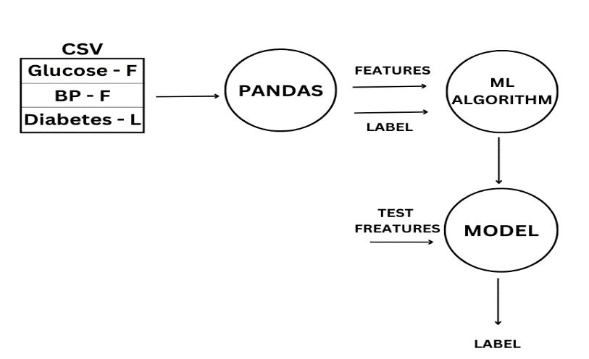

**Product Functionality:**

R1: Download data in CSV format

R2: Using pandas extract features and label from CSV file

R3: Build ML Model using ML Algorithm

R4: Predict and analyze

3.Functional Requirements

Using pandas extract features and label from CSV file

Build ML Model using ML Algorithm

4.Other Requirements N/A