**PRACTICAL 5**

**AIM: Simulate client server architecture using UDP on contiki-os.**

**THEORY:**

**CLIENT-SERVER ARCHITECTURE**

* Client Server Architecture is a computing model in which the server hosts, delivers and manages most of the resources and services to be consumed by the client.
* This type of architecture has one or more client computers connected to a central server over a network or internet connection. This system shares computing resources.
* Client/server architecture is also known as a networking computing model or client/server network because all the requests and services are delivered over a network.

**UDP**

* User Datagram Protocol (UDP) is a communications protocol that is primarily used to establish low-latency and loss-tolerating connections between applications on the internet.
* UDP speeds up transmissions by enabling the transfer of data before an agreement is provided by the receiving party.
* As a result, UDP is beneficial in time-sensitive communications, including voice over IP (VoIP), domain name system (DNS) lookup, and video or audio playback.

**IMPLEMENTATION:**

Step 1: Create a new simulation.

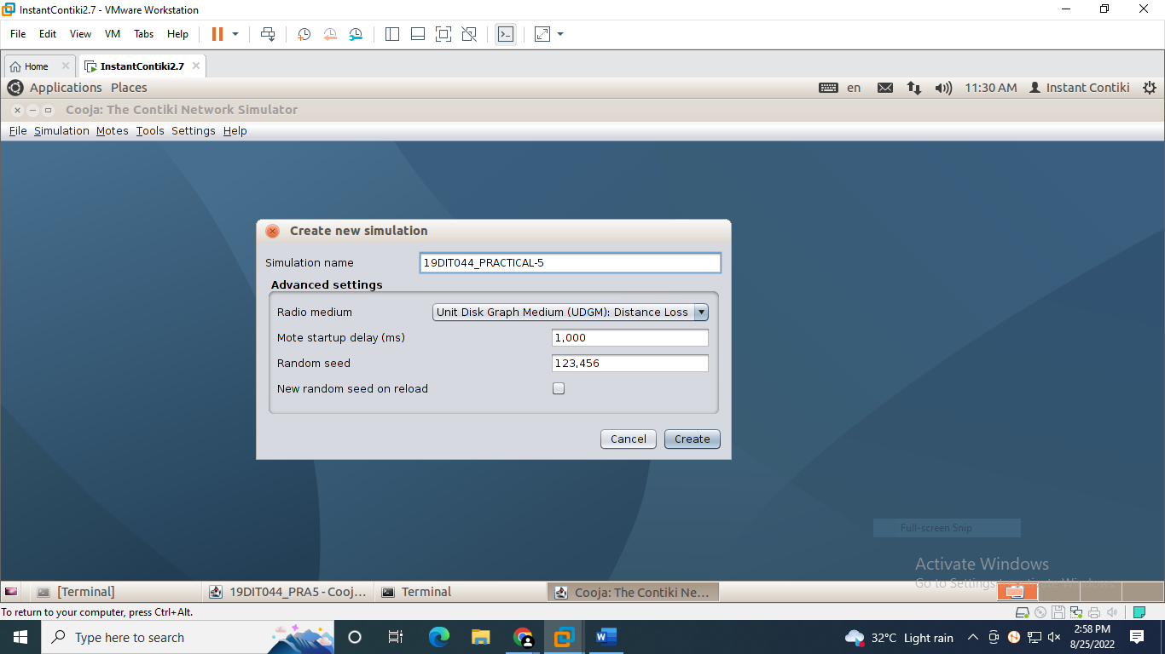

Step 2: Create a new sky mote with description UDPS. And select Contiki process source to /home/user/contiki/examples/ipv6/rpl-udp/udp-server.c and compile it.

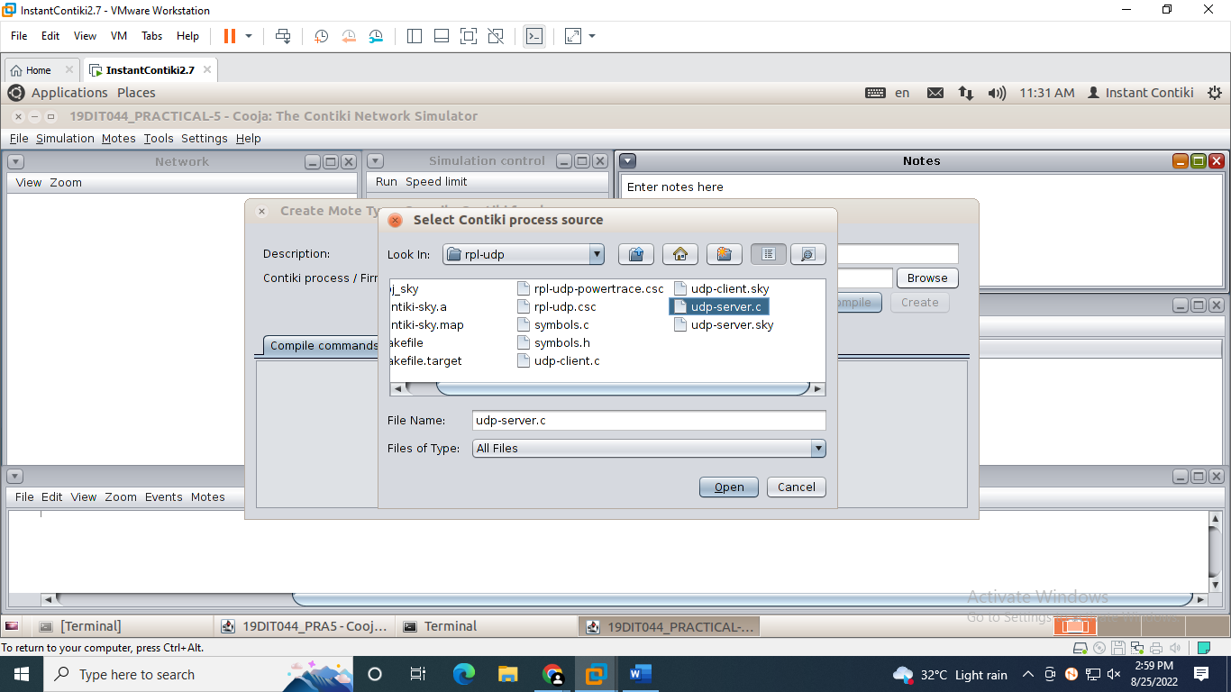

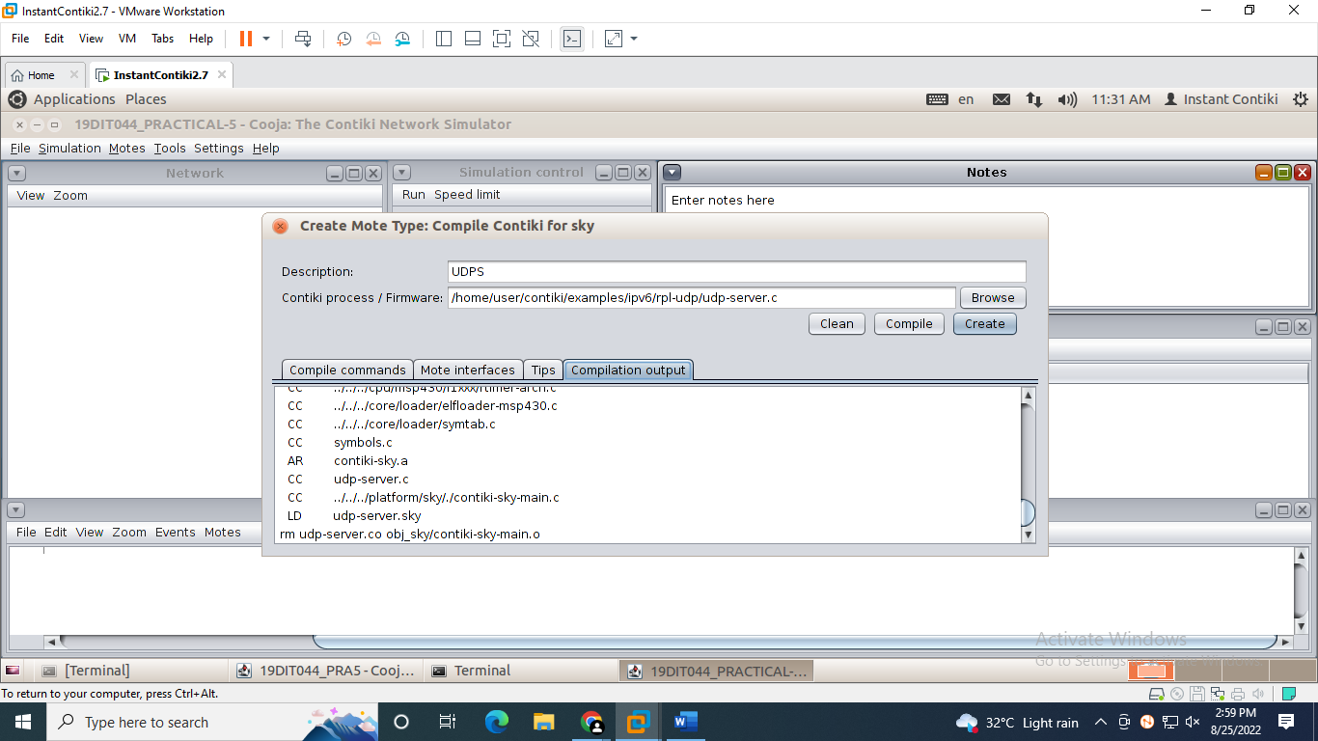

Step 3: Add number of motes as 1.

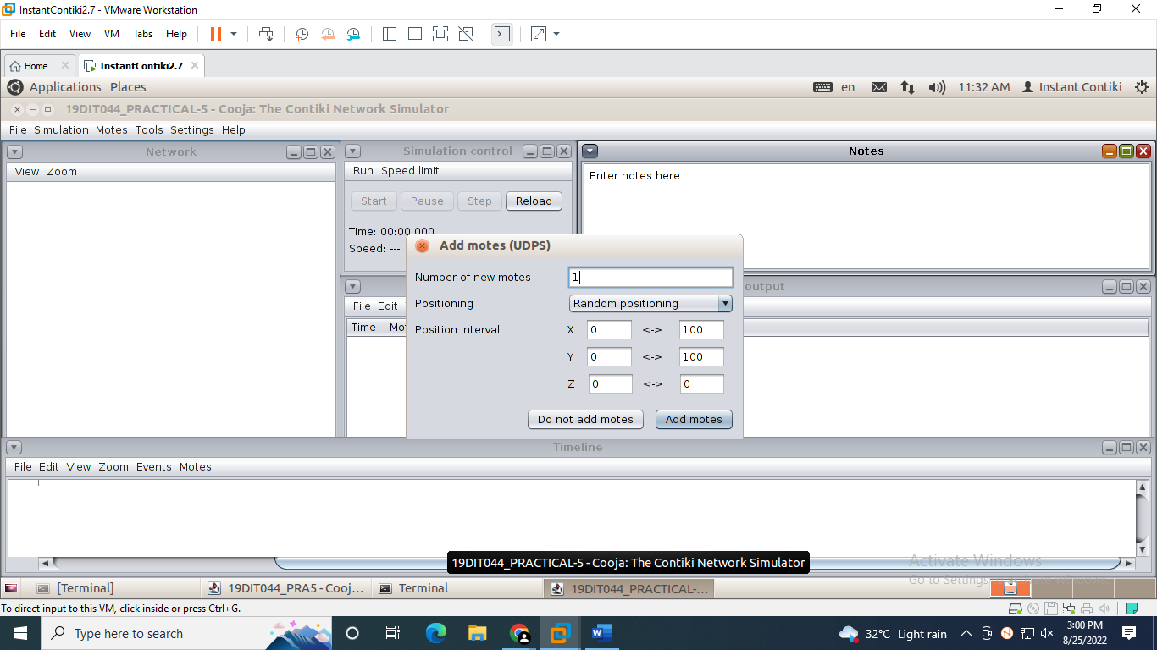

Step 4: Create a new sky mote with description UDPS. And select Contiki process source to /home/user/contiki/examples/ipv6/rpl-udp/udp-client.c

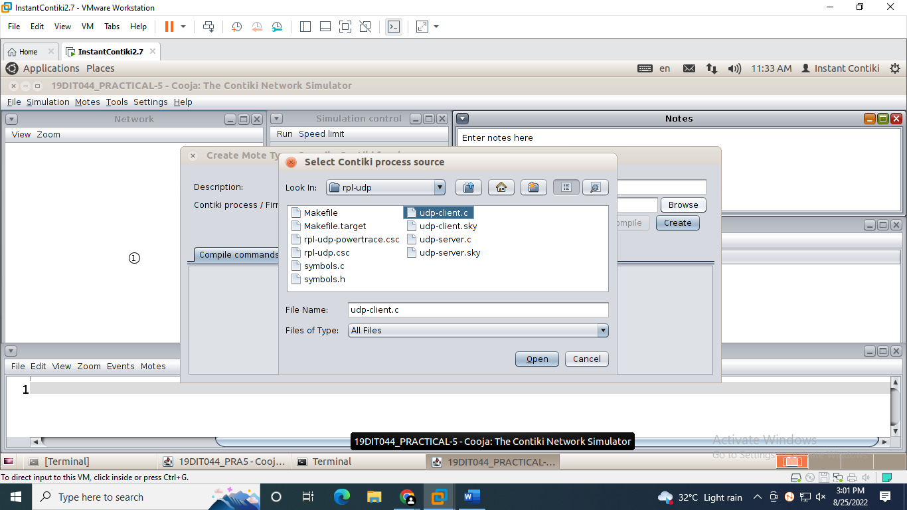

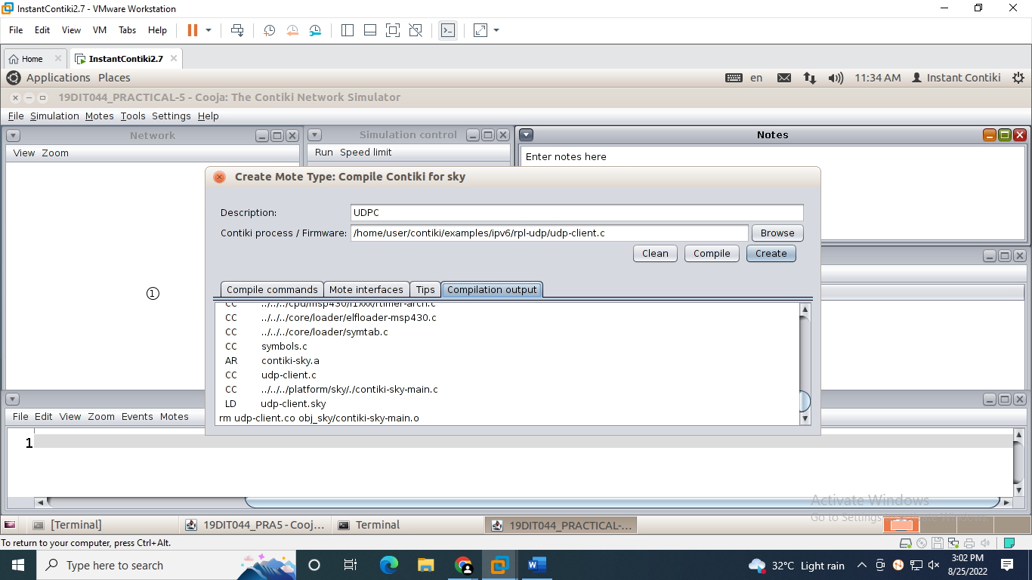

Step 5: Add number of motes as 10.

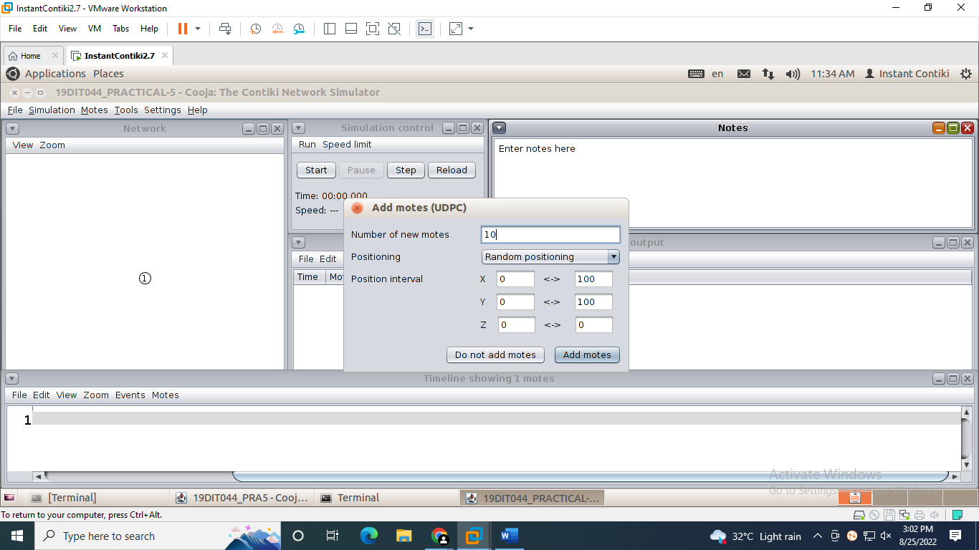

Step 6: The network looks as in the screenshot.

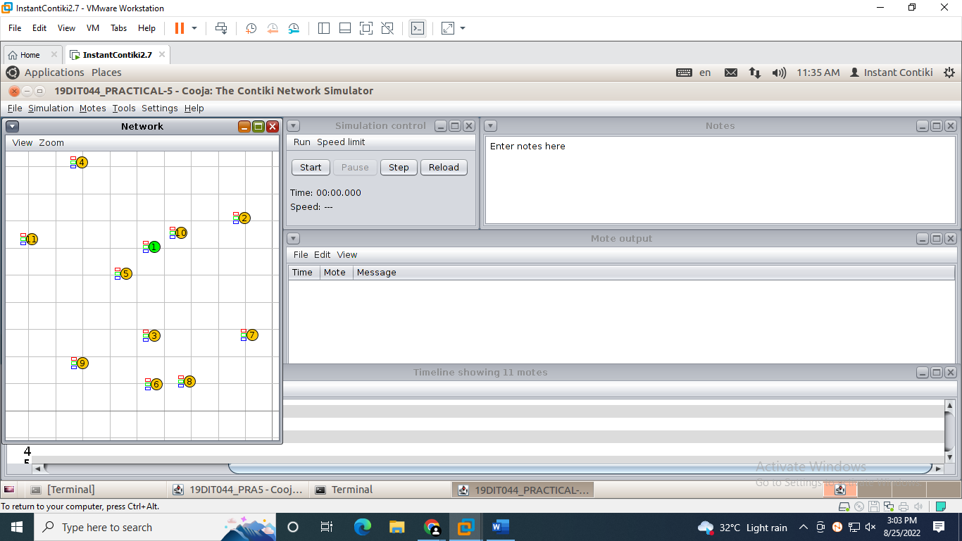

Step 7: The screenshot shows the simulation of the client-server architecture.

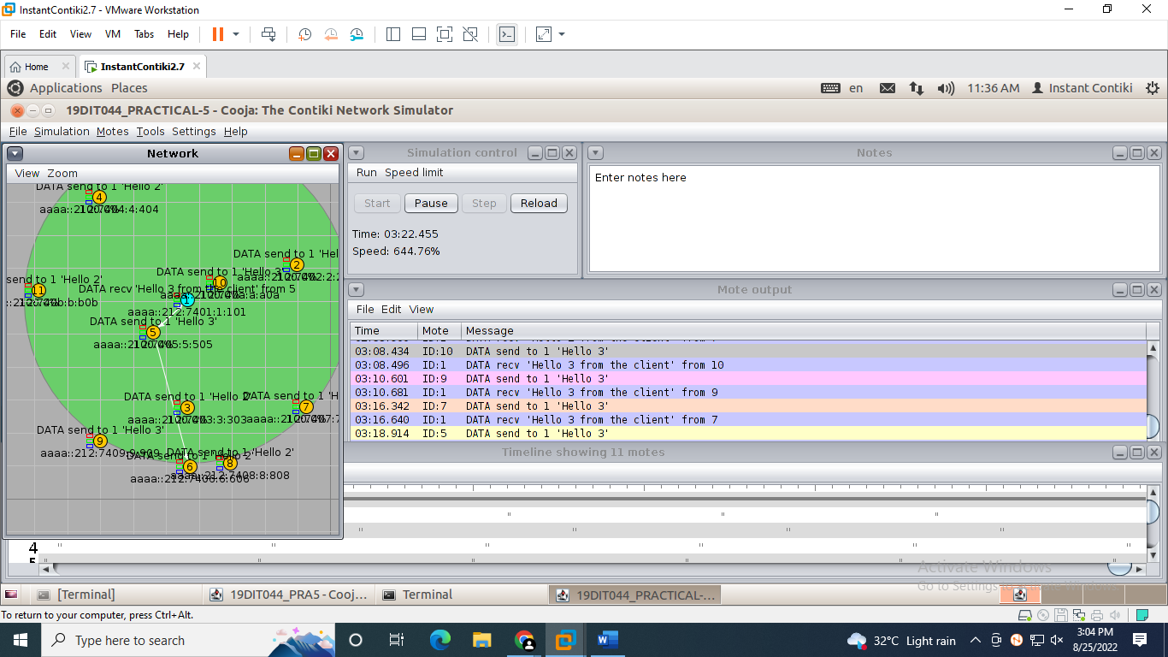

**CONCLUSION:**

From this practical, I learnt the simulation of the client-server architecture using UDP in cooja.