**PRACTICAL 6**

**AIM: Demonstrate message publish & subscribe mechanism of MQTT protocol using node red.**

**THEORY:**

**NODE RED:**

* Node-RED is a programming tool for wiring together hardware devices, APIs and online services in new and interesting ways.
* It provides a browser-based editor that makes it easy to wire together flows using the wide range of nodes in the palette that can be deployed to its runtime in a single-click.
* Node-RED provides a browser-based flow editor that makes it easy to wire together flows using the wide range of nodes in the palette. Flows can be then deployed to the runtime in a single-click.
* JavaScript functions can be created within the editor using a rich text editor.
* A built-in library allows you to save useful functions, templates or flows for reuse.
* The light-weight runtime is built on Node.js, taking full advantage of its event-driven, non-blocking model. This makes it ideal to run at the edge of the network on low-cost hardware such as the Raspberry Pi as well as in the cloud.

**MQTT:**

* MQTT is an OASIS standard messaging protocol for the Internet of Things (IoT).
* It is designed as an extremely lightweight publish/subscribe messaging transport that is ideal for connecting remote devices with a small code footprint and minimal network bandwidth.
* MQTT today is used in a wide variety of industries, such as automotive, manufacturing, telecommunications, oil and gas, etc.

**IMPLEMENTATION:**

* We can install node red on windows by following command.
* npm install -g --unsafe-perm node-red
* Then we can run “node-red” command in cmd to start the node-red.
* It will give us an IP address to use web-based node-red.

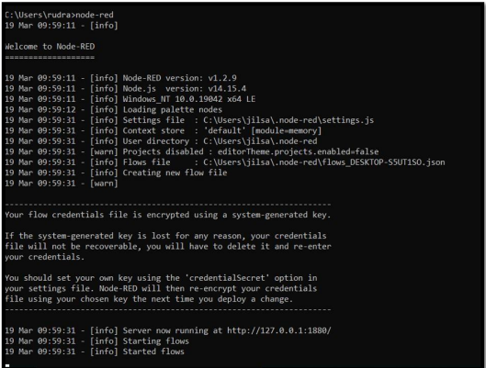

* First, we will install broker for MQTT protocol.
* For that, we will go to menu situated at top right corner.
* We will see Manage Palette option there.
* By clicking on it, User settings will be opened.
* We go to Install tab and search MQTT.

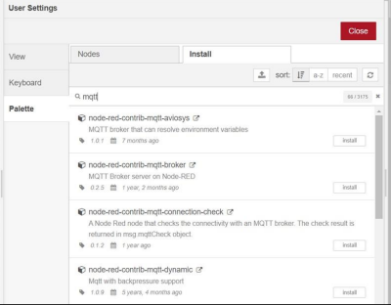

* We will install “node-red-contrib-mqtt-broker” or “node-red-contrib-aedes”

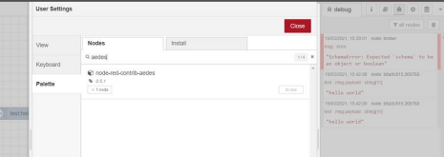

* Then we will add 4 nodes.
* Inject node, which will be renamed as Timestamp.
* Debug node, which will be renamed as msg.payload.
* We will connect timestamp node to MQTT out and debug node to MQTT in.
* Then we will add MOSCA MQTT broker or AEDES MQTT broker.

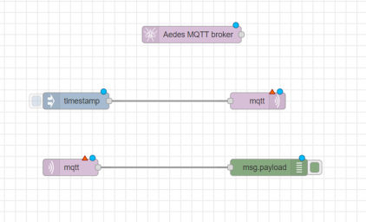

* We can double click on node to see and change their propertied.

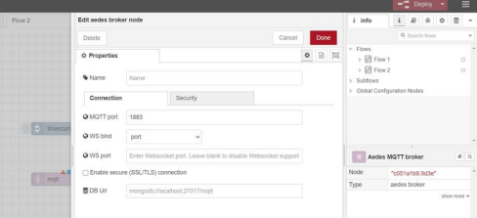

* We will first configure MQTT out node

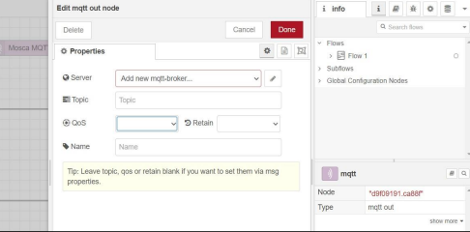

* We will add new mqtt-broker. So we click on the button beside it.
* We will add name and server IP address.
* We can add additional settings like security too if we want.

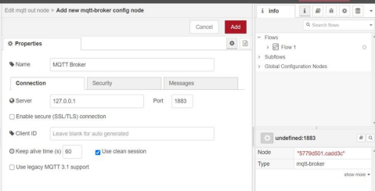

* When we click add, the server will be created and we will fill a couple of fields there like topic and QoS.
* We will provide same configuration for MQTT in node but we don’t need to create MQTT Broker again.

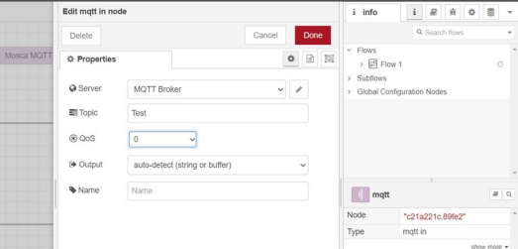

* We will give input string in timestamp node. We change the timestamp to string of “Hello world” and give it the topic name same as MQTT nodes.

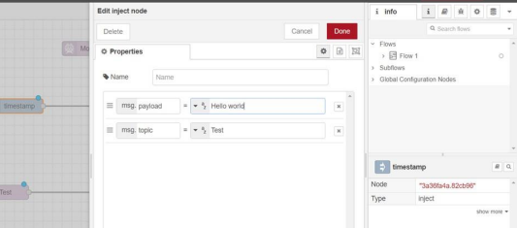

* Now we can deploy our model by “Deploy” button on top right corner.
* We can see “Successfully deployed” message.
* And in a moment, we will be able to see connected status if there is no error.
* In debug console, which can be opened from right panel, we can see the output received by.
* Debug node after clicking inject node to send the text.

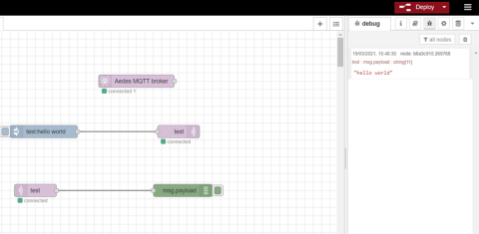



**CONCLUSION:**

In this practical, we learned about Node red and MQTT. We implemented the MQTT connection using Node red.