**PRACTICAL 3**

**AIM: Create a scenario by adding some motes. Do the simulation for the**

**same. Also observe the result for said scenario. When one mote send**

**the signal then led should turn green while one receive then it should**

**show red color.**

**IMPLEMENTATION:**

Step 1: Create new simulation. Name the simulation

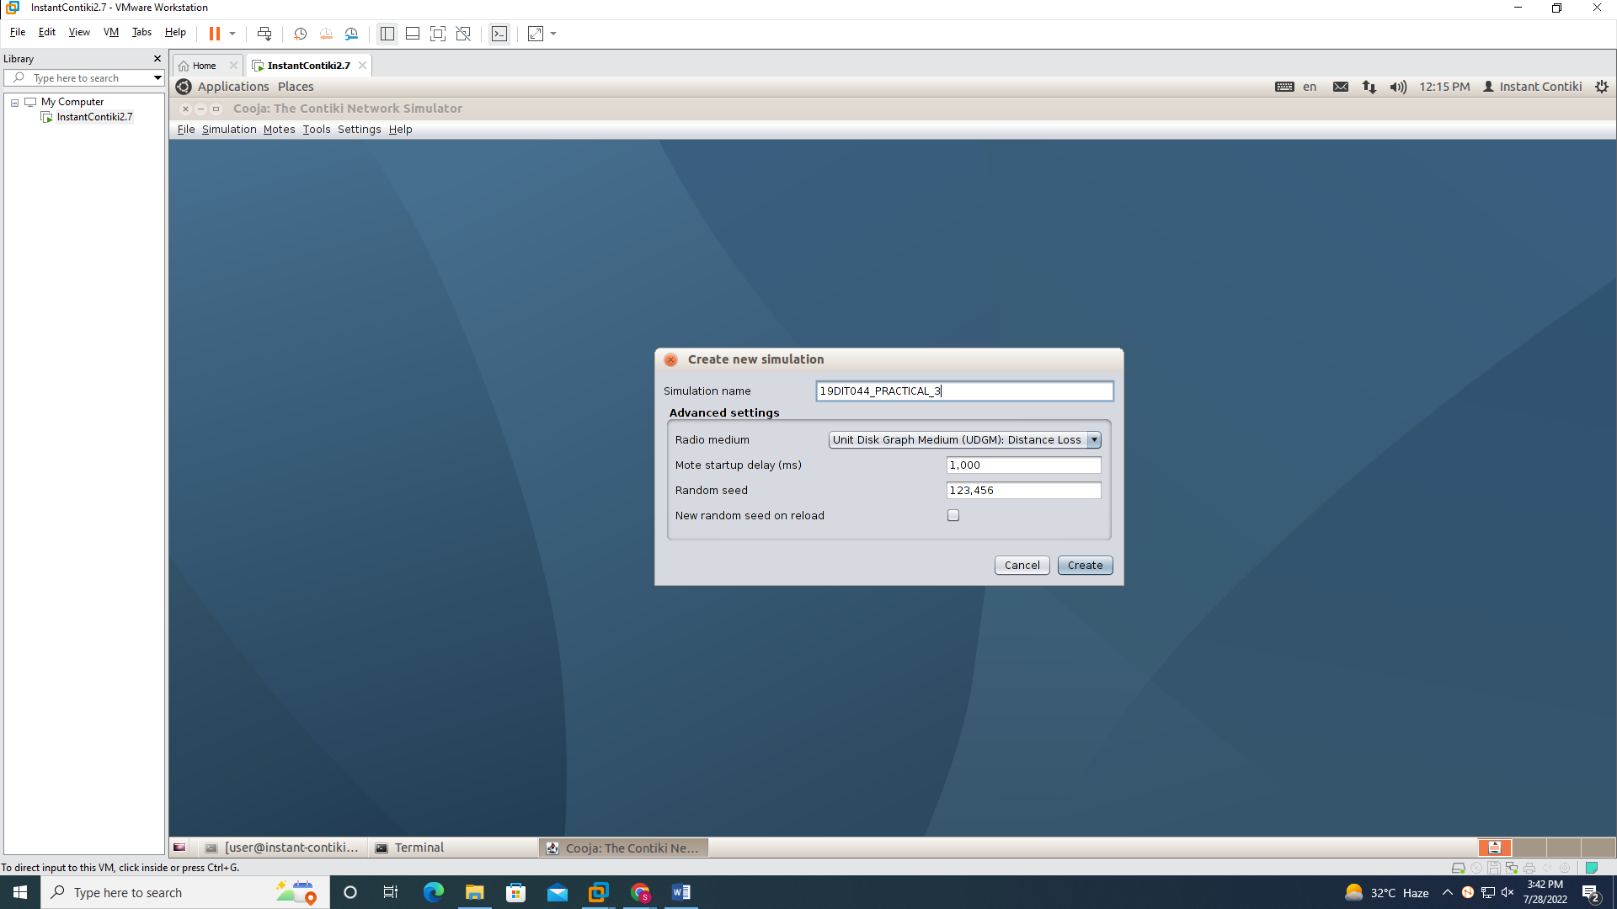

Step 2: Now click on View and select Log output: printf()’s, LEDs

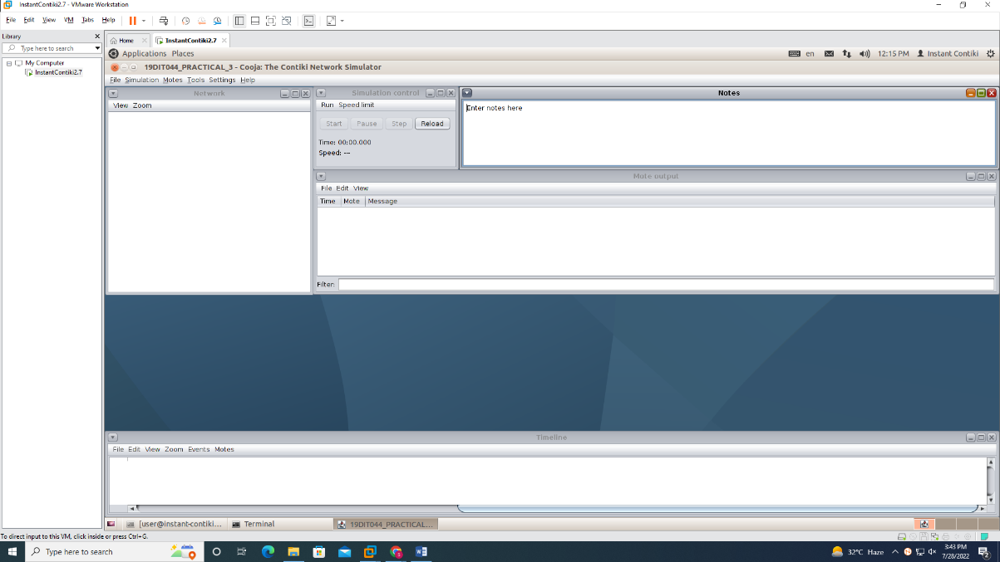  
Step 3: Navigate to Motes > Add motes > Sky mote**.** Now you will get a new panel as shown below.

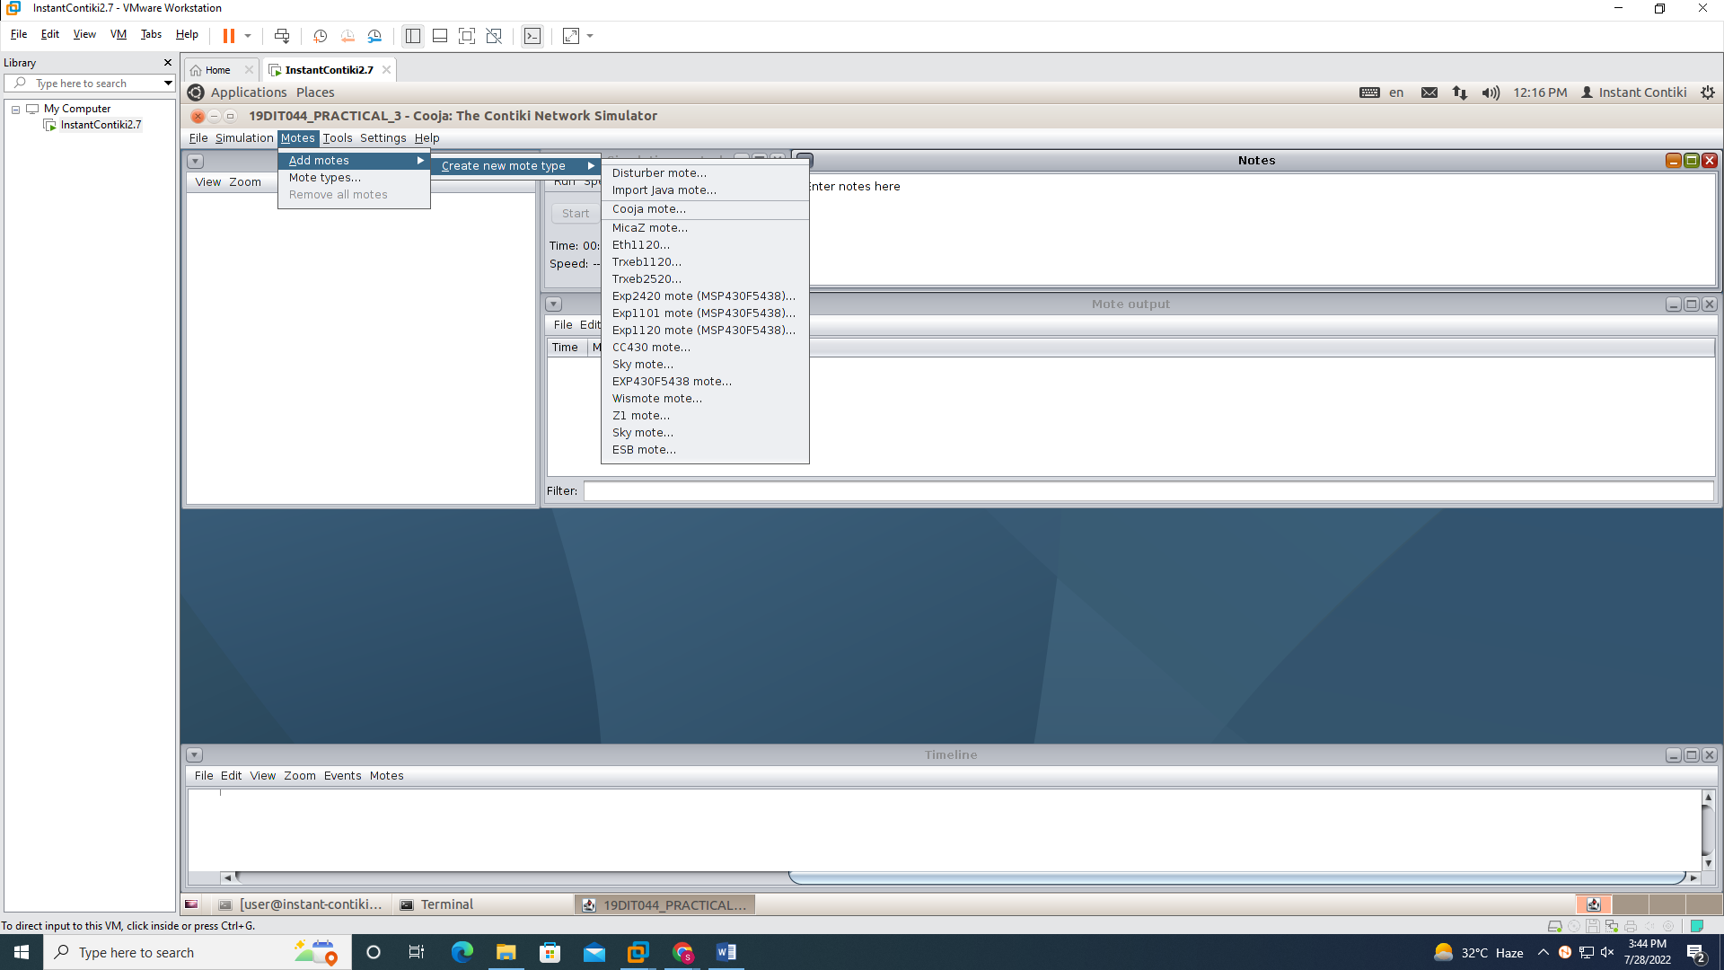

Step 4: Click browse and navigate to contiki-2.7/examples/ledprogramme/ledmodes.c and press Compile.

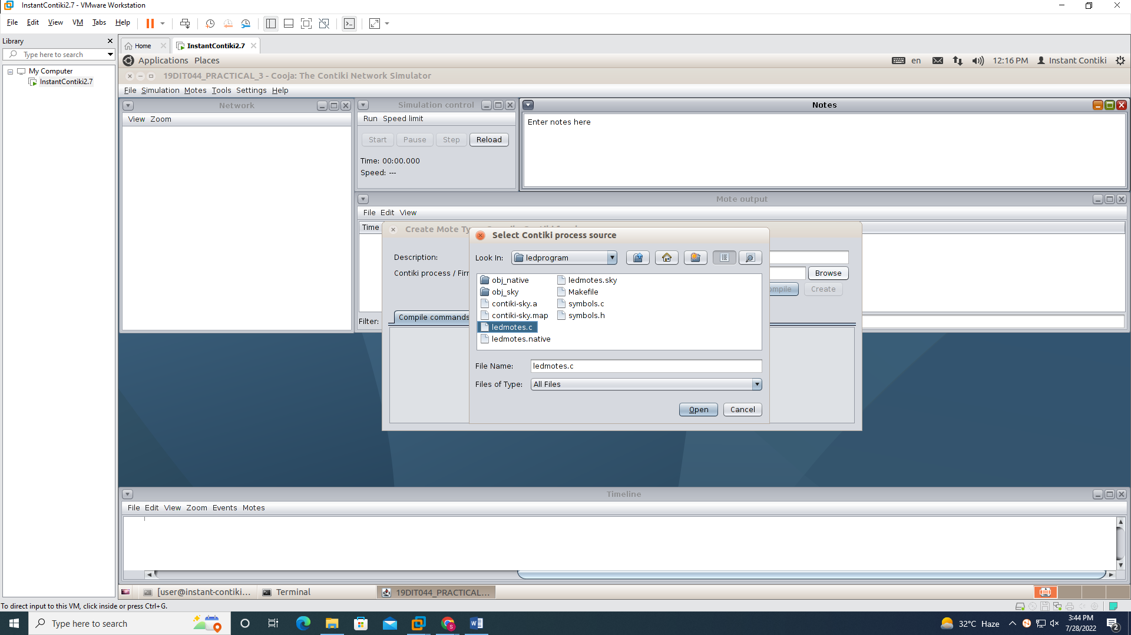

Step 5: After compilation press the Create button. You will get an option to add motes. Add 5 Motes.

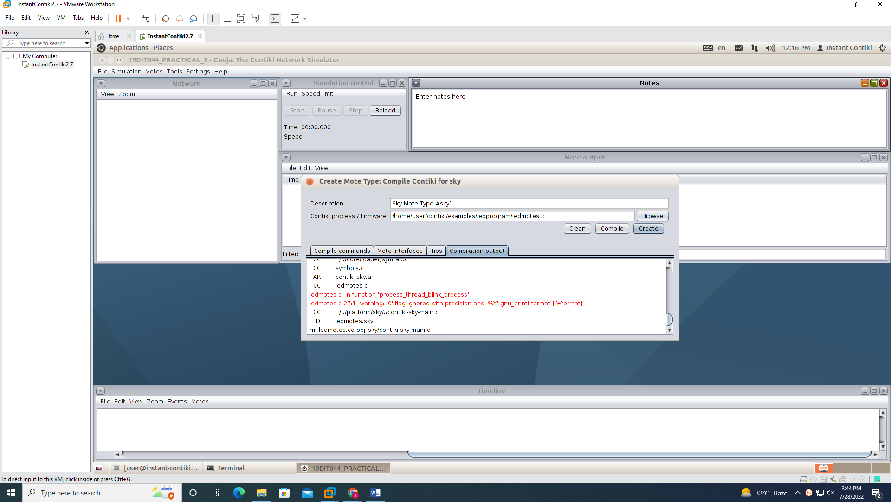

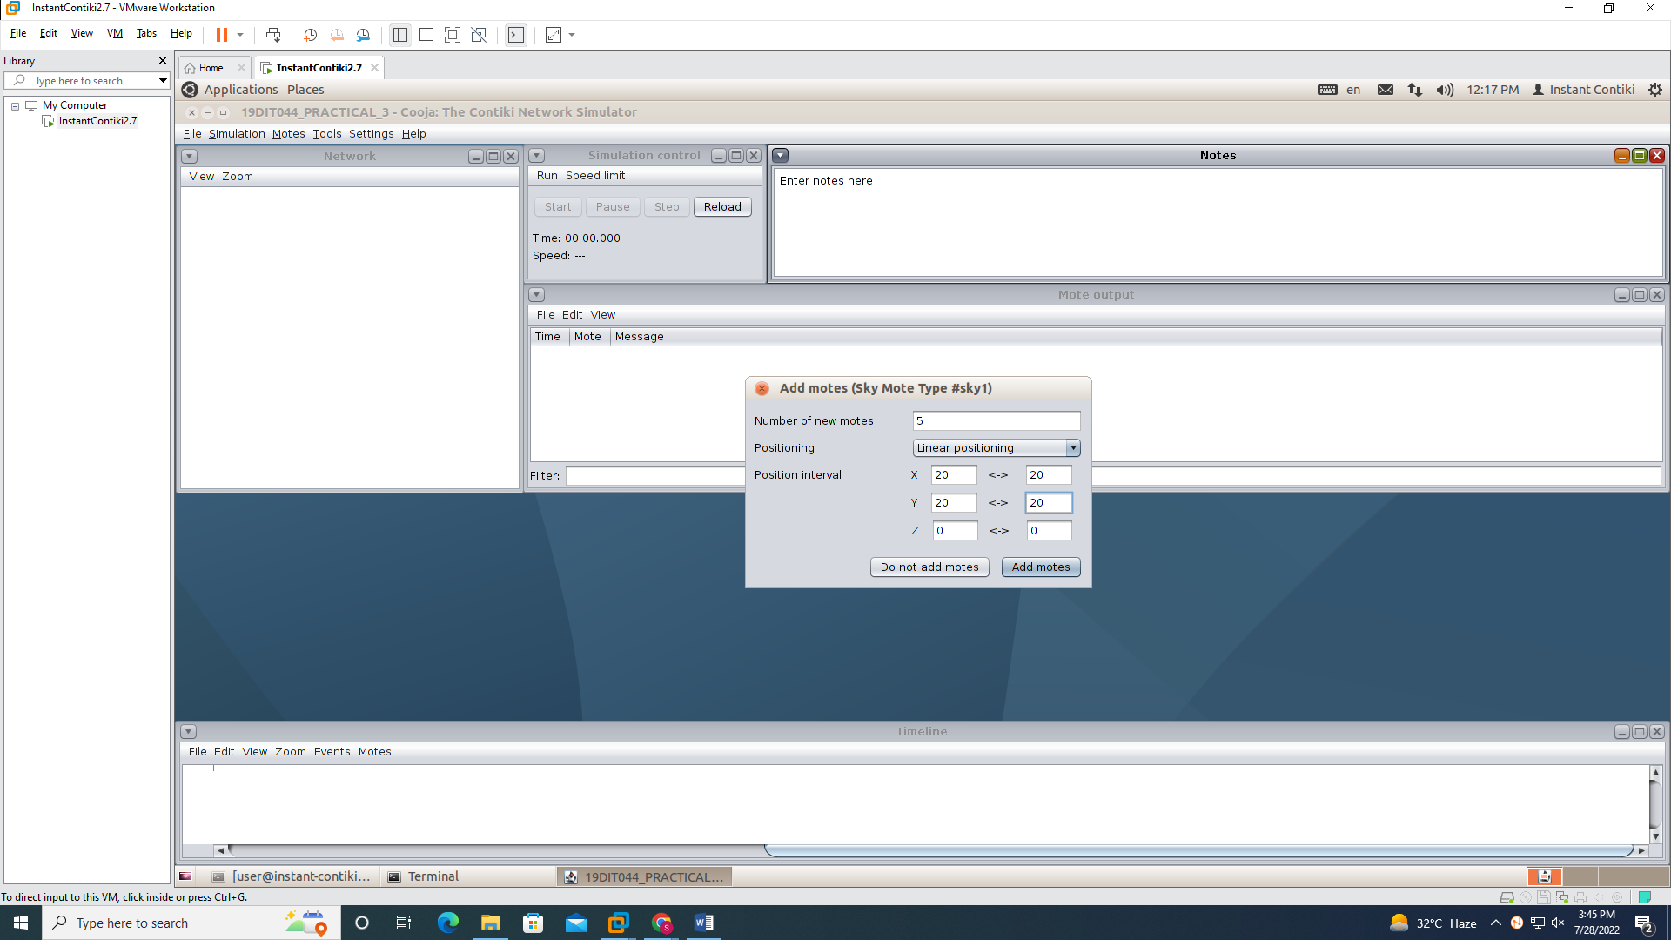

Step 6: Final output looks like in the screenshot.

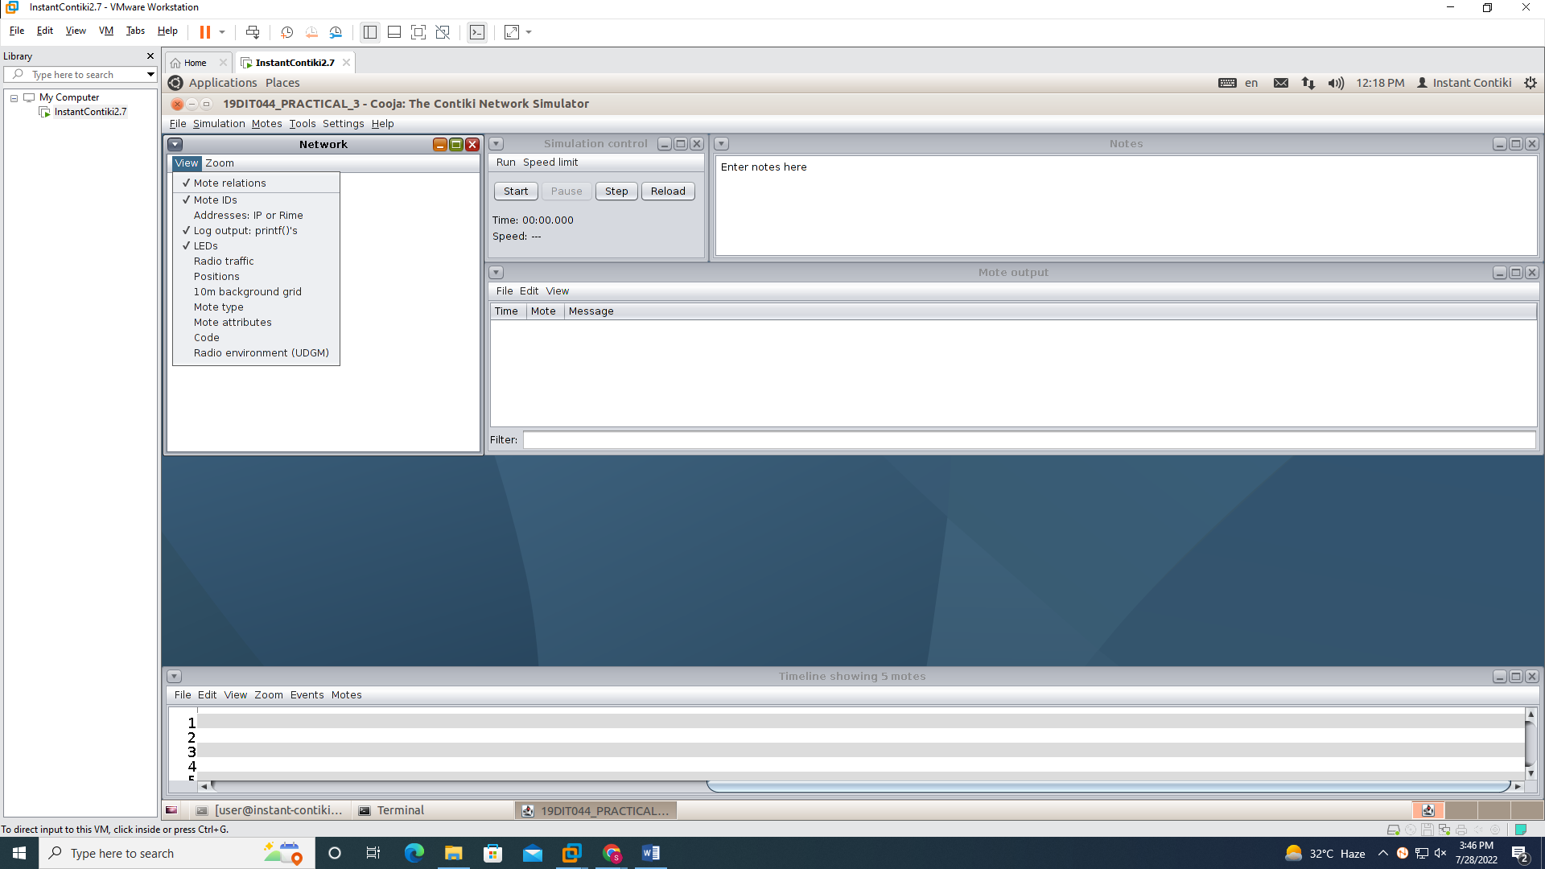

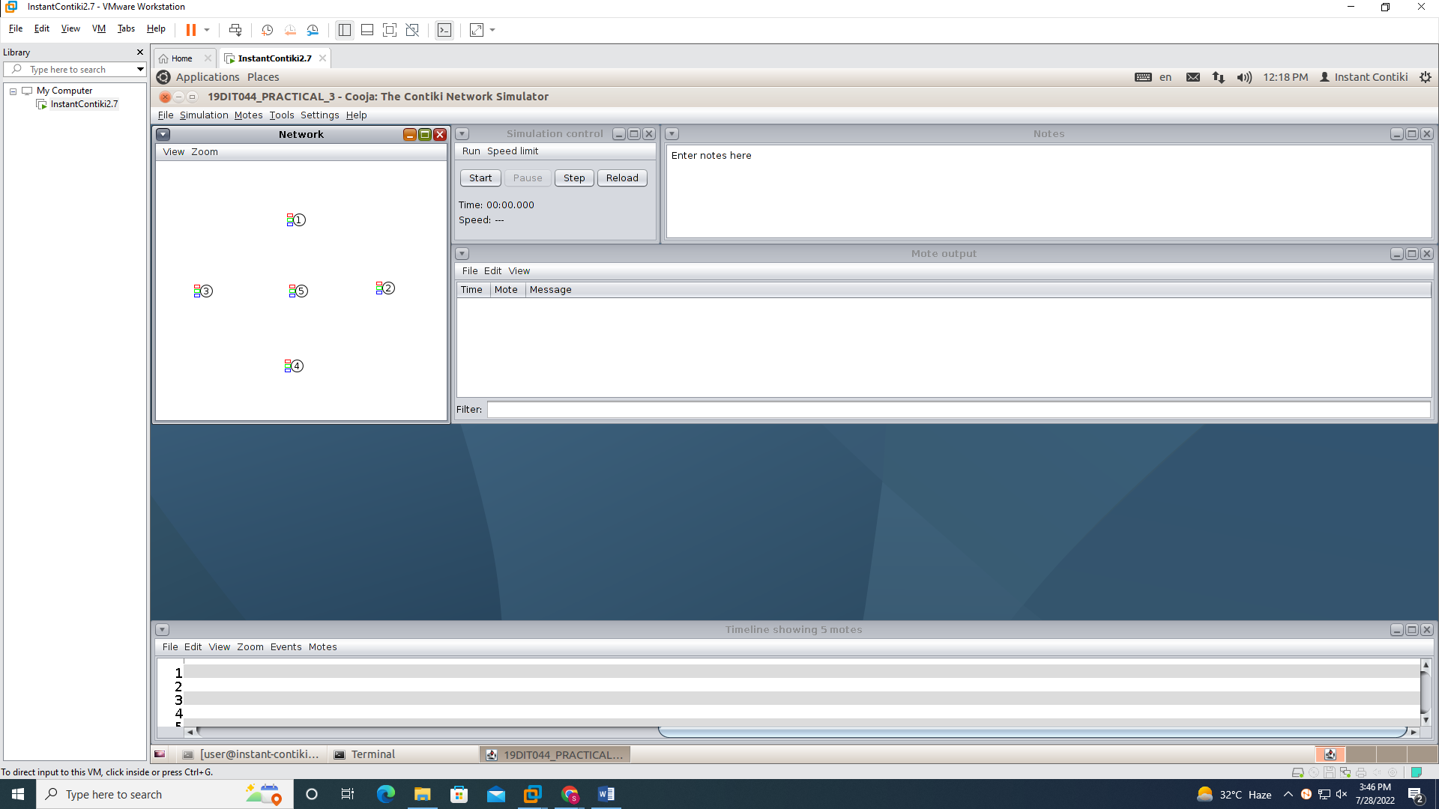

Step 7 : right click on any led and select show leds

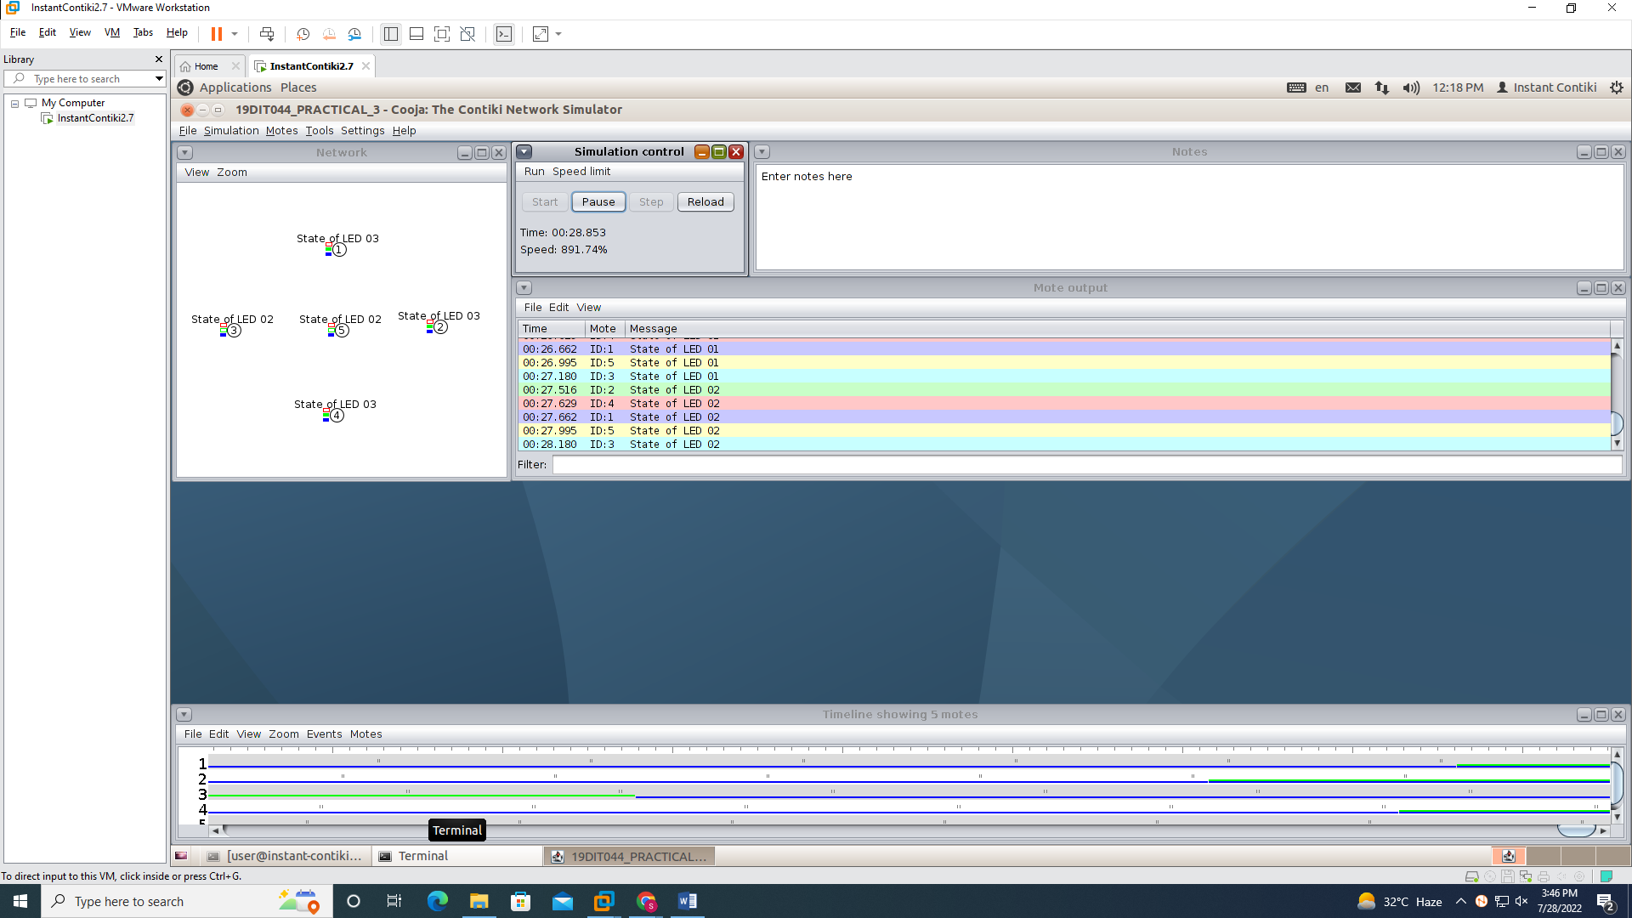

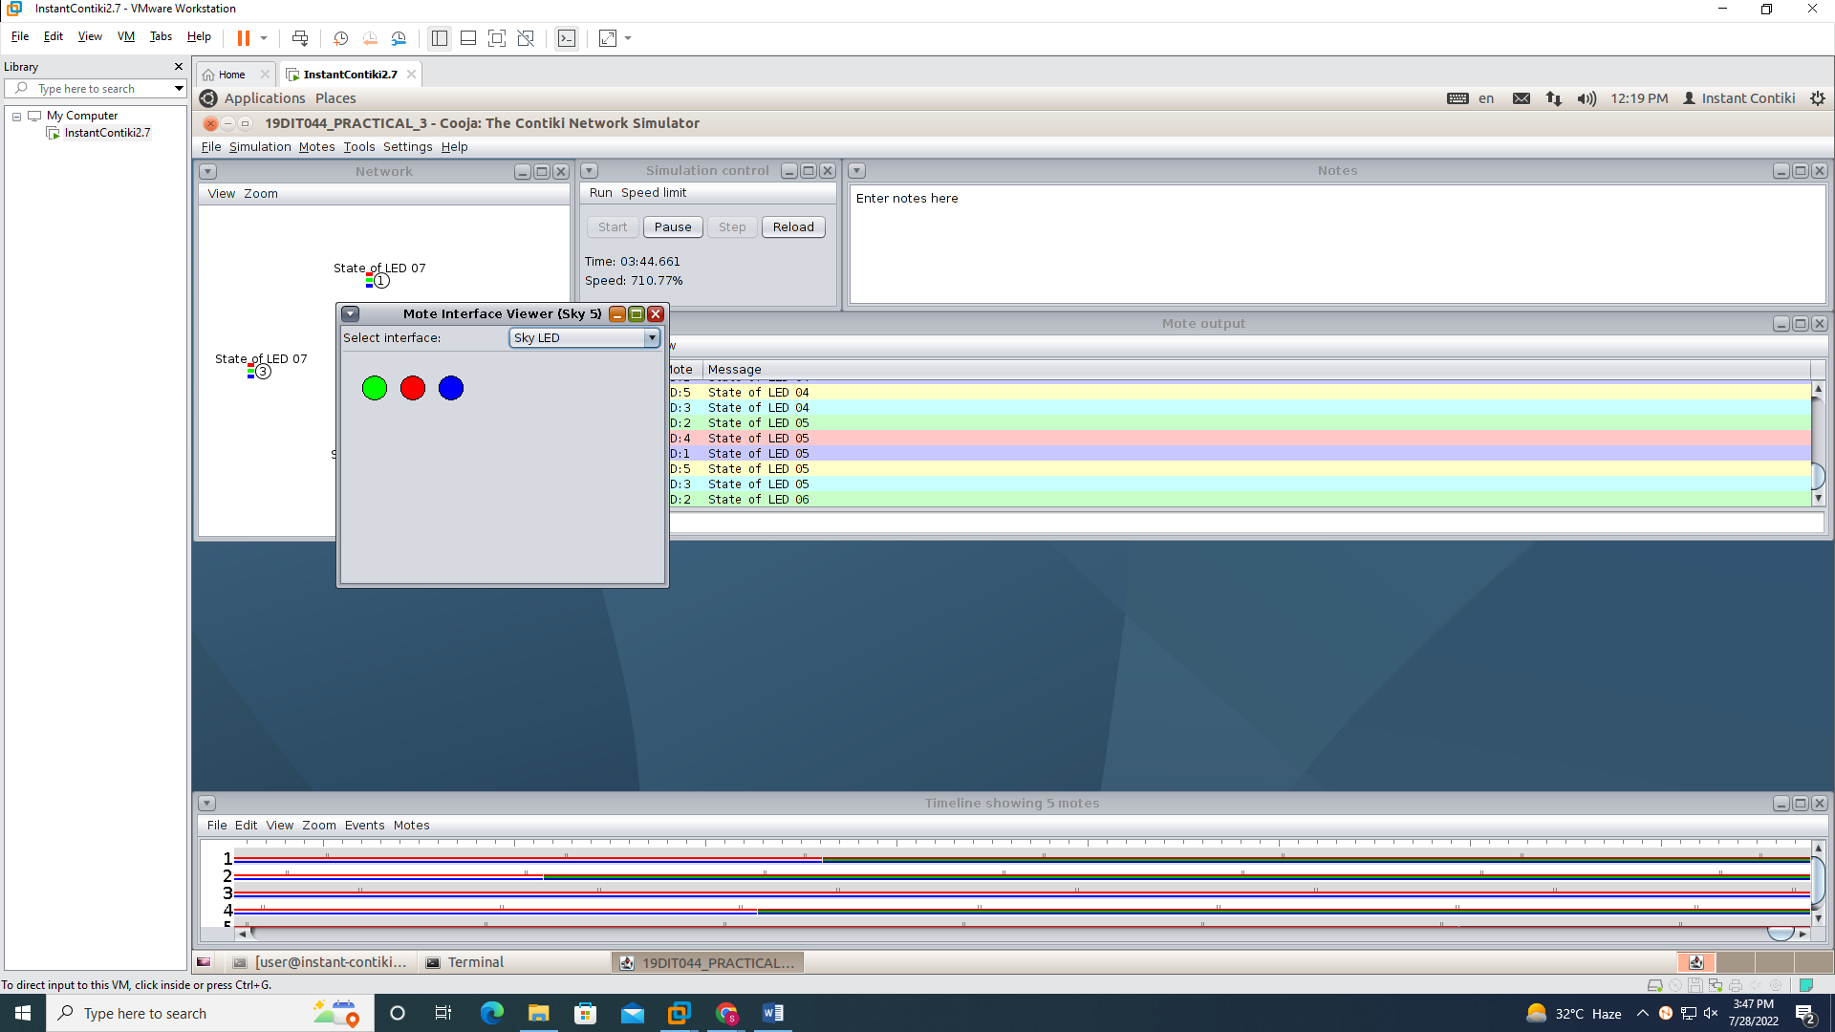

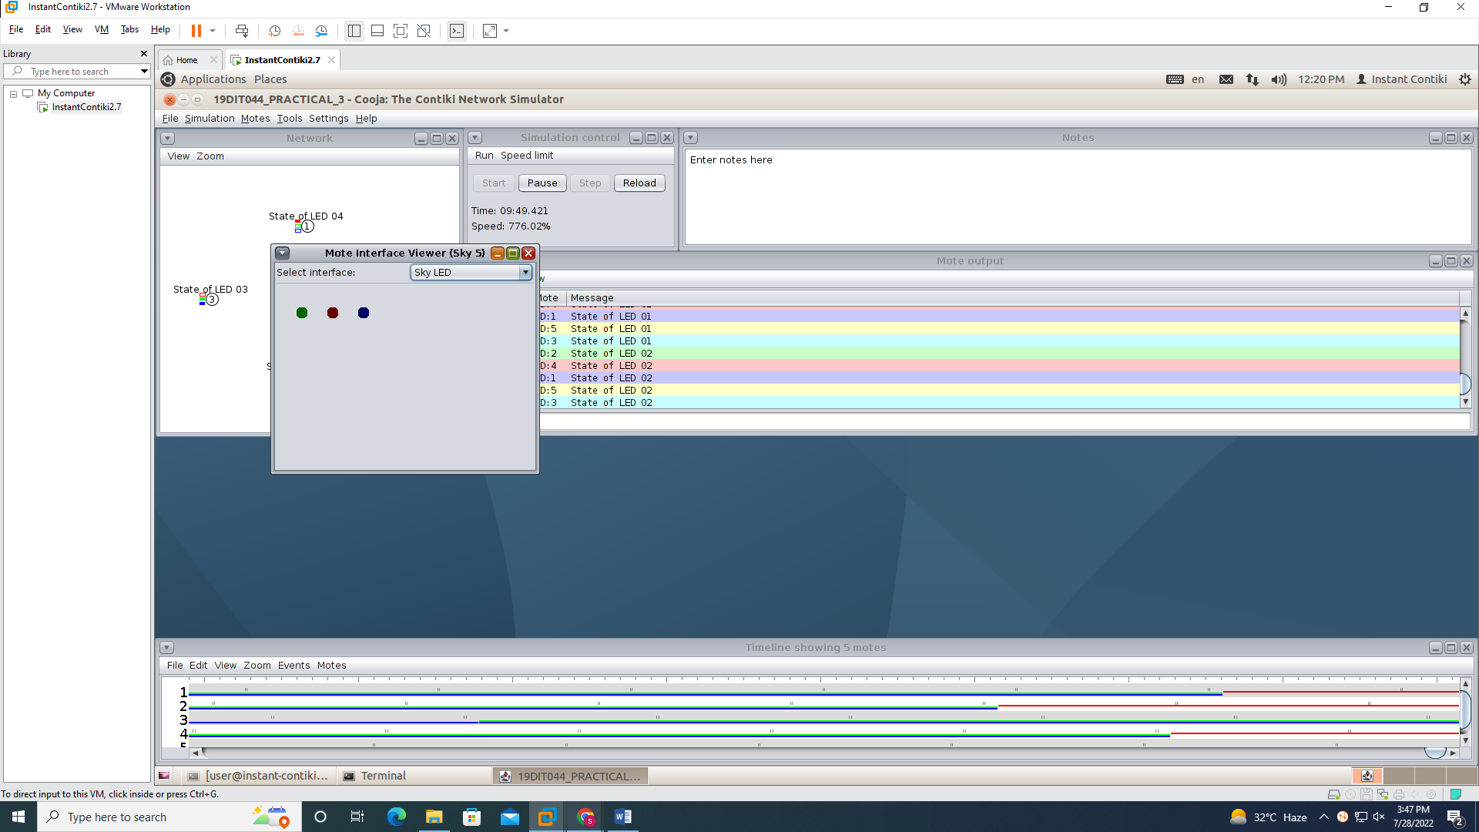

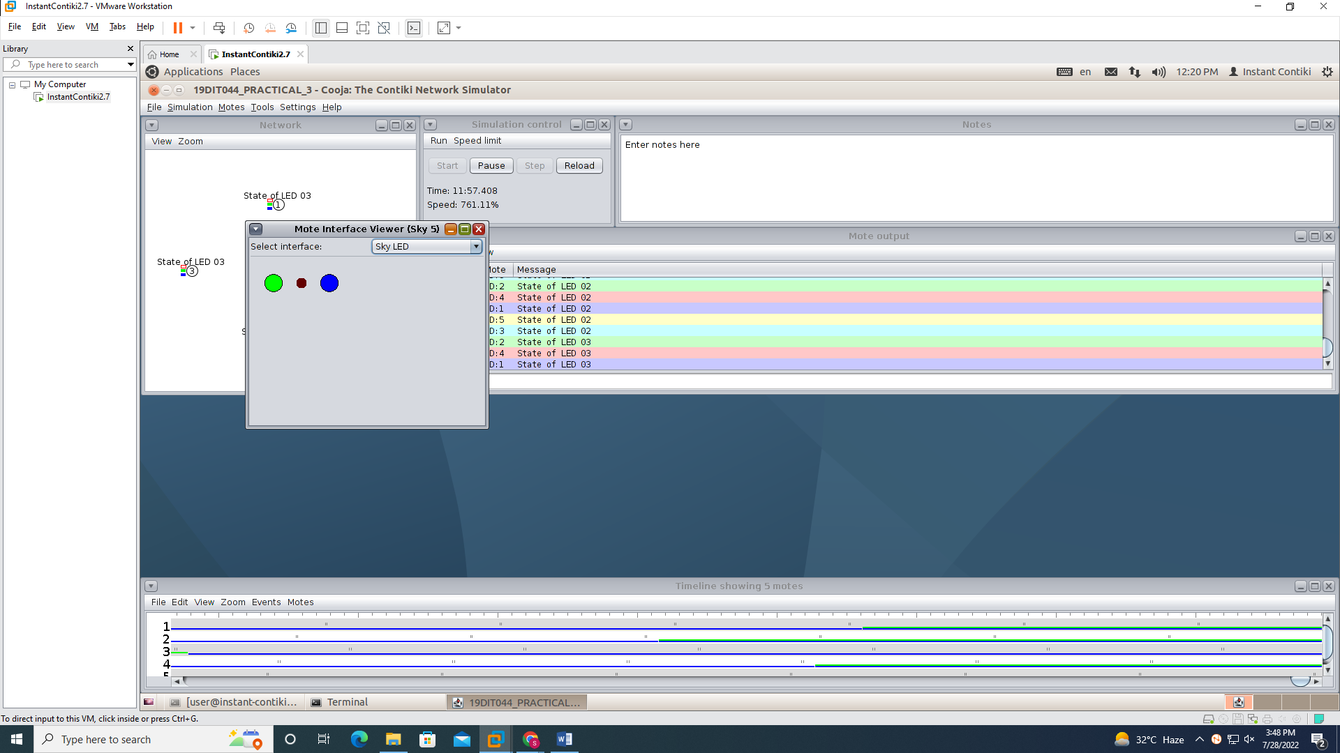

**CONCLUSION :** We have learnt about how to generate leds while sending a messages.