
“Mobile and Bluetooth ringing device for senior citizens”
A report Submitted in partial fulfillment of the award of degree of
Bachelor of Technology
(Artificial Intelligence & Machine Learning)
7th Semester

Submitted by
Hishita Sangtani
Pooja Sarode
Srushti Labade
Yashika Masram
Nishita Mankar

Guided by
Dr. Reena Thakur
Artificial Intelligence and Machine Learning
JIT, Nagpur

Department of Artificial Intelligence and Machine Learning
Jhulelal Institute of Technology
Session 2024-25
CERTIFICATE
This is to certify that the report entitled “Mobile and Bluetooth ringing device for senior citizens” submitted to the Rashtrasant Tukdoji Maharaj Nagpur University, Nagpur is the bonafide work of “Hishita Sangtani, Srushti Labade, Yashika Masram, Pooja Sarode, Nishita Mankar” of 7th semester in partial fulfillment of the requirement for the award of a degree of Bachelor of Technology in Artificial Intelligence & Machine Learning. It is the record of the candidates own work carried out under our supervision at the Department of Artificial Intelligence & Machine Learning, Jhulelal Institute of Technology, Nagpur during the academic year 2023-24. The matter embodied in this report is original and has not been submitted for the award of any other degree.

Dr. Reena Thakur Prof. Anuradha Gohad
Project Guide Project In-charge

Dr. Reena Thakur Dr. Narendra Bawane
Head of the Department Principal

Jhulelal Institute of Technology
Department of Artificial Intelligence and Machine Learning
Session 2024-25
DECLARATION

We hereby declare that the report titled “Mobile and Bluetooth ringing device for senior citizens”: Your freedom to earn” submitted herein has been carried by us in the Department of Artificial Intelligence & Machine Learning Jhulelal Institute of Technology, Nagpur. The work is original and has not been submitted earlier as a whole or in part for the award of any degree / diploma at this or any other Institution / University.

Date: Projectee’s name
Hishita Sangtani
Srushti Labade
Yashika Masram
Pooja Sarode
Nishita Mankar

7th Semester
B. Tech,
Artificial Intelligence & ML
JIT, Nagpur, India.

ACKNOWLEDGEMENT
We would like to take this opportunity to acknowledge our profound indebtedness and extend our deep sense of gratitude to our respected guide Dr. Reena Thakur, Department of Artificial Intelligence & Machine Learning. for his/her valuable guidance, profound advice and encouragement that has led to the successful completion of this project.

With profound feeling of immense gratitude and affection, we would like to thank our Respected Prof. Anuradha Gohad, Project Co-ordinator, Department of Artificial Intelligence & Machine Learning for his continuous support, motivation, enthusiasm and guidance. His encouragement, supervision with constructive criticism and confidence enabled us to complete this project.

We are grateful to respected Dr. Reena Thakur, HoD, Department of Artificial Intelligence & Machine Learning for her full cooperation, help and for providing necessary facility to complete our project. We also thank the staff members of the AIML department.

We also put forward our deepest sense of gratitude towards Respected Dr. Narendra Bawane, Principal, JIT, for constant motivation and providing necessary infrastructure.

We would like to thank all the people who have directly and indirectly help us in the completion of project.

Finally we would like to express our deepest gratitude to our parents for encouraging through the progress in the work.

Name of the projectees:
Hishita Sangtani
Srushti Labade
Yashika Masram
Pooja Sarode
Nishita Mankar
i
ABSTRACT
The need for effective communication and safety solutions for senior citizens has become increasingly pressing. This project proposes the development of a Mobile and Bluetooth Ringing Device specifically designed to enhance the accessibility and responsiveness of alert systems for elderly individuals. The device integrates a mobile application with a Bluetooth-enabled ringing mechanism that can be easily activated by caregivers or family members.
The core functionality allows users to receive notifications through their smartphones, alerting them to important events such as incoming calls, messages, or emergency alerts. The Bluetooth component ensures a reliable connection to the ringing device, which can be strategically placed within the home to ensure maximum visibility and audibility. Additionally, the application features customizable settings, enabling users to choose specific tones or vibration patterns to differentiate alerts.

.
ii
LIST OF FIGURES
FIG.NO | NAME OF FIGURES | PAGE NO.
Fig 1 | System Flow | 14
Fig 2 | Programming Code | 22
Fig 3 | Interface the Bluetooth and buzzer | 23
iii
LIST OF TABLES
NAMES OF TABLES | PAGE NO.
Table 1. HC06 | 21

iv
LIST OF ABBREVIATIONS
LIST OF ABBREVIATIONS | MEANING
PCB | Printed Circuit Board
IDE | Integrated Development Environment

INDEX
Page No.
Title
Certificate
Declaration
Acknowledgement
Abstract i
List of figures ii
List of table’s iii
List of Abbreviations iv
CHAPTERS
- INTRODUCTION
  - Introduction
  - Theoretical background
  - Origin of research problem
  - Interdisciplinary relevance
2. Literature Survey
3. PROBLEM STATEMENT AND OBJECTIVE
3.1 problem statement
3.2 objective
4. METHODOLOGY
5. FLOW CHART /DATA FLOW DIAGRAM
6. SOFTWARE & HARDWARE REQUIREMENT
7. IMPLEMENTATION OF PROPOSED SYSTEM
8. RESULT ANALYSIS & DISCUSSION
9. CONCLUSION AND FUTURE WORK FOR EVEN SEM
9.1 Conclusion
9.2 Scope for future work
10. REFERENCES
1. INTRODUCTION
1.1 Introduction:
People who are older may experience a variety of difficulties that make it harder for them to respond to phone calls, such as hearing loss, trouble moving around, or preoccupation. These difficulties may result from cognitive decline, physical restrictions, or unfamiliarity with technology. It is important to make sure that senior citizens can consistently receive and reply to phone calls, since these calls frequently contain critical messages from friends, family, medical professionals, or emergency services.
1.2 Theoretical Background:
The proportion of elderly people living independently is rising as the world's population ages. Although this independence is frequently desired, it also brings with it difficulties, especially when it comes to safety and communication. One major problem is that elderly people sometimes have trouble returning phone calls, which makes it harder for them to stay in social networks and deal with emergencies.
1.3 Origin of the Research Problem:
It has become increasingly common for elderly individuals not to answer their phones as Understanding the origins of this problem requires examining trends in population aging a result of a confluence of demographic, technological, and health factors., advances in technology, and the specific challenges faced by the elderly.
1.4 Interdisciplinary Relevance:
It involves a combination of technology, and communication skills. The collaboration between callers and receivers, and technologists is crucial in developing devices that cater to issue related to senior citizens. The integration of IoT technologies and healthcare expertise showcases the interdisciplinary approach to improve communication.

2. Literature Survey
The issue of elderly individuals’ not attending phone calls has been explored in various research studies, examining the factors contributing to this problem and potential solutions. Here we have taken various literature surveys that show’s Falls are significant threat to the health & of elder people, causing injuries, even death. Fall detection devices play a crucial role in ensuring timely medical attention preventing severe consequences Bluetooth devices can greatly benefit elder people by enhancing their safety, health, and independence.
The author Ystrengers & Kennedy has mentioned the investigation of adaption of smart wifi siri, alexa [1]. Mohammad Faisal , Mohammad Yusuf has mentioned about wearable devices for fall detection and prevention in elderly people [2]. Baecher,R.M., Wu,& masimmi, M has mentioned about using participatory activities with senior to evaluate mobile [3]. Kurniawan,s has mentioned about old people and mobile a investigate [4]. Gelberdom, J.H, Van Dyk, & Biljon has mentioned about Bluetooth device for elders[5].

3. PROBLEM STATEMENT AND OBJECTIVE
3.1 Problem statement:
The scope of the problem in developing mobile and Bluetooth ringing devices for senior citizens includes addressing the challenges posed by age-related hearing loss, reduced vision, limited dexterity, and cognitive decline. Seniors often struggle with complex interfaces, soft ringtones, and small buttons on conventional devices, leading to missed calls, communication difficulties, and potential safety risks. The project aims to solve these issues by creating devices that are loud, simple to use, and equipped with emergency features, ensuring that seniors can stay connected and safe in their daily lives. Seniors may struggle with complex user interfaces, leading to difficulties in using mobile phones for basic communication or emergency situations. Arthritis or reduced hand dexterity can make it challenging for seniors to operate small buttons or touchscreens on conventional devices. Difficulty in using mobile technology can lead to social isolation for seniors, as they may struggle to stay connected with family, friends, and emergency service. The lack of easily accessible emergency features can be dangerous for seniors, especially those living alone or with health conditions requiring immediate attention.

3.2 Objective:
Improve the safety and well-being of elderly citizens and enhance their independence and quality of life. As some elder citizen have physical disabilities so they are not able to answer the phone calls every time and some has hear loss so the device helps senior citizens to attend the calls which is connected with mobile phone via Bluetooth by alerting them.

4. METHODOLOGY
The system modeling approach for the mobile and Bluetooth ringing device project for senior citizens involves a user-centered design methodology, incorporating the principles of human-computer interaction and assistive technology. The system is modeled as a socio-technical system, comprising the senior citizen, the mobile device, the Bluetooth ringing device, and the caregivers or emergency services. The system's primary goal is to enhance the senior citizen's ability to receive and respond to phone calls and alerts, while also providing emergency response features and voice command functionality. By applying system modeling theory, the project aims to create a comprehensive and integrated solution that addresses the complex needs of senior citizens, promoting independence, safety, and social connectivity.
HC05 Bluetooth module for communication, this is cheap and easy to find on eBay. Make sure you have the HC05 module and not the HC06, they look the same, but the difference is that the HC05 works as both a master and client but the HC06 works only as a client. This project may not work with the HC06.
If you bought a module with the breakout board make sure it has a key terminal, if it has a Wakeup terminal you will have to solder a wire to the pin 34 which will act as a KEY pin. Then solder the pin 32 of the HC05 we will use this to reset the board each time we upload the code.

5. FLOW CHART /DATA FLOW DIAGRAM
Start
Detection Of Ringer tone
Sending it to Arduino
Receiving Through Bluetooth
Generating signal through Buzzer
Stop

FIG.1 SYSTEM FLOW
The above discern determines the device data flow diagram of the proposed machine. The system architecture involves following steps:
Start: The system is idle, awaiting an incoming call or signal from the connected mobile device.
Check Device Connectivity: The system checks whether the Bluetooth device is connected to the phone.
Bluetooth Connected: If the Bluetooth device is connected, the Arduino system will activate ringer. Arduino controller generates the high signal to pin where the buzzer is connected
Trigger Buzzer Ringer: The controller will send signal to buzzer
6. SOFTWARE & HARDWARE REQUIREMENT
Software Requirements
- Mysql
- Html
- JavaScript
- Python
- PHP
- XAMMP

Hardware Requirements
- Core i
- Ram
- Hard disk
- Keyboard
- Monitor
7. IMPLEMENTATION OF PROPOSED SYSTEM
We had divided our project in following parts: -
a. Designing of actual material.
b. Procurement of material.
c. Layout of PCB.
d. Preparation of PCB.
e. Assembling of components & their maintaining.
f. Software Implementation.
- Interfacing hardware with software.
h. Testing.
1)Layout Designing
The name printed circuit board suggests that printing processes involved in drawing the artwork on the board. And printing processes are often used to transfer an image to a PCB.
History of the PCB-
In 1930’s the technology for making a PC board was invented and name into use during 1945. Before that time circuits were constructed with point to point soldering component on an insulating board. But this is time consuming and bard to troubleshoot. Printed circuit board is a piece of art. The performance of an electronics circuit depends upon layout and sensing PCB.
PCB are used to route electrical urgent and signal through copper track while are firmly bonded to an insulating base. The base material used for PCB is paper phenolic, glass epoxy, polyester etc. paper phenolic is less costly and used to consumer electronic circuit. Paper phenolic is more resistance to moisture, but difficult to machine and drills compared to glass epoxy.

Rules for Layout-
PCB interconnects various electronics component by an interconnectivity pattern. The general considerations are:
- Mechanical consideration: size, shape, mounting of PCB, etc.
- User system consideration: that is whether for consumes or laboratory or industry etc.
- Electrical and electronics parameter such as impedance gain, electromagnetic coupling etc.
- Easy of maintenance.
Art Work-
For photographic reduction process the artwork should provide maximum contact between the portion to be each away and those to be left. Thus the art work should be generated on white sheet with black ink. A polyester foil can also be used with sticking tape and prepare artwork but it is costly. Tracking paper may be used but it is not stable with temperature.
Basic Methods of Preparing Artwork
- Ink the drawing. The method is cheap. High quality water proof ink base is to be used.
- Using black tape and sticking pattern.
- Using red and blue transparent tape.
Advantages of PCB-
Advantages of PCB over normal wiring are as follows.
CB is necessary for interconnection a large number of electronics component in a very small area with minimum parasitic wiring affects.
- PCB is stable for mass production with less chances of wiring error.
- Small component can be easily mounted on PCB.
- Wiring micro phony is avoided.
- Construction is neat, small and truly a work or art.
- By using PCB, the electronic equipment becomes more reliable in size and less costly.

Disadvantages of PCB-
- Art work is a Time Consuming activity.
- Art work requires skill and without designing a new board is not possible to make connection.
Etching of PCB-
Etching is the process of chemically attacking and removing the unprotected copper from the copper plate to yield the desired conductor pattern. The most common enchant used in the industry is ferric chloride. The erotically anyone of the following solution can be used to make PCB.
- ammonium per sulphate
- chromic acid
- cupric acid
- ferric chloride
Method of etching includes tray rocking tank etching and spray etching. Out of there May rocking is the simplest one. This consist of the tray of Pyrex glass, attached to a powered rocking table is not available , rocking of the tray with etching solution and the plate can be done manually also.Ferric chloride crystal of 500 gms are mix in water to make a total solution of 1 liter. During the etching process the connection weakens because the soluble cupric acid ferric ions precipitate out of the solution in the form of sludge that rends to settle on the bottom on the etching vat. Ideal etching condition required that the enchant be related to the temperature of between 60 to 70.The copper plate is immersed in enchant solution with copper side up in the tray. Only one board should be etched at one time. As the table is rocked the unprotected copper is dissolves.

Drilling-
Drilling is performed with the help of drilling machine. While doing drilling needles was change according to the required diameter of the hole is to be made.
Mounting-
After drilling mounting of the component is done. On PCB respective component was placed imperfective holes and finally soldered. After soldering the PCB was ready to be connected to the respective relays and supply. Before than wiring diagram areas draw which decide the external wire connection to the PCB.

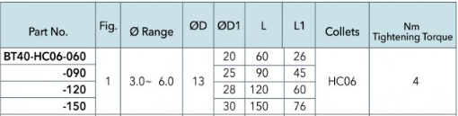

8. RESULT ANALYSIS & DISCUSSION
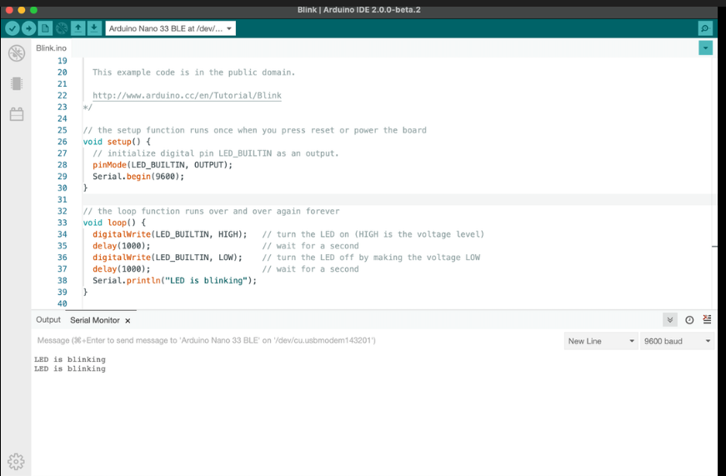

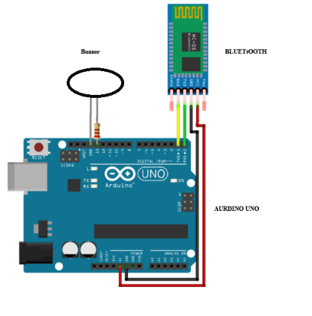

Fig2. Interface the Bluetooth and buzzer

9.CONCLUSION AND SCOPE FOR FUTURE WORK
9.1 Conclusion
Web-based service-providing applications have emerged as a powerful tool to tackle unemployment and provide better income opportunities for workers in the home services sector. By connecting service providers with customers in a streamlined and efficient manner, these platforms help reduce the reliance on informal networks and provide better protections for workers. Moreover, the convenience and accessibility of online platforms offer customers a hassle-free way to access a range of services from the comfort of their homes, while service providers benefit from increased flexibility, control over their schedules, and the potential for increased earnings. Web-based service-providing applications are poised to play a critical role in shaping the future of work in the home services sector
9.2 Scope for future work
Biometric Authentication: Introduce biometric authentication methods (e.g., fingerprint, facial recognition) for more secure user access, especially for sensitive operations such as payroll management.
Blockchain for Data Integrity: Explore the use of blockchain technology to ensure data integrity and enhance the transparency of transactions and records within the system.
- Job Matching and Recruitment
- Skill Development and Training
- Community Building and Networking
- Work Management and Productivity Tools
- Financial Services and Benefits
- Marketplace for Local Services
- Sustainability and Green Jobs

10.REFERENCES

[1] YStrengers & Kennedy, J 2020, The Smart Wife: Why Siri, Alexa, and Other Smart Home Devices Needa Feminist Reboot, MIT Press.
[2] Chen, Z-Y.A Wearable Device for Elderly People: A Case Study on User Acceptance and Satisfaction (International Journal of Medical Informatics, 2021)7.
[3] Yin, T. [Silver Haired Market] Design and Development of a Bluetooth-Based Wearable Device for Elderly People (International Journal of Advanced Computer Science and Applications, 2021). A Survey on Wearable Devices for Elderly People: Challenges and Opportunities (IEEE Access, 2021)
[4] Mohamad Faisal, Mohamad Yusof Wearable Devices for Fall Detection and Prevention in Elderly People(IEEE Journal of Biomedical and Health Informatics, 2023)
[5] Gelberdom, J.H, Van Dyk, T.J &Van Biljon Evaluating the Effectiveness of a Bluetooth-Based Wearable Device for Elderly People (Journal of Healthcare Engineering, 2022)

