PostgreSQL SQL Operations Documentation
Name: Nishita Nadimpalli
Course: Data Science - FastAPI SQL Assignment
UCID: nn436
This document provides a record of SQL operations executed in pgAdmin as part of the FastAPI Calculator Docker project. Each section includes the SQL command, its output, and a brief explanation of the operation performed.
1.Create Table
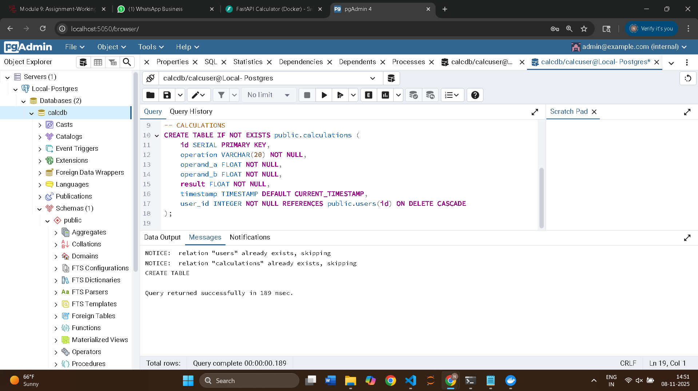
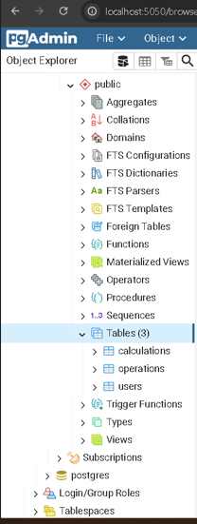

2. Insert Records
The following query inserts sample records into the 'calculations' table for users 'alice' and 'bob'. The 'ON CONFLICT' clause ensures duplicates are ignored.
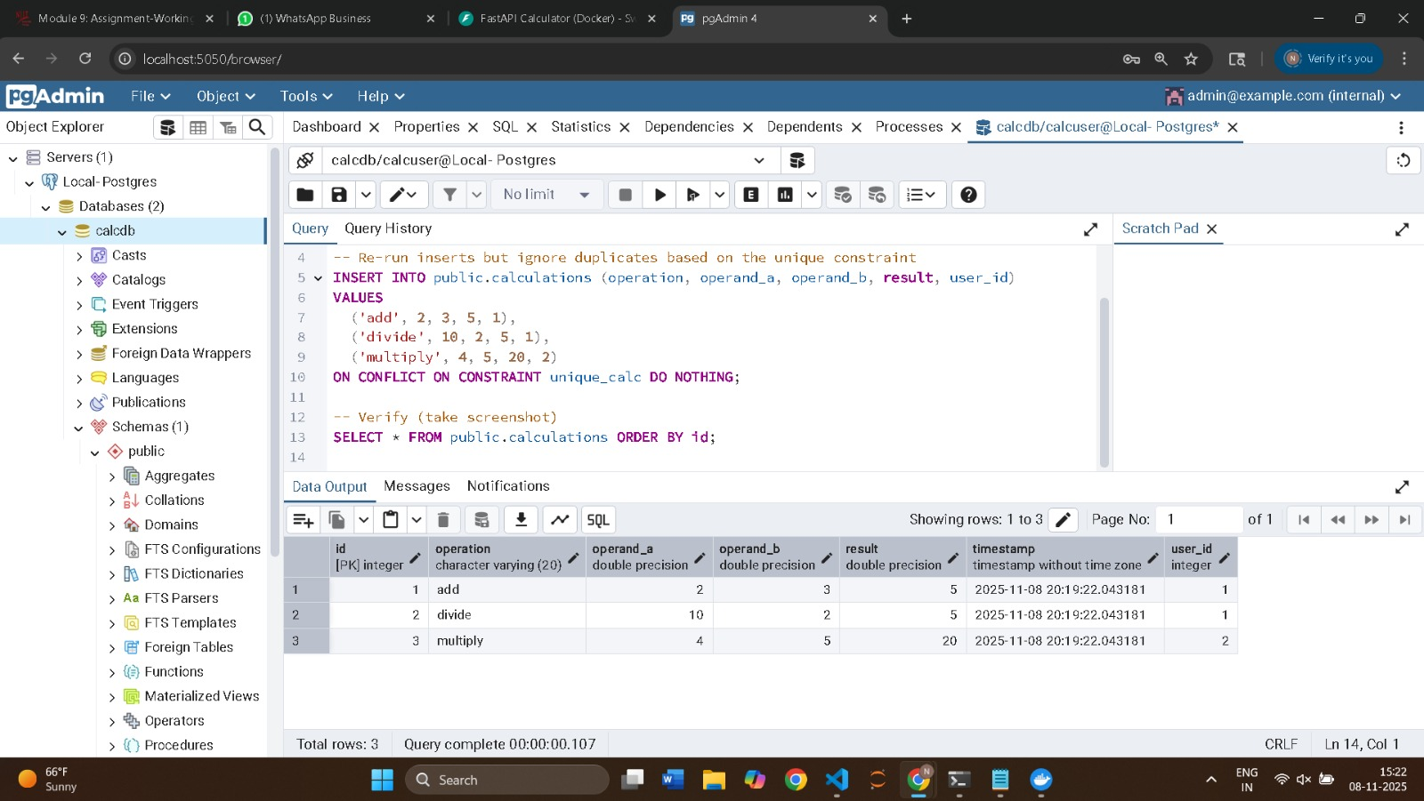

3. Query Data
The following screenshot shows results from selecting all records from both tables ('users' and 'calculations'), and a join query combining user and calculation data.
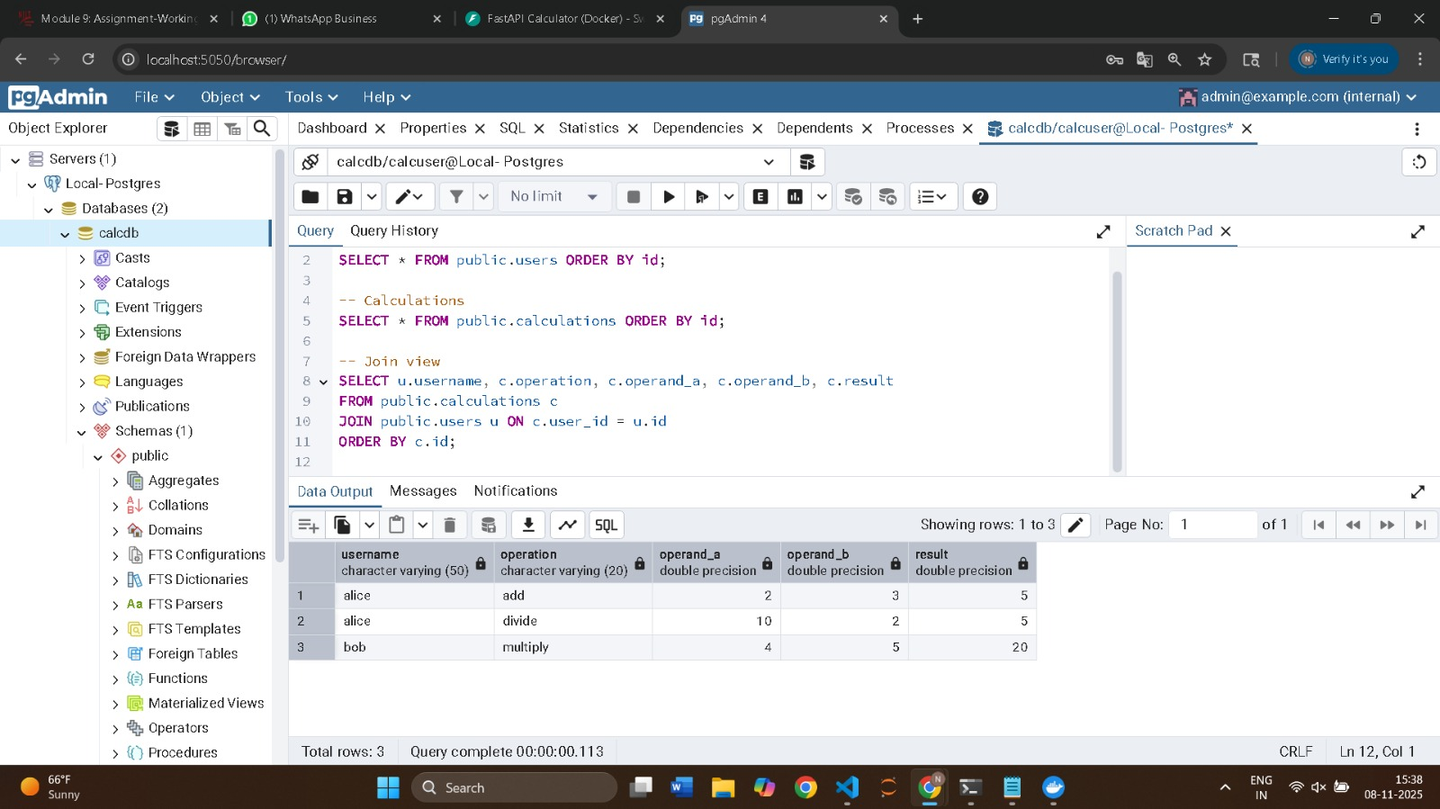

4. Update a Record
This query updates the result value of an existing record in the 'calculations' table where the operation was 'add'.
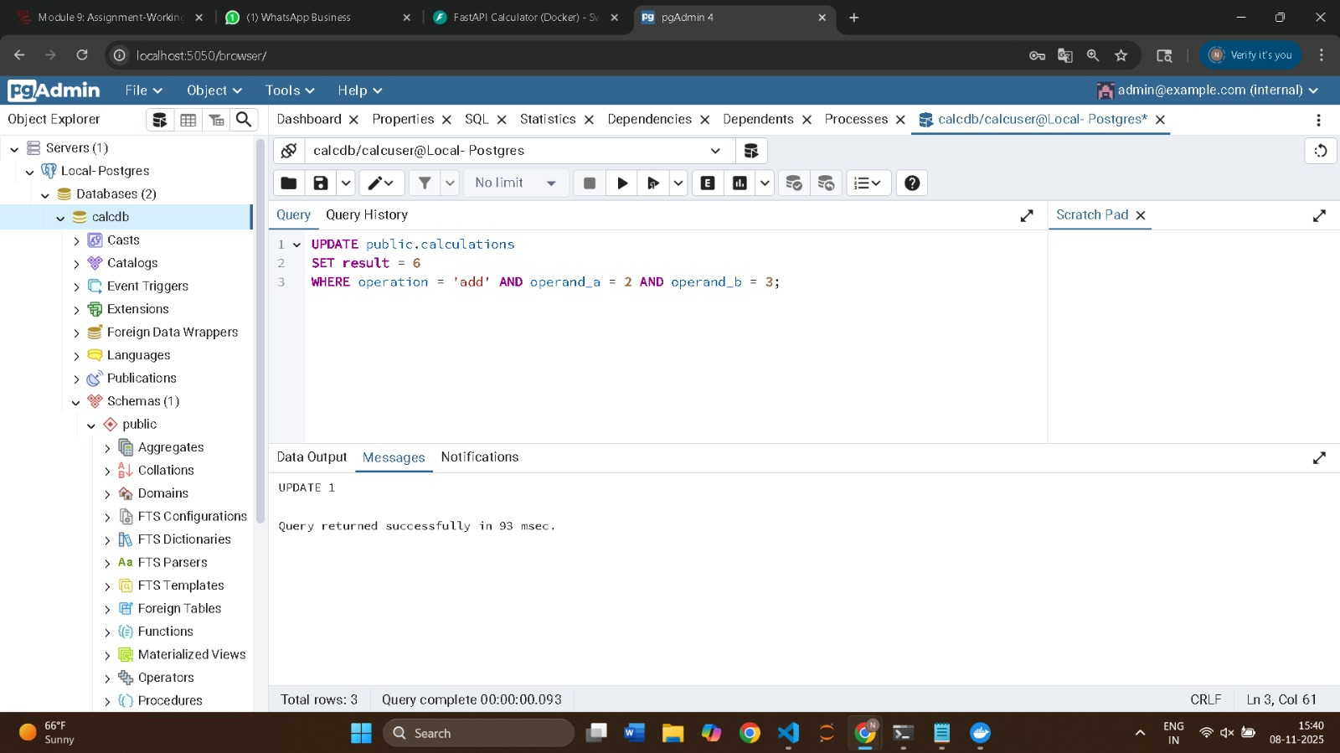

5. Verify Updated Data
This screenshot confirms that the updated result value appears in the 'calculations' table after the modification.
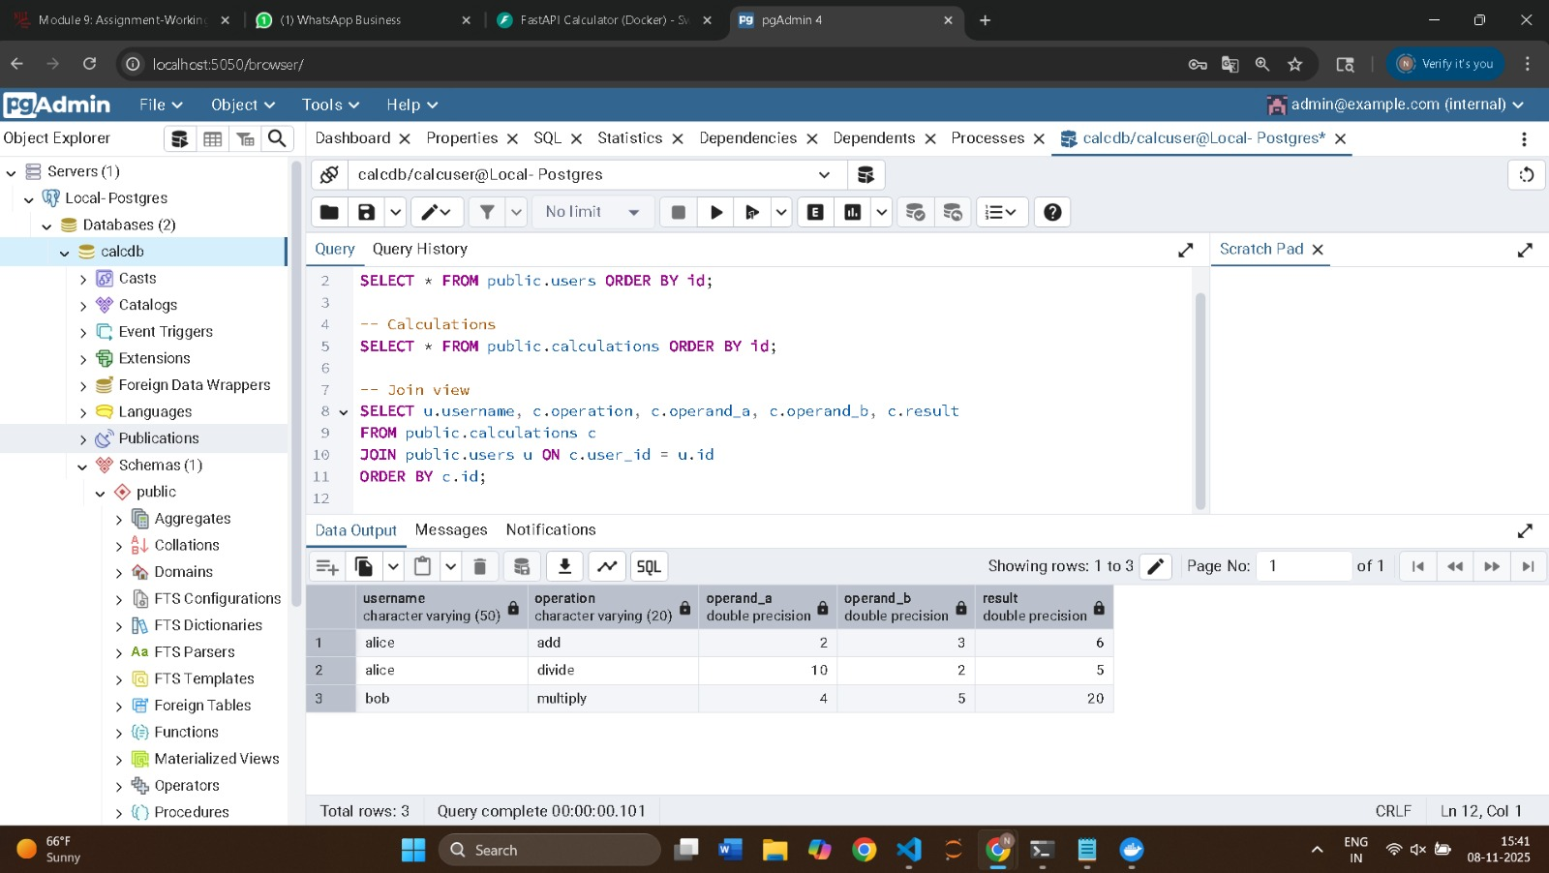

6. Delete a Record
The following query deletes the record from the 'calculations' table where the operation was 'divide'.
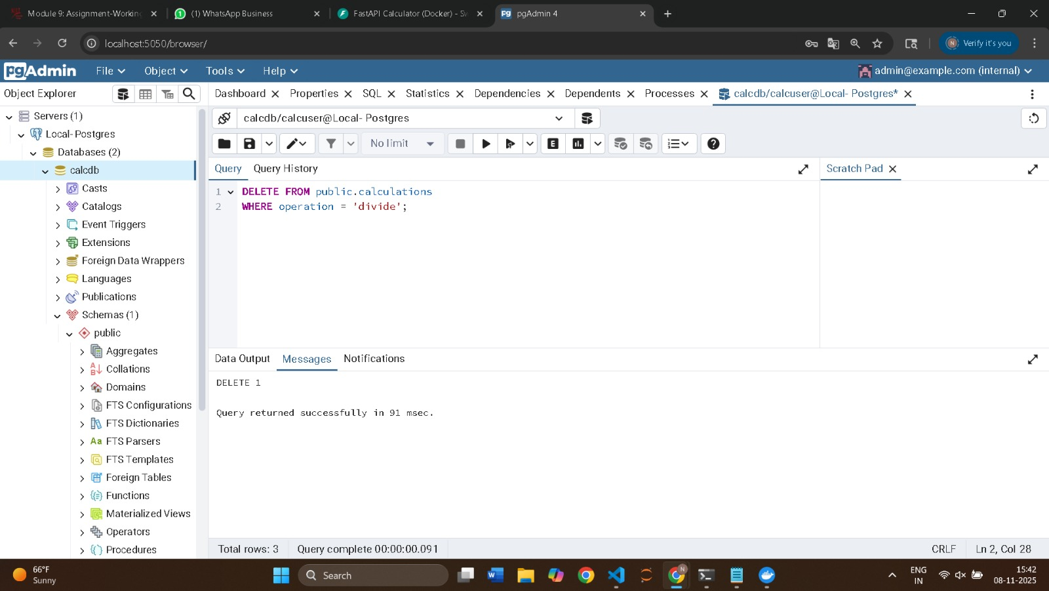

7. Final Data Verification
The final query shows the updated state of tables after the delete operation — confirming only 'add' and 'multiply' remain.
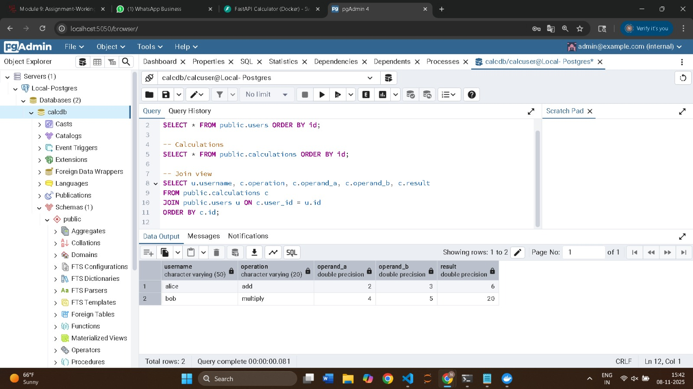

Conclusion
All SQL operations (CREATE, INSERT, SELECT, UPDATE, DELETE, and JOIN) were executed successfully through pgAdmin. The PostgreSQL database integrated seamlessly with FastAPI and Docker Compose services. This validates the correct configuration and functional database interaction within the containerized setup.

