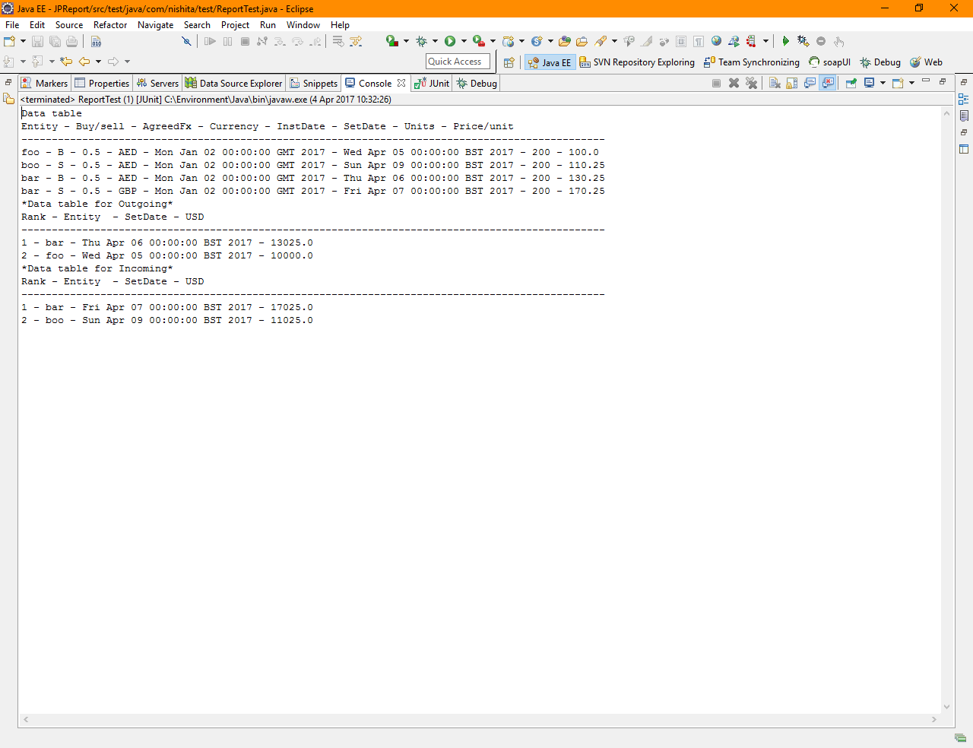

Run As junit-test testFullReportScenario test from ReportTest.java , You can see below outtput on console tab

Data table

Entity - Buy/sell - AgreedFx - Currency - InstDate - SetDate - Units - Price/unit

------------------------------------------------------------------------------------------------

foo - B - 0.5 - AED - Mon Jan 02 00:00:00 GMT 2017 - Wed Apr 05 00:00:00 BST 2017 - 200 - 100.0

boo - S - 0.5 - AED - Mon Jan 02 00:00:00 GMT 2017 - Sun Apr 09 00:00:00 BST 2017 - 200 - 110.25

bar - B - 0.5 - AED - Mon Jan 02 00:00:00 GMT 2017 - Thu Apr 06 00:00:00 BST 2017 - 200 - 130.25

bar - S - 0.5 - GBP - Mon Jan 02 00:00:00 GMT 2017 - Fri Apr 07 00:00:00 BST 2017 - 200 - 170.25

\*Data table for Outgoing\*

Rank - Entity - SetDate - USD

------------------------------------------------------------------------------------------------

1 - bar - Thu Apr 06 00:00:00 BST 2017 - 13025.0

2 - foo - Wed Apr 05 00:00:00 BST 2017 - 10000.0

\*Data table for Incoming\*

Rank - Entity - SetDate - USD

------------------------------------------------------------------------------------------------

1 - bar - Fri Apr 07 00:00:00 BST 2017 - 17025.0

2 - boo - Sun Apr 09 00:00:00 BST 2017 - 11025.0