**PRACTICAL: 7**

**AIM:**

Create an application that will change color of the screen, based on selected options from the menu.

**THEORY:**

**Menu:**

MenuInflater - This class is used to instantiate menu XML files into Menu objects. For performance reasons, menu inflation relies heavily on pre-processing of XML files that is done at build time. Therefore, it is not currently possible to use MenuInflater with an XmlPullParser over a plain XML file at runtime; it only works with an XmlPullParser returned from a compiled resource (R.something file.)

onOptionsItemSelected - This hook is called whenever an item in your options menu is selected. The default implementation simply returns false to have the normal processing happen (calling the item's Runnable or sending a message to its Handler as appropriate). You can use this method for any items for which you would like to do processing without those other facilities.

onCreateOptionsMenu - Initialize the contents of the Activity's standard options menu. You should place your menu items in to menu.

**TextView** - A user interface element that displays text to the user.

**CODE:**

|  |
| --- |
| **//MainActivity.java**  package com.example.pr_7_17it014;  import androidx.appcompat.app.AppCompatActivity;  import android.graphics.Color;  import android.os.Bundle;  import android.view.Menu;  import android.view.MenuItem;  import android.widget.LinearLayout;  import android.widget.RelativeLayout;  import android.widget.TextView;  import android.widget.Toast;  public class MainActivity extends AppCompatActivity {  TextView text1,text2;  @Override  protected void onCreate(Bundle savedInstanceState) {  super.onCreate(savedInstanceState);  setContentView(R.layout.activity_main);  text1 = findViewById(R.id.text1);  text2 = findViewById(R.id.text2);  }  public boolean onCreateOptionsMenu(Menu menu){  getMenuInflater().inflate(R.menu.menu_pr7,menu);  return true;  }  public boolean onOptionsItemSelected(MenuItem item){  text1.setText("");  RelativeLayout r1 = (RelativeLayout)findViewById(R.id.bgrnd_id);  switch(item.getItemId()){  case R.id.green1:  r1.setBackgroundColor(Color.GREEN);  text2.setText("GREEN");  text2.setBackgroundColor(Color.WHITE);  Toast.makeText(this, "GREEN", Toast.LENGTH_SHORT).show();  return true;  case R.id.black1:  r1.setBackgroundColor(Color.BLACK);  text2.setText("BLACK");  text2.setBackgroundColor(Color.WHITE);  Toast.makeText(this, "BLACK", Toast.LENGTH_SHORT).show();  return true;  case R.id.yellow1:  r1.setBackgroundColor(Color.YELLOW);  text2.setText("YELLOW");  text2.setBackgroundColor(Color.WHITE);  Toast.makeText(this, "YELLOW", Toast.LENGTH_SHORT).show();  return true;  case R.id.red1:  text2.setText("RED");  r1.setBackgroundColor(Color.RED);  text2.setBackgroundColor(Color.WHITE);  Toast.makeText(this, "RED", Toast.LENGTH_SHORT).show();  return true;  default:  Toast.makeText(this, "Nothing is selected", Toast.LENGTH_SHORT).show();  return true;  }  }  }  **//AndroidManifest.xml**  <?xml version="1.0" encoding="utf-8"?>  <manifest xmlns:android="http://schemas.android.com/apk/res/android"  package="com.example.pr_7_17it014">  <application  android:allowBackup="true"  android:icon="@mipmap/ic_launcher"  android:label="PR7_17IT014"  android:roundIcon="@mipmap/ic_launcher_round"  android:supportsRtl="true"  android:theme="@style/AppTheme">  <activity android:name=".MainActivity">  <intent-filter>  <action android:name="android.intent.action.MAIN" />  <category android:name="android.intent.category.LAUNCHER" />  </intent-filter>  </activity>  </application>  </manifest>  **//activity_main.xml**  <?xml version="1.0" encoding="utf-8"?>  <RelativeLayout xmlns:android="http://schemas.android.com/apk/res/android"  xmlns:app="http://schemas.android.com/apk/res-auto"  xmlns:tools="http://schemas.android.com/tools"  android:id="@+id/bgrnd_id"  android:gravity="center"  android:layout_width="match_parent"  android:layout_height="match_parent"  android:background="#FFFFFF"  tools:context=".MainActivity">  <TextView  android:id="@+id/text1"  android:layout_width="wrap_content"  android:layout_height="wrap_content"  android:text="TAP ON THREE DOTS"  android:textSize="20dp"></TextView>  <TextView  android:id="@+id/text2"  android:layout_width="wrap_content"  android:layout_height="wrap_content"  android:textSize="40dp"  android:text="" />  </RelativeLayout>  //**Menu_pr7.xml**  <?xml version="1.0" encoding="utf-8"?>  <menu xmlns:app="http://schemas.android.com/apk/res-auto"  xmlns:android="http://schemas.android.com/apk/res/android">  <item  android:id="@+id/green1"  android:title="GREEN" />  <item android:id="@+id/black1"  android:title="BLACK"></item>  <item  android:id="@+id/yellow1"  android:title="YELLOW" />  <item  android:id="@+id/red1"  android:title="RED" />  </menu> |

**OUTPUT:**

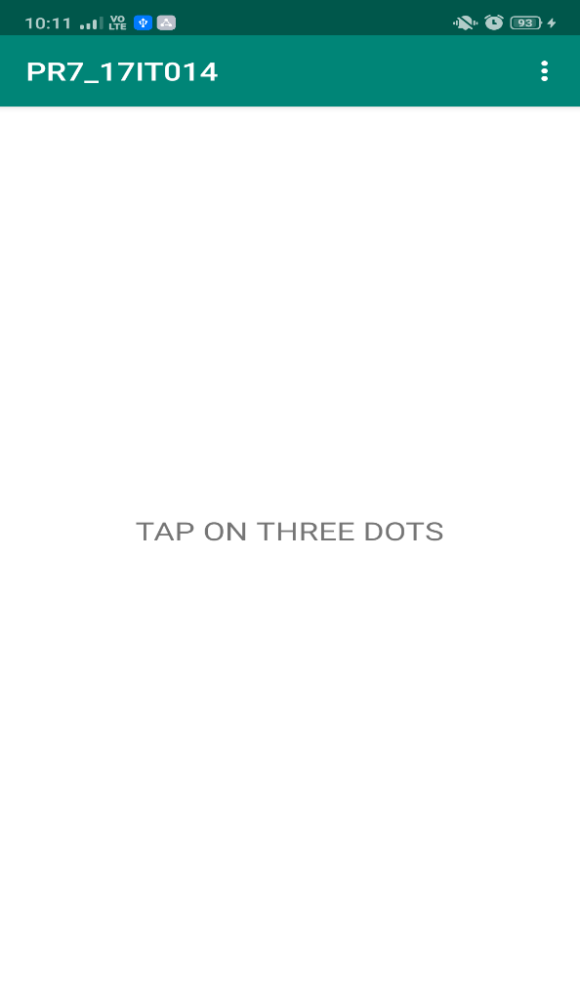 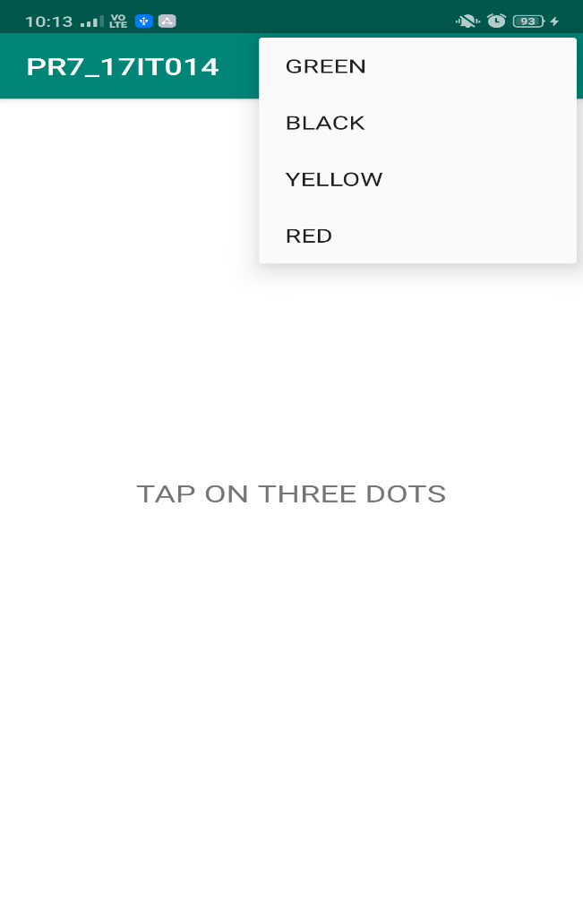

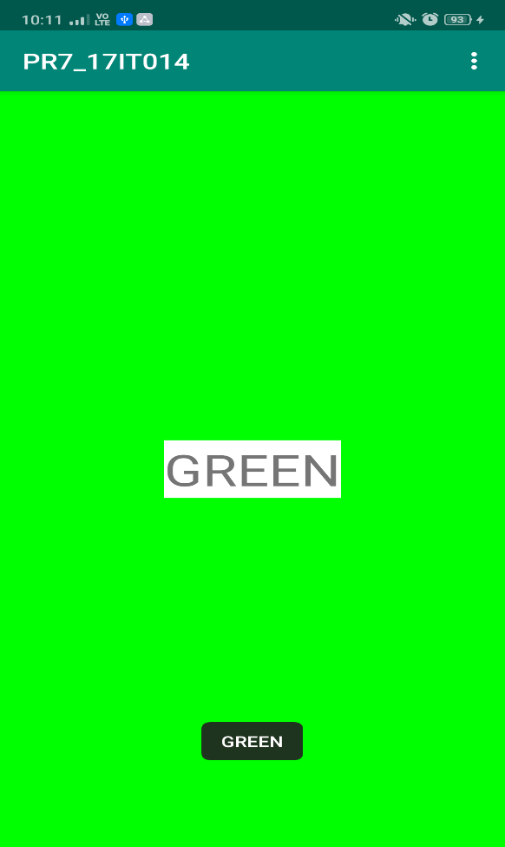 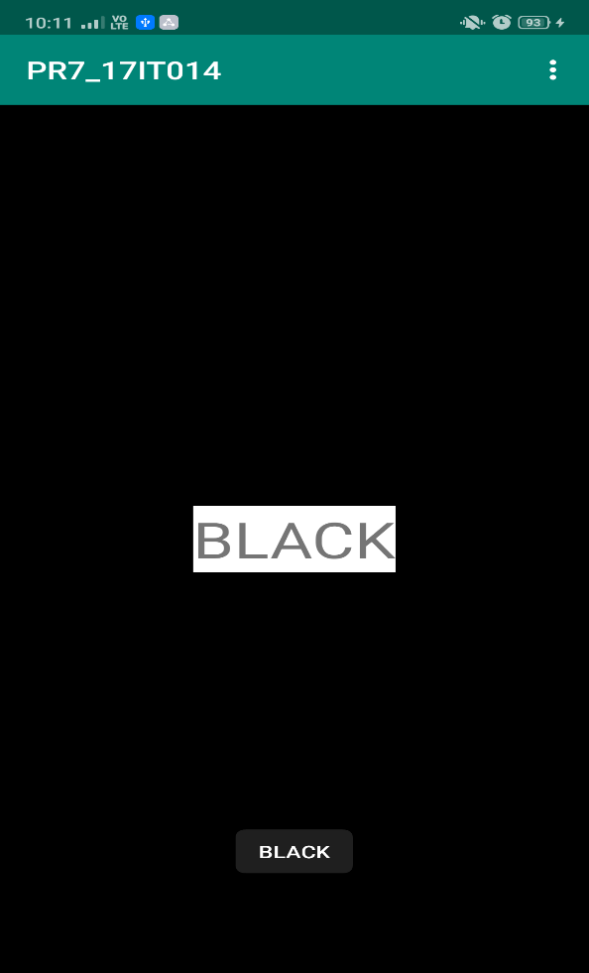 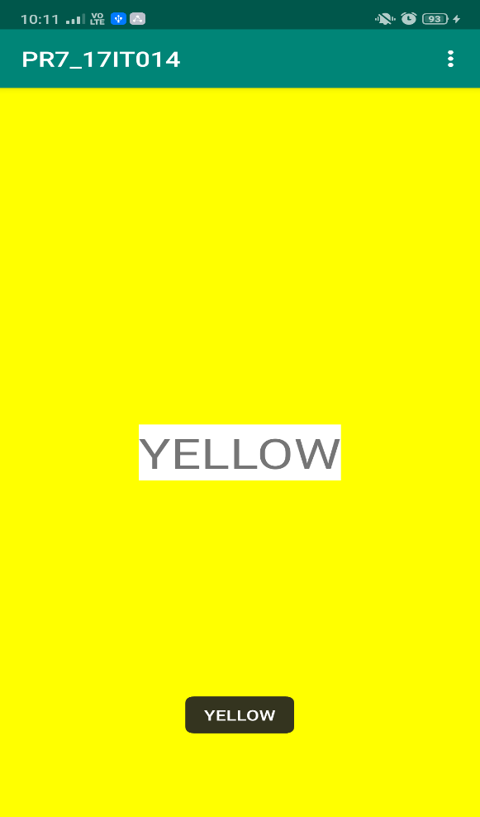 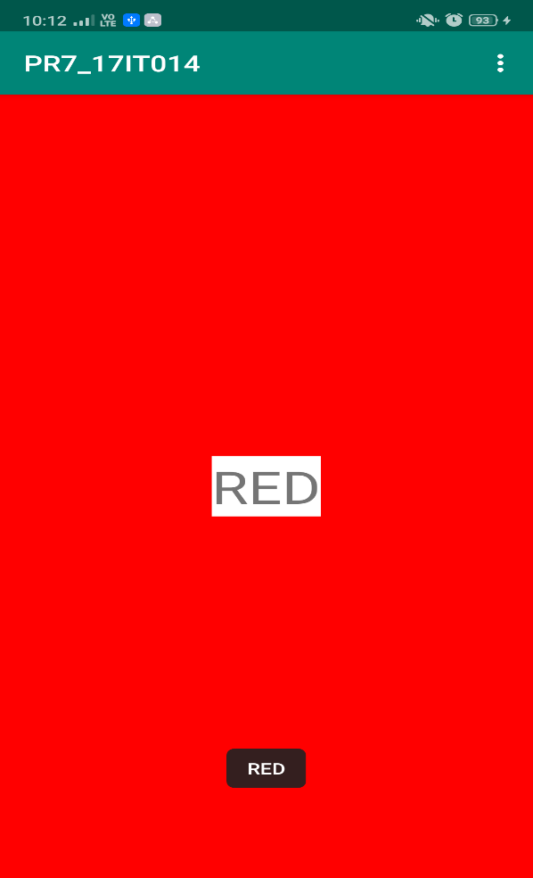

**LATEST APPLICATIONS:**

* Textra
* Paletta
* Cookpad
* Clue

**LEARNING OUTCOME:**

After doing this practical we learnt how to create a new Menu folder and then use the MenuInflater to get the menu in the application.