**PRACTICAL: 1**

**AIM:** Introduction to Android and Create “Custom Message” application. That will display “Custom Message” in the middle of the screen in the Black color with the Yellow background.

**CODE:**

|  |
| --- |
| **Activity_main.xml**  *<?*xml version="1.0" encoding="utf-8"*?>* <RelativeLayout xmlns:android="http://schemas.android.com/apk/res/android"  xmlns:app="http://schemas.android.com/apk/res-auto"  xmlns:tools="http://schemas.android.com/tools"  android:layout_width="match_parent"  android:layout_height="match_parent"  android:background="#FFEB3B"  tools:context=".MainActivity">   <TextView  android:id="@+id/textView"  android:layout_width="wrap_content"  android:layout_height="wrap_content"  android:layout_centerInParent="true"  android:text="HELLO WORLD"  android:textColor="#FF5722"  android:textSize="30sp"  app:layout_constraintBottom_toBottomOf="parent"  app:layout_constraintEnd_toEndOf="parent"  app:layout_constraintHorizontal_bias="0.408"  app:layout_constraintStart_toStartOf="parent"  app:layout_constraintTop_toTopOf="parent"  app:layout_constraintVertical_bias="0.43" /> </RelativeLayout>  **AndroidManifest.xml**  *<?*xml version="1.0" encoding="utf-8"*?>* <manifest xmlns:android="http://schemas.android.com/apk/res/android"  package="com.example.myapplication">  <application  android:allowBackup="true"  android:icon="@mipmap/ic_launcher"  android:label="17IT014"  android:roundIcon="@mipmap/ic_launcher_round"  android:supportsRtl="true"  android:theme="@style/AppTheme">  <activity android:name=".MainActivity">  <intent-filter>  <action android:name="android.intent.action.MAIN" />  <category android:name="android.intent.category.LAUNCHER" />  </intent-filter>  </activity>  </application>  </manifest>  **MainActivity.java**  package com.example.myapplication import androidx.appcompat.app.AppCompatActivity import android.os.Bundle import android.widget.Toast; import android.view.Gravity;  class MainActivity : AppCompatActivity() {  override fun onCreate(savedInstanceState: Bundle?) {  super.onCreate(savedInstanceState)  setContentView(R.layout.*activity_main*)  } } |

**OUTPUT:**

**Device:Google Nexus 7**

**PotraitView:**

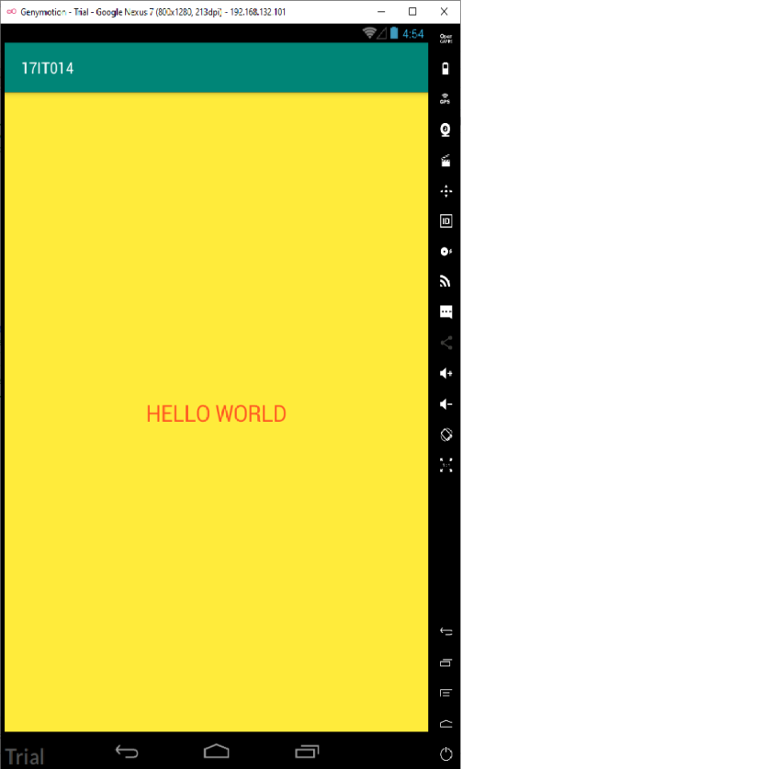

**LandscapeView:**

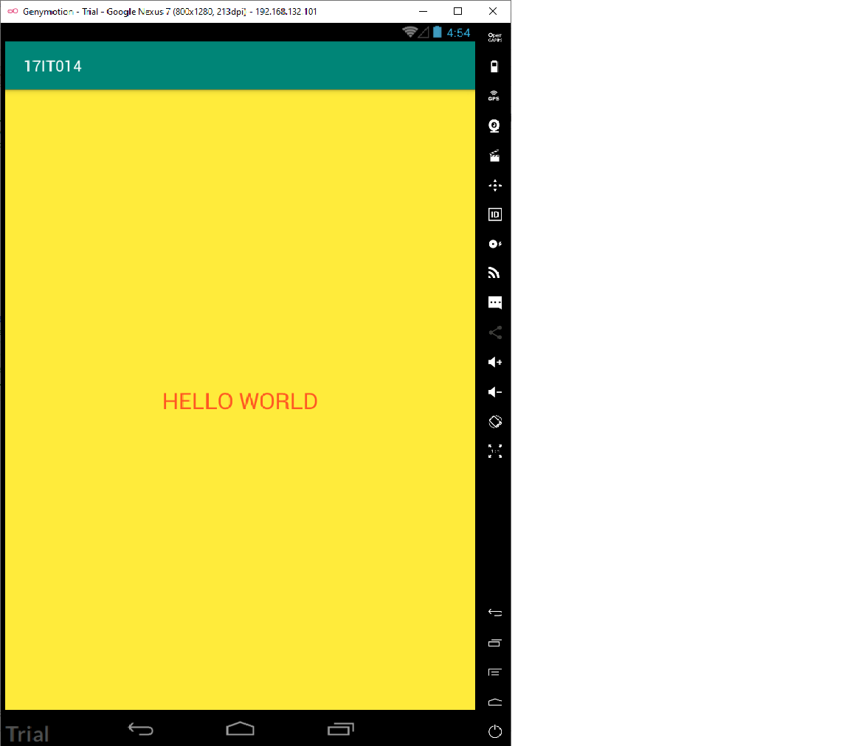

**Description**: Above Screenshots contain the yellow background with custom text in it.

In Portrait View and Landscape View**.**

**LEARNING OUTCOME:** 1. learned How install apps with USB debugging.

2. learned to use Relative layout in Activity_main.xml

3. learned To Run apps in Emulator.

4. learned to do the basic programming in android studio.