**PRACTICAL: 6**

**AIM:** Create an application which turns ON or OFF Torch/Flashlight of Camera.

**THEORY:**

* ToogleButton: **Android Toggle Button** can be used to display checked/unchecked (On/Off) state on the button.
* It is beneficial if user have to change the setting between two states. It can be used to On/Off Sound, Wifi, Bluetooth etc.

**CODE:**

|  |
| --- |
| **MainActivity.java**  package com.example.pr_6_flash;  import androidx.appcompat.app.AlertDialog;  import androidx.appcompat.app.AppCompatActivity;  import android.content.Context;  import android.content.DialogInterface;  import android.content.pm.PackageManager;  import android.hardware.camera2.CameraAccessException;  import android.hardware.camera2.CameraManager;  import android.os.Bundle;  import android.widget.CompoundButton;  import android.widget.Toast;  import android.widget.ToggleButton;  public class MainActivity extends AppCompatActivity {  private CameraManager mCameraManager;  private String mCameraId;  private ToggleButton toggleButton;  @Override  protected void onCreate(Bundle savedInstanceState) {  super.onCreate(savedInstanceState);  setContentView(R.layout.activity_main);  boolean isFlashAvailable = getApplicationContext().getPackageManager()  .hasSystemFeature(PackageManager.FEATURE_CAMERA_FLASH);  if (!isFlashAvailable) {  showNoFlashError();  }  mCameraManager = (CameraManager) getSystemService(Context.CAMERA_SERVICE);  try {  mCameraId = mCameraManager.getCameraIdList()[0];  } catch (CameraAccessException e) {  e.printStackTrace();  }  toggleButton = findViewById(R.id.onBtn);  toggleButton.setOnCheckedChangeListener(new CompoundButton.OnCheckedChangeListener() {  @Override  public void onCheckedChanged(CompoundButton buttonView, boolean isChecked) {  switchFlashLight(isChecked);  if(isChecked==true){  Toast.makeText(getApplicationContext(), "Flash On",Toast.LENGTH_SHORT).show();  }else{  Toast.makeText(getApplicationContext(), "Flash OFF",Toast.LENGTH_SHORT).show();  }  }  });  }  public void showNoFlashError() {  AlertDialog alert = new AlertDialog.Builder(this)  .create();  alert.setTitle("Oops!");  alert.setMessage("Flash not available in this device...");  alert.setButton(DialogInterface.BUTTON_POSITIVE, "OK", new DialogInterface.OnClickListener() {  public void onClick(DialogInterface dialog, int which) {  finish();  }  });  alert.show();  }  public void switchFlashLight(boolean status) {  try {  mCameraManager.setTorchMode(mCameraId, status);  } catch (CameraAccessException e) {  e.printStackTrace();  }  }  }  **activity_main.xml**  <?xml version="1.0" encoding="utf-8"?>  <RelativeLayout xmlns:android="http://schemas.android.com/apk/res/android"  xmlns:tools="http://schemas.android.com/tools"  android:layout_width="match_parent"  android:layout_height="match_parent"  android:background="@drawable/gradient1"  tools:context="com.example.pr_6_flash.MainActivity">  <TextView  android:id="@+id/textView"  android:layout_width="wrap_content"  android:layout_height="wrap_content"  android:layout_alignParentTop="true"  android:layout_centerHorizontal="true"  android:text="17IT008"  android:textColor="#b71c1c"  android:textSize="40dp" />  <ToggleButton  android:id="@+id/onBtn"  android:layout_width="wrap_content"  android:layout_height="wrap_content"  android:layout_below="@+id/textView"  android:layout_alignParentEnd="false"  android:layout_centerHorizontal="true"  android:layout_marginTop="280dp"  android:background="#66bb6a"  android:textSize="30sp" />  </RelativeLayout>  **AndroidManifest.xml**  <?xml version="1.0" encoding="utf-8"?>  <manifest xmlns:android="http://schemas.android.com/apk/res/android"  package="com.example.pr_6_flash">  <uses-permission android:name="android.permission.CAMERA"/>  <uses-feature android:name="android.hardware.camera"/>  <application  android:allowBackup="true"  android:icon="@mipmap/ic_launcher"  android:label="@string/app_name"  android:roundIcon="@mipmap/ic_launcher_round"  android:supportsRtl="true"  android:theme="@style/AppTheme">  <activity android:name=".MainActivity">  <intent-filter>  <action android:name="android.intent.action.MAIN" />  <category android:name="android.intent.category.LAUNCHER" />  </intent-filter>  </activity>  </application>  </manifest> |

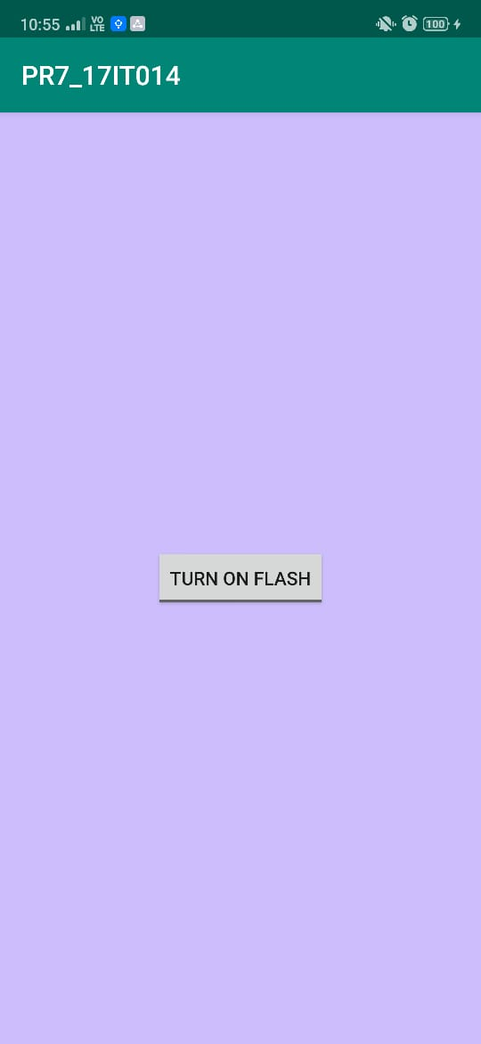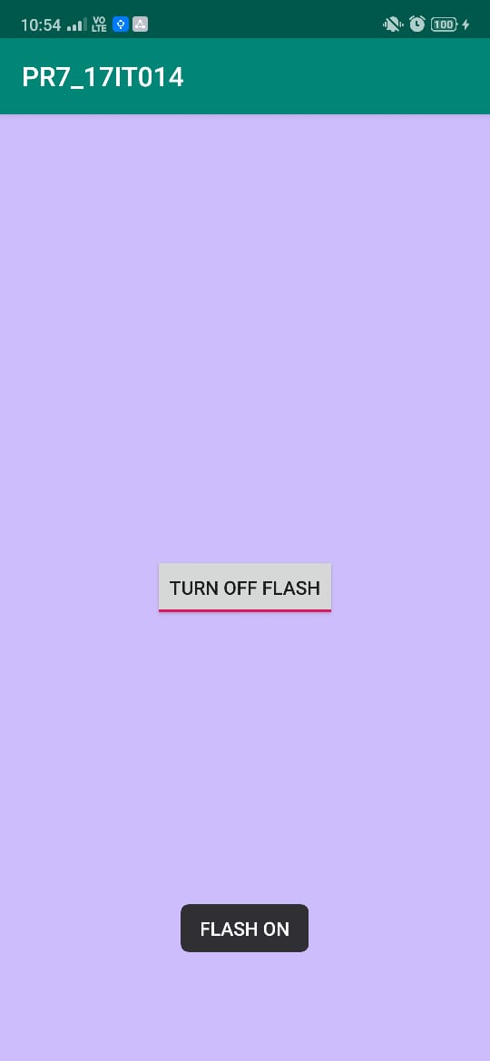**OUTPUT:**



**Description**:

* Screenshot 1: It shows the mainactivity of the app.
* Screenshot 2: When user press the button, the flashlight will be turned on and toast the message.
* Screenshot 3: When user again press the button, the flashlight will be turned on and toast the message.

**APPLICATIONS:**

Android Studio, ADB (Android Debug Bridge), AVD Manager, Eclipse, Fabric, Genymotion,

**LEARNING OUTCOME:**

1.We learn how to control device’s Camera and related hardware(Flash, Secondary .and Primary Camera).

2.We learned how to give device hardware permission in androidmanifest.