Database Assignment

Submitted by Nishit Gala

# Contents

Chapter 1 – Introduction 3

Chapter 2 – ER Diagrams with Constraints and Assumptions 4

Chapter 3 – Implementation 10

Chapter 4 – Demonstration using SQL Queries 31

Chapter 5 – Conclusion 45

# Chapter 1 – Introduction

This report demonstrates the day-to-day operations of a Wine-stopper Website that allows the customers to place online orders for Wine of their choice. Also, it will demonstrate the backend operations of a Distribution center stocking and ordering the wines from their respective warehouses when the stock needs to be replenished.

The Wine can be categorized as per Colour, Country, Sweetness Indicator. Additionally, there are various promotions on the offer with different types and delivery charge calculations. All of these factors are taken into consideration while designing the problem statement.

The objective of this report is to get a holistic view of Wine Stopper day-to day operations that includes following -

1. Customer adding Items into their shopping basket
2. Customer adding items into their shopping list
3. Customer placing an order to generate an invoice
4. Distribution center placing Standing Order for wine from the warehouse
5. Distribution center placing Special Order for wine from the warehouse
6. Promotions applied for shopping and its related calculations
7. Delivery charges calculation
8. Stock maintenance and updates at the distribution center
9. Setting the Expiry to the Shopping List (Wish List) and to clear it if it is more than 60 days

The first part of the report is mentioning about the ER Diagram that will be highlighted with the assumptions and constraints while designing the entity relationships.

This Diagram is classified into 3 main parts with corresponding entities designed as described below

|  |  |  |
| --- | --- | --- |
| Part |  | Entities (Tables) |
| Wine Entities | Main | WS_WINE, WS_WINE_DETAILS |
| Supporting | WS_WINE_CATEGORY, WS_WINE_INDICATOR, WS_COUNTRY |
| Customer Entities | Main | WS_CUSTOMER, WS_SHOPPING_BASKET, WS_SHOPPING_LIST, WS_INVOICE |
| Supporting | WS_PROMOTION, WS_CALCULATE_DELIVERY_CHARGE |
| Distribution Center Entities | Main | WS_CENTER, WS_WAREHOUSE, WS_STOCK_INFO, WS_ORDER, WS_ORDER_DETAILS |
| Supporting | WS_REGION, WS_LOCATION, WS_ORDER_TYPE |

The second part consist of the Implementation that will include screenshots from Oracle Apex for DDL commands including CREATE, ALTER statements

The third part consist of the critical SQL’s that demonstrates the functionalities described above

The last part is the conclusion of the entire case study with critical evaluation, explaining high level flow and related assumptions

# Chapter 2 – ER Diagrams with Constraints and Assumptions

The ER diagram designed for the day-to-day operations of a Wine-Stopper Web page is as shown below

This is the complete ER Diagram as shown

Below is the PDF File attached for better viewing.



The screenshot of the ER Diagram is specified as below (next page)

***Note – For better visibility, please refer the PDF file attached above***

ER Diagram is as shown in the below image 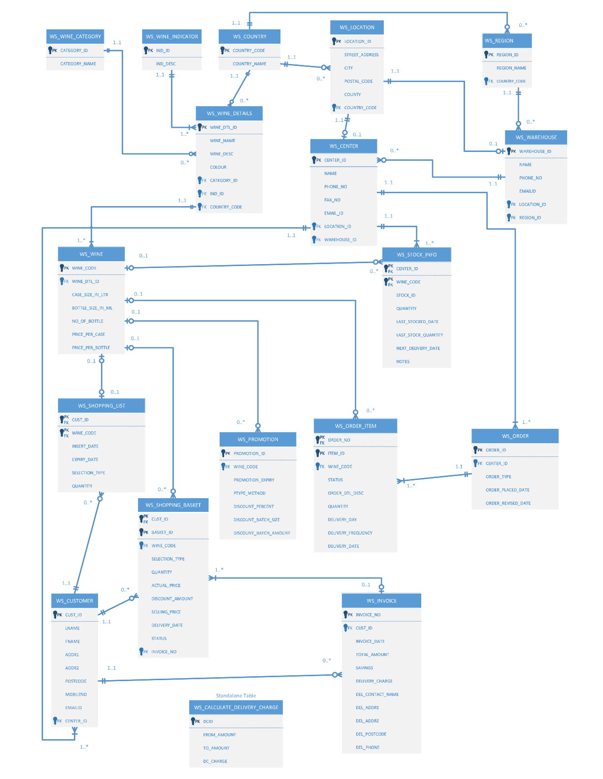

**Assumptions / Constraint Table:**

|  |  |  |  |
| --- | --- | --- | --- |
| **Table Name** | **Constraint Type / Assumption** | **Column Name** | **Comments** |
| **WS_WINE_DETAILS** | PK | WINE_DTL_ID | This table stores the information of Wine including Name, Description, Colour, Indicator, Country |
| Check | COLOUR | Colour in ('Red','White','Rose','Gold','Yellow','Orange') |
| FK, Assumption | CATEGORY_ID | Wine is categorized into 3 types  1) Regular 2) Sparkling 3) Dessert  FK Reference - WS_WINE_CATEGORY(CATEGORY_ID) |
| FK, Assumption | IND_ID | Indicator of Sweetness of the Wine as below 1 - Very Dry, 2 - Medium Dry, 3 - Mild Dry 4 - Mild Sweet, 5 - Medium Sweet, 6 - Sweet  FK Reference - WS_WINE_INDICATOR(IND_ID) |
| FK | COUNTRY_CODE | FK Reference - WS_COUNTRY(COUNTRY_CODE) |
| **WS_WINE** | PK | WINE_CODE | One Wine (as per WINE_DTL_ID) can have 1 or more unique Wine Codes |
| FK | WINE_DTL_ID | This will reference the Wine Name that is available in multiple forms (wine_codes) in the WINE table  FK Reference - WS_WINE_DETAILS(WINE_DTL_ID) |
| Assumption | CASE_SIZE_IN_LTR | CASE Size is assumed to be in LTR |
| Assumption | BOTTLE_SIZE_IN_ML | Bottle Size is assumed to be in ML |
| Auto Generated Column | NUM_OF_BOTTLE | auto calculated with formula - No Of Bottles = CASE_SIZE_IN_LTR * 1000 /BOTTLE_SIZE_IN_ML |
| Check | PRICE_PER_CASE | PRICE_PER_CASE > 0 |
| Check | PRICE_PER_BOTTLE | PRICE_PER_BOTTLE > 0 |
| Check | CHK_PRICE | PRICE_PER_BOTTLE < PRICE_PER_CASE |
| **WS_PROMOTION** | Composite PK, Assumption | WINE_CODE , START_DATE,EXPIRY_DATE,STATUS | Composite Primary Key to consider the promotion period and status of the promotion for the wine code Assumption - Promotion is on the Wine Codes and no generic promotions allowed as per design |
| Auto Generated Column | PROMOTION_ID | Autogenerated column as the table has composite key |
| FK | WINE_CODE | Reference - WS_WINE(WINE_CODE) |
| Check, Assumption | PTYPE_METHOD | 3 methods taken into consideration 1) PRICE_DISCOUNT - e.g. 15% OFF 2) QUANTITY_DISCOUNT - e.g. Buy 4 For 3 3) REDUCED_PRICE - e.g. Reduced Price 2.99 per bottle |
| Check | STATUS | Status in ('Active', 'Inactive', 'Expired') |
| Check | DISCOUNT_PERCENT | DISCOUNT_PERCENT BETWEEN 1 and 90 |
| Check | DISCOUNT_QUANTITY_BUY | DISCOUNT_QUANTITY_BUY > 0 |
| Check | DISCOUNT_QUANTITY_FOR | DISCOUNT_QUANTITY_FOR > 0 |
| Check | chck_buy_greater_than_for | DISCOUNT_QUANTITY_BUY > DISCOUNT_QUANTITY_FOR |
| Check | RED_PRICE_PER_CASE | RED_PRICE_PER_CASE > 0 |
| Check | RED_PRICE_PER_BOTTLE | RED_PRICE_PER_BOTTLE > 0 |
| Check | chck_Reduced_bottlePrice_less_CasePrice | RED_PRICE_PER_BOTTLE < RED_PRICE_PER_CASE |
| **WS_CUSTOMER** | PK | CUST_ID | Customer ID is the PK |
| Check | LNAME | Check that the Last Name contains only Alphabets REGEXP_LIKE(LNAME,'^[[:alpha:]]+$') |
| Check | FNAME | Check that the First Name contains only AlphabetsREGEXP_LIKE(FNAME,'^[[:alpha:]]+$') |
| Check | GENDER | GENDER in ('M','F','N') |
| Check | MOBILE_NO | Only Numbers allowed REGEXP_LIKE(MOBILE_NO,'^[[:digit:]]+$') |
| Check | EMAIL_ID | Email ID is in correct format  REGEXP_LIKE (EMAIL_ID, '^(\S+)\@(\S+)\.(\S+)$' |
| FK | CENTER_ID | A Center ID has to be allocated to Customer on registration using the Address information Reference - WS_CENTER(CENTER_ID) |
| **WS_SHOPPING_LIST** | FK | CUST_ID | Reference - WS_CUSTOMER(CUST_ID) |
| FK | WINE_CODE | Reference - WS_WINE(WINE_CODE) |
| Default | INSERT_DATE | Default to Sysdate |
| Default | EXPIRY_DATE | Default to Sysdate + 60 |
| Check | STATUS | STATUS IN ('WishList', 'Expired', 'UserDeleted') |
| Check | SELECTION_TYPE | SELECTION_TYPE in ('CASE','BOTTLE') |
| Composite PK | CUST_ID, WINE_CODE | Composite PK CUST_ID, WINE_CODE |
| **WS_SHOPPING_BASKET** | FK | CUST_ID | Reference - WS_CUSTOMER(CUST_ID) |
| FK | WINE_CODE | Reference - WS_WINE(WINE_CODE) |
| Check | SELECTION_TYPE | SELECTION_TYPE in ('CASE','BOTTLE') |
| Default, Assumption | DISCOUNT_AMOUNT | Default to 0 Assumption -  When User proceeds to checkout and upon successful payment, the status wil change to Ordered and Discount calculations will be done using Promotion table and the Discount_Amount column will be updated |
| Auto Generated Column | SELLING_PRICE | ACTUAL_PRICE - DISCOUNT_AMOUNT |
| Check, Assumption | STATUS | Status IN ('Pending','Ordered','Shipped','Fullfilled') Assumptions:  1) When the User adds the item in the shopping basket, the status is Pending and Discount Amount is defaulted to 0 2) When User proceeds to checkout and upon successful payment, the status wil change to Ordered and Discount calculations will be done using Promotion table and the Discount_Amount column will be updated |
| FK, Assumption | INVOICE_NO | Reference - WS_INVOICE(INVOICE_NO )  Assumptions: Invoice No will be updated When User proceeds to checkout and upon successful payment |
| **WS_CALCULATE_DELIVERY_CHARGE** | PK, Assumption | DC_ID | Assumption - **This is a standlone table** and the value of the delivery charge will be picked up from this table and updated in WS_INVOICE (DELIVERY_CHARGE) |
| Check | FRM_AMOUNT | FRM_AMOUNT > 0 |
| Check | TO_AMOUNT | TO_AMOUNT > 0 |
| Check | chck_ToAmt_greater_thn_FrmAmt | TO_AMOUNT  > FRM_AMOUNT |
| **WS_INVOICE** | PK | INVOICE_NO |  |
| FK | CUST_ID | Reference - WS_CUSTOMER(CUST_ID) |
| Check | DEL_CONTACT_NAME | Name contains only alphabets REGEXP_LIKE(DEL_CONTACT_NAME,'^[[:alpha:]]+$') |
| Check | DEL_PHONE | Phone no contains only digitsREGEXP_LIKE(DEL_PHONE,'^[[:digit:]]+$') |
| Assumption | TOTAL_AMOUNT | TOTAL_AMOUNT is sum of SELLING_PRICE from WS_INVOICE_ITEM for all the items ordered |
| Assumption | SAVINGS | SAVINGS is sum of DISCOUNT_AMOUNT from WS_INVOICE_ITEM for all the items ordered |
| Assumption | DELIVERY_CHARGE | Will be updated on the basis of rules configured in CALCULATE_DELIVERY_CHARGE |
| **WS_LOCATION** | PK | LOCATION_ID |  |
| FK | COUNTRY_CODE | REFERENCES WS_COUNTRY(COUNTRY_CODE) |
| **WS_WAREHOUSE** | PK | WAREHOUSE_ID |  |
| Check | EMAIL_ID | Email ID is in correct format  REGEXP_LIKE (EMAIL_ID, '^(\S+)\@(\S+)\.(\S+)$' |
| FK | LOCATION_ID | REFERENCES WS_LOCATION(LOCATION_ID) |
| FK | REGION_ID | REFERENCES WS_REGION(REGION_ID) |
| Check | PHONE_NO | Phone no contains only digits REGEXP_LIKE(PHONE_NO,'^[[:digit:]]+$') |
| Check | FAX_NO | Phone no contains only digits REGEXP_LIKE(FAX_NO,'^[[:digit:]]+$') |
| **WS_CENTER** | PK | CENTER_ID |  |
| Check | EMAIL_ID | Email ID is in correct format  REGEXP_LIKE (EMAIL_ID, '^(\S+)\@(\S+)\.(\S+)$' |
| FK | LOCATION_ID | REFERENCES WS_LOCATION(LOCATION_ID) |
| FK | WAREHOUSE_ID | REFERENCES WS_WAREHOUSE(WAREHOUSE_ID) |
| Check | PHONE_NO | Phone no contains only digits REGEXP_LIKE(PHONE_NO,'^[[:digit:]]+$') |
| Check | FAX_NO | Phone no contains only digits REGEXP_LIKE(FAX_NO,'^[[:digit:]]+$') |
| **WS_STOCK_INFO** | Auto Generated Column | STOCK_ID | Table with Composite PK |
| FK | CENTER_ID | REFERENCES WS_CENTER(CENTER_ID) |
| FK | WINE_CODE | Reference - WS_WINE(WINE_CODE) |
| Composite PK | CENTER_ID,WINE_CODE |  |
| **WS_ORDER** | PK | ORDER_ID |  |
| FK | CENTER_NO | REFERENCES WS_CENTER(CENTER_ID) |
| Check | ORDER_TYPE | ORDER_TYPE in ('ST','SP')) ST- Standing Order SP - Special order |
| **WS_ORDER_ITEM** | Auto Generated Column | ITEM_ID |  |
| FK | ORDER_ID | REFERENCES WS_ORDER(ORDER_ID) |
| FK | WINE_CODE | Reference - WS_WINE(WINE_CODE) |
| Check | Status | Status - Active, Inactive |
| Check, Assumption | DELIVERY_DAY | DELIVERY_DAY IN ('Sunday','Monday','Tuesday','Wednesday','Thursday','Friday','Saturday') Assumption - This field will be used for Standing Orders only |
| Check, Assumption | DELIVERY_FREQUENCY | DELIVERY_FREQUENCY IN ('Weekly','Fortnightly','Monthly','Quarterly') Assumption - This field will be used for Standing Order only |
| Assumption | DELIVERY_DATE | Assumption - This field will be used for setting Delivery Date of Special Order |

# Chapter 3 – Implementation

1. **WINE TABLES**

CREATE TABLE WS_WINE_CATEGORY (

    CATEGORY_ID NUMBER(4),

    CATEGORY_NAME VARCHAR2(15) NOT NULL,

    PRIMARY KEY(CATEGORY_ID)

)

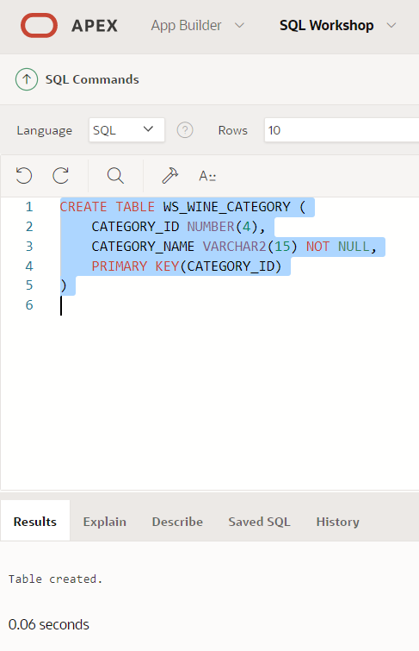

CREATE TABLE WS_WINE_INDICATOR (

    IND_ID NUMBER(2),

    IND_DESC VARCHAR2(25),

    PRIMARY KEY (IND_ID)

)

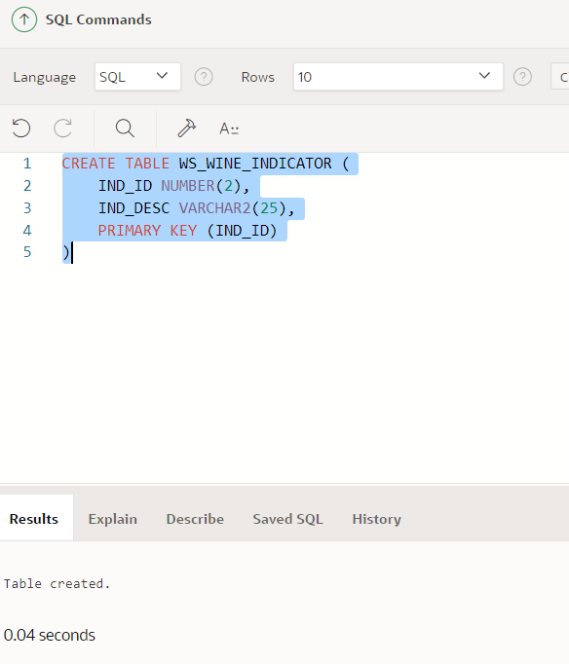

CREATE TABLE WS_COUNTRY(

    COUNTRY_CODE VARCHAR2(3),

    COUNTRY_NAME VARCHAR2(20),

    PRIMARY KEY(COUNTRY_CODE)

)

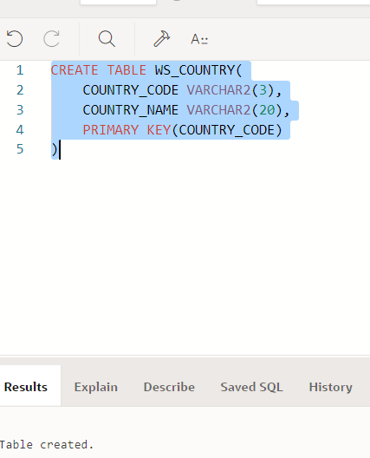

CREATE TABLE WS_WINE_DETAILS (

    WINE_DTL_ID NUMBER(9),

    WINE_NAME VARCHAR2(20) NOT NULL,

    WINE_DESC VARCHAR2(500) ,

    COLOUR VARCHAR2(10) CHECK(COLOUR in ('Red','White','Rose','Gold','Yellow','Orange') ),

    CATEGORY_ID NUMBER(4)  REFERENCES WS_WINE_CATEGORY(CATEGORY_ID) NOT NULL,

    IND_ID NUMBER(2) REFERENCES WS_WINE_INDICATOR(IND_ID) NOT NULL,

    COUNTRY_CODE  VARCHAR2(3) REFERENCES WS_COUNTRY(COUNTRY_CODE) NOT NULL,

    PRIMARY KEY(WINE_DTL_ID)

)

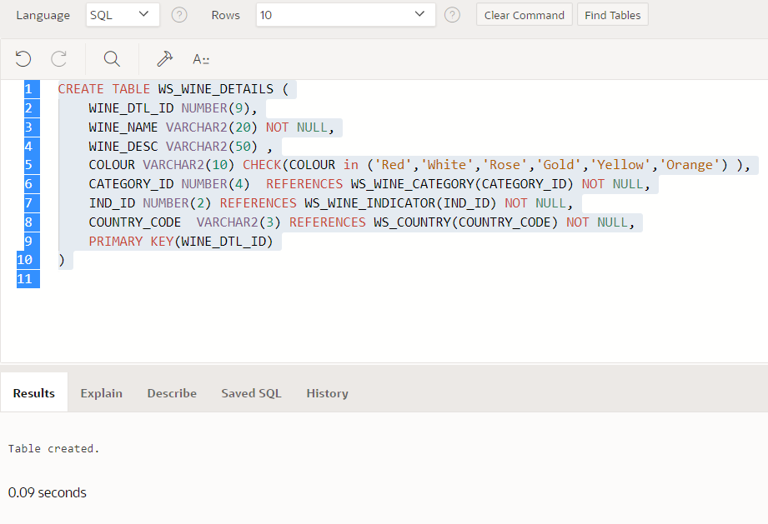

CREATE TABLE WS_WINE (

    WINE_CODE VARCHAR2(15) NOT NULL,

    WINE_DTL_ID NUMBER(9) REFERENCES WS_WINE_DETAILS(WINE_DTL_ID) NOT NULL,

    CASE_SIZE_IN_LTR NUMBER(4,2) NOT NULL,

    BOTTLE_SIZE_IN_ML NUMBER(4) NOT NULL,

    NUM_OF_BOTTLE NUMBER(4) GENERATED ALWAYS AS (round(CASE_SIZE_IN_LTR * 1000 /BOTTLE_SIZE_IN_ML)) VIRTUAL,

    PRICE_PER_CASE NUMBER(7,2) CHECK(PRICE_PER_CASE > 0 )NOT NULL,

    PRICE_PER_BOTTLE NUMBER(7,2) CHECK(PRICE_PER_BOTTLE > 0 ) NOT NULL,

    CONSTRAINT CHK_PRICE CHECK (PRICE_PER_BOTTLE < PRICE_PER_CASE),

    PRIMARY KEY(WINE_CODE)

)

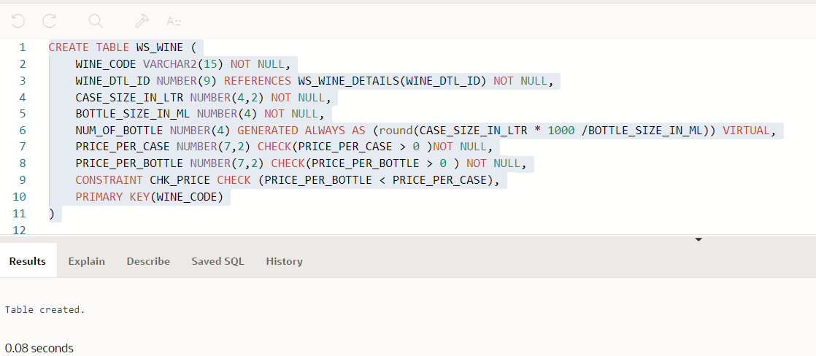

TYPEWS_WINE (WINE_CODE,WINE_DTL_ID,CASE_SIZE_IN_LTR,BOTTLE_SIZE_IN_ML,PRICE_PER_CASE,PRICE_PER_BOTTLE)

values ('CHAMP_001',14,5,1000,299.99,89.99)

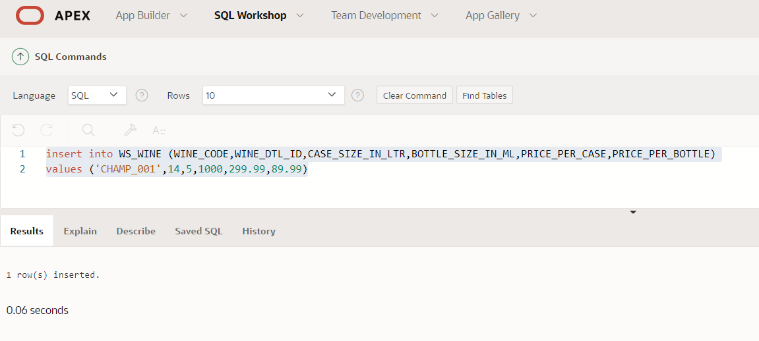

create table WS_PROMOTION (

    PROMOTION_ID NUMBER GENERATED ALWAYS as IDENTITY(START with 1 INCREMENT by 1),

    WINE_CODE VARCHAR2(15) REFERENCES WS_WINE(WINE_CODE) NOT NULL,

    PTYPE_METHOD VARCHAR2(25) CHECK (PTYPE_METHOD IN ('PRICE_DISCOUNT','QUANTITY_DISCOUNT')) NOT NULL,

    METHOD_DESC VARCHAR2(100) NOT NULL,

    START_DATE DATE NOT NULL,

    EXPIRY_DATE  DATE NOT NULL,

    STATUS VARCHAR2(15) CHECK (STATUS IN ('Active','Inactive','Expired')) NOT NULL,

    DISCOUNT_PERCENT NUMBER(2) CHECK (DISCOUNT_PERCENT BETWEEN 1 and 90),

    DISCOUNT_QUANTITY_BUY NUMBER(2) CHECK (DISCOUNT_QUANTITY_BUY > 0),

    DISCOUNT_QUANTITY_FOR NUMBER(2) CHECK (DISCOUNT_QUANTITY_FOR > 0),

    CONSTRAINT chck_buy_greater_than_for CHECK (DISCOUNT_QUANTITY_BUY > DISCOUNT_QUANTITY_FOR),

    PRIMARY KEY (WINE_CODE,START_DATE,EXPIRY_DATE,STATUS)

)

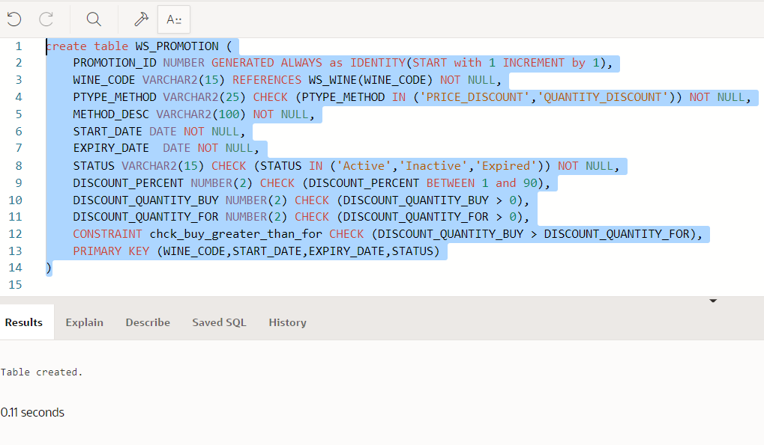

ALTER TABLE WS_PROMOTION

MODIFY (PTYPE_METHOD VARCHAR2(25) CHECK (PTYPE_METHOD IN ('PRICE_DISCOUNT','QUANTITY_DISCOUNT','REDUCED_PRICE')) )

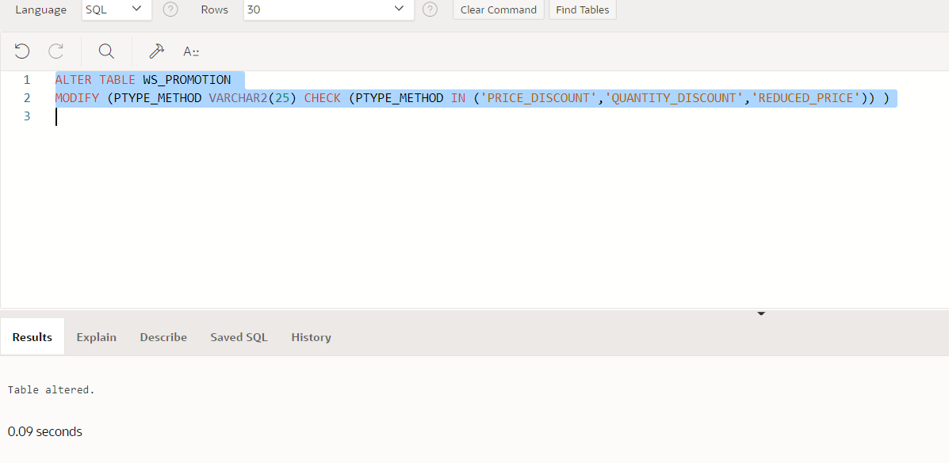

ALTER TABLE WS_PROMOTION

ADD (

    RED_PRICE_PER_CASE NUMBER(7,2) CHECK  (RED_PRICE_PER_CASE > 0),

    RED_PRICE_PER_BOTTLE NUMBER(7,2) CHECK  (RED_PRICE_PER_BOTTLE > 0)

)

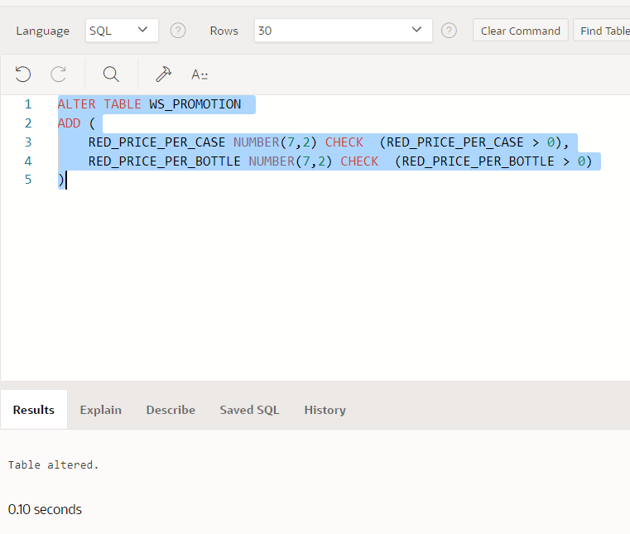

ALTER TABLE WS_PROMOTION

ADD CONSTRAINT chck_Reduced_bottlePrice_less_CasePrice CHECK(RED_PRICE_PER_BOTTLE < RED_PRICE_PER_CASE)

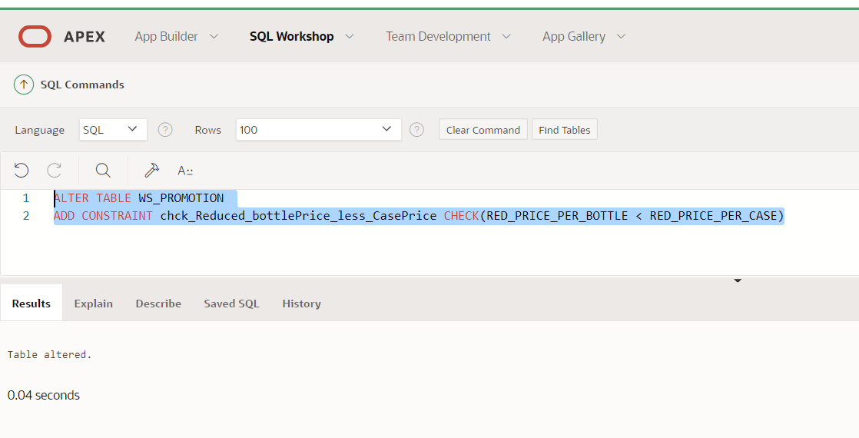

Record Insert:

1. Inserting a PRICE_DISCOUNT (10% OFF)

insert into WS_PROMOTION

(WINE_CODE,PTYPE_METHOD,METHOD_DESC, START_DATE,EXPIRY_DATE,STATUS,DISCOUNT_PERCENT)

values ('MER_004','PRICE_DISCOUNT','10% Off on price','15-April-2021','30-May-2021','Active',10)

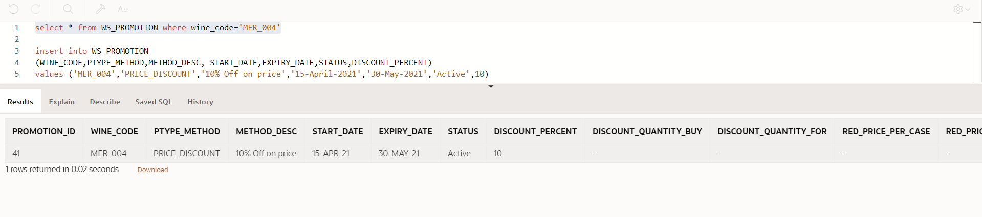

1. Inserting a QUANTITY_DISCOUNT ( Buy 3 for price of 2)

insert into WS_PROMOTION

(WINE_CODE,PTYPE_METHOD,METHOD_DESC, START_DATE,EXPIRY_DATE,STATUS,DISCOUNT_QUANTITY_BUY,DISCOUNT_QUANTITY_FOR)

values ('SHI_001','QUANTITY_DISCOUNT','Buy 3 Bottles for price of 2','09-April-2021','30-June-2021','Active',3,2)

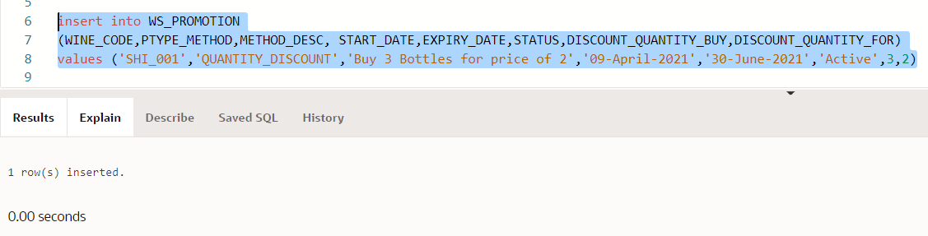

1. Inserting a Reduced price discount

insert into WS_PROMOTION

(WINE_CODE,PTYPE_METHOD,METHOD_DESC, START_DATE,EXPIRY_DATE,STATUS,RED_PRICE_PER_CASE,RED_PRICE_PER_BOTTLE)

values ('PINO_002','REDUCED_PRICE','Reduced Price by Case and Bottle','09-April-2021','30-June-2021','Active',65.99,1.99)

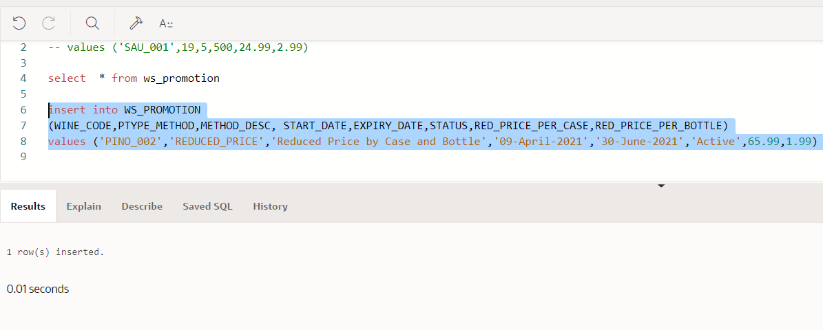

1. **CUSTOMER TABLE**

CREATE TABLE  WS_CUSTOMER

   (

    CUST_ID NUMBER NOT NULL,

    LNAME VARCHAR2(50) CHECK(REGEXP_LIKE(LNAME,'^[[:alpha:]]+$')) NOT NULL,

    FNAME VARCHAR2(50) CHECK(REGEXP_LIKE(FNAME,'^[[:alpha:]]+$')) NOT NULL,

    GENDER VARCHAR2(1) CHECK(GENDER in ('M','F','N')) NOT NULL,

    ADDR1 VARCHAR2(50) NOT NULL,

    ADDR2 VARCHAR2(50) NOT NULL,

    POSTCODE VARCHAR2(10) NOT NULL,

    MOBILE_NO NUMBER CHECK(REGEXP_LIKE(MOBILE_NO,'^[[:digit:]]+$')) NOT NULL,

    EMAIL_ID VARCHAR2(50) CHECK(REGEXP_LIKE (EMAIL_ID, '^(\S+)\@(\S+)\.(\S+)$')) NOT NULL,

    PRIMARY KEY ("CUST_ID")

     )

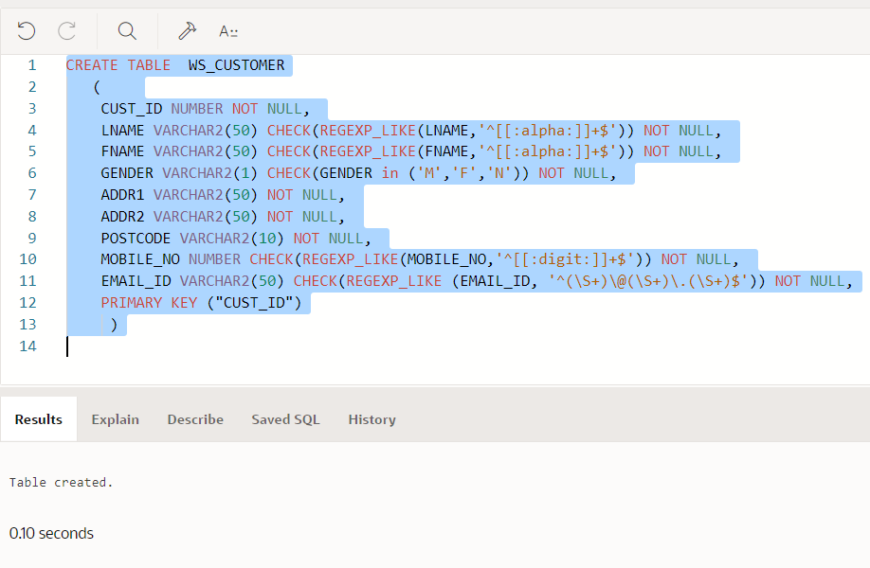

ALTER TABLE WS_CUSTOMER

ADD CENTER_ID REFERENCES WS_CENTER(CENTER_ID)

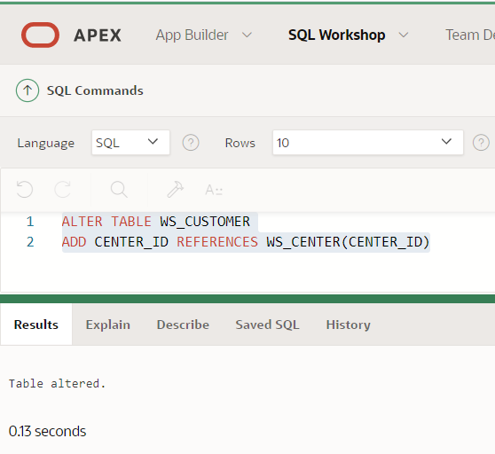

CREATE TABLE WS_SHOPPING_LIST

(

    CUST_ID NUMBER REFERENCES WS_CUSTOMER(CUST_ID) NOT NULL,

    WINE_CODE VARCHAR2(15) REFERENCES WS_WINE(WINE_CODE) NOT NULL,

    INSERT_DATE DATE DEFAULT SYSDATE ,

    EXPIRY_DATE DATE DEFAULT SYSDATE+60,

    STATUS VARCHAR2(15) CHECK (STATUS IN ('WishList','Expired','UserDeleted')),

    SELECTION_TYPE VARCHAR2(20) CHECK(SELECTION_TYPE in ('CASE','BOTTLE')) NOT NULL,

    QUANTITY NUMBER(4) NOT NULL,

    PRIMARY KEY(CUST_ID,WINE_CODE)

)

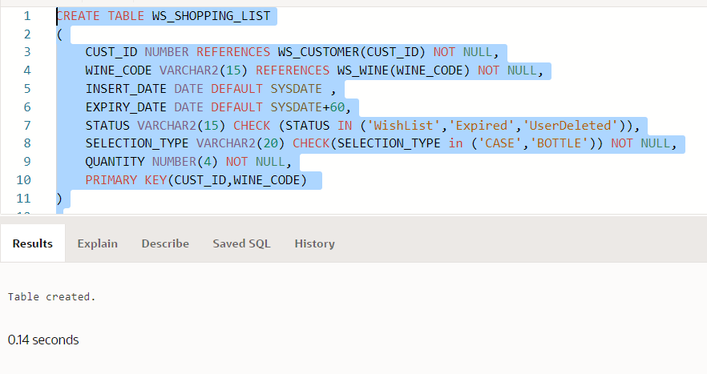

CREATE TABLE WS_SHOPPING_BASKET

(

    CUST_ID NUMBER REFERENCES WS_CUSTOMER(CUST_ID) NOT NULL,

    BASKET_ID NUMBER NOT NULL,

    WINE_CODE VARCHAR2(15) REFERENCES WS_WINE(WINE_CODE) NOT NULL,

    SELECTION_TYPE VARCHAR2(20) CHECK(SELECTION_TYPE in ('CASE','BOTTLE')) NOT NULL,

    QUANTITY NUMBER(4) NOT NULL,

    ACTUAL_PRICE NUMBER(7,2) NOT NULL,

    DISCOUNT_AMOUNT NUMBER(7,2) DEFAULT 0.00,

    SELLING_PRICE NUMBER(7,2) GENERATED ALWAYS AS (ACTUAL_PRICE - DISCOUNT_AMOUNT) VIRTUAL,

    DELIVERY_DATE DATE,

PRIMARY KEY(CUST_ID,BASKET_ID)

)

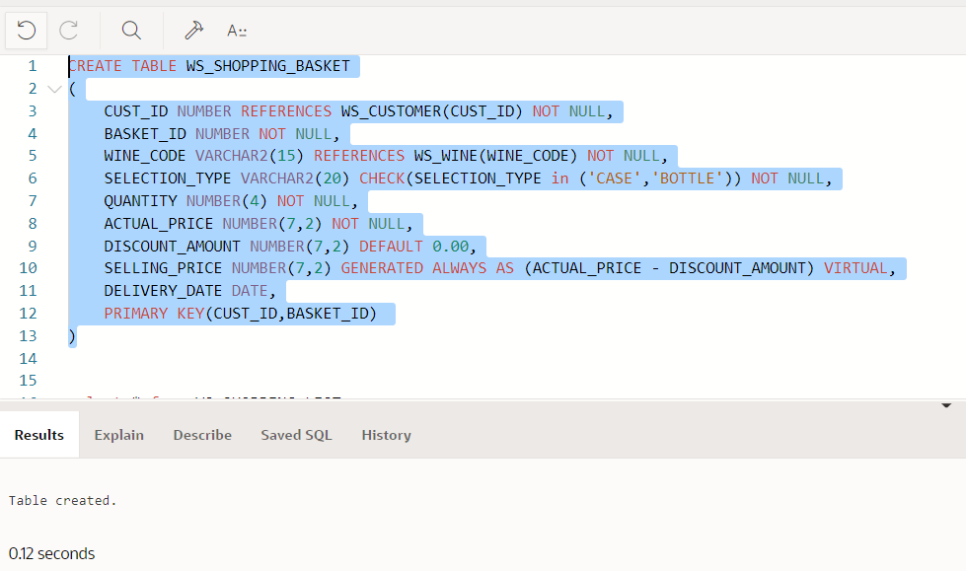

ALTER TABLE WS_SHOPPING_BASKET

ADD STATUS VARCHAR2(20) CHECK (STATUS IN ('Pending','Ordered','ToBeShipped','Shipped','Fullfilled'))

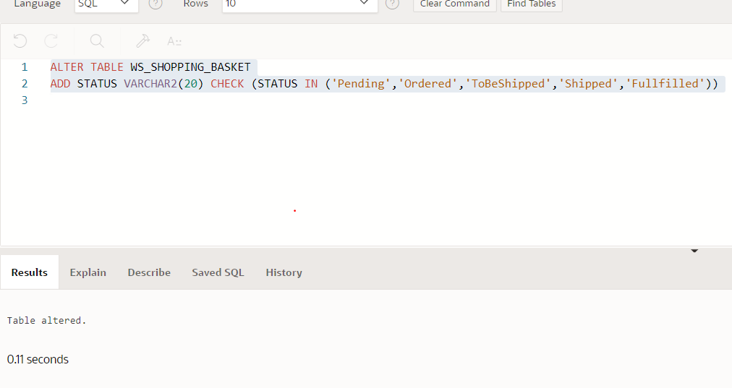

ALTER TABLE WS_SHOPPING_BASKET

MODIFY STATUS VARCHAR2(20) CHECK (STATUS IN ('Pending','Ordered','Shipped','Fullfilled'))

ALTER TABLE WS_SHOPPING_BASKET

ADD INVOICE_NO REFERENCES WS_INVOICE(INVOICE_NO)

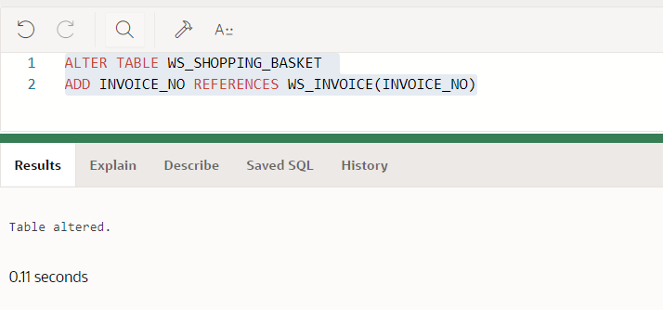

create table CALCULATE_DELIVERY_CHARGE(

    DC_ID NUMBER NOT NULL,

    FRM_AMOUNT NUMBER(7,2) CHECK (FRM_AMOUNT > 0) NOT NULL,

    TO_AMOUNT NUMBER(7,2)  CHECK (TO_AMOUNT > 0) NOT NULL,

    DELIVERY_CHARGE NUMBER(7,2) NOT NULL,

    PRIMARY KEY(DC_ID)

)

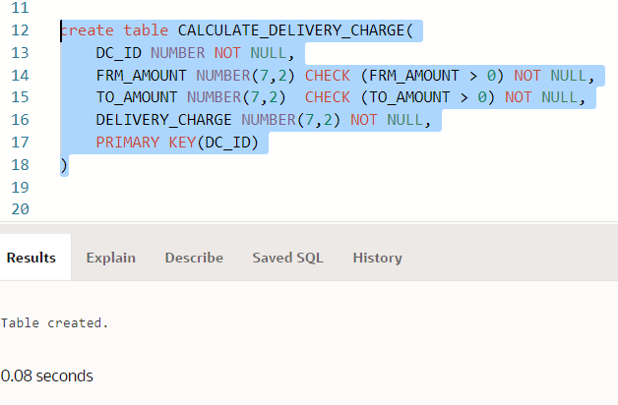

ALTER TABLE CALCULATE_DELIVERY_CHARGE

ADD CONSTRAINT chck_ToAmt_greater_thn_FrmAmt CHECK(TO_AMOUNT  > FRM_AMOUNT)

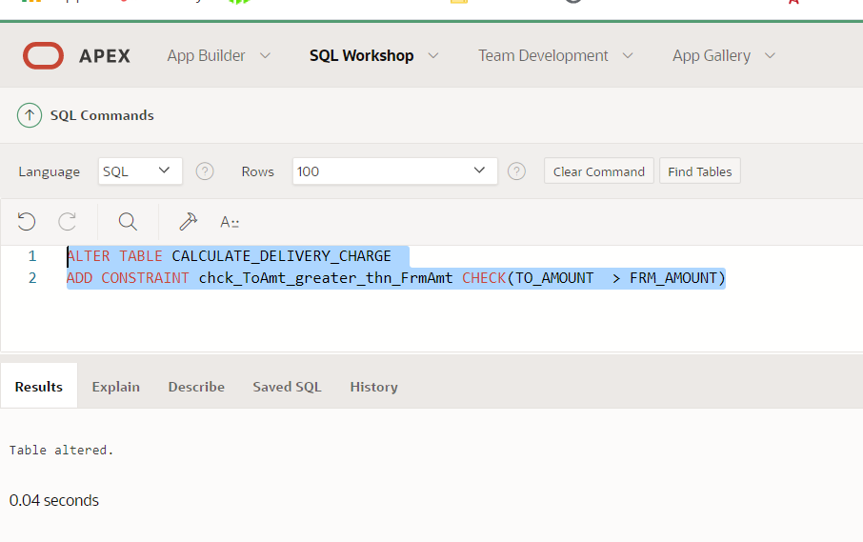

create table WS_INVOICE(

    INVOICE_NO VARCHAR2(25) NOT NULL,

    CUST_ID NUMBER REFERENCES WS_CUSTOMER(CUST_ID) NOT NULL,

    INVOICE_DATE DATE NOT NULL,

    TOTAL_AMOUNT NUMBER(7,2) NOT NULL,

    SAVINGS NUMBER(7,2),

    DC_ID NUMBER REFERENCES CALCULATE_DELIVERY_CHARGE(DC_ID) NOT NULL,

    PRIMARY KEY(INVOICE_NO)

)

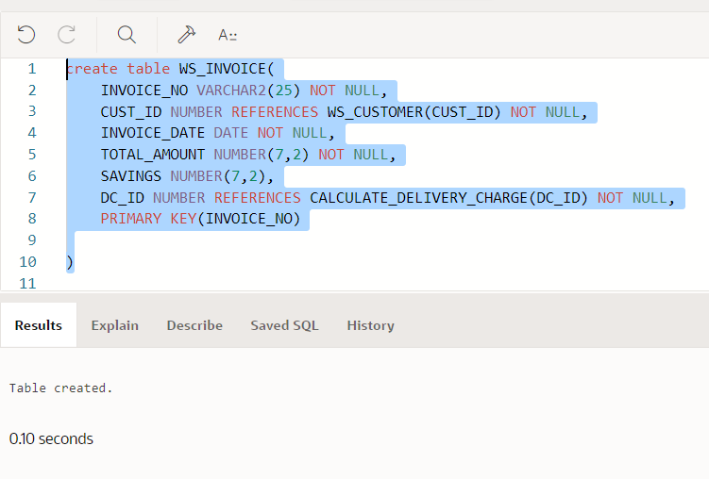

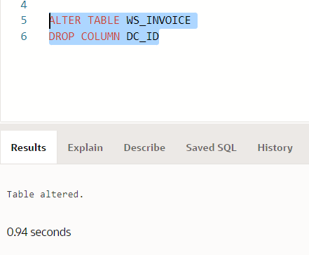

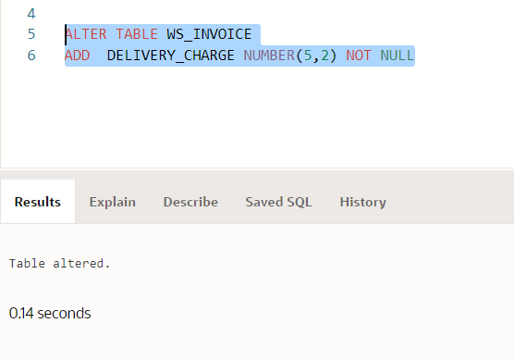

ALTER TABLE WS_INVOICE

ADD

(

 DEL_CONTACT_NAME VARCHAR2(50) CHECK(REGEXP_LIKE(DEL_CONTACT_NAME,'^[[:alpha:]]+$')) NOT NULL,

 DEL_ADDR1 VARCHAR2(50) NOT NULL,

 DEL_ADDR2 VARCHAR2(50) NOT NULL,

 DEL_POSTCODE VARCHAR2(10) NOT NULL,

 DEL_PHONE VARCHAR2(10) CHECK(REGEXP_LIKE(DEL_PHONE,'^[[:digit:]]+$')) NOT NULL

)

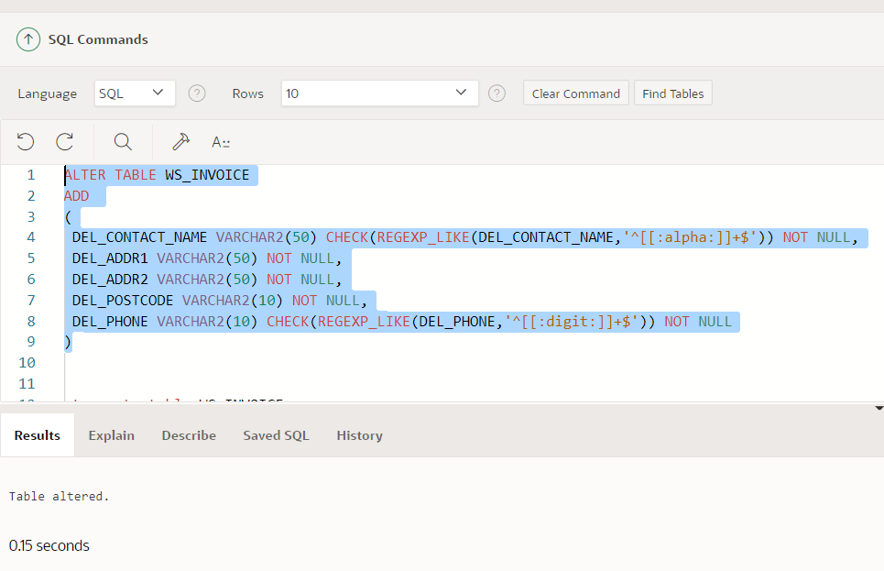

1. **WARESHOUSE and DISTRIBUTION CENTER TABLES**

WS_REGION

CREATE TABLE WS_REGION (

    REGION_ID NUMBER NOT NULL,

    REGION_NAME VARCHAR2(30) NOT NULL,

    COUNTRY_CODE REFERENCES WS_COUNTRY(COUNTRY_CODE) NOT NULL,

    PRIMARY KEY(REGION_ID)

)

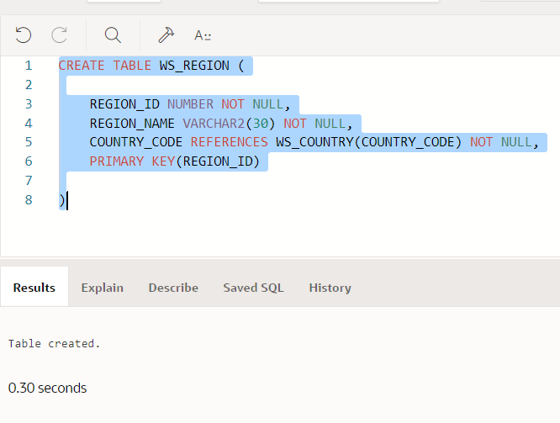

CREATE TABLE WS_LOCATION (

    LOCATION_ID NUMBER NOT NULL,

    STREET_ADDRESS VARCHAR2(50) NOT NULL,

    POSTAL_CODE VARCHAR2(10) NOT NULL,

    CITY VARCHAR2(25) NOT NULL,

    COUNTY VARCHAR2(25) NOT NULL,

    COUNTRY_CODE REFERENCES WS_COUNTRY(COUNTRY_CODE) NOT NULL,

    PRIMARY KEY(LOCATION_ID)

)

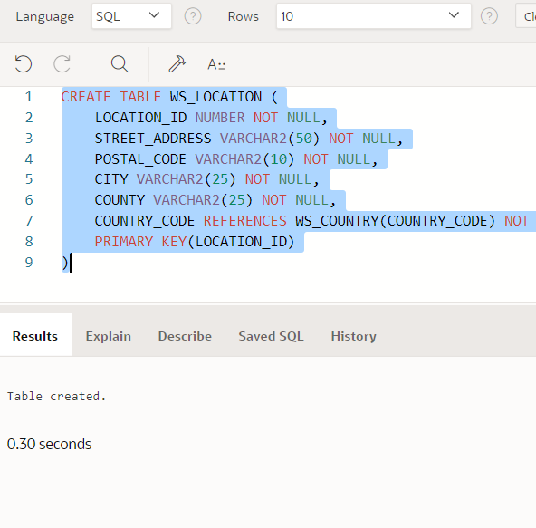

CREATE TABLE WS_WAREHOUSE (

    WAREHOUSE_ID NUMBER NOT NULL,

    WAREHOUSE_NAME VARCHAR2(50) NOT NULL,

    PHONE_NO VARCHAR2(10) NOT NULL,

    FAX_NO VARCHAR2(10) NOT NULL,

    EMAIL_ID VARCHAR2(50) CHECK(REGEXP_LIKE (EMAIL_ID, '^(\S+)\@(\S+)\.(\S+)$')) NOT NULL,

    LOCATION_ID REFERENCES WS_LOCATION(LOCATION_ID) NOT NULL,

    REGION_ID REFERENCES WS_REGION(REGION_ID) NOT NULL,

    PRIMARY KEY(WAREHOUSE_ID)

)

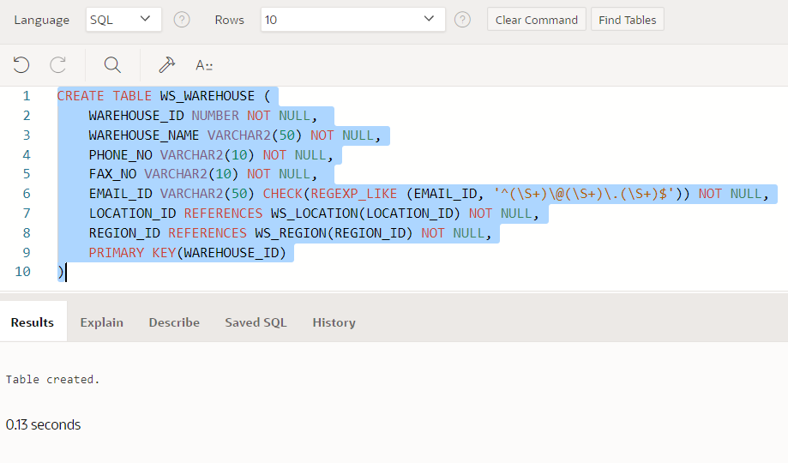

ALTER TABLE WS_WAREHOUSE MODIFY

(

    PHONE_NO NUMBER(10)  CHECK (REGEXP_LIKE(PHONE_NO,'^[[:digit:]]+$')) ,

    FAX_NO NUMBER(10)  CHECK(REGEXP_LIKE(FAX_NO,'^[[:digit:]]+$'))

)

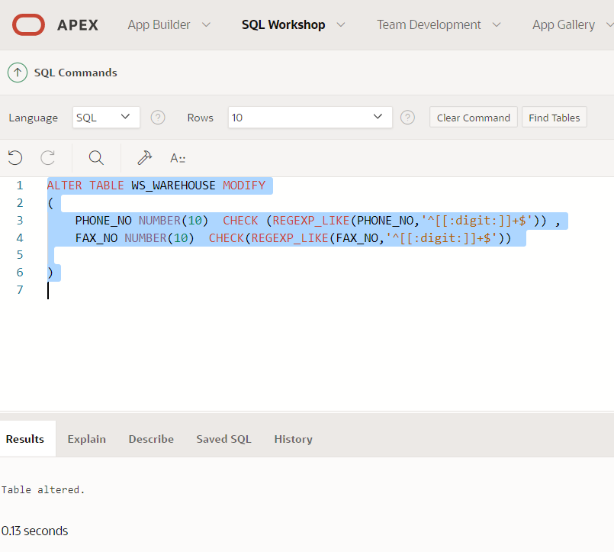

Inserting into table

INSERT INTO WS_WAREHOUSE VALUES (

    1,'WS_GREATER_LONDON',6532119809,4432557821,'ws_glondon@Wine-Stopper.co.uk',1,1)

INSERT INTO WS_WAREHOUSE VALUES (

    2,'WS_GREATER_MANCHESTER',5320953781,4421879042,'ws_gmanchester@Wine-Stopper.co.uk',2,2)

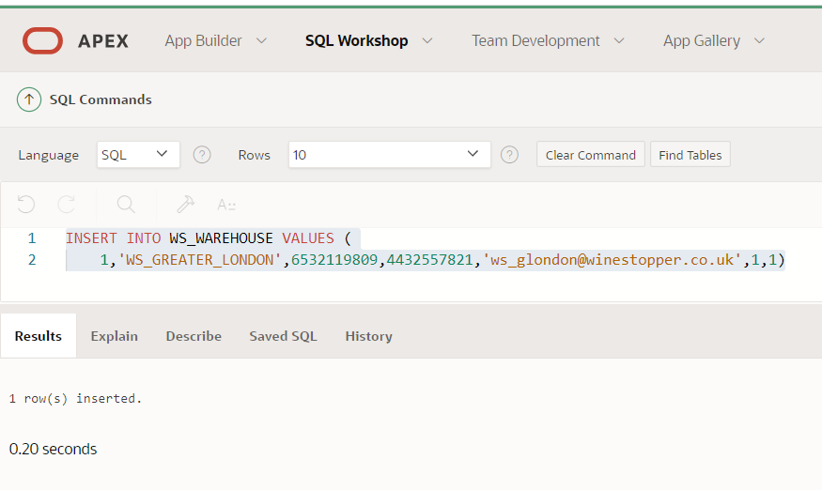

CREATE TABLE WS_CENTER(

    CENTER_ID NUMBER NOT NULL,

    CENTER_NAME VARCHAR2(25) NOT NULL,

    PHONE_NO VARCHAR2(10) NOT NULL,

    FAX_NO VARCHAR2(10) NOT NULL,

    EMAIL_ID VARCHAR2(50) CHECK(REGEXP_LIKE (EMAIL_ID, '^(\S+)\@(\S+)\.(\S+)$')) NOT NULL,

    LOCATION_ID REFERENCES WS_LOCATION(LOCATION_ID) NOT NULL,

    WAREHOUSE_ID REFERENCES WS_WAREHOUSE(WAREHOUSE_ID) NOT NULL,

    PRIMARY KEY(CENTER_ID)

)

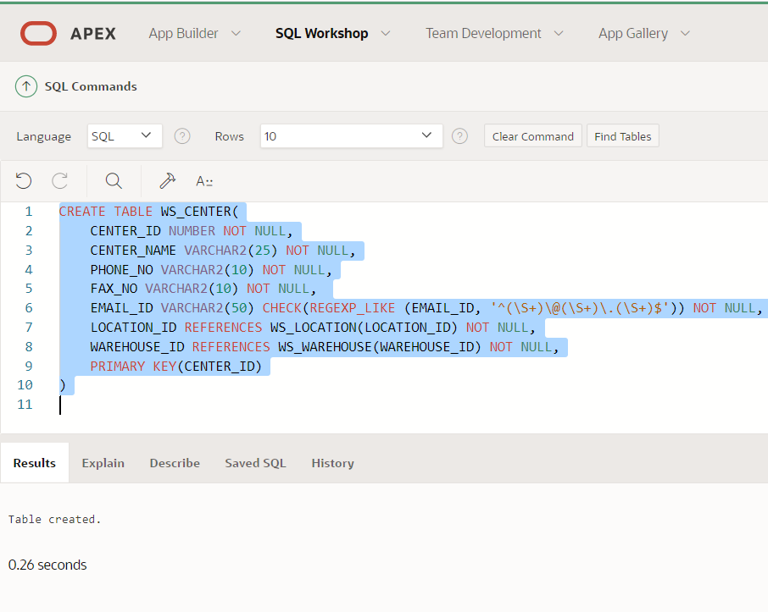

ALTER TABLE WS_CENTER MODIFY

(

    PHONE_NO NUMBER(10)  CHECK (REGEXP_LIKE(PHONE_NO,'^[[:digit:]]+$')) ,

    FAX_NO NUMBER(10)  CHECK(REGEXP_LIKE(FAX_NO,'^[[:digit:]]+$'))

)

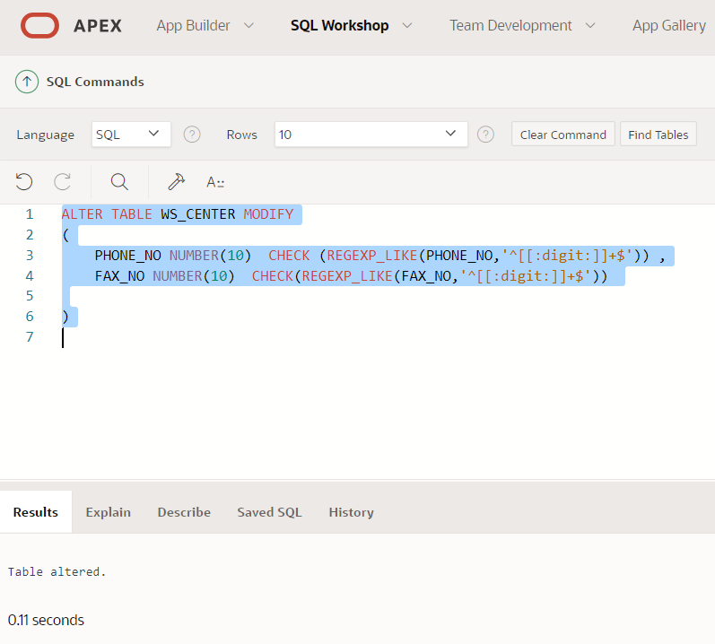

CREATE TABLE WS_STOCK_INFO (

    STOCK_ID NUMBER GENERATED ALWAYS AS IDENTITY,

    CENTER_ID REFERENCES WS_CENTER(CENTER_ID) NOT NULL,

    WINE_CODE REFERENCES WS_WINE(WINE_CODE) NOT NULL,

    QUANTITY NUMBER NOT NULL,

    LAST_STOCKED DATE,

    LAST_STOCKED_QUANTITY NUMBER,

    NEXT_DELIVERY DATE,

    NOTES VARCHAR2(500),

    PRIMARY KEY(CENTER_ID, WINE_CODE)

)

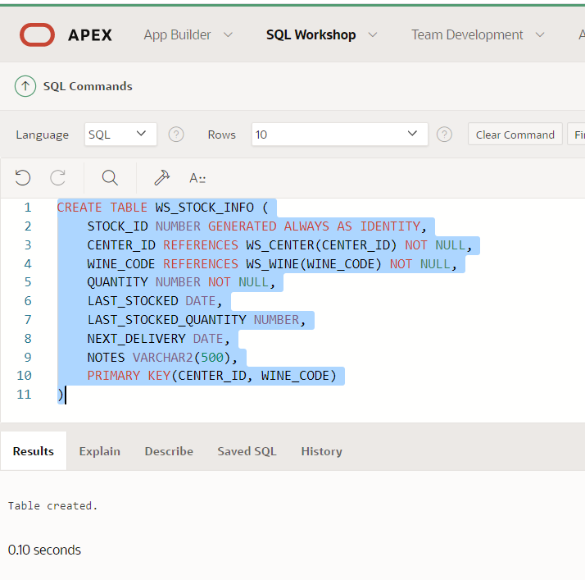

CREATE TABLE WS_ORDER

(

    ORDER_ID NUMBER NOT NULL,

    CENTER_NO REFERENCES WS_CENTER(CENTER_ID) NOT NULL,

    ORDER_TYPE VARCHAR(2) CHECK (ORDER_TYPE in ('ST','SP')) NOT NULL,

    ORDER_PLACED_DATE DATE NOT NULL,

    ORDER_REVISED_DATE DATE,

    PRIMARY KEY(ORDER_ID)

)

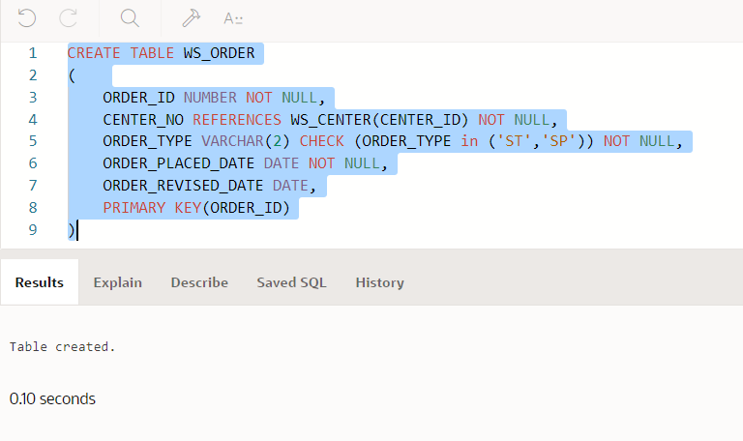

Inserting a Standing Order (ORDER_TYPE=”ST”)

INSERT INTO WS_ORDER (ORDER_ID,CENTER_NO,ORDER_TYPE,ORDER_PLACED_DATE )

VALUES(20789,1,'ST','9-April-2021')

Inserting a SPECIAL Order (ORDER_TYPE=”SP”)

INSERT INTO WS_ORDER (ORDER_ID,CENTER_NO,ORDER_TYPE,ORDER_PLACED_DATE )

VALUES(20790,1,'SP','9-April-2021')

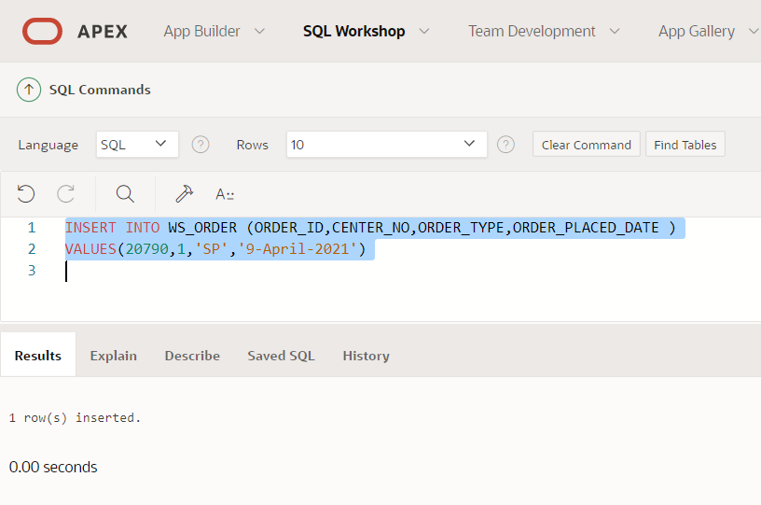

CREATE TABLE WS_ORDER_ITEM

(

    ITEM_ID NUMBER GENERATED ALWAYS AS IDENTITY,

    ORDER_ID REFERENCES WS_ORDER(ORDER_ID) NOT NULL,

    WINE_CODE REFERENCES WS_WINE(WINE_CODE) NOT NULL,

    STATUS VARCHAR2(15) CHECK(STATUS IN ('Active','Inactive')),

    ORDER_DTL_DESC VARCHAR2(200),

    QUANTITY NUMBER NOT NULL,

    DELIVERY_DAY VARCHAR2(10) CHECK(DELIVERY_DAY IN ('Sunday','Monday','Tuesday','Wednesday','Thursday','Friday','Saturday')),

    DELIVERY_FREQUENCY VARCHAR2(10) CHECK(DELIVERY_FREQUENCY IN ('Weekly','Fortnightly','Monthly','Quarterly')),

    DELIVERY_DATE DATE,

    PRIMARY KEY(ORDER_ID,ITEM_ID)

)

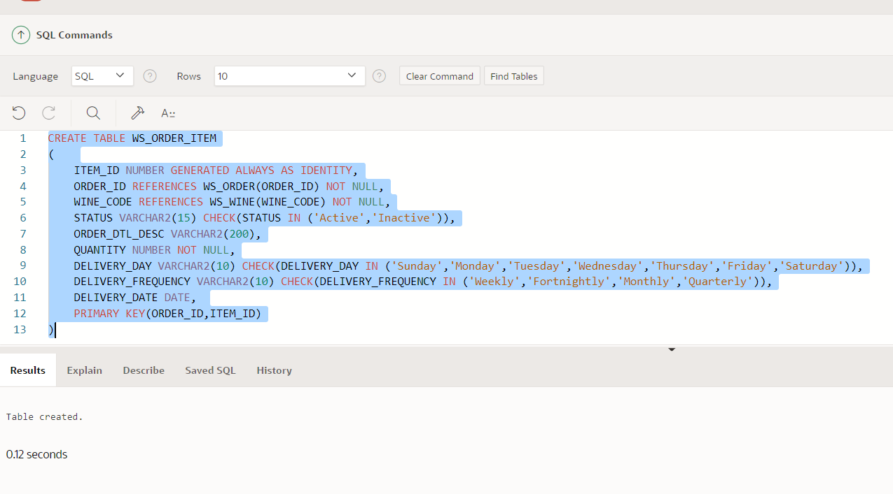

# Chapter 4 – Demonstration using SQL Queries

1. **Quantitative Analysis of Range of Wines on the Wine-Stopper Website**

The results are on the basis of Country, Colour, Category of Wine

SELECT WC.COUNTRY_NAME, WD.COLOUR,WCAT.CATEGORY_NAME , COUNT(WINE_CODE)  NO_OF_WINES

FROM WS_WINE W, WS_COUNTRY WC, WS_WINE_DETAILS WD , WS_WINE_CATEGORY WCAT

WHERE W.WINE_DTL_ID = WD.WINE_DTL_ID

AND WD.COUNTRY_CODE = WC.COUNTRY_CODE

AND WD.CATEGORY_ID = WCAT.CATEGORY_ID

GROUP BY WC.COUNTRY_NAME, WD.COLOUR,WCAT.CATEGORY_NAME

ORDER BY NO_OF_WINES DESC

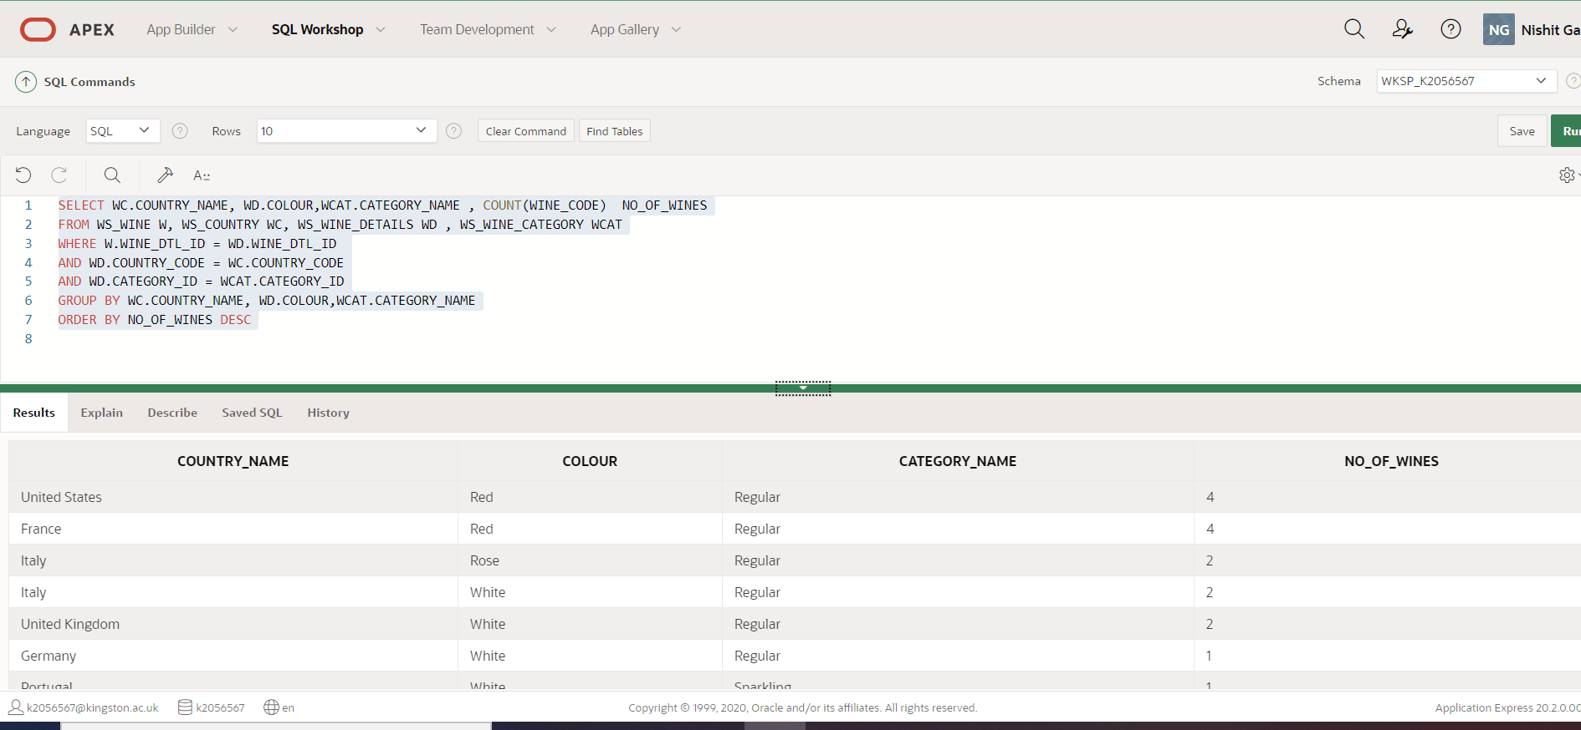

1. **Selection of Wines with information about Special Offers, Availability**

User has an option to filter by Wine Category of General, Sparkling and Dessert Wines

User has an option to select the colour of the wine

User has an option to set the country of the wine

The Center ID has to be provided on the basis of User location

SELECT  W.WINE_CODE, WD.WINE_NAME || '  ' ||  W.CASE_SIZE_IN_LTR  || ' LTR' AS "WINE_NAME" ,

WD.WINE_DESC AS WINE_DESC , WI.IND_DESC AS WINE_INDICATOR, W.PRICE_PER_BOTTLE AS "BOTTLE(£)", W.PRICE_PER_CASE AS "CASE(£)",

W.NUM_OF_BOTTLE || ' X ' ||  W.BOTTLE_SIZE_IN_ML AS "CASE CONTAINS",

CASE WHEN  WS.NEXT_DELIVERY IS NOT NULL AND WS.QUANTITY <= 0 THEN  'AVAILABLE IN ' ||  TO_CHAR(WS.NEXT_DELIVERY - TRUNC(SYSDATE)) || ' DAYS'

     WHEN  WS.NEXT_DELIVERY IS NULL AND WS.QUANTITY <= 0 THEN  'UNAVAILABLE'

     WHEN  WS.QUANTITY > 0 THEN  'IN STOCK'

END AS AVAILABILITY,

CASE

    WHEN  WP.DISCOUNT_PERCENT > 0

          AND TRUNC(SYSDATE) BETWEEN WP.START_DATE AND WP.EXPIRY_DATE

          AND WP.STATUS = 'Active'

    THEN WP.DISCOUNT_PERCENT || ' % OFF'

     WHEN WP.DISCOUNT_QUANTITY_BUY > 0 AND  WP.DISCOUNT_QUANTITY_FOR > 0

          AND TRUNC(SYSDATE) BETWEEN WP.START_DATE AND WP.EXPIRY_DATE

          AND WP.STATUS = 'Active'

     THEN 'BUY ' || WP.DISCOUNT_QUANTITY_BUY || ' FOR ' || DISCOUNT_QUANTITY_FOR

     WHEN WP.RED_PRICE_PER_CASE > 0  AND   WP.RED_PRICE_PER_BOTTLE > 0

          AND TRUNC(SYSDATE) BETWEEN WP.START_DATE AND WP.EXPIRY_DATE

          AND WP.STATUS = 'Active'

     THEN 'REDUCED PRICE PER CASE (£): ' || WP.RED_PRICE_PER_CASE ||   ', REDUCED PRICE PER BOTTLE (£): ' || WP.RED_PRICE_PER_BOTTLE

     WHEN WP.RED_PRICE_PER_CASE > 0

          AND TRUNC(SYSDATE) BETWEEN WP.START_DATE AND WP.EXPIRY_DATE

          AND WP.STATUS = 'Active'

     THEN 'REDUCED PRICE PER CASE (£): ' || WP.RED_PRICE_PER_CASE

     WHEN WP.RED_PRICE_PER_BOTTLE > 0

          AND TRUNC(SYSDATE) BETWEEN WP.START_DATE AND WP.EXPIRY_DATE

          AND WP.STATUS = 'Active'

     THEN 'REDUCED PRICE PER BOTTLE (£): ' || WP.RED_PRICE_PER_BOTTLE

END AS SPECIAL_OFFER

FROM WS_WINE W, WS_WINE_DETAILS WD, WS_COUNTRY WC, WS_WINE_INDICATOR WI,

WS_PROMOTION WP, WS_WINE_CATEGORY WCAT, WS_STOCK_INFO WS

WHERE W.WINE_DTL_ID = WD.WINE_DTL_ID

AND WD.COUNTRY_CODE = WC.COUNTRY_CODE

AND WD.IND_ID = WI.IND_ID

AND WD.CATEGORY_ID = WCAT.CATEGORY_ID

AND W.WINE_CODE = WP.WINE_CODE(+)

AND W.WINE_CODE = WS.WINE_CODE

AND UPPER(WCAT.CATEGORY_NAME) LIKE COALESCE('','%') --  REGULAR, SPARKLING, DESSERT

AND UPPER(WD.COLOUR) LIKE COALESCE('','%') -- RED, WHITE, GOLD, ROSE, YELLOW, ORANGE

AND UPPER(WC.COUNTRY_NAME) LIKE COALESCE('','%')  -- UNITED STATES, FRANCE, GERMANY, ITALY

AND WS.CENTER_ID=1 -- #1,2,3 DEPENDING UPON THE LOCATION DETECTED

ORDER BY 1

All Wines in CENTER 1 -

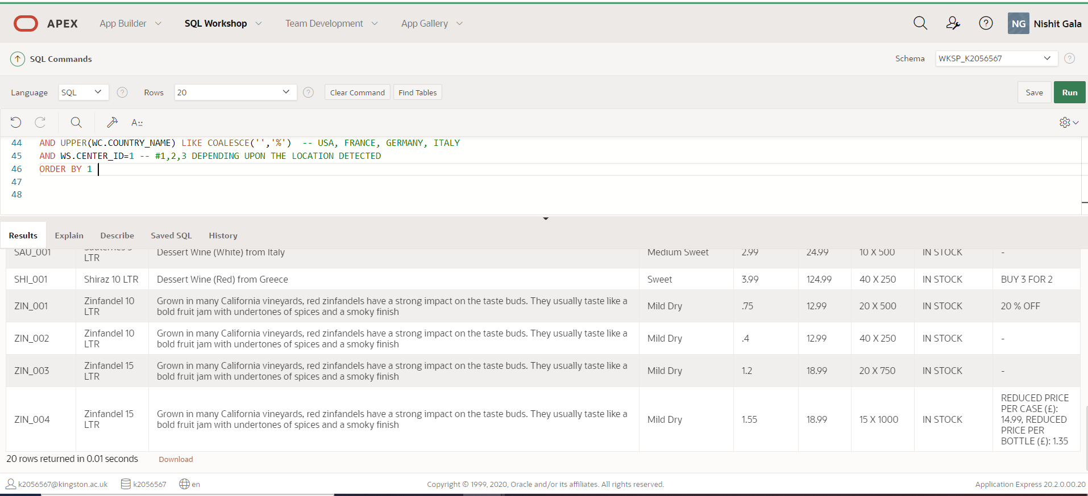

Italian Wine Example-

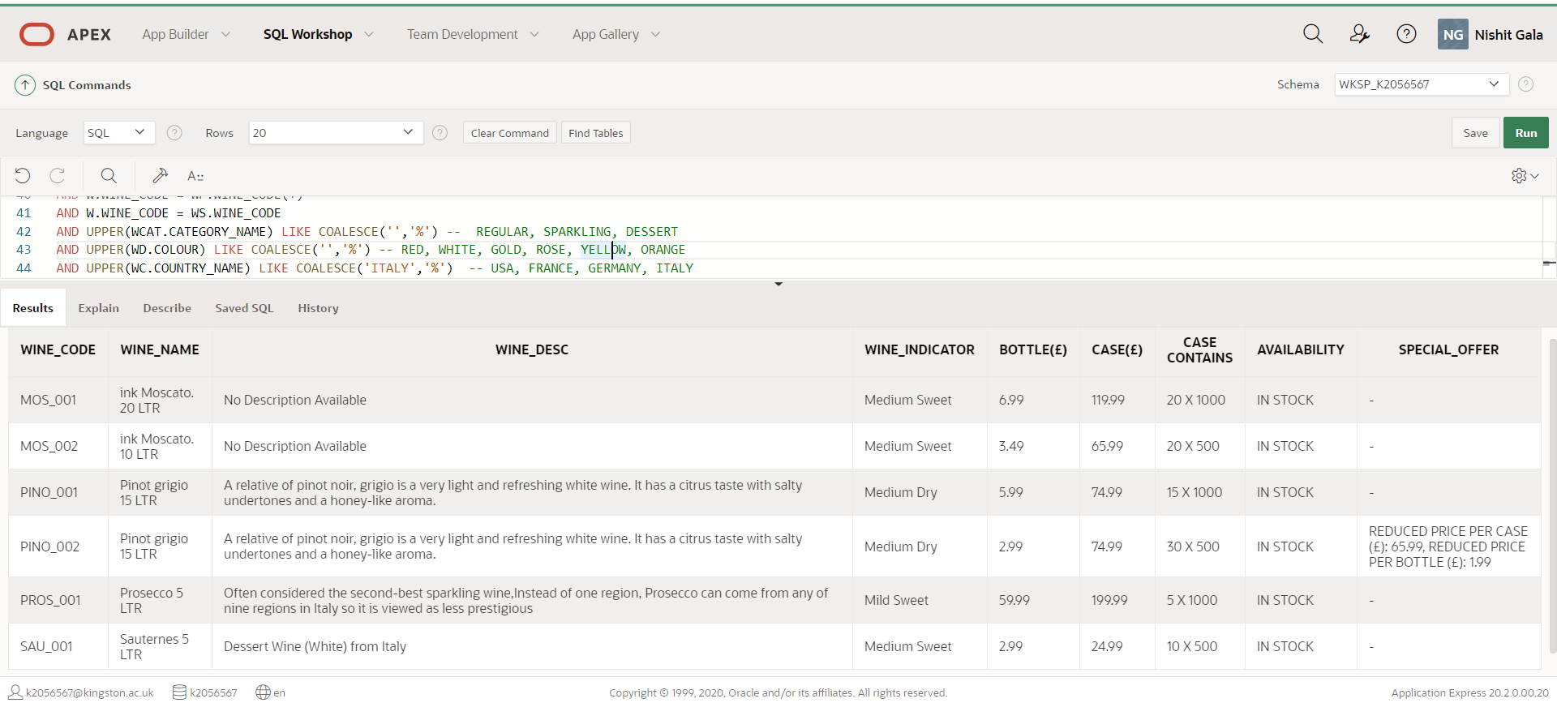

Sparkling Wine Example –

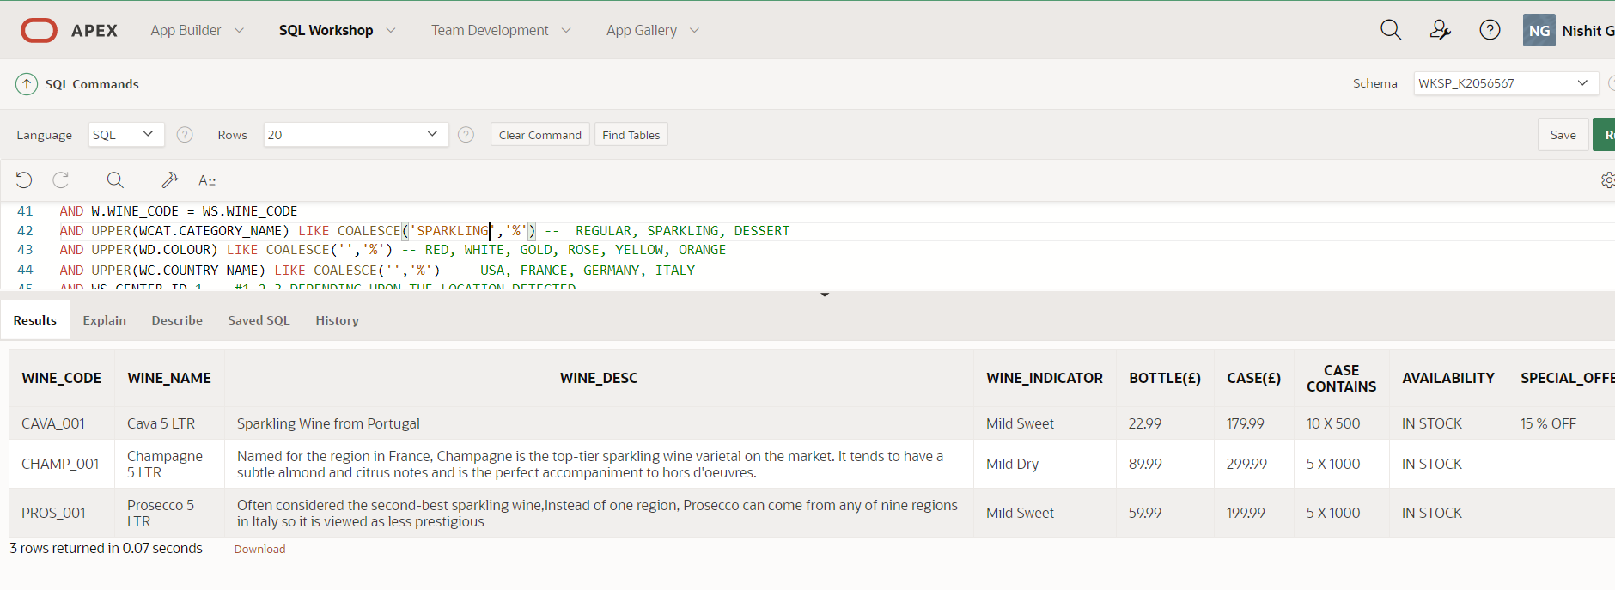

RED WINES of United States –

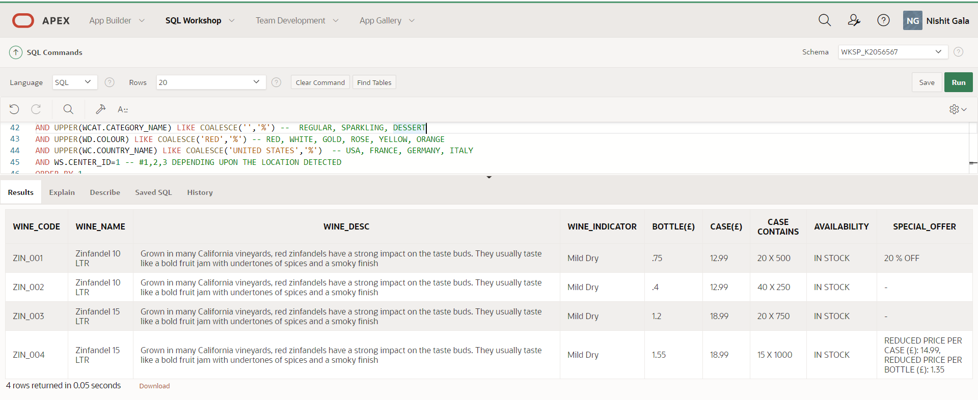

Output of Query for CENTER – 1 returning all wines:



1. On Promotion Wines

SELECT  W.WINE_CODE, WD.WINE_NAME || '  ' ||  W.CASE_SIZE_IN_LTR  || ' LTR' AS "WINE_NAME" ,

WD.WINE_DESC AS WINE_DESC , WI.IND_DESC AS WINE_INDICATOR, W.PRICE_PER_BOTTLE AS "BOTTLE(£)", W.PRICE_PER_CASE AS "CASE(£)",

W.NUM_OF_BOTTLE || ' X ' ||  W.BOTTLE_SIZE_IN_ML AS "CASE CONTAINS",

CASE WHEN  WS.NEXT_DELIVERY IS NOT NULL AND WS.QUANTITY <= 0 THEN  'AVAILABLE IN ' ||  TO_CHAR(WS.NEXT_DELIVERY - TRUNC(SYSDATE)) || ' DAYS'

     WHEN  WS.NEXT_DELIVERY IS NULL AND WS.QUANTITY <= 0 THEN  'UNAVAILABLE'

     WHEN  WS.QUANTITY > 0 THEN  'IN STOCK'

END AS AVAILABILITY,

CASE

    WHEN  WP.DISCOUNT_PERCENT > 0

          AND TRUNC(SYSDATE) BETWEEN WP.START_DATE AND WP.EXPIRY_DATE

          AND WP.STATUS = 'Active'

    THEN WP.DISCOUNT_PERCENT || ' % OFF'

     WHEN WP.DISCOUNT_QUANTITY_BUY > 0 AND  WP.DISCOUNT_QUANTITY_FOR > 0

          AND TRUNC(SYSDATE) BETWEEN WP.START_DATE AND WP.EXPIRY_DATE

          AND WP.STATUS = 'Active'

     THEN 'BUY ' || WP.DISCOUNT_QUANTITY_BUY || ' FOR ' || DISCOUNT_QUANTITY_FOR

     WHEN WP.RED_PRICE_PER_CASE > 0  AND   WP.RED_PRICE_PER_BOTTLE > 0

          AND TRUNC(SYSDATE) BETWEEN WP.START_DATE AND WP.EXPIRY_DATE

          AND WP.STATUS = 'Active'

     THEN 'REDUCED PRICE PER CASE (£): ' || WP.RED_PRICE_PER_CASE ||   ', REDUCED PRICE PER BOTTLE (£): ' || WP.RED_PRICE_PER_BOTTLE

     WHEN WP.RED_PRICE_PER_CASE > 0

          AND TRUNC(SYSDATE) BETWEEN WP.START_DATE AND WP.EXPIRY_DATE

          AND WP.STATUS = 'Active'

     THEN 'REDUCED PRICE PER CASE (£): ' || WP.RED_PRICE_PER_CASE

     WHEN WP.RED_PRICE_PER_BOTTLE > 0

          AND TRUNC(SYSDATE) BETWEEN WP.START_DATE AND WP.EXPIRY_DATE

          AND WP.STATUS = 'Active'

     THEN 'REDUCED PRICE PER BOTTLE (£): ' || WP.RED_PRICE_PER_BOTTLE

END AS SPECIAL_OFFER

FROM WS_WINE W, WS_WINE_DETAILS WD, WS_COUNTRY WC, WS_WINE_INDICATOR WI,

WS_PROMOTION WP, WS_WINE_CATEGORY WCAT, WS_STOCK_INFO WS

WHERE W.WINE_DTL_ID = WD.WINE_DTL_ID

AND WD.COUNTRY_CODE = WC.COUNTRY_CODE

AND WD.IND_ID = WI.IND_ID

AND WD.CATEGORY_ID = WCAT.CATEGORY_ID

AND W.WINE_CODE = WP.WINE_CODE

AND W.WINE_CODE = WS.WINE_CODE

AND UPPER(WCAT.CATEGORY_NAME) LIKE COALESCE('','%') --  REGULAR, SPARKLING, DESSERT

AND UPPER(WD.COLOUR) LIKE COALESCE('','%') -- RED, WHITE, GOLD, ROSE, YELLOW, ORANGE

AND UPPER(WC.COUNTRY_NAME) LIKE COALESCE('','%')  -- USA, FRANCE, GERMANY, ITALY

AND WS.CENTER_ID=1 -- #1,2,3 DEPENDING UPON THE LOCATION DETECTED

and TRUNC(SYSDATE) BETWEEN WP.START_DATE AND WP.EXPIRY_DATE

ORDER BY 1

Wines on Prmotion

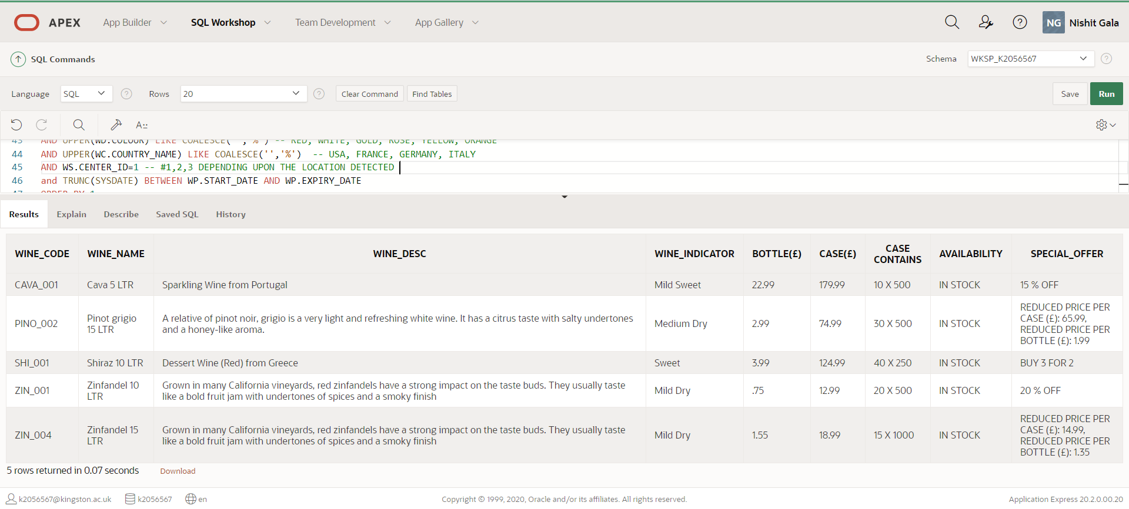

1. **Data shown in the User Shopping Basket before the purchase**

SELECT CUST.FNAME ,CUST.LNAME ,

WDET.WINE_NAME || '  ' ||  WINE.CASE_SIZE_IN_LTR  || ' LTR' AS "WINE_NAME" , WINE.WINE_CODE,

COUNTRY.COUNTRY_NAME AS "COUNTRY",  WDET.COLOUR AS "COLOUR",

WINE.PRICE_PER_BOTTLE AS "BOTTLE(£)", WINE.PRICE_PER_CASE AS "CASE(£)",

CASE WHEN  WS.NEXT_DELIVERY IS NOT NULL AND WS.QUANTITY <= 0 THEN  'AVAILABLE IN ' ||  TO_CHAR(WS.NEXT_DELIVERY - TRUNC(SYSDATE)) || ' DAYS'

     WHEN  WS.NEXT_DELIVERY IS NULL AND WS.QUANTITY <= 0 THEN  'UNAVAILABLE'

     WHEN  WS.QUANTITY > 0 THEN  'IN STOCK'

END AS AVAILABILITY,

CASE

    WHEN  PROMO.DISCOUNT_PERCENT > 0

          AND TRUNC(SYSDATE) BETWEEN PROMO.START_DATE AND PROMO.EXPIRY_DATE

          AND PROMO.STATUS = 'Active'

    THEN PROMO.DISCOUNT_PERCENT || ' % OFF'

     WHEN PROMO.DISCOUNT_QUANTITY_BUY > 0 AND  PROMO.DISCOUNT_QUANTITY_FOR > 0

          AND TRUNC(SYSDATE) BETWEEN PROMO.START_DATE AND PROMO.EXPIRY_DATE

          AND PROMO.STATUS = 'Active'

     THEN 'BUY ' || PROMO.DISCOUNT_QUANTITY_BUY || ' FOR ' || DISCOUNT_QUANTITY_FOR

     WHEN PROMO.RED_PRICE_PER_CASE > 0  AND   PROMO.RED_PRICE_PER_BOTTLE > 0

          AND TRUNC(SYSDATE) BETWEEN PROMO.START_DATE AND PROMO.EXPIRY_DATE

          AND PROMO.STATUS = 'Active'

     THEN 'REDUCED PRICE PER CASE (£): ' || PROMO.RED_PRICE_PER_CASE ||   ', REDUCED PRICE PER BOTTLE (£): ' || PROMO.RED_PRICE_PER_BOTTLE

     WHEN PROMO.RED_PRICE_PER_CASE > 0

          AND TRUNC(SYSDATE) BETWEEN PROMO.START_DATE AND PROMO.EXPIRY_DATE

          AND PROMO.STATUS = 'Active'

     THEN 'REDUCED PRICE PER CASE (£): ' || PROMO.RED_PRICE_PER_CASE

     WHEN PROMO.RED_PRICE_PER_BOTTLE > 0

          AND TRUNC(SYSDATE) BETWEEN PROMO.START_DATE AND PROMO.EXPIRY_DATE

          AND PROMO.STATUS = 'Active'

     THEN 'REDUCED PRICE PER BOTTLE (£): ' || PROMO.RED_PRICE_PER_BOTTLE

END AS "SPECIAL OFFER",

BASKET.SELECTION_TYPE || ' : ' || BASKET.QUANTITY AS "QUANTITY REQUESTED"

FROM WS_SHOPPING_BASKET BASKET, WS_CUSTOMER CUST, WS_WINE WINE, WS_WINE_DETAILS WDET, WS_COUNTRY COUNTRY, WS_PROMOTION PROMO, WS_STOCK_INFO WS

WHERE BASKET.CUST_ID = CUST.CUST_ID

AND BASKET.WINE_CODE = WINE.WINE_CODE

AND WINE.WINE_DTL_ID = WDET.WINE_DTL_ID

AND WDET.COUNTRY_CODE = COUNTRY.COUNTRY_CODE

AND WINE.WINE_CODE = PROMO.WINE_CODE(+)

AND WS.WINE_CODE= WINE.WINE_CODE

AND CUST.CENTER_ID = WS.CENTER_ID

AND UPPER(CUST.FNAME) LIKE 'FRED'

AND UPPER(CUST.LNAME) LIKE 'SMITH' -- DANIEL JAMES, FRED SMITH

AND BASKET.STATUS = 'Pending'

-- Status - Pending (for items in Basket), Ordered (for items ordered with Invoice generated)

FRED SMITH BASKET -

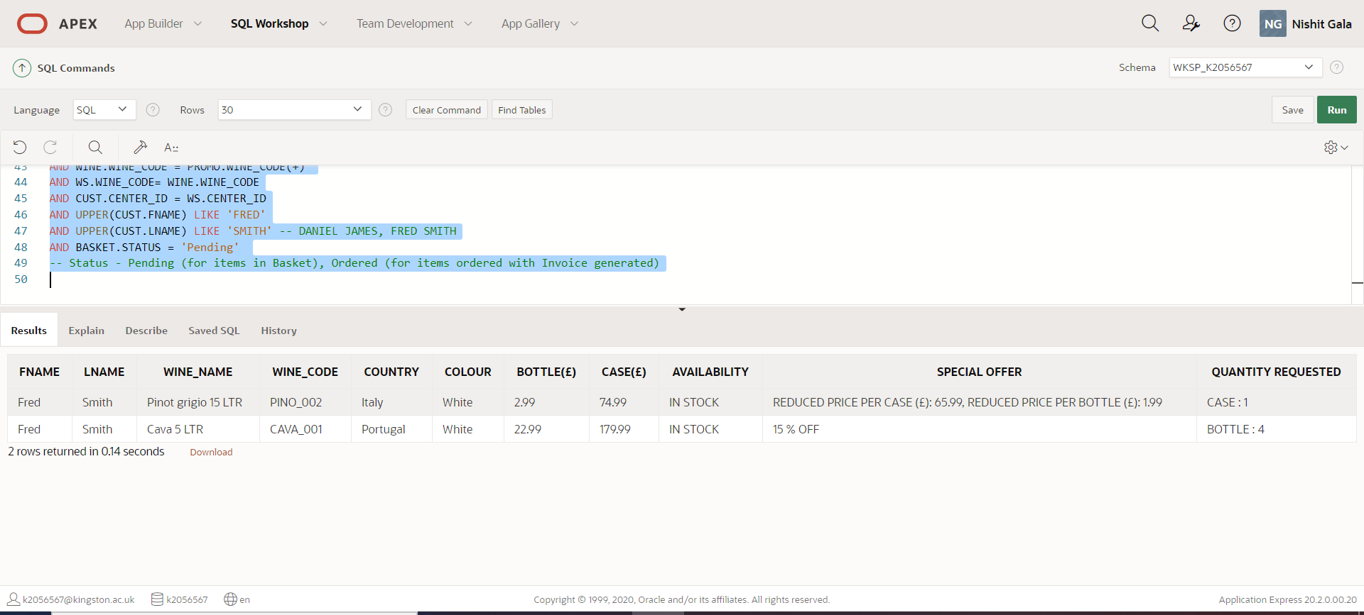

In Below example,

Note: Customer Name is not taken in where clause, so it will return all the customers which have items with Status = Pending in WS_SHOPPING_BASKET

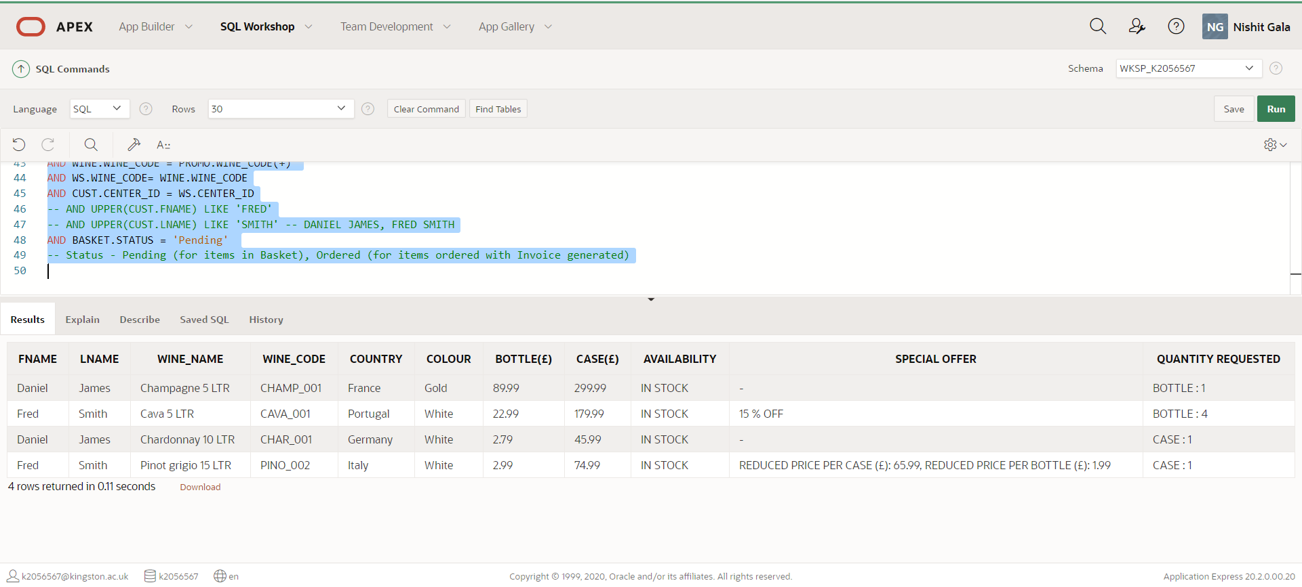

1. **Invoice Data post the Purchase is made**

**Part A – Displaying the purchased items with selling price, discount, total price for a customer on basis of either customer name or order no**

SELECT   INV.INVOICE_NO, INV.INVOICE_DATE, CUST.FNAME ,CUST.LNAME ,

WDET.WINE_NAME || '  ' ||  WINE.CASE_SIZE_IN_LTR  || ' LTR' AS "WINE_NAME",

BASKET.DELIVERY_DATE,

BASKET.SELECTION_TYPE || ' : ' || BASKET.QUANTITY AS "QUANTITY_REQUESTED" ,

CASE WHEN BASKET.SELECTION_TYPE = 'BOTTLE' THEN WINE.PRICE_PER_BOTTLE

     WHEN BASKET.SELECTION_TYPE = 'CASE' THEN WINE.PRICE_PER_CASE END AS "ITEM_PRICE (£)",

 '(' || BASKET.DISCOUNT_AMOUNT || ')'  AS "DISCOUNT (£)",

BASKET.SELLING_PRICE AS "TOTAL_COST (£)"

FROM WS_SHOPPING_BASKET BASKET, WS_CUSTOMER CUST, WS_WINE WINE, WS_WINE_DETAILS WDET, WS_INVOICE INV

WHERE BASKET.CUST_ID = CUST.CUST_ID

AND BASKET.WINE_CODE = WINE.WINE_CODE

AND WINE.WINE_DTL_ID = WDET.WINE_DTL_ID

AND CUST.CUST_ID = INV.CUST_ID

AND BASKET.STATUS = 'Ordered'  -- Status - Pending (for items in Basket), Ordered (for items ordered with Invoice generated)

AND UPPER(CUST.FNAME) LIKE COALESCE('FRED', '%') AND UPPER(CUST.LNAME) LIKE COALESCE('SMITH', '%')  -- DANIEL JAMES, FRED SMITH

AND INV.INVOICE_NO LIKE COALESCE('', '%') --- INVOICE NO FROM WS_INVOICE TABLE James - 32578, Smith - 34612

Note – Status is Ordered when order invoice is generated

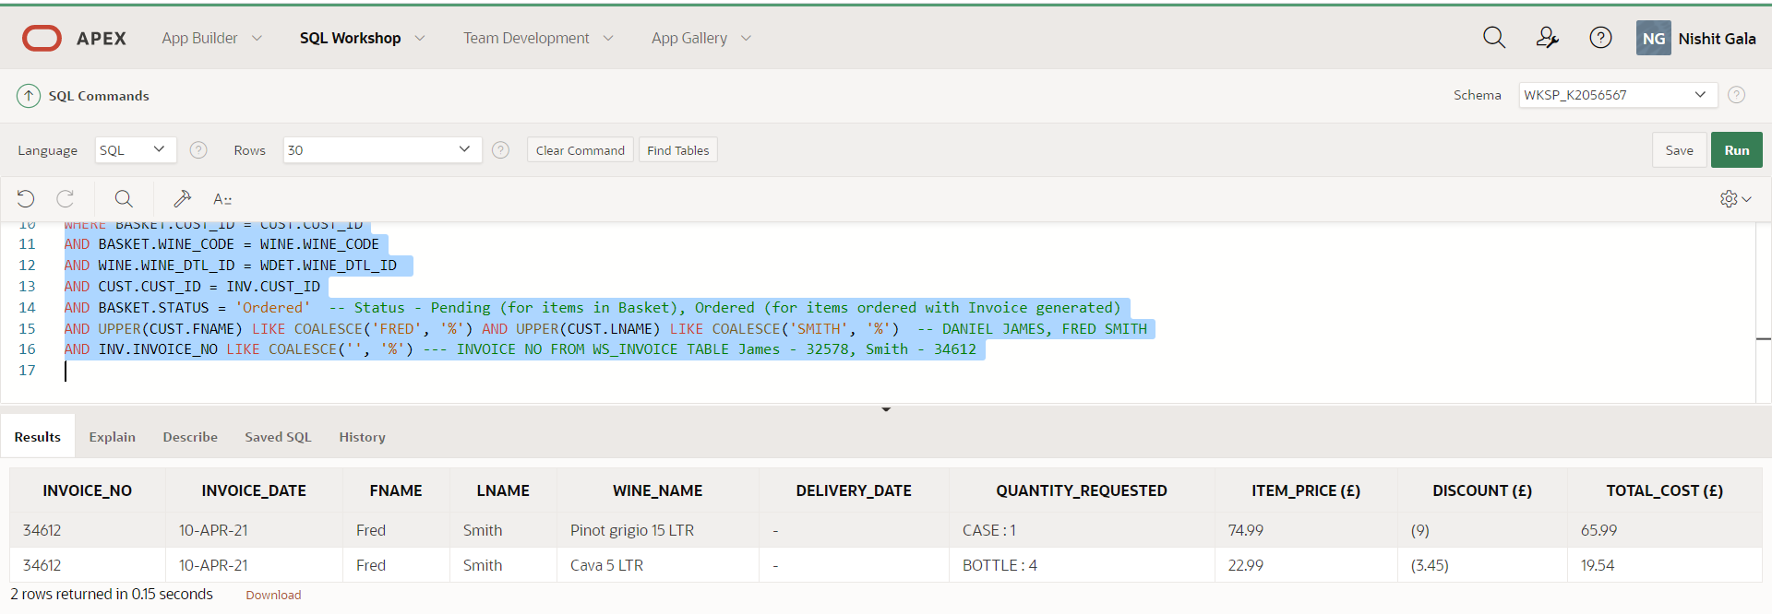

**Part B - Order Total, Delivery Charge will be populated using below query**

SELECT INVOICE_NO, INVOICE_DATE,

ACTUAL_PRICE_TOTAL as "ACTUAL_PRICE_TOTAL(£)",

SELLING_PRICE_TOTAL AS "SELLING_TOTAL(£)",

 '(' || SAVINGS_TOTAL  || ')' AS "SAVINGS_TOTAL(£)",

DELIVERY_CHARGE AS "DELIVERY_CHARGE(£)",

SELLING_PRICE_TOTAL + DELIVERY_CHARGE AS "ORDER_TOTAL(£)" FROM (

SELECT ORD.INVOICE_NO, ORD.INVOICE_DATE,ORD.ACTUAL_PRICE_TOTAL, ORD.SELLING_PRICE_TOTAL , ORD.SAVINGS_TOTAL,

( SELECT DELIVERY_CHARGE FROM WS_CALCULATE_DELIVERY_CHARGE

WHERE ORD.SELLING_PRICE_TOTAL BETWEEN FRM_AMOUNT AND TO_AMOUNT) AS DELIVERY_CHARGE

FROM

(SELECT INV.INVOICE_NO , INV.INVOICE_DATE,

SUM(BASKET.ACTUAL_PRICE) AS ACTUAL_PRICE_TOTAL,

SUM (BASKET.SELLING_PRICE) AS SELLING_PRICE_TOTAL,

SUM(BASKET.DISCOUNT_AMOUNT) as SAVINGS_TOTAL

FROM WS_SHOPPING_BASKET BASKET, WS_CUSTOMER CUST, WS_WINE WINE, WS_WINE_DETAILS WDET,

WS_INVOICE INV

WHERE BASKET.CUST_ID = CUST.CUST_ID

AND BASKET.WINE_CODE = WINE.WINE_CODE

AND WINE.WINE_DTL_ID = WDET.WINE_DTL_ID

AND CUST.CUST_ID = INV.CUST_ID

AND BASKET.STATUS = 'Ordered'  -- Status - Pending (for items in Basket), Ordered (for items ordered with Invoice generated)

-- and cust.fname like COALESCE('Daniel', '%') and cust.lname like COALESCE('James', '%')  -- Daniel James, Fred Smith

AND INV.INVOICE_NO LIKE COALESCE('34612', '%') --- INVOICE NO FROM WS_INVOICE TABLE

GROUP BY INV.INVOICE_NO, INV.INVOICE_DATE

)ORD

)

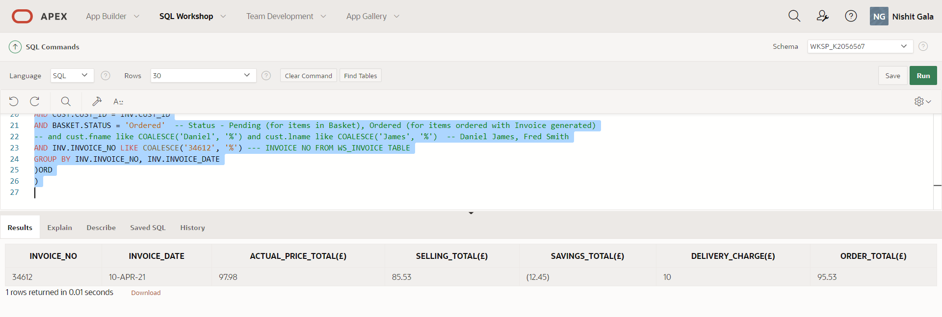

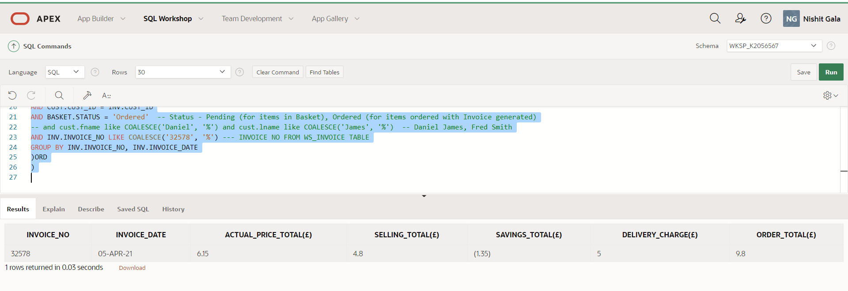

1. **Distribution Center placing Order**

**Part A – Special Order**

SELECT  ORD.ORDER_ID, 'SPECIAL_ORDER' AS "ORDER_TYPE" ,

ORD.ORDER_PLACED_DATE, ORD.ORDER_REVISED_DATE, WINE.WINE_CODE,

ITEM.DELIVERY_DATE, ITEM.STATUS,

WDET.WINE_DESC,ITEM.QUANTITY,

WL.STREET_ADDRESS || '  '  || WL.CITY || '  ' ||   WL.POSTAL_CODE || '  TEL:  '  || WC.PHONE_NO AS "DISTRIBUTION_CENTER",

WL2.STREET_ADDRESS || '  '  || WL2.CITY || '  ' ||   WL2.POSTAL_CODE || '  TEL:  '  || WH.PHONE_NO AS "DISTRIBUTION_CENTER",

WR.REGION_NAME

FROM WS_ORDER ORD, WS_ORDER_ITEM ITEM, WS_WINE WINE, WS_WINE_DETAILS WDET,

WS_CENTER WC, WS_LOCATION WL, WS_WAREHOUSE WH, WS_LOCATION WL2, WS_REGION WR

WHERE ORD.ORDER_ID = ITEM.ORDER_ID

AND WINE.WINE_CODE = ITEM.WINE_CODE

AND WDET.WINE_DTL_ID = WINE.WINE_DTL_ID

AND WC.CENTER_ID = ORD.CENTER_NO

AND WL.LOCATION_ID = WC.LOCATION_ID

AND WC.WAREHOUSE_ID = WH.WAREHOUSE_ID

AND WL2.LOCATION_ID = WH.LOCATION_ID

AND WR.REGION_ID = WH.REGION_ID

AND ORD.ORDER_TYPE ='SP'  -- ST FOR STANDARD ORDER, SP FOR SPECIAL ORDER

AND ORD.ORDER_ID LIKE COALESCE('20790','%')

AND ORD.CENTER_NO LIKE COALESCE('','%') -- # 1,2,3

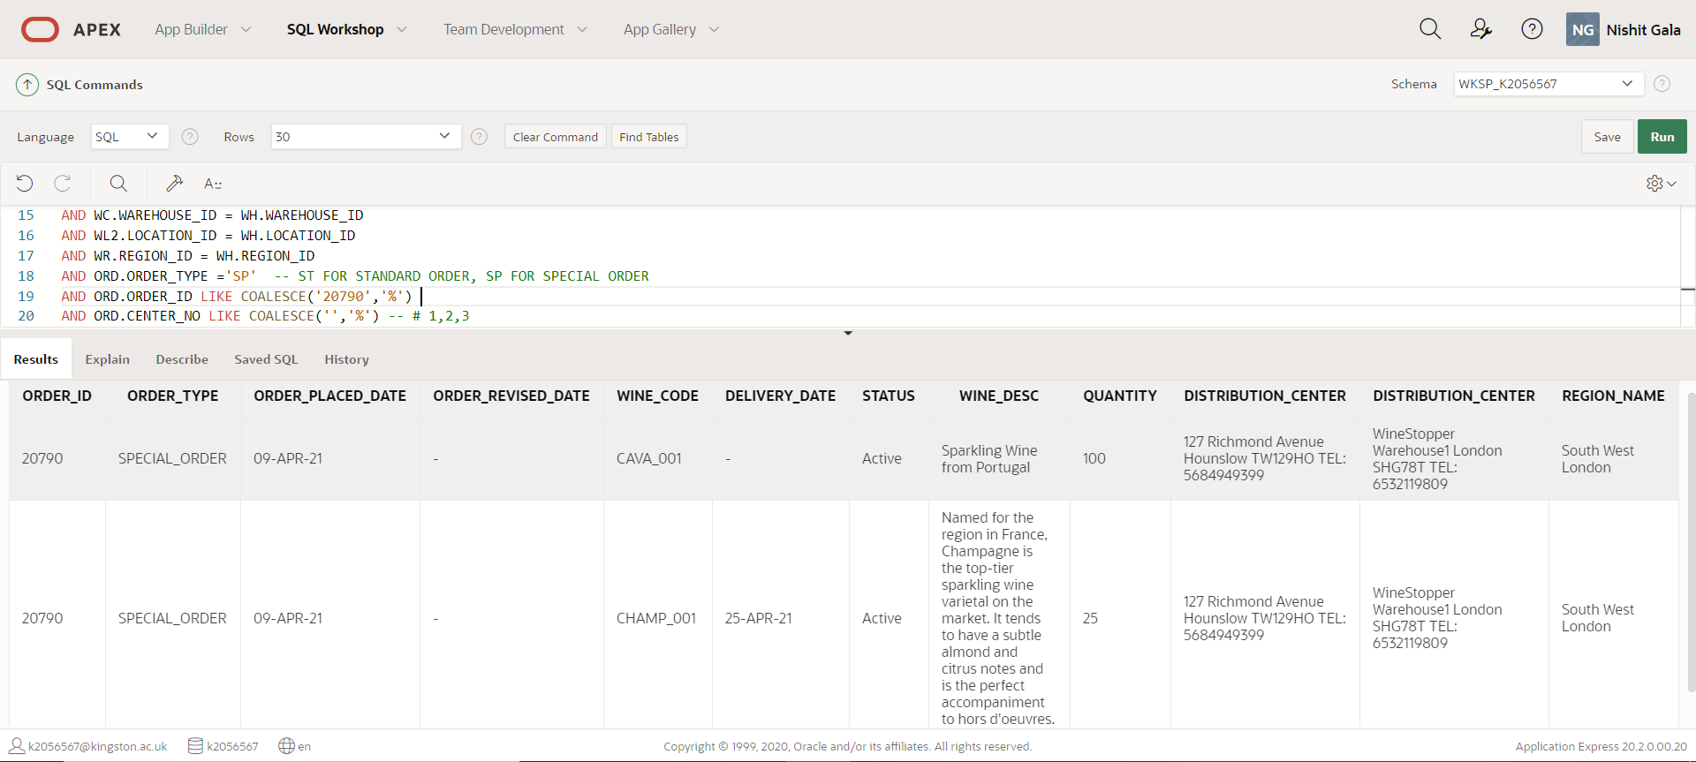

**Part B – Standard Order**

SELECT  ORD.ORDER_ID, 'STANDARD_ORDER' AS "ORDER_TYPE" ,

ORD.ORDER_PLACED_DATE, ORD.ORDER_REVISED_DATE, WINE.WINE_CODE,

ITEM.DELIVERY_DAY, ITEM.DELIVERY_FREQUENCY, ITEM.STATUS,

WDET.WINE_DESC,ITEM.QUANTITY,

WL.STREET_ADDRESS || '  '  || WL.CITY || '  ' ||   WL.POSTAL_CODE || '  TEL:  '  || WC.PHONE_NO AS "DISTRIBUTION_CENTER",

WL2.STREET_ADDRESS || '  '  || WL2.CITY || '  ' ||   WL2.POSTAL_CODE || '  TEL:  '  || WH.PHONE_NO AS "DISTRIBUTION_CENTER",

WR.REGION_NAME

FROM WS_ORDER ORD, WS_ORDER_ITEM ITEM, WS_WINE WINE, WS_WINE_DETAILS WDET,

WS_CENTER WC, WS_LOCATION WL, WS_WAREHOUSE WH, WS_LOCATION WL2, WS_REGION WR

WHERE ORD.ORDER_ID = ITEM.ORDER_ID

AND WINE.WINE_CODE = ITEM.WINE_CODE

AND WDET.WINE_DTL_ID = WINE.WINE_DTL_ID

AND WC.CENTER_ID = ORD.CENTER_NO

AND WL.LOCATION_ID = WC.LOCATION_ID

AND WC.WAREHOUSE_ID = WH.WAREHOUSE_ID

AND WL2.LOCATION_ID = WH.LOCATION_ID

AND WR.REGION_ID = WH.REGION_ID

AND ORD.ORDER_TYPE ='ST'  -- ST FOR STANDARD ORDER, SP FOR SPECIAL ORDER

AND ORD.ORDER_ID LIKE COALESCE('','%') -- 20789

AND ORD.CENTER_NO LIKE COALESCE('1','%')  -- # 1,2,3

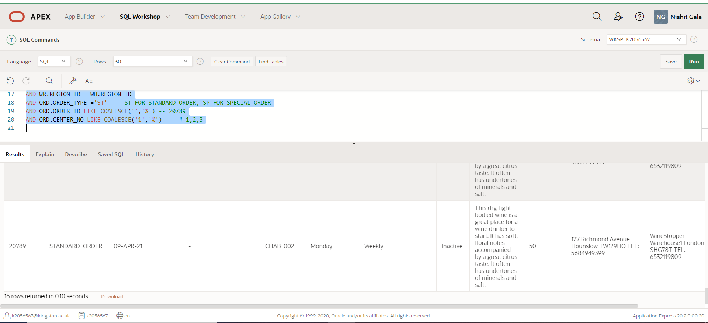

The Output is shown below in the tabular format as exported from Oracle Apex

|  |  |  |  |  |  |  |  |  |  |  |  |  |
| --- | --- | --- | --- | --- | --- | --- | --- | --- | --- | --- | --- | --- |
| ORDER_ID | ORDER_TYPE | ORDER_PLACED_DATE | ORDER_REVISED_DATE | WINE_CODE | DELIVERY_DAY | DELIVERY_FREQUENCY | STATUS | WINE_DESC | QUANTITY | DISTRIBUTION_CENTER | DISTRIBUTION_CENTER | REGION_NAME |
| 20789 | STANDARD_ORDER | 9-Apr-21 |  | MER_001 | Friday | Monthly | Inactive | merlot is a softer and more accessible red wine. It typically tastes like rich, ripe fruit and can have subtle earthy undertones | 125 | 127 Richmond Avenue Hounslow TW129HO Tel: 5684949399 | Wine-Stopper Warehouse1 London SHG78T Tel: 6532119809 | South West London |
| 20789 | STANDARD_ORDER | 9-Apr-21 |  | MER_004 | Friday | Fortnightly | Active | merlot is a softer and more accessible red wine. It typically tastes like rich, ripe fruit and can have subtle earthy undertones | 100 | 127 Richmond Avenue Hounslow TW129HO Tel: 5684949399 | Wine-Stopper Warehouse1 London SHG78T Tel: 6532119809 | South West London |
| 20789 | STANDARD_ORDER | 9-Apr-21 |  | ZIN_001 | Monday | Monthly | Active | Grown in many California vineyards, red zinfandels have a strong impact on the taste buds. They usually taste like a bold fruit jam with undertones of spices and a smoky finish | 100 | 127 Richmond Avenue Hounslow TW129HO Tel: 5684949399 | Wine-Stopper Warehouse1 London SHG78T Tel: 6532119809 | South West London |
| 20789 | STANDARD_ORDER | 9-Apr-21 |  | ZIN_002 | Monday | Weekly | Inactive | Grown in many California vineyards, red zinfandels have a strong impact on the taste buds. They usually taste like a bold fruit jam with undertones of spices and a smoky finish | 50 | 127 Richmond Avenue Hounslow TW129HO Tel: 5684949399 | Wine-Stopper Warehouse1 London SHG78T Tel: 6532119809 | South West London |
| 20789 | STANDARD_ORDER | 9-Apr-21 |  | CHAR_001 | Friday | Monthly | Active | he more flavorful cousin to Chablis, chardonnay is a medium-to-full-bodied wine. It has strong fruity notes ranging from apple to papaya with hints of oak and vanilla. | 50 | 127 Richmond Avenue Hounslow TW129HO Tel: 5684949399 | Wine-Stopper Warehouse1 London SHG78T Tel: 6532119809 | South West London |
| 20789 | STANDARD_ORDER | 9-Apr-21 |  | PINO_001 | Friday | Monthly | Active | A relative of pinot noir, grigio is a very light and refreshing white wine. It has a citrus taste with salty undertones and a honey-like aroma. | 20 | 127 Richmond Avenue Hounslow TW129HO Tel: 5684949399 | Wine-Stopper Warehouse1 London SHG78T Tel: 6532119809 | South West London |
| 20789 | STANDARD_ORDER | 9-Apr-21 |  | PINO_002 | Friday | Quarterly | Active | A relative of pinot noir, grigio is a very light and refreshing white wine. It has a citrus taste with salty undertones and a honey-like aroma. | 100 | 127 Richmond Avenue Hounslow TW129HO Tel: 5684949399 | Wine-Stopper Warehouse1 London SHG78T Tel: 6532119809 | South West London |
| 20789 | STANDARD_ORDER | 9-Apr-21 |  | MOS_001 | Friday | Monthly | Active | No Description Available | 40 | 127 Richmond Avenue Hounslow TW129HO Tel: 5684949399 | Wine-Stopper Warehouse1 London SHG78T Tel: 6532119809 | South West London |
| 20789 | STANDARD_ORDER | 9-Apr-21 |  | MOS_002 | Monday | Weekly | Active | No Description Available | 25 | 127 Richmond Avenue Hounslow TW129HO Tel: 5684949399 | Wine-Stopper Warehouse1 London SHG78T Tel: 6532119809 | South West London |
| 20789 | STANDARD_ORDER | 9-Apr-21 |  | CHAMP_001 | Monday | Fortnightly | Active | Named for the region in France, Champagne is the top-tier sparkling wine varietal on the market. It tends to have a subtle almond and citrus notes and is the perfect accompaniment to hors d'oeuvres. | 25 | 127 Richmond Avenue Hounslow TW129HO Tel: 5684949399 | Wine-Stopper Warehouse1 London SHG78T Tel: 6532119809 | South West London |
| 20789 | STANDARD_ORDER | 9-Apr-21 |  | PROS_001 | Monday | Weekly | Active | Often considered the second-best sparkling wine,Instead of one region, Prosecco can come from any of nine regions in Italy so it is viewed as less prestigious | 50 | 127 Richmond Avenue Hounslow TW129HO Tel: 5684949399 | Wine-Stopper Warehouse1 London SHG78T Tel: 6532119809 | South West London |
| 20789 | STANDARD_ORDER | 9-Apr-21 |  | SHI_001 | Friday | Quarterly | Active | Dessert Wine (Red) from Greece | 100 | 127 Richmond Avenue Hounslow TW129HO Tel: 5684949399 | Wine-Stopper Warehouse1 London SHG78T Tel: 6532119809 | South West London |
| 20789 | STANDARD_ORDER | 9-Apr-21 |  | SAU_001 | Friday | Monthly | Active | Dessert Wine (White) from Italy | 75 | 127 Richmond Avenue Hounslow TW129HO Tel: 5684949399 | Wine-Stopper Warehouse1 London SHG78T Tel: 6532119809 | South West London |
| 20789 | STANDARD_ORDER | 9-Apr-21 |  | CAVA_001 | Monday | Weekly | Active | Sparkling Wine from Portugal | 100 | 127 Richmond Avenue Hounslow TW129HO Tel: 5684949399 | Wine-Stopper Warehouse1 London SHG78T Tel: 6532119809 | South West London |
| 20789 | STANDARD_ORDER | 9-Apr-21 |  | CHAB_001 | Monday | Weekly | Inactive | This dry, light-bodied wine is a great place for a wine drinker to start. It has soft, floral notes accompanied by a great citrus taste. It often has undertones of minerals and salt. | 25 | 127 Richmond Avenue Hounslow TW129HO Tel: 5684949399 | Wine-Stopper Warehouse1 London SHG78T Tel: 6532119809 | South West London |
| 20789 | STANDARD_ORDER | 9-Apr-21 |  | CHAB_002 | Monday | Weekly | Inactive | This dry, light-bodied wine is a great place for a wine drinker to start. It has soft, floral notes accompanied by a great citrus taste. It often has undertones of minerals and salt. | 50 | 127 Richmond Avenue Hounslow TW129HO Tel: 5684949399 | Wine-Stopper Warehouse1 London SHG78T Tel: 6532119809 | South West London |

1. **Update Query to update the Shopping List post 60-day period**

Note – This update query needs to run via a CRON JOB on daily basis to clear the Shopping list and set the status as “Expired”

UPDATE WS_SHOPPING_LIST SET STATUS = 'Expired' WHERE TRUNC(EXPIRY_DATE) <= TRUNC(SYSDATE) AND STATUS = 'WishList'

# Chapter 5 – Conclusion

The Wine-Stopper Website has some complex day-to-day operations, and the system is designed to keep in mind that critical points of this application are accurately designed and demonstrated

For this we have considered below assumptions:

1. The promotions considered are at the organization level and if the entry is made in WS_PROMOTION table, it will be applied to all distribution centers
2. Employee should be mapped to a respective center upon registration by considering the address supplied in the registration process
3. The NEXT_DELIVERY in WS_STOCK_INFO table will only be populated by the Warehouse for Special Orders; this field is going to be null for Standing orders.
4. In case, if the quantity of Stock =0, the above point will lead us to show the Available in X days (X = NEXT_DELIVERY – SYSDATE) only for the Special Orders and it will be shown as Unavailable for Standing Orders
5. In the WS_SHOPPING_BASKET table, the record will be inserted with status as “PENDING” when they are added to basket and the default DISCOUNT will be 0.
6. When the customer makes a purchase, Invoice is generated and will be stored in the INVOICE_NO column of WS_SHOPPING_BASKET table, this will also change the status as “ORDERED” and if there are any applicable discount as per WS_PROMOTION table for respective WINE_CODE, then they will be applied
7. The TOTAL_AMOUNT column in the WS_INVOICE table will be sum of SELLING_PRICE from WS_INVOICE_ITEM for all the items ordered
8. The SAVINGS column in the WS_INVOICE table will be sum of DISCOUNT_AMOUNT from WS_INVOICE_ITEM for all the items ordered
9. The DELIVERY_CHARGE in WS_INVOICE table will be updated based on rules configured in CALCULATE_DELIVERY_CHARGE
10. The payment process is not designed as an Entity and the payment will be reflected upon the Status change in WS_SHOPPING_BASKET table once status is changed to “Ordered” and INVOICE_NO generated

The implementation at high level is described as below:

1. The WS_WINE_DETAILS table captures the Name, Colour, Country, Category, Sweetness Indicator of the wine, whilst the WS_WINE table captures the unique wine code and to cover the possibility of the same wine held in multiple sizes.
2. WS_WINE table will store the multiple variants in terms of size of case, bottle with a unique Wine Code. Hence this table is related to WS_WINE_DETAILS and one Wine record in Wine Details can have multiple Wine codes in the Wine table
3. The customer details are captured in the WS_CUSTOMER table when they register. This table is linked to the Shopping List (WS_SHOPPING_LIST) and Shopping basket (WS_SHOPPING_BASKET) along with the Invoice entity (WS_INVOICE) as shown in the ER Diagram in below section
4. The Shopping List (Wishlist) is captured in the WS_SHOPPING_LIST table and there is an expiry date to this table that is defaulted to 60 days from the SYSDATE. It also has a Status column to capture the status as Wishlist, Expired and User Deleted.
5. The Status column of WS_SHOPPING_LIST should be updated to “Expired” by a CRON JOB that will run an update statement on daily basis to clear out the Wishlist items that are reaching a 60-day limit.
6. The Shopping Basket (WS_SHOPPING_BASKET) is also linked to the Invoice (WS_INVOICE) table and is having multiple status that controls the flow of the order placed by the customer. This table also records the invoice number for an order placed by the customer.
7. The promotion table (WS_PROMOTION) is linked to the Wine table and records the wine that are on discounted price. We have taken into consideration the 3 forms of discount as specified below
8. Price Discount (e.g. - 10 % OFF)
9. Quantity Discount (e.g. – Buy 3 Get 4)
10. Reduced Price (Original Price – 3.99$ per bottle, 39.99$ per Case

Reduced Price - Buy at $2.99 per bottle, at 29.99 per case)

1. The information of Wine distribution centers is captured by WS_CENTER table whilst, the information about the Warehouses is captured in WS_WAREHOUSE table. The center table is linked to the Warehouse table through the Warehouse ID.
2. The WS_REGION table will supply the region ID to the WS_WAREHOUSE table and the Country code to region table will come from WS_COUNTRY table as defined.
3. The stock information of a distribution center is captured in the WS_STOCK_INFO table through the Center ID. The Stock Information table maintains the relationship with the Wine table using Wine Code. These relationships will ensure that each and every Distribution center is stocked as per the Wines configured in the Wine table.
4. The distribution center can place the orders of wine through Standard order also referred to as Standing Order and a special order to request goods that are in demand during a specific time of the year. The Ordering by a distribution center is captured in the WS_ORDER table
5. The WS_ORDER table captures both Standing and Specialized orders using a column called as Order type. This Order type column will have a constraint of having fixed values for Standing and Special Order.

The overall conclusion of this exercise is achieved through the list of assumptions provided above , however there is a coding required to set / update certain parameters in the table to correctly reflect the working on the functional flowof the Wine-Stopper day-to-day operations.

The Delivery date field in the stock table is one of the confusion area in this exercise as the statement provided for this field only covers for the special orders as warehouse will update this field, However for the standing orders this field is currently not being updated as this update needs to happen at the regular intervals (monthly, forthnightly, weekly etc). Hence the table needs to be monitored using a CRON Job or a Batch scheduler to achieve this functionality available. This has not been covered in the above solutioning.