model = Sequential()

model.add(tf.keras.layers.Dense(units=13,activation ='relu', input_shape = (len(imp_features),) ))

#model.add(tf.keras.layers.Dropout(0.25))

model.add(tf.keras.layers.Dense(units=15,activation ='relu'))

model.add(tf.keras.layers.Dropout(0.2))

model.add(tf.keras.layers.Dense(units=9,activation ='relu'))

model.add(tf.keras.layers.Dropout(0.2))

model.add(tf.keras.layers.Dense(units=5,activation='softmax'))

model.compile(optimizer = Adam(), loss = 'categorical_crossentropy',

              metrics = ['accuracy'])

class_wt = {0: 2.953333333333333,

            1: 0.899492385786802,

            2: 0.55375,

            3: 0.7875555555555556,

            4: 2.1095238095238096}

history = model.fit(X_train_scaled,y_train_cat,validation_split=0.25,

                    epochs=200, verbose=1,batch_size=20,class_weight=class_wt)

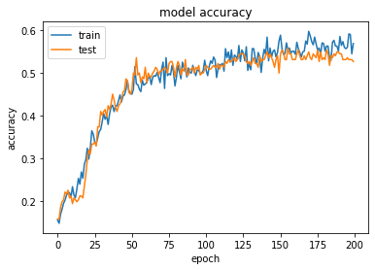

Testing

Accuracy Score for Sequential 0.5371621621621622

F1 Score for Sequential 0.532646185542527

Generalization

Accuracy Score for Sequential 0.5578703703703703

F1 Score for Sequential 0.5476033607306009

