# HTML and CSS

To get started with HTML and CSS, please see following videos.

1. <https://www.youtube.com/watch?v=OZeoiotzPFg>
2. <https://www.youtube.com/watch?v=yyqvXhu-HOc>

## HTML Task

1. What is HTML? Give basic structure of the HTML page.

* HTML stands for Hyper Text Markup Language. HTML is the standard markup language for creating Web pages. HTML describes the structure of a Web page. HTML consists of a series of elements. HTML elements tell the browser how to display the content. HTML elements label pieces of content such as "this is a heading", "this is a paragraph", "this is a link", etc.

An HTML Document is mainly divided into two parts:

HEAD: This contains the information about the HTML document. For Example, the Title of the page, version of HTML, Meta Data, etc.

BODY: This contains everything you want to display on the Web Page.

1. Difference between inline and block level element.

By default, inline elements do not force a new line to begin in the document flow. Block elements, on the other hand, typically cause a line break to occur (although, as usual, this can be changed using CSS).

1. Create an HTML page “index.htm” with following content

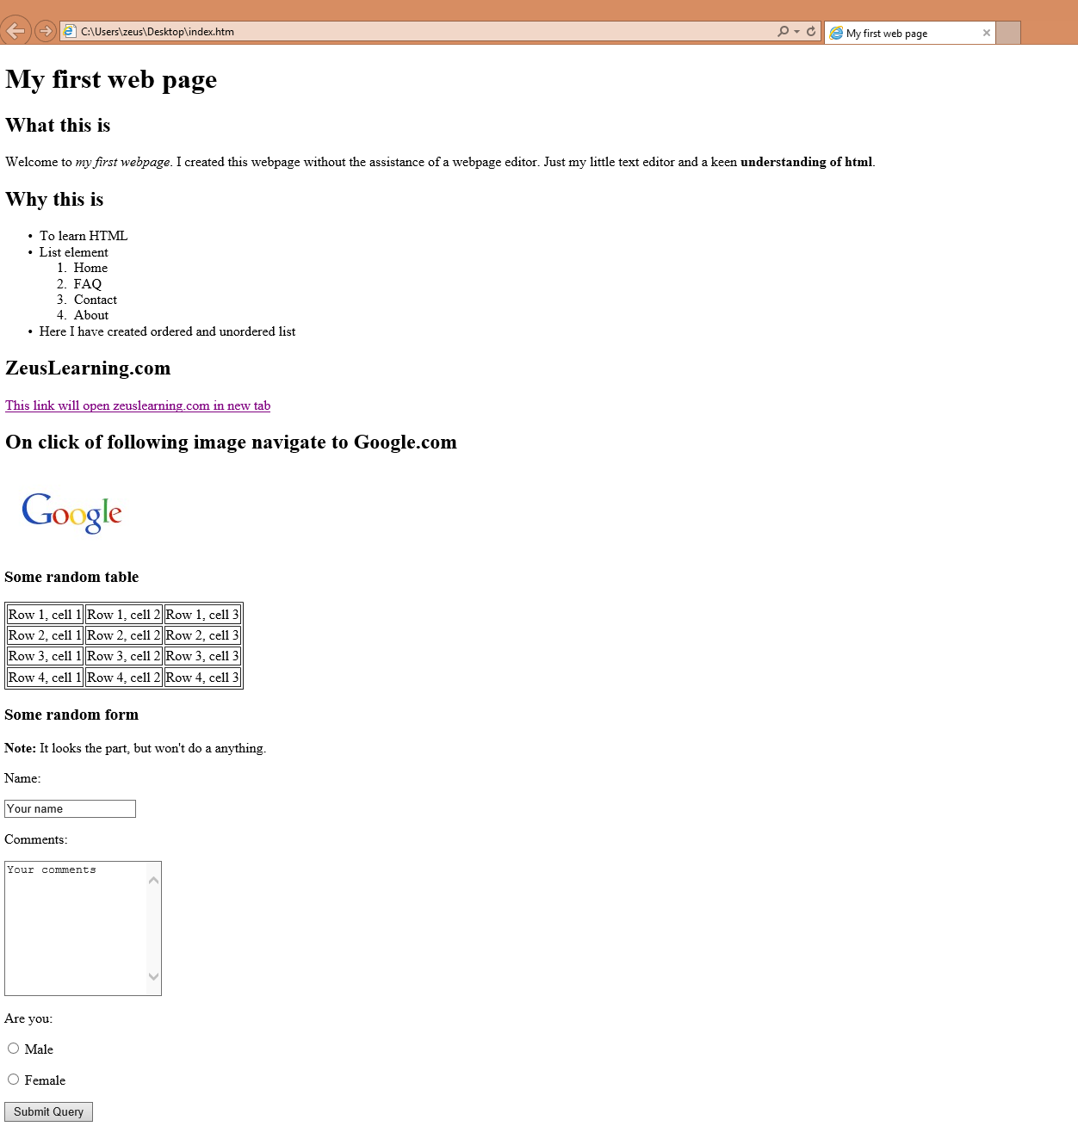

## CSS Task

1. Explain the different ways in which CSS can be applied to HTML, what is the preferred way and why.

🡪 CSS can be added to HTML documents in 3 ways:

Inline - by using the style attribute inside HTML elements

Internal - by using a <style> element in the <head> section

External - by using a <link> element to link to an external CSS file

The most common way to add CSS, is to keep the styles in external CSS files.

It is preferred way because modification at one place will reflect its effect everywhere.

1. What are different CSS selectors, with example explain Element, Class and Id selectors.

🡪 CSS selectors are used to "find" (or select) the HTML elements you want to style.

We can divide CSS selectors into five categories:

-Simple selectors (select elements based on name, id, class)

-Combinator selectors (select elements based on a specific relationship between them)

-Pseudo-class selectors (select elements based on a certain state)

-Pseudo-elements selectors (select and style a part of an element)

-Attribute selectors (select elements based on an attribute or attribute value).

The element selector selects HTML elements based on the element name.

p {

text-align: center;

color: red;

}

The id selector uses the id attribute of an HTML element to select a specific element.

#para1 {

text-align: center;

color: red;

}

The class selector selects HTML elements with a specific class attribute.

.center {

text-align: center;

color: red;

}

1. With the help of a diagram explain CSS Box Model.

In CSS, the term "box model" is used when talking about design and layout.

The CSS box model is essentially a box that wraps around every HTML element. It consists of: margins, borders, padding, and the actual content. The image below illustrates the box model:

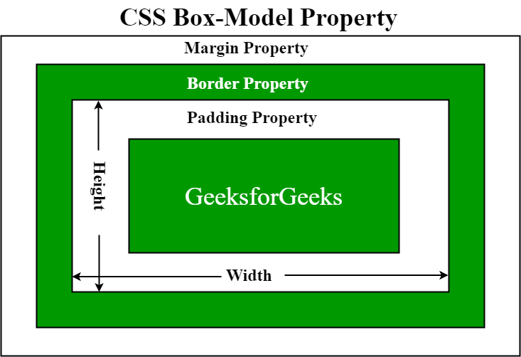

Explanation of the different parts:

Content - The content of the box, where text and images appear

Padding - Clears an area around the content. The padding is transparent

Border - A border that goes around the padding and content

Margin - Clears an area outside the border. The margin is transparent

1. To HTML page create in the task 1.a, apply following CSS

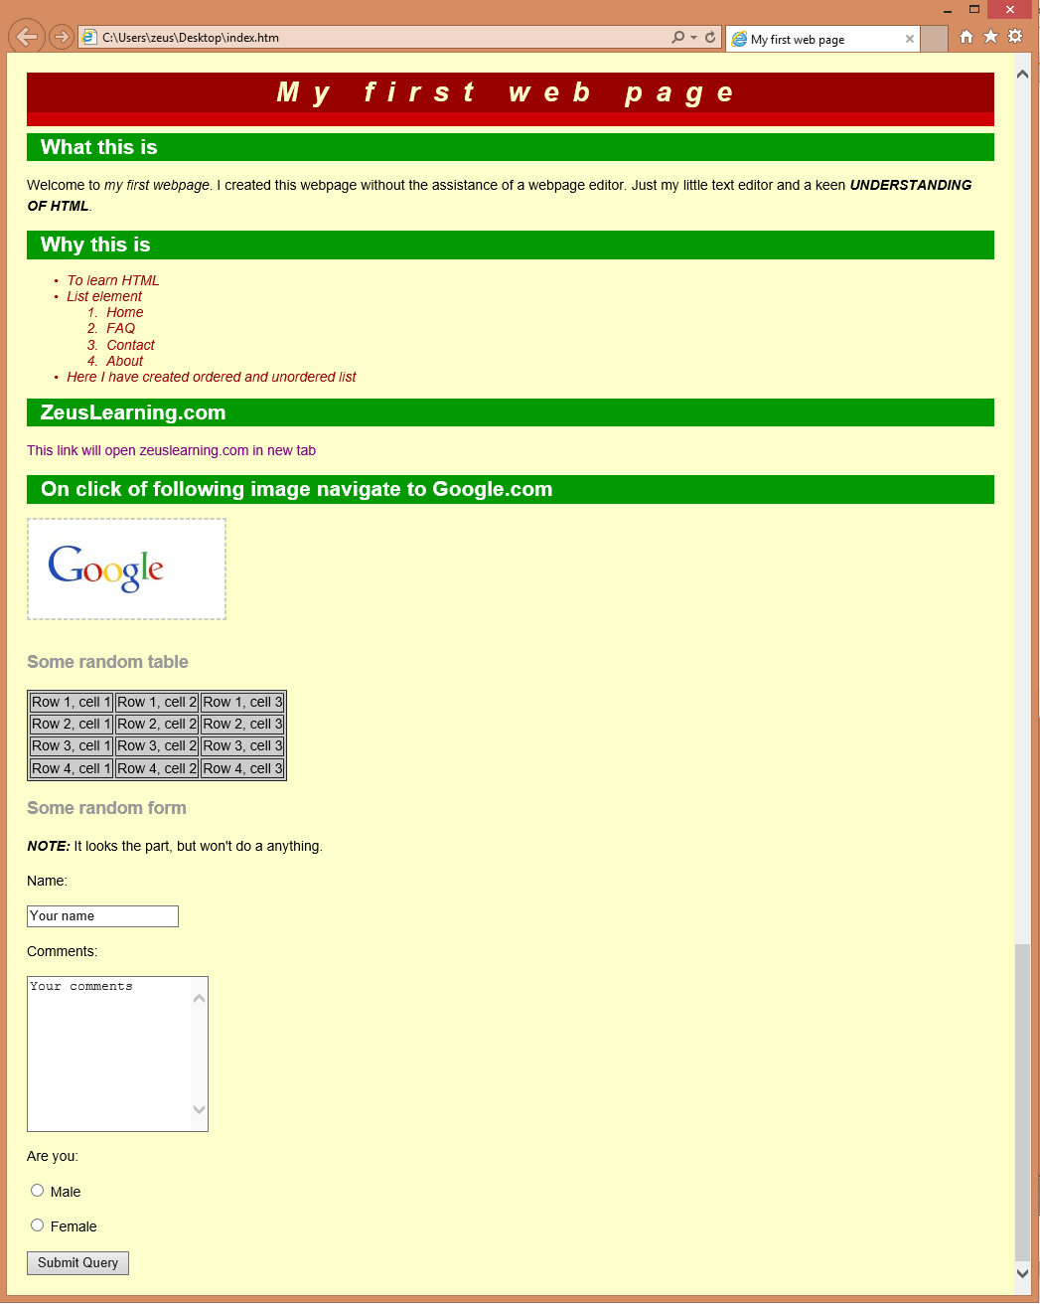

# JavaScript

1. List down ways in which JavaScript command can be added to a webpage, what is the preferred way.
2. To the webpage created in the task 2.d , on click of “Submit” button call JavaScript function to validate:
   1. Name and comments fields are not empty.
   2. User has selected one entry from male/female radio button
   3. In case user has not entered data for name and comment field or not selected anything from male/female radio button – show alert message “All fields are compulsory” and set focus to the first filed that is empty.