**Phase 3 -Instruction**

1. Create a folder for Ethereum private network

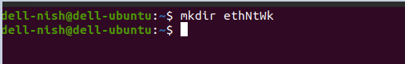

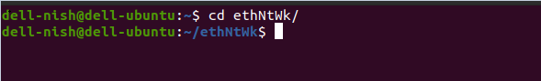

2. generate genesis file called init.json into text editor

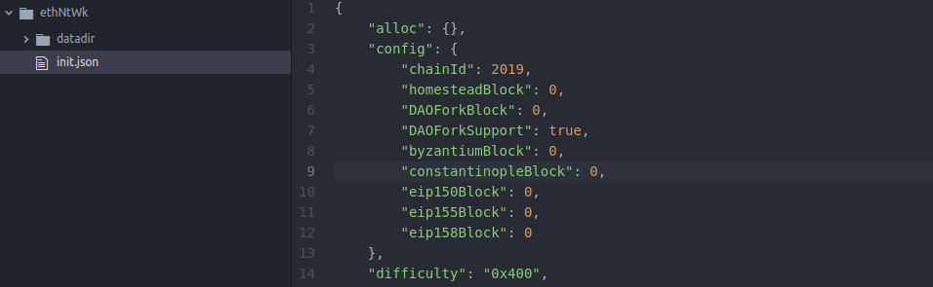

3. open command line type command - $geth - -datadir ./datadir init ./init.json

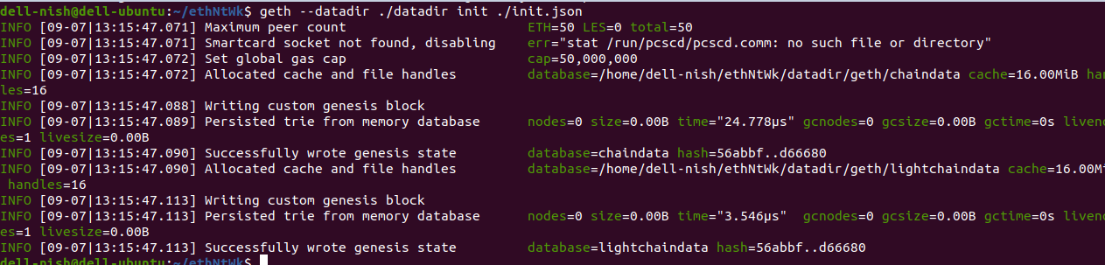

4. type command - $geth –datadir ./datadir/ --networkid 2019 console

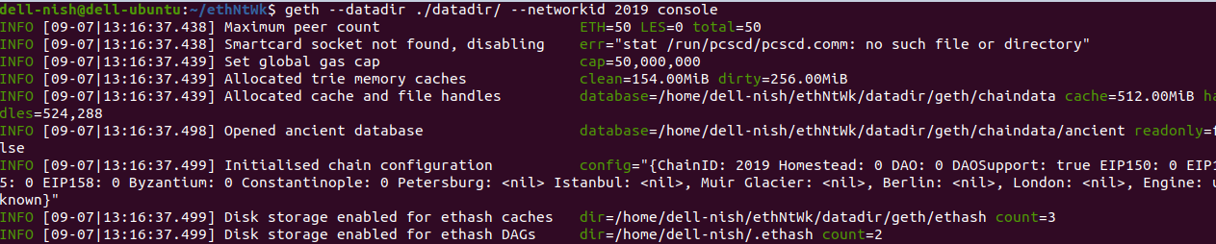

**Truffle migration and deployment of contract part:**

1. Go to Ethereum private network terminal and type below command

geth --datadir ./datadir --networkid 2019 --rpc --rpcport 30304 --allow-insecure-unlock console



2. unlock personal account and start mining process:



3. go to another terminal and go to KYC-SC folder type command - truffle init

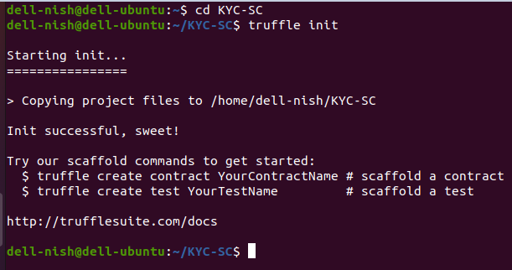

4. in text editor where build folder created with contracts (KYC and Migration json file created)

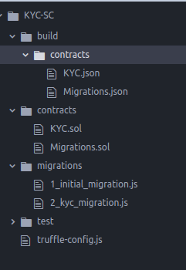

5. under migration folder -2_kyc_migration.js updated

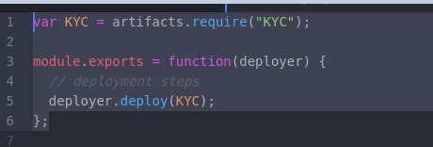

6. truffle-config.js

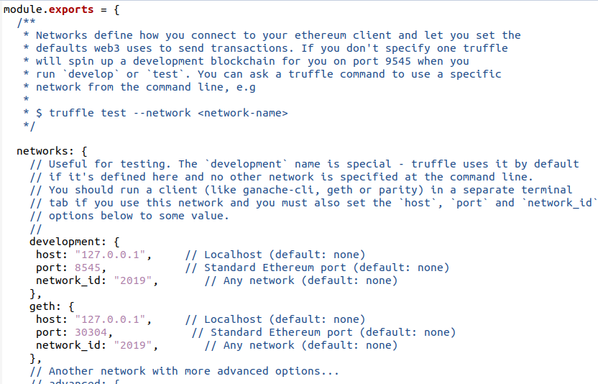

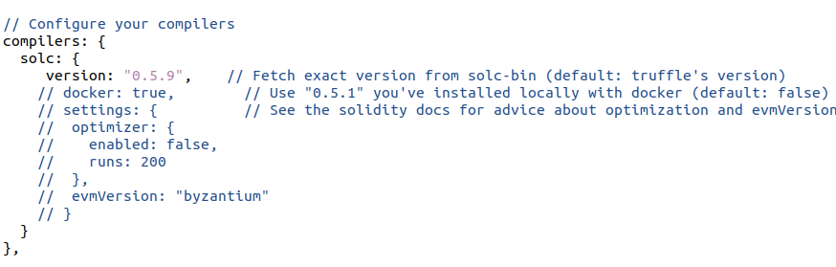

7.. go back to terminal and type -truffle compile

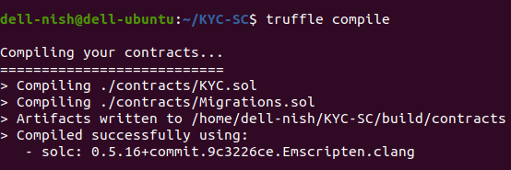

8. upon successfully compiled type command - truffle migrate - -network geth

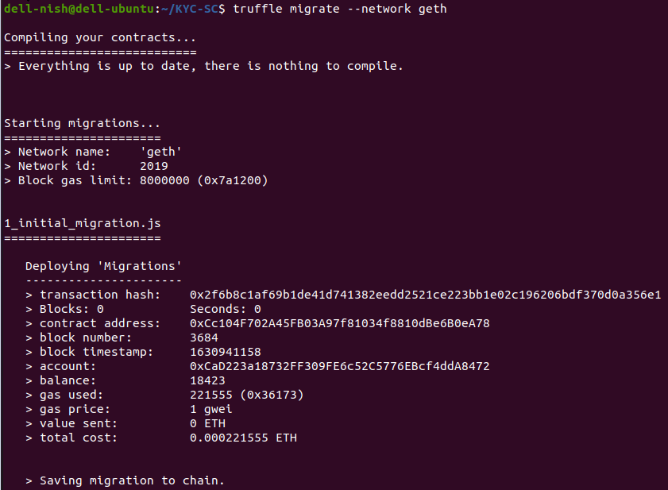

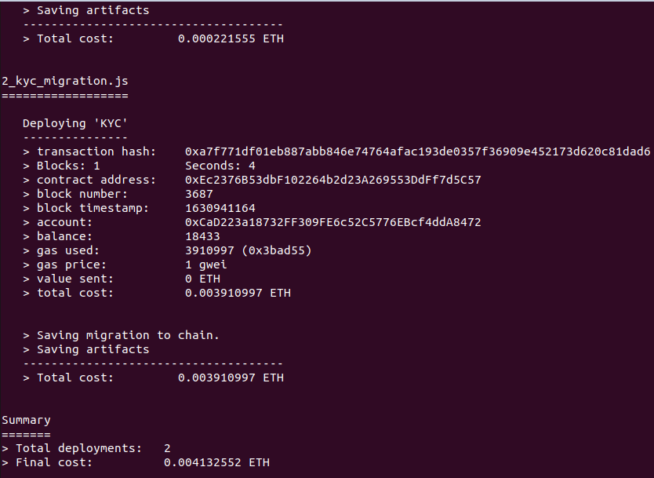

9. deploy contract once migration is done. -truffle console and truffle deployment

