SINGLE PHASE FIVE-LEVEL INVERTER

Description:

Designed a basic **Single phase Multi-level Inverter** (i.e., 5 level) with *cascade H-bridge* using **MOSFETs** as control switches and **Arduino Nano** as Micro Controller.

We were a team of five.

The basic aim of this project is to obtain variable frequency AC output from a constant DC supply where the variable frequency AC output is used to control the speed of AC machines like Induction Motors where the speed of the machine is directly proportional to frequency of the supply i.e., N = (120*f)/p. Where f is the frequency of input ac supply. And this is also useful for other variable frequency AC drives.

We divided this project into 3 sections:

* POWER CIRCUIT
* ISOLATION CIRCUIT
* CONTROL CIRCUIT

**Power Circuit:**

Power Circuit consists of a transformer which converts single phase ac 230V to 12V DC.

And this 12V dc is used to fed the main Control circuit.

**Control Circuit:**

Control Circuit is the heart of this project.

It consists of two units,

1. first unit consists of one H-bridge which has 2 legs and each leg have two switches and a total of four MOSFETs.
2. second unit consists of another H-bridge same as above. Control circuit is the combination of these two units i.e., the output of second unit is connected to first unit which is nothing but cascading the two H-bridges.

this is the circuit we are designed

Circuit Diagram:

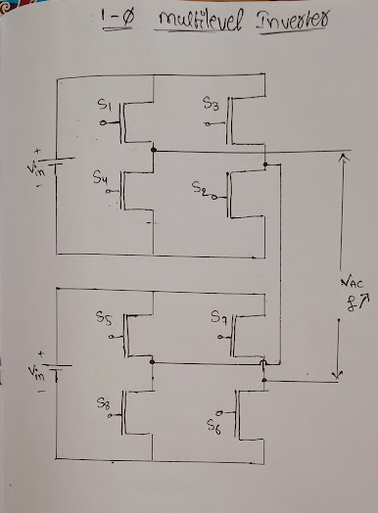

**Isolation Circuit:**

Isolation Circuit is to provide the isolation between Power Circuit and Control Circuit.

For this we are used optocouplers as isolators.

The main purpose of this Isolation circuit is to protect the Power Circuit if there are any faults like short circuits or any other faults in Control Circuit and vice-versa.

we used MCT2E optocoupler in this project.

The connection diagram of Isolation Circuit is:

Isolation Circuit:

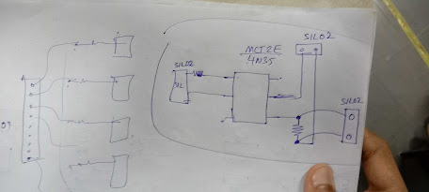

**Working of single unit H-bridge :**

From a single H-bridge unit we can get up to 3 levels such as +Vdc, 0, -Vdc.

the figure shown below is a single-phase single cell H-bridge,

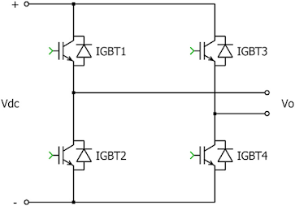

Just like single cell H-bridge inverter two cell H-bridge works on the same principle but it has two singe cell H-bridges and output of one bridge is connected with another bridge to combine outputs of both the bridges.

From a two cell H-bridge we can get up to 5 levels such are +2Vdc, +Vdc, 0, -Vdc, -2Vdc.

So, from a 'n' cell cascaded H-bridge we can get 2n+1 levels.

1. when switches 1 & 2 of first unit and 5 & 6 of the second unit are closed then the respective output voltages of the two units are +Vdc and +Vdc. So, the voltage appears across the V0 is +2Vdc ( (+Vdc) + (+Vdc) ).
2. when switches 3 & 4 of first unit and 7 & 8 of the second unit are closed then the respective output voltages of the two units are -Vdc and -Vdc. So, the voltage appears across the V0 is -2Vdc ( (-Vdc) + (-Vdc) ).
3. when switches 1 & 2 of first unit and 5 & 7 of the second unit are closed the respective outputs of the two units are +Vdc and 0V. So, the voltage appears across the V0 is +Vdc ( (+Vdc) + 0 ).

(or)

when switches 1 & 3 of first unit and 5 & 6 of the second unit are closed the respective outputs of the two units are 0V and +Vdc. So, the voltage appears across the V0 is +Vdc ( 0 + (+Vdc) ).

1. when switches 3 & 4 of first unit and 8 & 6 of the second unit are closed the respective outputs of the two units are -Vdc and 0V. So, the voltage appears across the V0 is -Vdc ( (-Vdc) + 0 ).

(or)

when switches 1 & 3 of first unit and 7 & 8 of the second unit are closed the respective outputs of the two units are 0V and -Vdc. So, the voltage appears across the V0 is -Vdc ( 0 + (-Vdc) ).

1. when switches 1 & 3 of first unit and 5 & 7 of the second unit are closed then the respective output voltages of the two units are 0V and 0V. So, the voltage appears across the V0 is 0V ( 0 + 0 ).

(or)

when switches 2 & 4 of first unit and 6 & 8 of the second unit are closed then the respective output voltages of the two units are 0V and 0V. So, the voltage appears across the V0 is 0V ( 0 + 0 )

This how we need to switch the MOSFETs to get 5levels.

**OUTPUT:**

This is the output we got which is not a smooth AC curve. It consists of harmonics. If you give this signal as the supply for any machine it produces vibrations and humming sound due to the presence of harmonics.

So, we need to make the waveform as smooth as possible in order to make the loads run under the  smooth conditions.

[**Video Link**](https://drive.google.com/file/d/1hQ_Bw8y4M5-HwPGoGcr6v7DhGI_P3E2D/view?usp=sharing)

We are working on smoothing the curve by using PWM and SPWM techniques☺

**Software Used :**

* Proteus PCB Design suite
* Arduino

Control Circuit PCB :

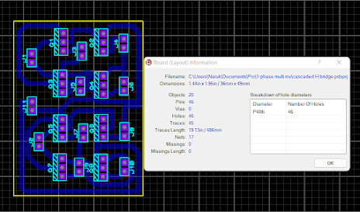

**Isolation circuit PCB :**

