GANPAT UNIVERSITY

U.V. PATEL COLLEGE OF ENGINEERING

Lab File

2CEIT304: Data Structures

B.Tech Semester: III
Computer Engineering/ Information Technology

Academic Year: 2020 (Odd Sem.)

Prepared By:
Patel Nishith Jagdishbhai
19012011050
Department of Computer Science & Engineering
UVPCE Ganpat University

LIST OF EXPERIMENTS

Sr. No | List | Date
5 | Implement Program for Linked List.  - To implement singly linked list with following operations:  - InsertAtFirst( )  - InsertAtLast( )  - InsertAfterspecifiednode( )  - DeleteAtFirst( )  - DeleteAtLast( )  - DeleteAfterspecifiednode( )  - Traverse (Display)  - To implement a doubly linked list with above functions.  - To implement a circular linked list with above functions.

Practical 5

Aim: Implement Program for Linked List :

- To implement singly linked list with following operations:
1. InsertAtFirst( )
2. InsertAtLast( )
3. InsertAfterspecifiednode( )
4. DeleteAtFirst( )
5. DeleteAtLast( )
6. DeleteAfterspecifiednode( )
7. Traverse (Display)

Pseudo code/Algorithm:
1. INSERTBEG (VAL,FIRST) : This function inserts a new element VAL at the beginning of the linked list. FIRST is a pointer which contains address of first node in the list.
1. [Check for availability stack underflow]
If AVAIL = NULL then
Write “Availability stack underflow”
Return
2. [Obtain address of next free node]
NEW←AVAIL
3. [Remove free node from availability stack]
AVAIL←LINK (AVAIL)
4. [Initialize node to the linked list]
INFO (NEW) ←VAL
LINK (NEW) ← First
5. [Assign the address of the Temporary node to the First Node ]
FIRST←NEW
6. [Finished]
Return (FIRST)
2. INSERTEND (VAL,FIRST) : This function inserts a new element VAL at the end of the linked list. FIRST is a pointer which contains address of first node in the list.
1. [Check for availability stack underflow]
If AVAIL = NULL then
Write “Availability stack underflow”
Return
2. [Obtain address of next free node]
NEW←AVAIL
3. [Remove free node from availability stack]
AVAIL←LINK (AVAIL)
4. [initialize field of new node]
INFO (NEW) ←VAL
LINK (NEW) ←NULL
5. [If list is empty?]
If FIRST = NULL then
FIRST←NEW
6. [initialize search for last node]
SAVE←FIRST
7. [Search end of the list]
Repeat while LINK (SAVE) ≠ NULL
SAVE←LINK (SAVE)
8. [Set LINK field of last node to NEW ]
LINK (SAVE) ←NEW
9. [Finished]
Return (FIRST)

3. INSPOS (VAL, FIRST, X) : This function inserts a new element VAL into the linked list before the node value X. FIRST is a pointer which contains address of first node in the list.
1. [Check for availability stack underflow]
If AVAIL = NULL then
Write “Availability stack underflow”
Return
2. [Obtain address of next free node]
NEW←AVAIL
3. [Remove free node from availability stack]
AVAIL←LINK (AVAIL)
4. [initialize field of new node]
INFO (NEW) ←VAL
5. [If list is empty?]
If FIRST = NULL then
LINK (NEW) ←NULL
FIRST←NEW,
Return FIRST
6. [If list contain only one node?]
If LINK(FIRST) = NULL then
LINK (NEW) ← FIRST
FIRST←NEW,
Return FIRST
7. [Search the list until desired address found]
SAVE←FIRST
Repeat while LINK (SAVE) ≠ NULL and INFO(SAVE) ≠ X
PRED←SAVE
SAVE←LINK (SAVE)
8. [Node found?]
If(LINK(SAVE)==NULL) {
LINK(NEW)←NULL,LINK(SAVE)←NEW }
else {
LINK (NEW) ⇓SAVE LINK(PRED)←NEW }
9. [Finished]
Return (FIRST)
4. DELFIRST(FIRST) : This function deletes a first node from the list. FIRST is a pointer which contains address of first node in the list.
1. [Check for empty list]
If FIRST = NULL then
Write “List is empty”
Return
2. [Check for the element in the list and delete it]
If LINK (FIRST) = NULL then
Y←INFO (FIRST)
FIRST←NULL
Else
TEMP←FIRST
Y←INFO (TEMP)
FIRST←LINK (TEMP)
3. [Finished]
Return (FIRST)
5. DELLAST(FIRST) : This function deletes a last node from the list. FIRST is a pointer which contains address of first node in the list.
1. [Check for empty list]
If FIRST = NULL then
Write “List is empty”
Return
2. [Check for the element in the list and delete it]
If LINK (FIRST) = NULL then
Y←INFO (FIRST)
FIRST←NULL
Else (Assign the address pointed by FIRST pointer to TEMP pointer)
TEMP←FIRST
Repeat while LINK (TEMP) ≠ NULL
PRED←TEMP
TEMP←LINK (TEMP)
3. [Delete Last Node]
Y←INFO (TEMP)
LINK (PRED) ←NULL
4. [Finished]
Return (FIRST)
6. DELPOS(FIRST,N) : This function deletes a node with specific value from the list. FIRST is a pointer which contains address of first node in the list.
1. [Check for empty list]
If FIRST = NULL then
Write “List is empty”
Return
2. [If there is only one node?]
If LINK (FIRST) = NULL then
Y←INFO (FIRST)
FIRST←NULL
3. [If list contains more than one node?]
TEMP←FIRST
Repeat while LINK (TEMP) ≠ NULL and INFO(TEMP) ≠ N
PRED←TEMP
TEMP←LINK (TEMP)
4. [Node found?]
If INFO(TEMP) ≠ N then
Write “Node not found”
Else
Y←INFO (TEMP)
LINK (PRED) ←LINK (TEMP)
5. [Finished]
Return (FIRST)

C Program:
#include<stdio.h>
#include<conio.h>
#include<stdlib.h>
struct node
{
int data;
struct node *nxt;
};
struct node *head=NULL;
void insert_first()
{
struct node *newnode;
newnode = (struct node *)malloc(sizeof(struct node));
printf("Enter the number : ");
scanf("%d",&(newnode->data));
newnode->nxt=head;
head = newnode;
}
void insert_last()
{
struct node *newnode,*temp;
newnode = (struct node *)malloc(sizeof(struct node));
printf("Enter the number : ");
scanf("%d",&(newnode->data));
newnode->nxt=NULL;
if(head==NULL)
{
head = newnode;
return;
}
temp=head;
while(temp->nxt!=NULL)
temp=temp->nxt;
temp->nxt=newnode;
}
void insert_after_any()
{
int n,count=0;
struct node *newnode,*temp;
newnode=(struct node *)malloc(sizeof(struct node));
printf("Enter the position : ");
scanf("%d",&n);
printf("Enter the number : ");
scanf("%d",&(newnode->data));
temp=head;
while(temp->nxt!=NULL)
{
temp=temp->nxt;
count++;
}
if(n>count)
printf("invalid position\n");// not print solve problem
else
{
count=0;
temp=head;
while(count<(n-1))
{
temp=temp->nxt;
count++;
}
newnode->nxt =temp->nxt;
temp->nxt=newnode;
}
}
void delete_first()
{
struct node *temp;
if(head==NULL)
return;
temp=head;
head=head->nxt;
printf("%d is delete from list\n",temp->data);
free(temp);
}
void delete_last()
{
struct node *temp,*prec;
if(head==NULL)
return;
temp=head;
if(temp->nxt==NULL)
{
printf("%d is delete from list\n",temp->data);
free(temp);
head=NULL;
return;
}
while(temp->nxt!=NULL)
{
prec = temp;
temp=temp->nxt;
}
prec->nxt=NULL;
printf("%d is delete from list\n",temp->data);
free(temp);
}
void delete_any()
{
int n,count=0;
struct node *temp,*prec;
if(head==NULL)
return;
printf("Enter the position of number for delete : ");
scanf("%d",&n);
temp=head;
while(temp->nxt!=NULL)
{
temp = temp->nxt;
count++;
if(count==n)
break;
}
temp=head;
while((n-1)>0)
{
prec = temp;
temp=temp->nxt;
n--;
}
prec->nxt=temp->nxt;
printf("%d is delete from list\n",temp->data);
free(temp);
}
void display()
{
struct node *temp;
if(head==NULL)
printf("List is empty");
else
{
temp=head;
printf("-------------------------------------------\n");
printf("List contains : \n\n");
while(temp->nxt!=NULL)
{
printf("%d -> %d\t",temp->data,temp->nxt);
temp=temp->nxt;
}
printf("%d -> %d",temp->data,temp->nxt);
}
getch();
}
void main()
{
int k;
again:
clrscr();
fflush(stdin);
printf("Nishith Patel 19012011050\n");
printf("-------------------------------------------\n");
printf("1. Insert first\n2. Insert Last\n3. Inser After Any\n4. Delete First\n5. Delete Last\n6. Delete Any\n7. Display\n8. Exit\n");
printf("-------------------------------------------\n");
printf("Enter your choice : ");
scanf("%d",&k);
printf("-------------------------------------------\n");
switch(k)
{
case 1:
insert_first();
display();
goto again;
case 2:
insert_last();
display();
goto again;
case 3:
insert_after_any();
display();
goto again;
case 4:
delete_first();
display();
goto again;
case 5:
delete_last();
display();
goto again;
case 6:
delete_any();
display();
goto again;
case 7:
display();
goto again;
case 8:
printf("\n\nPRESS Enter for exit");
break;
default:
goto again;
}
getch();
}

Output:
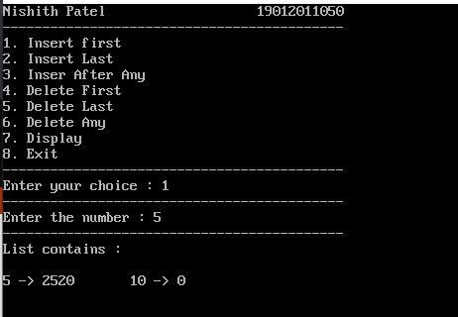
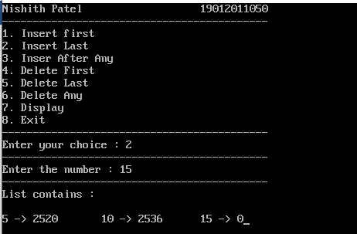
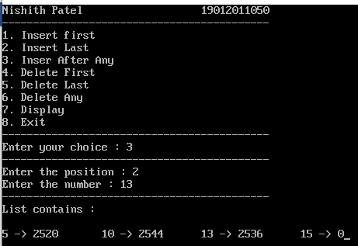
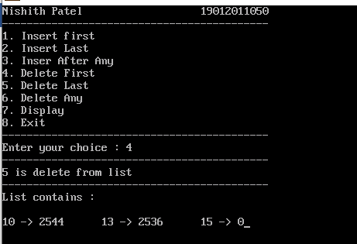
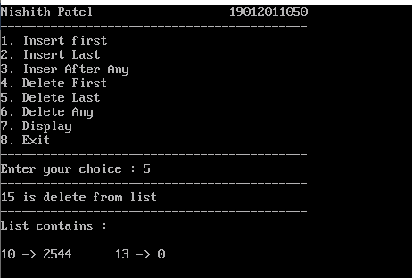
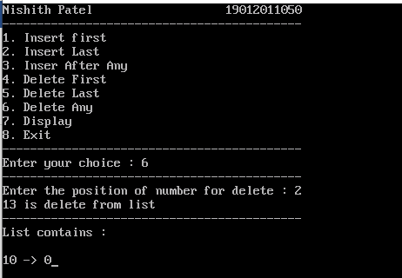
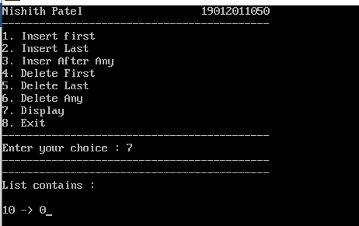

2. To implement a doubly linked list with following operations:
1. InsertAtFirst( )
2. InsertAtLast( )
3. InsertAfterspecifiednode( )
4. DeleteAtFirst( )
5. DeleteAtLast( )
6. DeleteAfterspecifiednode( )
7. Traverse (Display)

Pseudo code/Algorithm:
1. INSERTBEG (VAL,FIRST,LAST) : This function inserts a new element VAL at the beginning of the linked list. FIRST ,LAST is a pointer which contains address of first node in the list.
1. [Check for availability stack underflow]
If AVAIL = NULL then
Write “Availability stack underflow”
Return
2. [Obtain address of next free node]
NEW←AVAIL
LEFT(NEW)←NULL
3. [Remove free node from availability stack]
AVAIL←LINK (AVAIL)
4. [Initialize node to the linked list]
INFO (NEW) ←VAL
RIGHT (NEW) ← NULL

5. [Assign the address of the Temporary node to the First Node and last node ]
FIRST←NEW
LAST←NEW
6. [Finished]
Return (FIRST)
2. INSERTEND (VAL,FIRST) : This function inserts a new element VAL at the end of the linked list. FIRST is a pointer which contains address of first node in the list, LAST is a pointer which contains address of first node in the list.
1. [Check for availability stack underflow]
If AVAIL = NULL then
Write “Availability stack underflow”
Return
2. [Obtain address of next free node]
NEW←AVAIL
3. [initialize field of new node]
INFO (NEW) ←VAL
RIGHT (NEW) ←NULL
4. [If list is empty?]
If FIRST = NULL then
LEFT(NEW)←NULL
FIRST←NEW
ELSE
RIGHT(LAST)←NEW
LEFT(NEW)←LAST
LAST←NEW
5. [Finished]
Return (FIRST)
3. INSPOS (VAL, FIRST,LAST, X) : This function inserts a new element VAL into the linked list before the node value X. FIRST is a pointer which contains address of first node in the list, LAST is a pointer which contains address of first node in the list.
1. [Check for availability stack underflow]
If AVAIL = NULL then
Write “Availability stack underflow”
Return
2. [Obtain address of next free node]
NEW←AVAIL
3. [initialize field of new node]
INFO (NEW) ←VAL
4. [If list is empty?]
If FIRST = NULL then
LEFT (NEW) ←NULL
RIGHT(NEW)←NULL
FIRST←NEW,
Return FIRST
5. [If list contain only one node?]
If LINK(FIRST) = NULL then
LEFT (NEW) ← FIRST
RIGHT(FIRST)←NEW
FIRST←NEW,
Return FIRST
6. [Search the list until desired address found]
SAVE←FIRST
Repeat while LINK (SAVE) ≠ NULL and INFO(SAVE) ≠ X
PRED←SAVE
SAVE←RIGHT (SAVE)
7. [Node found?]
If(RIGHT(SAVE)==NULL) {
RIGHT(NEW)←NULL,
LEFT(NEW)←SAVE
RIGHT(SAVE)←NEW }
else {
LEFT (NEW) ←SAVE
RIGHT(NEW)←RIGHT(SAVE)
RIGHT(PRED)←NEW }
8. [Finished]
Return (FIRST)
4. DELFIRST(FIRST) : This function deletes a first node from the list. FIRST is a pointer which contains address of first node in the list.
1. [Check for empty list]
If FIRST = NULL then
Write “List is empty”
Return
2. [Check for the element in the list and delete it]
If RIGHT (FIRST) = NULL & LEFT(FIRST)=NULL then
Y←INFO (FIRST)
FIRST←NULL
Else
TEMP←FIRST
Y←INFO (TEMP)
FIRST←RIGHT (TEMP)
3. [Finished]
Return (FIRST)
5. DELLAST(FIRST,LAST) : This function deletes a last node from the list. FIRST is a pointer which contains address of first node in the list, LAST is a pointer which contains address of first node in the list.
1. [Check for empty list]
If FIRST = NULL then
Write “List is empty”
Return
2. [Check for the element in the list and delete it]
If RIGHT (FIRST) = NULL & LEFT(FIRST)=NULL then
Y←INFO (FIRST)
FIRST←NULL
Else (Assign the address pointed by FIRST pointer to TEMP pointer)
TEMP← LAST
Y←INFO (TEMP)
LAST←LAST(LEFT)
RIGHT(LAST)=NULL
3. [Finished]
Return (FIRST)
6. DELPOS(FIRST,N) : This function deletes a node with specific value from the list. FIRST is a pointer which contains address of first node in the list.
1. [Check for empty list]
If FIRST = NULL then
Write “List is empty”
Return
2. [If there is only one node?]
If LEFT (FIRST) = NULL &RIGHT(FIRST)=NULL then
Y←INFO (FIRST)
FIRST←NULL
3. [If list contains more than one node?]
TEMP←FIRST
Repeat while RIGHT (TEMP) ≠ NULL and INFO(TEMP) ≠ N
PRED←TEMP
TEMP←RIGHT(TEMP)
4. [Node found?]
If INFO(TEMP) ≠ N then
Write “Node not found”
Else
Y←INFO (TEMP)
RIGHT (PRED) ←RIGHT (TEMP)
5. [Finished]
Return (FIRST)

C Program:
#include<stdio.h>
#include<conio.h>
#include <stdlib.h>
struct node
{
int data;
struct node *left,*right;
};
struct node *first=NULL;
struct node *last=NULL;

void insert_first()
{
struct node *newnode;
newnode= (struct node *)malloc(sizeof(struct node));
printf("Enter the data : ");
scanf("%d",&(newnode->data));
newnode->left=NULL;
if(first==NULL)
{
newnode->right=NULL;
first=newnode;
last=newnode;
return;
}
newnode->right=first;
first->left=newnode;
first=newnode;
}
void insert_last()
{
struct node *newnode,*temp;
newnode=(struct node *)malloc(sizeof(struct node));
printf("Enter the data : ");
scanf("%d",&(newnode->data));
newnode->right=NULL;
if(first==NULL)
{
newnode->left=NULL;
first=newnode;
last=newnode;
return;
}
newnode->left=last;
last->right=newnode;
last=newnode;
}
void insert_after_any()
{
struct node *newnode,*temp;
int n,count=0;
newnode=(struct node *)malloc(sizeof(struct node));
printf("Enter the position : ");
scanf("%d",&n);
printf("Enetr the data : ");
scanf("%d",&(newnode->data));
temp=first;
while(temp->right!=NULL)
{
temp=temp->right;
count++;
}
if(n>count)
{
printf("Invalid position\n");
return;
}
temp=first;
count=0;
while(count<(n-1))
{
temp=temp->right;
count++;
}
newnode->left=temp;
newnode->right=temp->right;
temp->right=newnode;
}
void delete_first()
{
struct node *temp;
temp=first;
if(first==NULL)
{
printf("List is empty\n");
return;
}
else if (first==last)
{
printf("%d is remove from list \n",first->data);
first=NULL;
last=NULL;
return;
}
printf("%d is remove from list \n",first->data);
first=first->right;
first->left=NULL;
free(temp);
}
void delete_last()
{
struct node *temp;
temp=last;
if(first==NULL)
return;
else if (first==last)
{
printf("%d is remove from list \n",first->data);
first=NULL;
last=NULL;
return;
}
printf("%d is remove from list \n",last->data);
last=last->left;
last->right=NULL;
free(temp);
}
void delete_any()
{
struct node *temp,*prec,*next;
int n;
if(first==NULL)
return;
printf("enter the position : ");
scanf("%d",&n);
temp=first;
while((n-1)>0)
{
prec=temp;
temp=temp->right;
n--;
}
prec->right=temp->right;
next=temp->right;
next->left=temp->left;
printf("%d is delete from list\n",temp->data);
free(temp);
}
void display()
{
struct node *temp;
if(first==NULL)
{
printf("Link list is empty\n");
return;
}
temp=first;
printf("-------------------------------------------\n");
printf("List contains : \n\n");
while(temp->right!=NULL)
{
printf("%d\t",temp->data);
temp=temp->right;
}
printf("%d",temp->data);
getch();
}

void main()
{
int k;
again:
clrscr();
fflush(stdin);
printf("Nishith Patel 19012011050\n");
printf("-------------------------------------------\n");
printf("1. Insert first\n2. Insert Last\n3. Inser After Any\n4. Delete First\n5. Delete Last\n6. Delete Any\n7. Display\n8. Exit\n");
printf("-------------------------------------------\n");
printf("Enter your choice : ");
scanf("%d",&k);
printf("-------------------------------------------\n");
switch(k)
{
case 1:
insert_first();
display();
goto again;
case 2:
insert_last();
display();
goto again;
case 3:
insert_after_any();
display();
goto again;
case 4:
delete_first();
display();
goto again;
case 5:
delete_last();
display();
goto again;
case 6:
delete_any();
display();
goto again;
case 7:
display();
goto again;
case 8:
printf("\n\nPRESS Enter for exit");
break;
default:
goto again;
}
getch();
}

Output:
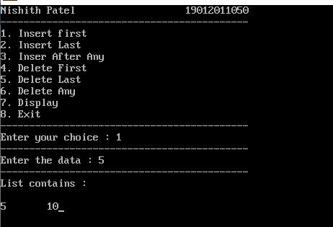
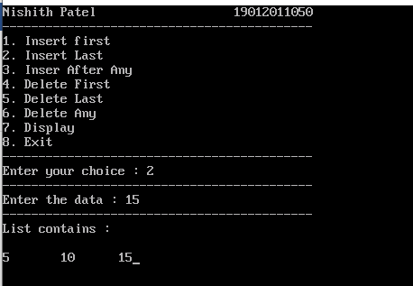
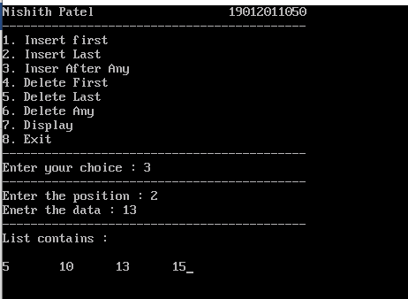
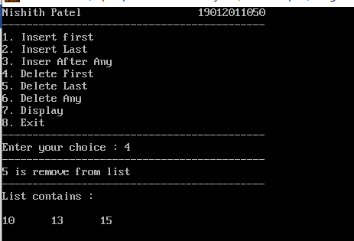
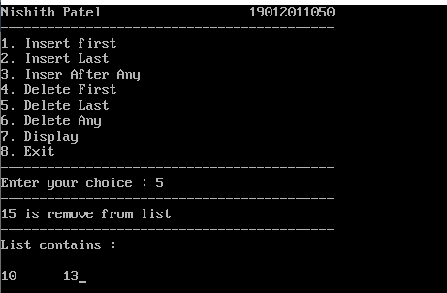
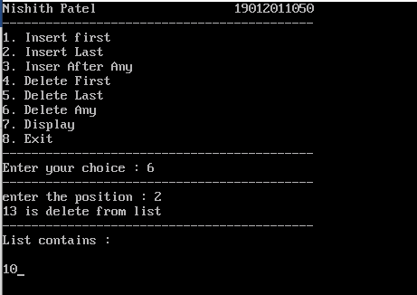
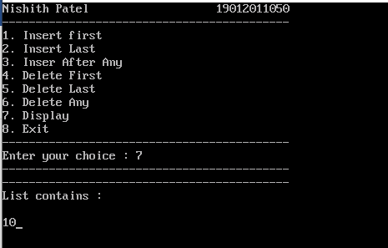

3. To implement a Circular linked list with following operations:
1. InsertAtFirst( )
2. InsertAtLast( )
3. InsertAfterspecifiednode( )
4. DeleteAtFirst( )
5. DeleteAtLast( )
6. DeleteAfterspecifiednode( )
7. Traverse (Display)

Pseudo code/Algorithm:
1. INSERTBEG (VAL,FIRST) : This function inserts a new element VAL at the beginning of the linked list. FIRST is a pointer which contains address of first node in the list.
1. [Check for availability stack underflow]
If AVAIL = NULL then
Write “Availability stack underflow”
Return
2. [Obtain address of next free node]
NEW←AVAIL
3. [Remove free node from availability stack]
AVAIL←LINK (AVAIL)
4. [Initialize node to the linked list]
INFO (NEW) ←VAL
LINK (NEW) ← FIRST
5. [Assign the address of the Temporary node to the First Node ]
FIRST←NEW
6. [ change the link of last node for new first node]
TEMP←FIRST
Repeat while LINK (TEMP) ≠ FIRST
LINK(TEMP)=FIRST

7. [Finished]
Return (FIRST)
2. INSERTEND (VAL,FIRST) : This function inserts a new element VAL at the end of the linked list. FIRST is a pointer which contains address of first node in the list.
1. [Check for availability stack underflow]
If AVAIL = NULL then
Write “Availability stack underflow”
Return
2. [Obtain address of next free node]
NEW←AVAIL
3. [Remove free node from availability stack]
AVAIL←LINK (AVAIL)
4. [initialize field of new node]
INFO (NEW) ←VAL
LINK (NEW) ←FIRST
5. [If list is empty?]
If FIRST = NULL then
FIRST←NEW
6. [initialize search for last node]
SAVE←FIRST
7. [Search end of the list]
Repeat while LINK (SAVE) ≠ FIRST
SAVE←LINK (SAVE)
8. [Set LINK field of last node to NEW ]
LINK (SAVE) ←NEW
9. [Finished]
Return (FIRST)
3. INSPOS (VAL, FIRST, X) : This function inserts a new element VAL into the linked list before the node value X. FIRST is a pointer which contains address of first node in the list.
1. [Check for availability stack underflow]
If AVAIL = NULL then
Write “Availability stack underflow”
Return
2. [Obtain address of next free node]
NEW←AVAIL
3. [Remove free node from availability stack]
AVAIL←LINK (AVAIL)
4. [initialize field of new node]
INFO (NEW) ←VAL
5. [If list is empty?]
If FIRST = NULL then
LINK (NEW) ←NEW
FIRST←NEW,
Return FIRST
6. [If list contain only one node?]
If LINK(FIRST) = FIRST then
LINK (NEW) ← FIRST
FIRST←NEW,
Return FIRST
7. [Search the list until desired address found]
SAVE←FIRST
Repeat while LINK (SAVE) ≠ FIRST and INFO(SAVE) ≠ X
PRED←SAVE
SAVE←LINK (SAVE)
8. [Node found?]
If(LINK(SAVE)==FIRST) {
LINK(NEW)←NULL,LINK(SAVE)←NEW }
else {
LINK (NEW) ←SAVE LINK(PRED)←NEW }
9. [Finished]
Return (FIRST)
4. DELFIRST(FIRST) : This function deletes a first node from the list. FIRST is a pointer which contains address of first node in the list.
1. [Check for empty list]
If FIRST = NULL then
Write “List is empty”
Return
2. [Check for the element in the list and delete it]
If LINK (FIRST) = FIRST then
Y←INFO (FIRST)
FIRST←NULL
Else
TEMP←FIRST
Y←INFO (TEMP)
FIRST←LINK (TEMP)
LAST←FIRST
Repeat while LINK (LAST) ≠ FIRST
LINK(LAST)=FIRST
3. [Finished]
Return (FIRST)
5. DELLAST(FIRST) : This function deletes a last node from the list. FIRST is a pointer which contains address of first node in the list.
1. [Check for empty list]
If FIRST = NULL then
Write “List is empty”
Return
2. [Check for the element in the list and delete it]
If LINK (FIRST) = FIRST then
Y←INFO (FIRST)
FIRST←NULL
Else (Assign the address pointed by FIRST pointer to TEMP pointer)
TEMP←FIRST
Repeat while LINK (TEMP) ≠ FIRST
PRED←TEMP
TEMP←LINK (TEMP)
3. [Delete Last Node]
Y←INFO (TEMP)
LINK (PRED) ←FIRST
4. [Finished]
Return (FIRST)
6. DELPOS(FIRST,N) : This function deletes a node with specific value from the list. FIRST is a pointer which contains address of first node in the list.
1. [Check for empty list]
If FIRST = NULL then
Write “List is empty”
Return
2. [If there is only one node?]
If LINK (FIRST) = FIRST then
Y←INFO (FIRST)
FIRST←NULL
3. [If list contains more than one node?]
TEMP←FIRST
Repeat while LINK (TEMP) ≠ FIRST and INFO(TEMP) ≠ N
PRED←TEMP
TEMP←LINK (TEMP)
4. [Node found?]
If INFO(TEMP) ≠ N then
Write “Node not found”
Else
Y←INFO (TEMP)
LINK (PRED) ←LINK (TEMP)
5. [Finished]
Return (FIRST)

C Program:
#include<stdio.h>
#include<conio.h>
#include<stdlib.h>
struct node
{
int data;
struct node *nxt;
};
struct node *head=NULL;
void insert_first()
{
struct node *newnode,*temp;
newnode = (struct node *)malloc(sizeof(struct node));
printf("Enter the number : ");
scanf("%d",&(newnode->data));
if(head==NULL)
{
newnode->nxt = newnode;
head=newnode;
return;
}
temp=head;
while(temp->nxt!=head)
temp=temp->nxt;
temp->nxt=newnode;
newnode->nxt = head;
head = newnode;
}
void insert_last()
{
struct node *newnode,*temp;
newnode =(struct node *)malloc(sizeof(struct node));
printf("Enter the number : ");
scanf("%d",&(newnode->data));
if(head==NULL)
{
newnode->nxt = newnode;
head=newnode;
return;
}
temp=head;
while(temp->nxt!=head)
temp=temp->nxt;
temp->nxt = newnode;
newnode->nxt = head;
}
void insert_after_any()
{
int n,count=0;
struct node *newnode,*temp;
newnode=(struct node *)malloc(sizeof(struct node));
printf("Enter the position of number : ");
scanf("%d",&n);
printf("Enter the number : ");
scanf("%d",&(newnode->data));
temp=head;
while(temp->nxt!=head)
{
temp = temp->nxt;
count++;
}
if (n > count)
{
printf("Invalid position\n");
return;
}
count = 0;
temp=head;
while(count<(n-1))
{
temp=temp->nxt;
count++;
}
newnode->nxt =temp->nxt;
temp->nxt=newnode;
}
void delete_first()
{
struct node *temp,*last;
if(head==NULL)
return;
temp=head;
if(head->nxt==head)
{
head=NULL;
printf("%d delete from the list\n",temp->data);
free(temp);
return;
}
last = head;
while(last->nxt!=head)
last=last->nxt;
last->nxt=temp->nxt;
head=head->nxt;
printf("%d delete from the list\n",temp->data);
free(temp);
}
void delete_last()
{
struct node *temp,*prec;
if(head==NULL)
return;
temp=head;
if(head->nxt==head)
{
head=NULL;
printf("%d delete from the list\n",temp->data);
free(temp);
return;
}
while(temp->nxt!=head)
{
prec=temp;
temp=temp->nxt;
}
prec->nxt=temp->nxt;
printf("%d delete from the list\n",temp->data);
free(temp);
}
void delete_any()
{
int n,count=1;
struct node *temp,*prec;
if(head==NULL)
return;
printf("Enter the position of number for delete : ");
scanf("%d",&n);
if(n==1)
{
delete_first();
return;
}
temp=head;
while(temp->nxt!=head)
{
temp = temp->nxt;
count++;
}
if(count<=n)
{
if(count==n)
{
delete_last();
return;
}
return;
}
temp=head;
while((n-1)>0)
{
prec = temp;
temp=temp->nxt;
n--;
}
prec->nxt=temp->nxt;
printf("%d delete from the list\n",temp->data);
free(temp);
}
void display()
{
struct node *temp;
if(head==NULL)
printf("List is empty");
else
{
temp=head;
printf("-------------------------------------------\n");
printf("List contains : \n\n");
while(temp->nxt!=head)
{
printf("%d -> %d\t",temp->data,temp->nxt);
temp=temp->nxt;
}
printf("%d -> %d",temp->data,temp->nxt);
}
getch();
}
void main()
{
int k;
again:
clrscr();
fflush(stdin);
printf("Nishith Patel 19012011050\n");
printf("-------------------------------------------\n");
printf("1. Insert first\n2. Insert Last\n3. Inser After Any\n4. Delete First\n5. Delete Last\n6. Delete Any\n7. Display\n8. Exit\n");
printf("-------------------------------------------\n");
printf("Enter your choice : ");
scanf("%d",&k);
printf("-------------------------------------------\n");
switch(k)
{
case 1:
insert_first();
display();
goto again;
case 2:
insert_last();
display();
goto again;
case 3:
insert_after_any();
display();
goto again;
case 4:
delete_first();
display();
goto again;
case 5:
delete_last();
display();
goto again;
case 6:
delete_any();
display();
goto again;
case 7:
display();
goto again;
case 8:
printf("\n\nPRESS Enter for exit");
break;
default:
goto again;
}
getch();
}

Output:
