CUSTOMER CHURN PREDICTION USING MACHINE LEARNING
Major Project Report Submitted for the Award of Master of Computer Applications

Submitted By
Nishi Tiwari
Academic Session: 2025-2026
Date: 23 May 2026

Declaration
I hereby declare that the project titled 'Customer Churn Prediction Using Machine Learning' submitted in partial fulfillment of the requirements for the degree of Master of Computer Applications is my original work and has not been submitted previously to any institution or university.

Acknowledgement
I express my sincere gratitude to my faculty members, mentors, and peers for their continuous support throughout the completion of this project. Their guidance and encouragement helped me understand the practical implementation of machine learning and data analytics concepts. I also thank the open-source community and the creators of Python libraries such as Pandas, Scikit-learn, and Streamlit.

Table of Contents
- Abstract
- Introduction
- Problem Statement
- Objectives
- Literature Review
- Research Methodology
- Exploratory Data Analysis
- Machine Learning Model
- Results and Evaluation
- Deployment using Streamlit
- Advantages
- Limitations
- Future Scope
- Conclusion
- References

Abstract
This project focuses on predicting customer churn using machine learning techniques and data analytics. Customer churn prediction has become an important area of research because organizations seek methods to retain valuable customers and improve business profitability. The project utilizes customer banking data containing more than 10,000 records and multiple customer attributes including age, balance, tenure, salary, active membership status, and product ownership.
The project involved multiple stages such as data cleaning, preprocessing, exploratory data analysis, feature engineering, model training, evaluation, and deployment. Python libraries such as Pandas, NumPy, Matplotlib, Seaborn, and Scikit-learn were used for data analysis and machine learning implementation. Logistic Regression was selected as the primary machine learning model because it performs effectively for binary classification problems and provides interpretable results.
The dataset was divided into training and testing datasets using an 80-20 train-test split. Feature scaling and encoding techniques were applied before training the model. The trained model achieved approximately 80% accuracy with a ROC-AUC score of 0.85, demonstrating strong predictive capability. Important factors influencing churn included age, tenure, and active membership status.
The project also includes deployment using Streamlit, which allows users to enter customer information and receive churn predictions in real time. This practical implementation highlights the importance of machine learning in customer relationship management and demonstrates how predictive analytics can support strategic business decisions.

Introduction
Customer retention has become one of the most critical business challenges in modern industries such as banking, telecommunications, insurance, and e-commerce. Acquiring a new customer often costs significantly more than retaining an existing customer. Therefore, businesses increasingly rely on data analytics and machine learning to identify customers who are likely to discontinue services.
Customer churn refers to the phenomenon where customers stop using a company’s products or services. Churn can negatively impact revenue, customer relationships, and brand value. Organizations aim to identify churn-prone customers early so that preventive actions can be implemented.
Machine learning provides an intelligent approach for predicting customer behavior by analyzing historical data and identifying hidden patterns. Predictive models can classify whether a customer is likely to churn based on demographic, financial, and behavioral attributes.
This project focuses on implementing a machine learning pipeline for customer churn prediction. The project demonstrates the practical use of data preprocessing, visualization, statistical analysis, model training, evaluation, and deployment using modern Python-based technologies.
Customer retention has become one of the most critical business challenges in modern industries such as banking, telecommunications, insurance, and e-commerce. Acquiring a new customer often costs significantly more than retaining an existing customer. Therefore, businesses increasingly rely on data analytics and machine learning to identify customers who are likely to discontinue services.
Customer churn refers to the phenomenon where customers stop using a company’s products or services. Churn can negatively impact revenue, customer relationships, and brand value. Organizations aim to identify churn-prone customers early so that preventive actions can be implemented.
Machine learning provides an intelligent approach for predicting customer behavior by analyzing historical data and identifying hidden patterns. Predictive models can classify whether a customer is likely to churn based on demographic, financial, and behavioral attributes.
This project focuses on implementing a machine learning pipeline for customer churn prediction. The project demonstrates the practical use of data preprocessing, visualization, statistical analysis, model training, evaluation, and deployment using modern Python-based technologies.

Problem Statement
Businesses lose a substantial amount of revenue when customers discontinue services. Traditional customer retention strategies are often reactive rather than proactive. There is a need for an intelligent system that can predict customer churn before it occurs. Such prediction systems enable organizations to target high-risk customers and reduce customer attrition.
The problem addressed in this project is the development of a machine learning model capable of predicting whether a customer is likely to churn based on historical customer data and behavioral patterns.
Objectives
1. To analyze customer behavior and identify factors contributing to churn.
2. To clean and preprocess customer data using Python.
3. To perform exploratory data analysis and visualization.
4. To build a Logistic Regression model for churn prediction.
5. To evaluate the model using machine learning metrics.
6. To deploy the predictive model using Streamlit.
7. To understand the practical implementation of predictive analytics.

Literature Review
Researchers and organizations have explored customer churn prediction extensively due to its significance in customer relationship management. Previous studies indicate that predictive analytics improves retention strategies and business profitability.
Many machine learning algorithms such as Logistic Regression, Random Forest, Decision Trees, Naive Bayes, and XGBoost have been used for churn prediction. Logistic Regression remains widely used because of its simplicity and interpretability.
Research studies suggest that customer demographics, product usage, account activity, and transaction behavior significantly influence churn. Feature engineering and preprocessing techniques are crucial for improving model performance.
Recent studies have also focused on deploying predictive systems through dashboards and web applications for real-time business intelligence. The integration of machine learning with cloud deployment and visualization tools has enhanced decision-making capabilities across industries.

Research Methodology

The methodology followed in this project includes the following phases:
Research Design:
The research design is descriptive and predictive in nature. Historical customer data was analyzed to identify churn patterns and develop a predictive model.
Data Collection:
The dataset was collected from publicly available sources and contains customer demographic and financial information.
Sampling Technique:
A non-probability sampling approach was used due to the nature of the dataset.
Data Preprocessing:
Data preprocessing included handling missing values, encoding categorical variables, removing inconsistencies, and scaling numerical features.
Exploratory Data Analysis:
EDA techniques and visualization methods were used to identify trends and relationships between variables.
Model Building:
Logistic Regression was selected as the machine learning algorithm for classification.
Model Evaluation:
Accuracy score, confusion matrix, precision, recall, and ROC-AUC score were used for evaluating performance.

Exploratory Data Analysis
Exploratory Data Analysis played a significant role in understanding customer behavior. Various statistical summaries and graphical visualizations were created.
Key findings from EDA:
• Customers with lower tenure were more likely to churn.
• Older customers had relatively higher churn rates.
• Active members showed lower churn probability.
• Customers with fewer products demonstrated higher churn tendencies.
• Balance and salary distributions affected churn patterns in some segments.
Visualization techniques such as bar graphs, histograms, heatmaps, and count plots were used to derive business insights.
Exploratory Data Analysis played a significant role in understanding customer behavior. Various statistical summaries and graphical visualizations were created.
Key findings from EDA:
• Customers with lower tenure were more likely to churn.
• Older customers had relatively higher churn rates.
• Active members showed lower churn probability.
• Customers with fewer products demonstrated higher churn tendencies.
• Balance and salary distributions affected churn patterns in some segments.
Visualization techniques such as bar graphs, histograms, heatmaps, and count plots were used to derive business insights.

Machine Learning Model
Logistic Regression was implemented using the Scikit-learn library. The machine learning pipeline included feature scaling using StandardScaler and train-test splitting.
The following features were used:
• Credit Score
• Age
• Tenure
• Balance
• Number of Products
• Has Credit Card
• Is Active Member
• Estimated Salary
The model was trained using an 80-20 train-test split. Logistic Regression is effective for binary classification problems and provides probabilities that help interpret customer churn risk.
The model successfully classified churn and non-churn customers with strong predictive performance.
Logistic Regression was implemented using the Scikit-learn library. The machine learning pipeline included feature scaling using StandardScaler and train-test splitting.
The following features were used:
• Credit Score
• Age
• Tenure
• Balance
• Number of Products
• Has Credit Card
• Is Active Member
• Estimated Salary
The model was trained using an 80-20 train-test split. Logistic Regression is effective for binary classification problems and provides probabilities that help interpret customer churn risk.
The model successfully classified churn and non-churn customers with strong predictive performance.

Results and Evaluation
The machine learning model achieved approximately 80% accuracy and a ROC-AUC score of 0.85. These results indicate that the model performs effectively in identifying churn-prone customers.
Performance metrics:
• Accuracy Score
• Confusion Matrix
• Precision
• Recall
• ROC-AUC Score
Important observations:
• Age significantly influenced churn.
• Customers with low engagement were more likely to churn.
• Active members demonstrated stronger retention.
• Lower tenure customers required targeted retention strategies.
The project demonstrates how machine learning can support data-driven business decision-making.
The machine learning model achieved approximately 80% accuracy and a ROC-AUC score of 0.85. These results indicate that the model performs effectively in identifying churn-prone customers.
Performance metrics:
• Accuracy Score
• Confusion Matrix
• Precision
• Recall
• ROC-AUC Score
Important observations:
• Age significantly influenced churn.
• Customers with low engagement were more likely to churn.
• Active members demonstrated stronger retention.
• Lower tenure customers required targeted retention strategies.
The project demonstrates how machine learning can support data-driven business decision-making.

Deployment using Streamlit
The trained machine learning model was deployed using Streamlit. The web application allows users to enter customer information through an interactive interface and obtain churn predictions instantly.
The deployment demonstrates:
• Real-time prediction capability
• User-friendly interface
• Practical implementation of machine learning
• Integration of predictive analytics into business workflows
GitHub was used for version control and Streamlit Cloud was used for hosting the application.
The trained machine learning model was deployed using Streamlit. The web application allows users to enter customer information through an interactive interface and obtain churn predictions instantly.
The deployment demonstrates:
• Real-time prediction capability
• User-friendly interface
• Practical implementation of machine learning
• Integration of predictive analytics into business workflows
GitHub was used for version control and Streamlit Cloud was used for hosting the application.

Advantages
• Helps organizations identify high-risk customers.
• Supports proactive customer retention.
• Demonstrates practical machine learning implementation.
• Provides real-time prediction capability.
• Enhances business intelligence and decision-making.
• Helps organizations identify high-risk customers.
• Supports proactive customer retention.
• Demonstrates practical machine learning implementation.
• Provides real-time prediction capability.
• Enhances business intelligence and decision-making.

Limitations
• Model performance depends on data quality.
• Logistic Regression may not capture highly nonlinear patterns.
• Predictions may vary for unseen data distributions.
• Dataset limitations may affect generalization.
• Model performance depends on data quality.
• Logistic Regression may not capture highly nonlinear patterns.
• Predictions may vary for unseen data distributions.
• Dataset limitations may affect generalization.

Future Scope
Future enhancements may include:
• Implementation of advanced algorithms such as Random Forest and XGBoost.
• Integration with cloud platforms.
• Automated retraining pipelines.
• Dashboard visualization.
• Real-time enterprise deployment.
• Integration with CRM systems.

Conclusion
This project successfully demonstrated the use of machine learning and data analytics for customer churn prediction. Through preprocessing, exploratory analysis, Logistic Regression modeling, and deployment, the project identified important customer churn factors and provided an intelligent predictive system.
The project highlights the importance of predictive analytics in improving customer retention strategies and business performance. It also strengthened practical understanding of machine learning workflows, deployment techniques, and real-world data analysis.
This project successfully demonstrated the use of machine learning and data analytics for customer churn prediction. Through preprocessing, exploratory analysis, Logistic Regression modeling, and deployment, the project identified important customer churn factors and provided an intelligent predictive system.
The project highlights the importance of predictive analytics in improving customer retention strategies and business performance. It also strengthened practical understanding of machine learning workflows, deployment techniques, and real-world data analysis.

Project Screenshots
Figure 1: GitHub Repository Structure
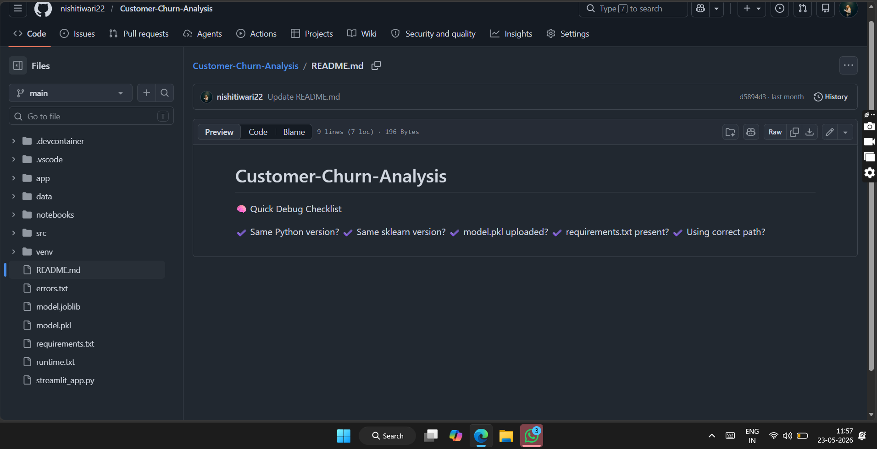
Figure 2: Streamlit Web Application
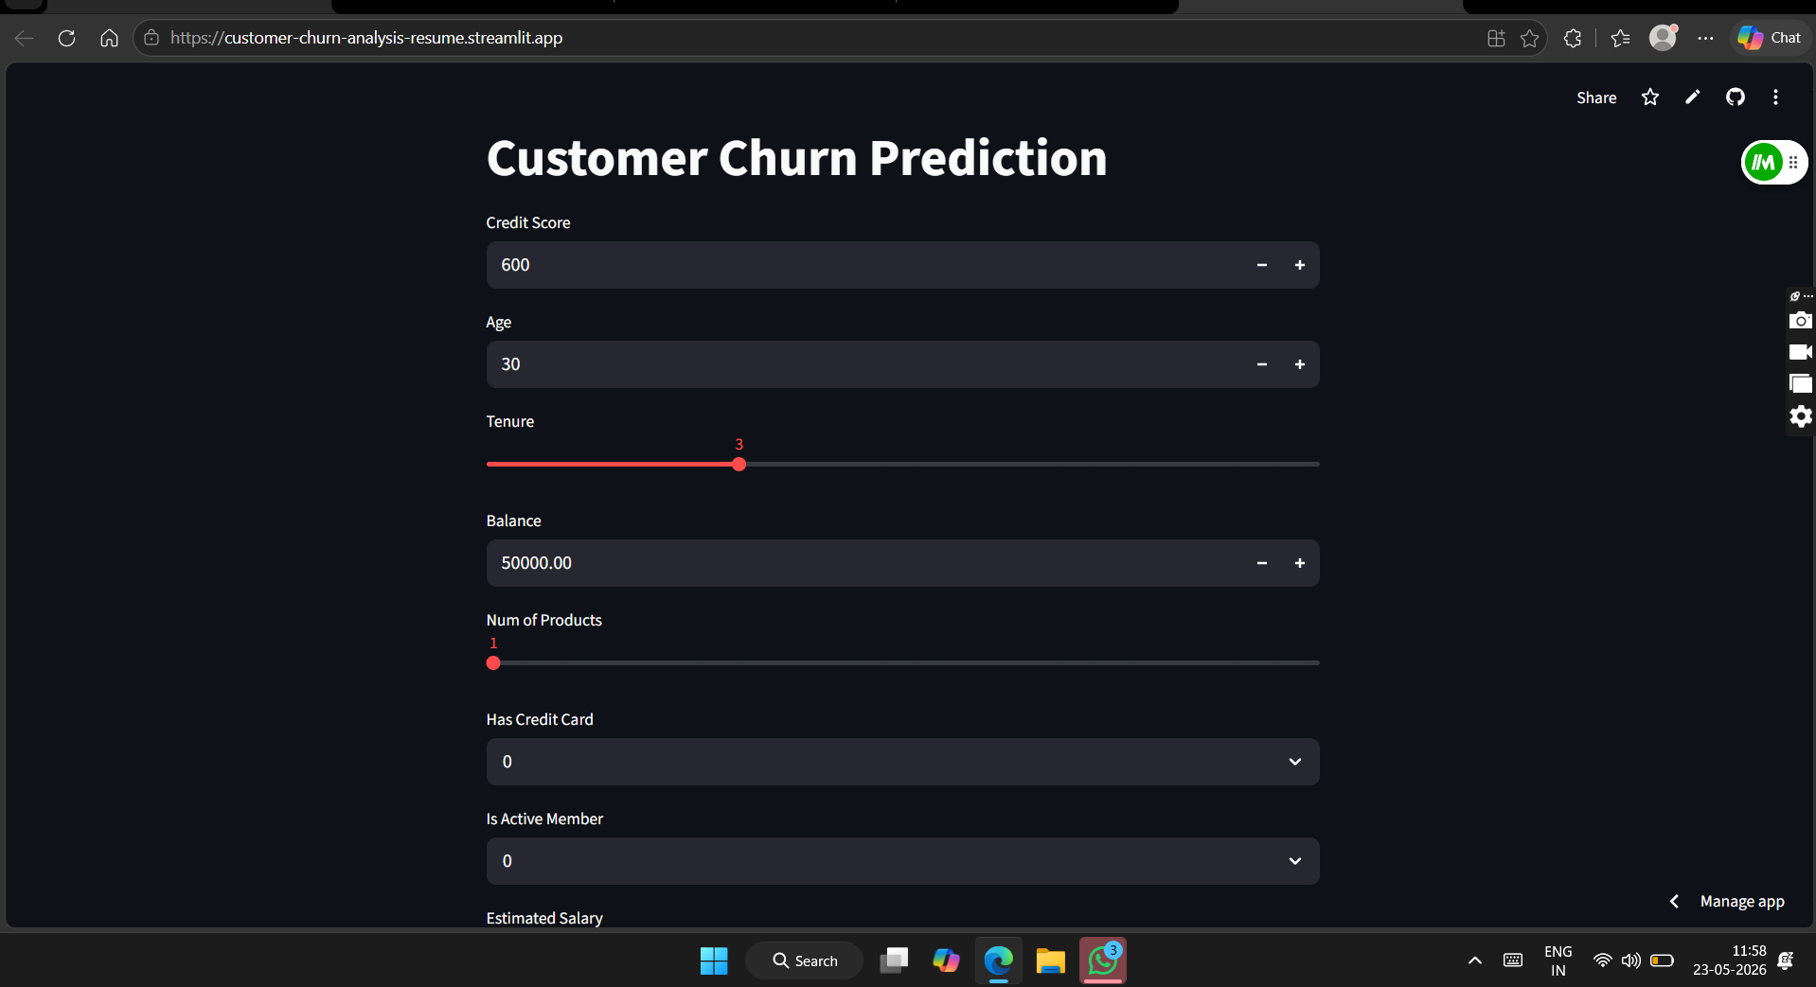

References
- Scikit-learn Documentation. https://scikit-learn.org
- Pandas Documentation. https://pandas.pydata.org
- Streamlit Documentation. https://streamlit.io
- Python Software Foundation. https://python.org
- Research papers related to customer churn prediction and machine learning.

To elevate your project from a “good MCA submission” to something that genuinely stands out during evaluation, viva, and even interviews, focus on adding evidence of analytical depth, technical maturity, and business thinking 📈
Highest-Impact Improvements
1. Add Model Comparison 🔥
Right now you only used Logistic Regression.
Add:
- Decision Tree
- Random Forest
- XGBoost (optional)
- KNN (basic comparison)
Then create:
Model | Accuracy | ROC-AUC
Logistic Regression | 80% | 0.85
Decision Tree | xx | xx
Random Forest | xx | xx
This alone dramatically improves evaluator perception because it shows:
- experimentation
- analytical thinking
- ML understanding

2. Add Proper Visualizations 📊
This is one of the biggest upgrades you can make.
Include:
- Churn distribution graph
- Heatmap
- Correlation matrix
- Age vs churn
- Tenure vs churn
- Balance distribution
- Confusion matrix
- ROC curve
Evaluators LOVE visuals because they make the report look:
- research-oriented
- data-driven
- professional

3. Add Feature Importance Analysis ⭐
Explain:
Which features influenced churn the most?
Examples:
- Age
- Tenure
- IsActiveMember
- NumOfProducts
This transforms the project from:
“just prediction”
to
“business intelligence + actionable insights.”

4. Add Business Recommendations 💼
This is massively underrated.
Add sections like:
Recommendations for Banks
- Offer loyalty rewards to low-tenure customers
- Increase engagement for inactive users
- Personalized retention campaigns
- Monitor customers with high balances but low engagement
This makes your project sound practical and industry-focused.

5. Add Architecture Diagram 🧠
Create a flow diagram like:
Dataset
↓
Preprocessing
↓
EDA
↓
Feature Engineering
↓
Model Training
↓
Evaluation
↓
Deployment (Streamlit)
This gives the report a polished engineering feel.

6. Add Dataset Description Table
Example:
Feature | Description
CreditScore | Customer credit score
Age | Customer age
Tenure | Years with bank
Balance | Account balance
Makes the report look formal and structured.

7. Add Confusion Matrix Interpretation
Not just the image.
Explain:
- True Positive
- False Positive
- Why false negatives matter in churn prediction
Shows understanding of ML evaluation.

8. Add ROC Curve Explanation
You already have ROC-AUC.
Now explain:
- what ROC means
- why 0.85 is strong
- threshold tradeoff
This strengthens viva performance too.

9. Add Real-World Impact Section 🌍
Example:
Real-World Applications
- Banking
- Telecom
- OTT platforms
- Insurance
- E-commerce subscriptions
This increases perceived relevance.

10. Add Challenges Faced Section
Evaluators LOVE this.
Examples:
- Handling imbalanced data
- Feature scaling issues
- Deployment dependency conflicts
- Streamlit version mismatch
- Model serialization errors
This makes the project feel authentic.

11. Add GitHub & Deployment Links
Very important for tech-oriented evaluation.
Include:
- GitHub repo
- Streamlit deployed URL
Makes your project verifiable and modern.

12. Add Future Enhancements
You can elevate it further with:
- Deep learning
- Real-time API integration
- Cloud deployment
- User authentication
- Retraining pipelines

13. Add Mini Research Angle 🧪
A small research insight helps tremendously.
Example:
“Customers with lower tenure and inactive membership showed significantly higher churn tendencies.”
This sounds analytical and academic.

14. Add Proper References
Right now references are weak.
Add:
- Kaggle dataset citation
- 5–8 IEEE/research papers
- Python docs
- Scikit-learn docs
This improves academic legitimacy.

15. Add Appendix 📎
Include:
- sample code snippets
- screenshots
- dataset sample
- confusion matrix
- ROC graph
- requirements.txt
Very professional touch.

Biggest Upgrade of All 🚀
Add SHAP or Explainable AI
Even a basic explanation section:
“The model predicted churn mainly due to low tenure and inactive membership.”
This makes your project sound:
- modern
- industry-aware
- AI-focused

What Will Impress Evaluators Most?
Highest ROI additions:
- Visualizations
- Model comparison
- Business recommendations
- Architecture diagram
- Proper evaluation metrics
- Deployment screenshots
- Research paper references

What Will Impress Recruiters Most?
Highest recruiter value:
- Streamlit deployment
- GitHub repo
- EDA
- model comparison
- clean UI
- business insights
- proper README
Your project already has a strong base because:
- it is deployed
- it is practical
- it uses ML
- it has a UI
- it solves a real problem
You are much closer to a strong portfolio-level project than most MCA submissions already.

