MY EXCLUSIVE BEGINNER TO ADVANCE DSA NOTES

[Use of "using namespace std” - Stack Overflow](https://stackoverflow.com/questions/18914106/what-is-the-use-of-using-namespace-std?lq=1)

[;] Use to terminate statements.

1 byte = 8 bits

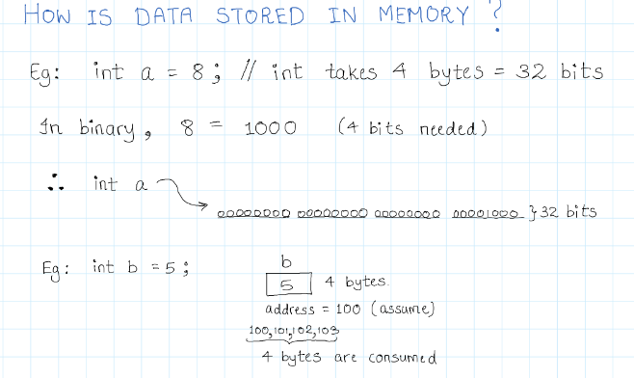

Conversion of one data type to another (if it is valid) is called typecasting.

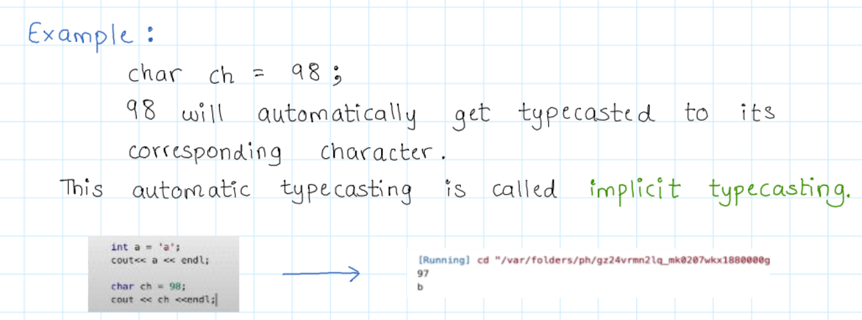

To store only +ve integers, we use unsigned.

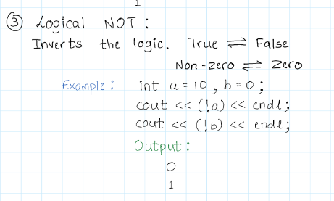

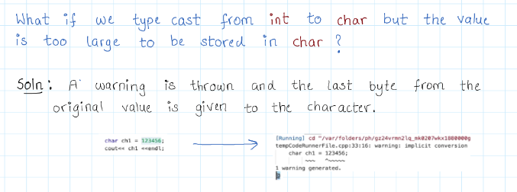

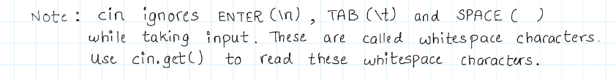

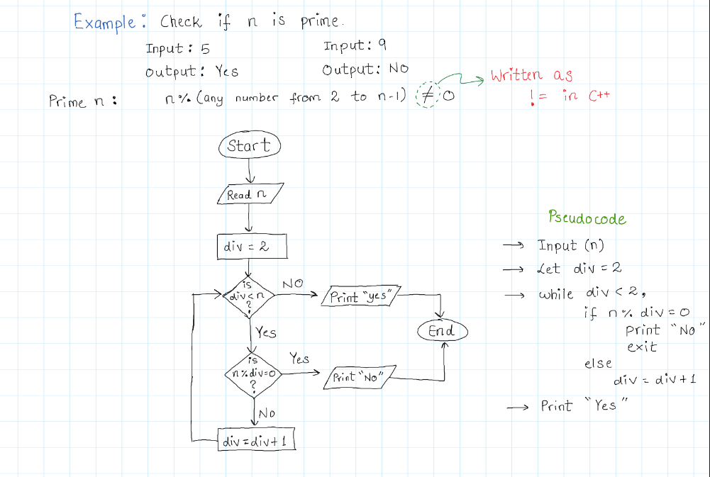

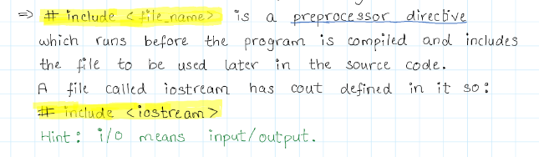

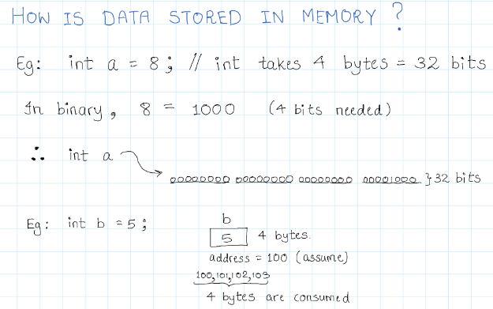

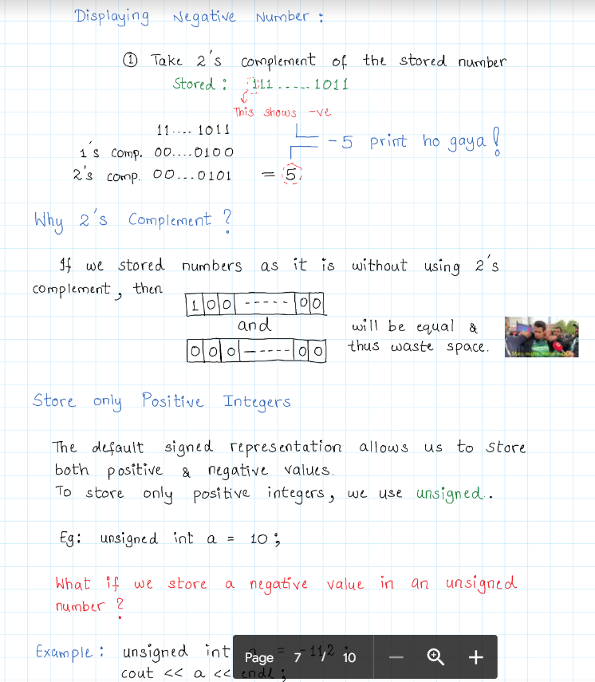

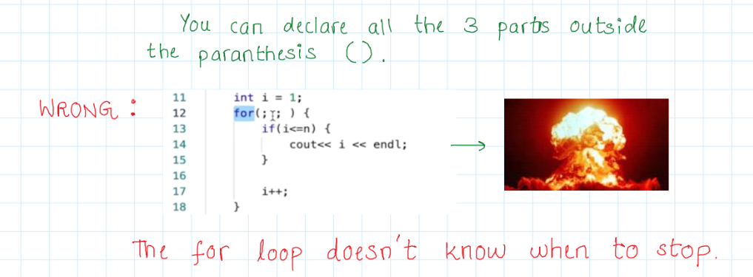

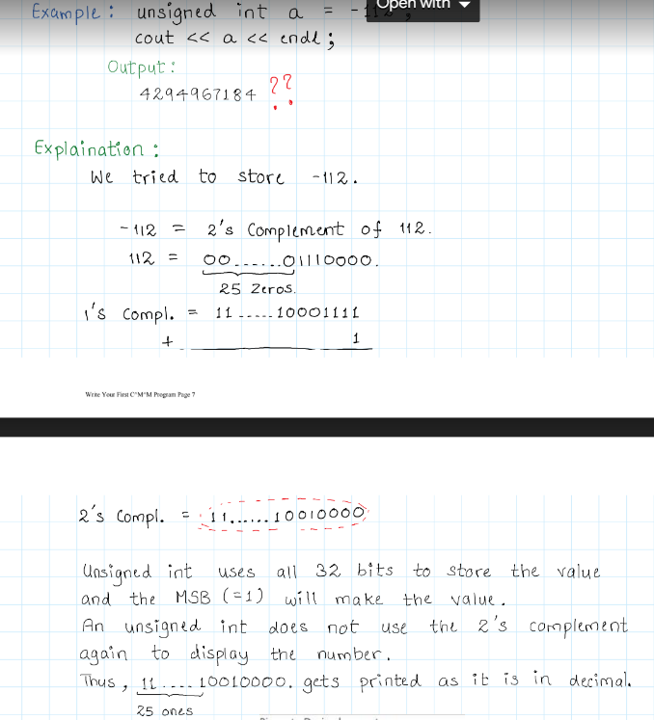

Bitwise operators can only be used alongside char and int data types.

[C++ Bitwise Operators (programiz.com)](https://www.programiz.com/cpp-programming/bitwise-operators)

<<, >> (In case of +ve Padding with 0 in case of -ve padding depends on compiler )

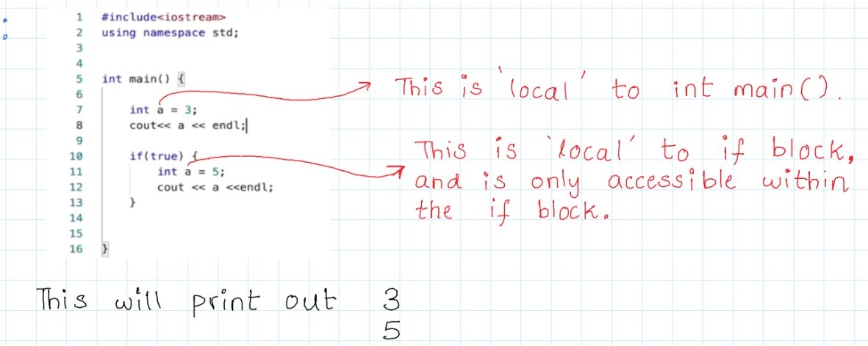

[Decimal and Binary System.pdf - Google Drive](https://drive.google.com/file/d/1hLijJiM2oHdDpTinO2ploLm3QhrsaGix/view)

