russian wildrye
Psathyrostachys junceus (Fisch.) Nevski
Plant Symbol = PSJU3

Contributed by: USDA NRCS Idaho State Office

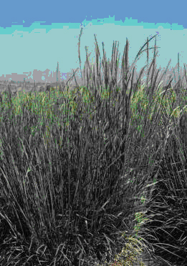
‘Bozoisky Select’ Russian Wildrye
Courtesy of Larry Holzworth

Alternate Names
Elymus junceus (Fisch.) ELJU
Leymostachys korovinii Tzvelev LEKO

Uses
Russian wildrye is one of the most versatile forage grasses available for dryland pastures. Its forage can be utilized during all seasons, and when cured, retains a higher protein percentage than wheatgrasses.

Use for Hay: Russian wildrye is not well suited to hay production. Most of the growth and production is from basal leaves, which are difficult to pick up with harvesting equipment.

Use for Pasture: This grass is best adapted for use as pasture in dry areas. It is as long-lived as crested wheatgrass. Russian wildrye begins spring growth a little later than crested wheatgrass. It continues growth and stays greener longer into the summer than crested wheatgrass. The forage is very palatable. It has a longer growing period than most dryland grasses. Russian wildrye has the ability to cure later in the growing season with good protein levels. This allows for a long grazing season. It is generally recommended for late summer through winter grazing. It is tolerant of grazing and regrows quickly after clipping lending itself to use as irrigated as well as dryland pasture.

Erosion control/reclamation: Russian wildrye gradually develops into stands with fairly wide spaced plants. It therefore is not considered the best choice for erosion control for either wind or water erosion objectives. In low rainfall areas, Russian wildrye requires wide spaced rows (18 inches or greater) to be productive. It is very competitive with weeds once established.

Salinity: Russian wildrye has good tolerance to salinity. It is a species of choice in low rainfall saline areas with moderate to well drained soils.

Wildlife: Russian wildrye is highly palatable to wildlife, especially deer, elk and antelope. It is generally utilized by wildlife in late summer through winter.

Status
Consult the PLANTS Web site and your State Department of Natural Resources for status, such as state noxious status and wetland indicator values.

Description
Russian wildrye is a large, cool-season, introduced, long-lived, perennial bunch grass. It has an abundance of long, dense, basal leaves that are from 6 to 18 inches long and up to ¼ inch in width. Plants vary from light to dark green, with many shades of blue-green.

The erect, leafless reproductive stems are about 30 to 40 inches tall. The seedhead is a short dense, erect spike with two or more short-awned spikelets clustered at axis joints. The seed shatters readily at maturity. The seed is about the same size as crested wheatgrass seed.

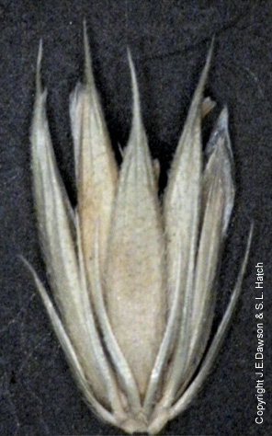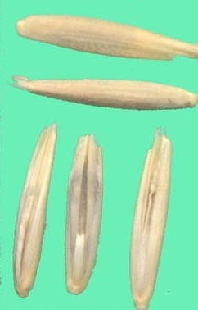
Russian wildrye spikelet

Russian wildrye seed

The roots are fibrous and may establish to a depth of 6 to 8 feet. However, about 75 percent of the roots are in the surface 6 to 24 inches. Russian wildrye roots have an extended horizontal spread and may draw heavily on soil moisture for a distance of up to 4 to 5 feet. Its long season of growth and its vigorous soil-feeding habit make this species an excellent competitor with weeds once the grass is well established.

Distribution
This species was introduced from Siberia. For current distribution, consult the Plant Profile page on the PLANTS Web site.

Adaptation
Russian wildrye can be grown successfully wherever crested wheatgrass is grown, but it is primarily a dryland pasture grass adapted to 8 to 16 inch annual precipitation areas.

Russian wildrye is well adapted to silt loam to heavy clay soils. It can be grown on a fairly wide range of soil types, but is most productive on fertile loam soils. It does poorly on soils with low fertility. It is more difficult to establish on sandy soils in dry areas than crested wheatgrass, but once established does very well.

It grows at elevations up to 7,500 feet in northern latitudes and to 9,000 feet in southern latitudes. Wide row spacing plantings (18 to 36 inch) produce more forage than narrow row spacing (6 to 14 inch) plantings.

It is exceptionally cold and drought tolerant and has moderate tolerance of salinity and sodic to saline-sodic soil conditions. Its production is affected beginning at electrical conductivity (EC) levels of 12. This grass is not tolerant of spring flooding or high water tables.

Establishment Russian wildrye requires special attention during the year it is seeded because it is difficult to establish. It must be planted in a firm, weed-free seedbed at ¼ inch depth or less. Wide row spacing plantings, 18 inches or greater, are recommended. The recommended seeding rate at this spacing is 4 pounds Pure Live Seed (PLS) per acre.

Seedlings are slow growing and weak requiring more time to establish a stand. The plants should be allowed to mature and set seed before they are grazed. Stands generally develop into widely spaced plants over time.

Stands are often open because Russian wildrye is usually seeded with wide row spacing, leaving the soil between plants susceptible to erosion. It should be planted on the contour where slopes are greater than 2 percent or may not be desirable at all where erosion control is the most important objective. Forage yields are similar to those of crested wheatgrass. Wide row spacing increases forage production.

Forage yields are also increased by seeding mixtures with legumes. Seeding the legume in alternate rows or cross-seeded rows decreases competition from Russian wildrye and optimizes forage quality and yield.
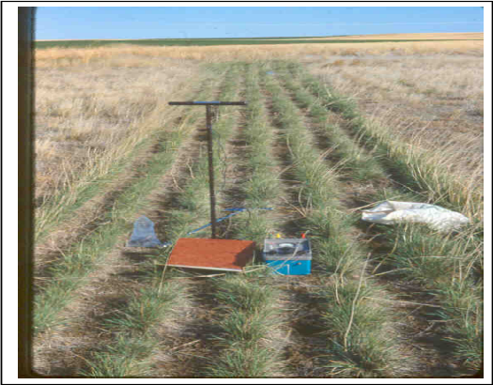
‘Bozoisky-Select’ Russian wildrye

Bridger PMC – Salinity Study
Mark Majerus

Environmental Concerns
Russian wildrye is long-lived and spreads via seed. It is not considered "weedy" or an invasive species. Most established stands do not spread beyond original plantings. It is not known to hybridize with native species.

It is subject to attack by grasshoppers, cutworms and other insects, but no troublesome diseases have been noted.

Properly established and managed stands of Russian wildrye generally exclude weeds and native grasses and forbs. Some native shrubs such as big sagebrush and rabbitbrush can invade Russian wildrye stands if seed sources are nearby.

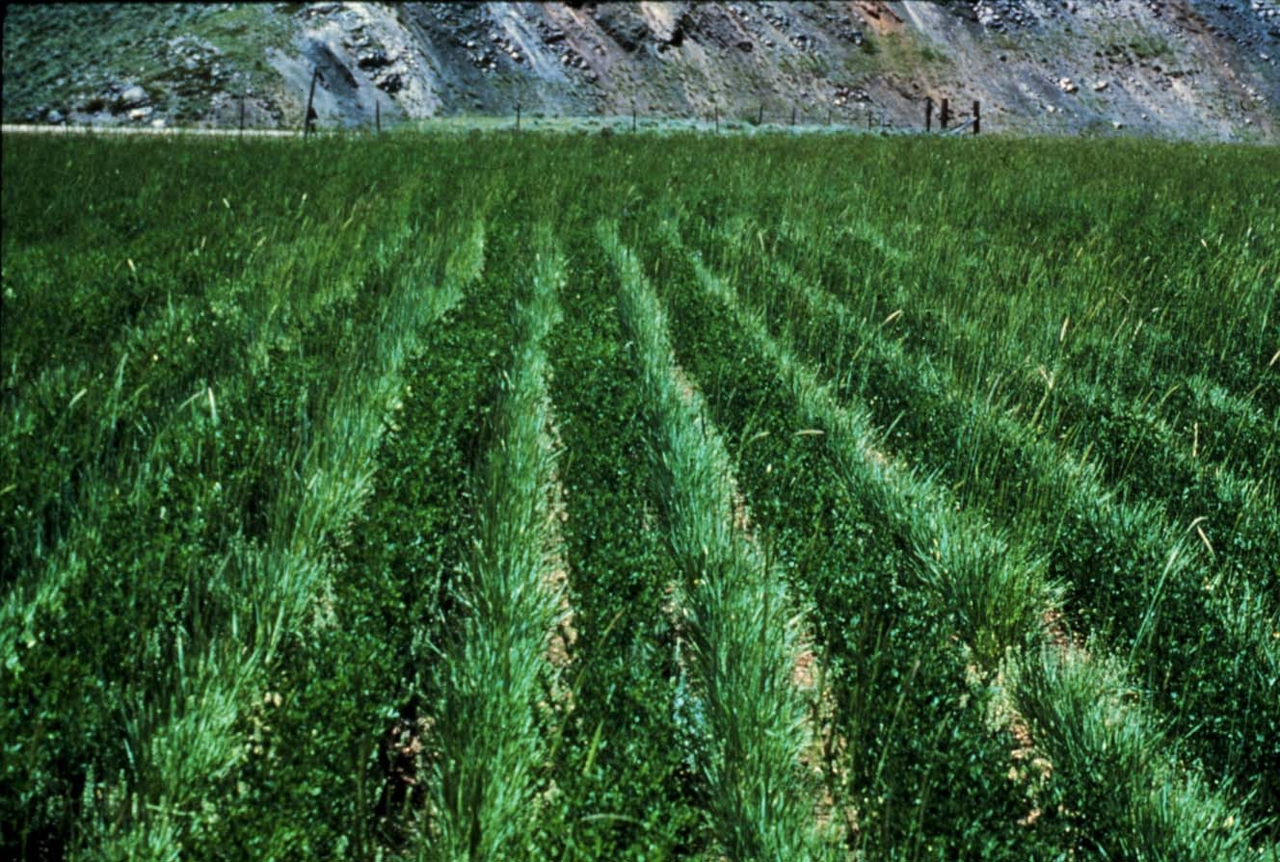
Alternate row planting with Russian wildrye and alfalfa
Larry Holzworth

Management
Russian wildrye begins growth in the spring a little later than crested wheatgrass and should not be grazed as early. However, fall regrowth of Russian wildrye is better than crested wheatgrass.

Russian wildrye is very tolerant of grazing and regrows quickly after grazing. Although grazing can occur from spring to winter, it is best to graze this grass lightly in the spring, if at all, and save most growth for late summer to fall to winter when other grasses are less productive or low in forage quality. Stands can be injured from extensive use by livestock and wildlife in early spring. Grazing should be carefully managed to avoid over utilization.

It remains palatable and of adequate nutritive quality for mature stock on winter maintenance rations. It is palatable to all classes of livestock and wildlife. It is high in protein and retains higher protein content than most grasses after maturity. Protein levels of 5 to 7 percent can be expected in late fall through winter. Because of its high palatability, competitiveness with other vegetation as well as itself, it is recommended for planting in pure stands and fenced for better utilization.

As a pasture grass, it recovers rapidly after grazing if soil moisture is available. Because of this characteristic, it has been used for irrigated pasture in rotational grazing systems.

It responds very well to applications of fertilizer and also to supplemental irrigation.

Because of its high digestibility and long season of use, Russian wildrye is unique among the semi-arid cool season grasses. In comparison trials with domestic sheep, Russian wildrye had a digestibility coefficient of 60.2 percent while crested wheatgrass had a coefficient of 45.1 percent. Its yield of forage per acre may not be as great as other adapted grasses, but high digestibility and its extended season of growth are compensating factors for livestock use.

In studies using protein supplements in the fall with yearling cattle at the Lee A. Sharp Experimental Area, Idaho by the University of Idaho, yearlings benefited from supplements when grazing crested wheatgrass, but not while grazing Russian wildrye. This study indicates that protein was not a limiting factor in fall while grazing Russian wildrye.

Seed Production
Seed production of Russian wildrye has been very successful under cultivated conditions. Row spacing of 36 inches-irrigated (seeding rate 3.0 pounds PLS per acre) to 48 inches-dryland (seeding rate 2.0 pounds PLS per acre) are recommended. Cultivation will be needed for weed control and to maintain row culture.

For seed production, Russian wildrye benefits from low levels of fertilization based on soil tests. Apply enough phosphorus fertilizer to last 3 years and incorporate into the soil. During establishment, apply approximately 30 pounds actual N (nitrogen) per acre on dryland plantings and 60 to 80 pounds actual N per acre on irrigated plantings for optimum stand establishment. On established stands apply at least 50 pounds actual N per acre on dryland plantings and 60 to 80 pounds actual N per acre on irrigated plantings each fall.

The seed heads have moderate rates of shatter and require close scrutiny of maturing stands to determine optimum harvest date. Seed is generally harvested in late July. The preferred method of harvest is to swath field when seed is in the hard dough stage prior to shatter. Allow 2-3 days curing time in the windrow and then combine using a pickup attachment. Seed must be dried immediately after combining (Moisture content: 12 percent bins and 15 percent sacks).

Crop residues from seed fields must be removed after harvest to maintain plant health, plant vigor and good future seed yields.

Seed production declines as stands get older. Seed fields are productive for at least four years. Average production of 100 to 200 pounds per acre can be expected under dryland conditions in 14- inch plus rainfall areas. Average production of 300 to 700 pounds per acre can be expected under irrigated conditions. Seed remains viable for at least ten years under good seed storage conditions.

Releases
Russian wildrye was introduced from Siberia as a forage crop. It was first grown in nurseries near Mandan, North Dakota in 1927. Because of its erratic seed yields, it did not come into common use until the 1950s.

The Russian wildrye cultivars that have performed the best in replicated plantings in the Northern Great Plains and Intermountain West (Idaho, Montana, Nevada, North Dakota, Wyoming and Utah), are ‘Bozoisky-Select’ and ‘Mankota’.

‘Bozoisky-Select’ Russian wildrye was selected by USDA ARS at Logan, Utah for improved seedling vigor and increased forage yield. It was released in 1984 and has shown good seedling performance. Forage yields are about 123 percent of Vinall. Breeder seed is maintained by ARS in Logan, UT and Foundation seed is produced at the NRCS Bridger, MT PMC.

‘Bozoisky II’ Russian wildrye was developed by USDA ARS at Logan, Utah and selected for seedling vigor (emergence from a deep planting depth), seed mass, seed yield, vegetative vigor, total dry matter production and response to drought. It is a broad-based 15 clone synthetic that is much broader than other Russian wildrye releases. It was released in 2004. Breeder and Foundation seed is maintained by USDA ARS Forage and Range Research Laboratory in Logan, Utah.

‘Cabree” Russian wildrye was selected by Agr. Canada Research Station, Lethbridge, Alberta, Canada for its improved seed retention, resistance to powdery mildew, leaf rust and spot blotch. It was released in 1976.

‘Mankota’ Russian wildrye was selected by USDA ARS at Mandan, North Dakota for resistance to leaf spot and improved forage yields. Breeder seed is maintained by ARS in Mandan, ND and Foundation seed is produced at the NRCS Bismarck, ND PMC.

‘Mayak’ Russian wildrye was selected by Agr. Canada Research Station, Lethbridge, Alberta, Canada for its high forage and seed yields and resistance to leaf spot. It was released in 1971.
‘Swift’ Russian wildrye was selected by Agr. Canada Research Station, Lethbridge, Alberta, Canada for better seedling emergence and good resistance to leaf spot. It was released in 1978.
‘Tetracan’ Russian wildrye was selected at Agr. Canada Research Station, Lethbridge, Alberta, Canada for its excellent seedling vigor, large seed size, and better seedling emergence from deeper seeding depths. It was released in 1988.

‘Vinall’ Russian wildrye was selected by USDA ARS at Mandan, North Dakota. It was the first released cultivar in 1960. It is no longer recommended and has been replaced by ‘Mankota’.

Contact your local Natural Resources Conservation Service (formerly Soil Conservation Service) office for more information. Look in the phone book under ”United States Government.” The Natural Resources Conservation Service will be listed under the subheading “Department of Agriculture.”

Prepared By
Dan Ogle, Plant Materials Specialist
USDA, NRCS, Boise, ID
Loren St. John, Manager, Plant Materials Center, USDA, NRCS, Aberdeen, ID
Jim Cornwell, Range Conservationist, USDA NRCS, Boise, ID
Larry Holzworth, Plant Materials Specialist
USDA NRCS, Bozeman, MT
Mark Majerus, Manager, Plant Materials Center, USDA, NRCS, Bridger, MT
Dwight Tober, Plant Materials Specialist
USDA NRCS, Bismarck, ND
Dr. Kevin B. Jensen, USDA-ARS, Forage and Range Research Laboratory, USU, Logan, UT
Dr. Ken Sanders, Rangeland Ecologist, University of Idaho, Twin Falls, ID

Species Coordinator
Dan Ogle, Plant Materials Specialist
USDA, NRCS, Boise, ID

Edited: 28sept04dgo; 10sept04kbj; 13sept04lsj; 20sept04ks; 21sept04jc; 22sept04lkh; 27sept04dt; 28sept04mm; 12oct04rln; 16feb05rln; 060803 jsp

For more information about this and other plants, please contact your local NRCS field office or Conservation District, and visit the PLANTS Web site<http://plants.usda.gov> or the Plant Materials Program Web site <http://Plant-Materials.nrcs.usda.gov>

The U.S. Department of Agriculture (USDA) prohibits discrimination in all its programs and activities on the basis of race, color, national origin, sex, religion, age, disability, political beliefs, sexual orientation, and marital or family status. (Not all prohibited bases apply to all programs.) Persons with disabilities who require alternative means for communication of program information (Braille, large print, audiotape, etc.) should contact USDA's TARGET Center at 202-720-2600 (voice and TDD).
To file a complaint of discrimination write USDA, Director, Office of Civil Rights, Room 326-W, Whitten Building, 14th and Independence Avenue, SW, Washington, DC 20250-9410 or call 202-720-5964 (voice or TDD). USDA is an equal opportunity provider and employer.
Read about Civil Rights at the Natural Resources Convervation Service.

