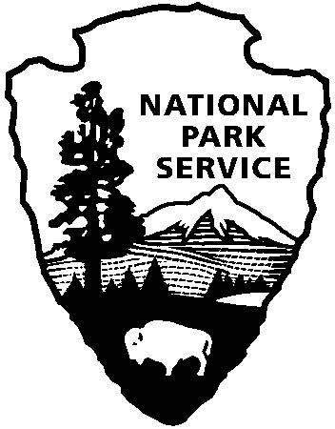
Minuteman Missile
National Historic Site
21280 SD Hwy 240
Philip, SD 57567

605-433-5552 phone
605-433-5558 fax
National Park Service
U.S. Department of the Interior
CONTACT: Mark Herberger, Minuteman Missile NHS, 605-433-5552

FOR IMMEDIATE RELEASE

July 9, 2007

MINUTEMAN MISSILE NATIONAL HISTORIC SITE Welcomes Russian Volunteer

Minuteman Missile National Historic Site has welcomed Egor Prokofiev to the park’s interpretive staff. Egor has come to Minuteman Missile via the Rotary sponsored International VIP program. Egor is from Saratov, Russia where he is studying journalism at the local university. He will be working at the park for eight weeks. During this time, Egor will help the park by developing Cold War interpretive exhibits from the Russian perspective. These fresh ideas will give the park an unprecedented window into the Russian mindset concerning this key world historical event.
Chief Ranger Pam Griswold, stated that “we are so happy to have Egor working with us this summer, it is an unbelievable opportunity to learn about the Cold War from an entirely unique point of view. The exchange of ideas will help us diversify our site interpretation.” Thus far, Egor has been able to assist the park by giving interpretive talks, performing translation of interpretive brochures and researching Russian sources for information concerning ICBMs.
Egor’s visit and volunteer duty with the park was made possible by the generosity of Rotary District #5440, specifically member George McIlvaine. George personally invited and sponsored Egor to come both the Rotary District #5440 Annual Conference and the Rotary International Conference. This was part of a project for Egor to experience Rotary first-hand and then do an NPS International Volunteer in the Parks Internship at Minuteman Missile NHS. This project fits well within the scope of what Rotary tries to do in the world and closely follows the Rotary motto of “service before self.” Since Egor was one of the first graduates of the first-ever Russian Rotary Youth Leadership Awards Camp (RYLA) program he was a good ambassador of what Rotary is doing Russia. Egor is the sixth Rotary sponsored vocational intern from Saratov to come and serve in a US National Park Service unit under Rotary district #5440 and individual Rotary Club sponsorships.
Egor commented on his experience by stating “that it is a very significant experience for me personally and for my work as a journalist in Russia. This is a unique chance to understand, to see the Cold War from the ‘opposite bank of the river,’ to see how it influenced the United States and its citizens. The Cold War was a period of history for both Russia and America that had a great affect on people’s minds and actually on the whole world situation nowadays. The Soviet Union does not exist any more but all the Russian citizens who are older than eighteen years old were born in the Soviet Union. And Russian people who are older than 30 experienced all the deprivations of this economical and ideological war. Now when the political situation in the world is more or less stable, it’s a good time to dig into our countries’ past, see what mistakes were made and try to avoid them in the future. And the exchange of ideas is the best way to figure those mistakes out.”
Egor will be at Minuteman Missile until late August, when he will then return to his native Russia, with a wealth of experiences and information to share with his countryman for years to come.

Minuteman Missile NHS was established by Congress in 1999 to tell the story of the Minuteman ICBM system, including the development of the system, the personnel who served at the 1,000 sites throughout the upper Great Plains, and the impact of the system on the communities nearby. Following the transfer of the property from the United States Air Force in September 2002, the National Park Service began preparing the site for public tours.

More information about the site can be found on the internet at www.nps.gov/mimi

