In Vivo Imaging Workspace
Imaging Query Formulation Developer-Phase II
(“IQ Project”)
Project Plan

Daniel L. Rubin MD, MS

Clinical Assistant Professor of Radiology

Research Scientist

Stanford University

Department of Medical Informatics

MSOB X-215

251 Campus Drive

Stanford, CA 94305

Phone: 650-725-5693

Fax: 650-725-7944

rubin@med.stanford.edu

David S. Channin MD

Associate Professor of Radiology

Chief, Imaging Informatics

Northwestern University

Joel H. Saltz MD, PhD

Professor and Chair

Department of Biomedical Informatics

Ohio State University

Brenda Young, BA

American College of Radiology Imaging Network (ACRIN)

American College of Radiology

TABLE OF CONTENTS
1. Introduction 3
2. SUMMARY OF RESULTS FROM PHASE I ACTIVITIES 6
2.1 Background Context: Survey of current approaches to image query 6
2.1.1 caGrid Query Mechanism 7
2.1.2 caBIG Cross Domain Data Query Projects 8
2.1.3 Summary of Existing Tools and Approaches 11
2.2 Functional Requirements: Use Cases for Image Query 12
2.2.1 ACRIN 12
2.2.2 COOPERATIVE GROUPS 14
2.2.3 CVRG 15
2.2.4 NCIA 16
2.2.5 SUMMARY OF USE CASES 18
2.3 DESIGN AND PROTOTYPE 18
2.3.1 AIM Data Service 19
2.3.2 Extended FQP and Demonstration Software 19
2.3.3 Requirements of Existing caGrid DCQL and FQP 20
2.3.4 Limitation of Existing caGrid DCQL and FQP 21
3. PHASE II REQUIREMENTS 22
3.1 REQUIREMENTS FOR Image Query FORMULATION, EXECUTION, AND IQ Tool 23
3.1.1 Application Ontology 23
3.1.2 User Interface (UI) 25
3.1.3 Query Formulation Engine 25
3.1.4 Query Execution Engine 28
3.1.5 Security Layer 30
3.1.6 Application Programming Interface (API) Layer 30
3.1.7 Historical vs Future Data 30

Introduction
Image query is a critical functional component of the cancer Biomedical Informatics Grid (caBIG™) effort to create an integrated biomedical informatics infrastructure for cancer research. In order to expedite the cancer research community’s access to key bioinformatics platforms, effective query tools are vital in order for them to find and retrieve the information they need. The caBIG™ informatics platform is accruing a wealth of resources for imaging, such as the eXtensible Imaging Platform (XIP) for researchers to analyze images and annotate them, the Annotation and Image Markup (AIM) standards for storing image annotations, the In Vivo Imaging Middleware (IVIM) for connectivity and interoperability with the caBIG™ grid, and the National Cancer Imaging Archive (NCIA) for storing vast image collections from the plethora of cancer trials. The current resources provide the cancer community technologies to federate these data archives, and browse and retrieve data from them in a seamless manner over the grid. There is however a need for techniques that will let researchers explore the various caBIG resources, pose questions, and correlate image data with related non-image data to formulate new hypotheses and research directions.
With the imminent release of the caBIG™ imaging tools, there is an emerging need for a query interface permitting users to search the caBIG™ resources in an intuitive way. Most users will not have intimate knowledge of database storage schemas, particular controlled terminologies or coding schemes. However, data resources in caBIG™ are being annotated and indexed using such terminologies. End users need query tools to help them create queries that exploit the capability of existing biomedical ontologies to enhance the search for images that are annotated using such knowledge sources in the AIM and XIP projects.
The Phase I IQ project undertook several activities to define the requirements for image query, resulting in this Phase II specification. This document details the results of Phase I functional requirements gathering and proposed work plan for Phase II. Specifically, Phase I accomplished the following:
- Compiled a list of the questions people ask and the kinds of data elements in various databases that are relevant. This not only provides a collection of use cases illustrating how people query images and image resources, but also identifies use cases that are made possible with the ability to query across multiple information models, such as the image metadata, outcome data, and AIM.

- Surveyed the various strategies for query processing in caBIG™ and related projects. This allows Phase II to be focused such that development not only leverages existing caBIG™ query efforts, but can be utilized by the wider caBIG™ community.

- Collected use cases, which demonstrate how people want to query images and image resources, made possible with the ability to query across multiple information models, such as the image metadata, annotation and markup data, and outcome data.

- Compiled a list of the questions people commonly ask and the kinds of data elements in various databases that are relevant.
- Surveyed query execution in caBIG™ and related projects to come up with a list of current approaches already in use within caBIG™ so that the software developed within this project will interoperate with other caBIG™ query efforts.
- Provided a demonstrable proof of concept presentation shown at the Radiological Society of North America (RSNA) 2007 Annual Meeting as a part of the caBIG™ Imaging Workspace. Two primary scenarios were created:
- Execute federated queries on the grid to aggregate data from homogeneous data resources.
- Execute distributed queries on the grid to join data from heterogeneous data resources with diverse data types, including images, annotations, and non-image data.
The goal of Phase II will be to create an Imaging Query Formulation tool which will provide an interface that automates the creation of ontology-based queries to image resources, with delivery of a platform and tool which we call the Image Query Tool (IQ Tool).
The specific objectives of the Query Formulation Project Phase II will be to:
- Create an application ontology that represents the kinds of information that users seek (obtained from the data collected in Phase I), and provides mapping from the conceptual types of information a user seeks to the granular data fields actually contained in various image-related databases that must be queried.

- Create a user interface which will allow end users to (1) select data elements and data element values, and to combine them with Boolean operators; (2) allow users to pursue the query ontology to formulate queries directly in terms of ontology classes if desired; and (3) permit a “Query by Example” method of search.

- Create a query formulation component that exploits knowledge in the ontology to expand user queries to improve recall of search, as well as to constrain the queries appropriately to improve the precision of search.

- Create a query execution engine which will plan and execute the query that is formulated by the above-mentioned user interface and application ontology. These queries will be capable of running on caBIG™ data services—such as the NCIA, American College of Radiology Imaging Network (ACRIN), and the grid enabled archives of some of the NCI Clinical Trial Cooperative Groups. The security issues involved in the query execution engine will also be identified and addressed. Our team includes members of the in vivo imaging middleware development team and they have been funded to develop a prototype for executing federated queries that are relevant to the imaging workspace. We will extend their prototype in the development of this query execution engine.

Successful execution of the work described in the RFP will require expertise in imaging informatics, ontology development and representation standards, middleware and grid technologies, and query methodologies. In particular, as the IQ Tool will need to work with databases that utilize AIM and are accessible on caGrid.

SUMMARY OF RESULTS FROM PHASE I ACTIVITIES
The core activities for Phase I defined the functional requirements for the Phase II work. The Phase I work addressed the following issues to determine requirements for the Phase II project:
- BACKGROUND CONTEXT: Survey of the current approaches to image query.
- FUNCTIONAL REQUIREMENTS: Use cases for how users are searching for images and composing queries for those searches.
- DESIGN AND PROTOTYPE: Proof-of-concept design and initial prototype to demonstrate that the design fulfills the functional requirements and that it could be useful in current query scenarios; also demonstrate that the design can be implemented in the prototype and that the prototype is able to realize a subset of the use cases.
We summarize the outcome of Phase activities for each of these tasks.

Background Context: Survey of current approaches to image query
The first step in developing the requirements for a tool enabling users to query image resources is to find out precisely the types of information that users actually seek. We looked at the types of questions people are asking and the data fields that are relevant to their queries. We also considered queries related both to image and clinical data.
Specifically, we surveyed the following groups and resources:

- Cooperative groups: We reviewed several ongoing protocols in cooperative groups and research projects such as RTOG, CALGB, and CVRG. These protocols have query needs related to images. See Section 2.2 for results of exploration of use cases.

- ACRIN: We worked with ACRIN to review their data warehouse project to understand their approach to query. This provides a very nice query mechanism, including a GUI for query formulation, and it appears promising for us to extend that interface to query images from federated Grid resources.

- NCIA: We reviewed the NCIA image query services, which provide query of this image archive. We also reviewed the DICOM elements used by NCIA in their data model to provide us the spectrum of information subject to query in NCIA.

- caBIG: We reviewed current query infrastructure within caBIG, specifically the motivation and design of CQL in caGrid. In addition, we reviewed several projects that exhibit similar “cross-domain” query requirements and examined their approaches to integrating data from multiple caGrid services. See Sections 2.1.1 and for more detail

caGrid Query Mechanism
A central goal of caBIG™ is to provide and support semantic and syntactic interoperability of the data rsources. To promote interoperability, caBIG requires that common vocabularies are published in the Enterprise Vocabulary Service (EVS), the common models and common data elements (CDE) are published in the Cancer Data Standards Repository (caDSR). The review and publication process for the vocabulary, model, and CDEs ensures that they are semantically harmonized, and discoverable by end users, developers, and software applications. To support this process, caBIG subscribes to an object oriented domain data modeling process using UML.
caGrid, the core software infrastructure of caBIG, significantly extends the standard web service and grid service infrastructure. As an extension of web services, caGrid services interfaces are specified via XML schemas which are programmatically generated from the UML domain models. caGrid ensures that semantic and syntactic interoperability are maintained by enforcing the use of published XML schemas and providing an object oriented view of the grid-based data using XML-to-object bindings. The caGrid Data Service specification further requires a common query interface for data content using the caBIG Query Language (CQL). All caGrid data services respond to CQL based queries and return domain objects in XML format.

CQL (http://www.cagrid.org/mwiki/index.php?title=Data_Services:CQL) is an object oriented query language. CQL allows a user to formulate a query statement that utilizes vocabulary and CDEs defined in caBIG domain data models. It explicitly specifies the association relationships between classes or commond data elements, and the containment relationships between classes and its attributes.
CQL allows filtering at the attribute level, using predicates such as “Equal”, “Less Than”, “Like”, based on user specified values. It also provides support for Boolean “and” and “or” operators for grouping attribute filters, including the containing classes. An XML representation of CQL is show in Figure 1

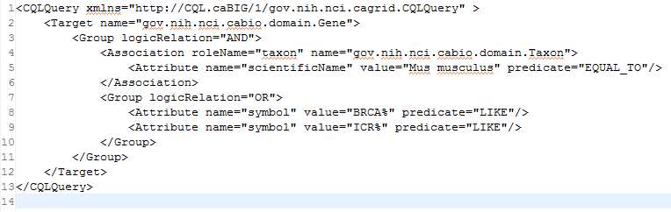
Figure 1: an example CQL statement in XML format.

CQL provides a common mechanism for querying individual caGrid data services. To support query across multiple data services and joining data from related domains, caGrid also provides Distributed CQL (DCQL) for query specification. DCQL is a distributed version of CQL to query across multiple data services using different domain models. caGrid also provides Federated Query Processor (FQP) for processing DCQL. Federated Query Processor (FQP) transforms DCQL to multiple CQLs for processing by individual caGrid data services. An example DCQL document illustrates a cross-domain query in Figure 2.

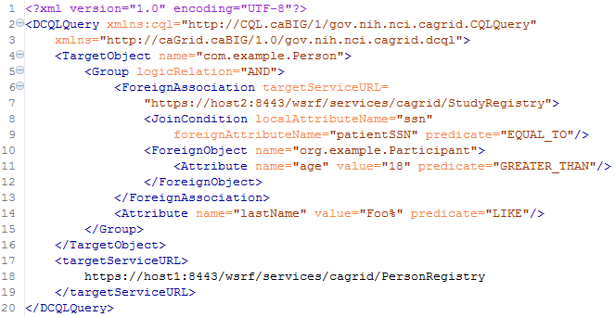
Figure 2 Example DCQL query statement in XML format
While caGrid data service, CQL, DCQL, and FQP together provide standardized mechanisms for accessing strongly typed data on the grid, several functionality extensions can greatly enhance the querying capability of the system. The limitations of current capabilities are discussed in Section 2.3.4.

caBIG Cross Domain Data Query Projects
We discussed the use cases for data query (not necessarily focused on images) with James Buntrock, who works in the Architecture workspace. He had recently created a White Paper related to use cases for terminologies in caBIG (“Vocabulary Services for caGrid: Strategy and Technical Approach”). This paper outlines the need for terminology query. However, beyond LexGrid and caDSR resources whose focus is terminology or data element query/access, no efforts focus on query involving the semantics of the data values in caBIG.
Within caBIG, several projects exist that deal specifically with cross-domain data query and integration. Three projects are highlighted below: caTRIP, caIntegrator, and caB2B.

caTRIP (see https://cabig.nci.nih.gov/tools/caTRIP)
caTRIP allows users to query across a number of caBIG data services, join on common data elements (CDEs), and view their results in a user-friendly interface. Having as its initial focus the enabling of outcomes analysis, caTRIP allows clinicians to query across data from existing patients with similar characteristics to find treatments that were administered with success. In doing so, caTRIP can help inform treatment and improve patient care, as well as enable the searching of available tumor tissue, locating patients for clinical trials, and investigating the association between multiple predictors and their corresponding outcomes such as survival. Of importance, caTRIP relies on the vast array of open source caBIG applications, including (1) Tumor Registry, a clinical system that is used to collect endpoint data; (2) the cancer Text Information Extraction System (caTIES, https://cabig.nci.nih.gov/tools/caties), a locator of tissue resources that works via the extraction of clinical information from free text surgical pathology reports while using controlled terminologies to populate caBIG-compliant data structures; (3) caTissue CORE (https://cabig.nci.nih.gov/tools/catissuecore), a tissue bank repository tool for biospecimen inventory, tracking, and basic annotation; (4) Cancer Annotation Engine (CAE) (https://cabig.nci.nih.gov/tools/cae), a system for storing and searching pathology annotations; (5) caIntegrator http://gforge.nci.nih.gov/projects/caintegrator/), a tool for storing, querying, and analyzing translational data, including SNP data.

caTRIP focuses on enabling outcome analysis to identify successful treatment strategies based on correlative data. It links together the following caGrid data services: CAE for pathology annotation management, caTISSUE CORE for biospecimens tracking, caTIES for textual information extraction from pathology reports, caIntegrator for accessing SNP data, and Tumor Registry for collecting endpoint data. caTRIP uses caGrid FQP as the distributed query engine and DCQL as the query language (Figure 3). It allows joining of data from these 5 services through shared common data elements (CDEs). caTRIP relies on existing CDE and vocabulary, and does not appear to support ontology driven queries.

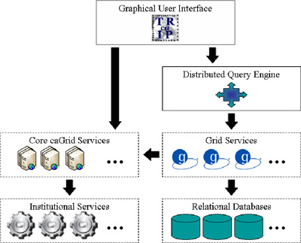
Figure 3. caTRIP architecture diagram

caIntegrator
caIntergrator supports the storage, query, and retrieval of translational data including SNP. It provides capabilities to allow researchers to perform queries crossing knowledge and data domain boundaries. caIntegrator defines a “Clinical Genomics Object Model”, which is essentially an integrated, super data model. This integrated data model allows for standardized programmatic access to the data in the caIntegrator data system, and naturally queries that crosses the sub-domains of the model. In addition, data is stored in a centralized database that conforms to the integrated data model. Figure 4 shows the architecture of the caIntegrator system. caIntegrator is used by the Rembrandt, I-SPY, and GMDI trials. The challenge that caIntegrator faces is how to integrate additional, new data models and data sources into the super model in a scalable way.

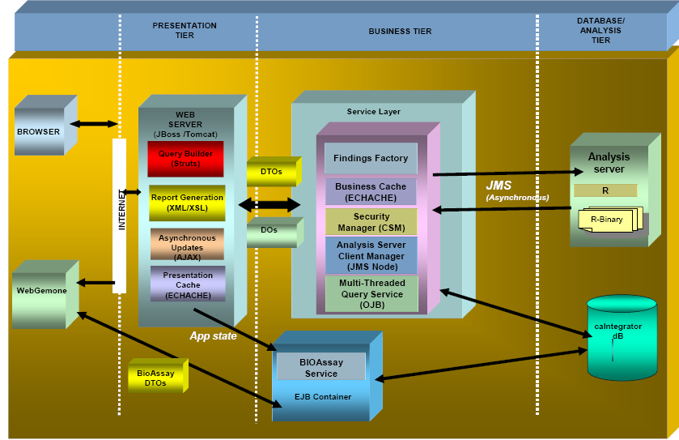
Figure 4. Architecture diagram of caIntegrator system.
caB2B

We also reviewed the Cancer Bench to Bedside (caB2B) project, which provides an interface for data and data field query. While that project is in early stages and does not focus on image query, its user interface may be relevant, allowing users to search for metadata fields before searching for particular values of those fields.
caB2B project focuses primarily on microarray and the corresponding clinical data. It supports querying caGrid data services, invoking caGrid analytical services, and display results. The graphical user interface allows for construction of query based on Categories, which are predefined collection of attributes; Limits, which are conditions or predicates that an attribute must satisfy to be considered a match; and Paths, which are association between categories. The data integration aspect of caB2B is captured via Paths, as they are computed from CDEs in the domain models. Attributes of CDEs are identified to be equivalent based on information nfrom caBIG EVS and caDSR, and Paths are generated to establish linkages between attributes of CDEs and models. Multiple paths can exist between attributes.
caB2B stores and manages the Categories, Limits, and Paths centrally in a database. The system supports cross-domain queries based on common caBIG CDE, and uses DCQL and FQP to transform queries for evaluation by caGrid data services. While this system does not utilize data ontology for formulating queries, it has significant features that relate to the Image Query Formulation project, and its functionalities should be examined in more details during Phase II. Figure 5 and Figure 6 show the user interface and the architecture respectively.

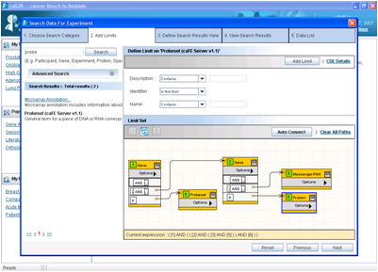
Figure 5. caB2B user interface.
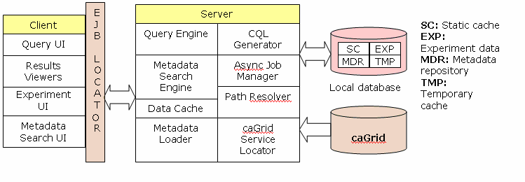
Figure 6. System architecture of caB2B.

Summary of Existing Tools and Approaches
While our initial goal in the above activities was to compile a list of the questions people ask and kinds of data elements in various databases that are relevant, in pursuing the use cases we found that there few questions people were asking per se; rather query was restricted to particular data fields in the database. The existing projects that we reviewed exhibit similar characteristics. However, their features strongly indicate the interest and need for the ability to integrate data with different domain models, such as images, their annotations, and other correlative data.
We believe our survey above was sufficiently broad to be representative of the needs of image query. The detailed information requirements are presented in the description of use cases below. The guiding principle for Phase II will be to provide as generic an approach as possible that has the greatest chance of relevance to other projects in caBIG™. The goal will be to develop tools that will interoperate with other caBIG query efforts as well as integrate and interoperate with existing caBIG™ tools such as DCQL, Federated Query Processor, terminological service, and caDSR. Existing user interfaces and tools such as caTRIP, caB2B, and caIntegrator will also be evaluated for reuse.

Functional Requirements: Use Cases for Image Query
The specific functional requirements for the image query tool developed in this project were gathered from a group of representative use cases that we selected for Phase I of the project. We believe these use cases are representative of the commonest scenarios for image query, yet be broad enough to cover some of the less common, but important use cases. In addition, the IQ Team investigated existing software tools and components that can be integrated to fulfill IQ Phase II project requirements. The goal was to come up with a list of the approaches and components already in use within caBIG™ to ensure that 1) the query mechanisms developed in this project will leverage and interoperate with other caBIG™ query efforts and 2) the other caBIG™ projects where ontology driven information query is needed can easily and effectively reuse our methods, ontologies, and query formulation.
The following is a summary of each use case and software being used for query that is relevant to image query.

ACRIN
Since its inception, ACRIN has fielded numerous data access requests because of the richness of its image archive and clinical data collected in its clinical trials. ACRIN provided the initial core use cases (see Table 1) based on reviewing the queries to their database for multiple recent studies.
Table 1: Summary of ACRIN Studies and Queries
Study | Clinical Data | Images | DICOM Metadata
6659 Prostate | Histology data | Spectral imaging and MRI  Pathology images
6659 Prostate | MRS & MRI readings by sextant along with matched pathology results. Determine the spatial relationships between sextants
6652 DMIST Breast |  | Digital mammograms of all 335 positive cases and all negative cases | X-ray technique  kVp  mAs  Filter/anode  Compressed breast height
6652 DMIST | Pathology information on lesion location  Rate of detection  Case report forms  BIRADS classification for each cancer case  Location of suspected cancer | Digital images by manufacturer  100 cases of confirmed cancer  All digital mammography images from 200 BIRADS 1 cases
6664 CTC | Coordinate of polyp  Location  Size  Type
6657 Breast MRI | Tumor longest diameter  Morphologic pattern | MRI images
6654 NLST | Nodule size  Nodule type | 100 thin slice CT

In addition to the use case for query, ACRIN also produced a data warehouse query interface. This interface permits users to compose queries using a structured metadata available as a drop-down (Error: Reference source not found).
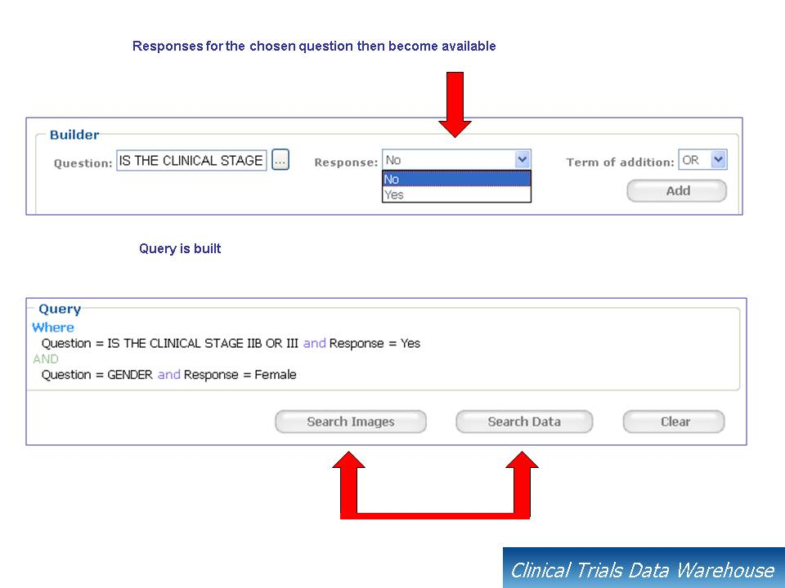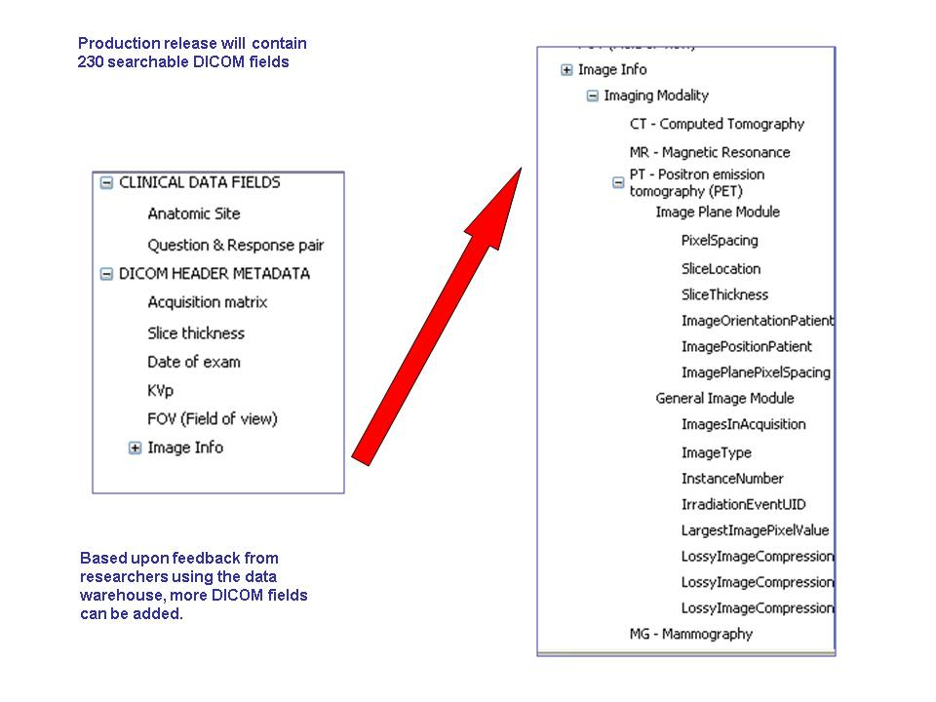
Figure 7. ACRIN data warehouse query interface. Users compose queries using structured metadata (left) and compose queries based on how metadata fields can be combined (right).

COOPERATIVE GROUPS
We reached out to a group of selected cooperative groups in developing our use cases, including cooperative groups such as CALBG, Radiation Therapy Oncology Group (RTOG), Image-Guided Therapy Center, and QARC (RTOG, QARC, RPC, and ITC comprise the Advanced Technology Consortium). The cooperative groups are a community that will be likely users of the proposed IQ tool. They will also likely be actively engaged in the Phase II project. The RTOG has a wealth of diverse data pertinent to image query relevant to caBIG™, such as cancer imaging and image-guided radiation treatment planning.
The key needs for image query in the RTOG use case is identifying evidence on images for treatment response and to predict survival. Querying images for change in image-based biomarkers is a common paradigm in RTOG. An example RTOG study seeks to determine the impact of PET on imaging endpoints: GTV, number of involved nodes, and location of involved nodes.
RTOG provides a Web client (“ITC Remote Tool”) for search, enabling users to review target volume, contours, dose prescription or dose hetorgeneity. Example queries for ITC Remote Tool are:

- “Retrieve DVH and CT Images and RT Contours where Case=0905 and Protocol=9999”
- “Find paired CT and PET/CT images and patient IDs where the number of involved nodes differs between CT and PET/CT image analyses”

RTOG also provides a richer review environment — Computational Environment for Radiotherapy Research (CERR). CERR has been grid enabled and an example query to retrieve objects for review could be constructed using the following attributes:
archive
tapeStandardNumber
intercomparisonStandard
institution
dateCreated
writer
sponsorID: 'RTOG'
protocolID: '0525'
subjectID: 222
submissionID: 7
timeSaved: {'3-Apr-2007 08:07:37'}
CERR also has the ability to produce metadata related to the DICOM RT objects and this metadata can also be used in formulating exploratory queries.
CALBG has similar needs with respect to image query—assessing disease response.

CVRG
The goal of the CardioVascular Research Grid (CVRG), similar to caBIG, is to create an environment for data and algorithm sharing and collaboration for cardiac researchers. The core infrastructure of CVRG (CVRG-Core) facilitates the representation, storage, federation and sharing of cardiovascular data and metadata. Organizations can join CVRG by using the CVRG-Core infrastructure and subscribing to the common data and resource sharing philosophy of CVRG. CVRG-Core provides caBIG interoperable data services for managing “multi-scale” data including SNP, transcriptional, proteomic, imaging, electrophysiological and patient/study data. CVRG-Core will also provide APIs by which users may add new data and analytic services that may be accessed by all users of the CVRG.
The core objective of CVRG studies is to understand cardiovascular disease underlying sudden cardiac death and populations for whom implantable cardioverter-defibrillator (ICD) is indicated. The approach is to study cardiac images and make quantitative measurements to detect regional wall motion abnormalities and correlate the cardiac morphologies with ECG and genomic, protein expression, and patient outcome data. The ultimate goal is to relate the cardiac morphology with molecular biomarkers to predict key phenotypes (inappropriate firing of ICD and sudden cardiac death). Some example queries for the CVRG use case are listed below:
- Identify subjects for further analysis (identify inappropriate firing of ICD)
“Find ECG, SNP, and Images for patients where ICD firing meets criteria X”.
“Find ECG and Images for patient who has SNP A”
- Identify high risk patients (identify risk factors for sudden cardiac death)
“Find patients where ECG shows QT variability index greater than X, possess SNP A with genotype of GC and SNP C with genotype GT or GG, and has CT ejection fraction below Y”
Most of these queries currently can be accomplished only by integrating the data across the different domains using the patient identifier. With appropriate semantic annotation and ontology based queries, it may be possible to formulate queries that allow for data integration via other data attributes.

NCIA
The National Cancer Image Archive (NCIA) collects a wealth of image metadata as part of its imaging archive. Currently, NCIA focuses on the storage and management of DICOM CT, PET, and MR images. The metadata indexed by NCIA include the DICOM attributes shown below. The list of DICOM attributes, in DICOM tag and verbose name pairs, are used in NCIA’s database schema, and is also published in the NCIA data model in the caDSR. The NCIA model is used by the In Vivo Imaging Middleware DICOM Data Service and NCIA’s own caGrid service interface. As described in Section 2.1.1, the NCIA data model defines the information that can be queried in the DICOM Data Service and the NCIA Data Service using CQL as the query language.
1. (0x0008,0x0008) ImageType
2. (0x0008,0x0016) SOPClassUID
3. (0x0008,0x0018) SOPInstanceUID
4. (0x0008,0x0020) StudyDate
5. (0x0008,0x0021) SeriesDate
6. (0x0008,0x0022) AcquisitionDate
7. (0x0008,0x0023) ContentDate
8. (0x0008,0x002a) AcquisitionDateTime
9. (0x0008,0x0030) StudyTime
10. (0x0008,0x0032) AcquisitionTime
11. (0x0008,0x0033) ContentTime
12. (0x0008,0x0060) Modality
13. (0x0008,0x0070) Manufacturer
14. (0x0008,0x0080) InstitutionName
15. (0x0008,0x1030) StudyDescription
16. (0x0008,0x103e) SeriesDescription
17. (0x0008,0x1080) AdmittingDiagnosesDescription
18. (0x0008,0x1084) AdmittingDiagnosesCodeSequence
19. (0x0008,0x1090) ManufacturerModelName
20. (0x0008,0x2218) AnatomicRegionSequence
21. (0x0010,0x0010) PatientName
22. (0x0010,0x0020) PatientID
23. (0x0010,0x0030) PatientBirthDate
24. (0x0010,0x0040) PatientSex
25. (0x0010,0x1010) PatientAge
26. (0x0010,0x1020) PatientSize
27. (0x0010,0x1030) PatientWeight
28. (0x0010,0x2160) EthnicGroup
29. (0x0010,0x2180) Occupation
30. (0x0010,0x21b0) AdditionalPatientHistory
31. (0x0012,0x0010) ClinicalTrialSponsorName
32. (0x0012,0x0020) ClinicalTrialProtocolID
33. (0x0012,0x0021) ClinicalTrialProtocolName
34. (0x0012,0x0030) ClinicalTrialSiteID
35. (0x0012,0x0031) ClinicalTrialSiteName
36. (0x0012,0x0040) ClinicalTrialSubjectID
37. (0x0012,0x0042) ClinicalTrialSubjectReadingID
38. (0x0012,0x0050) ClinicalTrialTimePointID
39. (0x0012,0x0051) ClinicalTrialTimePointDescription
40. (0x0012,0x0060) ClinicalTrialCoordinatingCenterName
41. (0x0018,0x0010) ContrastBolusAgent
42. (0x0018,0x0015) BodyPartExamined
43. (0x0018,0x0022) ScanOptions
44. (0x0018,0x0050) SliceThickness
45. (0x0018,0x0060) KVP
46. (0x0018,0x0081) EchoTime
47. (0x0018,0x0090) DataCollectionDiameter
48. (0x0018,0x1000) DeviceSerialNumber
49. (0x0018,0x1010) SecondaryCaptureDeviceID
50. (0x0018,0x1020) SoftwareVersion
51. (0x0018,0x1030) ProtocolName
52. (0x0018,0x1040) ContrastBolusRoute
53. (0x0018,0x1100) ReconstructionDiameter
54. (0x0018,0x1110) DistanceSourceToDetector
55. (0x0018,0x1111) DistanceSourceToPatient
56. (0x0018,0x1120) GantryDetectorTilt
57. (0x0018,0x1150) ExposureTime
58. (0x0018,0x1151) XrayTubeCurrent
59. (0x0018,0x1152) Exposure
60. (0x0018,0x1153) ExposureInuAs
61. (0x0018,0x1190) FocalSpot
62. (0x0018,0x1210) ConvolutionKernel
63. (0x0018,0x1310) AcquisitionMatrix
64. (0x0018,0x5100) PatientPosition
65. (0x0018,0x9305) RevolutionTime
66. (0x0018,0x9306) SingleCollimationWidth
67. (0x0018,0x9307) TotalCollimationWidth
68. (0x0018,0x9309) TableSpeed
69. (0x0018,0x9310) TableFeedPerRotation
70. (0x0018,0x9311) SpiralPitchFactor
71. (0x0020,0x000d) StudyInstanceUID
72. (0x0020,0x000e) SeriesInstanceUID
73. (0x0020,0x0010) StudyID
74. (0x0020,0x0011) SeriesNumber
75. (0x0020,0x0012) AcquisitionNumber
76. (0x0020,0x0013) InstanceNumber
77. (0x0020,0x0032) ImagePositionPatient
78. (0x0020,0x0037) ImageOrientationPatient
79. (0x0020,0x0052) FrameOfReferenceUID
80. (0x0020,0x0060) Laterality
81. (0x0020,0x0062) ImageLaterality
82. (0x0020,0x0200) SynchronizationFrameOfReferenceUID
83. (0x0020,0x1041) SliceLocation
84. (0x0020,0x4000) ImageComments
85. (0x0028,0x0010) Rows
86. (0x0028,0x0011) Columns
87. (0x0028,0x0030) PixelSpacing
88. (0x0028,0x2110) LossyImageCompression
89. (0x0088,0x0140) StorageMediaFileSetUID

SUMMARY OF USE CASES
We came up with the following typical queries that we think most people would want:

  - Get me all images in NCIA that are part of the RTOG 0522 study (or other study)
  - Of those, find me all of those that have PET/CT
  - Where are reports and measurements stored? Must deal with existing data and put that into AIM. Going forward people will annotate RTOG studies and save in AIM server.
  - Find images that have no annotations; find annotations showing >20% growth in disease
  - Get all images where AIM annotations show progression in disease

In addition to these general types of queries, there are higher-level *questions* that people have about these clinical trials that a series of queries would need to be able to answer:

- What is predictive value of PET/CT?
- Does pre-treatment PET correlate with (and predict) disease-free survival and lack of recurrence or particular surgical findings of the disease? (To answer this, we need to query AIM annotations on PET images as well as non-image clinical data)
- Do post-treatment PET findings correlate with (and predict) the nodal response and nodal relapse in patients? (To answer that, we could probably simply query AIM annotations on PETs and CTs.

DESIGN AND PROTOTYPE
To illustrate the challenges and benefits of cross-domain data query and integration, we developed a demonstration project focused on supporting queries such as "Find all AIM annotations related to a specified set of patients" and "Find the AIM annotations located at the upper right lob and created by a certain radiologist for a certain study". The query integrates AIM and DICOM data formats. For this prototype, we utilize the existing DICOM Data Service from the caBIG In Vivo Imaging Middleware as DICOM data source. We have also developed a new prototype AIM Data Service for storage and management of AIM XML documents, an extended version of the caGrid FQP, and a client application to demonstrate the query use case.

AIM Data Service
A central component of the prototype is the Annotation and Image Markup (AIM) data service. AIM documents contain the annotations that describe features and observations in the images. An example annotation may be a RECIST longest diameter measurement.
The AIM project defines the AIM data model, whose conforming data may be represented as XML, DICOM SR, or HL7 CDA documents. For the demonstration of federated query, we have created an AIM Data Service using the XML Data Service Extension jointly developed for the In Vivo Imaging Middleware, Cardiovascular Research Grid, and caGrid. The AIM Data Service supports the storage and retrieval of XML AIM documents. The documents are stored natively in a XML database. The AIM data service provides the grid service interface to support query and retrieval of the AIM XML using CQL as the query language.

Extended FQP and Demonstration Software
Our work involved leveraging the existing federated querying processing (FQP) infrastructure available in caGrid for federating remote AIM and DICOM data services on the grid. This FQP infrastructure provides the means to execute distributed queries over multiple data services with potentially different data models and to make data aggregations and joins over the results generated by the services. FQP uses DCQL for query specification.
Our application of this infrastructure is composed of five pieces: an FQP service, an FQP result service, an FQP client GUI, one or more DICOM data services, and one or more AIM data services. Currently, using this infrastructure, it is possible to execute federated queries that will retrieve AIM annotations that are restricted by specified AIM and DICOM attribute values.

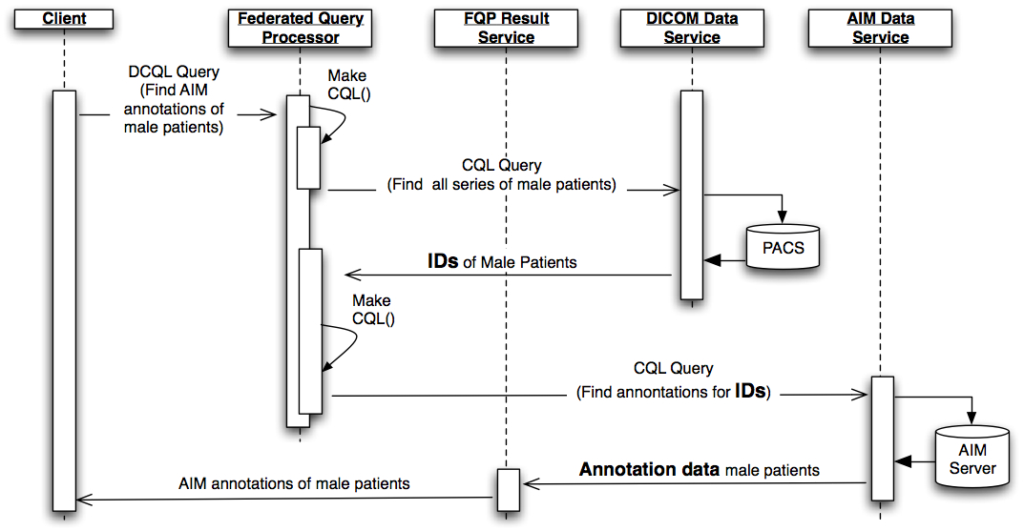
Figure 7. Sequence of events during a DCQL query.
In our infrastructure, the execution of a sample DCQL query that targets certain AIM objects is as follows: The user sets a number of DICOM and AIM object attributes using the FQP client GUI. The client automatically translates this selection into a DCQL query. The query is submitted to an FQP service, which will orchestrate the query execution. The FQP service converts the received query into a CQL query that will target a specific set of DICOM objects based on the attributes selected by the user. This query is executed on a DICOM data service and the DICOM object results are returned to the FQP service that initiated the query. Figure 7 depicts these steps. These results are used to create a second CQL query that will query an AIM data service and retrieve the target AIM objects matching the criteria specified by the client. The retrieved AIM objects are temporarily stored in the FQP result service and then can be retrieved by the client (Figure 8)

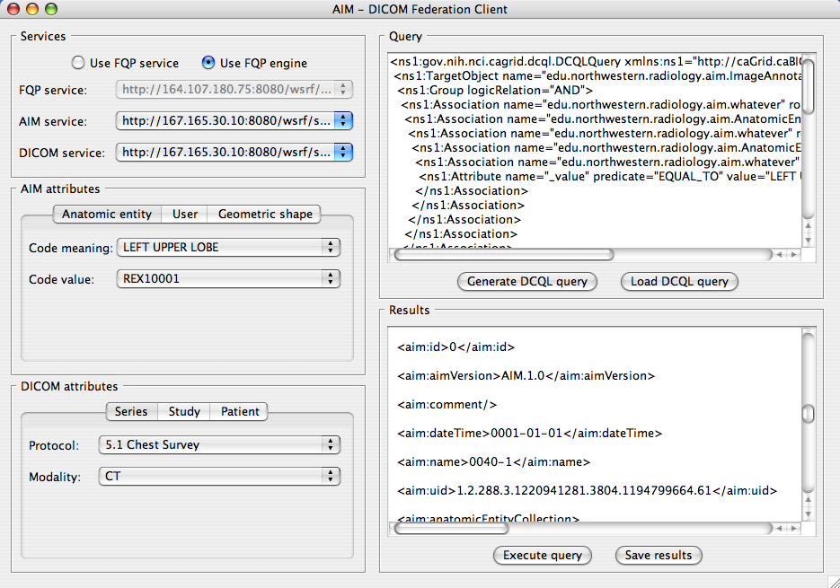
Figure 8. Federated query client user interface

Requirements of Existing caGrid DCQL and FQP
For correct integration of the FQP infrastructure with caGrid services, we identified three requirements on the individual query processor of the data services. First, the query processor must fully implement the CQL specification and be able to return distinct attribute values in response to a query. This can be done by implementing the queryModifier methods on the service side.
Second, the query processors must support the "OR" logical operation. This is used to limit the set of possible attribute values when making joins between multiple data models.
Finally, “IS_NULL” and “IS_NOT_NULL” attribute predicates must be supported. When a data service returns an empty result set, the second CQL query is constructed with a Boolean “AND” of these these two predicates, which evaluates to false and ensures that the overall DCQL query is evaluated to an empty set.

Limitation of Existing caGrid DCQL and FQP
Currently, DCQL supports only one object type as the return type. This limits the query to a filter operation where the search results is filtered by a foreign attribute that exists in a different domain model. The join attribute serves to link the two domain models. The limitation of returning only a single type of object means that to perform a true join operation, where both types of objects are required, the objects of different types must be retrieved separately using separate DCQL queries.
Other limitations of DCQL include the support of a single join attribute. This precludes the formulation of queries where two domain objects are joined when both attributes A and B are equivalent. DCQL and FQP currently also supports joining attributes using only the “EQUAL” predicate. Federated queries with join operation involving range queries therefore are not possible currently. Finally, there is currently no explicit enforcement that the join attributes of the two domain models are semantically equivalent or even related. The quality and meaning of the query result therefore is suspect.
In future extension to DCQL and FQP, several features therefore have been identified as beneficial: support for object tuples with heterogeneous types; support for multiple join attributes; support for joins using predicates in addition to EQUAL; and enforcing semantic meaningful joining of attributes.

PHASE II REQUIREMENTS
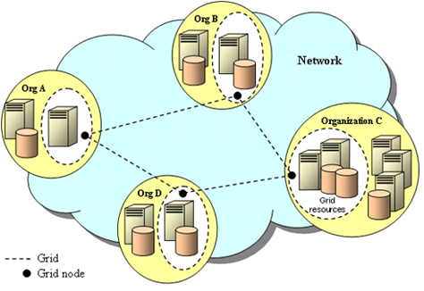




Based on our survey of query approaches and use cases, we have compiled the following requirements for Phase II of the IQ project.
Figure 10. Core components and architecture of the Image Query Platform. The IQ platform consists of components that provide a means for users to compose queries using user-friendly paradigms and to execute them across image database resources accessible on caGrid. Researchers formulate queries using the User Interface, a component that uses the Application Ontology for Query to help the user compose ontology-based queries. The Query Formulation Engine represents the query as a query graph, while the Query Execution Engine translates the query into a low-level query tailored and optimized to be run on caGrid resources. The component also checks for security-related constraints through the Security Layer and executes the query on the Grid, returning the results to the user. The API Layer provides programmatic access to application developers to use the core components for new applications and to enable interoperability of the IQ platform with other caBIG™ projects that require query of data resources.
Application
Ontology for Query
User Interface
Query Formulation Engine
Query Execution Engine
Security Layer

REQUIREMENTS FOR Image Query FORMULATION, EXECUTION, AND IQ Tool
In this portion of the project, we will specify the key components of the IQ Tool and the functional requirements necessary for each component in order to implement a working system. Moreover, in this part of the project, we will describe exactly what the whole software stack will look like in order to support image query. This will clarify the requirements for Phase II of this project and set the stage for a smooth transition into executing that phase of the work.
The following are the core components of the IQ Tool whose functional requirements will be compiled in Phase I, and that will be developed and implemented in Phase II of this project.
- Application ontology for image query
- User interface
- Query formulation engine
- Query execution engine
- Security layer
- Application programming interface layer
An architecture diagram for the IQ Tool showing these components and how they relate to each other is shown in Error: Reference source not found. Users interact with the IQ Tool via the User Interface (application developers can interact with these components via an API Layer). The User Interface enables the user to compose queries to search image databases on the Grid using intuitive paradigms that guide the user in composing an ontology-based query. The User Interface accomplishes its task by interacting with the Query Formulation Engine, a component that accesses an Application Ontology for Query in order to create ontology-based queries. The output from the Query Formulation Engine is a query graph (see Section 3.3.1 and Error: Reference source not found), an abstract representation of the user query in a form that can be translated into different implementing query languages, such as SQL, OQL, or others. The Query Execution Engine performs this translation and executes the query on the Grid, returning results to the user. The execution engine also accesses a Security Layer to take into account access privileges and other data security issues.
Below, we will describe our methods and considerations for developing our design and prototype (Task 2.3), which will address each of these components.

Application Ontology
Our strategy for addressing the challenges of language (such as synonymy and polysemy described in Section 1) and for matching user information needs to the ontology terms used to annotate caBIG™ image resources is to use ontologies for creating user queries. Ontologies provide two key benefits in terms of query formulation: (1) they are declarative structures that make the knowledge needed by applications explicit, and (2) they can be used to map between different resources, provided that entities in those resources are each described using ontologies. Many of the language issues related to a query can be resolved by putting the knowledge needed to resolve synonymy, polysemy, and other issues into an ontology. Then, when a user uses particular search terms, they can be mapped to the canonical form using the ontology as a knowledge source. For example, if a user enters a search term “hepatic carcinoma,” then synonymous search terms such as “heptocellular carcinoma” and “hepatoma” can be included in the search to increase coverage. Hierarchical relations can also be exploited to broaden the search or to narrow it by searching on parents or children of search terms, respectively. Thus, if a user searched for “pheochromocytoma,” the search could be expanded to include terms such as “adrenal medullary neoplasms” if a broader search is desired.
The requirements for the ontology for query will be specified in this part of the project. Those requirements will include the need to represent the kinds of information that users seek (obtained from Task 2.1 and Task 2.2; Section 3.1 and 3.2 above), and the granular data fields actually contained in various image-related databases. Requirements will be gathered to specify how ontology will provide a mapping from the conceptual types of information a user seeks to the low-level data fields needed to be queried. Thus, this task will require a survey of existing metadata related to imaging so mappings from the ontology to existing databases (such as ACRIN, Section 3.2) can be established. In addition, a survey of the existing AIM model will be necessary because AIM specifies the metadata associated with images which will be subject of image search. Relevant components of AIM for the image query ontology could include regions of interest on images associated with annotations taken from ontologies and descriptive metadata, such as anatomy, pathology, and observed characteristics seen on images. Our team is particularly capable of ontology and AIM metadata aspects of the project because in addition to ontology expertise, it contains both of the AIM lead investigators.
Another component of this task is to evaluate existing tools that have search functionality to reconcile the ontology to information models they use. For example, the Freestyle tool is being developed to find Common Data Elements (CDEs).
The ontologies used for query formulation would also need to be stored, managed, and retrieved. Protégé provides programmatic access to ontological information, and is a widely adopted tool. The BioPortal ontology repository (http://bioportal.bioontology.org) will be used for this purpose.
The ontology will also provide the information needed to feed the user interface (Section 3.3.2). The user will not actually see the raw ontology, but it will provide the knowledge necessary to the application to enable users to choose attributes and values for those attributes that will enable their search; all those parameters and values will be obtained from the ontology. The application ontology will organize and specify all the elements that can be queried. The ontology will organize the elements and specify the meaning of the elements so that users can see related elements.
We will specify the approaches to be followed in creating the ontologies for this project. Ontologies must be robust in applications such as this, as they contribute the core knowledge needed by the application. Our methodology will follow best practices in ontology design [1]. Our team has developed many ontologies using the methodology described above in a variety of biomedical domains, including radiology. Recently, members of our Northwestern and Stanford teams collaborated to create an ontology of radiology procedural knowledge to enable integration of information for PACS systems [1]. The ontology-building tasks in this work are similar to that which will be required in this RFP, in that we identified use cases, a target domain, and created ontologies to satisfy the use cases.

User Interface (UI)
Most users know little about ontologies (and probably would prefer not to know about them since they are complex). The UI must be intuitive and easy to use. Its core functional requirement is that it enables users to (1) browse image resources to get a sense for the types of data they contain, and (2) search image resources for specific types of images or image results. The UI should exploit the ontology in enabling the user to broaden and/or narrow their search for caBIG image resources. Because the imaging resources are indexed using ontologies, and users are unlikely to know the terms that are used for indexing, the UI must provide a seamless mechanism to map from a user’s intuitive queries and ontology-based queries. This could be accomplished in a variety of ways, such as providing options to the user to expand free-text queries using the ontology, or providing a direct ontology-oriented method of constructing the queries in the first place.
There are several different requirements for designing the UI to accomplish the above needs. First, the UI could allow users to select data elements from term lists that are filtered according to the context—the type of information the user is seeking. In this manner, they need not peruse a huge and complex ontology. Second, the UI should permit users to formulate more complex ontology-based queries, using data elements and values of those elements. The UI should permit the user to combine query elements with Boolean operators. The user will see a form with various types of fields with drop-down boxes, perhaps a tool palette. The ultimate goal will be to reduce complexity of query formulation for the user.
The ultimate UI created in this project should be reconciled with other UIs used in caBIG, such as that being used by NCIA and other image resources. The UI design should support creating libraries of queries, and allow users to save their queries. The UI may incorporate components from existing tools that has cross-domain query capability, such as caTRIP and caB2B.

Query Formulation Engine
Query Formulation Engine will translate user queries that are formulated using the IQ Tool UI into an ontology-based query graph. A query graph is an information structure that conveys the key components of user query needed to execute it, independent of the specific language used to implement that query. An example query graph is shown in Error: Reference source not found.
These requirements specify how researchers and other users query images and discover and query associated data. Query formulation will support the following types of queries:
- Exact term query: Find images and data containing specified metadata whose values exactly match the term(s) in the user query.
- Concept-based query: Map the user’s query to terms in ontologies and controlled terminologies (“concepts”), and then search for resources indexed with those concepts.
- Query expansion by synonym: Process a user query to find terms that are synonymous with other terms, and use the collected list of synonyms to expand the user query in searching for indexed data resources.
- Query expansion by abstraction: Perform the prerequisite processing to map user queries to concepts (as in the concept-based query type above), but instead of searching on the concepts, search on parents of those concepts (this is the same as hypernym searching).
- Query expansion by progressive refinement: Perform the prerequisite processing to map user queries to concepts (as in the concept-based query type above), present the children of those concepts to allow the user to refine and construct new queries, and search using the new queries (this is the same as hyponym searching).
- Boolean query: Enable users to combine search terms with Boolean operators AND, OR and NOT.
- Query by example: Enable users to search for data based on an example in the form of a “graphical” query language that uses visual views of potential query fields that the user partially fills out in order to initiate a search.
- Correlative query: Enable users to construct queries using terms from multiple ontologies, and execute the queries on services that conform to different data domains and models.
An advantage of representing the query as a query graph is that it maps very nicely to ontologies that are used to compose it. Specifically, the graph contains entities (ovals as in Error: Reference source not found)—the “things” that exist in biomedical reality, and relations between entities (the lines connecting ovals in Error: Reference source not found). Another advantage of adopting a query graph is that we can use this paradigm to implement the Query by Example functionality required by this RFP—the user composes a graphical query with partially-filled values and submits that for processing. All data that match the graphical search pattern will be returned.
“Mary J.”
Breast Cancer
Figure 11. Example Query Graph. This figure illustrates the result of an example query: “find me all patients with breast cancer who had progressive disease by RECIST criteria on CT images while on chemotherapy.” The information elements of the query comprises instances (Breast Cancer, Chemotherapy, CT images, Progressive Disease etc) and relations (has Disease, has Treatment, has Disease Assessment, etc). These entities and relations come from the IQ query ontology (inset lower right) to be developed in this project, and include classes such as DISEASE, PATIENT, TREATMENT, etc. A user query, composed in terms of the ontology, is represented in the form of a graph, with empty placeholders inserted where values are expected to be returned from the query (in this example, placeholders were placed in the graph for PATIENT and DISEASE IMAGING; accordingly, this query returns values of “Mary J.” and “Mary J’s CT Images” when the query was executed). Not shown is the specification of attributes for each instance as part of the query, so that a user can specify particular stages of breast cancer, duration of the chemotherapy, or other characteristics. While this example focuses on queries related to images, the queries can include non-image data, such as results of physical examination for specifying the disease assessment (dashed lines in the figure).
Chemo-therapy
“Mary J’s CT Images”
Progressive Disease (RECIST)
PATIENT
DISEASE
TREATMENT
DISEASE STATUS
DISEASE IMAGING
has Disease Assessment
has RECIST Assessment
has Disease
has Treatment
Physical Exam
has Disease Assessment
A third advantage of the query graph is that it provides a computable representation of the query that can be translated into many different specific query syntaxes. The key advantage of the query graph is that it provides a mechanism to compose a user query independent of the query syntax, enabling interoperability amongst systems that may use different query syntaxes and enabling the IQ Tool to use different query execution engines in the future.
The query graph will be created by the IQ tool after the user interacts with the UI to formulate the query. Once the query graph is created, it will be submitted to the query execution engine (Section 3.3.1) to search all caBIG™ data services supporting this query mechanism on the grid. Any data resource that is compliant with caBIG™ data services, including image and non-image data services, will be able to be queried through this query mechanism, now as well as in the future. Thus, this will be a scaleable method for image query. . The ACRIN use case will be particularly advantageous to develop as a queryable resource, because a subset of ACRIN data will be accessible via caGrid data service interface. This data service interface is provided via the caGrid enabled NCIA instance running at ACRIN.
If new data types become available subsequent to implementation of this project, the application ontology would need to be updated. The IQ system will be designed to minimize the impacts of and facilitate these ontological updates. However, this would be a maintenance operation, not in scope for this project, though it would need to be addressed and taken up by those maintaining the project once it is deployed.

Query Execution Engine
Once user queries are formulated in terms of an ontology-based query graph, this knowledge structure needs to be interpreted properly in order to connect the diverse data sources to which the query applies, and pertinent data must then be retrieved. We call these steps query execution. Specifically, query execution includes the following steps:

- Query Validation. The ontology based query tree is analyzed for validity in the caBIG™ environment. The concepts in the query tree are mapped to terms in caBIG™ EVS, and CDEs and models related to the concepts are identified from the caDSR. Unmappable ontological concepts in the query tree indicate problems in the query tree, requiring user intervention.
- Query Translation. The ontology-based query graph is converted into a query statement in DCQL form. The translation is based on the terms, CDEs, and models discovered from EVS and caDSR from the previous step. The Query Execution Engine will need to access the ontology to perform the translation. Multiple queries involving different models may result from the translation process as a term may be mapped to multiple models.
- Query Planning and Optimization. The CQL query statement is simplified and optimized based on the data models that have been identified to be involved in the query. Model attributes and associations are grouped according to the models to which they belong. A priori information may be injected to facilitate query optimization, such as the size of expected query result, in order to maximize query performance and/or minimize data movement.
- Query Processing. The optimized DCQL query statement is then executed either using a local caGrid Federated Query engine or a remote caGrid Federated Query Service, and the results are returned to the user.
- Result Aggregation. The result of the query from multiple data services will need to be aggregated into an efficient storage structure for return to the user. The structure will need to maintain join relationships while minimizing data replication and facilitate ease of data access.

The Query Execution Engine as described above is general in principle, and can potentially be used for distributed and federated query of all silver compliant, caGrid-based services. In the primary anticipated use case of federated query on DICOM Data Service and AIM Data Service, the DICOM Data Service will present the image metadata using the NCIA DICOM data model, and the AIM Data Service will present the data via the AIM data model. While the services may store the images and AIM objects using different storage formats and database mechanisms, the grid services present the standard interfaces conforming to the NCIA and AIM models. The Query Execution Engine constructs the DCQL query statement based on the caBIG™ accepted models and executes the queries using the standard, common DICOM and AIM Data Service interfaces.

Preliminary investigation in the distributed and federated query for DICOM image data indicates that there are several areas that would require modifications and additional development. DCQL supports queries with a single, strongly typed object type for the query result, which must be defined during the construction of the DCQL statement. There is no support for tuples of objects with different data types. One consequence is that the DCQL query is performed more similar to a filter operation, using foreign attributes as filters, rather than a true join operation. The results must be joined by the client application post query. Another consequence of this restriction is that a typical join operation would necessitate multiple query passes. For example, if we wish to retrieve images where the annotations satisfy a certain criteria and display the images with annotations, then the current caGrid infrastructure will require us to execute two queries. The first query will retrieve only those images which have the annotations satisfying our query criteria. The second query will retrieve the qualified annotations themselves. For efficient operation of the IQ tool, the caGrid Federated Query Processing Infrastructure and DCQL will need to be modified and extended to support multiple data type results and true join. In addition, the performance and scalability of the Federated Query Processing Infrastructure will need to be evaluated and potentially improved. Extension of the caGrid federated query processing infrastructure may include:

- Support for sequence of queries
- Performance optimization via data model aware query planning
- Efficient data join operation
- Support for multiple, aggregated data types in the result
- Potential optimization in the caGrid infrastructure for efficient querying of data services

A second challenge that was discovered during the preliminary investigation is that DICOM does not support multiple values in a query, which is equivalent to the OR Boolean operation for attribute value filtering. For example, it is not possible to construct a DICOM C_FIND messages to query for all images with PatientName=JohnDoe OR PatientName=JaneDoe. This query needs to be decomposed into 2 C_FIND operations. A scalable approach needs to be devised to address this limitation for the IQ toolkit. Similarly, existing data repositories such as QARC, ACRIN, and NCIA may require repository-size modification to support query and retrieve image and non-image datasets efficiently for IQ project use cases.

Security Layer
Security for distributed and federated query formulation and execution follow the same guidelines and policies as those for security for individual data resources. Security will be addressed in two aspects: authentication and authorization.
Authentication includes user authentication and service authentication. For user authentication, we will leverage the Dorian authentication service in the caGrid GAARDS infrastructure. Dorian provides grid-based authentication and credential management. The user will log in through the Query Formulation UI, which in turn authenticates the user against the Dorian service. Service authentication involves using a host-based certificate to ensure that the UI and the Query Execution Engine are communicating with authenticated data services.
Proper authorization will require that the administrators for each data service properly configure role-based access to the data service, the query operation, and the data instances managed by the service. In addition, the Query Execution Engine must properly delegate the user’s credential to each data service in order for the data services to properly authorize and log data access.
A functionality and corresponding policy that will need to be designed during the execution of the project is how to handle a failure in authorization. An incomplete query may generate incomplete and even erroneous results, which may lead to incorrect conclusions during interpretation. Proper procedure for handling these exceptions will be critical.

Application Programming Interface (API) Layer
As mentioned earlier in the proposal, the paradigm of querying data resources is common to caBIG and is applicable to other caBIG projects. To enable interoperability of our query platform with other caBIG projects now and in the future, we will provide an API Layer to enable developers to access the core functionality of the IQ system. In addition, this API will enable developers who want to create applications that use ontology-based query to integrate this functionality into their systems. For example, we anticipate that XIP would integrate image query into its platform by wrapping the IQ Tool using this API.

Historical vs Future Data
The Phase II work needs to address dealing with historical and future data. For historical data, it will be necessary to find out how current source data is stored. That activity would point to a way to convert historical data to AIM. An alternative would be to create data services that IQ can talk to. For future data, AIM will be used for annotating data, so IQ-compliance is assured.

Other Design Considerations
Software Development
Though no software will be created in Phase I of this project, the requirements set forth for Phase II will include a stipulation that all software to be developed will be created in compliance with caBIG principles of Open Source / Open Access, Open Development and Federation.
All software will be developed according to the caBIG Compatibility Guidelines (version 2, July 2005). We intend the software developed to be of Silver level maturity.
Vocabularies and Ontologies
All of the concepts develop in the context of the AIM ontologies will be reconciled with the EVS. This process will entail searching EVS for existing terms that can be reused in our ontologies before creating new ontology terms. If existing terms are located in EVS, they will be included in our ontologies with the appropriate source name and unique identifiers to serve as back-references to the source terminology. If there are no existing terms in EVS required by our ontologies, we will create new terms and submit them for consideration by NCI for incorporation into EVS.
Common Data Elements
Any common data elements developed will be reconciled with caDSR. This process will entail searching caDSR for any existing CDEs (if applicable) that need to be created in this project. If a CDE already exists in caDSR, then it will be used instead of creating a new CDE, and the appropriate identifier and source for the CDE will be recorded. If there are no existing CDEs, we will create new CDEs and submit them to NCI for consideration to be added to caDSR.
Information Models
Based on the content of the query ontologies developed in this project and in reconciliation with other pertinent ontologies/terminologies, we will create an information model for representing user queries. We will use Enterprise Architect (Sparx Systems Pty Ltd, Creswick, Victoria, Australia) to produce object-oriented query models expressed in UML as class diagrams and as XMI files. The Enterprise Architect software package provides unified modeling language (UML) tools and manages detailed requirements, modeling and analysis, generating and importing source code, generating and importing database schema, generating and importing XML schema, creating component and deployment models, tracking changes and managing tests. These files shall be delivered to the GForge site.
caGrid Data Services
For this project, the primary goal is to integrate Image related annotations and metadata to the images. A requirement is ability to interact with data services in a standard way. For phase II of the Image Query project, the focus will be the ontology-driven query of caGrid based Data Services that support CQL as the standard query language. Phase II project will need to support DICOM centric image data services that utilize the NCIA data model, as well as annotation data services that uses the AIM data model.
caGrid Enhancements
To support query execution against caGrid data services, CQL and DCQL may need to be extended as described in Section 2.3.4, and the Federate Query Processor may also need to be enhanced.

