AI Usage DISCLOSURE FORM

1. Team Details
Team Name: ____Byte Sized Brains___________
Project / Product Name: _____Autonomous GenAI Research Navigator_______________
Organization / Institution (if any): ______MS Ramaiah Institute of Technology______________
Submission Date: _____07/05/2026__________________

2. AI Usage Declaration
Did your team use any Artificial Intelligence (AI) in developing this project? Yes / No
___________Yes____________________

3. Purpose of AI Usage (Brief Details)
Idea generation / brainstorming ______ Used AI to identify unexplored research gaps, generate innovative project ideas, and assist in brainstorming solution workflows and multi-agent architecture concepts. ____________
Code generation or assistance __ Used AI for backend API integration, multi-agent pipeline logic, OpenAI API handling, react component generation, and debugging implementation workflows.______________
UI / UX design _______ Used AI to design the research dashboard layout, workflow visualization, knowledge graph interaction ideas, and improve overall user experience and presentation flow. _________
Content creation ________ Used AI to generate PPT content, project descriptions, technical documentation, demo explanations, and structured research summaries. ________
Data analysis _________ Used AI to analyze research papers, extract key themes, identify relationships between concepts, and detect underexplored research areas. ______
Testing / debugging ___ Used AI to troubleshoot API integration issues, debug frontend/backend errors, optimize prompts, and validate workflow outputs. ___________
Other _______ Used AI for multi-agent orchestration planning, workflow simulation, prompt engineering, and research intelligence pipeline design. _________________

4. Feature Origin Classification (Please add/delete based on the number of the feature)
1. Feature Name _________ Research Gap Detection Engine___________
2. Self-Generated/AI-Generated/Both _______ Both____________
3. Description (include AI tools/platform Used, prompt used, Output Summary, Modification) ___________ This feature was designed to identify underexplored research areas and missing connections between domains. AI tools such as ChatGPT and OpenAI APIs were used to refine prompts and analyze research summaries.
AI Tools / Platforms Used: ChatGPT, OpenAI API, arXiv API, Kiro, GitHub Copilot
Sample Prompt:
“Analyze these research papers and identify unexplored gaps or weakly connected research areas.”
Output Summary:
Generated structured gap analysis and innovation opportunities from research papers.
Modifications Made:
Outputs were manually refined and integrated into the multi-agent workflow for better relevance and clarity.

1. Feature Name _______Multi-Agent Research Workflow_____________
2. Self-Generated/AI-Generated/Both ______Both_____________
3. Description (include AI tools/platform Used, prompt used, Output Summary, Modification) _______________________the multi-agent architecture was self-designed based on the project concept. AI assistance was used to optimize workflow orchestration, agent responsibilities, and backend pipeline logic.
AI Tools / Platforms Used: ChatGPT, OpenAI API
Sample Prompt:
“Design a multi-agent workflow for research analysis and idea generation.”
Output Summary:
Generated agent roles including Research Agent, Summarizer Agent, Gap Detection Agent, and Idea Generation Agent.
Modifications Made:
The workflow was customized into an OpenClaw-inspired orchestration pipeline suitable for the project implementation.

1. Feature Name _________AI-Based Idea Generation___________
2. Self-Generated/AI-Generated/Both _______Both____________
3. Description (include AI tools/platform Used, prompt used, Output Summary, Modification) ________________________This feature generates innovative project ideas based on detected research gaps. AI was used for prompt engineering, structured response generation, and improving idea relevance.
AI Tools / Platforms Used: ChatGPT, OpenAI API
Sample Prompt:
“Based on these identified research gaps, generate a unique and feasible project idea with explanation.”
Output Summary:
Generated project ideas with reasoning, innovation potential, and possible applications.
Modifications Made:
Outputs were filtered and refined to improve practicality and alignment with the project domain.

1. Feature Name _______Knowledge Graph & Research Relationship Mapping_____________
2. Self-Generated/AI-Generated/Both _______Both____________
3. Description (include AI tools/platform Used, prompt used, Output Summary, Modification) ________This feature visualizes relationships between papers, concepts, and research domains using an interactive knowledge graph. AI assistance was used to improve relationship mapping logic and visualization ideas.
AI Tools / Platforms Used: ChatGPT, OpenAI API, D3.js concepts
Sample Prompt:
“Suggest methods to visualize relationships between research topics and papers using graph-based structures.”
Output Summary:
Generated approaches for node connections, concept mapping, and interactive research exploration.
Modifications Made:
The visualization workflow was simplified and optimized for real-time interaction and better user understanding.

5. Ethical & Compliance Confirmation
AI usage complies with guidelines and policies. Yes
No proprietary or copyrighted data misused. I Agree

6. Declaration & Sign-Off
Name of Team Representative: Kotadia Nishka Ankitkumar
Role: Team Lead
Signature:
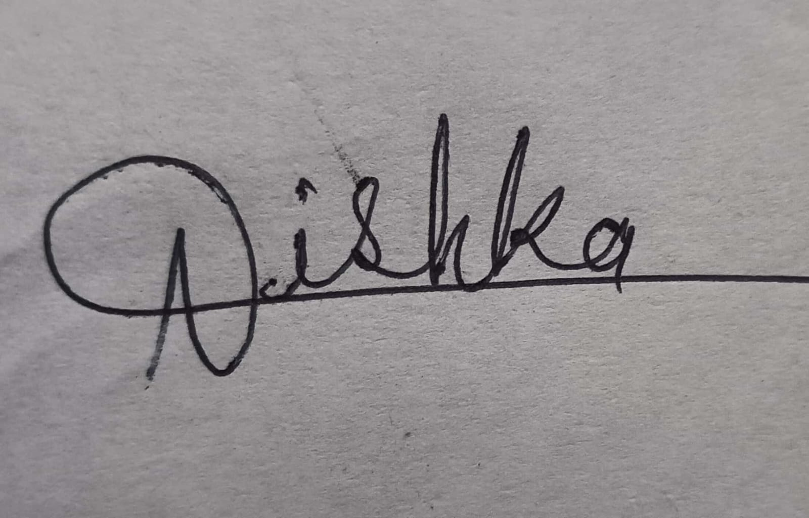
Date: 07-05-2026

