#include <stdio.h>

int main()

{

int age;

char name;

char school;

printf("enter the age ");

scanf("%d",&age);

printf("enter the name\n");

scanf("%c",&name);

printf("enter the school");

scanf("%c",&school);

return 0;

}

**OUTPUT**

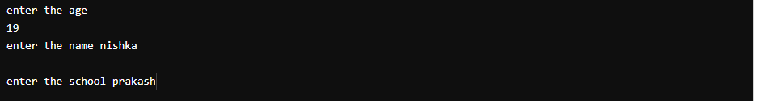

#include <stdio.h>

int main()

{

printf("- - - - - -\n|\t\t\t");

printf("|\n|\t\t\t");

printf("|\n");

printf("| N A M E \n|\t\t\t");

printf("|\n|\t\t\t");

printf("|\n");

printf("- - - - - -\n");

return 0;

}

**OUTPUT**

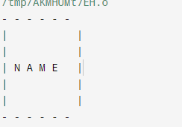

#include <stdio.h>

int main()

{

printf("*\n");

printf("* *\n");

printf("* * *\n");

printf("* *\n");

printf("*\n");

return 0;

}

**OUTPUT**

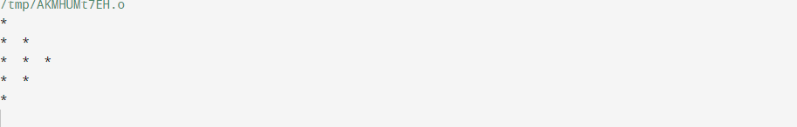

#include <stdio.h>

int main()

{

printf("*\n");

printf("*\n");

printf("*\n");

printf("* * *\n");

printf("* * * * *\n");

printf("* * * *\n");

printf("* * * *\n");

printf("* * * *\n");

printf("*\n");

return 0;

}

**Output**

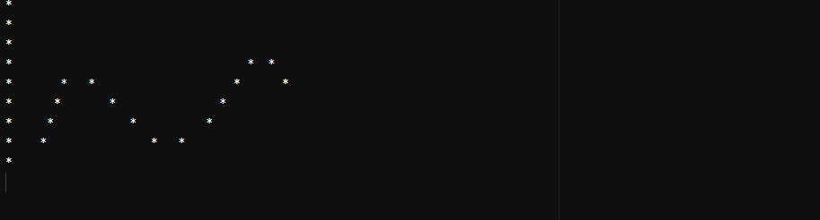

#include <stdio.h>

int main()

{

printf("* * * * *\n");

printf("* *\n");

printf("* *\n");

printf("* * * * *\n");

printf("* *\n");

printf("* *\n");

printf("* *\n");

return 0;

}

**Output**

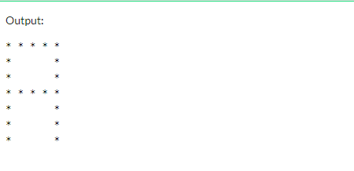

#include <stdio.h>

int main() {

// Write C code here

printf("* * * * *\n");

printf(" *\n");

printf(" *\n");

printf(" *\n");

printf(" *\n");

printf(" * *\n");

printf(" * *\n");

return 0;

}

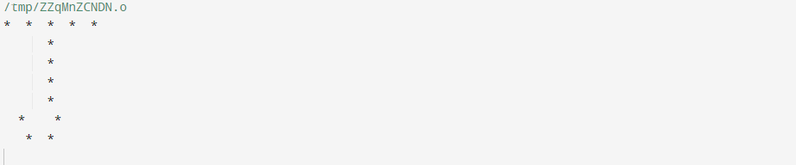

#include <stdio.h>

int main() {

// Write C code here

printf("* *\n");

printf("* *\n");

printf("* *\n");

printf("* *\n");

printf("* *\n");

printf("* *\n");

printf("* *\n");

return 0;

}

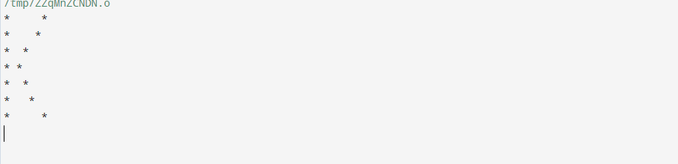

#include <stdio.h>

int main() {

// Write C code here

printf("*\n");

printf("*\n");

printf("*\n");

printf("*\n");

printf("*\n");

printf("*\n");

printf("* * * *\n");

return 0;

}

OUTPUT

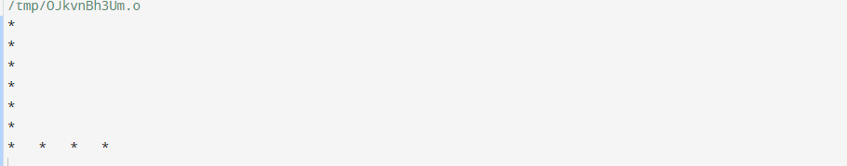

#include <stdio.h>

int main() {

// Write C code here

printf("* *\n");

printf("* * * *\n");

printf("* * *\n");

printf("* *\n");

printf("* *\n");

printf("* *\n");

printf("* *\n");

return 0;

}

Output

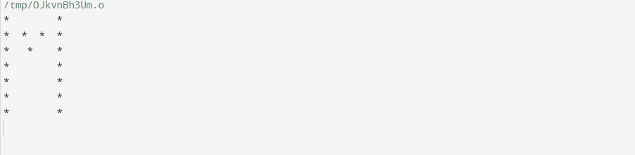

#include <stdio.h>

int main() {

// Write C code here

printf("* *\n");

printf("* *\n");

printf("* * *\n");

printf("* * *\n");

printf("* **\n");

printf("* *\n");

printf("* *\n");

return 0;

}

Output

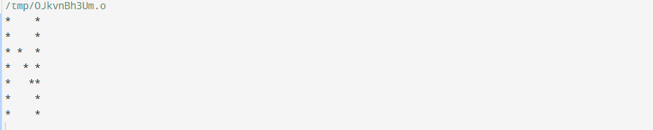

#include <stdio.h>

int main() {

// Write C code here

printf(" * * *\n");

printf("* *\n");

printf("* *\n");

printf("* *\n");

printf("* *\n");

printf("* *\n");

printf(" * * *\n");

return 0;

}

Output

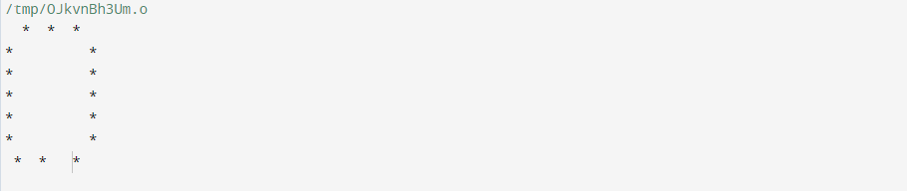

#include <stdio.h>

int main() {

printf("* * * *\n");

printf("* *\n");

printf("* *\n");

printf("* * * *\n");

printf("*\n");

printf("*\n");

printf("*\n");

return 0;

}

Output

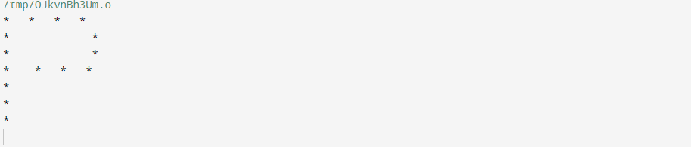

nclude <stdio.h>

int main() {

printf("* * *\n");

printf("* *\n");

printf("* *\n");

printf(" * * *\n");

printf("* *\n");

printf("* *\n");

printf("* *\n");

return 0;

}

Output

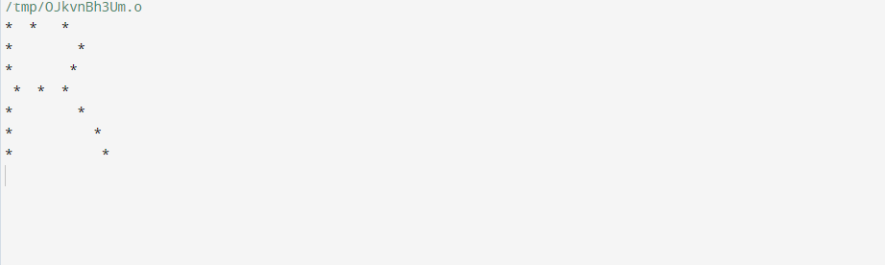#include <stdio.h>

int main() {

printf(" * * *\n");

printf("* *\n");

printf("* *\n");

printf("* *\n");

printf("* * *\n");

printf("* *\n");

printf(" * * *\n");

return 0;

}

Output

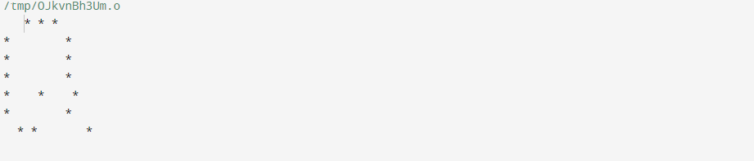

#include <stdio.h>

int main() {

printf(" * * * *\n");

printf("*\n");

printf("*\n");

printf(" * * *\n");

printf(" *\n");

printf(" *\n");

printf(" * * * *\n");

return 0;

}

Output

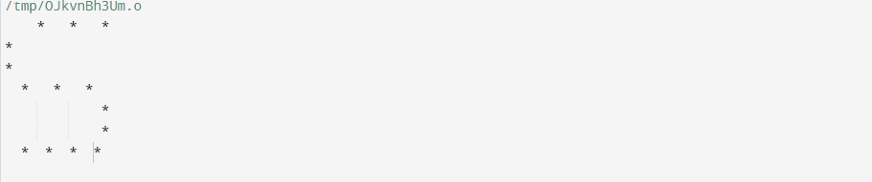

#include <stdio.h>

int main() {

printf("* * * *\n");

printf(" * \n");

printf(" * \n");

printf(" * \n");

printf(" * \n");

printf(" * \n");

printf(" * \n");

return 0;

}

Output

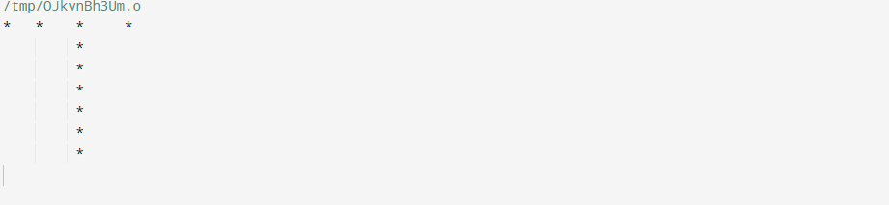

#include <stdio.h>

int main() {

printf("* *\n");

printf("* *\n");

printf("* *\n");

printf("* *\n");

printf("* *\n");

printf("* *\n");

printf(" * * *\n");

return 0;

}

Output

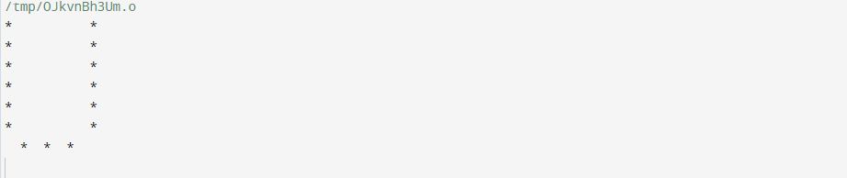

#include <stdio.h>

int main() {

printf("* *\n");

printf("* *\n");

printf("* *\n");

printf("* *\n");

printf(" * *\n");

printf(" *\n");

return 0;

}

Output

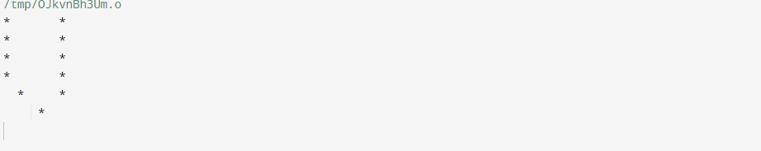

#include <stdio.h>

int main() {

printf("* *\n");

printf("* *\n");

printf("* *\n");

printf("* *\n");

printf("* * *\n");

printf("* * * *\n");

printf("* *\n");

return 0;

}

Output

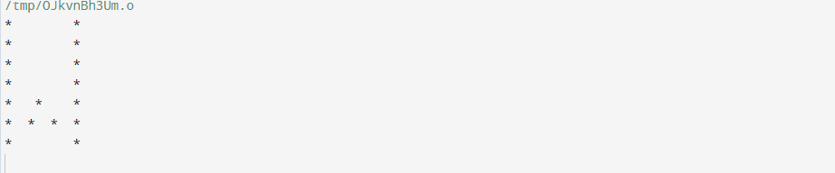

#include <stdio.h>

int main() {

printf("* *\n");

printf(" * *\n");

printf(" *\n");

printf(" *\n");

printf(" *\n");

printf(" *\n");

printf(" *\n");

return 0;

}

Output

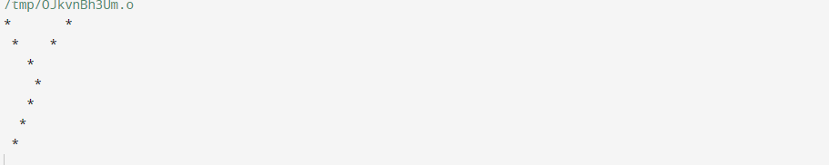

#include <stdio.h>

int main() {

printf("* * * * *\n");

printf(" *\n");

printf(" *\n");

printf(" *\n");

printf(" *\n");

printf(" *\n");

printf(" * * * * *\n");

return 0;

}

Output

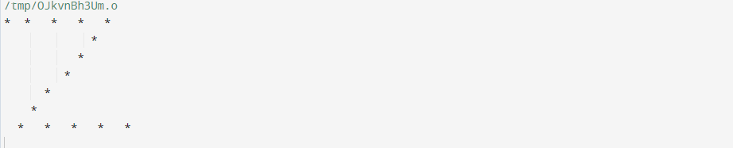

#include <stdio.h>

int main() {

printf("* *\n");

printf(" * *\n");

printf(" * *\n");

return 0;

}