FirstRmarkdown

Sowmya Vajjala

February 8, 2018

I will show how to add 2 numbers in R. I will also show how to plot. 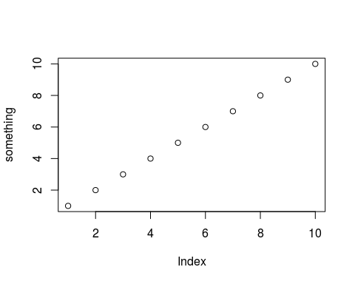

I am repeating the process, with different numbers 