REPORT

DATA FOR 1 PERSISTENT DATA

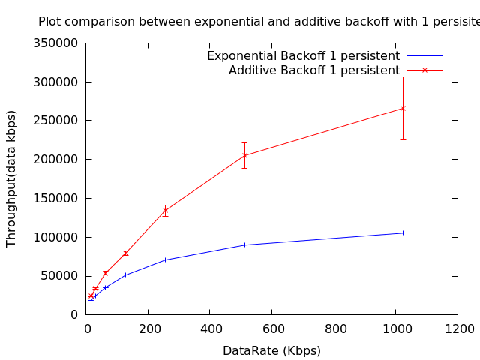

This is the plot for throughput of exponential and additive back off. The reason for a larger throughput for additive may be because we are waiting for less period of time between consecutive retries to transmit a packet. As within a short interval we are trying more often to send the packet the chances of sensing an idle state for the channel increases and thus more percentage of packets gets sent. However the number of packets dropped should also increase as we fill our quota of maximum retries in a short time. It seems that the former effect is more profound and hence the plot.

Another interesting thing is that for additive back off the variation of throughput at a particular data rate is much less compared to exponential back off.

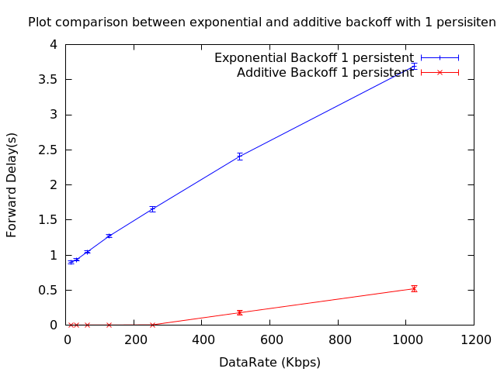

We are effectively decreasing the queuing time as the packet gets sent sooner in additive back off. The large difference is also due to the fact that we have only 4 transmitters transmitting at any one point of time. So the channel becomes idle in a much smaller period of time compared to the real world where we have thousands of broadcasting points for which the exponential back off was modeled. As such we see this steep difference.

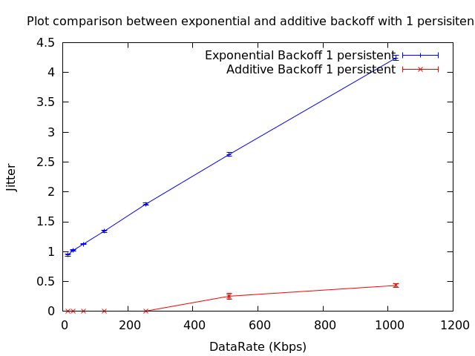

We can state similar reasons as the one above. Jitter is almost negligible for additive back off up to a data rate of 256 Kbps and then it picks up.

The variation is more for exponential back off because given a packet is not transmitted as the channel is busy it waits for a longer period of time compared to additive back off.

DATA FOR p PERSISTENT DATA

Throughput:

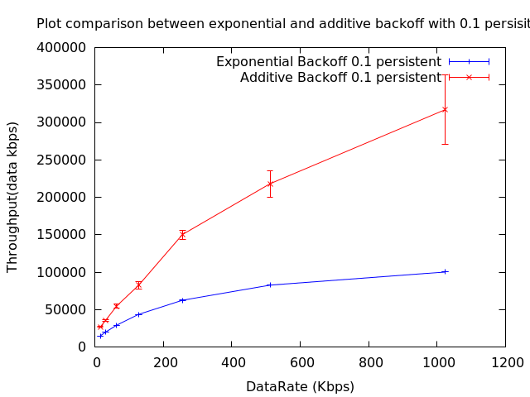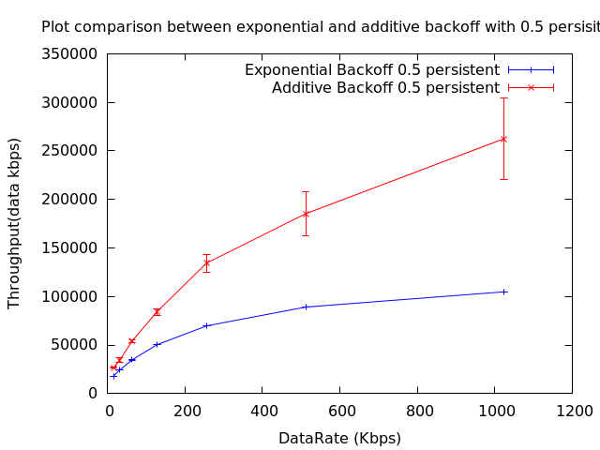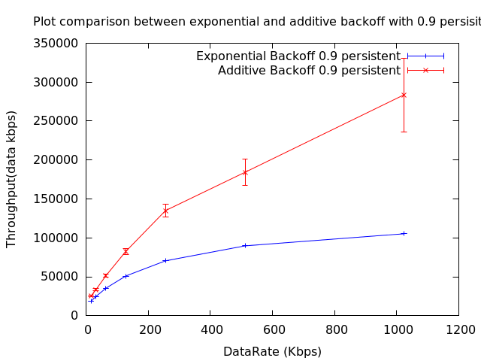

The value of throughput is not varying much with change in persistence. The reason is because we are dealing with pretty light channel traffic and the number of collisions is as such less.

With increase in probability of transmitting packet given that the channel is idle increases the throughput. However the increase is not much because we are dealing with only 4 client server pairs. For 0.1 persistence the throughput is less than that at 0.5 persistence which is less than the throughput at 0.9 persistence.

Delay:

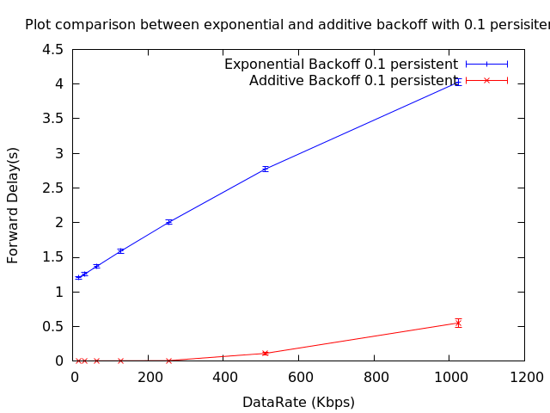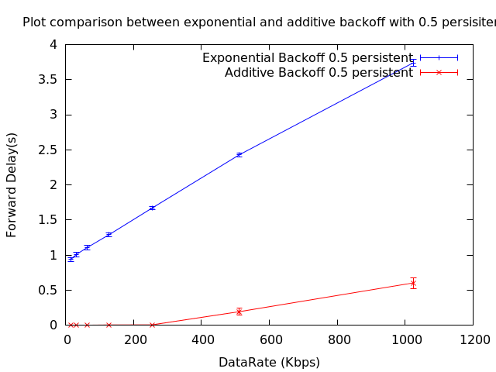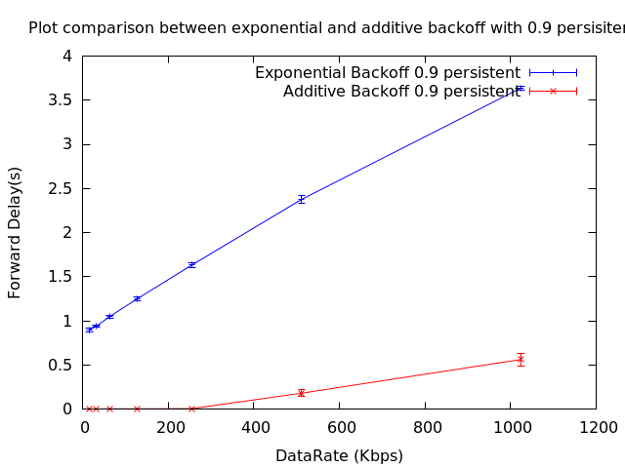

There is no perceivable change in delay in additive back off.

Jitter:

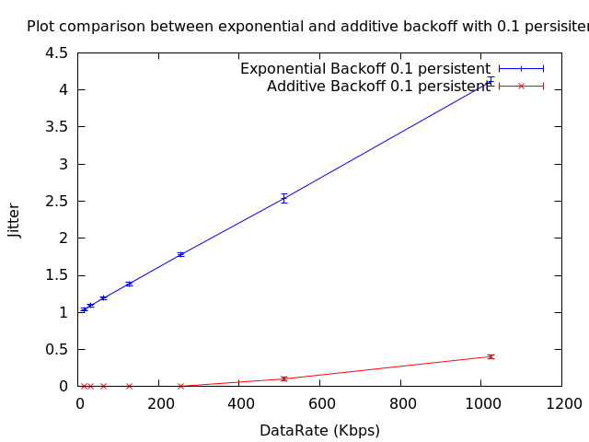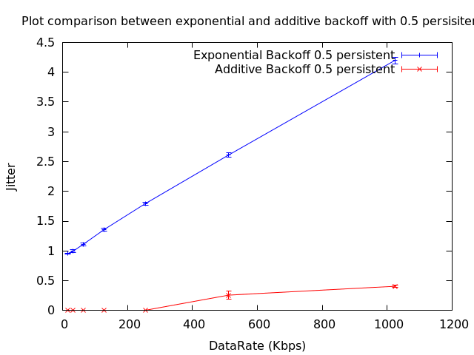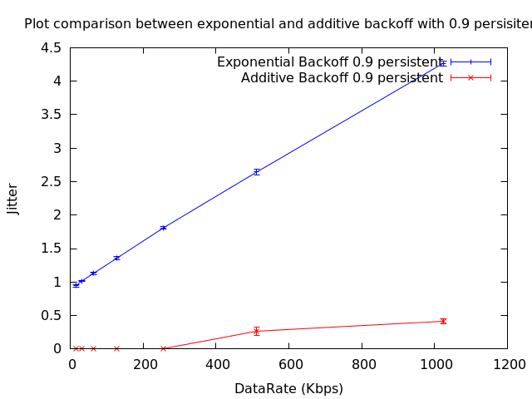

Jitter increases from 0.1 persistence to 0.5 persistence and then decreases when we simulate at 0.9 persistence.