A framework for Modelling and Simulation of Fog Computing Infrastructure and Services

The “pay-as-you-go” Cloud Computing model is an efficient alternative to owning and managing private data centers (DCs) for customers facing Web applications and batch processing. Several factors contribute to the economy of scale of mega DCs: higher predictability of massive aggregation, which allows higher utilization without degrading performance. Cloud computing frees the enterprise and the end user from the specification of many details. But this bliss becomes a problem for latency-sensitive applications, which require nodes in the vicinity to meet their delay requirements. An emerging wave of Internet deployments, most notably the Internet of Things (IoTs), requires mobility support and geo-distribution in addition to location awareness and low latency. This is where a new platform of Fog Computing is emerging. Fog computing is not here to remove the Cloud paradigm, it makes a very useful interplay between Cloud and Fog.

Need for the fog computing arose due to the following issues faced by many applications when dealing with a cloud framework:

1. Application that require very low and somewhat predictable latency . Example Gaming,Video conferencing
2. Geo-Distributed Applications ( pipeline monitoring, traffic monitoring, sensor networks)
3. Fast mobile applications (smart connected vehicles,connected rail)
4. Large scale distributed control systems (smart grid, connected rail, smart traffic light systems)

As the IoT has emerged more and more use cases of interest pertaining to above problems are faced by researchers day by day. Moreover it is also bringing Big Data with a twist, rather than high volume, it brings upon high number of data sources to work upon. As we delve deeper into the realm of Fog Computing, we will realize that the mutual existence of Cloud computing is necessary for this paradigm to work successfully.

Architectural View of Fog and Cloud

Cloud computing mainly consists of homogenous physical resources that are managed and deployed in a very centralized fashion. Fog complements and extends the cloud to the edge and endpoints which means that Fog’s distributed infrastructure comprising of heterogeneous resources needs to be managed in a distributed fashion. As can be seen in the figure given below, one can observe the various players involved in the distributed Fog infrastructure which range from data centres, core of the network, edge of the network and end points.

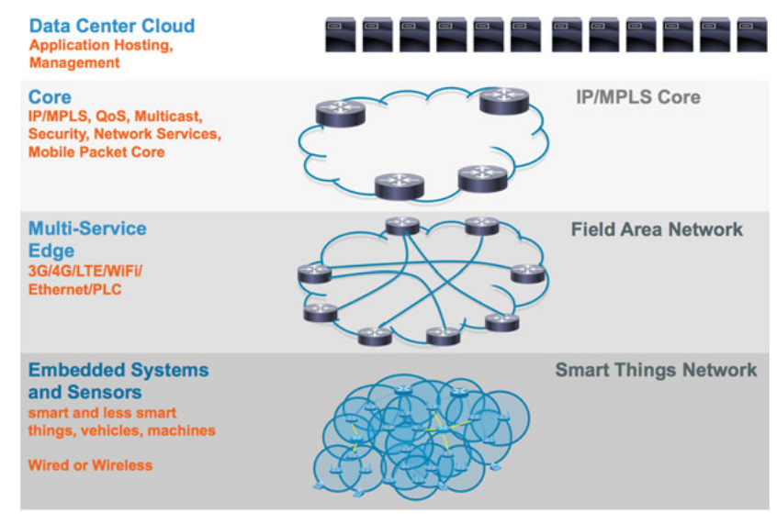

Figure 1: Fog distributed infrastructure in IoT

Similar to the Cloud, Fog also pertains to the existence of multiple tenants, with each tenant perceiving its resources as dedicated and defining its own topology. As can be seen in figure 2, there are two active tenants, A and B, with their respective applications. The distributed application A has one Cloud component and two Fog components on the other hand B has one Cloud component, a component in the core and one fog component. A virtual network topology is assigned to each of them.

In order to fully manifest this distributed architecture, Fog relies on technology components for scalable virtualization of the key resource classes:

* Computing: Requiring the selection of hypervisors in order to virtualize both the computing and I/O resources.
* Storage: Requiring a Virtual File System and a Virtual Block and/or Object Store.
* Networking: Requiring the appropriate Network Virtualization Infrastructure   
  (eg. Software Defined Networking technology).

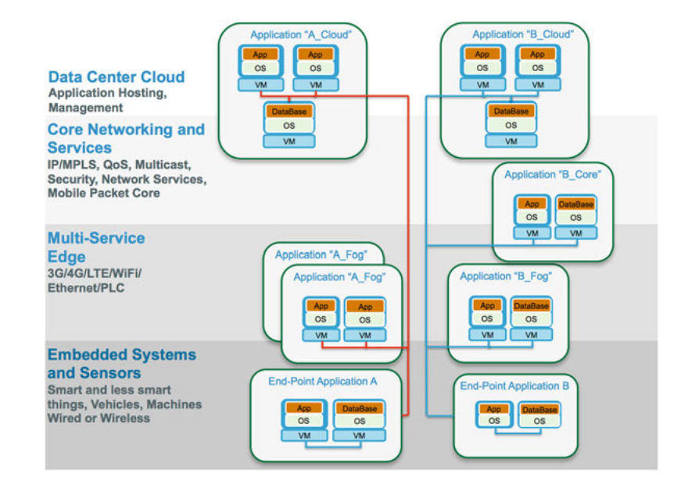

**Figure 2: Distributed IoT/IoE applications on the fog infrastructure**

Use Cases

Mention the two use cases in the following pages.

**Thermal Sensing in different labs located in the institute**

**Intelligent Traffic Light management**

**Software Architecture**

The use cases described above necessitates the following key objectives of Fog architecture:

* Nodes are heterogeneous in nature and deployed in variety of environments including core,edge, access networks and endpoints.
* The Fog platform hosts diverse set of applications belonging to various verticals smart connected vehicles to smart cities, oil and gas, smart grid etc. Fog architecture should expose **generic APIs** that can be used by the diverse set of applications to leverage Fog platform.
* The Fog platform should provide necessary means for distributed policy-based orchestration, resulting in scalable management of individual subsystems and the overall service.