- Find Sum of Array Elements

import java.util.Scanner;

public class Q_01 {
public static void main(String[] args) {

Scanner sc = new Scanner(System.in);

System.out.print("Enter the size of array: ");
int n = sc.nextInt();

int[] arr = new int[n];

System.out.println("Enter " + n + " elements:");

for (int i = 0; i < n; i++) {
arr[i] = sc.nextInt();
}

int sum = 0;

for (int i = 0; i < n; i++) {
sum = sum + arr[i];
}

System.out.println("Sum of array elements: " + sum);

sc.close();
}
}

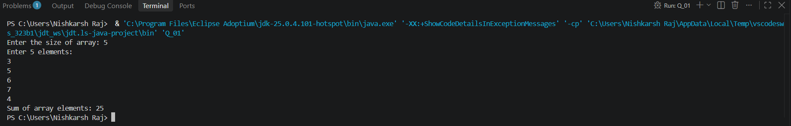

- Find Largest Element in an Array

import java.util.Scanner;

public class Q_02 {

public static void main(String[] args) {

Scanner sc = new Scanner(System.in);

System.out.print("Enter the size of array: ");
int n = sc.nextInt();

int[] arr = new int[n];

System.out.println("Enter " + n + " elements:");

for (int i = 0; i < n; i++) {
arr[i] = sc.nextInt();
}

int largest = arr[0];

for (int i = 1; i < n; i++) {
if (arr[i] > largest) {
largest = arr[i];
}
}

System.out.println("Largest element: " + largest);

sc.close();
}
}

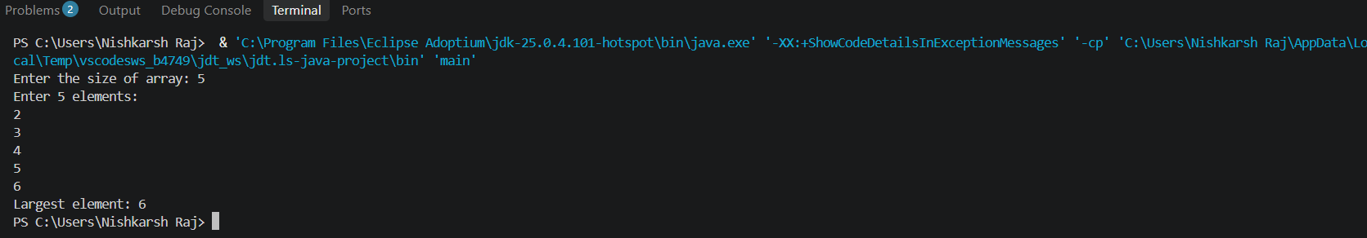

- Search an Element in an Array

import java.util.Scanner;

public class Q_03 {

public static void main(String[] args) {

Scanner sc = new Scanner(System.in);

System.out.print("Enter the size of array: ");
int n = sc.nextInt();

int[] arr = new int[n];

System.out.println("Enter " + n + " elements:");

for (int i = 0; i < n; i++) {
arr[i] = sc.nextInt();
}

System.out.print("Enter the element to search: ");
int search = sc.nextInt();

boolean found = false;

for (int i = 0; i < n; i++) {
if (arr[i] == search) {
System.out.println("Element found at index: " + i);
found = true;
break;
}
}

if (!found) {
System.out.println("Element not found");
}

sc.close();
}
}
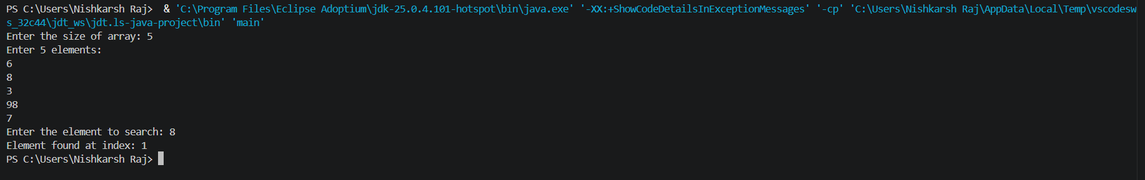

- Reverse an Array

import java.util.Scanner;

public class Q_04 {

public static void main(String[] args) {

Scanner sc = new Scanner(System.in);

System.out.print("Enter the size of array: ");
int n = sc.nextInt();

int[] arr = new int[n];

System.out.println("Enter " + n + " elements:");

for (int i = 0; i < n; i++) {
arr[i] = sc.nextInt();
}

System.out.println("Reversed array:");

for (int i = n - 1; i >= 0; i--) {
System.out.print(arr[i] + " ");
}

sc.close();
}
}
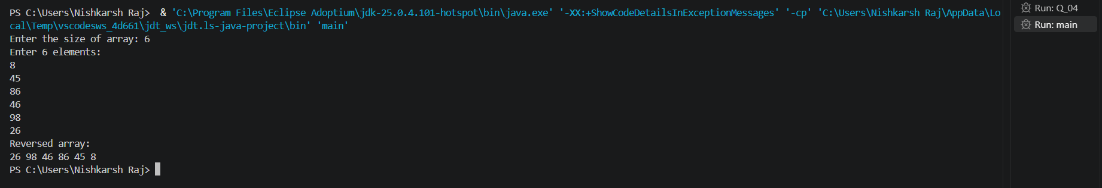
5. Count Occurrence of an Element in an Array

import java.util.Scanner;

public class Q_05 {

public static void main(String[] args) {

Scanner sc = new Scanner(System.in);

System.out.print("Enter the size of array: ");
int n = sc.nextInt();

int[] arr = new int[n];

System.out.println("Enter " + n + " elements:");

for (int i = 0; i < n; i++) {
arr[i] = sc.nextInt();
}

System.out.print("Enter the element to count: ");
int search = sc.nextInt();

int count = 0;

for (int i = 0; i < n; i++) {
if (arr[i] == search) {
count++;
}
}

System.out.println(search + " occurs " + count + " time(s)");

sc.close();
}
}
