Assignment: Polymorphism in Java
Part A: Understanding of Theory Concept

1. Explain Polymorphism in Java
Polymorphism is one of the four fundamental principles of Object-Oriented Programming (OOP). The word polymorphism means “many forms.” In Java, polymorphism allows the same method name or interface to perform different tasks depending on the situation.
For example, a method named add() may add two integers, three integers, or two decimal numbers.
Importance of Polymorphism:
- Improves code flexibility and reusability.
- Reduces code duplication.
- Makes programs easier to maintain.
- Supports method overloading and method overriding.
- Helps achieve dynamic and flexible behavior in applications.

2. Explain the Types of Polymorphism
Java mainly supports two types of polymorphism:
A. Compile-Time Polymorphism (Static Polymorphism)
Definition: Compile-time polymorphism is achieved when the method to be executed is determined by the compiler during compilation.
It is mainly implemented using Method Overloading.

B. Run-Time Polymorphism (Dynamic Polymorphism)
Definition: Run-time polymorphism is achieved when the method to be executed is determined during program execution rather than compilation.
It is mainly implemented using Method Overriding and inheritance.

3. Explain Method Overloading
Method Overloading is a feature of Java in which multiple methods have the same name but different parameter lists. It is an example of compile-time polymorphism.
Rules
- Methods must have the same name.
- Parameters must differ in number, type, or order.
- Return type may be same or different.
- Changing only the return type is not method overloading.
Ways to Overload a Method
1. Different number of parameters:
void show(int a)
void show(int a, int b)
2. Different data types:
void show(int a)
void show(double a)
3. Different order of parameters:
void show(int a, String b)
void show(String b, int a)
Why Return Type Alone Is Not Enough
Java identifies methods using their name and parameter list, not their return type. Therefore, two methods with the same name and parameters cannot be overloaded by changing only the return type.
Overloading vs Overriding
Overloading | Overriding
Same name, different parameters | Same method signature in parent and child
Compile-time polymorphism | Run-time polymorphism
Inheritance not required | Inheritance required
Parameters must differ | Parameters must be the same

Part B: Programming Questions

1. Calculator Addition
class Calculator {
// Add two integers
int add(int a, int b) {
return a + b;
}
// Add three integers
int add(int a, int b, int c) {
return a + b + c;
}
// Add two decimal numbers
double add(double a, double b) {
return a + b;
}
}
public class partB_Q1 {
public static void main(String[] args) {
Calculator c = new Calculator();
System.out.println("Sum of two integers: " + c.add(10, 20));
System.out.println("Sum of three integers: " + c.add(10, 20, 30));
System.out.println("Sum of two decimal numbers: " + c.add(10.5, 20.5));
}
}

2. Display Method
class Display {
// Display only name
void show(String name) {
System.out.println("Name: " + name);
}
// Display name and age
void show(String name, int age) {
System.out.println("Name: " + name);
System.out.println("Age: " + age);
}
// Display name, age and marks
void show(String name, int age, double marks) {
System.out.println("Name: " + name);
System.out.println("Age: " + age);
System.out.println("Marks: " + marks);
}
}
public class partB_Q2 {
public static void main(String[] args) {
Display d = new Display();
d.show("Nishkarsh");
System.out.println();
d.show("Nishkarsh", 20);
System.out.println();
d.show("Nishkarsh", 20, 85.5);
}
}
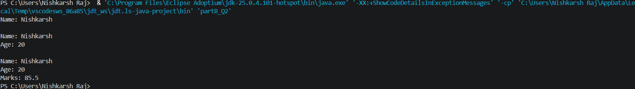

3. Find Maximum
class Maximum {
// Maximum between two integers
int max(int a, int b) {
return (a > b) ? a : b;
}
// Maximum between three integers
int max(int a, int b, int c) {
if (a > b && a > c)
return a;
else if (b > c)
return b;
else
return c;
}
// Maximum between two decimal numbers
double max(double a, double b) {
if (a > b)
return a;
else
return b;
}
}
public class partB_Q3 {
public static void main(String[] args) {
Maximum m = new Maximum();
System.out.println("Maximum of two integers: " + m.max(10, 20));
System.out.println("Maximum of three integers: " + m.max(10, 30, 20));
System.out.println("Maximum of two decimal numbers: " + m.max(10.5, 20.8));
}
}

