Part A – Conceptual Questions
1. What are Wrapper Classes in Java? Explain why Java provides Wrapper Classes.
Wrapper Classes are classes that convert primitive data types into objects. Each primitive data type has a corresponding wrapper class.
Java provides Wrapper Classes because some features, such as collections (ArrayList), work only with objects. They also provide useful methods for converting and handling data.
Example: int → Integer

2. Corresponding Wrapper Class for Each Primitive Data Type
Primitive Data Type | Wrapper Class
byte | Byte
short | Short
int | Integer
long | Long
float | Float
double | Double
char | Character
boolean | Boolean

3. Differentiate Between Primitive Data Type and Wrapper Class
Primitive Data Type | Wrapper Class
Stores a simple value. | Stores a primitive value inside an object.
It is not an object. | It is a class and its objects can be created.
Generally uses less memory. | Generally uses more memory because it is an object.
Cannot directly be used where an object is required. | Can be used where objects are required.
Examples:
- int a = 10; → Primitive data type
- Integer b = 10; → Wrapper class object (autoboxing)
4. What is Autoboxing? Explain with a Suitable Example.
Autoboxing is the automatic conversion of a primitive data type into its corresponding wrapper class object.
Example:
int a = 10;
Integer b = a; // Autoboxing
System.out.println(b);
Here, the primitive int value is automatically converted into an Integer object.

5. What is Unboxing? Explain with a Suitable Example.
Unboxing is the automatic conversion of a wrapper class object into its corresponding primitive data type.
Example:
Integer a = 20;
int b = a; // Unboxing
System.out.println(b);
Here, the Integer object is automatically converted into an int value.

6. Difference Between Integer.parseInt() and Integer.valueOf()
Integer.parseInt() | Integer.valueOf()
Converts a string into a primitive int. | Converts a string into an Integer object.
Returns int. | Returns Integer.
Useful when a primitive integer is required. | Useful when an object is required.
Example:
String s = "100";

int a = Integer.parseInt(s);
Integer b = Integer.valueOf(s);

System.out.println(a);
System.out.println(b);
Output:
100
100
In short: parseInt() returns a primitive int, while valueOf() returns an Integer object.

Part B – Basic Programming

- Primitive and Wrapper Variables

public class PrimitiveWrapperDemo {
public static void main(String[] args) {

// Primitive data type variables
byte b = 10;
short s = 20;
int i = 30;
long l = 40000L;
float f = 5.5f;
double d = 10.25;
char c = 'A';
boolean bool = true;

// Wrapper class variables
Byte wb = b;
Short ws = s;
Integer wi = i;
Long wl = l;
Float wf = f;
Double wd = d;
Character wc = c;
Boolean wbool = bool;
// Display primitive values
System.out.println("Primitive Data Type Values:");
System.out.println("byte: " + b);
System.out.println("short: " + s);
System.out.println("int: " + i);
System.out.println("long: " + l);
System.out.println("float: " + f);
System.out.println("double: " + d);
System.out.println("char: " + c);
System.out.println("boolean: " + bool);
// Display wrapper class values
System.out.println("\nWrapper Class Values:");
System.out.println("Byte: " + wb);
System.out.println("Short: " + ws);
System.out.println("Integer: " + wi);
System.out.println("Long: " + wl);
System.out.println("Float: " + wf);
System.out.println("Double: " + wd);
System.out.println("Character: " + wc);
System.out.println("Boolean: " + wbool);
}
}
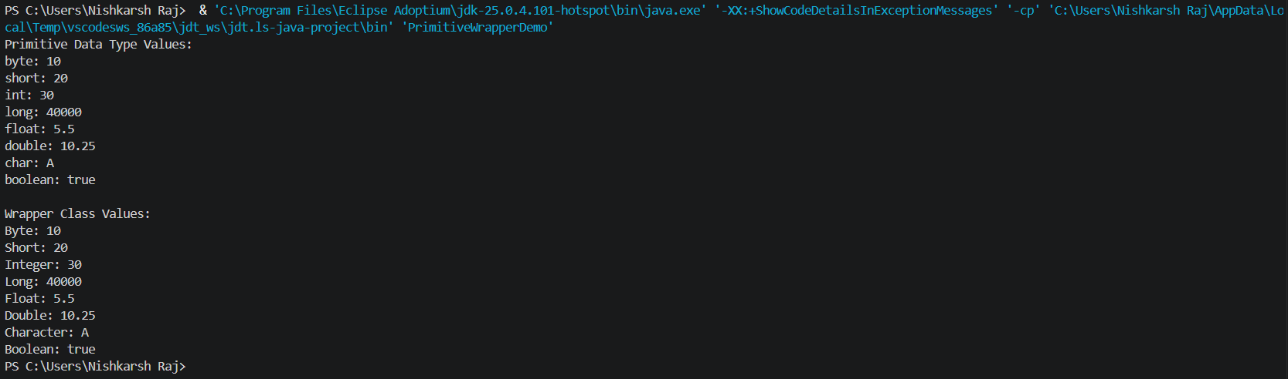
- Autoboxing Demonstration
public class AutoboxingDemo {
public static void main(String[] args) {

// Primitive values
int number = 100;
double decimal = 25.5;
char letter = 'A';
boolean status = true;

// Autoboxing: Primitive to Wrapper objects
Integer intObj = number;
Double doubleObj = decimal;
Character charObj = letter;
Boolean boolObj = status;

// Display converted values
System.out.println("Integer object: " + intObj);
System.out.println("Double object: " + doubleObj);
System.out.println("Character object: " + charObj);
System.out.println("Boolean object: " + boolObj);
}
}
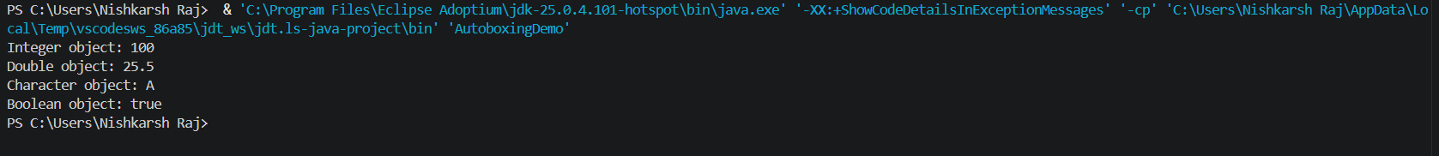

- Unboxing Demonstration
public class UnboxingDemo {
public static void main(String[] args) {

// Wrapper class objects
Integer intObj = 100;
Double doubleObj = 25.5;
Character charObj = 'A';
Boolean boolObj = true;

// Unboxing: Wrapper objects to primitive values
int number = intObj;
double decimal = doubleObj;
char letter = charObj;
boolean status = boolObj;

// Display converted values
System.out.println("int value: " + number);
System.out.println("double value: " + decimal);
System.out.println("char value: " + letter);
System.out.println("boolean value: " + status);
}
}
