EMPLOYEE DOCUMENT VAULT
Case Study & Technical Documentation
AWS Serverless Document Management System
Version 1.0

1. Executive Summary

1.1 Project Overview
The Employee Document Vault is a secure, centralized document management system designed to manage employee-related records such as offer letters, contracts, payslips, appraisal reports and compliance documents.
The system follows a serverless AWS architecture and uses Amazon S3 for document storage, Amazon DynamoDB for document metadata and audit records, Amazon Cognito for authentication, AWS Lambda for backend processing, and Amazon API Gateway for exposing REST APIs.
The primary objective is to provide employees with controlled access to their own documents, managers with controlled access to documents belonging to their teams, and HR administrators with broader administrative access.
The solution also introduces audit logging so that important document operations such as uploads, downloads and deletions can be traced to an authenticated user.
[FIGURE 1.1 — Project Overview]
Suggested image: a simple conceptual illustration showing employees, managers and HR accessing a centralized secure document vault.

1.2 Problem Statement
Traditional employee document storage can create several problems:
- Documents may be distributed across local systems and shared drives.
- Access may be granted too broadly.
- There may be limited visibility into who accessed a document.
- Manual document management increases the possibility of accidental deletion or unauthorized access.
- Employee documents contain sensitive information and therefore require controlled access.
The project addresses these challenges by implementing authentication, role-based authorization, centralized storage and audit logging.

1.3 Objectives
The main objectives are:
Objective | Description
Centralized storage | Store employee documents in a structured S3 repository
Authentication | Authenticate users using Amazon Cognito
Authorization | Restrict access according to employee, manager and HR roles
Metadata management | Store document information in DynamoDB
Auditability | Record document operations in an audit table
Secure APIs | Expose document operations through API Gateway
Soft deletion | Prevent physical deletion of S3 documents during normal delete operations
Scalability | Use serverless AWS services to reduce infrastructure management

2. Requirements and User Roles

2.1 Functional Requirements
The system provides four primary document APIs:
Operation | API | Purpose
Upload | POST /upload | Upload a document and create metadata
List | GET /files | Retrieve documents available to the authenticated user
Download | GET /download/{doc_id} | Retrieve a specific document
Delete | DELETE /files/{doc_id} | Soft-delete a document

Additional requirements include:
- Cognito authentication
- Role-based access control
- S3 document storage
- DynamoDB metadata
- Audit logging
- Document tagging/metadata support
- Version-history support through S3 versioning as part of the storage design

2.2 Non-Functional Requirements
Requirement | Implementation Approach
Security | Cognito + API Gateway authorizer + Lambda authorization
Availability | AWS managed/serverless services
Scalability | Lambda, S3 and DynamoDB
Auditability | DynamoDB audit log
Data protection | S3 and DynamoDB access controlled through IAM
Maintainability | Common Python modules for authentication, responses and audit logging
Performance | Direct AWS service integration through Lambda

2.3 Employee, Manager and HR_Admin Roles
Three primary Cognito groups were created:
Role | Intended Access
Employee | Access to their own documents
Manager | Access to documents belonging to their managed employees
HR_Admin | Administrative access across employee documents
The role is obtained from Cognito claims and used by Lambda authorization logic.
[FIGURE 2.1 — Role-Based Access Model]

3. System Architecture

3.1 Architecture Overview
The application uses a serverless architecture where individual AWS services perform specialized responsibilities.
The major components are:
- Amazon Cognito
- API Gateway
- AWS Lambda
- Amazon S3
- Amazon DynamoDB
The frontend is designed to communicate with API Gateway rather than accessing the backend services directly.
[FIGURE 3.1 — Complete AWS Architecture]

3.2 AWS Services
AWS Service | Responsibility
Amazon Cognito | User authentication and groups
API Gateway | REST API exposure and Cognito authorization
AWS Lambda | Application logic and access control
Amazon S3 | Binary document storage
DynamoDB | Document metadata
DynamoDB Audit Table | Audit events
IAM | Service permissions

3.3 Data Flow
A typical authenticated request follows this sequence:
User
↓
Frontend
↓
Cognito Authentication
↓
JWT Token
↓
API Gateway
↓
Cognito Authorizer
↓
Lambda
↓
get_user()
↓
Role + Employee ID extracted
↓
Authorization decision
↓
DynamoDB / S3
↓
Response
[FIGURE 3.2 — Request Processing Flow]

3.4 Security Architecture
Security is implemented in multiple layers rather than relying on a single permission check.
Layer 1 → Cognito Authentication
↓
Layer 2 → API Gateway Authorizer
↓
Layer 3 → Lambda Authorization
↓
Layer 4 → IAM permissions
↓
Layer 5 → S3 / DynamoDB access
This layered approach prevents authentication and storage permissions from being treated as the same problem.

4. AWS Infrastructure and Data Storage

4.1 S3 Storage Design
Amazon S3 is used as the primary storage layer for employee documents. The S3 bucket provides centralized storage while the application controls access through Cognito authentication, API Gateway authorization, Lambda-level authorization and IAM permissions.
The project uses the following S3 bucket:
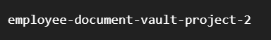
Documents are organized using a structured prefix based on the employee and document type:
For example:
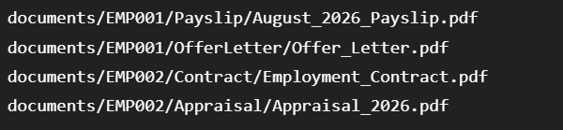
This structure provides logical separation of employee documents while also grouping files according to their document type.
S3 Prefix Structure
Level | Example | Purpose
Root prefix | documents/ | Identifies application documents
Employee ID | EMP001/ | Separates documents by employee
Document Type | Payslip/ | Groups documents by category
Filename | August_2026_Payslip.pdf | Identifies the actual file
The resulting structure can be represented as:

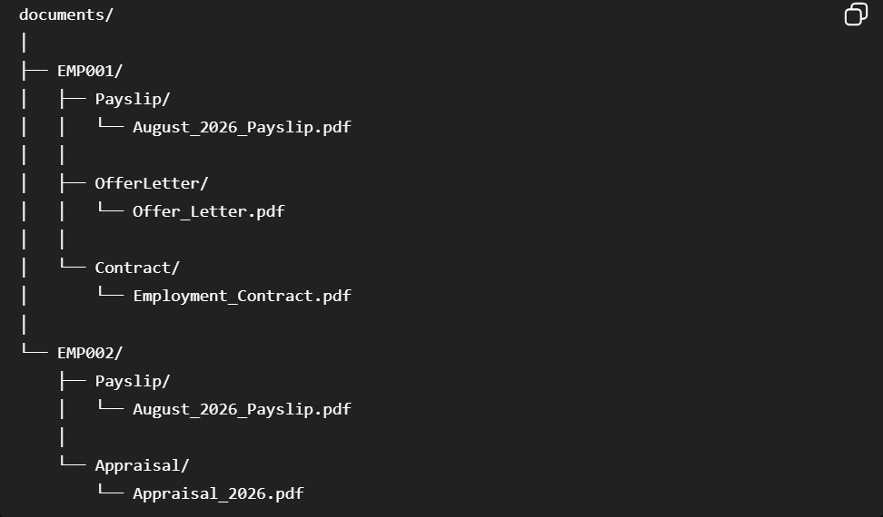
Why this structure was selected
The structure makes document organization easier to understand and provides a predictable storage location for each employee's records. It also allows the application to distinguish between different categories of employee documents such as payslips, contracts, offer letters and appraisal reports. DynamoDB stores the metadata associated with each document rather than the document binary itself.

4.2 DynamoDB Design
DynamoDB stores the metadata associated with each document rather than the document binary itself.
The main table is:
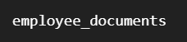
The document itself remains in S3, while DynamoDB maintains information required by the application to locate, identify and authorize the document.

Attribute | Purpose
document_id | Unique identifier for the document
employee_id | Employee associated with the document
employee_name | Employee name
manager_id | Employee's manager
document_type | Category of document
file_name | Original filename
s3_key | S3 location of the document
uploaded_by | User who uploaded the document
upload_timestamp | Upload timestamp
deleted | Soft-delete status
tags | Optional document classification metadata
[FIGURE 4.2 — S3 and DynamoDB Document Relationship]

4.3 S3 Versioning and Lifecycle
S3 Versioning is used to preserve previous versions of documents when an existing file is updated.
Instead of permanently replacing the previous object version, S3 can retain the earlier version, allowing the system to support document history.
The lifecycle configuration is designed to transition older object versions to S3 Standard-IA after the defined retention period.
[FIGURE 4.3 — S3 Versioning and Lifecycle Workflow]

4.4 Encryption and IAM
The storage layer is protected through AWS security controls.
S3 protects the stored documents, while IAM policies control which AWS services and identities can perform operations against the resources.
The Lambda execution role provides the backend with the permissions required to perform its operations.
The security relationship is:
[FIGURE 4.4 — IAM and Storage Security Architecture]

5. Authentication and Authorization

5.1 Cognito User Pool
Amazon Cognito provides the authentication layer.
The configured User Pool is:
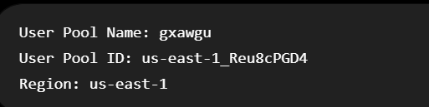
The application client is configured for frontend authentication.

5.2 User Groups
The Cognito groups are:
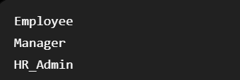
Example test identities include:
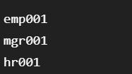
[FIGURE 5.1 — Cognito User Groups]

5.3 JWT and Claims
After successful authentication, Cognito provides tokens containing identity information.
The backend uses claims such as:
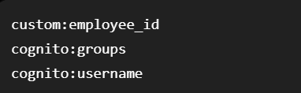
The application extracts these values through the shared authentication helper.
Example conceptual flow:
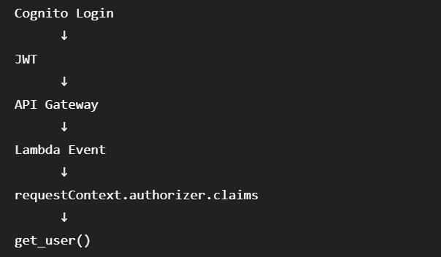

5.4 Lambda-Level Authorization
API Gateway authentication is not treated as the complete authorization mechanism.
Lambda performs resource-level checks.
For example, an employee requesting document DOC123 is not automatically allowed to access it merely because the employee is authenticated.
The Lambda compares:
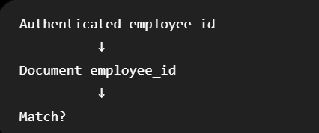
If the values do not satisfy the role's authorization rule: 403 Access Denied is returned.

6. Backend Implementation

6.1 Lambda Architecture
The backend is divided into Lambda functions responsible for separate operations:
Function | Responsibility
Upload Lambda | Upload document + metadata + audit
List Lambda | List authorized documents
Download Lambda | Retrieve authorized document
Delete Lambda | Soft-delete authorized document
Common modules reduce duplication:
[FIGURE 6.1 — Lambda Backend Component Diagram]

6.2 Upload Workflow
The upload operation performs:
- Parse request.
- Validate required fields.
- Generate document ID.
- Generate S3 key.
- Decode file content.
- Upload to S3.
- Store metadata in DynamoDB.
- Write audit event.
- Return success response.
[FIGURE 6.2 — Upload Lambda Execution Flow]

6.3 List Documents Workflow
The list operation identifies the authenticated user and determines which documents can be returned.
[FIGURE 6.3 — List Documents Workflow]

6.4 Download Workflow
The download Lambda:
- Receives doc_id.
- Retrieves metadata from DynamoDB.
- Determines the user's role.
- Checks authorization.
- Retrieves the corresponding S3 object.
- Records the download in the audit table.
- Returns the file.
[FIGURE 6.4 — Download Authorization Flow]
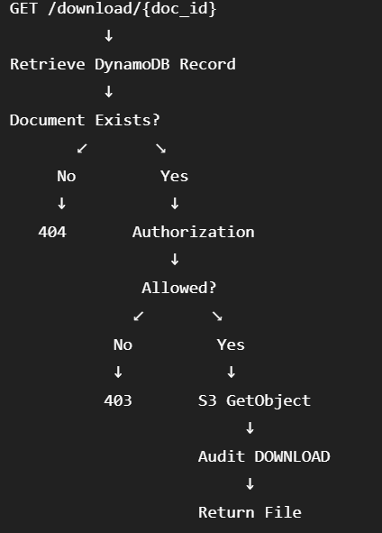

6.5 Delete and Soft Delete
Instead of physically deleting the S3 object, the document metadata is updated: deleted = true
Authorization currently follows:
Role | Delete
Employee | Own document only
Manager | Denied
HR_Admin | Allowed

Workflow:
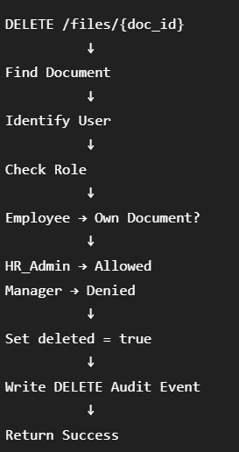
This allows the system to preserve the underlying S3 object while hiding the document from normal application-level access.

6.6 Audit Logging
he system records important document operations.
Example audit attributes:
Attribute | Example
audit_id | AUD-UPLOAD-20260810-ABC123
user_id | hr001
employee_id | EMP001
action | UPLOAD
document_id | DOCB81FCD68
remarks | Document uploaded successfully
timestamp | ISO UTC timestamp
[FIGURE 6.5 — DynamoDB Audit Log Screenshot]

7. API Gateway

7.1 API Architecture
API Gateway provides the public REST interface for the backend.
Base URL:https://c9d8wcytpj.execute-api.us-east-1.amazonaws.com/prod

7.2 Endpoint Design
Method | Endpoint | Lambda
POST | /upload | Upload Lambda
GET | /files | List Lambda
GET | /download/{doc_id} | Download Lambda
DELETE | /files/{doc_id} | Delete Lambda

The API uses {doc_id} as a path parameter.
For example: GET /download/DOCB81FCD68
API Gateway converts this into:
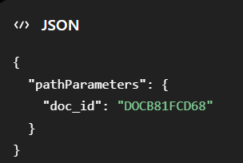

7.3 Cognito Authorizer
The API Gateway methods use the Cognito authorizer.
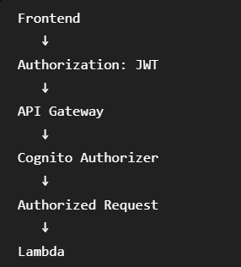
[FIGURE 7.1 — API Gateway Resource Tree]
[FIGURE 7.2 — Cognito Authorizer Configuration]

7.4 Request and Response Examples
Examples add from json

8. Frontend and Integration
This section should be written based on the frontend your teammate actually builds, so we should leave some screenshot/content placeholders for now.

8.1 Frontend Architecture
The frontend acts as the presentation layer.
[FIGURE 8.1 — Frontend-to-AWS Integration]

8.2 Cognito Login
The frontend uses the Cognito User Pool to authenticate users.
The frontend configuration includes:
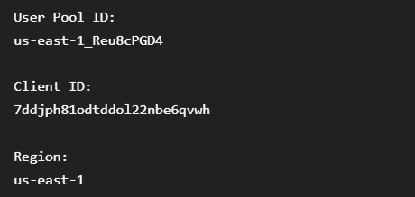

8.3 API Integration
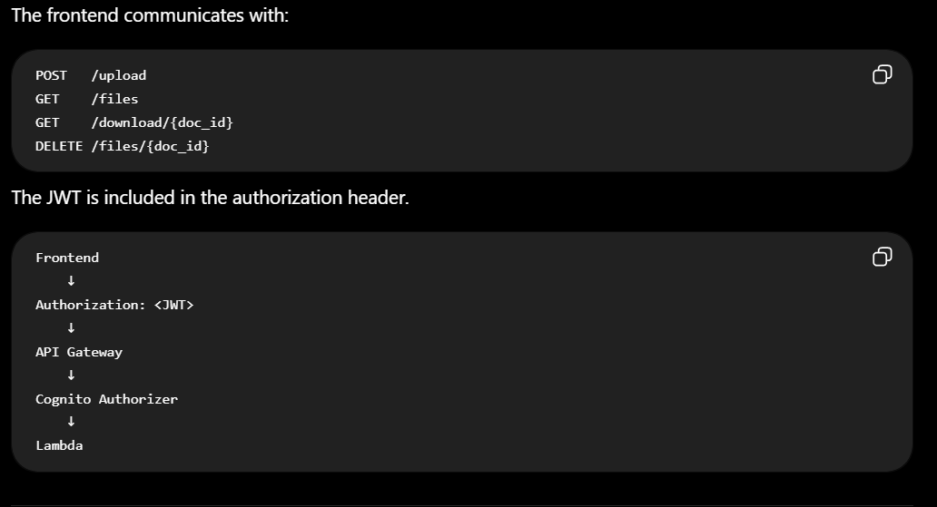

8.4 File Management Interface
The frontend should provide:
- File listing
- Document-type grouping
- Upload
- Download
- Delete
- Search
- Sorting
- Tags
- Version history
[FIGURE 8.2 — Frontend File Browser]
[FIGURE 8.3 — Frontend Upload Screen]
[FIGURE 8.4 — Frontend Document Details / Version History]

8.5 Search, Tags, Sorting and Version History

9. Security and Compliance

9.1 Access Control
The system uses multiple security controls:
Layer | Control
Authentication | Cognito
API authentication | API Gateway Cognito Authorizer
Application authorization | Lambda
Storage permissions | IAM
Document isolation | Employee/manager authorization
Audit | DynamoDB audit table

9.2 Encryption
The architecture should protect information:
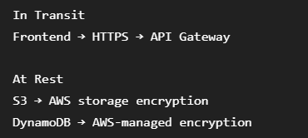
[FIGURE 9.1 — Security Architecture Diagram]

9.3 Auditability
Every important document operation generates an audit record.
This provides:
- User identification
- Document identification
- Action identification
- Timestamp
- Operation traceability

9.4 Threat Considerations
The design considers threats such as:
Threat | Mitigation
Unauthorized user access | Cognito authentication
Employee accessing another employee's file | Lambda authorization
Manager accessing unauthorized documents | Manager-resource validation
Direct S3 access | Controlled IAM permissions
Accidental deletion | Soft delete
Lack of accountability | Audit logging
Token-less API requests | API Gateway authorizer

10. Testing and Results

10.1 Upload Testing
Test objective: Verify that an authorized upload creates both an S3 object and DynamoDB metadata.
[FIGURE 10.1 — Successful Upload Test]

10.2 Access-Control Testing
Employee accessing own document
Employee accessing another employee's document
Manager accessing managed employee document
Manager accessing unauthorized document
HR_Admin

[FIGURE 10.2 — Employee Access Denied]
[FIGURE 10.3 — Manager Access Denied]

Test | User | Resource | Expected | Result
T01 | Employee | Own document | Allow | PASS
T02 | Employee | Other employee | Deny | PASS
T03 | Manager | Team document | Allow | PASS
T04 | Manager | Unauthorized document | Deny | PASS
T05 | HR_Admin | Any document | Allow | PASS

10.3 Download Testing
Verify:
- Correct document retrieved
- Unauthorized document denied
- Audit entry created
[FIGURE 10.4 — Successful Download]

10.4 Delete Testing
The actual deletion is:deleted = true ,rather than physical S3 deletion.

[FIGURE 10.5 — Delete Authorization Test]

10.5 Audit Log Verification
[FIGURE 10.6 — Audit Log Evidence]

10.6 Test Results
Use a final test matrix:
ID | Component | Scenario | Expected | Actual | Status
T01 | Upload | Valid upload | 200 | 200 | PASS
T02 | Download | Authorized user | 200 | 200 | PASS
T03 | Download | Unauthorized user | 403 | 403 | PASS
T04 | Delete | Employee own file | 200 | 200 | PASS
T05 | Delete | Manager | 403 | 403 | PASS
T06 | Delete | HR_Admin | 200 | 200 | PASS
T07 | Audit | Upload logged | Yes | Yes | PASS
T08 | Audit | Download logged | Yes | Yes | PASS
T09 | Audit | Delete logged | Yes | Yes | PASS
We can expand this table later with your actual screenshots/results.

11. Deployment and Demonstration

11.1 Deployment Process
The major deployment components are:
1. Cognito User Pool
2. DynamoDB Tables
3. S3 Bucket
4. Lambda Functions
5. API Gateway
6. Cognito Authorizer
7. Frontend
[FIGURE 11.1 — AWS Deployment Overview]

11.2 Demo Workflow
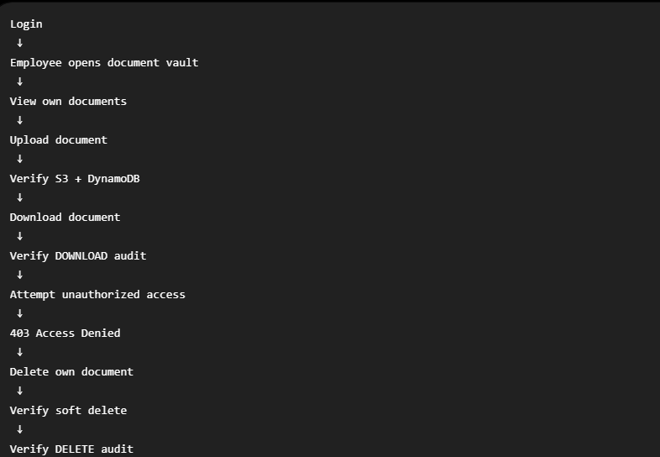

11.3 AWS Configuration
Component | Value
AWS Region | us-east-1
S3 Bucket | employee-document-vault-project-2
Document Table | employee_documents
Audit Table | audit_log
API Stage | prod
API Base URL | https://c9d8wcytpj.execute-api.us-east-1.amazonaws.com/prod
Cognito User Pool | us-east-1_Reu8cPGD4
Cognito Client | 7ddjph81odtddol22nbe6qvwh

11.4 Screenshots and Evidence
Recommended evidence:
- Cognito users/groups
- S3 bucket
- S3 objects
- DynamoDB document table
- DynamoDB audit table
- Lambda functions
- API Gateway resource tree
- Cognito authorizer
- Successful upload
- Successful download
- Access denied
- Delete
- Audit record

12. Conclusion and Future Improvements

12.1 Results
The Employee Document Vault successfully demonstrates a secure, centralized document management solution using AWS serverless services.
The implemented system provides:
- Centralized employee document storage in Amazon S3.
- Structured document organization using:
/documents/{employee_id}/{document_type}/{filename}
- Document metadata storage in DynamoDB.
- Authentication through Amazon Cognito.
- Role-based access control for Employee, Manager and HR_Admin users.
- API access through Amazon API Gateway.
- Lambda-based business logic and resource-level authorization.
- Document download functionality.
- Soft-delete functionality.
- Audit logging for document operations.
- S3 versioning support for document history.
The testing phase demonstrated that authorization is enforced according to the user's role and document ownership.

12.2 Limitations
Although the core document management workflow has been implemented, there are several areas that can be improved in future iterations:
- Upload Architecture
The current upload workflow sends the document content through the API/Lambda flow. A future implementation could use a presigned S3 upload URL so that large files can be uploaded directly to S3 without passing the complete file through Lambda.
- Frontend Completion
The frontend is developed as a separate component and its final functionality depends on integration with the deployed API Gateway and Cognito configuration.
- Advanced Search
The current metadata model can support basic filtering, but a more advanced search mechanism could be introduced for larger document collections.
- Monitoring and Alerting
CloudWatch dashboards, alarms and automated notifications could be added for operational monitoring.
- Audit Log Protection
Additional controls could be introduced to strengthen protection of audit records, such as more restrictive IAM permissions and dedicated retention policies.
- Automated Deployment
A CI/CD pipeline could be introduced to automate Lambda, API Gateway and frontend deployments.

12.3 Future Enhancements
Potential future improvements include:
Enhancement | Benefit
Presigned S3 uploads | Better handling of large files
Advanced document search | Faster retrieval of large document collections
CloudWatch dashboards | Improved operational visibility
Automated alerts | Faster detection of failures or unusual activity
CI/CD pipeline | Faster and more reliable deployments
Enhanced audit protection | Stronger accountability and compliance
Advanced version-history UI | Easier access to previous document versions
Pagination | Better performance with large numbers of documents
Document notifications | Inform users about new or updated documents

13. Appendix

13.1 API Details
Base URL:
https://c9d8wcytpj.execute-api.us-east-1.amazonaws.com/prod
Method | Endpoint | Purpose
POST | /upload | Upload a document
GET | /files | List accessible documents
GET | /download/{doc_id} | Download a document
DELETE | /files/{doc_id} | Soft-delete a document

13.2 Sample JSON
Include the final tested JSON payloads here.

13.3 Audit Log Samples
Suggested table:[FIGURE 13.1 — Audit Log DynamoDB Screenshot]

13.4 Additional Screenshots
If any

