SENTARI
An Earnings-Call & Filings Intelligence Platform for Retail Investors
Aspect-based sentiment analysis with grounded multi-agent briefs
Project Report
Final Year Project — Sentiment Analysis (231CAUEC51)
Submitted by
Nishant Vikas Narudkar
Ramrao Adik Institute of Technology
D Y Patil University, Navi Mumbai
September 2026
Source code: github.com/nishnarudkar/Sentari

Abstract
Retail investors who follow fifteen to twenty companies cannot read every earnings-call transcript, 10-K/10-Q filing and news item each quarter, so subtle but important signals — softer guidance language, hedging in the Q&A, litigation risk in a footnote — are routinely missed. Sentari is a daily intelligence service that ingests these disclosures, measures sentiment at the level of six financial aspects (guidance, margins, demand, litigation, management tone and liquidity) instead of one document-level score, tracks how each aspect moves from quarter to quarter, and produces a written brief in which every sentence is traceable to the source sentence that supports it.
The system comprises an idempotent ingestion pipeline with transcript-aware parsing (speakers, prepared remarks versus Q&A), an aspect-extraction stage combining rules with spaCy dependency parsing, and a model ladder of ten sentiment models — VADER, SentiWordNet, Loughran-McDonald, a finance-directional rule model, Naive Bayes, Decision Tree, CNN, BiLSTM, and FinBERT both zero-shot and fine-tuned — all evaluated on one held-out gold set and tracked in MLflow. A LangGraph pipeline of Extractor, Bull, Bear, Skeptic and Judge agents writes the brief; the Skeptic acts as a grounding gate that checks citations, numbers, semantic similarity and entailment, and removes unsupported claims before the Judge sees them. Results are served through a FastAPI service and a Next.js dashboard with drill-down from brief to source sentence, together with a drift monitor and a daily digest.
On a hand-written gold set of 94 aspect-labelled sentences, fine-tuned FinBERT reached a macro-F1 of 0.938 and the finance-directional rule model 0.892, against 0.647 for VADER and 0.490 for SentiWordNet. On 26 "trap" sentences where financial meaning inverts everyday polarity (falling costs are good news), VADER was wrong 61.5% of the time and SentiWordNet 73.1%. In an adversarial grounding audit the Skeptic caught every fabricated number, missing or wrong citation and invented claim; the heuristic Skeptic caught only 22.7% of polarity-flipped claims, which rose to 100% with a transformer NLI model.
These numbers are reported with their limitations: the gold set is small, the training data are template-generated weak labels, and the demonstration corpus is synthetic. The signal-validity study and a human grounding audit are designed and implemented but have not yet been run on real data. The report states throughout which parts are measured, which are built but unverified, and which remain to be done.
Keywords: aspect-based sentiment analysis, financial NLP, Loughran-McDonald, FinBERT, multi-agent LLM systems, grounding, hallucination detection, earnings calls
Table of Contents
1 Introduction 1
1.1 Background and motivation 1
1.2 Problem statement 1
1.3 Objectives 1
1.4 Scope 2
1.5 Contributions 2
1.6 Organisation of this report 2
2 Background and Related Work 3
2.1 Levels of sentiment analysis 3
2.2 Lexicon- and knowledge-based methods 3
2.3 Machine-learning and deep-learning methods 3
2.4 Transformers and FinBERT 3
2.5 LLM agents, hallucination and grounding 3
2.6 Monitoring deployed models 4
3 System Design 5
3.1 Architecture overview 5
3.2 End-to-end data flow 6
3.3 Database design 7
3.4 Agent orchestration 8
3.5 Technology stack 10
4 Implementation 11
4.1 Ingestion service 11
4.2 Preprocessing 12
4.3 Aspect extraction 12
4.4 The model ladder 13
4.5 Scoring and the prepared-versus-Q&A signal 14
4.6 Model registry and serving 14
4.7 Agent layer 14
4.8 Drift monitoring 15
4.9 API and delivery 16
4.10 Dashboard 16
4.11 Configuration and deployment 16
5 User Interface Walkthrough 18
5.1 Watchlist 18
5.2 Aspect trajectories and drill-down 18
5.3 Grounded brief 20
5.4 Drift monitor and model registry 23
5.5 Dark mode and small screens 25
6 Evaluation 27
6.1 Data and protocol 27
6.2 Model ladder 27
6.3 Lexicon failure analysis 29
6.4 Grounding audit 31
6.5 Signal validity 32
6.6 Latency and cost 33
6.7 Qualitative findings from the end-to-end run 33
7 Testing 35
7.1 Strategy 35
7.2 Continuous integration 35
7.3 Defects found and fixed 36
8 Syllabus Mapping 37
9 Ethical and Legal Considerations 38
10 Project Status Against the Plan 39
10.1 Remaining work, in priority order 39
11 Limitations and Future Work 40
11.1 Limitations 40
11.2 Future work 40
12 Conclusion 41
References 42
Appendix A Running the System 44
Appendix B Configuration 45
Appendix C API Reference 46
Appendix D Repository Structure 47

List of Figures
Figure 3.1: System architecture. Dark arrows follow the processing order; grey arrows are reads and writes to the database; the dashed arrow is the registry selecting the serving model. 6
Figure 3.2: Database schema. Solid edges are foreign keys; dashed edges are logical references stored as values. 7
Figure 3.3: Agent graph. Rejected claims never reach the Judge but remain in the audit trail. 9
Figure 4.1: Command-line analysis of a five-sentence passage (rule-based model): each sentence yields one score per detected aspect, with the matched trigger in brackets. 13
Figure 4.2: Interactive API documentation generated by FastAPI (/docs). 16
Figure 5.1: Watchlist: top aspect moves and per-ticker aspect scores from the latest call. 18
Figure 5.2: Ticker view for ACMX: six aspect trajectories with prepared-remarks and Q&A lines. 19
Figure 5.3: Drill-down: the management-tone point for the Q2 call opens the sentences, sections, scores and model behind it. 19
Figure 5.4: Source drawer: the selected sentence highlighted in its surrounding transcript, with the model's verdict. 20
Figure 5.5: Brief for ACMX: stance, confidence breakdown and a summary in which every claim is cited. 20
Figure 5.6: Verified bull and bear claims grouped by aspect. 21
Figure 5.7: Following a citation from the brief to its source sentence. 22
Figure 5.8: Agent audit trail: the Skeptic's per-claim checks and NLI probabilities. 22
Figure 5.9: Drift monitor: PSI and confidence shift per ticker and for the whole watchlist, with baseline versus current aspect mix. 23
Figure 5.10: Model registry: every rung with gold-set metrics and the serving flag. 24
Figure 5.11: MLflow experiment sentari-absa-ladder with one run per model. (Durations are logging times; training times are in Section 6.2.) 24
Figure 5.12: Ticker view in dark mode (NVLT). 25
Figure 5.13: Watchlist at phone width (390 px). 26
Figure 6.1: Macro-F1 by model, coloured by rung. 28
Figure 6.2: Confusion matrices for the general-purpose lexicon, the best rule model and the best learned model. 28
Figure 6.3: Accuracy against inference cost per sentence on CPU (log scale). 29
Figure 6.4: Error rate on finance-inverted (trap) sentences versus the rest. 30
Figure 6.5: Output of python -m evaluation.lexicon_failure. 31
Figure 6.6: Skeptic catch rate by corruption type, heuristic versus NLI entailment. 32
Figure 7.1: Test run: 58 passed. 35

List of Tables
Table 1.1: Project goals (from the project specification) 1
Table 3.1: Database tables 7
Table 3.2: Technology stack (planned in the specification vs. used) 10
Table 4.1: Code base by package (lines including comments and blank lines) 11
Table 4.2: Data sources 11
Table 4.3: Transcript parsing output (first sentences of the ACMX Q1 2025 sample call) 12
Table 4.4: Models on the ladder 13
Table 4.5: Skeptic checks, applied to every claim in order 15
Table 6.1: Evaluation plan status 27
Table 6.2: Model ladder on the 94-sentence gold set (P / R / F1 per class) 27
Table 6.3: Error rate on trap and non-trap sentences 30
Table 6.4: Representative trap sentences mis-scored by VADER 30
Table 6.5: Adversarial grounding audit (caught = rejected or flagged; hard reject = rejected) 31
Table 6.6: Measured latency 33
Table 7.1: Automated tests by module (58 in total; one test is parametrised six ways) 35
Table 7.2: Defects found through testing and use 36
Table 8.1: Mapping to the Sentiment Analysis course (231CAUEC51) 37
Table 10.1: Roadmap from the project specification 39
Table B.1: Configuration variables 45
Table C.1: HTTP endpoints 46
Table D.1: Repository layout 47

Abbreviations
Term | Meaning
ABSA | Aspect-Based Sentiment Analysis
API | Application Programming Interface
BiLSTM | Bidirectional Long Short-Term Memory network
CNN | Convolutional Neural Network
DT | Decision Tree
DVC | Data Version Control
EDGAR | SEC Electronic Data Gathering, Analysis and Retrieval system
F1 / macro-F1 | Harmonic mean of precision and recall / unweighted mean of per-class F1
FinBERT | BERT model further trained on financial text (ProsusAI/finbert)
LLM | Large Language Model
LM | Loughran-McDonald financial sentiment dictionary
MD&A | Management's Discussion and Analysis section of a 10-K/10-Q
NB | Naive Bayes
NLI | Natural Language Inference (entailment / neutral / contradiction)
NSE / BSE | National Stock Exchange / Bombay Stock Exchange of India
PSI | Population Stability Index
Q&A | The unscripted question-and-answer part of an earnings call
SWN | SentiWordNet
TF-IDF | Term Frequency – Inverse Document Frequency
VADER | Valence Aware Dictionary and sEntiment Reasoner

1 Introduction

1.1 Background and motivation
Listed companies publish a steady stream of text: quarterly earnings-call transcripts, annual and quarterly reports (10-K and 10-Q in the United States, results and investor presentations filed with NSE and BSE in India), and a larger volume of news. Much of what moves a company's prospects is expressed in this text before it shows up in the numbers — a guidance range narrowed toward its low end, a CFO who becomes evasive about margins in the Q&A, a new lawsuit described in a risk-factor footnote.
Institutional investors pay analysts and data vendors to monitor this. A retail investor following fifteen to twenty stocks usually cannot: a single earnings call runs to ten thousand words or more, and each company produces several documents per quarter. General-purpose sentiment tools do not close the gap, because they score a whole document as positive or negative and because their vocabularies were built for reviews and social media, where "liability", "decrease" or "cost" carry the opposite implications to the ones they carry in finance.

1.2 Problem statement
Build a daily intelligence service that watches a user's watchlist, extracts sentiment about specific financial aspects rather than whole documents, tracks how that sentiment moves quarter over quarter, and produces a grounded, human-readable brief in which every claim can be traced back to the exact sentence that generated it — while being honest, by measurement, about where the approach works and where it does not.

1.3 Objectives
Table 1.1: Project goals (from the project specification)
# | Goal | Where it is addressed
G1 | Aspect-level (not document-level) sentiment extraction from unstructured financial text | Chapter 4.3–4.5
G2 | Show empirically where general-purpose lexicons fail on financial language | Chapter 6.3
G3 | Multi-agent reasoning (bull / bear / skeptic / judge) that is grounded — no hallucinated claims | Chapters 4.7, 6.4
G4 | A real deployed service: scheduled ingestion, persistent storage, drift monitoring, a UI | Chapters 4, 5, 10
G5 | An honest evaluation, including where the signal does not predict anything | Chapters 6, 11

1.4 Scope
In scope: US and NSE/BSE-listed companies with public transcripts and filings; the six aspects guidance, margins, demand, litigation, management tone and liquidity; a daily batch pipeline; a web dashboard and an e-mail/Slack digest.
Out of scope: real-time or intraday sentiment, trade execution or portfolio management, and any guarantee that a signal predicts returns. Sentari is a research and decision-support tool; every screen, API response and digest carries a not-investment-advice notice.

1.5 Contributions
- An end-to-end, tested pipeline from raw disclosures to a cited brief, runnable fully offline on a bundled synthetic corpus and configurable for live sources.
- A ten-model sentiment ladder scored on one held-out, aspect-labelled gold set, with per-class precision, recall and F1, latency, and MLflow tracking.
- A lexicon failure analysis built around trap sentences, quantifying how general-purpose lexicons invert financial meaning.
- A grounding gate (the Skeptic agent) and an adversarial audit that measures what it catches, showing both its strengths and a specific weakness (polarity flips) and how an NLI model removes it.
- A prepared-remarks-versus-Q&A sentiment delta as a per-call signal, and a statistical harness to test whether it predicts post-earnings drift.

1.6 Organisation of this report
Chapter 2 reviews the relevant methods. Chapter 3 presents the system design and Chapter 4 its implementation. Chapter 5 walks through the user interface with screenshots. Chapter 6 reports the evaluation and Chapter 7 the testing. Chapter 8 maps the work to the course syllabus, Chapter 9 covers ethics, Chapter 10 compares progress with the project plan, Chapter 11 discusses limitations and future work, and Chapter 12 concludes. Appendices give run instructions, configuration, the API reference and the repository layout.

2 Background and Related Work

2.1 Levels of sentiment analysis
Sentiment can be analysed at document, sentence or aspect level [10]. Document-level scores are too coarse for earnings calls, where a company commonly reports strong demand, weaker margins and a cautious outlook in the same call. Aspect-based sentiment analysis (ABSA) identifies the targets being evaluated (aspects) and the polarity expressed toward each; it was formalised by the SemEval-2014 shared task [9]. Sentari uses a fixed, domain-defined aspect set and treats aspect detection and polarity scoring as separate stages.

2.2 Lexicon- and knowledge-based methods
VADER [2] is a rule-based lexicon tuned for social media, with heuristics for negation, intensifiers and punctuation. SentiWordNet 3.0 [3] assigns positive and negative scores to WordNet synsets. Both are general-purpose. Loughran and McDonald [1] showed that almost three-quarters of the words that general dictionaries mark as negative are not negative in 10-K filings (for example tax, cost, liability), and built finance-specific word lists — negative, positive, uncertainty and litigious — now standard in financial text analysis. A known limitation of all word-list methods is directionality: in finance the polarity of decreased depends on its subject (falling costs are good, falling margins are bad).

2.3 Machine-learning and deep-learning methods
Supervised classifiers over bag-of-words or TF-IDF features — Naive Bayes and decision trees among them — are strong, cheap baselines [15]. Convolutional networks over word embeddings [5] and recurrent networks such as LSTMs [6] learn local n-gram patterns and longer dependencies respectively, and can capture negation and word order that bag-of-words features miss.

2.4 Transformers and FinBERT
BERT [7] pre-trains a Transformer encoder on large corpora and is fine-tuned for downstream tasks. FinBERT [4] further adapts BERT to financial text and was fine-tuned for sentiment on the Financial PhraseBank [11]. For ABSA, Sun et al. [8] showed that feeding the aspect as an auxiliary second sentence lets one encoder handle all aspects; Sentari's transformer rung uses this sentence-pair formulation.

2.5 LLM agents, hallucination and grounding
Large language models can write fluent summaries but are prone to hallucination — statements not supported by their inputs [13]. Common mitigations are retrieval (giving the model the evidence), requiring citations, and verifying claims after generation, for instance with natural language inference (NLI) models that classify whether a premise entails, contradicts or is neutral to a hypothesis. Sentari combines all three: agents argue only from retrieved, scored evidence; each claim must cite chunk IDs; and a separate Skeptic stage verifies claims before they can reach the brief.

2.6 Monitoring deployed models
Deployed NLP models degrade when their input distribution shifts. The Population Stability Index (PSI) [14], widely used in credit scoring, measures the shift between two categorical distributions; Cohen's d [17] measures a standardised shift in a mean. Sentari applies PSI to the mix of aspects mentioned and d to model confidence, per ticker and week.

3 System Design

3.1 Architecture overview
Sentari is organised as a pipeline of services around a single relational store (Figure 3.1). A scheduler triggers the daily run; the ingestion service fetches, deduplicates and chunks documents; the ABSA service tags aspects and scores them with whichever model the registry marks as serving; the agent layer turns scored evidence into a brief; and the delivery layer exposes everything through an API, a dashboard, a digest and a drift monitor.
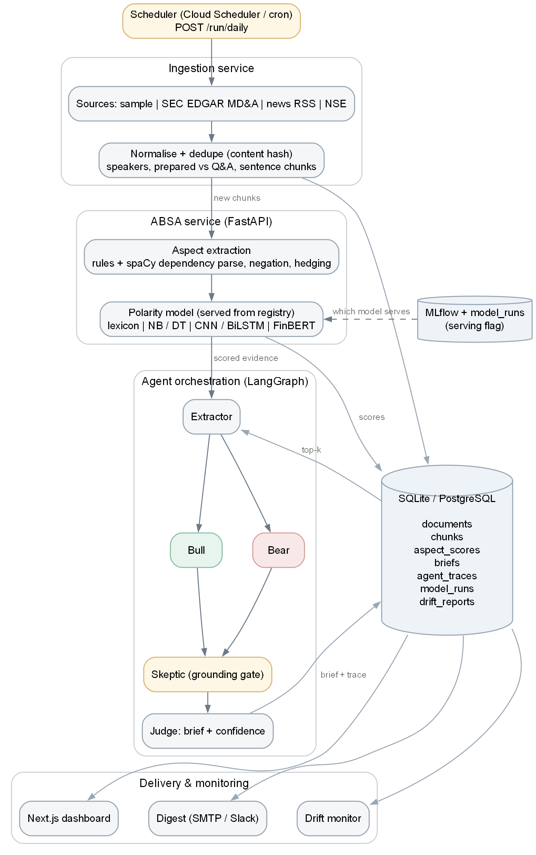
Figure 3.1: System architecture. Dark arrows follow the processing order; grey arrows are reads and writes to the database; the dashed arrow is the registry selecting the serving model.

3.2 End-to-end data flow
- Trigger. Cloud Scheduler (or cron) calls POST /run/daily, optionally authenticated with a shared token.
- Ingest. Each configured scraper returns raw documents; text is normalised and hashed; documents already seen are skipped, so re-runs never duplicate data.
- Chunk. Transcripts are split by speaker and section (prepared remarks or Q&A) and then into sentences; filings and news are split into sentences.
- Score. Every new chunk is embedded for retrieval, its aspect mentions are extracted, and each mention is scored by the serving model. Operator lines and analysts' questions are not scored, because they are not company statements.
- Brief. For each ticker whose inputs changed, the agent graph runs and writes the brief and a full audit trail. Unchanged inputs reuse the cached brief.
- Monitor and deliver. Drift reports are computed and the digest of the day's largest aspect moves is rendered and, if configured, sent.

3.3 Database design
All state lives in one SQLAlchemy schema that runs on SQLite for development and tests and on PostgreSQL in production (Figure 3.2, Table 3.1). Aspect scores are denormalised with ticker, date and section so trajectory queries need no joins. Embeddings are stored as JSON arrays so no vector extension is required; the Postgres migration enables pgvector for later ANN search.
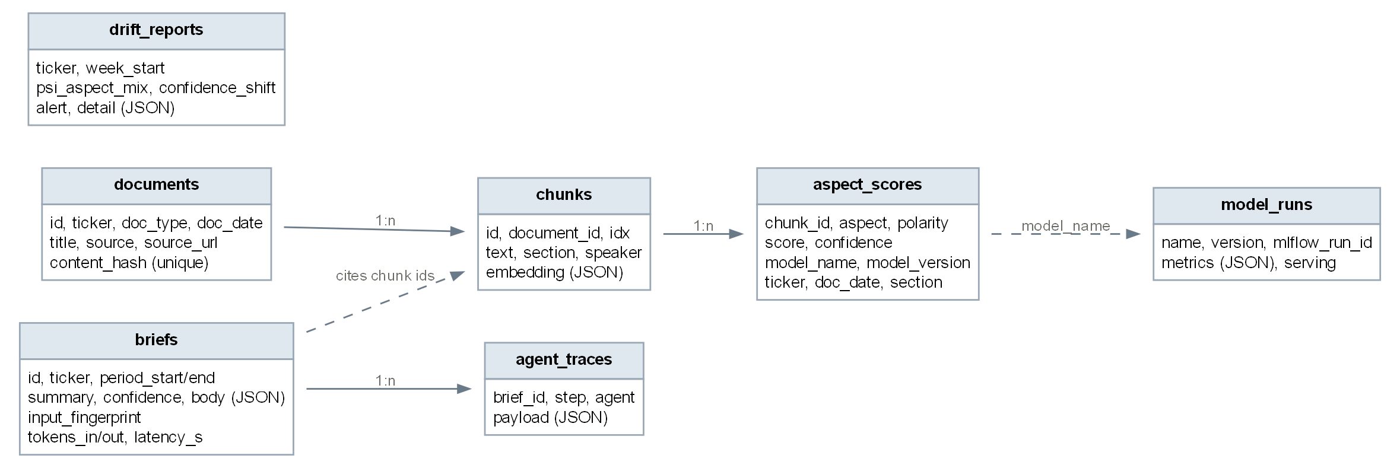
Figure 3.2: Database schema. Solid edges are foreign keys; dashed edges are logical references stored as values.
Table 3.1: Database tables
Table | Purpose | Key constraints
documents | One row per ingested document (transcript, 10-K, 10-Q, news, NSE filing) | content_hash unique — makes ingestion idempotent
chunks | Sentences with section (prepared / qa / mdna / body), speaker and embedding | (document_id, idx) unique
aspect_scores | Polarity, signed score and confidence per chunk × aspect × model | (chunk_id, aspect, model_name) unique
briefs | Final brief as structured JSON, confidence, token counts, latency | input_fingerprint indexed — brief cache
agent_traces | Every agent step of every brief, with cited chunk IDs | ordered by step
model_runs | Every trained/evaluated model version, metrics, MLflow run ID | serving flag selects the live model
drift_reports | Weekly PSI and confidence shift per ticker, with alert flag | one row per (ticker, window)

3.4 Agent orchestration
The agent layer is a LangGraph state graph (Figure 3.3). The Bull and Bear agents run in parallel after the Extractor; the Skeptic waits for both; the Judge sees only what the Skeptic lets through. Agent state carries an append-only trace, so every intermediate result is persisted in agent_traces.
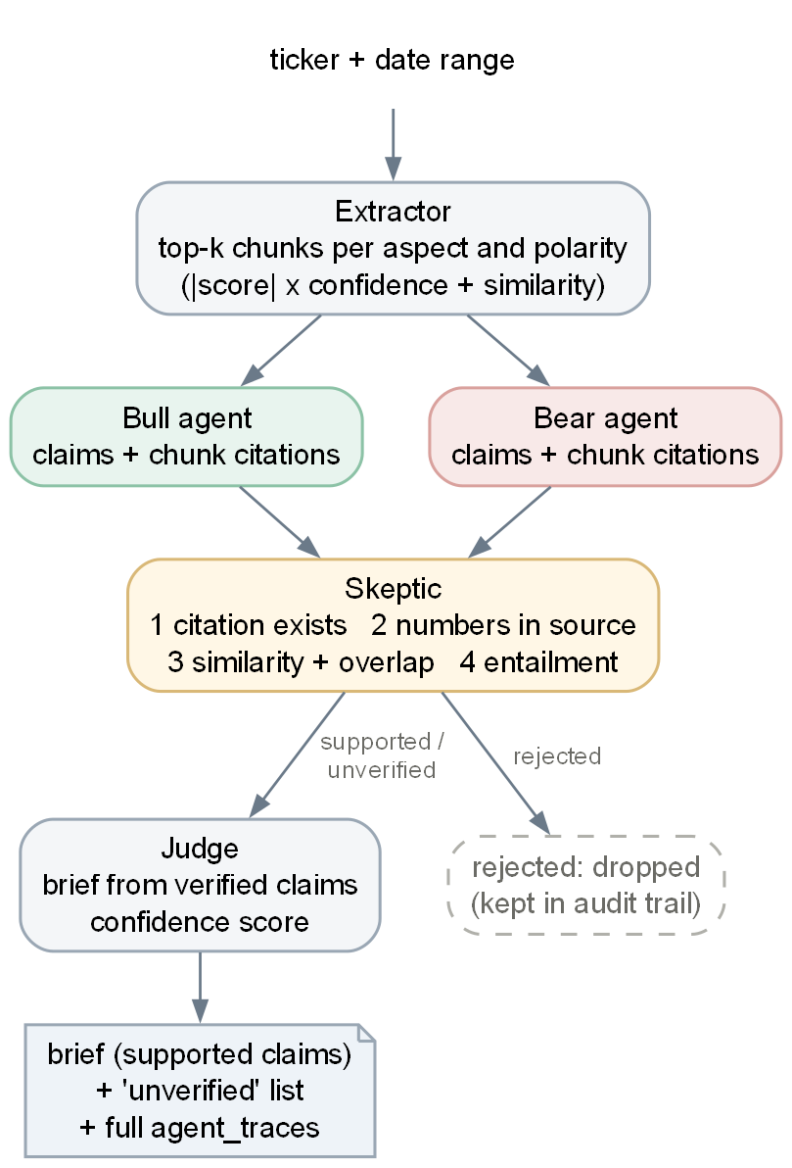
Figure 3.3: Agent graph. Rejected claims never reach the Judge but remain in the audit trail.

3.5 Technology stack
Table 3.2: Technology stack (planned in the specification vs. used)
Layer | Planned | Used in this build
Languages | Python, TypeScript | Python 3.13 (services), TypeScript (dashboard)
NLP | spaCy, NLTK/VADER, SentiWordNet | spaCy en_core_web_sm, vaderSentiment, NLTK SentiWordNet
ML / DL | scikit-learn, PyTorch | scikit-learn 1.8, PyTorch 2.13 (CPU), Hugging Face Transformers
Agents | LangGraph, LangChain | LangGraph; Anthropic SDK (optional LLM backend); LangChain not needed
API | FastAPI | FastAPI + Uvicorn
Tracking / versioning | MLflow, DVC | MLflow (file store or server); dvc.yaml pipeline written
Database / vectors | PostgreSQL, pgvector or Qdrant | SQLite (dev/tests), PostgreSQL (Compose); JSON embeddings
Scheduling | Cloud Scheduler / Airflow | Cloud Scheduler design + /run/daily endpoint; Airflow not used
Containers / deploy | Docker, Compose, Cloud Run | Dockerfiles, Compose and Cloud Run guide written (not yet built or deployed)
Frontend | Next.js | Next.js 16, React 19, dependency-free SVG charts
Notifications | SMTP / Slack API | SMTP and Slack incoming webhook

4 Implementation
The implementation is about 4,000 lines of Python across seven packages and 600 lines of TypeScript, with 58 automated tests (Table 4.1). This chapter describes each component in pipeline order.
Table 4.1: Code base by package (lines including comments and blank lines)
Package | Lines | Responsibility
ingestion/ | 499 | scrapers, normalisation, transcript parsing, idempotent pipeline
absa_service/ | 2,029 | preprocessing, aspect extraction, ten models, training, scoring, signals, registry, API, CLI
agents/ | 686 | extractor, bull/bear, skeptic, judge, LangGraph graph, LLM backends
storage/ | 180 | SQLAlchemy schema, engine/session helpers, migration
monitoring/, delivery/ | 165 | drift monitor; digest rendering, SMTP and Slack delivery
evaluation/ | 546 | metrics, lexicon failure, grounding audit, signal validity, latency/cost, report
tests/ | 586 | 58 tests (unit, integration, API)
dashboard/ | 626 | Next.js pages, chart and drawer components, API client

4.1 Ingestion service
Each source implements a Scraper.fetch(ticker, since) interface and returns raw documents tagged with ticker, document type and date (Table 4.2). Network scrapers share a client that caches every raw response on disk before parsing — so a parsing bug never forces a re-download — and retries with exponential back-off on rate limits.
Table 4.2: Data sources
Scraper | Source | Status
sample | Bundled synthetic transcripts and a 10-Q for two fictional companies (ACMX, NVLT) | Used for all tests and the demonstration
sec_edgar | SEC EDGAR submissions API; extracts the MD&A section of 10-K/10-Q filings [16] | Implemented; not yet run against live EDGAR (needs a contact User-Agent)
news_rss | Public news RSS search by company name | Implemented; not verified live
nse | NSE corporate announcements; returns nothing rather than circumvent access controls | Implemented; not verified live

Normalisation and deduplication. Text is Unicode-normalised, quotes and dashes unified, and stage directions such as [Operator Instructions] removed. A SHA-256 hash of ticker, document type and whitespace-normalised text is the document's identity; a unique constraint makes re-ingestion a no-op.
Transcript parsing. Lines beginning with a speaker tag ("Maria Chen -- CEO:") switch the current speaker; phrases such as "question-and-answer session" or the operator opening the line switch the section from prepared remarks to Q&A. Sentences are then split with a regular expression that respects financial abbreviations (Inc., Q3., U.S.). Table 4.3 shows the result on the start of a sample call.
Table 4.3: Transcript parsing output (first sentences of the ACMX Q1 2025 sample call)
# | Section | Speaker | Sentence
2 | prepared | Maria Chen (CEO) | We delivered a strong first quarter.
5 | prepared | Maria Chen (CEO) | We are raising our full-year guidance and now expect revenue growth of 10% to 12%.
7 | prepared | David Osei (CFO) | Gross margin expanded 180 basis points to 34.2% on favorable mix and productivity gains.
12 | qa | Operator | We will now begin the question-and-answer session.
17 | qa | Maria Chen (CEO) | Well, we believe demand should remain healthy, although visibility beyond the third quarter is limited.
23 | qa | David Osei (CFO) | We cannot comment on the details, but we could face a material charge if the outcome is unfavorable.

4.2 Preprocessing
- Negation scope. A negation cue (not, no, without, cannot, unable, …n't) marks the following tokens as negated until a clause boundary or four tokens. Negated tokens are prefixed NEG_ for the learned models and flip polarity for the lexicons.
- Hedging. Modal and epistemic words (may, could, believe, expect, visibility, uncertain) give each clause a hedge score in [0, 1], used by the management-tone aspect.
- Clause splitting. Sentences are split at contrast conjunctions and semicolons, so "Demand held up, but aerospace orders declined" yields two separately scored clauses.

4.3 Aspect extraction
Aspect detection combines a trigger lexicon with dependency parsing. Each aspect has a list of trigger terms (for margins: gross margin, operating margin, input costs, pricing, tariffs, …). In each clause the earliest matching trigger per aspect is taken. spaCy then parses the clause and, starting from the trigger's syntactic head, collects the opinion words that govern it — adjectival modifiers, the head verb, complements and negations — walking up to four ancestors to find negation attached to a governing verb (as in "we do not expect any material impact from ongoing litigation"). Without spaCy the extractor falls back to a six-token window; a test checks that both paths detect the same aspects.
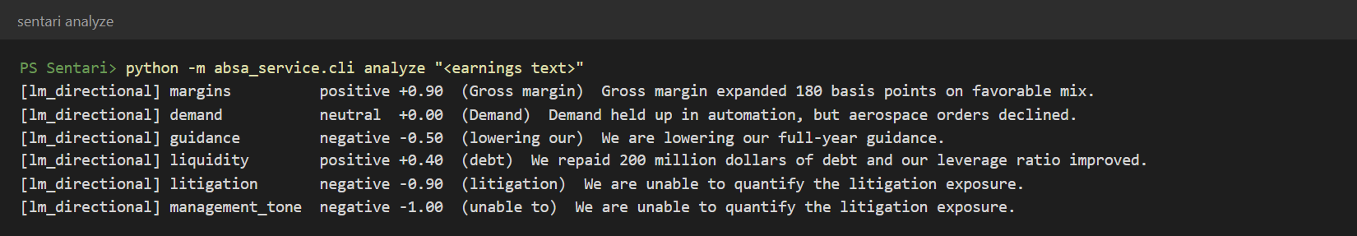
Figure 4.1: Command-line analysis of a five-sentence passage (rule-based model): each sentence yields one score per detected aspect, with the matched trigger in brackets.
Figure 4.1 shows the behaviour on a mixed passage. The second sentence contains one positive and one negative demand clause; the two scores are averaged to neutral, which is a deliberate simplification discussed in Chapter 11. The last sentence is tagged both litigation and management tone, because unable to is a tone trigger.

4.4 The model ladder
All ten models implement one interface, predict(items) → predictions, where an item is an aspect clause plus its aspect and a prediction is a label (negative/neutral/positive), a signed score in [−1, 1] and a confidence. This makes every rung interchangeable in the scoring pipeline and directly comparable in evaluation (Table 4.4).
Table 4.4: Models on the ladder
Rung | Model | How it scores a clause
Lexicon | VADER | Compound score of the clause; ±0.05 thresholds
Lexicon | SentiWordNet | Weighted positive−negative score of the first three synsets per word, sign-flipped under negation
Lexicon | Loughran-McDonald | Positive minus negative word counts with negation flips (curated seed subset of the LM categories; the official dictionary can be dropped in)
Lexicon + rules | LM + directional | LM lists plus directionality: up/down verbs flip sign for metrics where higher is worse (costs, debt, churn, litigation expense); event phrases (named as a defendant, undrawn); uncertainty words for tone
Classical ML | Naive Bayes, Decision Tree | TF-IDF over word 1–2-grams of negation-marked tokens with an aspect token prepended
Deep learning | CNN | Kim-style CNN [5]: 100-d embeddings, filter widths 2/3/4 × 64, max-pool, dropout 0.4
Deep learning | BiLSTM | Bidirectional LSTM (96 units per direction) with masked mean pooling; optional GloVe initialisation
Transformer | FinBERT zero-shot | ProsusAI/finbert applied as-is to the (clause, "aspect: …") sentence pair
Transformer | FinBERT fine-tuned | FinBERT fine-tuned on the sentence pair (2 epochs, AdamW, lr 3e-5, 1,500 examples, CPU)

Training data. Hand-labelling at scale was out of reach, so, as the project plan anticipated, the trainable models learn from weak labels: 4,000 template-generated sentences whose labels follow from financial directionality (for example "input costs fell" → positive, "gross margin fell" → negative), negation, valence words and event phrases, balanced across the six aspects. Any template sentence that coincides with a gold sentence is removed, and 15% is held out for validation. The consequences of this choice for the evaluation are discussed in Section 6.2.

4.5 Scoring and the prepared-versus-Q&A signal
For each new chunk the scorer extracts aspect mentions, scores each clause with the serving model, averages clauses of the same aspect, and writes one aspect_scores row per aspect with ticker, date and section. It also stores an embedding of the chunk for retrieval (a deterministic 384-dimensional feature-hashing embedder by default; Sentence-Transformers optionally).
The platform's signature signal compares what management says in the scripted part of a call with what it says unscripted. For a transcript and aspect a:
Δ(a) = mean score of a in Q&A − mean score of a in prepared remarks
and the per-call delta is the mean of Δ(a) over aspects present in both sections. A strongly negative delta means management sounded markedly weaker when answering analysts than when reading its script. The naive comparator used in the signal-validity study is the plain document-level mean.

4.6 Model registry and serving
Training (python -m absa_service.train) fits every trainable model, evaluates every model on the gold set, logs parameters and metrics to MLflow, records a model_runs row, and marks the best model by gold macro-F1 as serving. The API resolves which model to use in the order: explicit request → SENTARI_MODEL → registry serving flag → the rule-based model. If trained weights are missing the service falls back to the rule-based model rather than failing.

4.7 Agent layer

Extractor
For a ticker and date range the Extractor loads all aspect scores and ranks each aspect's chunks by:
rank = |score| × (0.5 + confidence) + 0.3 × cosine(chunk, aspect query)
It keeps the top k = 4 positive and top 4 negative chunks per aspect, so both sides of the debate get material, and computes an aspect summary and the per-call Q&A deltas.

Bull and Bear
Each side builds the strongest case from evidence of its polarity and must cite chunk IDs for every claim. The offline backend makes at most one claim per aspect and cites each sentence at most once per side: candidates are taken in order of the Extractor's ranking, and a sentence that triggers several aspects is used only for the aspect it expresses most strongly. The Judge also merges claims from the same side that cite exactly the same sentences, which guards against an LLM restating one sentence under several aspects. With an Anthropic API key the claims are written by Claude, prompted to use only the numbered evidence; without one, a deterministic backend composes claims directly from the strongest chunks. Claim IDs are prefixed bl and br so the two sides can never collide in the brief or the trace — a bug that the tests caught during development (Section 7.3).

Skeptic — the grounding gate
Table 4.5: Skeptic checks, applied to every claim in order
Check | Test | On failure
1 Citation | Every cited ID exists in the retrieved evidence | rejected
2 Numbers | Every number in the claim appears in the cited text | rejected
3 Similarity | Embedding cosine ≥ 0.12 and content-word overlap ≥ 45% with the cited text | unverified
4 Entailment | Heuristic: claim polarity cues must not contradict the chunk's scored polarity. NLI mode: cross-encoder entailment ≥ 0.5; contradiction ≥ 0.6 rejects | rejected (contradiction) / unverified

Only supported claims enter the brief body. Unverified claims are shown separately and flagged; rejected claims are dropped but kept in the audit trail. Near-verbatim quotes are exempt from the heuristic polarity check, because the cue lists cannot see negation (a faithful quote of "we do not expect any material impact from litigation" was otherwise rejected — found during development).

Judge
The Judge assembles the brief from surviving claims: a stance from the net aspect sentiment, bull and bear claims grouped by aspect, the largest negative Q&A delta if below −0.3, and a confidence score. With an LLM the summary is rewritten in prose, and is discarded in favour of the template if it cites any claim that did not survive. Confidence is a transparent heuristic, not a calibrated probability:
confidence = 0.5 × survival + 0.3 × mean evidence confidence + 0.2 × aspect coverage
where survival = (supported + 0.4 × unverified) / all claims.

Cost control
Each brief is fingerprinted by a hash of its exact inputs (ticker, window, every chunk ID and rounded score, and the LLM name). If a brief with the same fingerprint exists it is returned without running the agents, so the LLM is invoked only when new documents actually arrive for a ticker.

4.8 Drift monitoring
For each ticker and for the watchlist as a whole, the monitor compares the last seven days with the preceding 28:
PSI = Σₐ (pₐ − qₐ) · ln(pₐ / qₐ) d = (μ_current − μ_baseline) / σ_pooled
where p and q are the current and baseline aspect-mention shares and d is Cohen's d on model confidence. An alert fires when PSI > 0.25 or |d| > 0.8; windows with fewer than five scores report insufficient data. Reports are keyed by (ticker, window) so re-running the daily job replaces rather than duplicates them.

4.9 API and delivery
The FastAPI service exposes analysis endpoints, the dashboard's read API and the daily-run trigger (Figure 4.2; full list in Appendix C). The digest ranks, across the watchlist, the largest changes in a ticker's per-document aspect mean between its two most recent documents, appends drift alerts and the disclaimer, and sends to Slack and/or e-mail when configured.
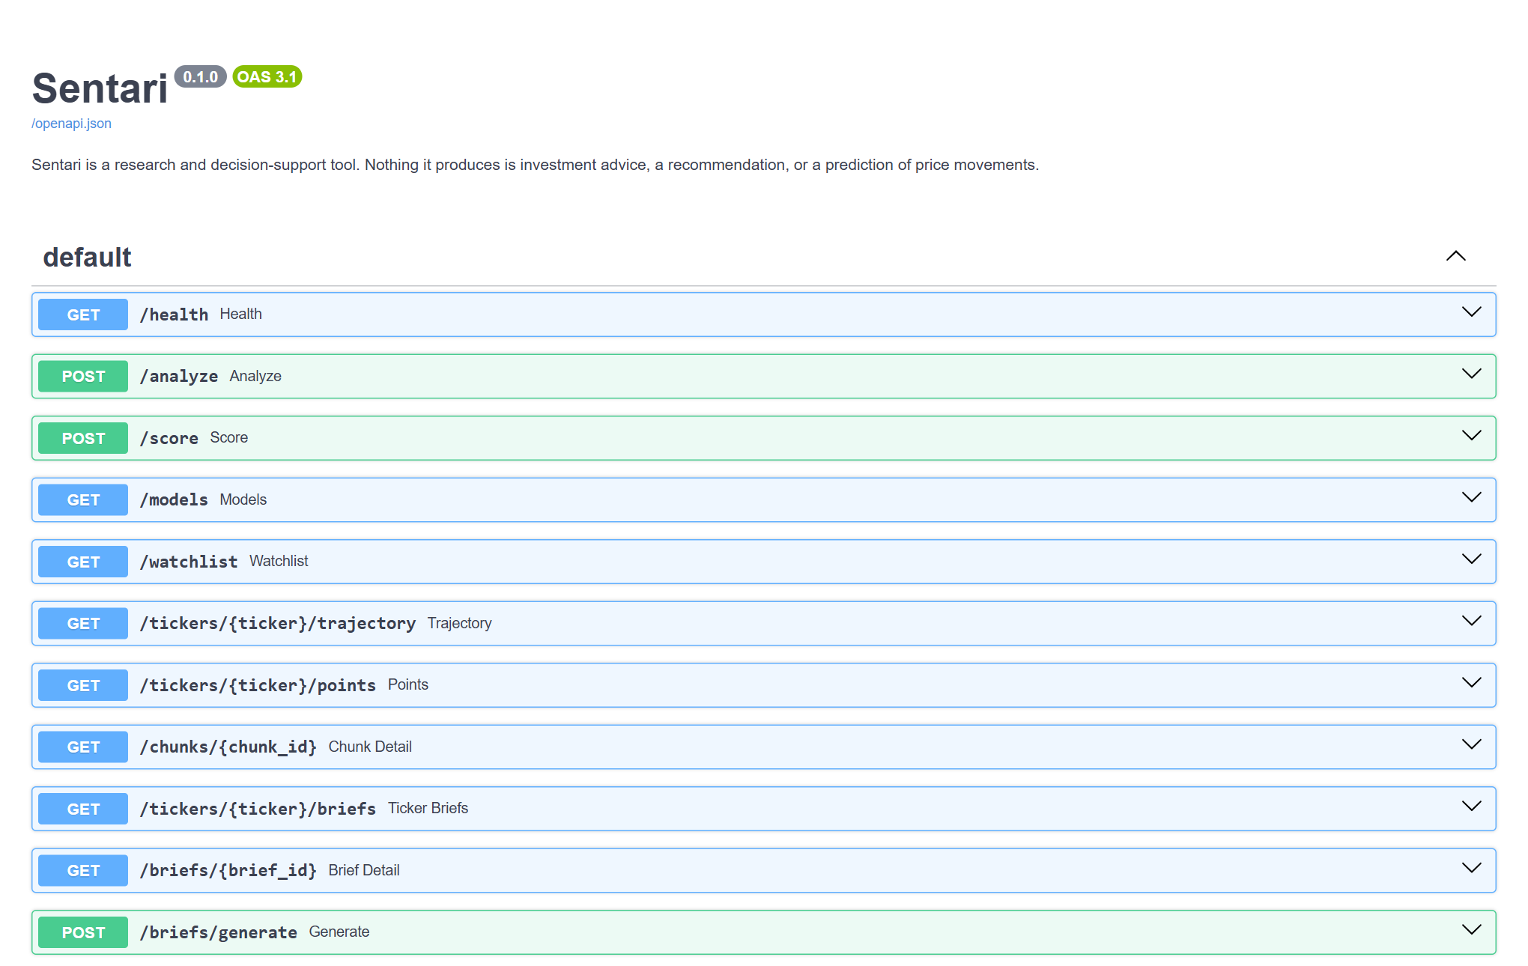
Figure 4.2: Interactive API documentation generated by FastAPI (/docs).

4.10 Dashboard
The Next.js dashboard has five views — watchlist, ticker, brief, drift monitor and model registry — described with screenshots in Chapter 5. Charts are hand-written SVG with no charting dependency; colour tokens adapt to light and dark mode; and every page repeats the research-use disclaimer.

4.11 Configuration and deployment
- Configuration. A .env file (template: .env.example) is loaded before any module reads its settings; real environment variables always win and empty values are ignored. A test fails if the code reads a variable that the template does not document.
- Containers. A CPU-only backend image, a standalone Next.js image, and a Compose file adding PostgreSQL (pgvector) and an MLflow server.
- Cloud. A Cloud Run guide covers Cloud SQL, both services and a Cloud Scheduler job that calls /run/daily with a token; the endpoint is idempotent, so scheduler retries are safe.
- Reproducibility. dvc.yaml defines the train → lexicon-failure → grounding stages; CI runs the Python tests and the dashboard type-check and build on every push.
Status: the container images have not been built and nothing has been deployed yet (Docker Desktop was not running during development and no cloud project was available). These files are written and reviewed but unverified.

5 User Interface Walkthrough
All screenshots in this chapter were captured from the running system using the bundled synthetic corpus — two fictional companies, Acme Industrial (ACMX) and Novalite Software (NVLT), with two earnings calls each and one 10-Q — after one daily run. The serving model was fine-tuned FinBERT (selected by the registry) and the Skeptic used the NLI backend. Company names, people and figures in these screens are invented.

5.1 Watchlist
The landing page shows the day's largest aspect moves and one card per ticker with the latest call's six aspect scores. A ⚠ marks aspects where the Q&A was more than 0.5 below the prepared remarks. The badge shows the latest brief's stance and confidence.
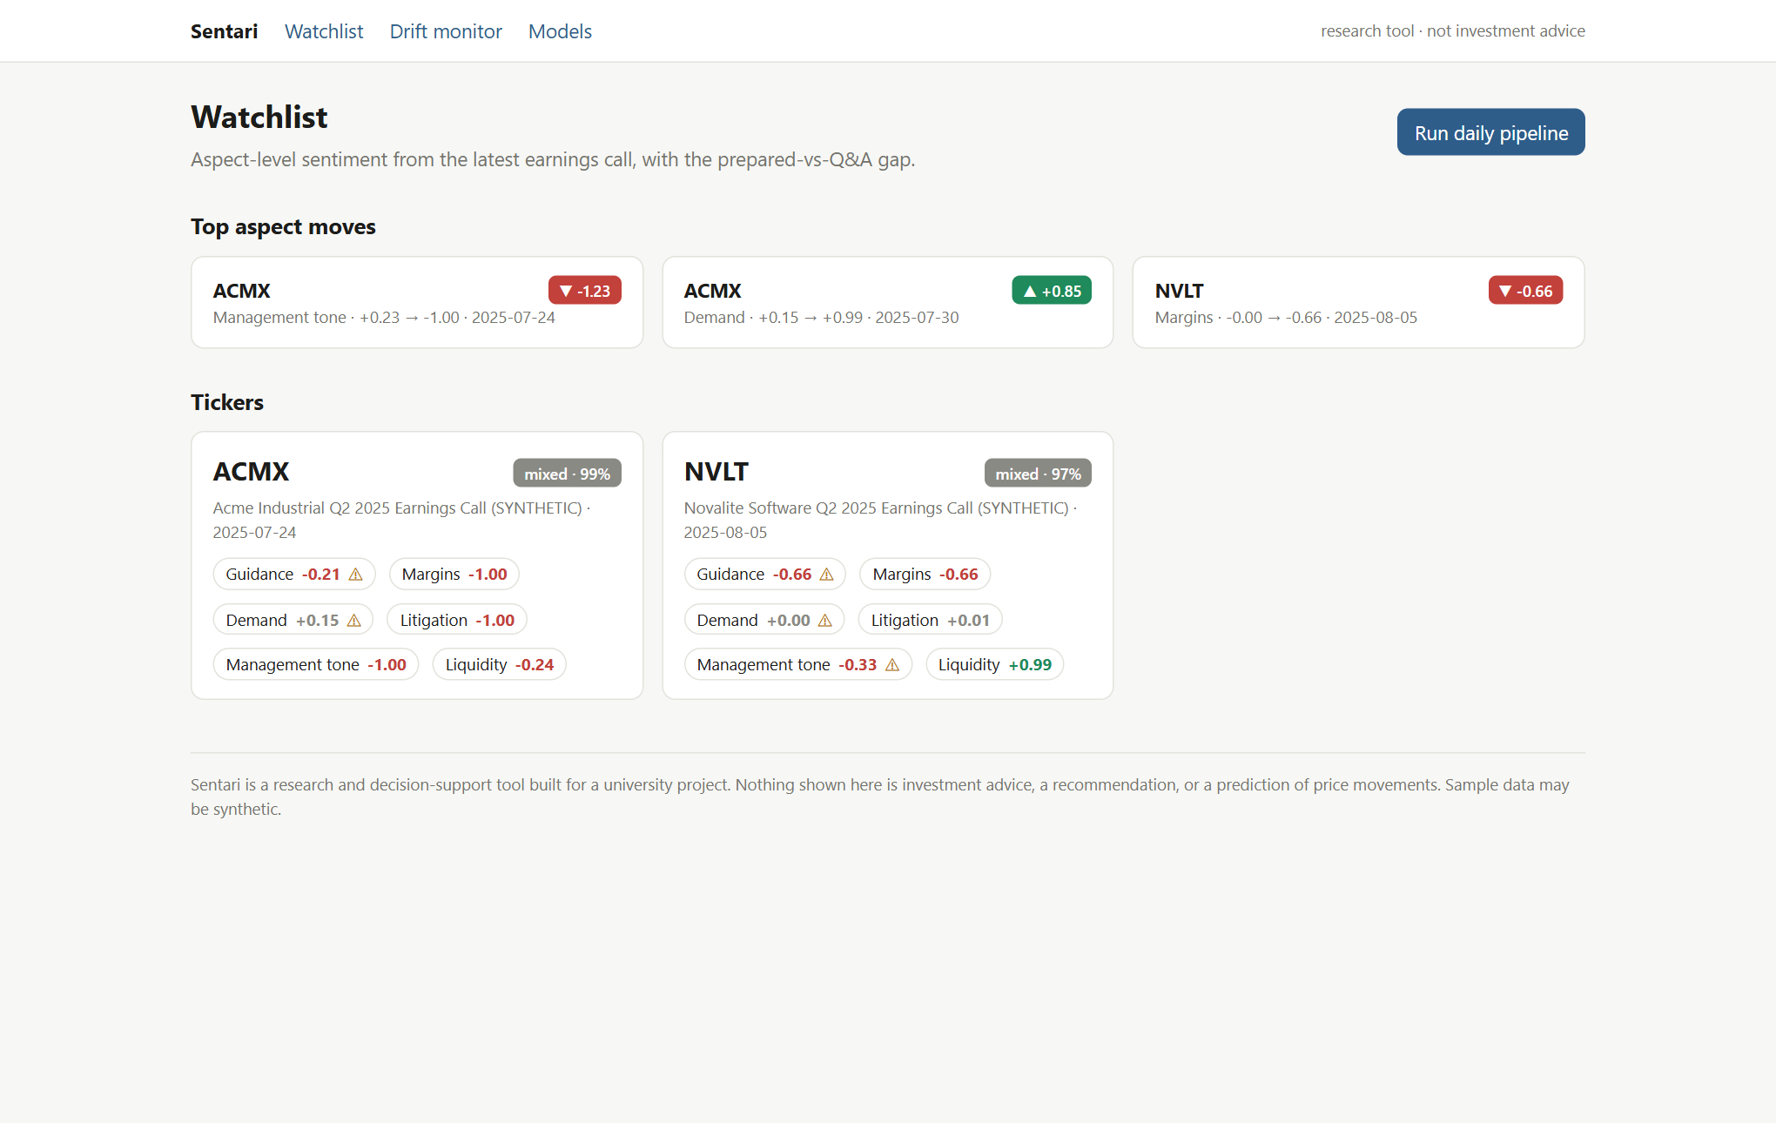
Figure 5.1: Watchlist: top aspect moves and per-ticker aspect scores from the latest call.

5.2 Aspect trajectories and drill-down
The ticker page plots each aspect over time: the solid line is the document mean, the green and red dashed lines the prepared-remarks and Q&A means. For ACMX the Q&A line sits below the prepared line for most aspects — the pattern the prepared-versus-Q&A signal is designed to surface.
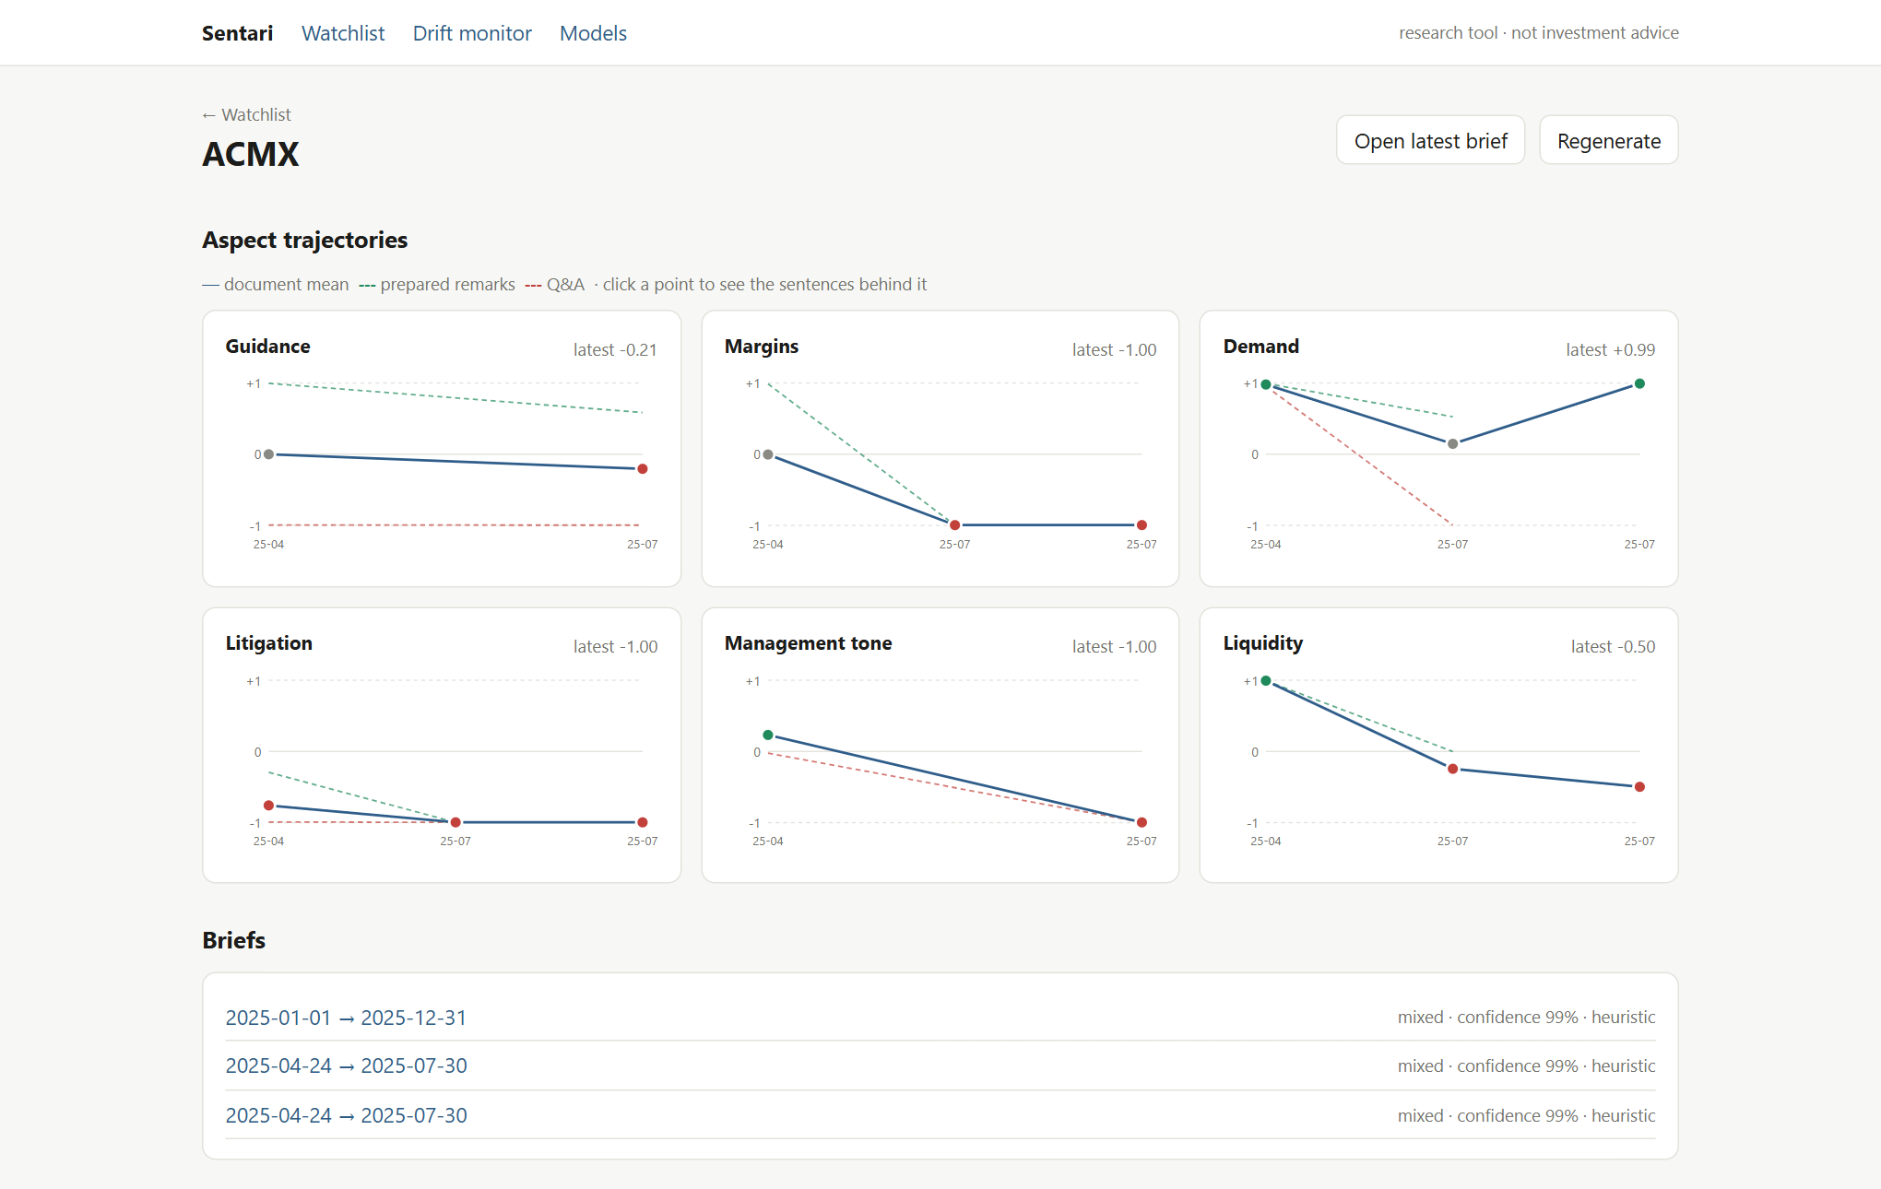
Figure 5.2: Ticker view for ACMX: six aspect trajectories with prepared-remarks and Q&A lines.
Clicking any point lists the scored sentences behind it (Figure 5.3); clicking a sentence opens the source drawer (Figure 5.4), which shows the sentence in context with speakers, the document it came from, and every model verdict stored for it.
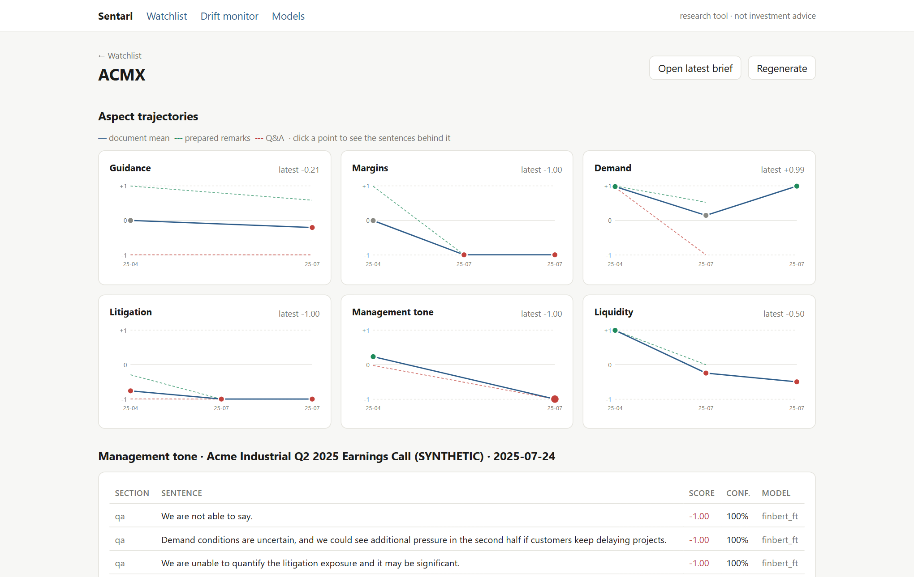
Figure 5.3: Drill-down: the management-tone point for the Q2 call opens the sentences, sections, scores and model behind it.
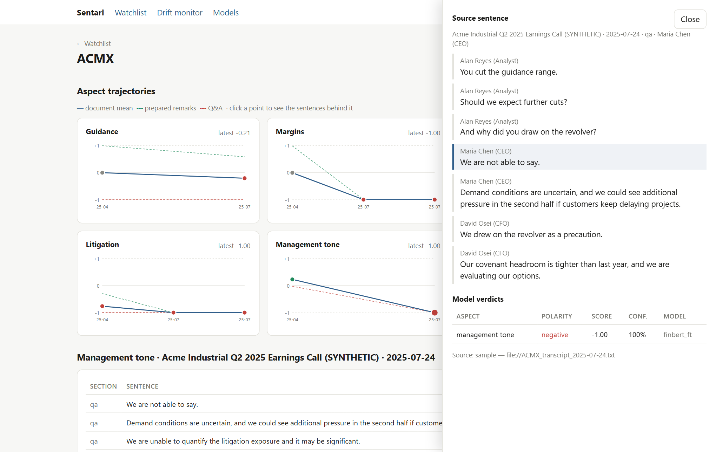
Figure 5.4: Source drawer: the selected sentence highlighted in its surrounding transcript, with the model's verdict.

5.3 Grounded brief
The brief page shows the stance, the confidence with its components, the summary, and the verified bull and bear claims by aspect. Every claim carries src chips; each opens the cited source sentence. Unverified claims, if any, are listed separately, and the number of rejected claims is stated.
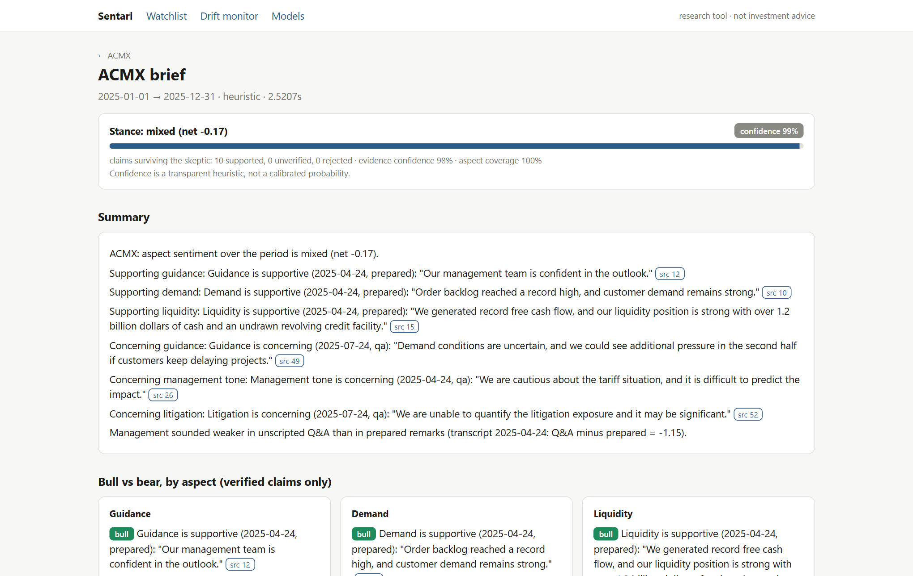
Figure 5.5: Brief for ACMX: stance, confidence breakdown and a summary in which every claim is cited.
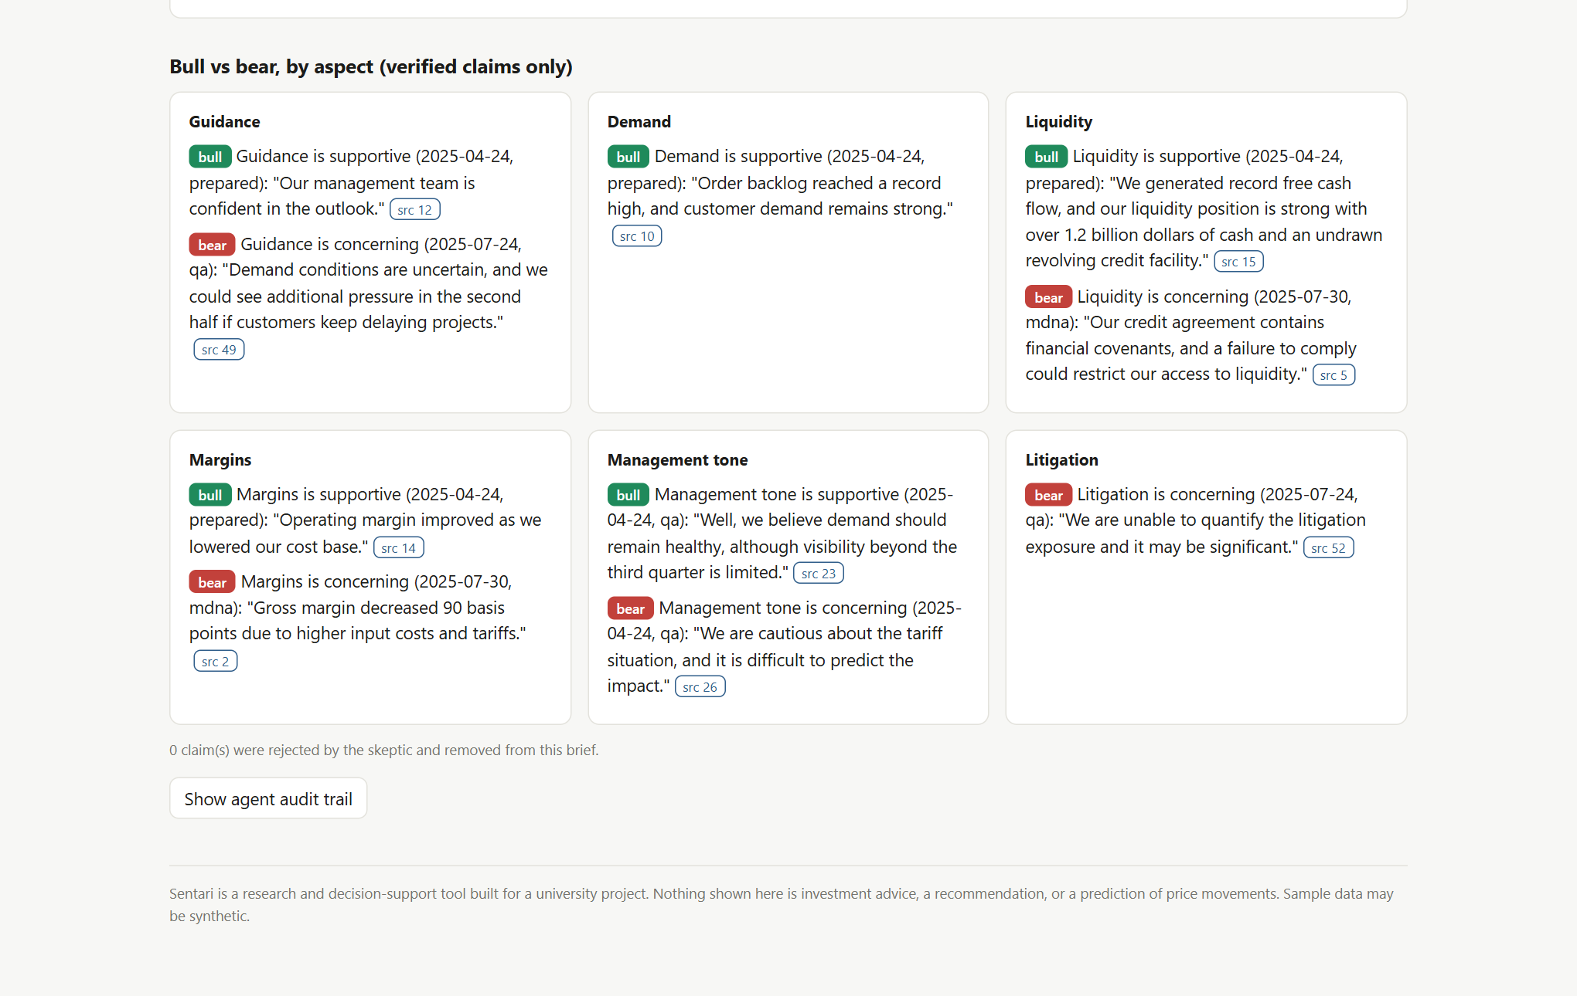
Figure 5.6: Verified bull and bear claims grouped by aspect.
Fixed while preparing this report: repeated claims. The first version of this brief cited one sentence ("Demand conditions are uncertain …") three times, as the bear claim for guidance, demand and management tone, because one sentence can trigger several aspects and each aspect picked its strongest sentence independently. Sentences are now cited at most once per side (Section 4.7). The ACMX brief shown here has 10 claims from 10 different sentences. The bear case lost its demand claim, because no other negative demand sentence exists, and gained a more specific tone claim ("We are cautious about the tariff situation …"). One imprecision remains: "Our management team is confident in the outlook" is filed under guidance because outlook is a guidance trigger.
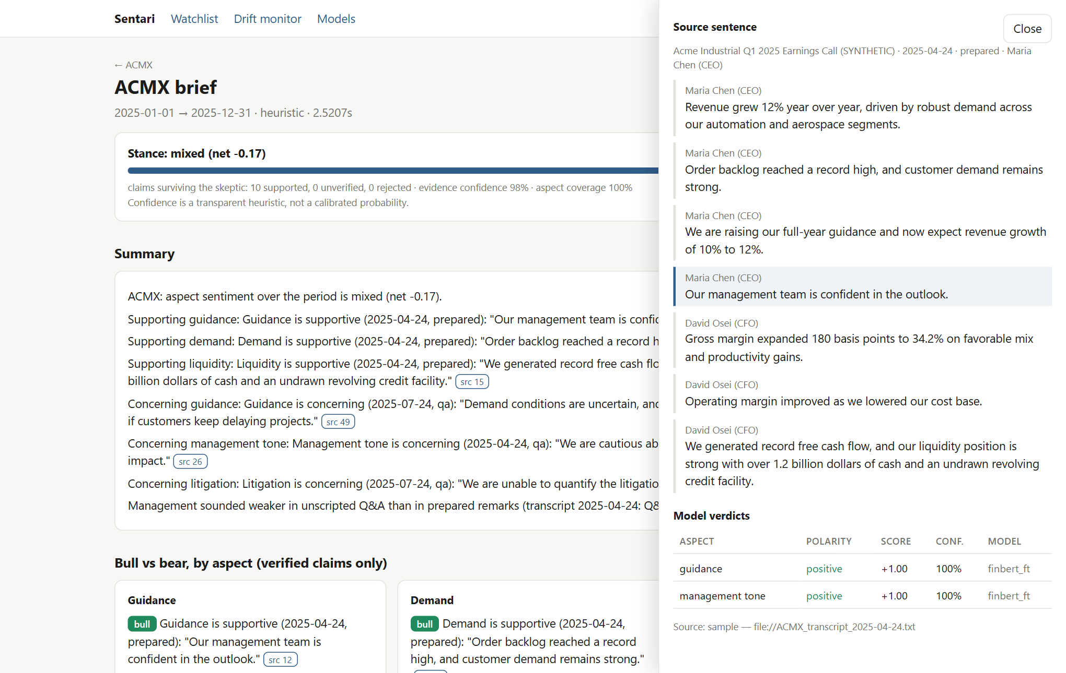
Figure 5.7: Following a citation from the brief to its source sentence.
The audit trail (Figure 5.8) exposes the output of every agent. For the Skeptic it records, per claim, each check's result, the similarity and overlap values and the NLI probabilities — here 0.976 entailment for a quoted claim.
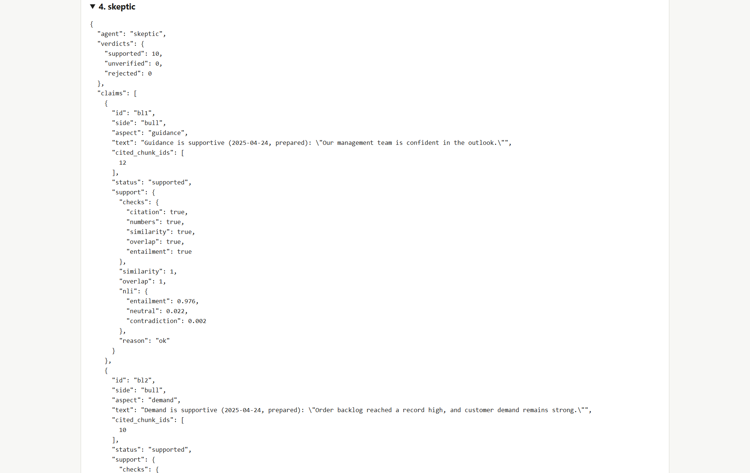
Figure 5.8: Agent audit trail: the Skeptic's per-claim checks and NLI probabilities.

5.4 Drift monitor and model registry
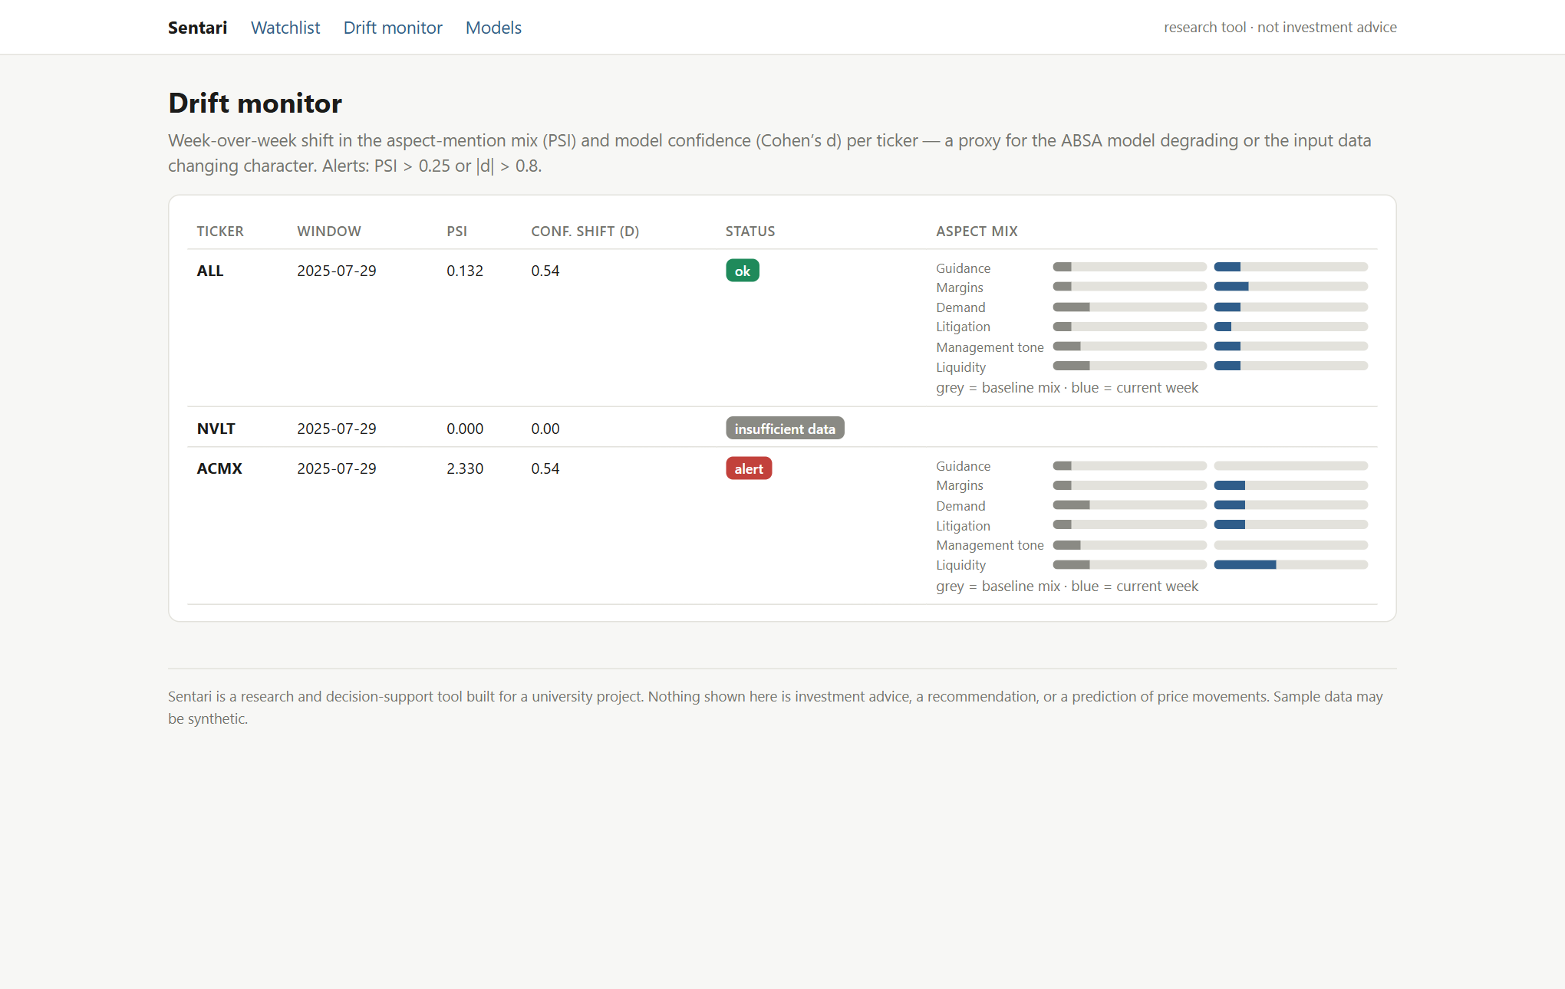
Figure 5.9: Drift monitor: PSI and confidence shift per ticker and for the whole watchlist, with baseline versus current aspect mix.
The ACMX alert (PSI 2.33) illustrates a limitation rather than real drift: the current window contains only five scores, all from one 10-Q, whose aspect mix naturally differs from calls. The five-score minimum is too low for a watchlist this small; Chapter 11 discusses it.
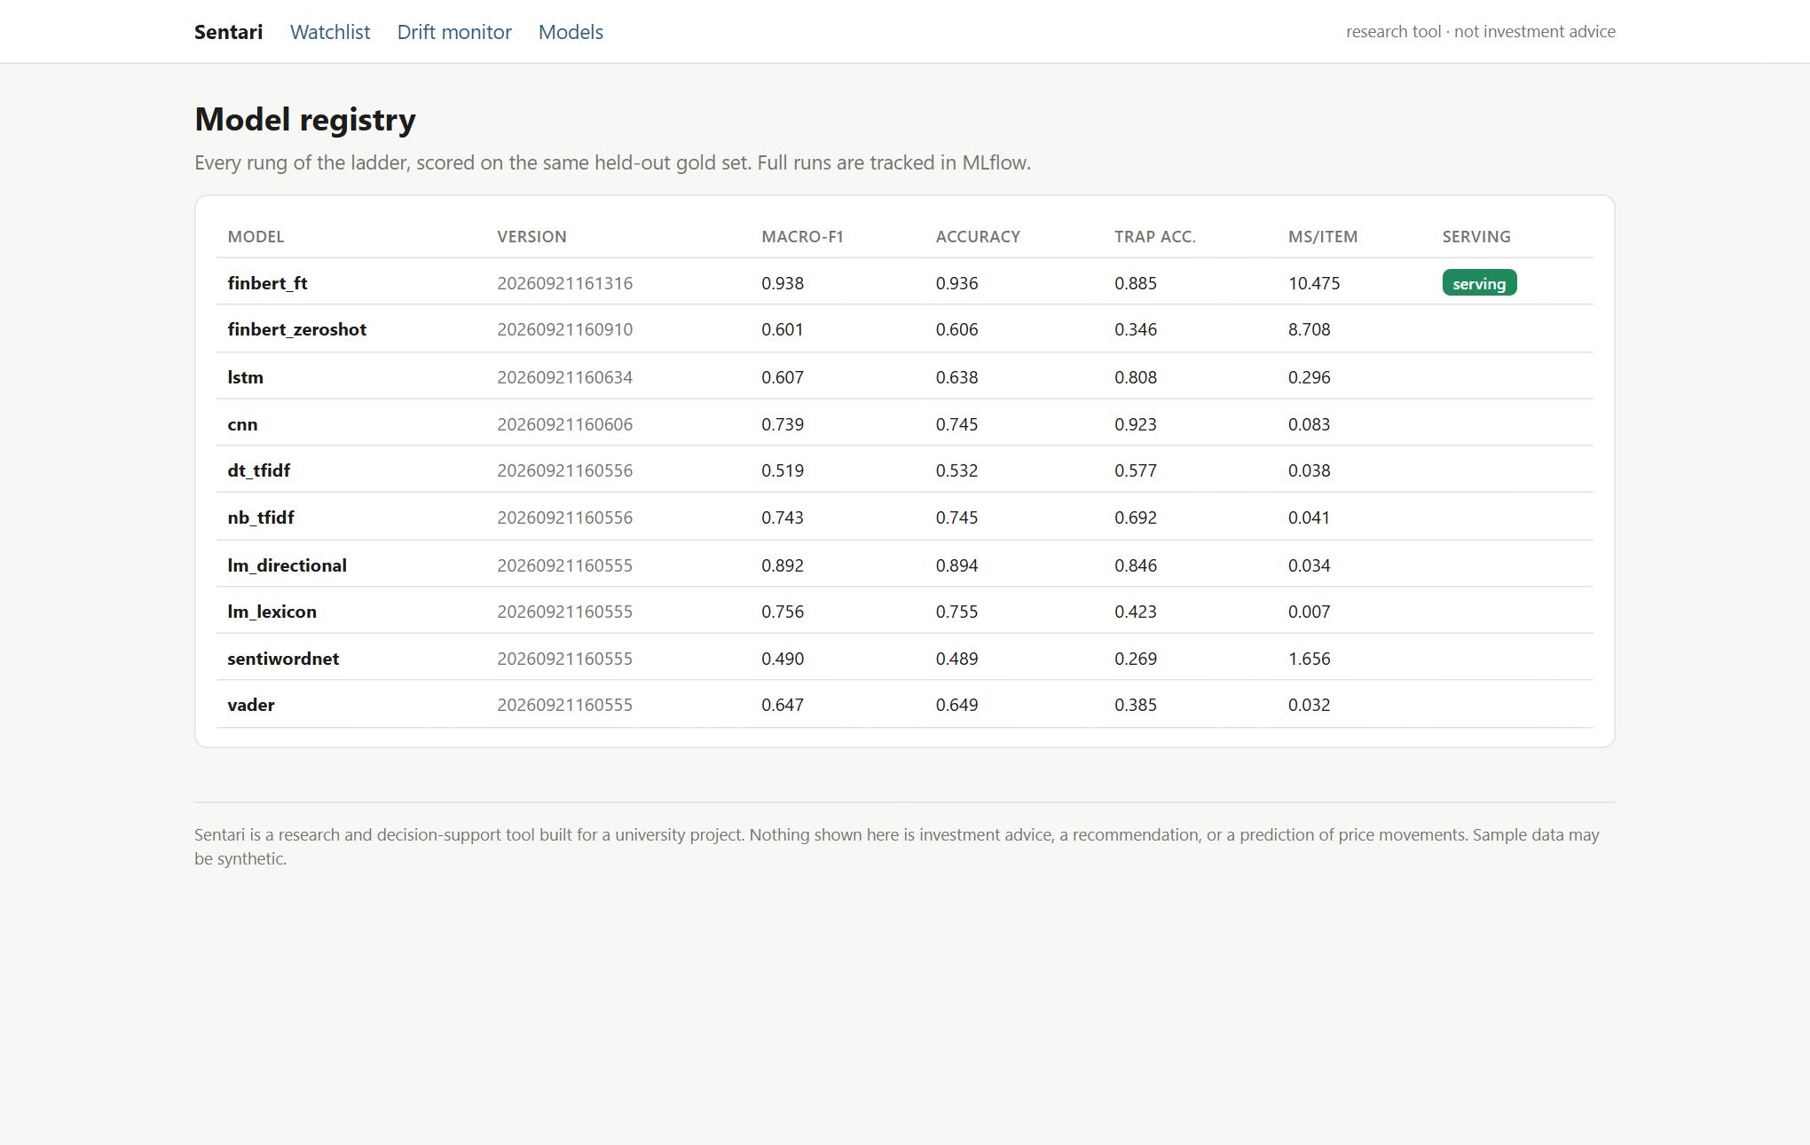
Figure 5.10: Model registry: every rung with gold-set metrics and the serving flag.
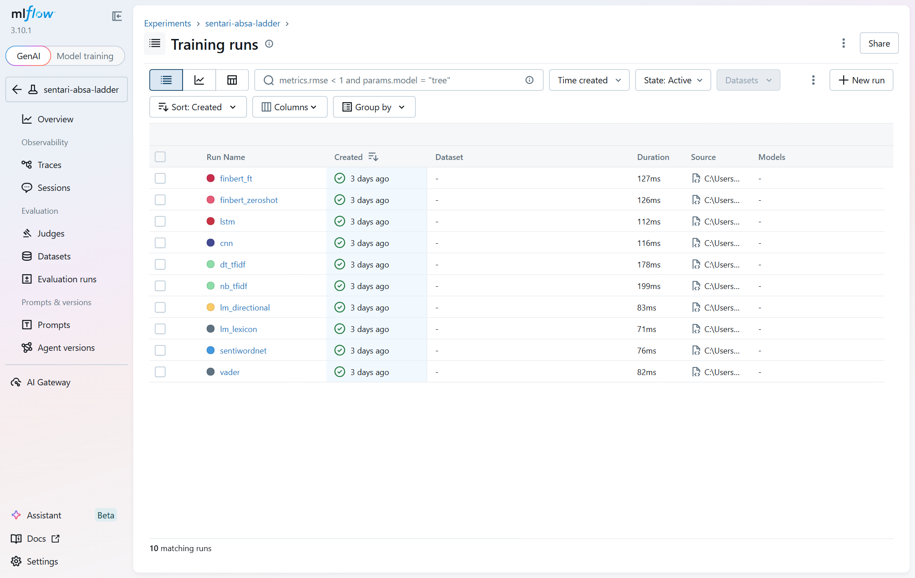
Figure 5.11: MLflow experiment sentari-absa-ladder with one run per model. (Durations are logging times; training times are in Section 6.2.)

5.5 Dark mode and small screens
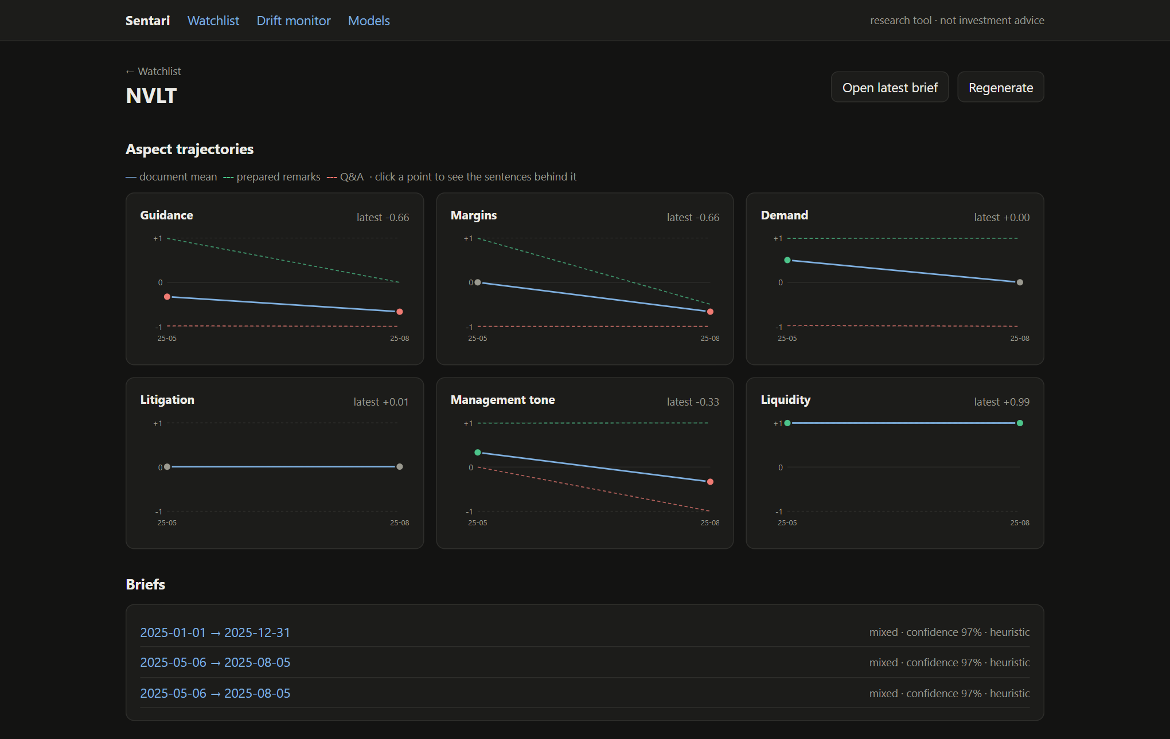
Figure 5.12: Ticker view in dark mode (NVLT).
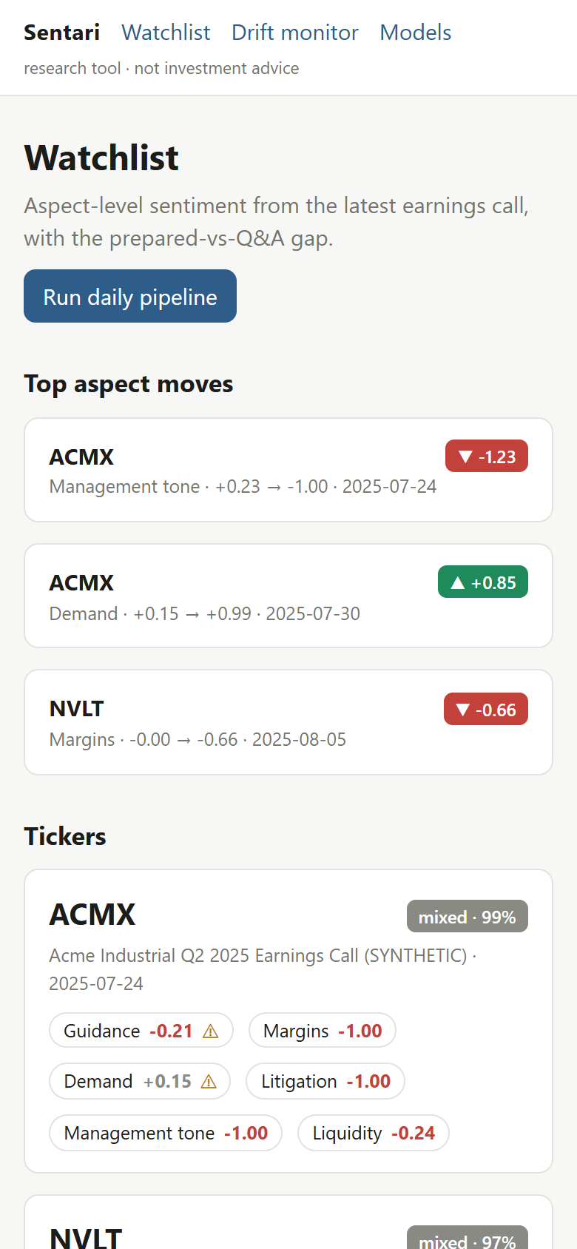
Figure 5.13: Watchlist at phone width (390 px).
At 390 px the cards reflow to a single column. The navigation bar wraps: the links stay on one line and the disclaimer moves to a line of its own. (An earlier version let the disclaimer overflow the right edge of the screen; it was fixed while preparing this report.)

6 Evaluation
The project plan asks for five evaluations. Table 6.1 summarises their status; the rest of the chapter reports each one.
Table 6.1: Evaluation plan status
# | Evaluation | Status
1 | Model ladder comparison on one held-out set | Done (Section 6.2)
2 | Lexicon failure analysis | Done (Section 6.3)
3 | Grounding audit | Adversarial audit done; human-annotated audit tooling built, not yet run (Section 6.4)
4 | Signal validity (Q&A delta vs. post-earnings drift) | Harness built and tested; not run — needs real transcripts and prices (Section 6.5)
5 | Latency and cost per brief | Latency measured; LLM cost not measured — no API key used (Section 6.6)

6.1 Data and protocol
- Gold (test) set: 94 hand-written sentences, each labelled with one aspect and a polarity: every aspect has 5–6 positive, 6 negative and 4 neutral examples. 26 are flagged as traps — sentences where financial meaning inverts everyday polarity. The gold set is used only for evaluation.
- Training set: 3,400 weak-labelled template sentences, with 600 more held out for validation (Section 4.4). FinBERT was fine-tuned on the first 1,500 for CPU time.
- Metrics: accuracy, macro-F1, per-class precision/recall/F1, accuracy on the trap subset, and inference time per sentence on CPU. One training seed.

6.2 Model ladder
Table 6.2: Model ladder on the 94-sentence gold set (P / R / F1 per class)
Model | Acc. | Macro-F1 | Negative | Neutral | Positive | Trap acc. | ms/item
VADER | 0.649 | 0.647 | 0.69 / 0.61 / 0.65 | 0.59 / 0.67 / 0.63 | 0.66 / 0.68 / 0.67 | 0.38 | 0.03
SentiWordNet | 0.489 | 0.490 | 0.56 / 0.42 / 0.48 | 0.38 / 0.63 / 0.47 | 0.59 / 0.47 / 0.52 | 0.27 | 1.66
Loughran-McDonald (seed list) | 0.755 | 0.756 | 0.92 / 0.67 / 0.77 | 0.57 / 1.00 / 0.73 | 0.88 / 0.68 / 0.77 | 0.42 | 0.01
LM + directional rules | 0.894 | 0.892 | 0.97 / 0.86 / 0.91 | 0.79 / 0.96 / 0.87 | 0.91 / 0.88 / 0.90 | 0.85 | 0.03
Naive Bayes (TF-IDF) | 0.745 | 0.743 | 0.69 / 0.81 / 0.74 | 0.88 / 0.63 / 0.73 | 0.74 / 0.76 / 0.75 | 0.69 | 0.04
Decision Tree (TF-IDF) | 0.532 | 0.519 | 0.47 / 0.75 / 0.57 | 0.58 / 0.46 / 0.51 | 0.71 / 0.35 / 0.47 | 0.58 | 0.04
CNN (Kim-style) | 0.745 | 0.739 | 0.69 / 0.86 / 0.77 | 0.83 / 0.63 / 0.71 | 0.77 / 0.71 / 0.74 | 0.92 | 0.08
BiLSTM | 0.638 | 0.607 | 0.58 / 0.81 / 0.67 | 0.80 / 0.33 / 0.47 | 0.68 / 0.68 / 0.68 | 0.81 | 0.30
FinBERT, zero-shot | 0.606 | 0.601 | 0.67 / 0.39 / 0.49 | 0.61 / 0.71 / 0.65 | 0.58 / 0.76 / 0.66 | 0.35 | 8.71
FinBERT, fine-tuned | 0.936 | 0.938 | 0.94 / 0.92 / 0.93 | 0.96 / 0.96 / 0.96 | 0.91 / 0.94 / 0.93 | 0.88 | 10.47

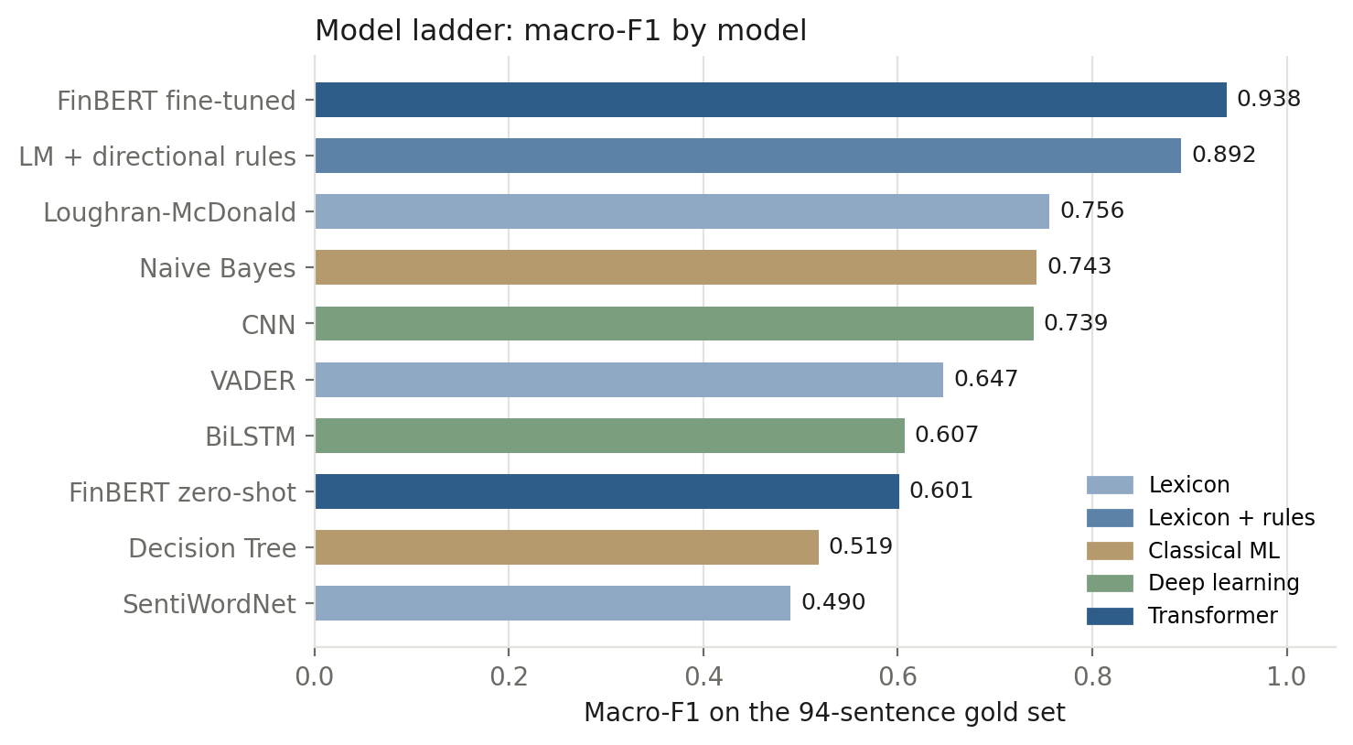
Figure 6.1: Macro-F1 by model, coloured by rung.
Fine-tuned FinBERT is the strongest model (macro-F1 0.938), followed by the LM + directional rule model (0.892). Adding finance-specific vocabulary alone moves the lexicon rung from 0.647 (VADER) to 0.756 (Loughran-McDonald); adding directionality moves it to 0.892. Zero-shot FinBERT (0.601) does worse than plain Loughran-McDonald: it was trained for sentence-level sentiment and does not know which aspect it is being asked about, so fine-tuning on the aspect pair is what makes it useful here.
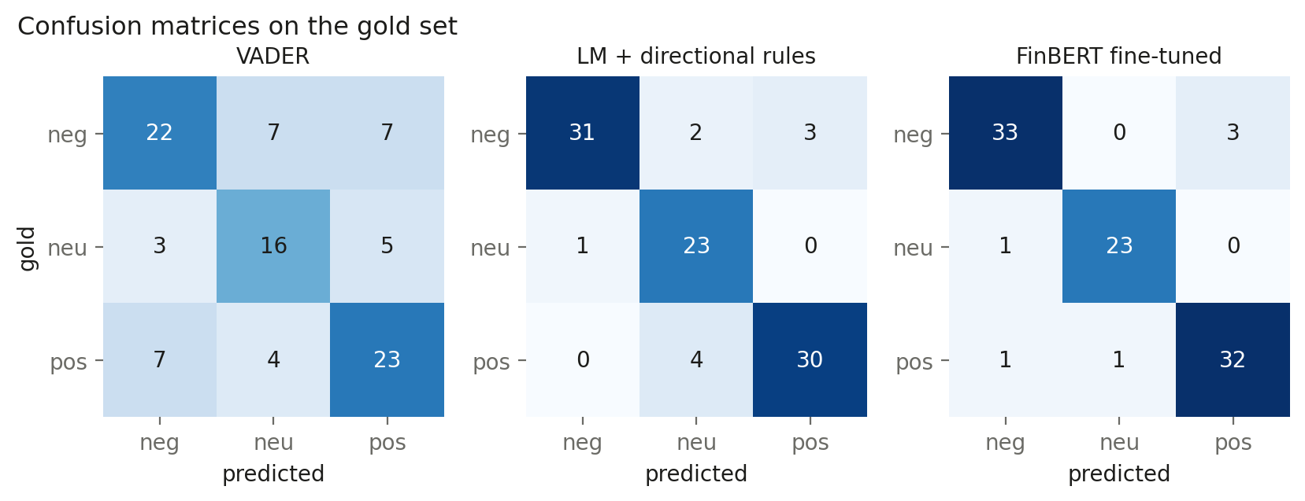
Figure 6.2: Confusion matrices for the general-purpose lexicon, the best rule model and the best learned model.
VADER's errors are spread across all cells, including 14 negative/positive swaps — the direction errors that matter most for an investor. FinBERT's six errors are mostly positive/negative confusions on trap sentences about costs and cash (Section 6.3); the rule model's errors are mostly confusions with neutral.
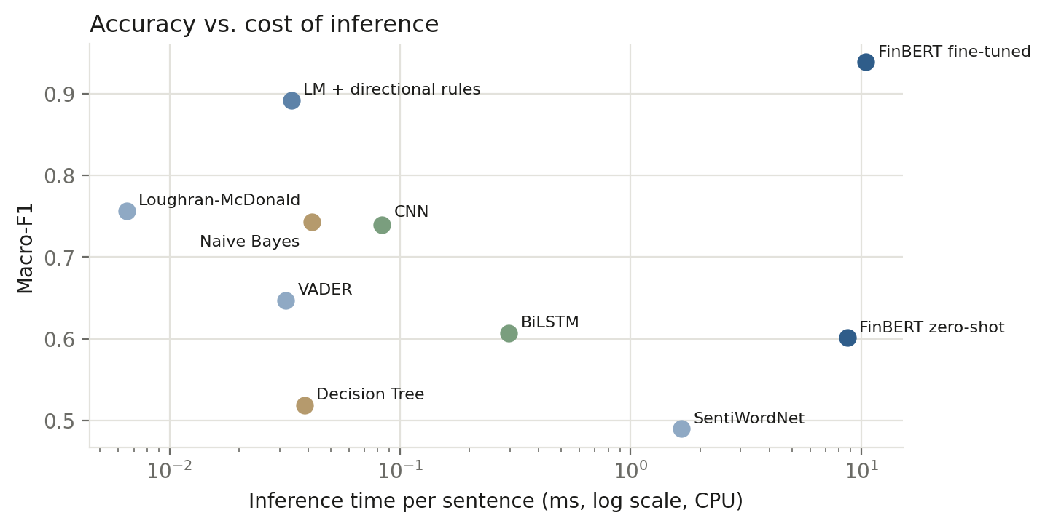
Figure 6.3: Accuracy against inference cost per sentence on CPU (log scale).
The rule model scores a sentence in about 0.03 ms; FinBERT takes about 10 ms, three hundred times longer. At watchlist scale both are affordable, which is why the registry serves FinBERT, but the rule model is a strong fallback and remains the default when no trained weights are present.

Why these numbers are optimistic
- Weak labels are too easy. CNN, BiLSTM and FinBERT all reached 100% accuracy on the weak-label validation split within a few epochs, yet 74%–94% on gold. The templates are far more regular than real language; validation accuracy on them says nothing about real performance.
- The gold set is small. One sentence is about 1.1 accuracy points; differences of a few points between models are within noise, and only one seed was run.
- Gold and templates share phrasing. Both were written by the same author about the same six aspects, so the trained models' gold scores will overstate performance on real transcripts.
- The rule model was written with sight of the gold set. Its directional rules reflect patterns the author had read; its score is an optimistic upper bound. (Gold-derived words were removed from the plain LM seed list to keep that baseline fair.)
- The LM lexicon is a curated subset, not the official ~86,000-word dictionary.

6.3 Lexicon failure analysis
Table 6.3 and Figure 6.4 split each model's error rate between the 26 trap sentences and the other 68.
Table 6.3: Error rate on trap and non-trap sentences
Model | All (n=94) | Trap (n=26) | Non-trap (n=68)
VADER | 35.1% | 61.5% | 25.0%
SentiWordNet | 51.1% | 73.1% | 42.6%
Loughran-McDonald (seed list) | 24.5% | 57.7% | 11.8%
LM + directional rules | 10.6% | 15.4% | 8.8%
Naive Bayes (TF-IDF) | 25.5% | 30.8% | 23.5%
CNN (Kim-style) | 25.5% | 7.7% | 32.4%
FinBERT, fine-tuned | 6.4% | 11.5% | 4.4%

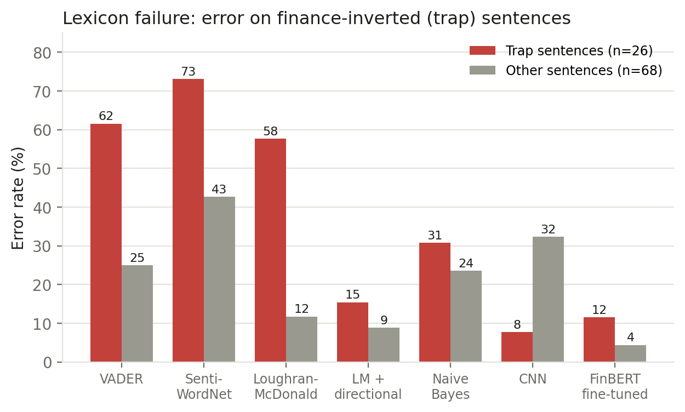
Figure 6.4: Error rate on finance-inverted (trap) sentences versus the rest.
General-purpose lexicons are wrong on most trap sentences: 61.5% for VADER and 73.1% for SentiWordNet. Plain Loughran-McDonald counting fixes much of the vocabulary problem on ordinary sentences (11.8% error) but not the trap problem (57.7%), because a word list cannot tell whether decreased is good or bad without knowing what decreased. Directional rules (15.4%) and the learned models close most of the gap. Table 6.4 lists representative failures.
Table 6.4: Representative trap sentences mis-scored by VADER
Aspect | Sentence | Gold | VADER | LM+dir. | FinBERT
demand | Customer churn decreased to its lowest level in three years. | pos | neg | ✓ | ✓
liquidity | Total liabilities decreased and our net debt fell to its lowest level in a decade. | pos | neg | ✓ | ✓
litigation | Legal expenses decreased as the dispute was resolved earlier than planned. | pos | neg | ✓ | ✓
litigation | Litigation expenses increased this quarter as the patent case moved toward trial. | neg | pos | ✓ | ✓
litigation | The jury verdict went against us and we recorded a 90 million dollar provision. | neg | pos | ✓ | ✓
demand | Churn increased in the mid-market as customers consolidated vendors. | neg | pos | ✓ | ✓
margins | Cost of revenue increased 14% year over year, outpacing sales growth. | neg | pos | ✓ | ✗ pos
liquidity | Cash declined by 400 million dollars and we fully drew our credit facility. | neg | pos | ✓ | ✗ pos
guidance | We now expect operating expenses to come in below the low end of our prior guidance. | pos | neg | ✓ | ✗ neg
guidance | We do not expect to meet our prior guidance for free cash flow this year. | neg | pos | ✗ | ✓

The residual FinBERT errors are the same phenomenon in a subtler form: increased next to a cost, or declined next to cash, pulls the model toward the polarity of the verb rather than the implication for the company. This supports the project's premise that financial directionality must be modelled explicitly or learned from data that contains it.
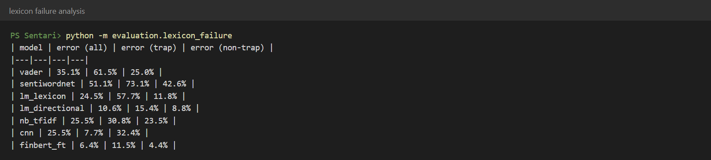
Figure 6.5: Output of python -m evaluation.lexicon_failure.

6.4 Grounding audit
Adversarial audit. Starting from 43 faithful claims (verbatim scored sentences), the audit creates five kinds of corrupted claims that imitate how a generator fails, passes all of them through the Skeptic, and counts a corrupted claim as caught if it is rejected or flagged unverified — both keep it out of the brief body.
Table 6.5: Adversarial grounding audit (caught = rejected or flagged; hard reject = rejected)
Corruption | n | Heuristic caught | Heuristic rejected | NLI caught | NLI rejected
Number changed | 13 | 100.0% | 100.0% | 100.0% | 100.0%
Citation removed | 43 | 100.0% | 100.0% | 100.0% | 100.0%
Wrong chunk cited | 43 | 100.0% | 51.2% | 100.0% | 34.9%
Fabricated claim | 43 | 100.0% | 32.6% | 100.0% | 58.1%
Polarity flipped | 22 | 22.7% | 22.7% | 100.0% | 100.0%
Faithful claims (false alarms) | 43 | 0 flagged | 0 rejected | 0 flagged | 0 rejected

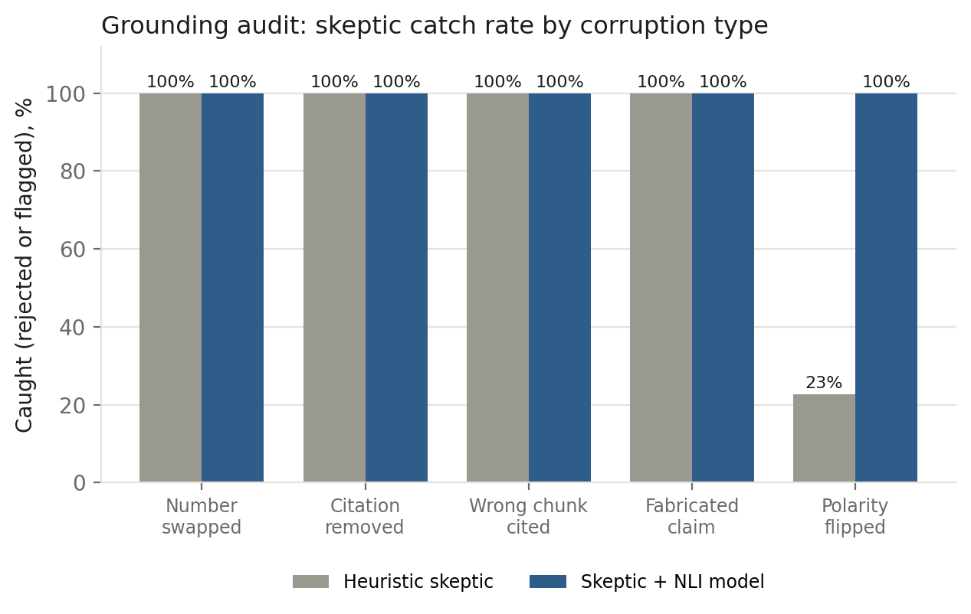
Figure 6.6: Skeptic catch rate by corruption type, heuristic versus NLI entailment.
Structural failures — invented numbers, missing or wrong citations, fabricated claims — are caught in both modes, and no faithful claim was wrongly flagged. The heuristic Skeptic, however, let 17 of 22 polarity-flipped claims through ("gross margin contracted 180 basis points" citing a sentence that says it expanded): the claim shares almost every word and number with its source, so similarity checks pass, and the polarity-cue heuristic is too coarse. With the NLI model all 22 were rejected. The NLI backend should therefore be treated as required, not optional, for real use.
Caveats. The corruptions are synthetic and the faithful claims are verbatim, which is the easy case; paraphrased LLM claims are harder to verify. The audit therefore bounds the Skeptic's catch rate from above. A human audit — grounding_audit --export N samples claims from real briefs into a spreadsheet for 1/0 annotation and --score computes the supported fraction and the Skeptic's agreement with the annotator — is implemented and tested but has not been run, because no LLM-written briefs have been generated yet.

6.5 Signal validity
The question is whether the prepared-versus-Q&A delta correlates with the subsequent five-day return (market-adjusted) better than document-level sentiment does. The harness builds three predictors per call (delta, document-level mean, prepared-only mean), joins them to forward returns from a CSV or from Yahoo Finance, and reports Spearman ρ with p-value, Pearson r, a 2,000-sample bootstrap 95% confidence interval, and the difference between the delta and document-level correlations, together with an explicit interpretation that defaults to a null result when nothing is significant.
Not run. The only corpus available is synthetic, so any correlation with real prices would be meaningless, and no returns file is bundled on purpose. Tests exercise the harness on fake returns only to check the plumbing. With a watchlist-sized sample (tens of calls) a null result is the expected outcome; the project plan treats a clearly reasoned null result as a legitimate finding.

6.6 Latency and cost
Table 6.6: Measured latency
Operation | Measured | Notes
Score one sentence | 0.03 ms (rules) – 10.5 ms (FinBERT) | CPU, gold-set average (Table 6.2)
Generate one brief, offline agents | 0.79 s mean, 1.55 s max | Rule-based model, heuristic Skeptic, 2 briefs
Generate one brief, NLI Skeptic | 0.4 – 2.5 s | NLI model already loaded (NVLT, ACMX)
Load the NLI model | 4 s – 51 s | One-off per process; varies with disk cache and Hugging Face hub checks
Full daily run on the sample corpus | 84 s | Fresh database; 5 documents, 88 chunks, FinBERT scoring, NLI Skeptic, 2 briefs, drift, digest; includes loading both models
LLM tokens and cost per brief | not measured | Recorded per brief (tokens in/out) once an API key is configured
Fine-tuning time | CNN 10 s · BiLSTM 28 s · FinBERT 238 s | CPU; FinBERT on 1,500 examples, 2 epochs

Cached briefs cost nothing: a second daily run with no new documents skipped all five documents as duplicates, wrote no new scores or embeddings and returned both cached briefs. It did re-analyse six chunks that contain no aspect mention (they leave no score row to mark them as done) — harmless, but wasted work at scale.

6.7 Qualitative findings from the end-to-end run
- Q&A is weaker than the script. On ACMX's first call the Q&A-minus-prepared delta was −1.15, driven by guidance (−1.99: "raising our full-year guidance" in the script, "visibility beyond the third quarter is limited" in the Q&A) and margins (−1.98: a 180 bp expansion in the script, input costs "a headwind" and tariffs "difficult to predict" in the Q&A). The signal behaves as designed on text written to exhibit it; whether it does so on real calls is the open question of Section 6.5.
- Repeated claims across aspects in the first version of the brief, now fixed (Section 5.3).
- Over-confident transformer. FinBERT assigned −1.00 with 100% confidence to "We are not able to say." — a reasonable negative-tone reading, but the certainty is not warranted; confidence values are uncalibrated.
- Mixed document types. The top digest move (ACMX demand +0.15 → +0.99) compares a call with a 10-Q filed six days later; trajectories mix document types, which inflates moves.
- Noisy drift alerts on very small windows (Section 5.4).

7 Testing

7.1 Strategy
Every test runs offline in about 30 seconds with no API keys: the LLM backend is pinned to the deterministic heuristic, the serving model to the rule-based model, and the .env loader is disabled, so results never depend on a developer's local files. Tests use in-memory SQLite, the bundled sample corpus and FastAPI's test client.
Table 7.1: Automated tests by module (58 in total; one test is parametrised six ways)
Module | Tests | What is covered
test_ingestion.py | 6 | normalisation, abbreviation-aware splitting, speaker/section parsing, hashing, idempotent ingestion
test_absa.py | 20 | negation scope, hedging, clause splitting, aspect triggers, spaCy vs. fallback agreement, directional scoring, VADER's failure, gold-set integrity, no gold leakage into training data, trainable model beats chance
test_agents.py | 12 | Skeptic accepts faithful claims; rejects fabricated numbers, bad citations and contradictions; full graph produces a cited brief with every agent in the trace; brief caching; rejected claims never reach the brief; no sentence cited twice by one side; Judge merges duplicate claims
test_api_and_monitoring.py | 9 | PSI, drift alerting and idempotency, API validation and errors, daily run followed by every dashboard endpoint, cron-token enforcement
test_evaluation.py | 6 | lexicon failure analysis, adversarial grounding thresholds, human-audit export/score round trip, signal-validity plumbing and null reporting, latency report
test_env_loader.py | 5 | real environment wins over .env, empty values ignored, skip flag, parser edge cases, every variable documented

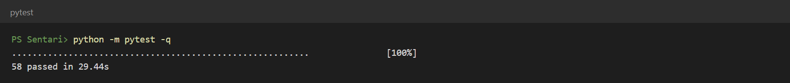
Figure 7.1: Test run: 58 passed.

7.2 Continuous integration
A GitHub Actions workflow installs CPU-only PyTorch and the NLP models, runs the Python suite, and type-checks and builds the dashboard on every push and pull request. (Its results on GitHub were not inspected during this phase.)

7.3 Defects found and fixed
Table 7.2: Defects found through testing and use
Defect | Found by | Fix
Bull and bear claim IDs both started with b, so a rejected bear claim could hide an accepted bull claim | Test: rejected claims never reach the brief | Distinct bl / br prefixes
Skeptic rejected a verbatim quote containing negation as "contradicted" | Inspecting a generated brief | Near-verbatim quotes exempt from the cue heuristic
Offline LLM backend reported its name as base, breaking cost reports | Test: latency/cost report | Name set in the constructor
Dashboard shipped a Next.js release with known security advisories | npm audit | Upgraded to Next.js 16 / React 19 (0 advisories)
Daily CLI crashed printing the digest (▲ ▼ ⚠) on Windows consoles | Running the pipeline for this report | stdout reconfigured to UTF-8
Each daily run appended duplicate drift reports | Screenshot of the drift page for this report | One report per (ticker, window); regression test added
Briefs repeated one sentence as several claims (one per aspect it triggered) | Screenshot of the brief for this report | Each sentence cited once per side; Judge merges duplicate claims; 3 tests added
Navigation bar overflowed the screen at phone width | Phone-width screenshot for this report | Nav wraps; disclaimer on its own line below 600 px

8 Syllabus Mapping
Table 8.1: Mapping to the Sentiment Analysis course (231CAUEC51)
Module | Topic | Where it appears in Sentari
M1 | Levels, challenges, applications | Aspect-level framing (1.1, 2.1); non-advice ethics (9)
M2 | Preprocessing and feature engineering | Transcript-aware segmentation, negation scope, hedging, clause splitting, TF-IDF, embeddings (4.1, 4.2)
M3 | Lexicon- and knowledge-based methods | VADER, SentiWordNet, Loughran-McDonald, directional rules; lexicon failure analysis (4.4, 6.3)
M4 | Machine-learning and deep-learning methods | Naive Bayes, Decision Tree, CNN, BiLSTM, fine-tuned FinBERT — one ladder, one test set (4.4, 6.2)
M5 | Aspect-based sentiment analysis | Aspect triggers with dependency-parsed opinion targets, aspect-pair transformer, per-aspect trajectories (4.3–4.5)
M6 | Applications | Financial decision support: dashboard, digest, grounded briefs, drift monitoring (4.7–4.10, 5)

9 Ethical and Legal Considerations
- Not investment advice. Sentari describes what companies said; it makes no recommendation and no price prediction. The disclaimer appears in the API description and every response that carries analysis, on every dashboard page, and in every digest and brief.
- Honest uncertainty. Confidence is labelled a heuristic, unverified claims are visibly flagged, and the evaluation reports negative and missing results alongside positive ones.
- Source terms. Official APIs are preferred (SEC EDGAR with a contact User-Agent, as the SEC requires). Scrapers respect terms of use; the NSE scraper returns nothing rather than work around access controls. Raw responses are cached to minimise load on sources.
- Data protection. Only public corporate disclosures and news are processed; no personal data is collected. Speaker names in transcripts are public officers' statements. API keys live in a gitignored .env and never in code or logs.
- Synthetic data. The demonstration corpus is fictional and labelled SYNTHETIC in every document title shown in the UI.

10 Project Status Against the Plan
Table 10.1: Roadmap from the project specification
Phase | Deliverable | Status
1 Data pipeline | Ingestion for a 10-ticker pilot watchlist | Pipeline built and tested on sample data; live pilot pending a transcript source and watchlist
2 Preprocessing & lexicons | Clean corpus; VADER/SWN/LM scored; failure analysis | Done
3 Classical ML + DL | NB, DT, CNN, LSTM trained and logged in MLflow | Done
4 Aspect extraction | POS/dependency-based extraction; aspect-level scoring | Done (rules + dependency parse; supervised aspect tagger not built)
5 Transformer | FinBERT fine-tuned on aspect sentiment | Done (on weak labels)
6 Agent layer | Bull/bear/skeptic/judge with grounding checks | Done
7 Storage + dashboard | Schema live; dashboard with drill-down | Done (SQLite verified; PostgreSQL untested)
8 Deployment + monitoring | Dockerised, on Cloud Run, drift monitor running | Drift monitor done; Docker/Cloud Run files written, not built or deployed
9 Evaluation | Ladder table, grounding audit, signal validity | Ladder and adversarial audit done; human audit and signal validity pending real data
10 Report + demo | Final report, recorded demo, GitHub polish | This report; demo video not recorded

10.1 Remaining work, in priority order
- Real transcripts. Choose a source (public dataset, NSE/BSE transcript PDFs, company IR pages or a paid API), write the scraper, and ingest the 10-ticker pilot.
- Real gold set. Annotate a few hundred sentences from real filings and calls, then re-run the ladder and the lexicon analysis against the official Loughran-McDonald dictionary.
- Signal validity on the pilot with real forward returns; report the result whatever it is.
- LLM agents with an API key; human grounding audit of about 50 claims; measure tokens and cost per brief.
- Deploy: build the images, run on Cloud Run with Cloud SQL and the scheduler, then record the demo.
- Remaining fixes found in this report: raise the drift minimum sample; separate trajectories by document type; re-analysing aspect-less chunks on every run.

11 Limitations and Future Work

11.1 Limitations
- Evaluation data. A 94-sentence self-written gold set, weak template labels and a synthetic corpus limit what the numbers can show; Section 6.2 lists the specific biases.
- Aspect handling. One sentence can still be tagged with several aspects (it is now cited only once per side); mixed clauses of one aspect are averaged, so a strong positive and a strong negative cancel to neutral; aspect detection is rule-based with no learned tagger, so a word like outlook can file a tone statement under guidance.
- Grounding. The heuristic Skeptic cannot detect polarity inversions; even with NLI, verification is only as good as the entailment model, and has not been tested on paraphrased LLM claims.
- Calibration. Model confidences (notably FinBERT's) and the brief confidence are not calibrated probabilities.
- Monitoring. Drift alerts on very small windows are noisy; trajectories mix document types.
- Deployment. Live scrapers, containers, PostgreSQL, cloud deployment and digest sending are implemented but unverified.

11.2 Future work
- A supervised aspect tagger trained on the real gold set, to reduce multi-aspect and mis-filed sentences.
- Calibrated confidence (temperature scaling on a real validation set) and per-aspect thresholds.
- Multiple training seeds and bootstrap confidence intervals for every ladder metric.
- pgvector or Qdrant approximate-nearest-neighbour retrieval over sentence-transformer embeddings for larger watchlists.
- Speaker-level analysis (CEO versus CFO tone) and question-level Q&A analysis (which analyst question triggered hedging).
- Indian-market coverage through exchange-filed transcript PDFs, including PDF text extraction.

12 Conclusion
Sentari shows that aspect-level analysis of financial disclosures can be delivered as a working, end-to-end service: from raw documents, through six-aspect sentiment scored by a comparable ladder of ten models, to a written brief in which every claim is tied to its source sentence and checked by an explicit grounding gate before a reader sees it.
The measurements support the project's two central premises. General-purpose lexicons fail on financial language in a specific, predictable way — they read the direction of a verb rather than its implication for the company — and both finance-specific directionality and fine-tuned transformers largely correct it. And a grounding gate does stop the structural errors that generative models make; the adversarial audit also exposed where a heuristic gate fails and showed that an entailment model closes that gap.
Equally, the report is explicit about what is not yet shown. The model numbers come from a small self-written test set and weak labels; the corpus is synthetic; and the platform's signature signal has not been tested against real prices. The next steps are therefore clear and practical: real transcripts, a larger real gold set, the signal-validity study and a deployed service. The pipeline, evaluation harnesses and tests needed for each of them are already in place.

References
[1] T. Loughran and B. McDonald, "When is a liability not a liability? Textual analysis, dictionaries, and 10-Ks," The Journal of Finance, vol. 66, no. 1, pp. 35–65, 2011.
[2] C. J. Hutto and E. Gilbert, "VADER: A parsimonious rule-based model for sentiment analysis of social media text," in Proc. 8th Int. AAAI Conf. on Weblogs and Social Media (ICWSM), 2014.
[3] S. Baccianella, A. Esuli and F. Sebastiani, "SentiWordNet 3.0: An enhanced lexical resource for sentiment analysis and opinion mining," in Proc. LREC, 2010.
[4] D. Araci, "FinBERT: Financial sentiment analysis with pre-trained language models," arXiv:1908.10063, 2019.
[5] Y. Kim, "Convolutional neural networks for sentence classification," in Proc. EMNLP, 2014, pp. 1746–1751.
[6] S. Hochreiter and J. Schmidhuber, "Long short-term memory," Neural Computation, vol. 9, no. 8, pp. 1735–1780, 1997.
[7] J. Devlin, M.-W. Chang, K. Lee and K. Toutanova, "BERT: Pre-training of deep bidirectional transformers for language understanding," in Proc. NAACL-HLT, 2019.
[8] C. Sun, L. Huang and X. Qiu, "Utilizing BERT for aspect-based sentiment analysis via constructing auxiliary sentence," in Proc. NAACL-HLT, 2019.
[9] M. Pontiki et al., "SemEval-2014 Task 4: Aspect based sentiment analysis," in Proc. 8th Int. Workshop on Semantic Evaluation (SemEval), 2014.
[10] B. Liu, Sentiment Analysis and Opinion Mining. Morgan & Claypool, 2012.
[11] P. Malo, A. Sinha, P. Korhonen, J. Wallenius and P. Takala, "Good debt or bad debt: Detecting semantic orientations in economic texts," JASIST, vol. 65, no. 4, pp. 782–796, 2014.
[12] N. Reimers and I. Gurevych, "Sentence-BERT: Sentence embeddings using Siamese BERT-networks," in Proc. EMNLP-IJCNLP, 2019. (Cross-encoder NLI model cross-encoder/nli-deberta-v3-small from the Sentence-Transformers library.)
[13] Z. Ji et al., "Survey of hallucination in natural language generation," ACM Computing Surveys, vol. 55, no. 12, 2023.
[14] N. Siddiqi, Credit Risk Scorecards: Developing and Implementing Intelligent Credit Scoring. Wiley, 2006.
[15] F. Pedregosa et al., "Scikit-learn: Machine learning in Python," JMLR, vol. 12, pp. 2825–2830, 2011.
[16] U.S. Securities and Exchange Commission, "EDGAR application programming interfaces," sec.gov developer resources.
[17] J. Cohen, Statistical Power Analysis for the Behavioral Sciences, 2nd ed. Lawrence Erlbaum, 1988.
[18] A. Paszke et al., "PyTorch: An imperative style, high-performance deep learning library," in Proc. NeurIPS, 2019.
[19] T. Wolf et al., "Transformers: State-of-the-art natural language processing," in Proc. EMNLP: System Demonstrations, 2020.
[20] M. Zaharia et al., "Accelerating the machine learning lifecycle with MLflow," IEEE Data Engineering Bulletin, vol. 41, no. 4, 2018.

Appendix A Running the System
Prerequisites: Python 3.12+, Node.js 20+. All commands run from the repository root.
pip install -r requirements.txt
python -m spacy download en_core_web_sm

# tests (offline) and the daily pipeline
python -m pytest -q
python -m absa_service.cli daily
python -m absa_service.cli analyze "<any earnings text>"

# model ladder and evaluation
python -m absa_service.train --transformer --transformer-zero-shot
python -m evaluation.lexicon_failure
SENTARI_NLI=hf python -m evaluation.grounding_audit --adversarial
python -m evaluation.signal_validity --returns returns.csv
python -m evaluation.report

# services
uvicorn absa_service.main:app --port 8000 # API; docs at /docs
cd dashboard && npm install && npm run dev # http://localhost:3000
docker compose up --build # full stack (not yet verified)

Appendix B Configuration
Copy .env.example to .env (gitignored). Everything is optional for offline use; SETUP.md explains how to obtain each value.
Table B.1: Configuration variables
Variable | Purpose
DATABASE_URL | SQLAlchemy URL; default local SQLite
SENTARI_MODEL | Force the serving model (else the registry decides)
ANTHROPIC_API_KEY, SENTARI_LLM, SENTARI_LLM_MODEL | LLM agents; SENTARI_LLM=heuristic forces offline
SENTARI_NLI=hf | Transformer NLI entailment in the Skeptic (recommended)
SENTARI_USER_AGENT | Contact User-Agent required by SEC EDGAR
SENTARI_EMBEDDER, SENTARI_GLOVE, SENTARI_BASE_MODEL | Embeddings, GloVe vectors, transformer checkpoint
MLFLOW_TRACKING_URI | MLflow server (default local file store)
SLACK_WEBHOOK_URL, SMTP_*, DIGEST_TO | Digest delivery
SENTARI_CRON_TOKEN, CORS_ORIGINS | Protect /run/daily; allowed dashboard origins
SENTARI_ARTIFACTS, SENTARI_CACHE_DIR | Model weights and raw-response cache locations

Appendix C API Reference
Table C.1: HTTP endpoints
Method | Path | Purpose
GET | /health | Service status, aspect list, disclaimer
POST | /analyze | Aspect sentiment for free text
POST | /score | Raw polarity for (text, aspect) pairs with any model
GET | /models | Model registry: runs, metrics, serving flag
GET | /watchlist | Per-ticker latest aspect summary and brief
GET | /tickers/{ticker}/trajectory | Per-document aspect means over time
GET | /tickers/{ticker}/points | Scored sentences behind a trajectory point
GET | /chunks/{chunk_id} | Source sentence with context and all model verdicts
GET | /tickers/{ticker}/briefs | Recent briefs for a ticker
GET | /briefs/{brief_id} | Brief with audit trail and resolved sources
POST | /briefs/generate | Generate or fetch the cached brief
GET | /drift | Drift reports
GET | /digest | Current top aspect moves
POST | /run/daily | Daily pipeline (scheduler target; optional token)

Appendix D Repository Structure
Table D.1: Repository layout
Path | Contents
ingestion/ | scrapers/ (sample, sec_edgar, news, nse), normalize.py, pipeline.py, scheduler_config.yaml
absa_service/ | preprocessing/, models/ (lexicon, classical_ml, deep_learning, transformer), aspect_extraction.py, scoring.py, signals.py, train.py, registry.py, serving.py, main.py + api.py (FastAPI), orchestration.py, cli.py
agents/ | extractor_agent.py, bull_bear_agents.py, skeptic_agent.py, judge_agent.py, graph.py (LangGraph), llm.py
storage/ | models.py (schema), db.py, migrations/
monitoring/, delivery/ | drift.py; digest.py
dashboard/ | Next.js app: watchlist, ticker, brief, drift and model pages
evaluation/ | metrics, lexicon_failure, grounding_audit, signal_validity, latency_cost, report, model_comparison.ipynb
data/ | sample/ (synthetic corpus), gold/gold.tsv (evaluation set)
results/ | committed evaluation outputs quoted in this report
report/ | this report, its figures and screenshots, and the scripts that regenerate them
tests/ | 58 automated tests
root | Dockerfile, docker-compose.yml, dvc.yaml, .github/workflows/ci.yml, deploy/, .env.example, SETUP.md, CLAUDE.md

Development tooling. Git and GitHub for version control; pytest; Playwright for the screenshots in this report; and Claude Code, an AI coding assistant, used during development.

