**Process model identification and justification**

**Title** : Data clustering and statistical modelling of CSV datasets

**Version** : 1.0

**Group name** : siDBa

**Members** :

|  |  |  |
| --- | --- | --- |
| Nishant Rohan Rodrigues | 16BCE0098 | [rohan.rodrigues2016@vitstudent.ac.in](mailto:rohan.rodrigues2016@vitstudent.ac.in) |
| Annam Sai Kaushik | 16BCE0527 | [annamsai.kaushik2016@vitstudent.ac.in](mailto:annamsai.kaushik2016@vitstudent.ac.in) |
| Shubham Vishwakarma | 15BCE0334 | [shubhamvishwakarma.2015@vit.ac.in](mailto:shubhamvishwakarma.2015@vit.ac.in) |

**Process model identification**

The development of this software project requires a very stream lined flow as each module is dependent on the proper functioning of its previous modules. Due to this constraint we have decided to use **sashimi model** developed by Peter De-Grace. It is a modified waterfall model. This waterfall model is very strict and allows only unidirectional flow of development. But the sashimi model overcomes this by allowing us to create a waterfall model with overlapping phases. As the phases are overlapping making changes in the previous model is possible. This allows for a better and faster integration on the various modules in the software. The complete flow can be visualized with the help of the following Gantt chart. It specifies all the modules and the milestones.

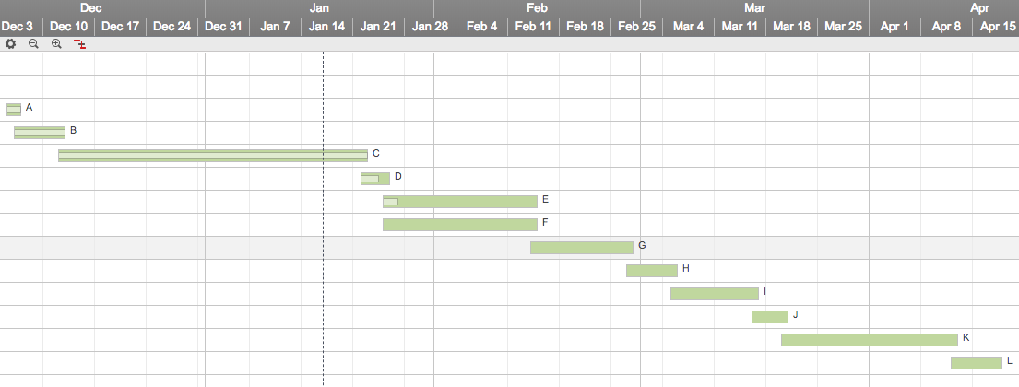

Fig 1. Gantt chart

**Process model justification**

The sashimi model is a great fit for this type of software. This can be well proven with the help of a simple example.

Module 1 - Reads the input csv data set.

Module 2 – Checks for data types and handles type conversion.

Module 3 – Generates the requires data set after formatting

In this situation Module 2 requires input from the Module 1. It the output of Module 1 correct only then can the process move ahead. Similarly for Module 3 to function it requires the Module 2 to perform correctly. This inter dependency means that the modules are completely dependent on the previous modules.

During testing is any issues found with the integration, changes may be required in the previous modules. But the normal waterfall model does not allow any such changes. Hence using the sashimi model allows us to create overlapping tasks and the integration can be completed during this overlapped time gap.

This model allows some agile techniques but prevents the developers from making any drastic changes to the entire procedure. It takes the best features of the waterfall model and creation features from the agile model to over come the drawbacks of the waterfall model. These properties make this model the best suited for our software development process.