Week 8: Jenkins Automation
- Hands-on practice on manual creation of Jenkins pipeline using Maven projects from Github
- Create the job and build the pipeline for maven-java and maven-web project.
- Questions on Jenkins
- Upload the Screenshots.

- Steps for MavenJava Automation:
Maven Java Automation Steps:
Step 1: Open Jenkins (localhost:8080)
├── Click on "New Item" (left side menu
Step 2: Create Freestyle Project (e.g., MavenJava_Build)
├── Enter project name (e.g., MavenJava_Build)
├── Click "OK"
└── Configure the project:
├── Description: "Java Build demo"
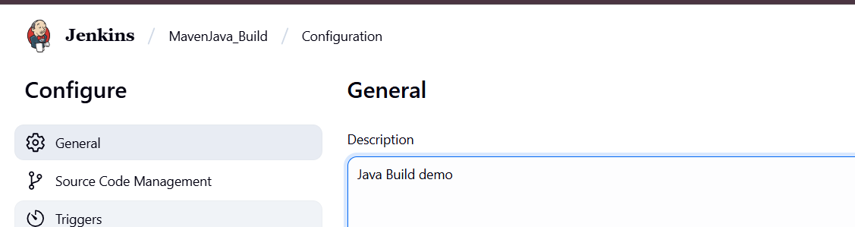
├── Source Code Management:
└── Git repository URL: [GitMavenJava repo URL]
├── Branches to build: */Main or */master
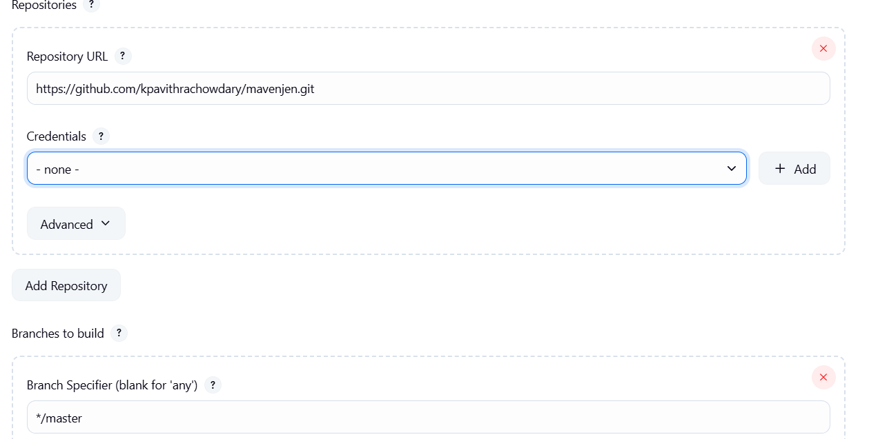
└── Build Steps:
├── Add Build Step -> "Invoke top-level Maven targets"
└── Maven version: MAVEN_HOME
└── Goals: clean
├── Add Build Step -> "Invoke top-level Maven targets"
└── Maven version: MAVEN_HOME
└── Goals: install
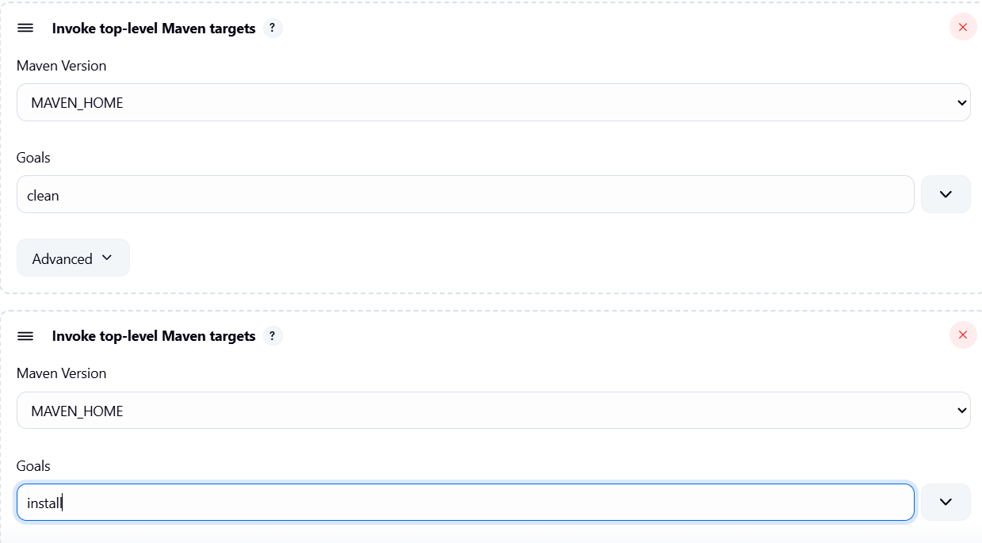
└── Post-build Actions:
├── Add Post Build Action -> "Archive the artifacts"
└── Files to archive: **/*
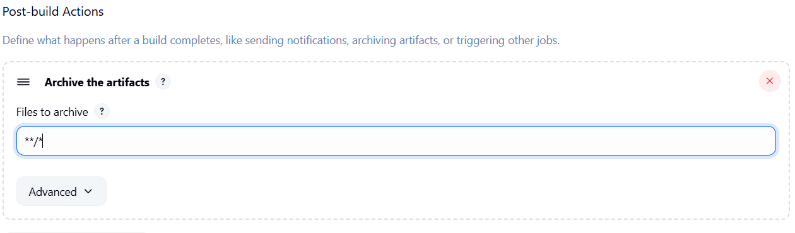
├── Add Post Build Action -> "Build other projects"
└── Projects to build: MavenJava_Test
└── Trigger: Only if build is stable
└── Apply and Save
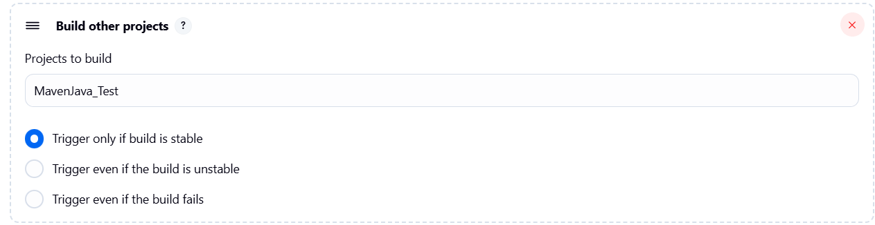

└── Step 3: Create Freestyle Project (e.g., MavenJava_Test)
├── Enter project name (e.g., MavenJava_Test)
├── Click "OK"
└── Configure the project:
├── Description: "Test demo"
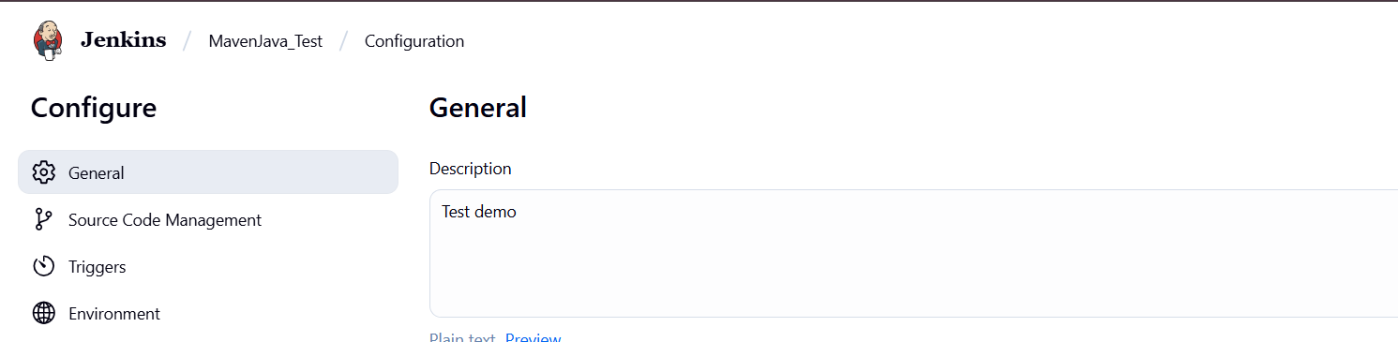
├── Build Environment:
└── Check: "Delete the workspace before build starts"
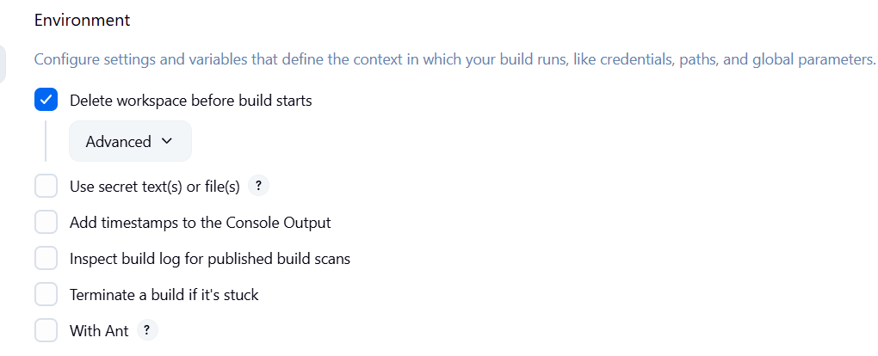
├── Add Build Step -> "Copy artifacts from another project"
└── Project name: MavenJava_Build
└── Build: Stable build only // tick at this
└── Artifacts to copy: **/*
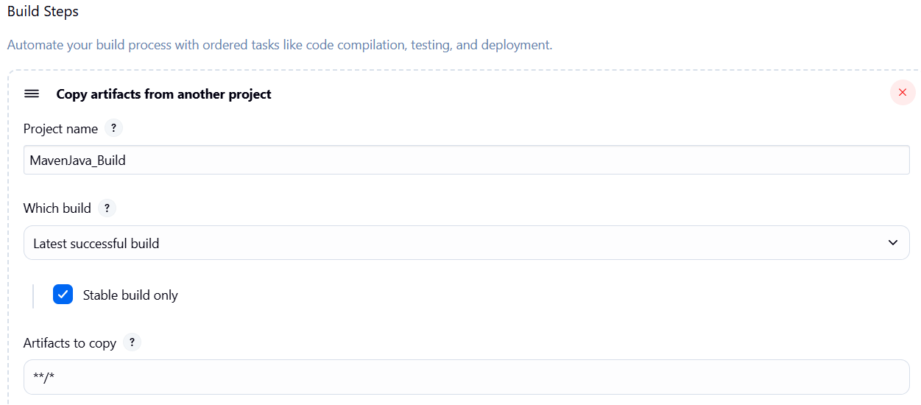 ├── Add Build Step -> "Invoke top-level Maven targets"
└── Maven version: MAVEN_HOME
└── Goals: test
└── Post-build Actions:
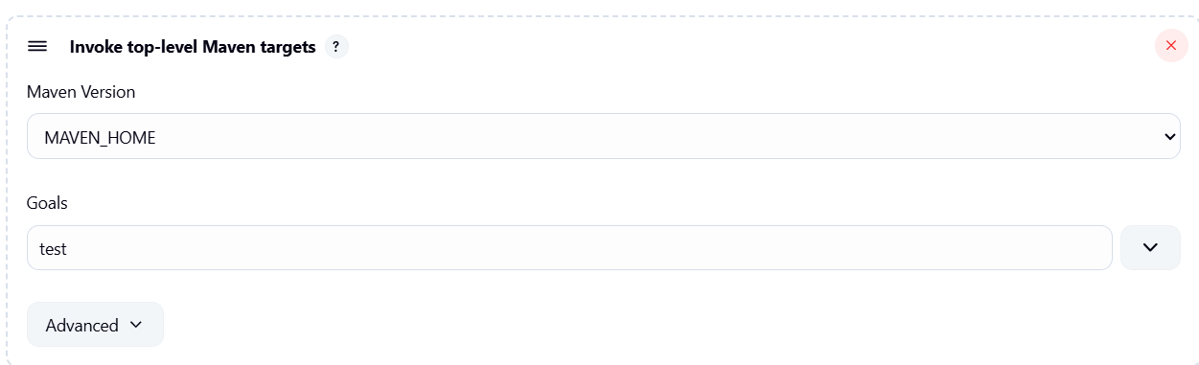
├── Add Post Build Action -> "Archive the artifacts"
└── Files to archive: **/*
└── Apply and Save
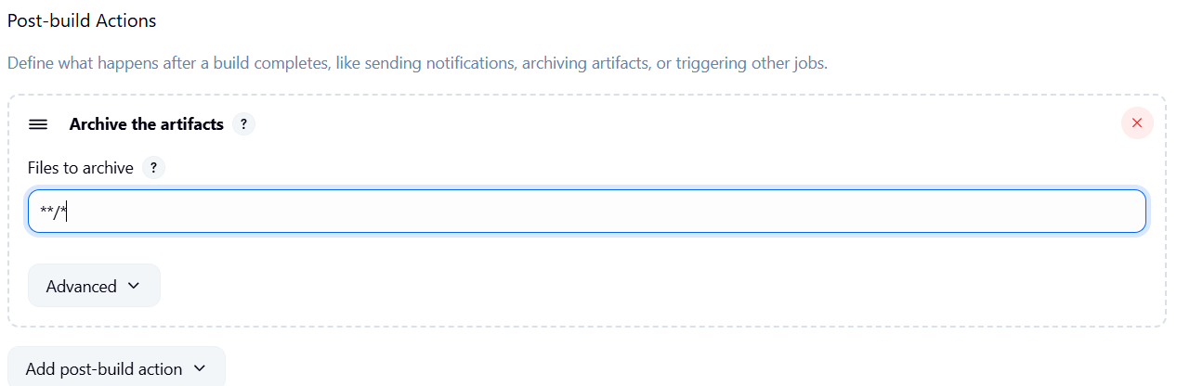
└── Step 4: Create Pipeline View for Maven Java project
├── Click "+" beside "All" on the dashboard
├── Enter name: MavenJava_Pipeline
├── Select "Build pipeline view" // tick here
|--- create
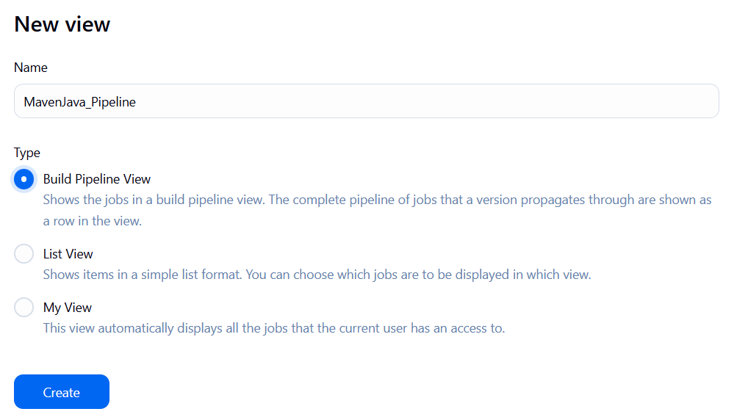
└── Pipeline Flow:
├── Layout: Based on upstream/downstream relationship
├── Initial job: MavenJava_Build
└── Apply and Save OK
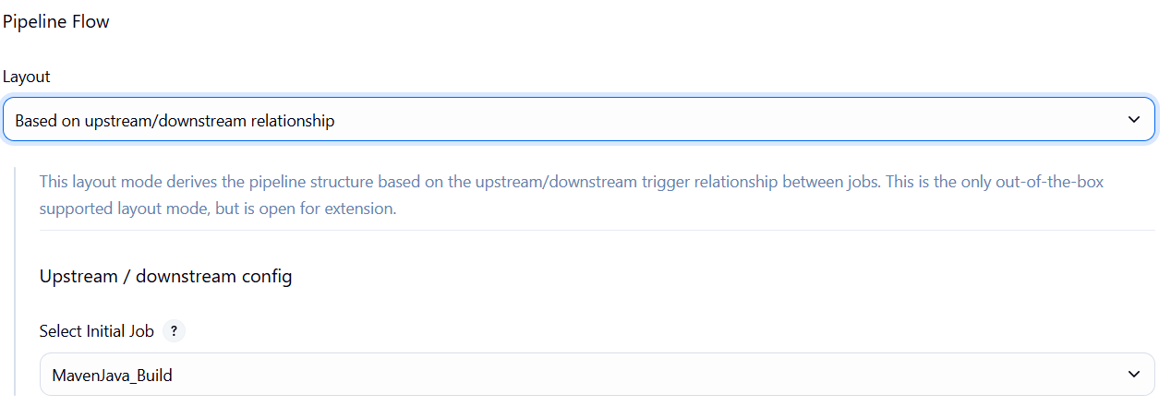
└── Step 5: Run the Pipeline and Check Output
├── Click on the trigger to run the pipeline
├── click on the small black box to open the console to check if the build is success
Note :
- If build is success and the test project is also automatically triggered with name
“MavenJava_Test”
- The pipeline is successful if it is in green color as shown ->check the console of the test project
- The test project is successful and all the artifacts are archived successfully
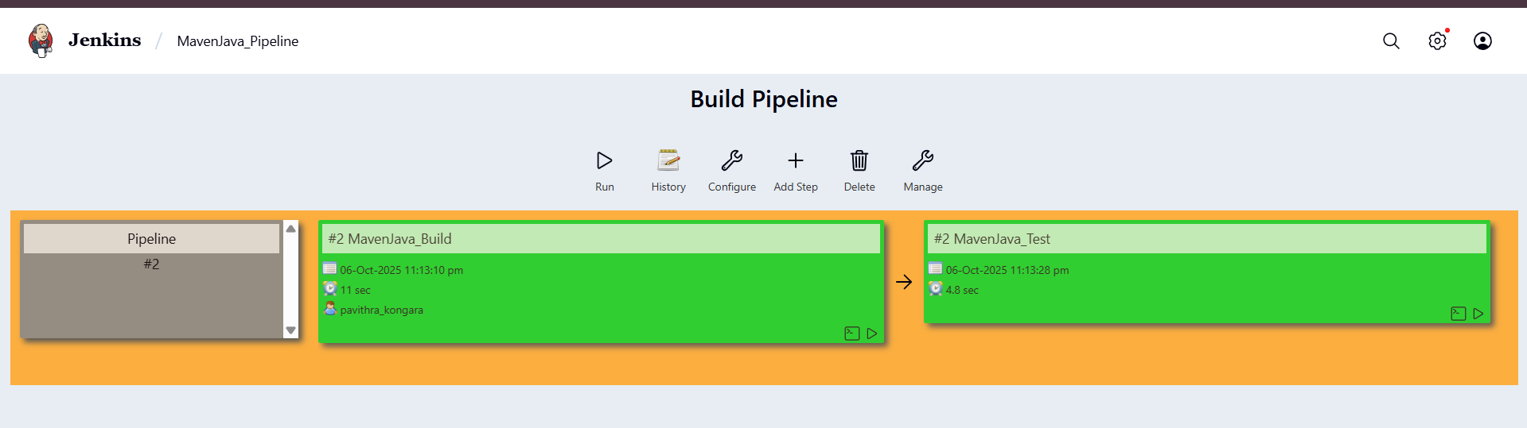
II. Maven Web Automation Steps:
└── Step 1: Open Jenkins (localhost:8080)
├── Click on "New Item" (left side menu)
└── Step 2: Create Freestyle Project (e.g., MavenWeb_Build)
├── Enter project name (e.g., MavenWeb_Build)
├── Click "OK"
└── Configure the project:
├── Description: "Web Build demo"
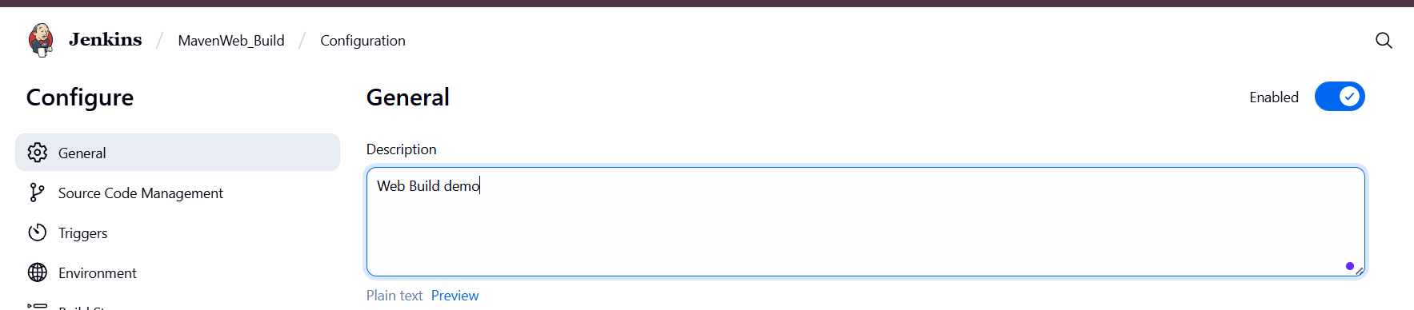
├── Source Code Management:
└── Git repository URL: [GitMavenWeb repo URL]
├── Branches to build: */Main or master
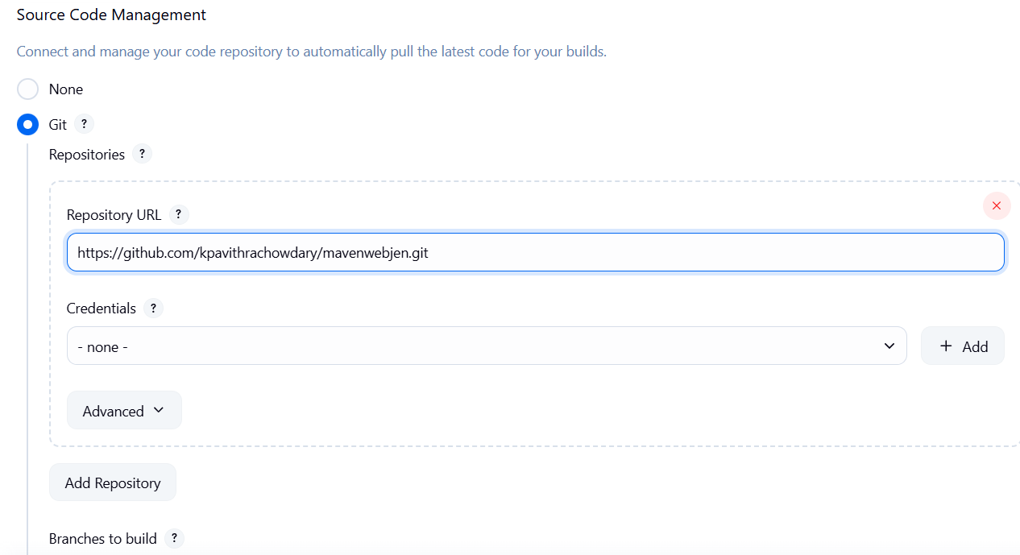
└── Build Steps:
├── Add Build Step -> "Invoke top-level Maven targets"
└── Maven version: MAVEN_HOME
└── Goals: clean
├── Add Build Step -> "Invoke top-level Maven targets"
└── Maven version: MAVEN_HOME
└── Goals: install
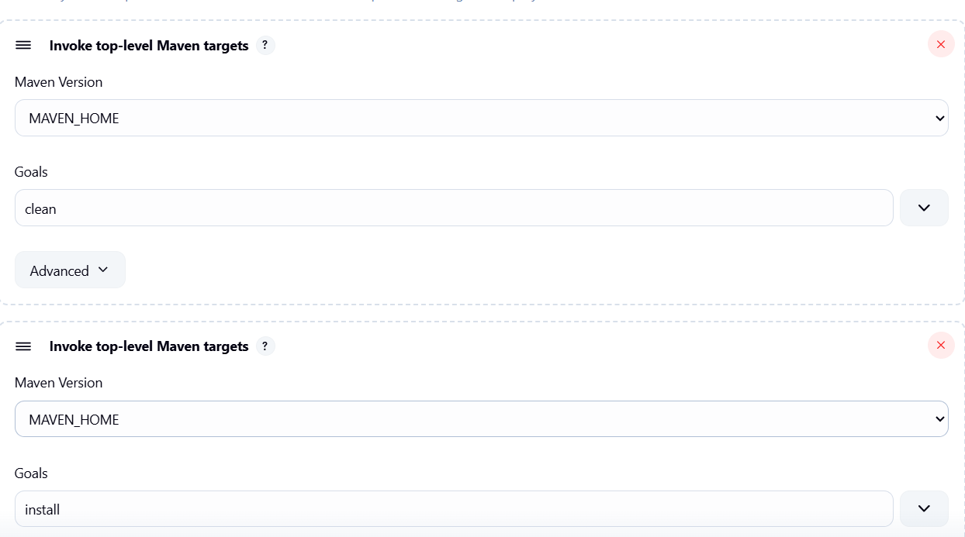
└── Post-build Actions:
├── Add Post Build Action -> "Archive the artifacts"
└── Files to archive: **/*
├── Add Post Build Action -> "Build other projects"
└── Projects to build: MavenWeb_Test
└── Trigger: Only if build is stable
└── Apply and Save
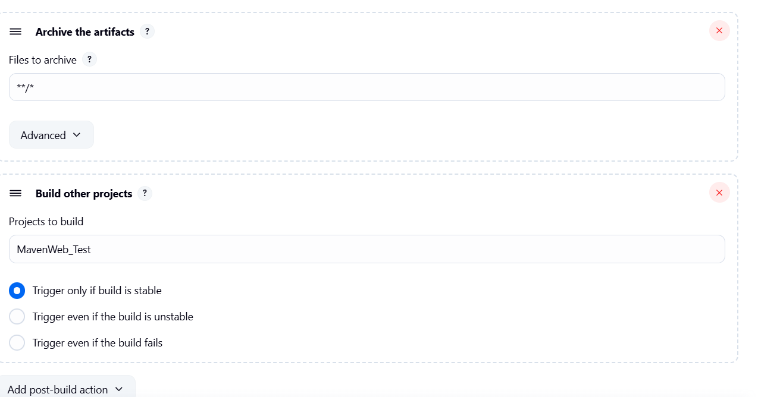

└── Step 3: Create Freestyle Project (e.g., MavenWeb_Test)
├── Enter project name (e.g., MavenWeb_Test)
├── Click "OK"
└── Configure the project:
├── Description: "Test demo"
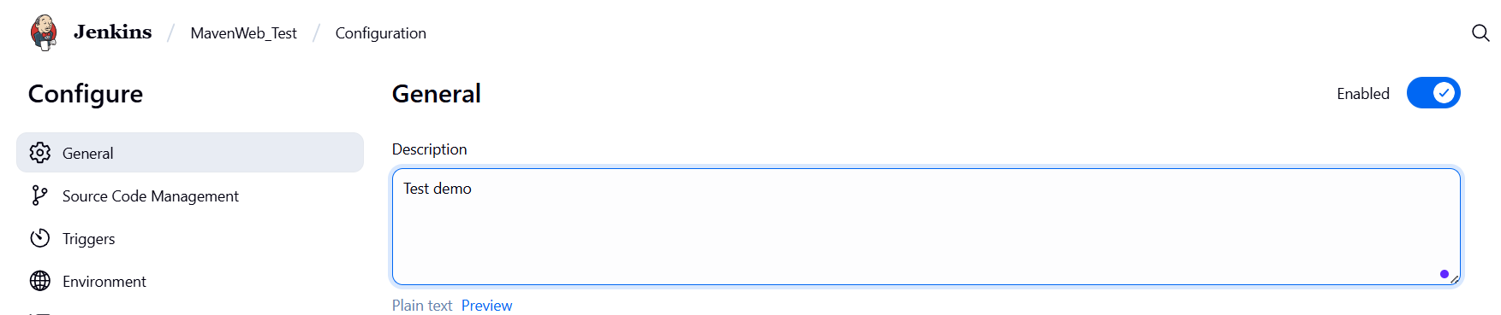
├── Build Environment:
└── Check: "Delete the workspace before build starts"
├── Add Build Step -> "Copy artifacts from another project"
└── Project name: MavenWeb_Build
└── Build: Stable build only
└── Artifacts to copy: **/*
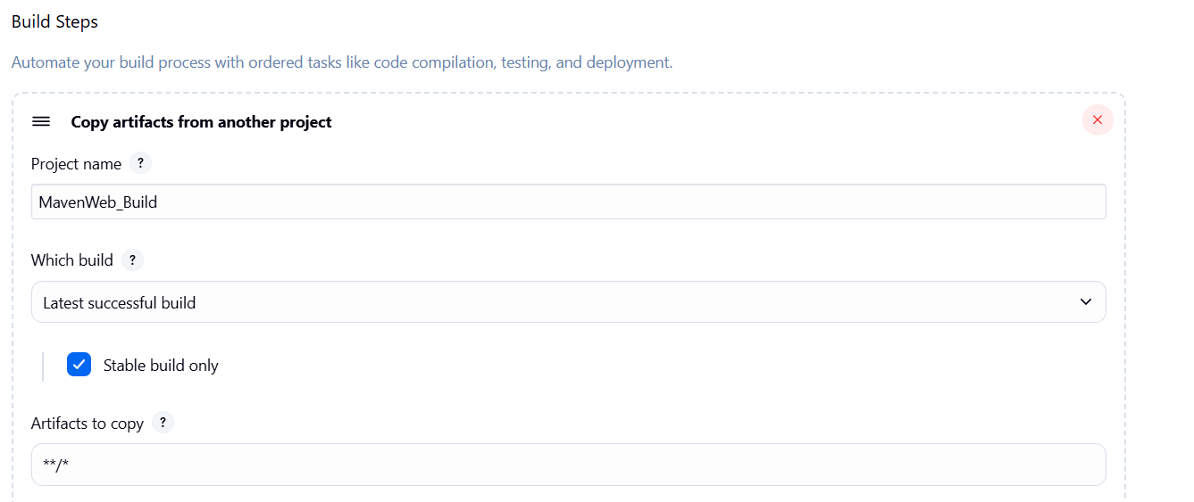
├── Add Build Step -> "Invoke top-level Maven targets"
└── Maven version: MAVEN_HOME
└── Goals: test
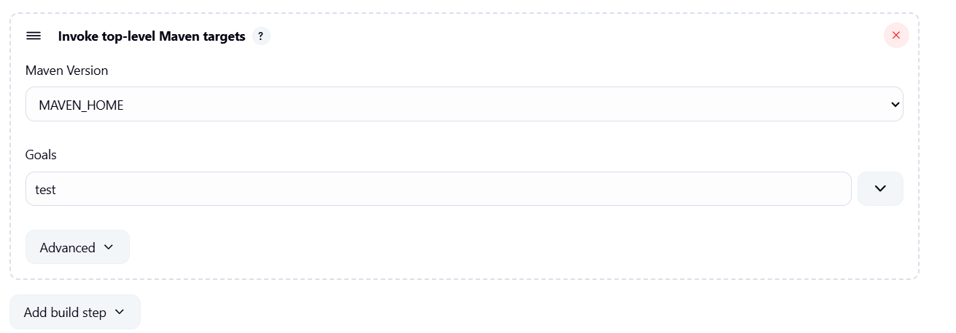
└── Post-build Actions:
├── Add Post Build Action -> "Archive the artifacts"
└── Files to archive: **/*
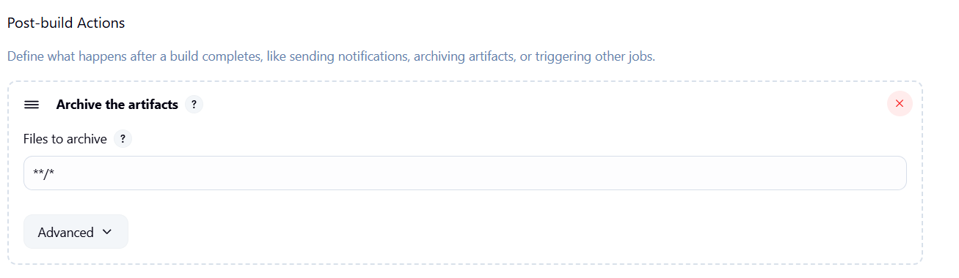
├── Add Post Build Action -> "Build other projects"
└── Projects to build: MavenWeb_Deploy
└── Apply and Save
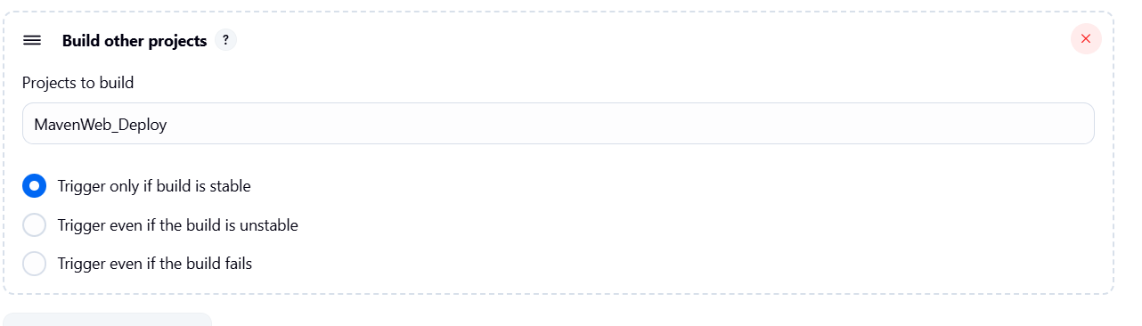

└── Step 4: Create Freestyle Project (e.g., MavenWeb_Deploy)
├── Enter project name (e.g., MavenWeb_Deploy)
├── Click "OK"
└── Configure the project:
├── Description: "Web Code Deployment"
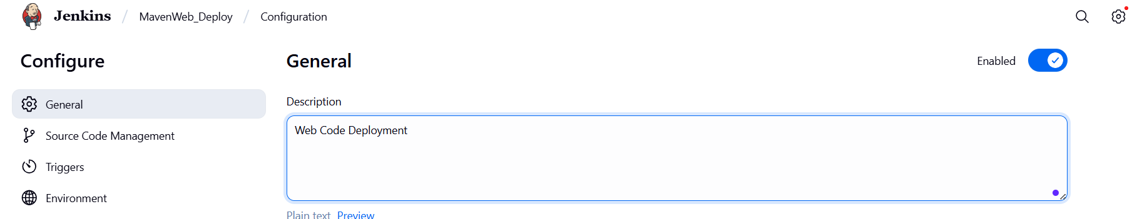
├── Build Environment:
└── Check: "Delete the workspace before build starts"
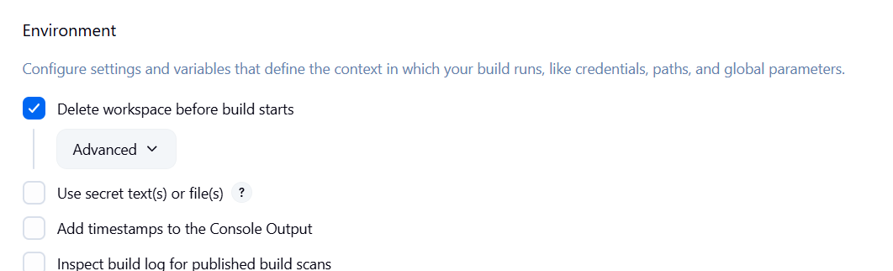
├── Add Build Step -> "Copy artifacts from another project"
└── Project name: MavenWeb_Test
└── Build: Stable build only
└── Artifacts to copy: **/*
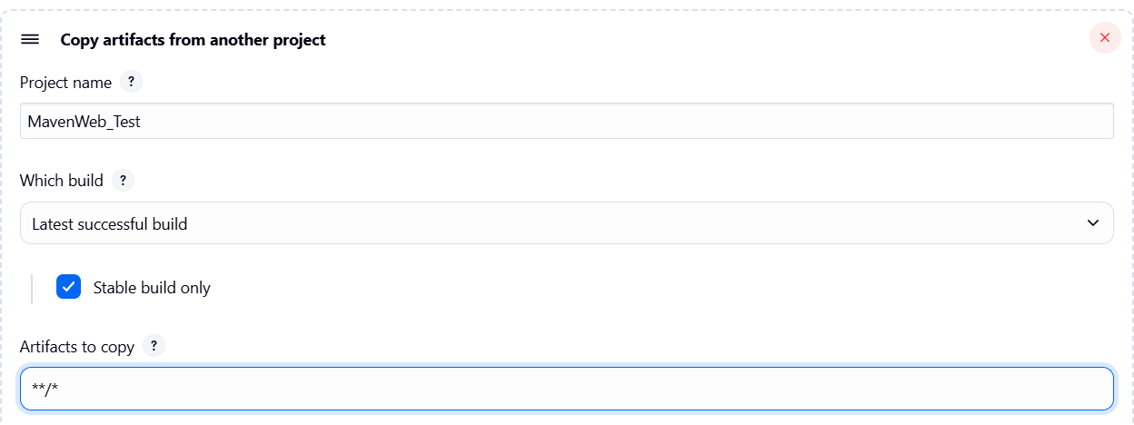
└── Post-build Actions:
├── Add Post Build Action -> "Deploy WAR/EAR to a container"
└── WAR/EAR File: **/*.war
└── Context path: Webpath
└── Add container -> Tomcat 9.x remote
└── Credentials: Username: admin, Password: 1234
── Tomcat URL: https://localhost:8085/
└── Apply and Save
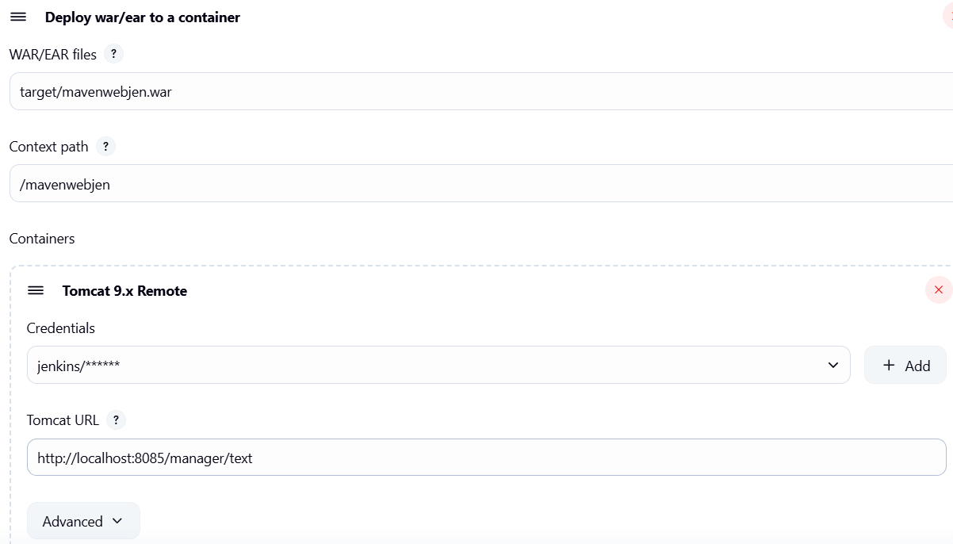

└── Step 5: Create Pipeline View for MavenWeb
├── Click "+" beside "All" on the dashboard
├── Enter name: MavenWeb_Pipeline
├── Select "Build pipeline view"
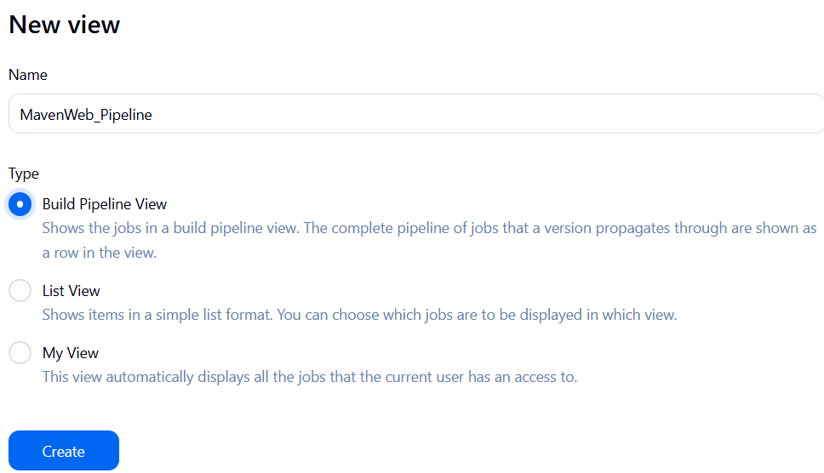
└── Pipeline Flow:
├── Layout: Based on upstream/downstream relationship
├── Initial job: MavenWeb_Build
└── Apply and Save
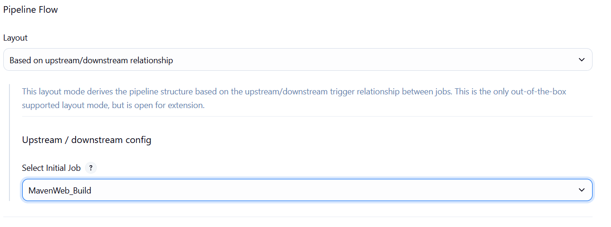
└── Step 6: Run the Pipeline and Check Output
├── Click on the trigger “RUN” to run the pipeline
Note:
- After Click on Run -> click on the small black box to open the console to check if the build is success
- Now we see all the build has success if it appears in green color
- 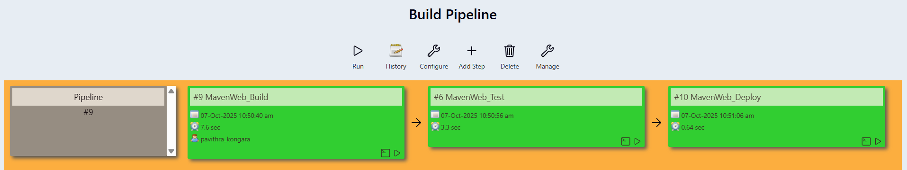
├── Open Tomcat homepage in another tab
├── Click on the "/webpath" option under the manager app

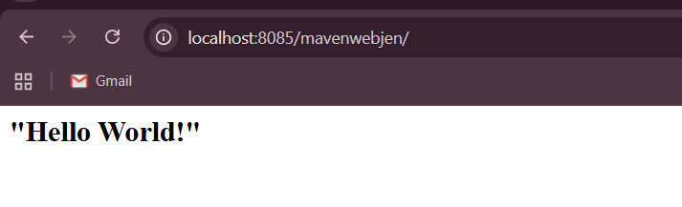

Note:
- It ask for user credentials for login ,provide the credentials of tomcat.
- It provide the page with out project name which is highlighted.
- After clicking on our project we can see output.

- Questions on Jenkins
1.What is Jenkins primarily used for?
Jenkins is used for continuous integration (CI) and continuous deployment/Delivery (CD).
2.What is feature of Jenkins?
pipeline support, extensibility
3.What is the default port on which Jenkins runs?
8080
4.What can be integrated with Jenkins for version control?
Git
5.What is the purpose of Jenkins plugins?
Plugins help in functionality like scm, email and tools
6.Which type of Jenkins job is best suited for running one-off tasks or small scripts?
Freestyle project
7.How can you manage sensitive information such as API keys in Jenkins?
It is stored in Jenkins credentials plugin
8.What does the "blue ocean" feature in Jenkins refer to?
Blue Ocean is a modern UI for Jenkins ,improves usability and user-friendly
9.What does the "blue ocean" feature in Jenkins refer to?
Blue Ocean is a modern UI for Jenkins ,improves usability and user-friendly
10.Which Jenkins component allows for distributed builds across multiple machines?
It uses Master-Agent Architecture
11.List at least five Jenkins plugins that you would consider important for a microservices-based application CI/CD pipeline. Briefly explain the purpose of each plugin.
Git Plugin → Integrates Git repositories for version control.Pipeline Plugin → Allows defining CI/CD pipelines using Groovy (Jenkinsfile).Docker Plugin → Builds, runs, and manages Docker containers for microservices
12.Explain the steps you would take to install a plugin in Jenkins through the Jenkins UI. What considerations would you keep in mind regarding plugin compatibility and updates?
In Manage Plugins we can search for plugin and install
13.Explain the steps you would take to install a plugin in Jenkins through the Jenkins UI. What considerations would you keep in mind regarding plugin compatibility and updates?
Dashboard ->Manage Jenkins->Manage plugin ->install
14.After installing a plugin, explain how you would configure it within Jenkins. For example, if you installed the Git Plugin, what steps would you take to set it up for your pipeline?
After installation configure it with global tools and add credentials and it in pipeline
15.Discuss common issues that might arise when using Jenkins plugins, such as dependency conflicts or version compatibility problems. How would you troubleshoot these issues?
Version compatibility, Dependency conflict

