Assignment 4

Wireshark Analysis

UDP Analysis – Same text file

Total number of datagrams received for UDP = 1930

The datagram size was of 1074 bytes

An equal number of acknowldegement packets were also transferred which increased from 46 to 49 bytes.

Initial connection request was of 562 bytes and it's acknowledgment of 63 bytes

MD5 hash acknowledgment was of 87 bytes

Number of retransmitted packets = 0

Total time taken for the complete transmission = 21.991435 – 6.485147

= 15.50 secs

Though UDP should have been faster it is very slow here due to the fact that the application layer is implementing a reliability check before transmitting each data packet. This makes UDP very slow here though TCP also does reliability check but it implements a sliding window algorithm allowing it to transfer data packets parallely.

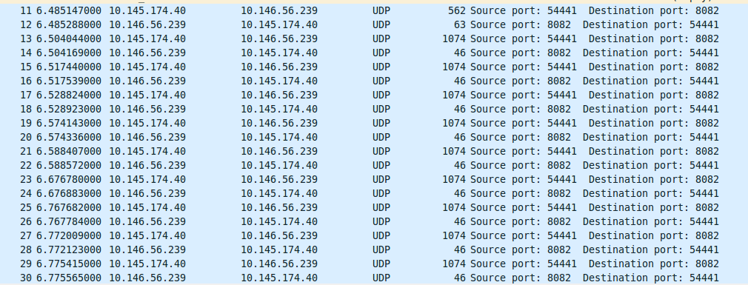

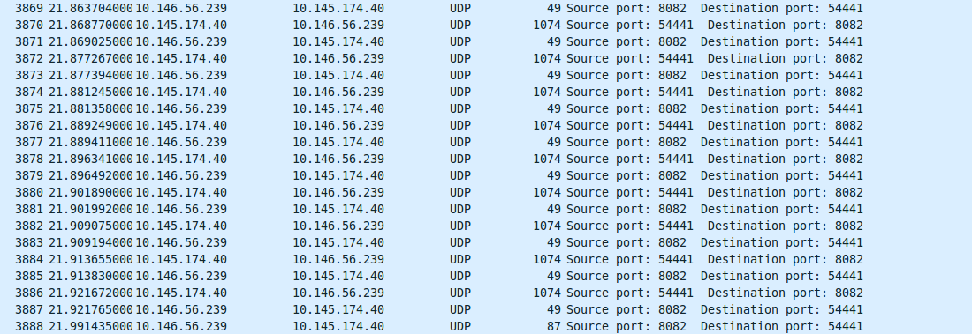

TCP Concurrent Server Analysis

To test the concurrent servers 3 files were sent together 2 image files one of 287 Kb , other of 4Mb and one text file of 2 Mb .

Server Side

Number of packets received from 3 files = 7189

The packet sizes were mostly of size 1414 bytes , the acknowledgements were of 66 bytes.

Initial sequences were of sizes 54,58, 64 and 61, 60 bytes. There were also packets of 154, 1212 bytes received and acknowledgments of 54 bytes. There were some packets of size 551 and duplicate acknowledgments were of size 74 bytes and 82 bytes. Some spurious retransmission of 969 bytes was also there. Previous segment received was of 154 bytes, 526 bytes etc.

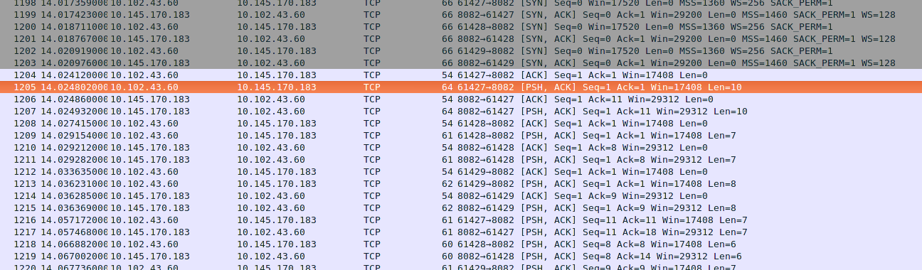

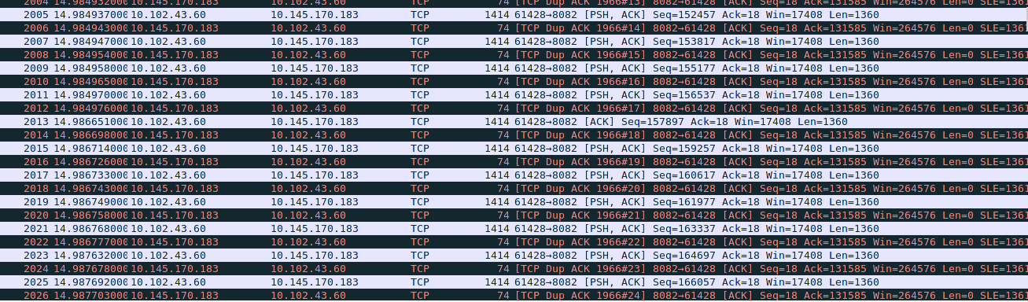

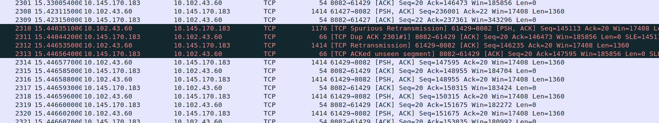

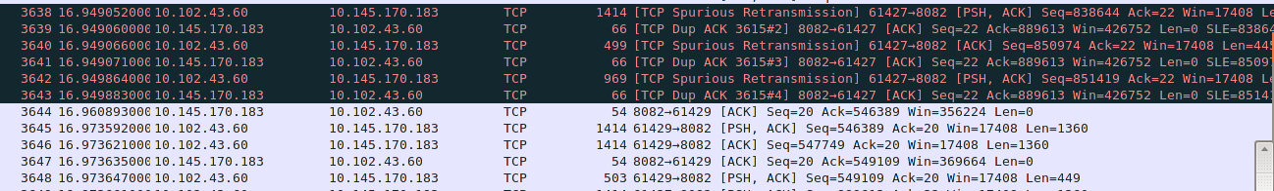

Number of retransmitted bytes = 37

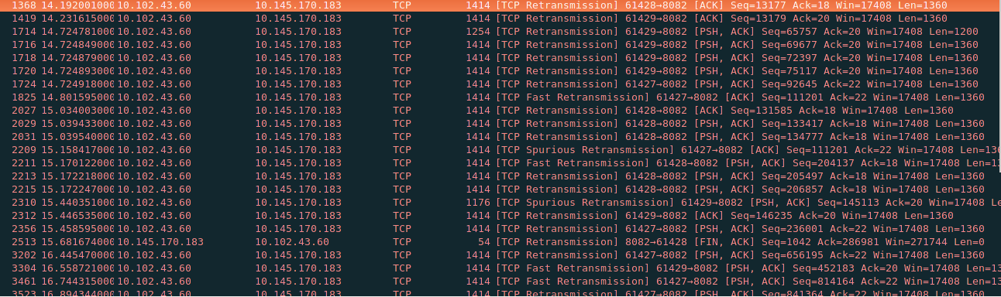

Total time to receive the 3 files = 8.657 seconds

TCP Client Side

Number of segments = 7994

The size distributions were of 74 bytes, 54 bytes, 60 bytes, 64 bytes and 61 bytes. These mainly constituted the small acknowledgements. The larger data packets were of size 2974 bytes, 1533 bytes, 7354 bytes, 2993 bytes, 10293 bytes, 8814 bytes, 10160 bytes

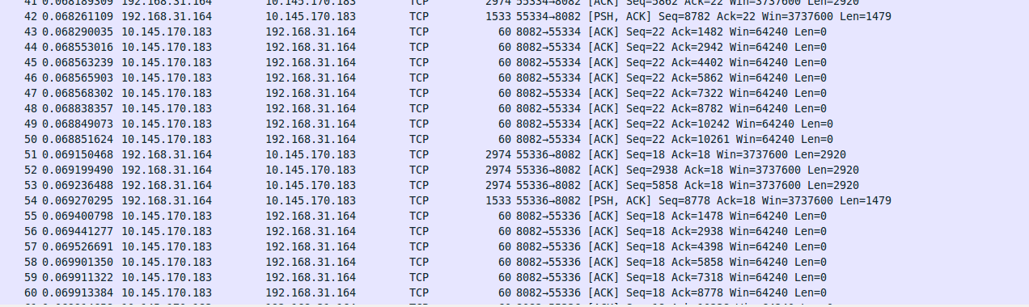

There were packets saying TCP Window Full of 2974 bytes and 1514 bytes

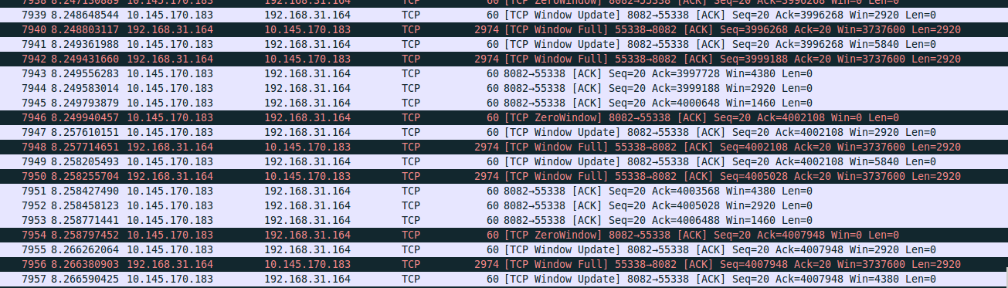

Number of packets retransmitted = 0

Time taken to send the 3 files = 8.6498 seconds