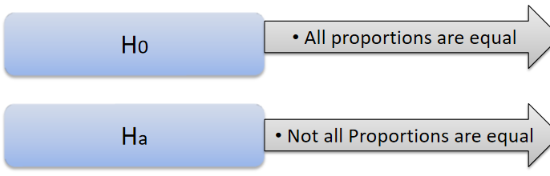

**import pandas as pd**

**import numpy as np**

**from scipy import stats**

**data = {'East':[50, 550],**

**'West':[142,351],**

**'North':[131,480],**

**'South':[70,350]**

**}**

**df = pd.DataFrame(data, index =['Males','Females'])**

**df**

**males = df.iloc[0,:]**

**males**

**females = df.iloc[1,:]**

**females**

**stats.ttest_ind(males,females)**

**Ttest_indResult(statistic=-6.139294288037571, pvalue=0.00085481666847)**

**As p value value is clearly less than alpha we accept Ha which says that not all proportions are equal.**