**Code :**

#include<stdio.h>

#include<conio.h>

#include<graphics.h>

#include<math.h>

void main()

{

int gd=DETECT,gm,i,opt;

float x1,x2,y1,y2,dx,dy,xinc,yinc;

float x0=320.0,y0=240.0;

int steps;

initgraph(&gd,&gm,"");

printf("Enter the first point :\n");

scanf("%f%f",&x1,&y1);

printf("Enter the second point :\n");

scanf("%f%f",&x2,&y2);

x1+=x0;

x2+=x0;

y1=y0-y1;

y2=y0-y2;

dx=x2-x1;

dy=y2-y1;

if(abs(dx)>abs(dy))

steps=abs(dx);

else

steps=abs(dy);

xinc=dx/steps;

yinc=dy/steps;

printf("1.Regular\n2.Dotted\n3.Thick\n4.Multicolored\n5.Dashed Line\n6.Centre Line\n");

scanf("%d",&opt);

clrscr();

cleardevice();

line(0,240,700,240);

line(320,0,320,700);

switch(opt)

{

case 1:

for(i=0;i<steps;i++)

{

x1+=xinc;

y1+=yinc;

putpixel(x1,y1,YELLOW);

}

break;

case 2:

for(i=0;i<steps/4;i++)

{

x1+=xinc*4;

y1+=yinc*4;

putpixel(x1,y1,YELLOW);

}

break;

case 3:

for(i=0;i<steps;i++)

{

x1+=xinc;

y1+=yinc;

putpixel(x1,y1,YELLOW);

if(abs(dx)>abs(dy))

{

putpixel(x1,y1+1,YELLOW);

putpixel(x1,y1-1,YELLOW);

}

else

{

putpixel(x1+1,y1,YELLOW);

putpixel(x1-1,y1,YELLOW);

}

}

break;

case 4:

for(i=0;i<steps;i++)

{

x1+=xinc;

y1+=yinc;

if(i%16!=0)

putpixel(x1+1,y1,i%16);

}

break;

case 5:

for(i=0;i<steps;i++)

{

x1+=xinc;

y1+=yinc;

if(i%10<5)

putpixel(x1,y1,YELLOW);

}

break;

case 6:for(i=0;i<steps;i++)

{

x1+=xinc;

y1+=yinc;

if(i%20<7||i%20==9||i%20==10||i%20>14)

putpixel(x1,y1,YELLOW);

}

break;

}

getch();

closegraph();

}

**Output :**

Case 1:

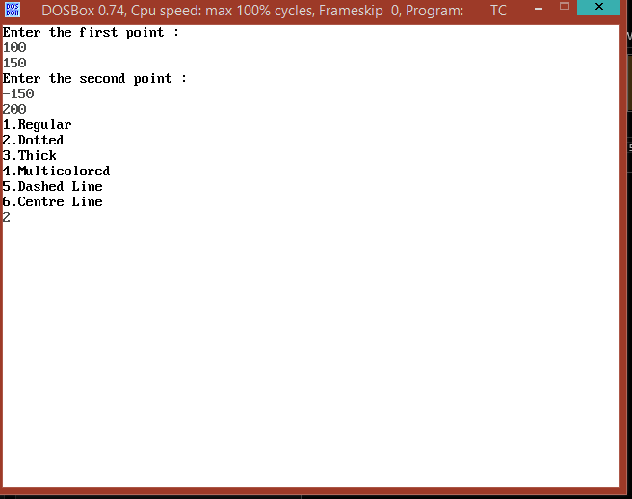

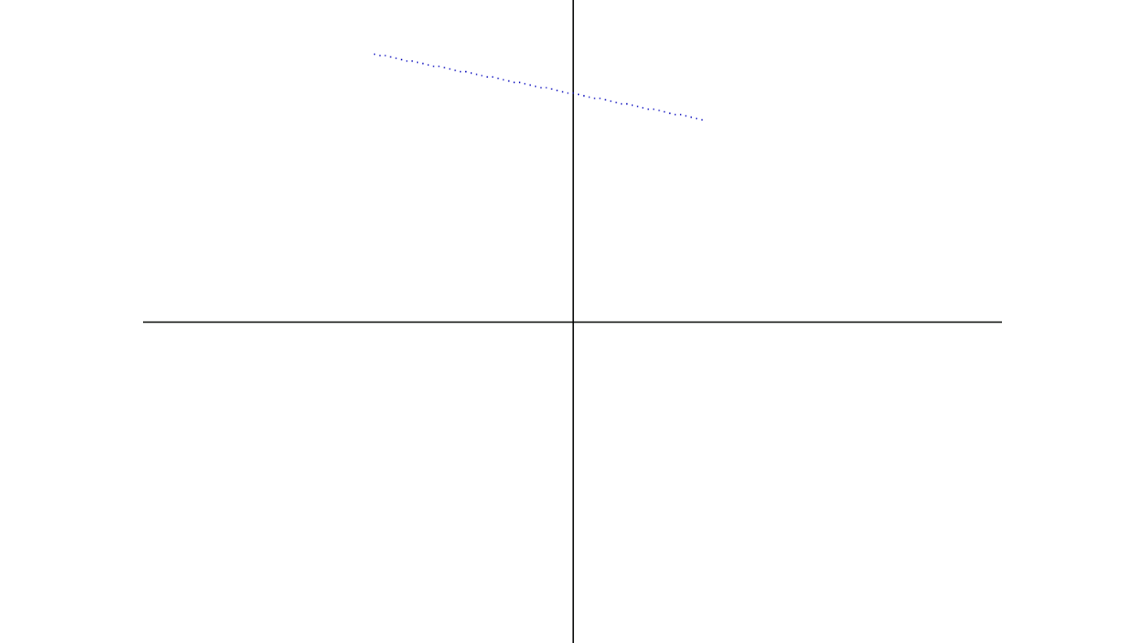

Case 2:

