**DATA**

**Customers:**

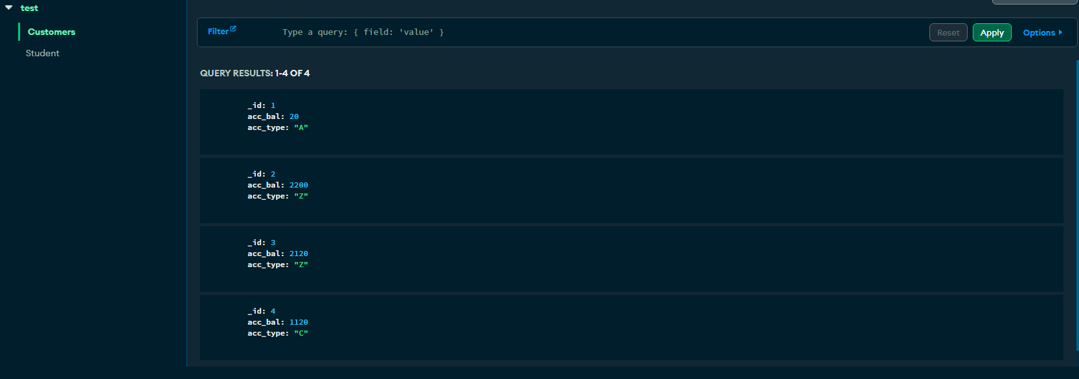

**Students:**

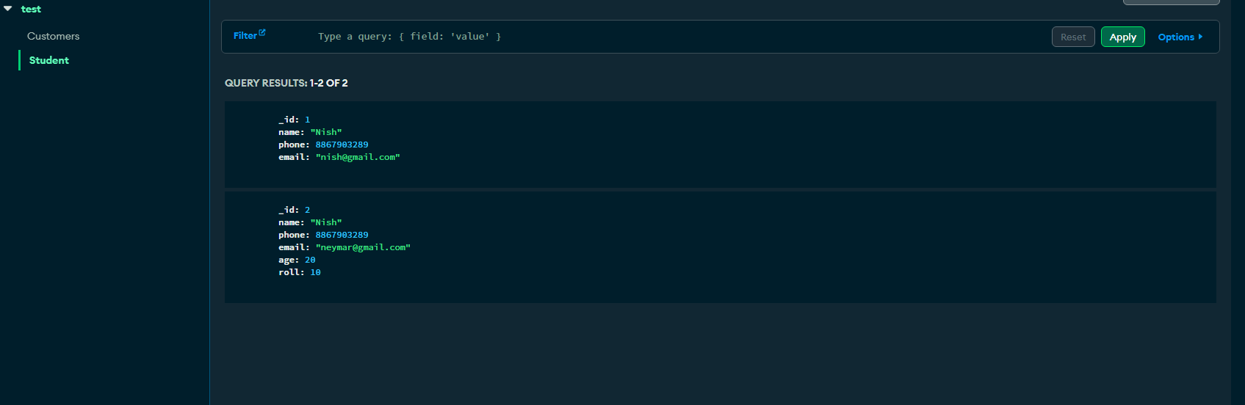

**QUERIES:**

1. Update to add hobbies

**db.Student.update({_id: 1}, { $set: { hobbies: "crciket" }});**

**db.Student.updateOne({_id: 2}, { $set: { hobbies: "footy" } });**

1. Find documents where hobbies is set neither to Chess nor to Skating

**db.Student.find({ hobbies: { $nin: ["Chess", "Skating"] } });**

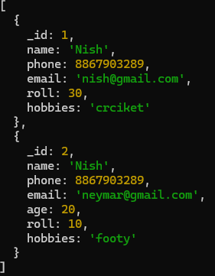

1. Find documents whose name begins with A

**db.Student.find({ name: { $regex: /^a/ } });**

Output: null

1. Create a collection blogPOsts and document structure id, title and comments

db.createCollection("blogPosts");

db.blogPosts.insertOne({ _id: 1, title: "He;;p", comments: [] });

1. Adding an element into araay

db.blogPosts.updateOne({ _id: 1 }, { $push: { comments: {username: "neymar", text: "helloooooo"} } });