WEEK-4

Create database BANK034;

Use Bank034 ;

create table Branch (branch_name varchar(30), branch_city varchar(20), assets real, primary key(branch_name));

insert into Branch values('SBI_Chamrajpet','Bangalore',50000);

insert into Branch values('SBI_ResidencyRoad','Bangalore',10000);

insert into Branch values('SBI_ShivajiRoad','Bombay',20000);

insert into Branch values('SBI_ParliamentRoad','Delhi',10000);

insert into Branch values('SBI_Jantarmantar','Delhi',20000);

insert into Branch values('SBI_MantriMarg','Delhi',200000);

select * from Branch;

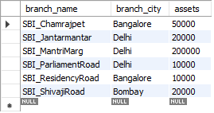

create table BankAccount (accno int, branch_name varchar(30), balance real,

primary key (accno),

foreign key (branch_name) references Branch(branch_name));

insert into BankAccount values(1,'SBI_Chamrajpet',2000);

insert into BankAccount values(2,'SBI_ResidencyRoad',5000);

insert into BankAccount values(3,'SBI_ShivajiRoad',6000);

insert into BankAccount values(4,'SBI_ParliamentRoad',9000);

insert into BankAccount values(5,'SBI_Jantarmantar',8000);

insert into BankAccount values(6,'SBI_ShivajiRoad',4000);

insert into BankAccount values(8,'SBI_ResidencyRoad',4000);

insert into BankAccount values(9,'SBI_ParliamentRoad',3000);

insert into BankAccount values(10,'SBI_ResidencyRoad',5000);

insert into BankAccount values(11,'SBI_Jantarmantar',2000);

insert into BankAccount values(12,'SBI_MantriMarg',2000);

select * from BankAccount;

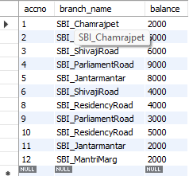

create table BankCustomer (customer_name varchar(20), customer_street varchar(20),customer_city varchar(20),primary key(customer_name));

insert into BankCustomer values('Avinash', 'Bull_Temple_Road', 'Bangalore');

insert into BankCustomer values('Dineshh', 'Bannergatta_Road', 'Bangalore');

insert into BankCustomer values('Mohan', 'NationalCollege_Road', 'Bangalore');

insert into BankCustomer values('Nikil', 'Akbar_Road', 'Delhi');

insert into BankCustomer values('Ravi', ' Prithviraj_Road', 'Delhi');

select * from BankCustomer;

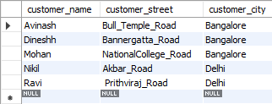

create table Depositer(customer_name varchar(20), accno int, primary key(customer_name, accno),

foreign key (customer_name) references BankCustomer(customer_name),

foreign key (accno) references BankAccount(accno));

insert into Depositer values('Avinash', 1);

insert into Depositer values('Dineshh', 2);

insert into Depositer values('Nikil', 4);

insert into Depositer values('Ravi', 5);

insert into Depositer values('Avinash', 8);

insert into Depositer values('Nikil', 9);

insert into Depositer values('Dineshh', 10);

insert into Depositer values('Nikil', 11);

insert into Depositer values('Nikil',12);

select * from Depositer;

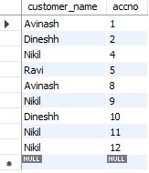

create table LOAN (loan_number int, branch_name varchar(30), amount real,

primary key(loan_number),

foreign key (branch_name) references Branch(branch_name));

insert into LOAN values(1,'SBI_Chamrajpet',1000);

insert into LOAN values(2,'SBI_ResidencyRoad',2000);

insert into LOAN values(3,'SBI_ShivajiRoad',3000);

insert into LOAN values(4,'SBI_ParliamentRoad',4000);

insert into LOAN values(5,'SBI_Jantarmantar',5000);

select * from LOAN;

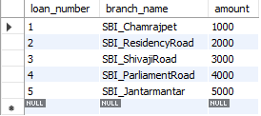

create table Borrower(customer_name varchar(20),loan_number int);

insert into Borrower values('Avinash',1);

insert into Borrower values('Dinesh',2);

insert into Borrower values('Mohan',3);

insert into Borrower values('Nikil',4);

insert into Borrower values('Ravi',5);

select * from Borrower;

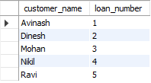

1. Find all the customers who have an account at all the branches

located in a specific city (Ex. Delhi).

SELECT d.customer_name

From bankaccount a,branch b, depositer d

WHERE b.branch_name=a.branch_name AND a.accno=d.accno AND b.branch_city='Delhi'

GROUP BY d.customer_name

HAVING COUNT(distinct b.branch_name)=(SELECT COUNT(branch_name)FROM branch

WHERE branch_city='Delhi');



2. Find all customers who have a loan at the bank but do not have

an account.

select customer_name from Borrower

where customer_name not in(select customer_name from Depositer);



3. Find all customers who have both an account and a loan at the

Bangalore branch

select distinct d.customer_name from Depositer d

where d.customer_name in(

select d.customer_name from Branch b,depositer d,BankAccount ba

where b.branch_city='bangalore'and b.branch_name=ba.branch_name

and ba.accno=d.accno and customer_name IN(select customer_name from Borrower));



4.Find the names of all branches that have greater assets than all

branches located in Bangalore.

select b.branch_name from Branch b

where b.assets>ALL(select sum(b.assets) from Branch b where b.branch_city='bangalore');



5. Demonstrate how you delete all account tuples at every branch

located in a specific city (Ex. Bombay).

delete from BankAccount where branch_name =

(select branch_name from Branch where branch_city='Bombay');

6. Update the Balance of all accounts by 5%

UPDATE BankAccount set balance=(0.05*balance)+balance;

select * from BankAccount;

