Data Analysis of Pedestrian Counting in Melbourne City

Executive summary
Cities reveal their identities through movement. This report utilizes the pedestrian statistics system of Melbourne to analyze the hourly, daily, monthly and annual walking activities in the central area of Melbourne from May 2009 to October 2026. The report integrates the hourly records from multiple locations and correlates them with public holidays, permitted event holding, and daily weather conditions for analysis. The core question of this report is: Has the "pulse" of the city's pedestrians returned to the pre-pandemic pattern? Is the recovery process uniform in terms of time and space?
Four findings stand out. First, the rhythm remains strongly structured: activity peaks in the late afternoon, stays high through the middle of the day, falls to a minimum around 04:00, and is higher on Friday and Saturday than on Sunday and Monday. Second, recovery is incomplete: across 27 locations measured consistently in 2017–2019 and 2023–2025, median daily activity is 28.5% lower in the later period. Third, deviations from routine are systematic: public holidays account for 34.4% of significant dips though only 3.7% of eligible days, while days with at least 20 mm of rain have a 37.0% dip rate versus 1.5% on dry days. Fourth, the city contains at least two activity regimes: a commuter profile with sharp morning and evening peaks, and a visitor profile with a broad midday plateau.
The report contributes an auditable integration of a discontinuous record, a transparent definition of "unusual" days, and an interpretation distinguishing commuter from leisure demand. It concludes that Melbourne's pulse has not simply slowed: its composition has changed. Planning should respond to a more distributed, weather-sensitive and event-led pattern of activity.

Introduction
The level of pedestrian traffic is the most direct observation basis for evaluating the vitality of a city. This indicator can reflect the daily travel characteristics of commuters, permanent residents, consumers, and tourists, and will respond sensitively to factors such as traffic conditions, employment situation, meteorological environment, urban cultural atmosphere, and public space renovation. The high level of pedestrian traffic in the central area of Melbourne relies heavily on walking. Hourly observed pedestrian data provide rich materials for restoring the real usage state of the urban space. Since 2009, Melbourne has deployed an automated pedestrian monitoring sensor network. This monitoring sequence has completely recorded the entire process of urban development expansion, the impact of the COVID-19 pandemic, and the uneven recovery process.
This study sets four core research questions:
1.During the complete observation period, how do pedestrian activities change in terms of daily, weekly, monthly, and seasonal dimensions?
2.After the impact of the COVID-19 pandemic, what changes have occurred in the overall scale and internal structure of pedestrian activities from a long-term perspective?
3.On which dates will there be significant deviations from normal pedestrian traffic? What is the degree of correlation between such abnormal fluctuations and public holidays, official approval activities, and meteorological conditions?
4.Are the pedestrian change patterns at each monitoring point in the city consistent, or are there multiple completely different activity patterns?
Just drawing the flow summary curve is not enough to answer the above research questions. The pedestrian monitoring network is in a dynamic update state, and sensor equipment will be newly installed or relocated. The annual snapshot data set and real-time API interface data are cross-referenced, and some historical timestamps need to be corrected. Thus, data preprocessing and integration are key links that cannot be ignored in this study. After cleaning and processing, the final data set is obtained, with no duplicate primary keys at the sensor-hour dimension, and no missing statistical values or invalid time fields, enabling comparable analysis between samples and avoiding misinterpreting the adjustment of monitoring equipment as a change in population behavior patterns.
The paper explains the data sources and analysis methods of the study. It presents the empirical results, including data set validity verification, activity patterns in different time dimensions, long-term evolution before and after the pandemic, abnormal dates and urban activities, the influence of meteorological factors, and spatial distribution characteristics. It also discusses and interprets the empirical results, and finally explains the limitations of this study.

Data and methods

Data sources and integration
The primary dataset is the City of Melbourne Pedestrian Counting System, which records hourly counts from automated sensors across the central city. Two extracts were used: a historical monthly file for May 2009 to December 2022, and a current API extract extending coverage to 12 October 2026. Because the files use different column names and, in places, different hour conventions, both were standardised to a common schema: location identifier, sensing date, hour of day, pedestrian count and source.
Annual snapshot files for 2022 to 2025 were also supplied, because the live API does not necessarily preserve every historical record in a stable form. Each snapshot was checked for date coverage, sensor coverage, hourly observations and duplicate location-date-hour keys. All four contained 24 distinct hours per day and complete calendar coverage: 365 days in 2022, 2023 and 2025, and 366 days in 2024. Reporting sensors rose from 80 in 2022 to 94 in 2023, 100 in 2024 and 102 in 2025.
The snapshots were then compared with API-derived records. The 2022 snapshot contains 589,155 observations and reconciles exactly with the sum of its two direction fields. Against the early API extract, 10,298 records differed, concentrated at location 6. These differences were traced to duplicated timestamps: where 24 distinct hourly observations carried repeated time labels, the hour sequence was reconstructed from record order and the repaired observations were flagged. For 2024 and 2025, every overlapping record matched exactly. The 2022–2025 snapshots were therefore used in place of the API records for those years.
The final dataset spans 1 May 2009 to 12 October 2026 and contains 7,523,688 sensor-hour records from 118 locations. Validation found no duplicate location-date-hour combinations, missing counts, negative counts or hours outside 0–23. Coverage is uneven before 2017, and 2009 and 2026 are partial years; these features are retained and flagged.
Three external datasets support interpretation. Daily weather from Open-Meteo covers 6,338 days to 6 September 2026, with no missing rainfall values; variables are rainfall, maximum and minimum temperature, and maximum wind speed. Victorian public holidays came from the official state calendar for 2019 and 2023–2026. Event permits for 2014–2018 came from the City of Melbourne open data portal; of 2,827 records, 749 were suitable for automatic matching, while long or incomplete permits were excluded.

Measures and analytical approach
This study takes the sensor hour as the observation unit. For the daily flow data, samples with an effective duration of less than 20 hours are excluded. The clustering threshold is set at 23 hours. The city-wide indicators use the median of the sensors. Two types of standardized indices are constructed to depict the temporal rhythm, and the daily median is used to measure the absolute change. Based on 27 sensor balanced panel stripping points, the interference of point position changes is eliminated. During the COVID period, the monthly average values from 2015 to 2019 are used as the benchmark. The criteria for determining abnormal days are set according to the flow data in the previous and following four weeks, and the characteristics of the decline in holiday crowd are compared. The influence of rainfall is analyzed in different categories. K-means clustering is carried out based on the 48-dimensional temporal characteristics of 44 high-coverage points. The silhouette coefficient shows that the two-class clustering is the best, and it is used for pattern description.

Results

A validated foundation
The integrated dataset passed the tests required for longitudinal analysis. The absence of duplicate keys is particularly important. Otherwise, duplicate records could lead to an overestimation of counts during peak hours and distort seasonal averages and anomaly detection results. The main residual issue lies in the timestamp correction in 2022. Since the correction retains the hourly time series, its impact on annual and monthly summaries may be minimal, but the marked records still need to be treated with caution in future hourly analyses.
Table 1. Validation of the integrated pedestrian dataset
Temporal coverage | 1 May 2009 – 12 October 2026
Sensor-hour records | 7,523,688
Distinct locations | 118
Duplicate location-date-hour keys | 0
Missing pedestrian counts | 0
Negative counts | 0
Invalid hours (outside 0–23) | 0
2022 repaired hourly records | 10,298 (1.7% of 2022)
Snapshot daily coverage | 365/365 (2022, 2023, 2025); 366/366 (2024)
Snapshot duplicate keys | 0 in all four years
The network's changing composition is a second structural feature. Reporting sensors rose from 80 in 2022 to 102 in 2025, and the historical network was smaller before 2017. This is why the long-term comparison uses a balanced panel of 27 sensors and why citywide figures are medians across sensors rather than sums. A rising sensor count would otherwise create the false impression of rising activity even if behaviour were unchanged.

Daily and weekly rhythm
The daytime flow pattern in Melbourne shows an asymmetrical feature. The activity is at its lowest at 4 a.m., then rises, forms a wide plateau at noon, and reaches its peak at 5 p.m. The index at midday has already approached its peak, indicating that this area is a mixed functional zone for offices, commerce, and leisure, rather than a simple commuting route.
The shape has changed since 2019. The 08:00 index fell from 128 to 108 between 2019 and 2025, while the 17:00 index remained high, falling only from 227 to 216. The morning peak has therefore softened much more than the evening peak, which is consistent with hybrid working: fewer workers make the early trip, but the city still fills during the day and after work. Midday hours have been comparatively resilient, helping explain why aggregate activity can remain substantial even when the traditional commuter peak weakens.
The weekly rhythm tells a similar story. Across all years, Friday is strongest (median index 115.8), followed by Thursday (105.6) and Wednesday (103.6); Sunday is weakest (82.9). But the weekday–weekend gap has narrowed. In 2019, Saturday registered 94.5 against Friday's 115.5, a gap of 21 index points; in 2025, Saturday reached 107.5 against Friday's 108.9, a gap of only 1.4 points. Over the same period, Monday fell from 96.5 to 89.5 and Sunday rose from 78.7 to 87.9. Melbourne's weekend is no longer simply quieter than its working week; it is now a more important part of the pedestrian economy.

Monthly and seasonal rhythm
At the monthly scale, activity follows a consistent seasonal arc (Figure 1). Average daily counts rise from January to a March peak of roughly 10,800, decline through autumn, reach a June trough of roughly 8,700, and recover to a December level of roughly 10,400. The March and December peaks are separated by a winter trough almost 20% below March. The pattern is not a simple summer maximum: March, April and December are strong, while June, July and August are weak. This fits Melbourne's event calendar, university terms, retail cycles and the discomfort of winter walking, rather than temperature alone.
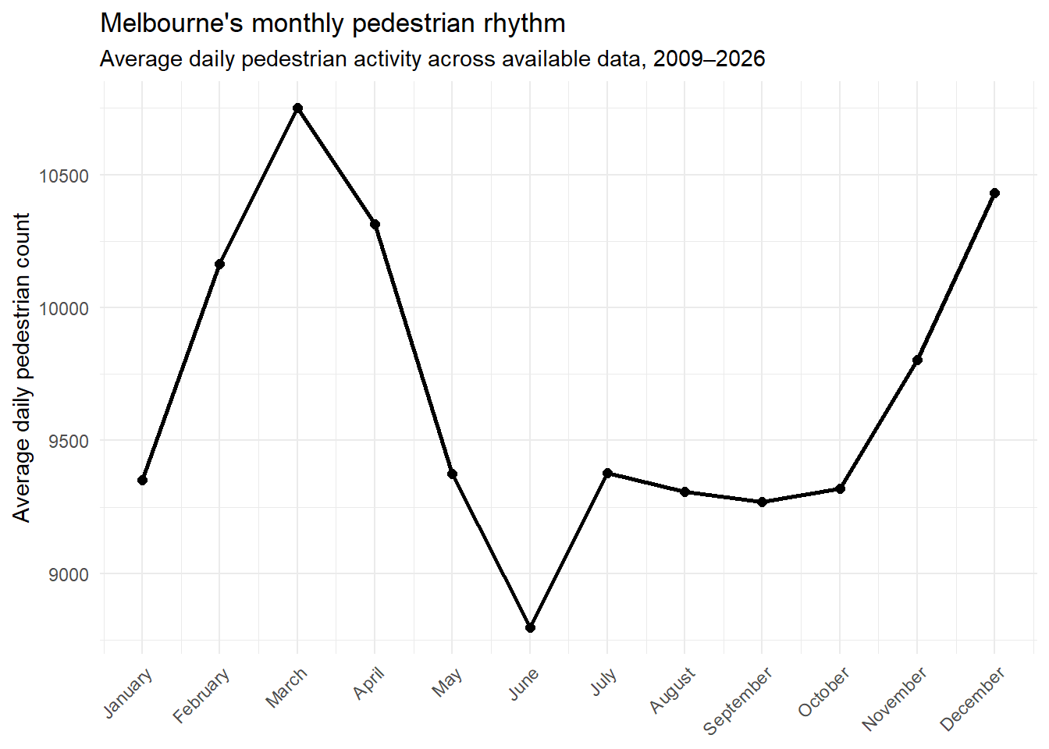
Figure 1. Monthly walking pace in Melbourne from 2009 to 2026.
The seasonal aggregation in Figure 2 confirms the structure. Summer and autumn are strongest, winter weakest, and spring intermediate. The differences are modest but consistent, which matters for operations: an average that ignores season will over-predict winter demand and under-predict late-summer and pre-Christmas demand. Seasonality also complicates weather effects, because rain is more common in cooler months.
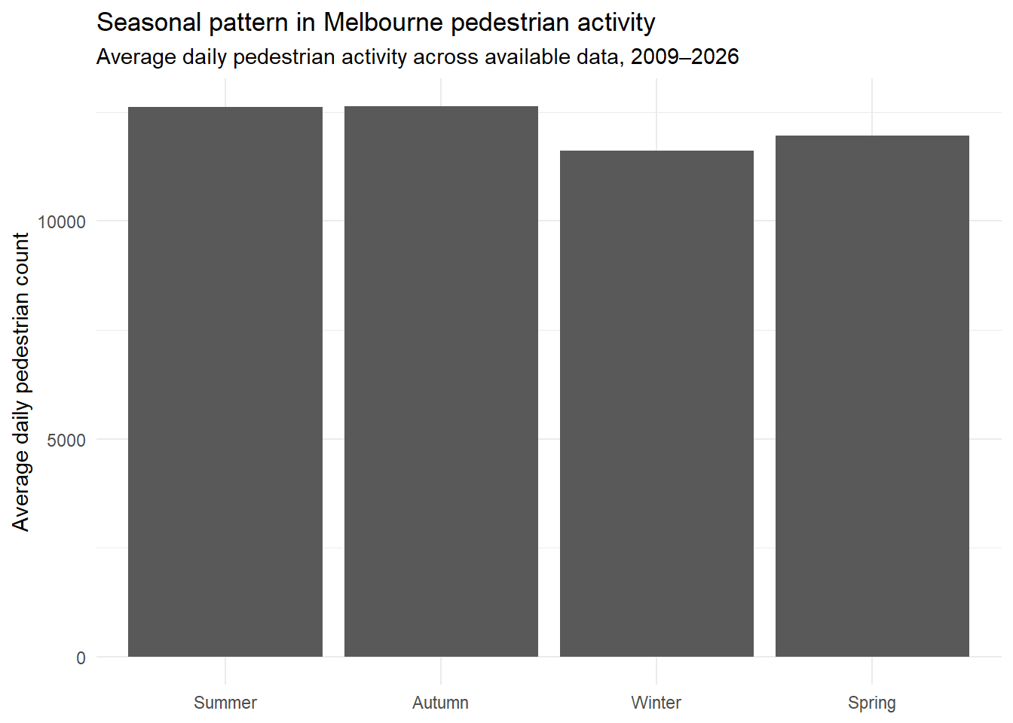
Figure 2. Seasonal patterns of pedestrian activities in Melbourne from 2009 to 2026.

Long-term change and COVID-19
The balanced 27-sensor comparison provides the clearest answer to the recovery question. Median daily activity was 10,091 in 2017–2019 and 7,211 in 2023–2025, a decline of 28.5% (Figure 3). This is a large gap after three full post-pandemic years, and it is neither an artefact of network growth nor driven by missing days: the same sensors are used in both periods and each recorded at least 300 days every year. Central Melbourne's pedestrian economy therefore remains materially smaller than before COVID-19, even after the reopenings of 2022 and 2023.
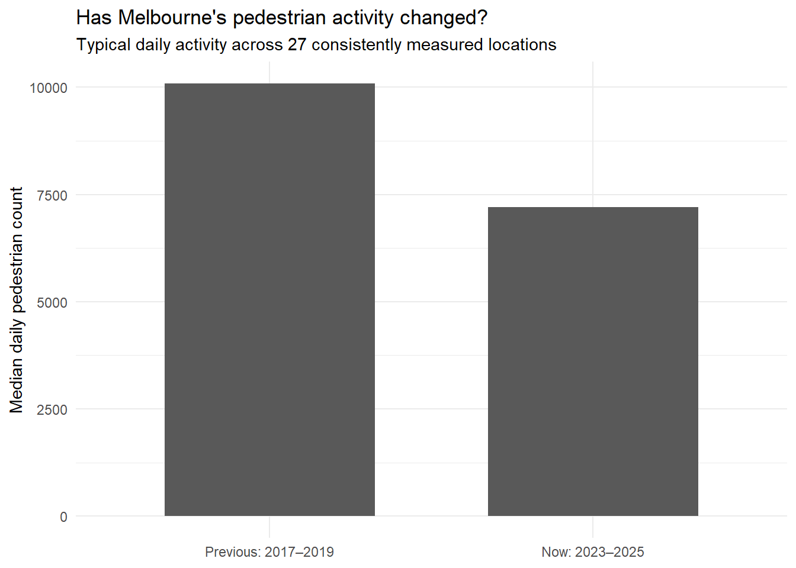
Figure 3. Typical daily pedestrian activity across 27 consistently measured locations.
The monthly COVID-19 index shows how the disruption unfolded (Figure 4). Relative to the same-month 2015–2019 baseline, activity fluctuated around 100 from 2015 to early 2020. It collapsed in the second quarter of 2020, fell below 10 index points during the deepest lockdown, and remained volatile through 2020 and 2021 as restrictions tightened and eased. The 2021 lockdowns produced repeated troughs, with the index falling to roughly 18–20 in several months. Recovery began in late 2021, accelerated in early 2022, and reached the mid-80s by late 2022. The trajectory is one of partial recovery followed by a plateau, not a return to the old level.
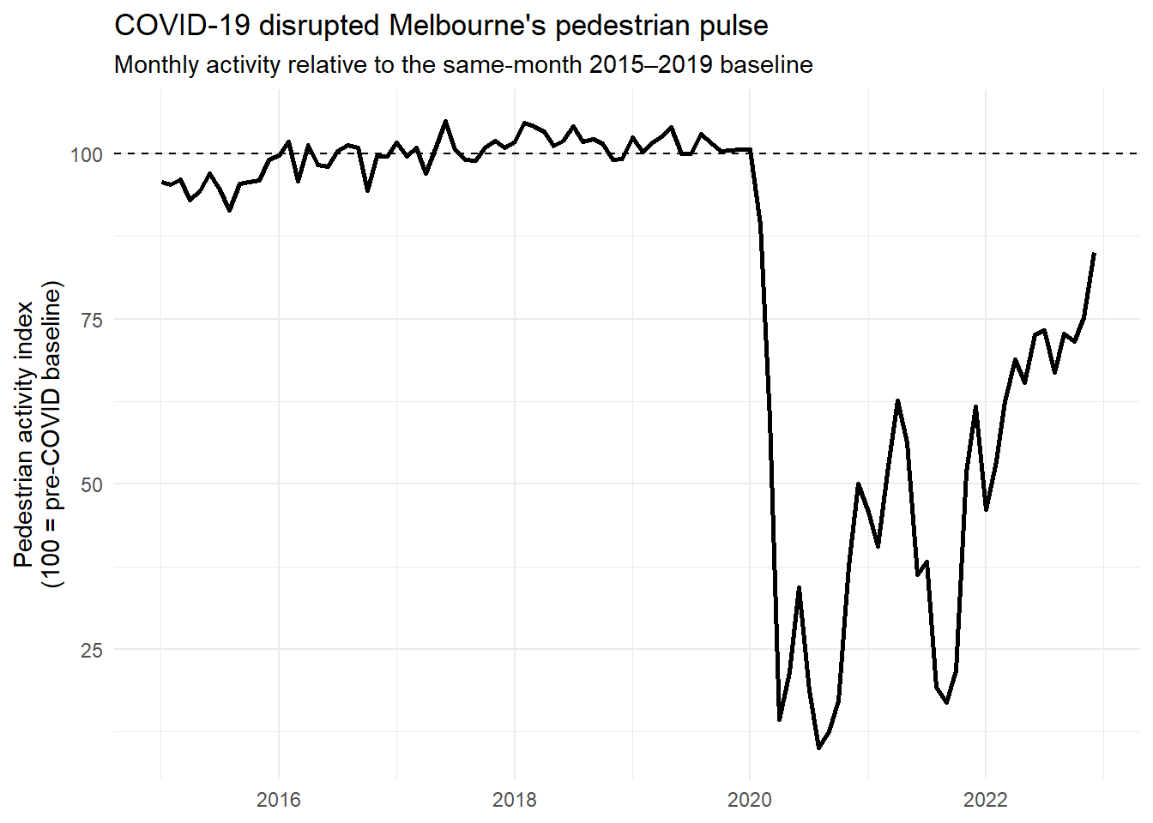
Figure 4. COVID-19 disruption to Melbourne's pedestrian pulse.
The difference between the mid-80s recovery in late 2022 and the 28.5% gap in 2023–2025 is partly methodological: the COVID index uses a 2015–2019 same-month baseline and all sensors with sufficient coverage, while the long-term comparison uses a fixed 27-sensor panel and a 2017–2019 baseline. Both point in the same direction: the city regained much of its former activity but not all, and the residual gap is large enough to be structural. The weekly evidence suggests missing activity is concentrated in commuter hours and early-week days, while weekend and midday activity held up better.

Outlier days, events and public holidays
The calendar-adjusted analysis identifies 64 significant citywide dips in 2019 and 2023–2026. Of these, 22 fall on Victorian public holidays. Holidays make up only 3.7% of the 1,717 eligible days but 34.4% of significant dip days, an enrichment factor of 9.4. They are therefore not minor perturbations: they reorganise the city's walking economy.
Table 2 lists the holiday dips. Christmas Day is the most consistent and deepest suppression: the four Christmas Days record median decreases of 53.1%, 50.0%, 44.4% and 43.2%. Australia Day, ANZAC Day, Good Friday, Boxing Day, the AFL Grand Final Friday and Melbourne Cup Day also appear repeatedly. These are days when offices, universities, courts and many shops close, and activity shifts to suburban retail, family homes and leisure destinations. Magnitudes vary by year, likely reflecting weather, the weekday on which the holiday fell, and post-COVID changes in the baseline.
Table 2. Significant pedestrian decreases on Victorian public holidays
Date | Public holiday | Median decrease (%) | Sensors reporting
2019/12/25 | Christmas Day | -53.1 | 56
2023/12/25 | Christmas Day | -50 | 77
2025/12/25 | Christmas Day | -44.4 | 91
2024/12/25 | Christmas Day | -43.2 | 86
2019/1/28 | Australia Day | -42.9 | 49
2025/1/27 | Australia Day (observed Monday) | -37.8 | 84
2019/4/25 | ANZAC Day | -34.9 | 51
2019/9/27 | Friday before AFL Grand Final | -32.3 | 50
2024/12/26 | Boxing Day | -31.5 | 86
2019/4/19 | Good Friday | -30.9 | 51
2023/11/7 | Melbourne Cup | -30.1 | 78
2024/4/1 | Easter Monday | -29.8 | 75
2019/4/22 | Easter Monday | -29.2 | 51
2019/11/5 | Melbourne Cup Day | -26.6 | 54
2019/1/1 | New Year’s Day | -25.3 | 49
2023/4/7 | Good Friday | -25.1 | 69
2025/4/25 | ANZAC Day | -25 | 87
2025/11/4 | Melbourne Cup | -24.3 | 89
2023/1/2 | New Year’s Day (additional public holiday) | -24 | 67
2019/6/10 | Queen’s Birthday | -23.8 | 52
2024/11/5 | Melbourne Cup | -23.1 | 86
2025/6/9 | King’s Birthday | -21.7 | 81
Holiday dips should be distinguished from event surges: holidays suppress routine commuter activity, while major events can concentrate and amplify it. Table 3 summarises the strongest event-linked surges. The largest occurred on 22 February 2014, when median activity was 51.7% above expectation and 80% of reporting sensors were more than 20% above benchmark. Permits link that date to four events, including the Australian Henley Regatta, the 100mm Car Festival, White Night and the MS Melbourne Cycle. Other surges align with major runs, parades, White Night and New Year's Eve. Events can temporarily override the ordinary weekday and seasonal structure.
Table 3. Strongest event-linked pedestrian surges, 2014–2018
Date | Median uplift (%) | Sensors >20% above expected | Matched event(s)
22-Feb-14 | 51.7 | 80% | Australian Henley Regatta; 100mm Car Festival; White Night; MS Melbourne Cycle
22-Feb-15 | 32.2 | 63% | Melanoma March 2015
3-Nov-14 | 27.7 | 55% | Emirates Melbourne Cup Parade
20-Feb-16 | 26.8 | 64% | White Night 2016; Australian Henley Regatta; Go The Tan; Tree Climbing Championships
31-Dec-17 | 26.3 | 60% | VRR Fun Run – New Year’s Eve
1-Oct-15 | 22.8 | 55% | Festival of Tabernacles
17-Apr-14 | 22.8 | 58% | Dave Matthews Band
24-Apr-16 | 22.1 | 54% | Sri Chinmoy Princes Park 15km Run; Anzac Day 2016
26-Jan-14 | 21.1 | 50% | Australia Day 2014; Kensington Festival; MS Colour Dash; Share the Spirit; Docklands
14-Feb-15 | 20.5 | 52% | Collingwood FC Family Fun Run/Walk; Antipodes Festival
18-Feb-17 | 20.2 | 50% | Docklands Corporate and Community Cup; Outdoor Cinema; Movies Under the Stars; Yoga in the Gardens
The permits cover 2014–2018, so event attribution cannot be extended with the same confidence to later years. The post-2022 record contains several large surges, including 24 August 2025 (+26.2%), 8 March 2026 (+26.0%) and 18 February 2024 (+24.1%), but these are identified from pedestrian data alone. They are candidate event days for future verification, not confirmed attributions.

Weather sensitivity
Weather is associated with large differences in the probability of a significant dip. After excluding public holidays, there were 42 significant dip days and 1,612 other days (Table 4). On dip days, median rainfall was 10.4 mm versus 0.2 mm; 52.4% of dip days had at least 10 mm of rain, versus 4.2% of other days. Median maximum wind was also higher (24.8 versus 19.8 km/h). Median maximum temperature was 21.1°C on dip days and 18.5°C on other days, which likely reflects the seasonal timing of rain-bearing systems once holidays are removed; temperature should not be read as protective.
Table 4. Weather on significant dip days and other days, excluding public holidays
Measure | Significant dip days (n = 42) | Other days (n = 1,612)
Median rainfall (mm) | 10.4 | 0.2
Days with ≥10 mm rain (%) | 52.4 | 4.2
Median maximum temperature (°C) | 21.1 | 18.5
Median minimum temperature (°C) | 12.8 | 10.4
Median maximum wind (km/h) | 24.8 | 19.8
The rainfall gradient is more informative than any single threshold (Table 5). On dry days, 1.5% were significant dip days; at 5–10 mm the rate rose to 6.4%, at 10–20 mm to 17.4%, and at 20 mm or more to 37.0%. The relationship is not perfectly monotonic at very low rainfall, but the increase above 5 mm is clear and large. Heavy rain does not merely reduce counts slightly; it changes the probability that the whole city has an unusually quiet day, which matters for staffing, transport and public-space operations.
Table 5. Significant dip rates by daily rainfall, excluding public holidays
Daily rainfall group | Days | Significant dip days | Dip rate (%)
No rain | 717 | 11 | 1.5
0–2 mm | 542 | 1 | 0.2
2–5 mm | 189 | 1 | 0.5
5–10 mm | 110 | 7 | 6.4
10–20 mm | 69 | 12 | 17.4
20 mm or more | 27 | 10 | 37
All non-holiday days | 1,654 | 42 | 2.5
The results are associational: rainfall correlates with season, cloud cover and event cancellations, and the analysis cannot isolate rain's direct discomfort from alternative-activity effects. Weather is nonetheless a first-order source of day-to-day variation, comparable to the calendar.

Spatial structure and activity types
The busiest locations are concentrated in the traditional retail and transport core. In 2025, sensor 41 on Swanston Street recorded a typical daily count of about 40,000, followed by sensor 4 on Swanston Street at about 36,000, sensor 35 at Southbank at about 31,000, sensor 84 on Elizabeth Street at about 29,000, and sensor 66 at QV at about 28,000 (Figure 5). Princes, Collins, Bourke and Elizabeth Streets also appear in the top ten. A relatively small number of CBD spines carry a disproportionate share of activity.
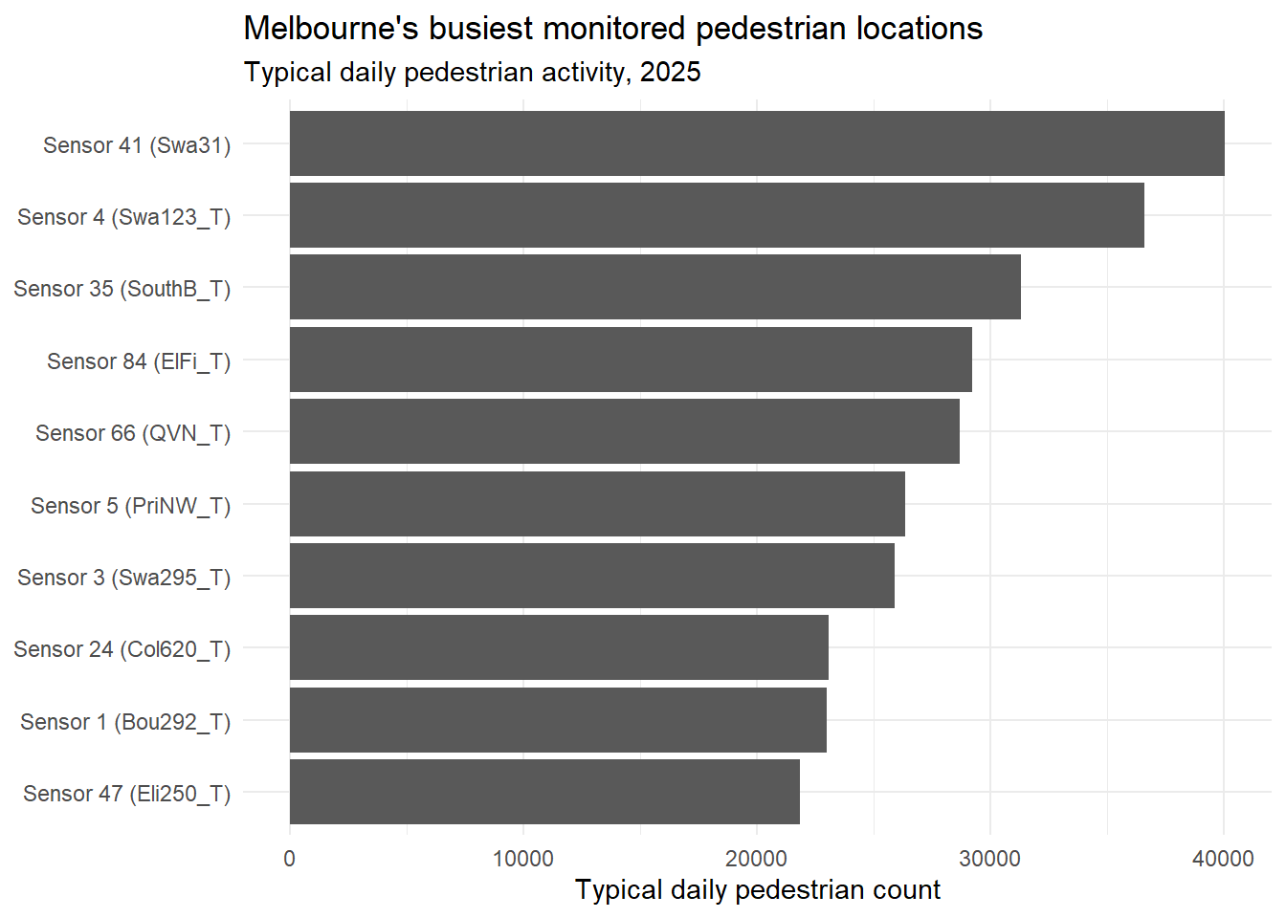
Figure 5. Melbourne's busiest monitored pedestrian locations.
Clustering shows that locations do not all share one rhythm. The two-cluster solution separates nine sensors with a sharply peaked weekday profile from 35 with a broader midday profile (Figure 6). Cluster 1 rises steeply at 08:00, falls at midday, rises again at 17:00, and is comparatively quiet at weekends. Cluster 2 rises more gradually, stays high from late morning to late afternoon, and retains a substantial weekend profile. The first is consistent with office and commuter precincts; the second with retail, hospitality and visitor precincts. The weekend panels show the distinction is not absolute—both have a midday hump—but the weekday contrast is strong.
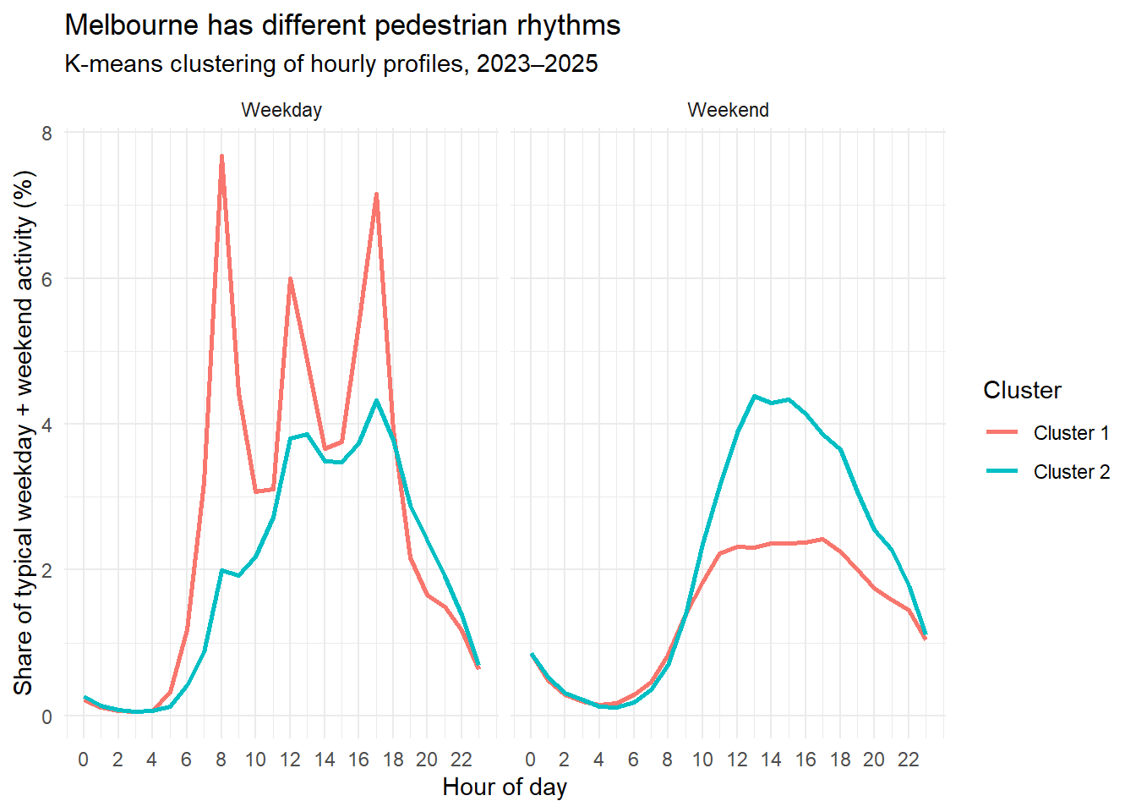
Figure 6. K-means clustering of hourly pedestrian profiles, 2023–2025.
The cluster result is a summary of similarity, not a land-use classification. The silhouette of 0.442 indicates moderate separation: the groups are distinguishable but not sharply isolated. Its value is to demonstrate heterogeneity that citywide averages conceal: a policy that revives a commuter precinct may do little in a visitor precinct. Sensor-level dip rates show the same local variation: the highest in 2023–2025 were 35% at sensors 7 and 136, followed by 23.6% at sensor 44, 22.7% at sensor 42 and 22.2% at sensors 29 and 43. These locations warrant investigation, because persistent local volatility is unlikely to be explained by weather or holidays alone.

Discussion
The research reveals that the structure of urban walking activities has become more dispersed, and the traditional morning and evening commuting peaks have weakened. Midday and weekend activities are stable, and the activity level on Saturdays is close to that on Fridays, which aligns with the trend of mixed working. The consumption and leisure functions in the city center have strengthened. However, the panel gap indicates that the recovery is not complete and there is significant regional differentiation. Holidays inhibit walking, while large-scale events attract people. Rainfall significantly reduces the activity level of walking. Different districts require differentiated spatial governance. Major roads focus on investment in transportation and public spaces, while some areas are more suitable for the provision of leisure and dining facilities. At the same time, the selection of indicators will change the conclusion. It is necessary to integrate total volume, time period, and spatial data to construct an indicator dashboard for comprehensive assessment of urban recovery.

Limitations
This study has several methodological constraints. Firstly, the research is an observational empirical analysis, which can only identify the correlations between pedestrian flow and holidays, cultural and sports activities, and meteorological conditions, but cannot establish causal relationships between the variables. Holidays and large-scale events do not occur randomly, and meteorological changes also fluctuate with the seasons; at the same time, factors such as transportation shutdowns, school holidays, and road construction that were not included in the observation also interfere with the empirical results.
Secondly, the monitoring points do not meet the condition of random sampling throughout the city. Most sensors are concentrated in the city center and areas with high pedestrian flow, and the layout of the points changes over time. Although the balanced panel composed of 27 points can reduce the bias in time series comparison, it still cannot represent the entire city area; the cluster sample consisting of 44 points only covers high-density pedestrian flow areas and has limited overall representativeness.
Thirdly, the historical raw data has been corrected manually. In 2022, it was verified that there were 10,298 abnormal count records at the 6th monitoring point. The study relied on data time series to complete the hour labels. Although the corrected data is internally consistent, this processing method introduces errors to the hourly observation values. Therefore, compared to the data from 2024 and 2025 that were completely matched, the 2022 data must be used with greater caution. The authorized dataset only covers the years 2014-2018, and the conclusion cannot be extrapolated to subsequent periods. The peak pedestrian flow after 2022 can only be statistically identified, and there is no cross-validation with authorized data. On the same day, multiple activities often occur simultaneously, making it difficult to attribute the sudden increase in pedestrian flow to a single event.
Fourthly, the determination of abnormal peak days is based on an artificially set standard, with pedestrian flow deviating by 20% from the benchmark value and covering 30% of the monitoring points. This division is only for practical convenience and has a strong subjective nature. Adjusting the threshold will directly change the statistical results of the number of abnormal days. Therefore, this conclusion is only applicable to depicting large-scale fluctuations in pedestrian flow and cannot be regarded as an accurate event list.

Conclusion
Melbourne's pedestrian pulse is neither flat nor fully restored. It is a structured rhythm that peaks in the late afternoon, holds up through the middle of the day, varies by season and day of week, and is highly sensitive to holidays, events and rain. The long-term comparison shows a persistent 28.5% gap in median daily activity across consistently measured locations, even as weekend and midday activity proved more resilient than the morning commute. Activity is also spatially uneven: a few CBD spines carry very large volumes, while many locations follow a slower, midday-oriented rhythm.
The most useful conclusion is not that Melbourne has "recovered" or "not recovered", but that the composition of activity has changed. Commuter demand has weakened, leisure and event demand have become more important, and weather is now a first-order source of day-to-day variation. Planning should reflect that composition: protect the public spaces and transport links that carry high volumes, support precincts dependent on weekend and midday trade, prepare for weather-driven quiet days, and use the calendar to manage both holiday lulls and event surges. A city's pulse is not a single number but a pattern of times and places, and the better that pattern is understood, the better the city can respond.

References
Kabacoff, R. I. (2022). R in action: data analysis and graphics with R and Tidyverse. Simon and Schuster.
Xia, Y., Sun, J., & Chen, D. G. (2018). Introduction to R, RStudio and ggplot2. In Statistical analysis of microbiome data with R (pp. 77-127). Singapore: Springer Singapore.

