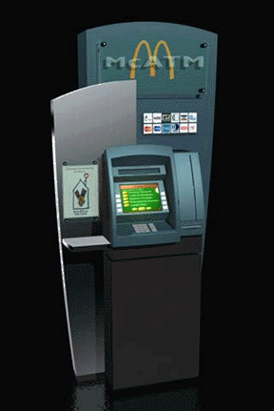

Presented by: Under the guidance of: Nishtha Dutta- Group Leader Mr. Vijay Dwivedi
(0800818120) (Academic in charge)
Mudassir Islam
(0800818108)

Mohd. Arshi

(0800818101)

Manish Rai

(0800818098)

APPLICATION_DETAIL

status | form_cost | sold_date | account_no
Sold | 50 | 10/2/2006 | 1090
Sold | 50 | 12/14/2003 | 2378
sold | 50 | 2/8/2000 | 3245
sold | 50 | 8/9/2000 | 4444
sold | 50 | 11/11/2004 | 5034
sold | 50 | 6/4/2002 | 5643
sold | 50 | 10/17/2002 | 7845

CARD DETAIL

cancel_date | blocked | reissuse_date | Expiry_date | Request_date | card_no | Issue_date
 |  |  | 3/4/2030 | 6/4/2002 | 100000001 | 7/4/2010
 |  |  | 2/8/2020 | 2/8/2000 | 100000002 | 3/8/2000
 |  |  | 12/11/2024 | 11/11/2004 | 100000003 | 12/11/2004
 |  |  | 7/8/2021 | 7/8/2001 | 100000004 | 8/8/2001
 |  |  | 8/9/2023 | 7/9/2003 | 100000006 | 8/9/2003
 |  |  | 3/21/2010 | 2/21/1990 | 100000007 | 3/21/1990
 |  |  | 12/9/2009 | 11/9/1989 | 100000017 | 12/9/1989

CUSTOMER DETAIL

card_  no | a/c_  no | a/c_  type | First name | Last name | address | city | gender
100000017 | 1090 | saving | rohit | mehra | cooper road | agra | M
100000006 | 2378 | current | preti | zinta | town hill | shimla | F
100000004 | 3245 | saving | pooja | tiwari | bahadurganj | saharenpur | F
100000001 | 4444 | saving | nisha | mishra | rambagh | allahabad | F
100000002 | 5034 | current | deepa | yadav | civil lines | lucknow | F
100000007 | 5643 | current | hrithik | arora | cooper road | delhi | M
100000003 | 7845 | saving | shahid | kumar | kydganj | kanpur | M

ATM MANAGEMENT SYSTEM

If any branch of the bank has ATM (Automated Transaction Machine) facility, it can be availed by its customers free of cost. Only one card is issued to a single user. For obtaining an ATM card customer has to contact his branch and demand ATM application form. Filled application form is submitted with the branch manager.
Then the manager determines whether ATM card can be issued to that customer or not. For this purpose they normally go through last 6 or 12 months transaction (especially continuous debit/credit, minimum balance and cheque’s bouncing etc). Customer’s account should not be in-operating and customer should not be bank’s defaulter on any ground. Customer’s minimum balance should not be less than Rs 1000/- for a longer period. When bank is fully satisfied with the account, favorable certificate that “ATM card can be issued to the customer” is endorsed on the form by the manager and customer’s request is forwarded to bank’s HQ office for further course of action.
As a next action, HQ office allots a secret PIN code number to the customer and sends it to the customer’s address along the intimation letter by registered post giving intimation that ATM card has been dispatched to the request forwarding branch and it can be collected from there producing HQ’s intimation letter. Sealed PIN code number slip is opened carefully and after reading it thoroughly it is tear off immediately. This PIN code number is not shown or disclosed to any person nor should be written at ATM card or any other place for memory. ATM card given by the branch is always kept in a safe custody to avoid its fraudulent use in future. If a ATM card is lost by any customer, issuing branch should be informed immediately so that ATM may be locked and its fraudulent use may be stopped. For getting new ATM card customer has to submit a fresh application to the bank. Generally, the valid period for an ATM card is about 10 to 20 years and after expiry of this period the user has to renew his ATM card. On customer’s request validity of the ATM card is extended for a further period of 10 to 20 years.
Sometimes bank cancels the ATM card due to following reasons:-
- When the user does not interact with the bank for long period.
- When user wants to close his account.
- When ATM card is broken and it is not in useable condition.

It has been a great pleasure for all four of us to work on one the most interesting projects, the ATM management system. We have taken great care in providing our users with a beautiful and interactive interface. We hope that the project goes successful without any unwanted errors.
When we begin working on this project, we decomposed the whole problem into different modules, since working with a modular approach is far efficient than considering the whole project as a single problem. Decomposing the problem into different modules made us notice different requirements at different stages. One of them was developing a database - a collection of tables - since a permanent storage for information was required.
The development of database followed creation of different tables. We took great care in normalising the database so as none of the data is repeated.
One of the other interesting problems was working upon the interface designs. We took great care in developing user friendly and interactive designs so as a common user understands what to do for a required task.
As a whole, we all took great interest in developing this project. We hope that our integrated efforts bring shining colours for us and could prove beneficial for our users.

ATM card Management

- Submission of requisition by the customer
- Sending customer’s requisition to HQ
- Renewing the ATM
- Cancelling the ATM
- Blocking the ATM
- Filling of application form
- Reissuing of ATM

With the advent of newer technologies every now and then, users demand that they should be provided with flexible systems that could adapt changes in the technologies. We have taken great care of this demand while developing our project. Since we have visual basic – one of the most advanced languages in the current era- as our development language, in the later stages our project can be migrated to any advanced phase of the language such as visual basic .net, and hence can be used as a web application.
We hope to receive comments and feedbacks from our users once they start using our software. Any of the precious suggestions to make the software more flexible is highly expected.

The project team

Thanks for taking a look at the project report you are holding in your hands right now. It is a sole endeavor of four students namely – Mohd Arshi, Mudassir Islam, Nishtha Dutta and Manish Rai. We have put our whole integrated experience and efforts in making this project a complete success. Still, we expect to face healthy criticism and any unexpected error.
We are highly thankful to Mr. Vijay Dwivedi for helping us in several ways. First of all, we would thank him for giving us the opportunity to develop this project on ATM management system. Apart from this, we are grateful to him for providing us with every little piece of help, whenever we required it.
In last we would like to thank everyone who helped us in this project. We welcome any of the precious suggestions.
Thanks.
The project team members

APPLICATION FORM
Dim db As Database
Dim rs As Recordset
Dim rs1 As Recordset
Dim rs2 As Recordset
Private Sub Command1_Click()
Dim n As String
If Option1.Value = True Then
n = "M"
Else
n = "F"
End If
Set db = OpenDatabase("atm.mdb")
Set rs = db.OpenRecordset("customer")
Set rs1 = db.OpenRecordset("card_details")
Set rs2 = db.OpenRecordset("application_form")
rs.Edit
rs.Fields(0).Value = Text9.Text
rs.Fields(1).Value = Text2.Text
rs.Fields(2).Value = Text3.Text
rs.Fields(3).Value = Text4.Text
rs.Fields(4).Value = Text1.Text
rs.Fields(5).Value = Text5.Text
rs.Fields(6).Value = Text7.Text
rs.Fields(7).Value = n
rs.Fields(8).Value = Text6.Text
rs.Fields(9).Value = Text8.Text
rs.Fields(10).Value = DTPicker1.Value
rs.update
MsgBox "Form accepted", vbInformation
rs1.Edit
rs1.Fields(4).Value = VBA.Date
rs1.Fields(6).Value = VBA.Date + 31
rs1.Fields(3).Value = VBA.Date + 7336
rs1.Fields(5) = Text9.Text
rs1.update
rs2.Edit
rs.Fields(2).Value = VBA.Date
rs.Fields(0).Value = "sold"
rs2.Fields(3).Value = Text2.Text
rs2.update
Unload Me
main.Show
End Sub
Private Sub Command2_Click()
Unload Me
main.Show
End Sub
Private Sub Command3_Click()
Text2.Text = " "
Text3.Text = " "
Text4.Text = " "
Text6.Text = " "
Text8.Text = " "
Text9.Text = " "
Text5.Text = " "
Text7.Text = " "
Option1.Value = False
Option2.Value = False
End Sub
Private Sub Text1_KeyPress(keyascii As Integer)
If keyascii <> 8 And keyascii <> 32 And (keyascii < 65 Or keyascii > 90) And (keyascii < 97 Or keyascii > 122) Then
MsgBox "PLZ ENTER ALPHABETS", vbCritical
keyascii = 0
End If
End Sub
Private Sub Text2_KeyPress(keyascii As Integer)
If keyascii <> 8 And (keyascii < 48 Or keyascii > 57) Then
MsgBox "PLZ ENTER DIGIT 0-9", vbCritical
keyascii = 0
End If
End Sub
Private Sub Text3_KeyPress(keyascii As Integer)
If keyascii <> 8 And keyascii <> 32 And (keyascii < 65 Or keyascii > 90) And (keyascii < 97 Or keyascii > 122) Then
MsgBox "PLZ ENTER ALPHABETS", vbCritical
keyascii = 0
End If
End Sub
Private Sub Text4_KeyPress(keyascii As Integer)
If keyascii <> 8 And keyascii <> 32 And (keyascii < 65 Or keyascii > 90) And (keyascii < 97 Or keyascii > 122) Then
MsgBox "PLZ ENTER ALPHABETS", vbCritical
keyascii = 0
End If
End Sub
Private Sub Text7_KeyPress(keyascii As Integer)
If keyascii <> 8 And keyascii <> 32 And (keyascii < 65 Or keyascii > 90) And (keyascii < 97 Or keyascii > 122) Then
MsgBox "PLZ ENTER ALPHABETS", vbCritical
keyascii = 0
End If
End Sub
Private Sub Text8_KeyPress(keyascii As Integer)
If keyascii <> 8 And (keyascii < 48 Or keyascii > 57) Then
MsgBox "PLZ ENTER DIGIT 0-9", vbCritical
keyascii = 0
End If
End Sub
Private Sub Text9_Change()
If keyascii <> 8 And (keyascii < 48 Or keyascii > 57) Then
MsgBox "PLZ ENTER DIGIT 0-9", vbCritical
keyascii = 0
End If
End Sub

APPLICATION FORM DETAIL FORM

Dim db As Database
Dim rs As Recordset
Dim rs1 As Recordset
Dim rs2 As Recordset
Private Sub add_Click()
rs.Edit
rs.Fields(0) = Text2.Text
rs.Fields(3) = Text4.Text
rs.Fields(2) = DTPicker1.Value
rs.update
End Sub
Private Sub Delete_Click()
w = MsgBox("Are you sure to delete the record ??", vbQuestion + vbYesNo)
If w = vbYes Then
rs.delete
MsgBox "Record deleted successfully !!", vbInformation
Text2.Text = ""
Text4.Text = ""
DTPicker1.Value = 6 / 9 / 1990
End If
End Sub
Private Sub first_Click()
rs.MoveFirst
Text2.Text = rs.Fields(0)
Text4.Text = rs.Fields(3)
DTPicker1.Value = rs.Fields(2)
End Sub
Private Sub next_Click()
If rs.EOF = True Then
rs.MoveLast
l:
MsgBox "No more records !!", vbCritical
Else
rs.MoveNext
If rs.EOF = True Then
GoTo l
End If
Text2.Text = rs.Fields(0)
Text4.Text = rs.Fields(3)
DTPicker1.Value = rs.Fields(2)
End If
End Sub
Private Sub last_Click()
rs.MoveLast
Text2.Text = rs.Fields(0)
Text4.Text = rs.Fields(3)
DTPicker1.Value = rs.Fields(2)
End Sub
Private Sub previous_Click()
If rs.BOF = True Then
rs.MoveFirst
l:
MsgBox "No more records !!", vbCritical
Else
rs.MovePrevious
If rs.BOF = True Then
GoTo l
End If
Text2.Text = rs.Fields(0)
Text4.Text = rs.Fields(3)
DTPicker1.Value = rs.Fields(2)
End If
End Sub
Private Sub Delete_Click()
rs.Edit
rs.delete
rs.update
End Sub
Private Sub back_Click()
Unload Me
existing.Show
End Sub
Private Sub Text1_KeyPress(keyascii As Integer)
If keyascii <> 8 And (keyascii < 48 Or keyascii > 57) Then
MsgBox "PLZ ENTER DIGIT 0-9", vbCritical
keyascii = 0
End If
End Sub
Private Sub Form_Load()
Set db = OpenDatabase("atm.mdb")
Set rs = db.OpenRecordset("application_form")
End Sub
Private Sub Text2_KeyPress(keyascii As Integer)
If keyascii <> 8 And keyascii <> 32 And (keyascii < 65 Or keyascii > 90) And (keyascii < 97 Or keyascii > 122) Then
MsgBox "PLZ ENTER ALPHABETS", vbCritical
keyascii = 0
End If
End Sub
Private Sub Text4_KeyPress(keyascii As Integer)
If keyascii <> 8 And (keyascii < 48 Or keyascii > 57) Then
MsgBox "PLZ ENTER DIGIT 0-9", vbCritical
keyascii = 0
End If
End Sub
Private Sub Text5_keypress(keyascii As Integer)
If keyascii <> 8 And (keyascii < 48 Or keyascii > 57) Then
MsgBox "PLZ ENTER DIGIT 0-9", vbCritical
keyascii = 0
End If

rs.MoveFirst
Do While Not rs.EOF
If Text4.Text = rs.Fields(3) Then
rs.Edit
rs.Fields(0) = Text2.Text
rs.Fields(2) = DTPicker1.Value
rs.update
Exit Do
Else
rs.MoveNext
End If
Loop
End Sub

CARD DETAIL FORM

Dim db As Database
Dim rs As Recordset
Dim rs1 As Recordset
Dim s As String
Private Sub Command1_Click()
Dim f As Boolean
If st = "1" Then
rs1.MoveFirst
While Not rs1.EOF
If rs1.Fields(1) = Text1.Text Then
s = rs1.Fields(0)
End If
rs1.MoveNext
Wend
rs.MoveFirst
While Not rs.EOF
If s = rs.Fields(5) Then
If rs.Fields(3) - VBA.Date = 0 Then
rs.Edit
rs.Fields(3) = rs.Fields(3) + 7300
rs.update
MsgBox "Record updated", vbInformation
Else
MsgBox "Your validity has not expired", vbCritical
End If
End If
rs.MoveNext
Wend
ElseIf st = "5" Then
ac = Text1.Text
view.Show
Unload Me
ElseIf st = "2" Then
f = False
rs1.MoveFirst
While Not rs1.EOF
If rs1.Fields(1).Value = Text1.Text Then
s = rs1.Fields(0).Value
End If
rs1.MoveNext
Wend
rs.MoveFirst
While Not rs.EOF
If s = rs.Fields(5) And rs.Fields(1) = "Y" Then
rs.Edit
rs.Fields(2) = VBA.Date
rs.Fields(1) = "N"
rs.update
f = True
MsgBox "Card reissued", vbInformation
Exit Sub
End If
rs.MoveNext
Wend
If f = False Then
MsgBox "Your card cannot be reissued as it is not blocked", vbCritical
End If
ElseIf st = "3" Then
rs1.MoveFirst
While Not rs1.EOF
If rs1.Fields(1).Value = Text1.Text Then
s = rs1.Fields(0).Value
End If
rs1.MoveNext
Wend
f = False
rs.MoveFirst
Dim w As String
While Not rs.EOF
w = Format$(rs.Fields(0), "mm/dd/yyyy")
If s = rs.Fields(5).Value And w = "" Then
rs.Edit
rs.Fields(0).Value = VBA.Date
rs.update
MsgBox "Card cancelled successfully", vbInformation
f = True
End If
rs.MoveNext
Wend
If f = False Then
MsgBox "card is already cancelled", vbCritical
Exit Sub
End If
ElseIf st = "4" Then
f = False
rs1.MoveFirst
Do While Not rs1.EOF
If rs1.Fields(1).Value = Text1.Text Then
s = rs1.Fields(0).Value
Exit Do
End If
rs1.MoveNext
Loop
rs.MoveFirst
Do While Not rs.EOF
If s = rs.Fields(5).Value Then
If rs.Fields(1).Value = "Y" Then
f = True
MsgBox "Card is already blocked", vbCritical
Exit Sub
Else
rs.Edit
rs.Fields(1).Value = "Y"
rs.update
MsgBox "Card blocked sucessfully", vbInformation
End If
End If
rs.MoveNext
Loop
End If
End Sub
Private Sub Clear_Click()
Text1.Text = " "
End Sub
Private Sub Back_Click()
st = ""
existing.Show
Unload Me
End Sub
Private Sub Form_Load()
Set db = OpenDatabase("atm.mdb")
Set rs = db.OpenRecordset("card_details")
Set rs1 = db.OpenRecordset("customer")
If st = "1" Then
Label1.Caption = "RENEW CARD"
ElseIf st = "2" Then
Label1.Caption = "REISSUE CARD"
ElseIf st = "3" Then
Label1.Caption = "CARD CANCELLATION"
ElseIf st = "4" Then
Label1.Caption = "CARD BLOCKING"
ElseIf st = "5" Then
Label1.Caption = " CARD DETAILS"
End If
End Sub
Private Sub Text1_LostFocus()
Dim flag As Boolean
flag = False
rs1.MoveFirst
Do While Not rs1.EOF
If Text1.Text = rs1.Fields(1) Then
flag = True
Exit Do
End If
rs1.MoveNext
Loop
If flag = False Then
MsgBox "account number doesnot exist", vbCritical
End If
End Sub

EXISTING FORM

Private Sub Command1_Click()
st = "2"
Unload Me
Card.Show
End Sub
Private Sub Command2_Click()
st = "3"
Unload Me
Card.Show
End Sub
Private Sub Command3_Click()
st = "4"
Unload Me
Card.Show
End Sub
Private Sub Command4_Click()
st = "1"
Unload Me
Card.Show
End Sub
Private Sub Command5_Click()
Unload Me
main.Show
End Sub
Private Sub Command6_Click()
st = "5"
Unload Me
Card.Show
End Sub
Private Sub Command7_Click()
st = "6"
Unload Me
APPLICATION_FORM.Show
End Sub

LOGIN FORM

Dim db As Database
Dim rs As Recordset
Private Sub C_Click()
Unload Me
input_form.Show
End Sub
Private Sub cmdCancel_Click()
Unload Me
thank.Show
End Sub
Private Sub cmdOK_Click()
If txtPassword = rs.Fields(0) And txtUserName = rs.Fields(1) Then
main.Show
Unload Me
Else
MsgBox "Invalid Password or user name, try again!", , "Login"
txtPassword.Text = ""
txtUserName.Text = ""
End If
End Sub
Private Sub Form_Load()
Set db = OpenDatabase("atm.mdb")
Set rs = db.OpenRecordset("login")
End Sub
Private Sub Timer1_Timer()
If Label1.Left = 0 Then Label1.Left = 2880
Label1.Left = Label1.Left - 60
End Sub

CHANGE PASSWORD FORM

Dim db As Database
Dim rs As Recordset
Private Sub cancel_Click()
Unload Me
frmLogin.Show
End Sub
Private Sub Form_Load()
Set db = OpenDatabase("atm.mdb")
Set rs = db.OpenRecordset("login")
End Sub
Private Sub ok_Click()
If rs.Fields(0) <> Text2.Text And rs.Fields(1) <> Text3.Text Then
MsgBox "Invalid username or password", vbCritical
Exit Sub
ElseIf Text1.Text <> input_text Then
MsgBox "Your new password and confirm password doesnot match", vbCritical
Exit Sub
ElseIf Text1.Text = "" And input_text = "" Then
MsgBox "Please enter the new password and cofirm password", vbCritical
Exit Sub
Else
rs.Edit
rs.Fields(0) = Text1.Text
rs.update
MsgBox "Your password has successfully changed", vbInformation
End If
End Sub

HELP FORM

Private Sub Command1_Click()
st = "1"
Unload Me
helping.Show
End Sub
Private Sub Command2_Click()
st = "2"
Unload Me
helping.Show
End Sub
Private Sub Command3_Click()
st = "3"
Unload Me
helping.Show
End Sub
Private Sub Command4_Click()
st = "4"
Unload Me
helping.Show
End Sub
Private Sub Command5_Click()
Unload Me
main.Show
End Sub
Private Sub Command7_Click()
st = "5"
Unload Me
helping.Show
End Sub
Private Sub Command8_Click()
st = "6"
Unload Me
helping.Show
End Sub

HELPING FORM

Private Sub back_Click()
Unload Me
help.Show
End Sub
Private Sub Form_Load()
If st = "1" Then
Text1.Visible = True
ElseIf st = "2" Then
Text5.Visible = True
ElseIf st = "3" Then
Text3.Visible = True
ElseIf st = "4" Then
Text4.Visible = True
ElseIf st = "5" Then
Text2.Visible = True
ElseIf st = "6" Then
Text6.Visible = True
End If
End Sub

MAIN FORM

Private Sub Command1_Click()
existing.Show
Unload Me
End Sub
Private Sub Command2_Click()
APPLICATION.Show
Unload Me
End Sub
Private Sub Command3_Click()
help.Show
Unload Me
End Sub
Private Sub Command4_Click()
Unload Me
thank.Show
End Sub

THANKS FORM

Dim A As Integer
Private Sub Timer1_Timer()
If Image2.Visible = True Then
Image2.Visible = False
Else
Image2.Visible = True
End If
If A = 50 Then
Unload Me
Else
A = A + 1
End If
End Sub

SPLASH SCREEN FORM

Private Sub Form_KeyPress(keyascii As Integer)
Unload Me
End Sub
Private Sub Frame1_Click()
Unload Me
End Sub
Private Sub Timer1_Timer()
If ProgressBar1.Value > 99 Then
Unload Me
frmLogin.Show
Else
If Label1.Visible = True Then
Label1.Visible = False
Else
Label1.Visible = True
End If
Label2.Caption = "Loading" + Str(ProgressBar1.Value) + "%"
ProgressBar1.Value = ProgressBar1.Value + 1
End If
End Sub

CUTOMER DETAIL FORM

Dim db As Database
Dim rs As Recordset
Dim rs1 As Recordset
Private Sub add_Click()
rs.MoveFirst
rs.Edit
rs.Fields(1) = Text2.Text
rs.Fields(3) = Text4.Text
rs.Fields(5) = Text5.Text
rs.Fields(6) = Text7.Text
rs.Fields(9) = Text8.Text
rs.Fields(0) = Text9.Text
rs.Fields(2) = Text3.Text
rs.Fields(8) = Text6.Text
If Option1.Value = True Then
rs.Fields(7) = "M"
Else
rs.Fields(7) = "F"
End If
rs.update
rs1.Edit
If rs.Fields(0) = rs1.Fields(5) Then
rs1.Fields(3) = DTPicker2.Value
End If
End Sub
Private Sub back_Click()
Unload Me
existing.Show
End Sub
Private Sub Delete_Click()
w = MsgBox("Are you sure to delete the record ??", vbQuestion + vbYesNo)
If w = vbYes Then
rs.delete
MsgBox "Record deleted successfully !!", vbInformation
Text2.Text = ""
Text4.Text = ""
Text5.Text = ""
Text7.Text = ""
Text8.Text = ""
Text9.Text = ""
Text3.Text = ""
Text6.Text = ""
Option1.Value = False
Option2.Value = False
DTPicker2.Value = 6 / 9 / 1990
End If
End Sub
Private Sub first_Click()
rs.MoveFirst
Text2.Text = rs.Fields(1)
Text4.Text = rs.Fields(3)
Text5.Text = rs.Fields(5)
Text7.Text = rs.Fields(6)
Text8.Text = rs.Fields(9)
Text9.Text = rs.Fields(0)
Text3.Text = rs.Fields(2)
Text6.Text = rs.Fields(8)
If rs.Fields(7) = "M" Then
Option1.Value = True
Else
Option2.Value = True
End If
rs1.MoveFirst
While Not rs1.EOF
If rs.Fields(0) = rs1.Fields(5) Then
DTPicker2.Value = rs1.Fields(3)
End If
rs1.MoveNext
Wend
End Sub
Private Sub Form_Load()
Set db = OpenDatabase("atm.mdb")
Set rs = db.OpenRecordset("customer")
Set rs1 = db.OpenRecordset("card_details")
If rs.RecordCount = 0 Then
MsgBox " Table is empty", vbCritical
Exit Sub
ElseIf rs.EOF Then
MsgBox "No such record", vbCritical
Exit Sub
Else
rs.MoveFirst
While Not rs.EOF
If rs.Fields(1) = ac Then
Text2.Text = rs.Fields(1)
Text4.Text = rs.Fields(3)
Text5.Text = rs.Fields(5)
Text7.Text = rs.Fields(6)
Text8.Text = rs.Fields(9)
Text9.Text = rs.Fields(0)
Text3.Text = rs.Fields(2)
Text6.Text = rs.Fields(8)
If rs.Fields(7) = "M" Then
Option1.Value = True
Else
Option2.Value = True
End If
rs1.MoveFirst
While Not rs1.EOF
If rs.Fields(0) = rs1.Fields(5) Then
DTPicker2.Value = rs1.Fields(3)
End If
rs1.MoveNext
Wend
Exit Sub
End If
rs.MoveNext
Wend
End If
End Sub
Private Sub last_Click()
rs.MoveLast
Text2.Text = rs.Fields(1)
Text4.Text = rs.Fields(3)
Text5.Text = rs.Fields(5)
Text7.Text = rs.Fields(6)
Text8.Text = rs.Fields(9)
Text9.Text = rs.Fields(0)
Text3.Text = rs.Fields(2)
Text6.Text = rs.Fields(8)
If rs.Fields(7) = "M" Then
Option1.Value = True
Else
Option2.Value = True
End If
While Not rs1.EOF
If rs.Fields(0) = rs1.Fields(5) Then
DTPicker2.Value = rs1.Fields(3)
End If
rs1.MoveNext
Wend
End Sub
Private Sub next_button_Click()
If rs.EOF = True Then
rs.MoveLast
l:
MsgBox "No more records !!", vbCritical
Else
rs.MoveNext
If rs.EOF = True Then
GoTo l
End If
Text2.Text = rs.Fields(1)
Text4.Text = rs.Fields(3)
Text5.Text = rs.Fields(5)
Text7.Text = rs.Fields(6)
Text8.Text = rs.Fields(9)
Text9.Text = rs.Fields(0)
Text3.Text = rs.Fields(2)
Text6.Text = rs.Fields(8)
If rs.Fields(7) = "M" Then
Option1.Value = True
Else
Option2.Value = True
End If
rs1.MoveFirst
While Not rs1.EOF
If rs.Fields(0) = rs1.Fields(5) Then
DTPicker2.Value = rs1.Fields(3)
End If
rs1.MoveNext
Wend
End If
End Sub
Private Sub Prev_Click()
If rs.BOF = True Then
rs.MoveFirst
l:
MsgBox "No more records !!", vbCritical
Else
rs.MovePrevious
If rs.BOF = True Then
GoTo l
End If
Text2.Text = rs.Fields(1)
Text4.Text = rs.Fields(3)
Text5.Text = rs.Fields(5)
Text7.Text = rs.Fields(6)
Text8.Text = rs.Fields(9)
Text9.Text = rs.Fields(0)
Text3.Text = rs.Fields(2)
Text6.Text = rs.Fields(8)
If rs.Fields(7) = "M" Then
Option1.Value = True
Else
Option2.Value = True
End If
rs1.MoveFirst
While Not rs1.EOF
If rs.Fields(0) = rs1.Fields(5) Then
DTPicker2.Value = rs1.Fields(3)
End If
rs1.MoveNext
Wend
End If
End Sub
Private Sub update_Click()
rs.MoveFirst
Do While Not rs.EOF
If Text2.Text = rs.Fields(3) Then
rs.Edit
rs.Fields(1) = Text2.Text
rs.Fields(3) = Text4.Text
rs.Fields(5) = Text5.Text
rs.Fields(6) = Text7.Text
rs.Fields(9) = Text8.Text
rs.Fields(0) = Text9.Text
rs.Fields(2) = Text3.Text
rs.Fields(8) = Text6.Text
If Option1.Value = True Then
rs.Fields(7) = "M"
Else
rs.Fields(7) = "F"
End If
rs.update
Exit Do
Else
rs.MoveNext
End If
Loop
End Sub

Our objective with this topic ATM MANAGEMENTSYSTEM is to automate the record keeping system which is maintained manually by the bank, which is a very challenging task to do for any employee and a bank have to hire a person for this purpose. With are system bank can maintain their records electronically and in the simplest way.
In making the purposed system our main focus is on to make the record keeping system more reliable and we try to maintain the data consistency and providing data security by providing appropriate password to avoid unauthorized access to data, which is hard to achieve previously with manual system.

The project team members

HARDWARE REQUIRED:-

- PROCESSOR :
- RAM :
- HARD DISK :

SOFTWARE REQUIRED:-

- MICROSOFT VISUAL STUDIO 6.0
- MICROSOFT OFFICE

FRONT END

- VISUAL BASIC

BACK END

- MS ACCESS

- Black book of visual basic.
- Learning MS Access in 20 days.
- How to program in visual basic 6.0.
By Deitel & Deitel

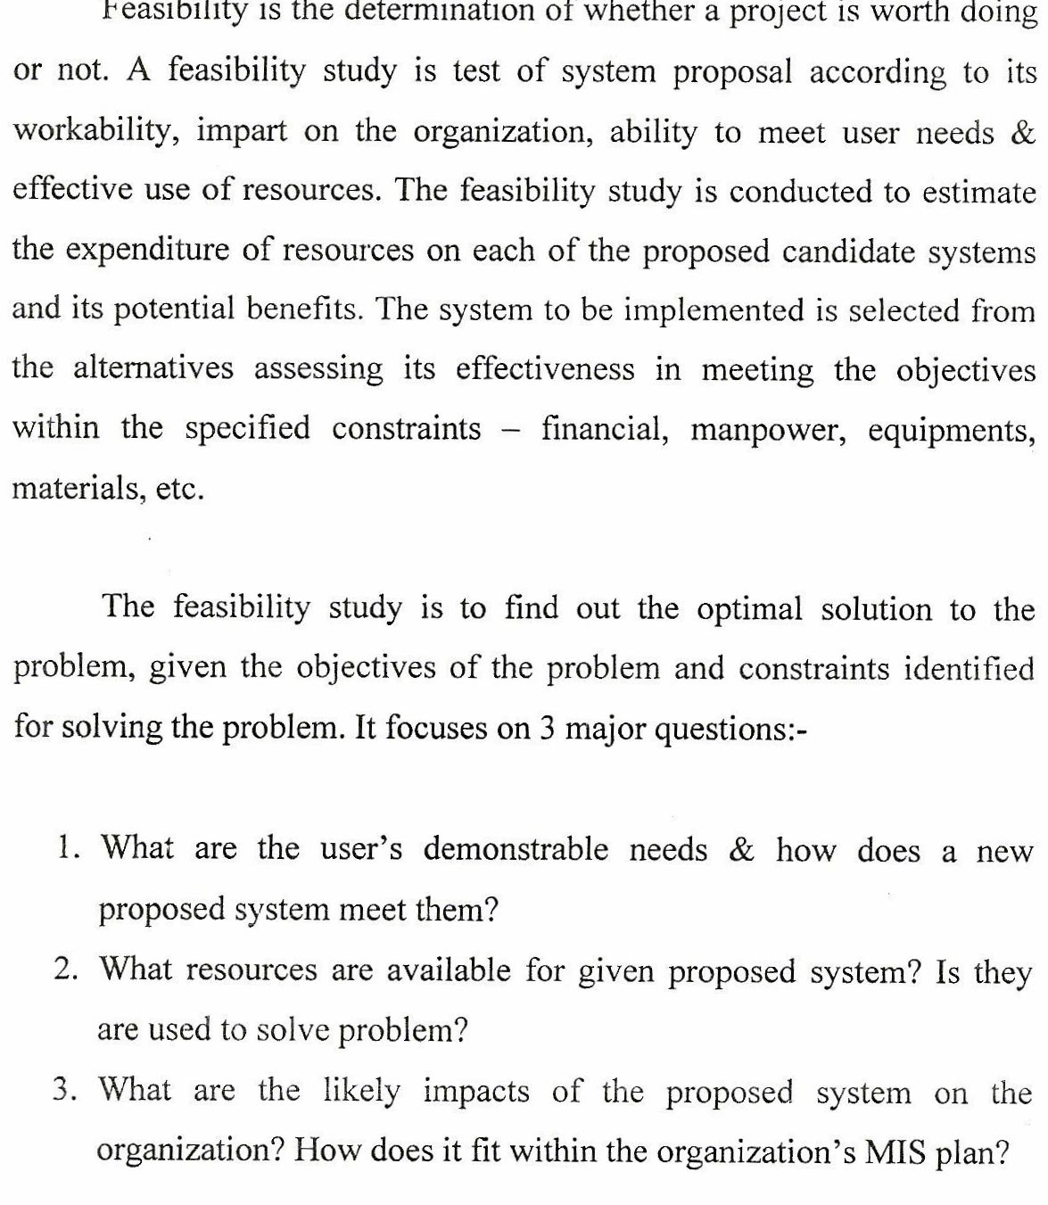

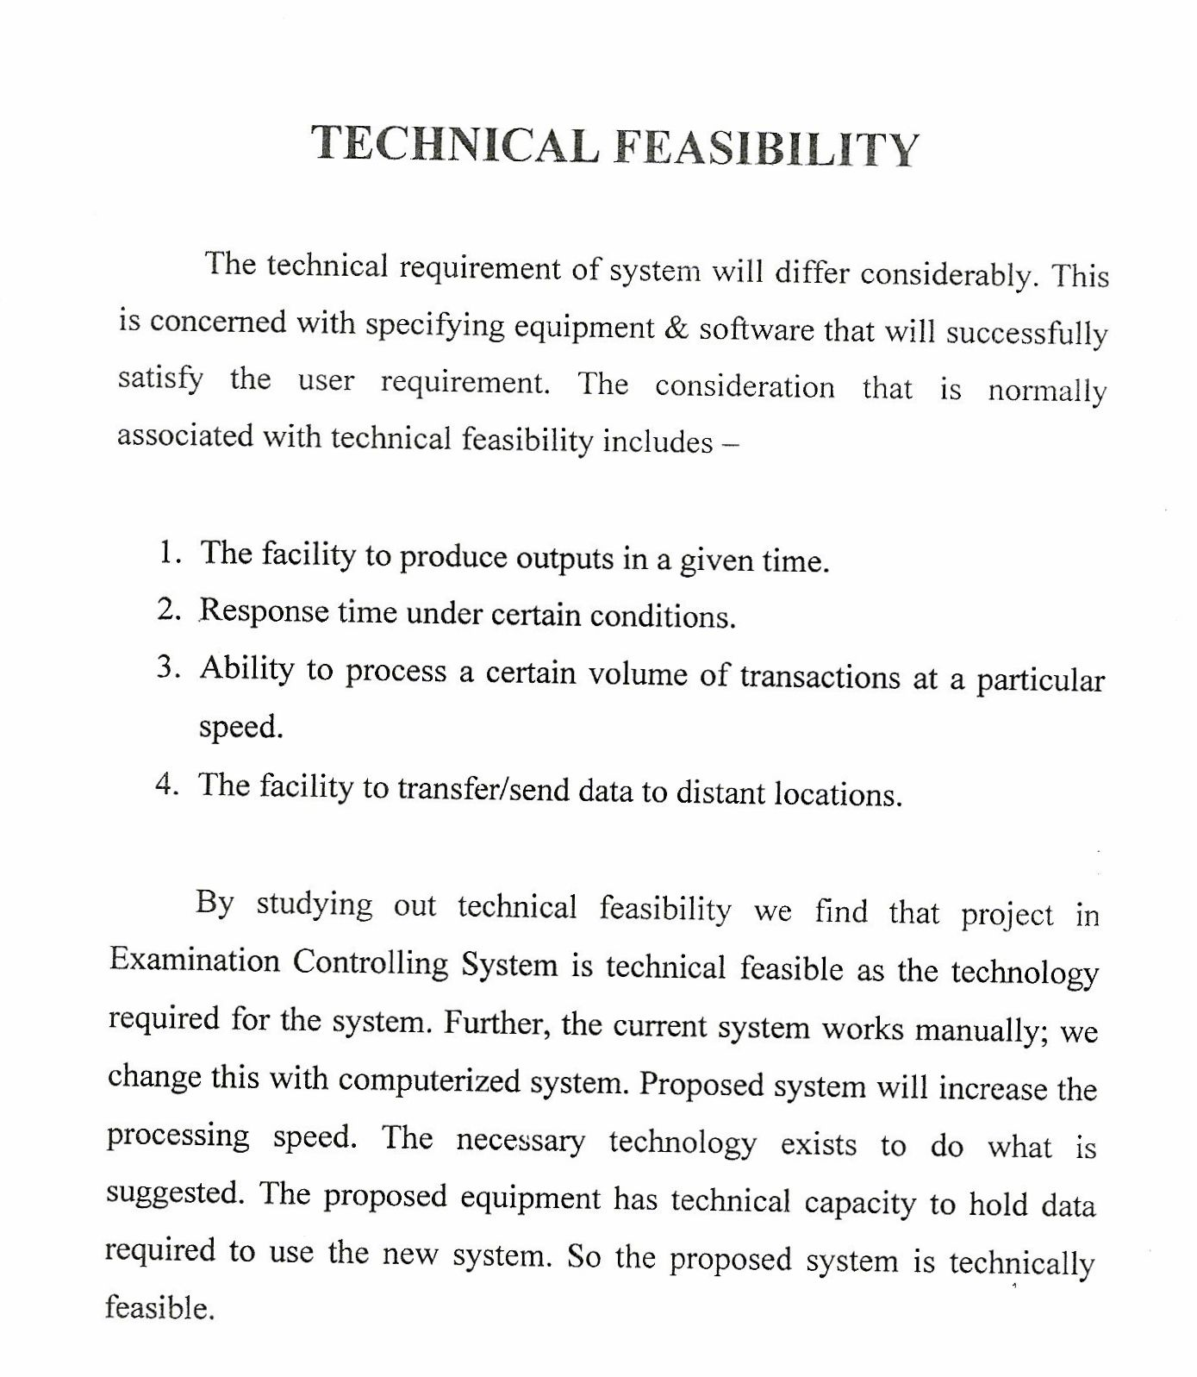

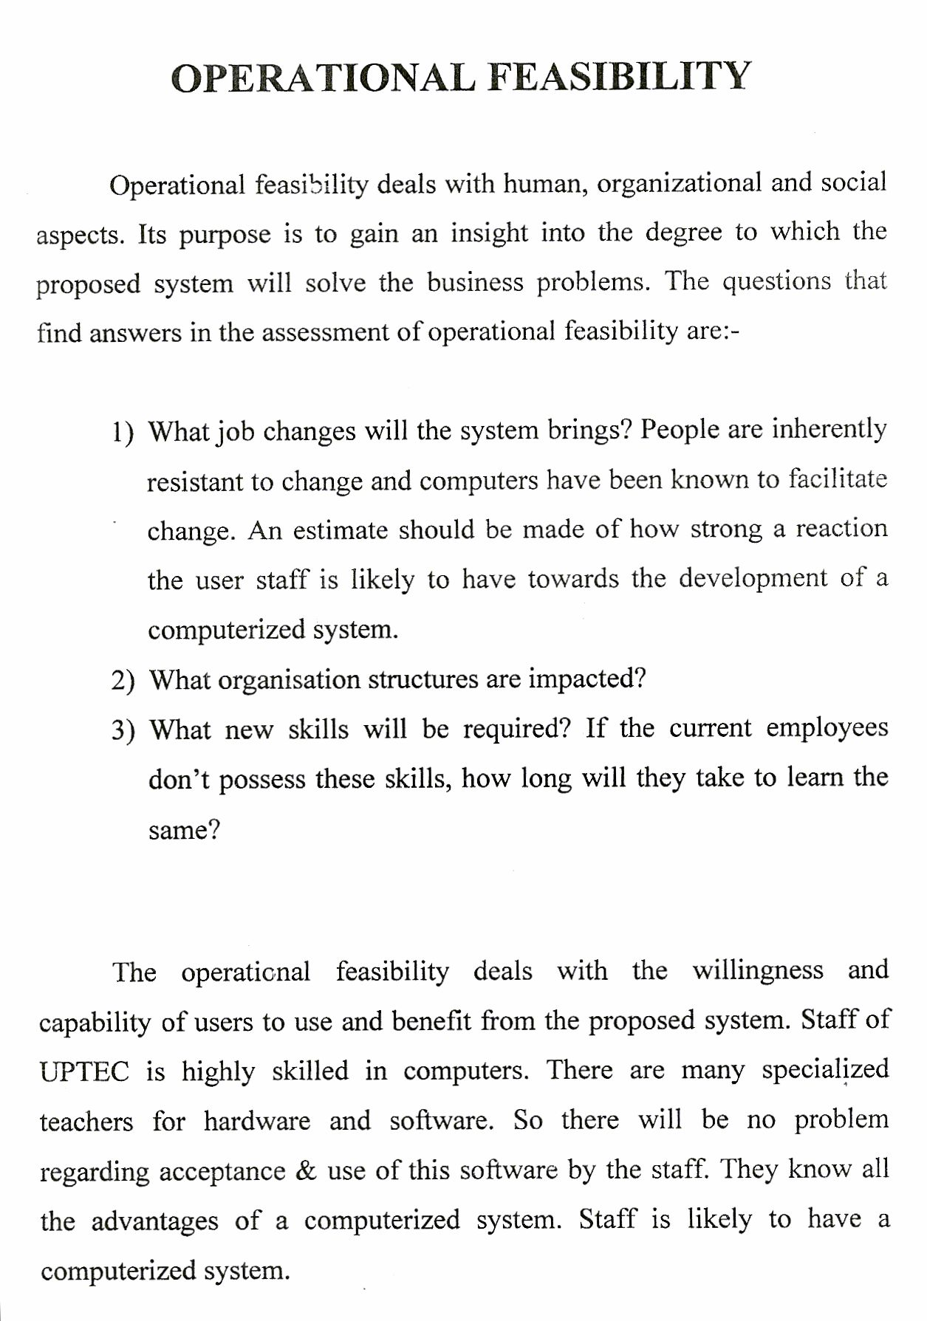
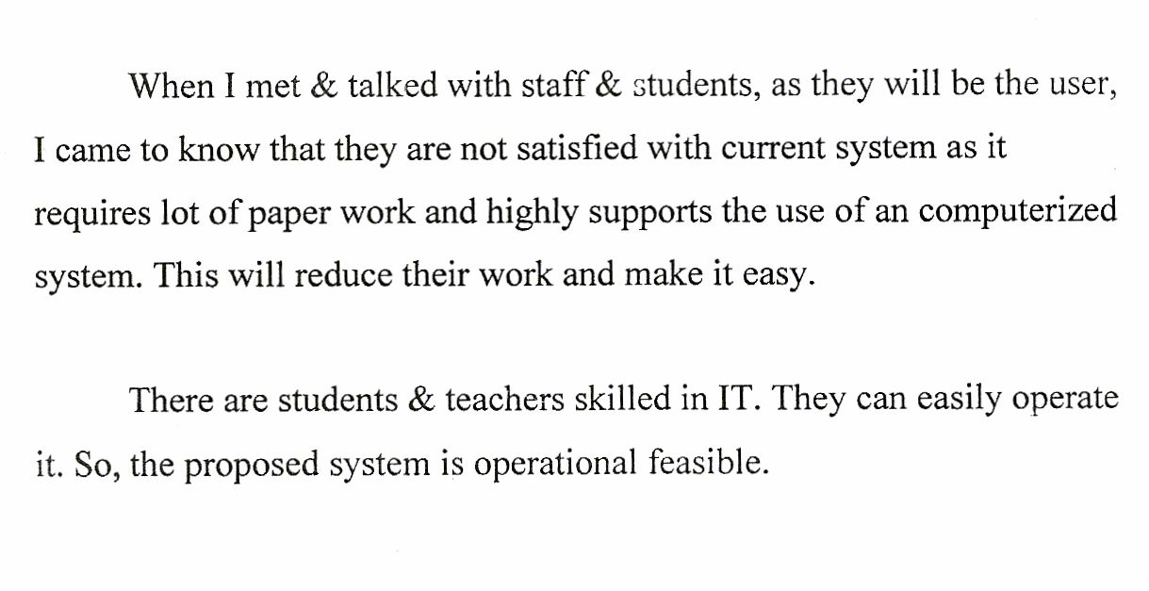
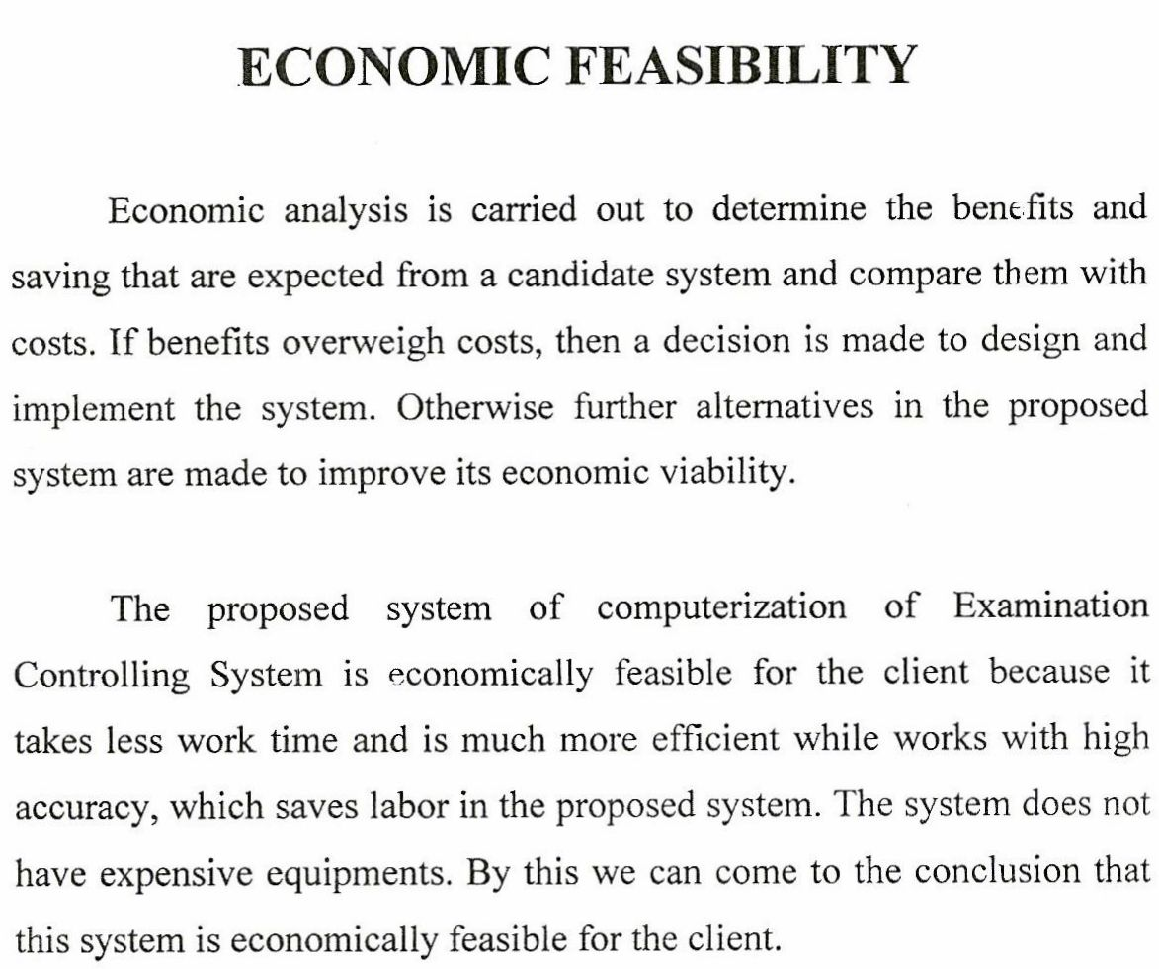

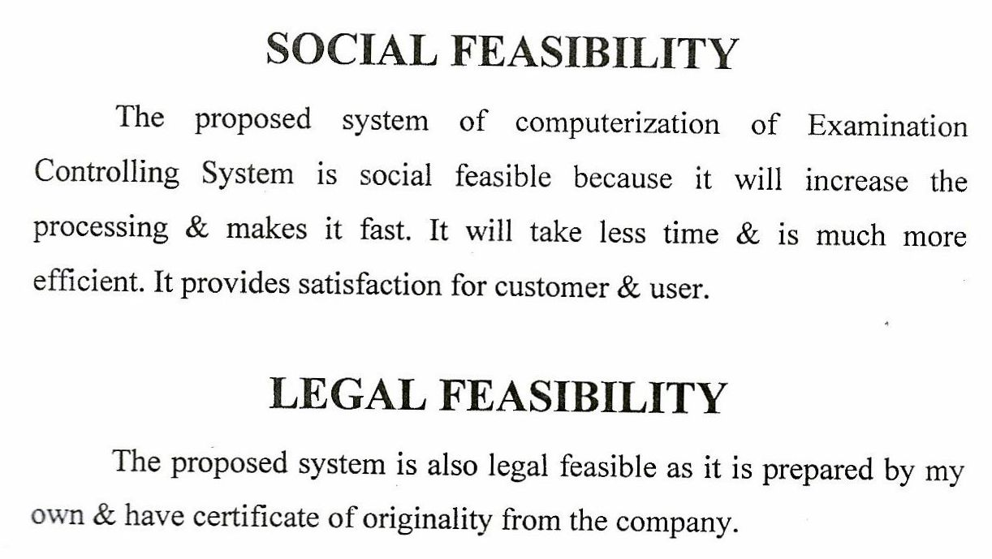

CERTIFICATE

This is certifying that Mohd Arshi, Mudassir Islam, Nishtha Dutta and Manish Rai have successfully completed their mini project report “ATM MANAGEMENT SYSTEM” under the guidance of Mr. Vijay Dwivedi.

Examiner’s Signature: Teacher In-Charge:

--------------------------------------------- ----------------------------------------------
Dated:
----------------------------------
Team Members:-

Nishtha dutta (0800818120) -Group Leader
Mudassir Islam (0800818108)
Mohd arshi (0800818101)
Manish rai (0800818098)

