**OUTPUTS**

**APPROACH 1: PYTHON**



Original point cloud Outliers (objects) Inliers (final output)

**APPROACH 2: MATLAB**

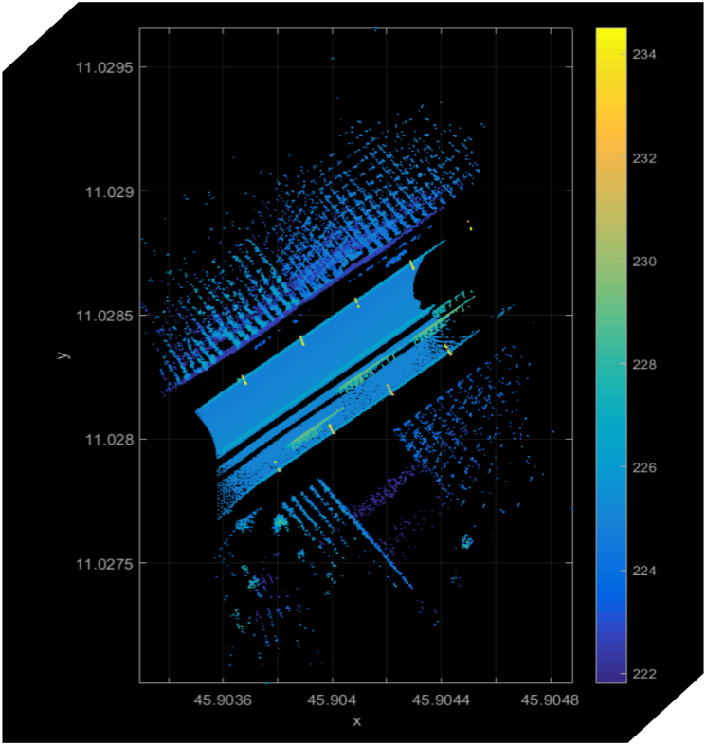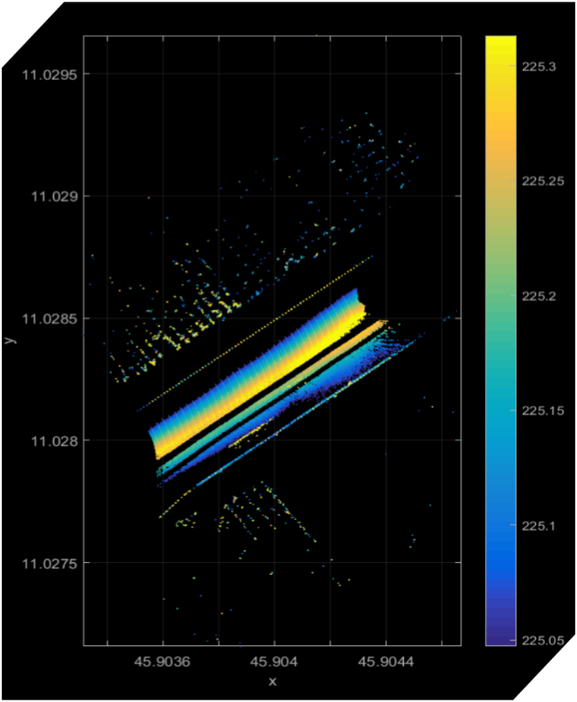

Original point cloud Inliers (final output)