## Front End Engineering-II

Project Report

Semester-IV (Batch-2022)

**AdoptADoggo**

**Supervised By: Submitted By:**

Ms. Parul Gahelot **Nishtha Tandon, 2210990621**

Khushi Gupta, 2210990512

Kashvi Sharma, 22109904

Keshav Wadhwa, 2210990506

(Group 7)

**Department of Computer Science and Engineering**

**Chitkara University Institute of Engineering & Technology,**

**Chitkara University, Punjab**

## Table of Contents

|  |  |  |
| --- | --- | --- |
| S.No. | Title | Page no. |
| 1. | **Introduction**  1.1 Background of the Project  1.2 Objectives  1.3 Significance | 2-4 |
| 2. | **Problem Definition and Requirements**  2.1 Problem Definition  2.2 Software Requirements  2.3 Hardware Requirements | 5-6 |
| 3. | **Proposed Design / Methodology**  3.1 Flowchart  3.2 Technologies Used | 7-11 |
| 4. | **Results**  4.1 Home Page  4.2 Pet Shop  4.3 Services  4.4 Contact Us | 12-17 |
| 5. | **Refrences** | 18 |

## 

## ABSTRACT

This project focuses on enhancing the dog adoption experience by providing an online platform where prospective adopters can choose dogs based on various breeds. The aim is to streamline the adoption process, making it easier for individuals to find their ideal canine companions while supporting animal shelters in reducing the number of homeless dogs. Our platform allows users to search and filter available dogs by breed, size, age, and temperament, ensuring a better match between adopters and dogs.

The project highlights the benefits of breed-specific adoption searches, addressing the unique needs and preferences of both dogs and adopters. Through this initiative, we aim to increase adoption rates, reduce shelter overcrowding, and promote responsible pet ownership. The report details the design and implementation of the platform, user feedback, and the overall impact on adoption rates. We also provide recommendations for future improvements and expansions, with the goal of continuously enhancing the adoption process and supporting the well-being of both dogs and their new families.

By leveraging technology to facilitate more personalized and efficient adoptions, our project underscores the importance of adopting pets and the positive outcomes for communities and animal welfare organizations.

**INTRODUCTION**

The “AdoptADoggo” website is an innovative digital platform designed to streamline the dog adoption process, making it easier for potential adopters to connect with animal shelters and rescue organizations. The primary objective of “AdoptADoggo” is to increase the adoption rates of dogs by providing a user-friendly, informative, and engaging online experience. The platform caters to individuals and families looking to adopt a dog, as well as animal shelters and rescue groups that need a robust tool to list and manage dog profile. “AdoptADoggo” offers an array of features designed to enhance the adoption journey. Users can search for dogs based on various criteria such as breed, size, age, and location, and access detailed profiles that include photos, descriptions, and health information. The website also provides a streamlined adoption process, guiding users through application submission and follow-up stages, ensuring a smooth and transparent experience. “AdoptADoggo” not only facilitates the adoption process but also fosters a community of dog lovers through blogs, forums, and success stories. Social media integration further extends the platform's reach, encouraging user engagement and broader awareness. By leveraging technology and a user-centered design, “AdoptADoggo” aims to make a significant impact in the realm of dog adoption, supporting shelters, rescuers, and adopters in finding the perfect match.

* 1. **BACKGROUND OF THE PROJECT:**

The “AdoptADoggo” project was conceived in response to the growing need for an efficient and user-friendly platform that connects prospective dog adopters with animal shelters and rescue organizations. Traditional methods of dog adoption often involve cumbersome processes, limited visibility for shelters, and inadequate information for adopters, leading to lower adoption rates and prolonged stays for dogs in shelters.

Recognizing these challenges, the “AdoptADoggo” project aims to leverage modern web technologies to transform the adoption experience. The project was initiated by a team of developers, designers, and animal welfare advocates who observed the potential of a centralized online platform to bridge the gap between shelters and potential adopters. With an increasing number of people turning to the internet for solutions, there was a clear opportunity to create a comprehensive digital solution that could streamline and enhance the adoption process.

* 1. **OBJECTIVES**

**1. Increase Adoption Rates: The project aims to boost adoption rates by creating a user-friendly online platform that connects potential adopters with available dogs from shelters and rescues, increasing visibility and accessibility.**

**2. Enhance User Experience: “ AdoptADoggo” focuses on delivering an exceptional user experience through intuitive design and seamless navigation, ensuring that users feel engaged and empowered to find their perfect canine companion.**

**3. Streamline the Adoption Process: “AdoptADoggo” will simplify the adoption process with a user-friendly interface guiding users through application submission, scheduling meet-and-greets, and completing necessary paperwork, facilitating quicker adoptions.**

**4. Support Shelters and Rescues: Shelters and rescues will benefit from tools and resources for managing dog listings, updating information, and communicating with potential adopters, improving efficiency and outreach.**

**5.Foster Community Engagement: “AdoptADoggo” will promote community engagement through features like blogs, forums, and social media integration, encouraging sharing of adoption stories, advice, and support among users.**

**SIGNIFICANCE**

**1. Saving Lives: Dog adoption websites play a crucial role in saving the lives of countless dogs by providing them with an opportunity to find loving and permanent homes. By connecting shelters and rescues with potential adopters, these platforms help reduce overcrowding in shelters and prevent euthanasia of healthy animals.**

**2. Promoting Responsible Pet Ownership: Adoption websites emphasize the importance of responsible pet ownership by providing resources and information to potential adopters. This includes educational materials on dog care, training, and behavior, helping ensure that dogs are placed in homes where they will receive proper care and attention.**

**3. Matching Dogs with Compatible Families: These websites facilitate the matching process by allowing potential adopters to search for dogs based on specific criteria such as breed, size, age, and temperament. This helps ensure that dogs are placed in homes where they will thrive and be compatible with their new families' lifestyles and preferences.**

**4. Supporting Shelters and Rescues: Dog adoption websites provide valuable support to shelters and rescues by increasing the visibility of their available animals and helping them reach a wider audience of potential adopters. This can lead to more adoptions, increased donations, and greater community engagement, ultimately enhancing the organization's ability to care for animals in need.**

**5. Reducing Overpopulation: By facilitating adoptions and promoting spaying and neutering, adoption websites contribute to reducing pet overpopulation. By encouraging individuals to adopt from shelters rather than buying from breeders or pet stores, these platforms help alleviate the burden on animal welfare organizations and reduce the number of homeless animals.**

**6. Building Community: Adoption websites often foster a sense of community among adopters, volunteers, and animal welfare advocates. Through features such as forums, blogs, and social media integration, these platforms provide a space for sharing adoption stories, seeking advice and support, and advocating for animal welfare issues, creating a supportive and engaged community dedicated to helping animals in need.**

**2. PROBLEM DEFINITION AND REQUIREMENTS**

**2.1 PROBLEM DEFINITION:**

**Despite the abundance of dogs in animal shelters and rescues, many potential adopters struggle to find the right canine companion due to fragmented adoption processes, limited visibility of available dogs, and lack of comprehensive information. Additionally, shelters and rescues face challenges in efficiently managing their dog listings and reaching a broad audience of potential adopters. This disconnect between adopters and available dogs results in prolonged shelter stays for animals and missed opportunities for loving homes.**

**The problem statement for “AdoptADoggo” is to address these challenges by creating a centralized online platform that streamlines the dog adoption process, enhances visibility of adoptable dogs, and provides comprehensive information to potential adopters. By bridging the gap between adopters and shelters/rescues “AdoptADoggo” aims to increase adoption rates, reduce overcrowding in shelters, and promote responsible pet ownership.**

**2.2 SOFTWARE REQUIREMENTS:**

**Software Requirements specifies the logical characteristics of each interface and software components of the system. The following are some software requirements:**

**1. HTML, CSS, JavaScript, and React: The project will be implemented using these technologies, providing a robust and dynamic front-end interface for user interaction and engagement.**

**2. Code Editor:**  **Visual Studio Code (VSCode): A versatile and widely-used code editor that supports HTML, CSS, JavaScript, and React development, offering features such as syntax highlighting, code completion, and debugging capabilities.**

**3. Front-end Libraries and Frameworks:**

# • **React: A popular JavaScript library for building user interfaces, facilitating the creation of interactive and responsive web applications.**

# • **Bootstrap: A front-end framework for building responsive and mobile-first websites, providing pre-designed components and layouts for rapid development.**

# • **Styled-components: For styling React components with dynamic and scoped CSS.**

**4. Version Control System:**

# • **Git: A distributed version control system widely used for tracking changes in source code and collaborating on projects. Git provides features such as branching, merging, and version history tracking, ensuring efficient code management and collaboration among team members.**

**5. Package Manager:**

# • **npm (Node Package Manager): A package manager for JavaScript, used for installing, managing, and updating dependencies required for the project. npm facilitates the integration of third-party libraries and tools, enhancing the development process and productivity.**

**By leveraging these software requirements, the project aims to deliver a modern and feature-rich web application that meets the needs and expectations of users, while ensuring maintainability, scalability, and efficiency in development and deployment processes.**

**2.3 HARDWARE REQUIREMENTS:**

Hardware interfaces specify the logical characteristics of each interface between the software product and the hardware components of the system. The following are some hardware requirements.

• System : Intel Core i5.

• Hard Disk : 1 TB.

• Monitor : 15 ’’LED

• Input Devices : Keyboard, Mouse

• Ram : 4 GB

**3. METHODOLOGY**

**3.1 FLOWCHART:**

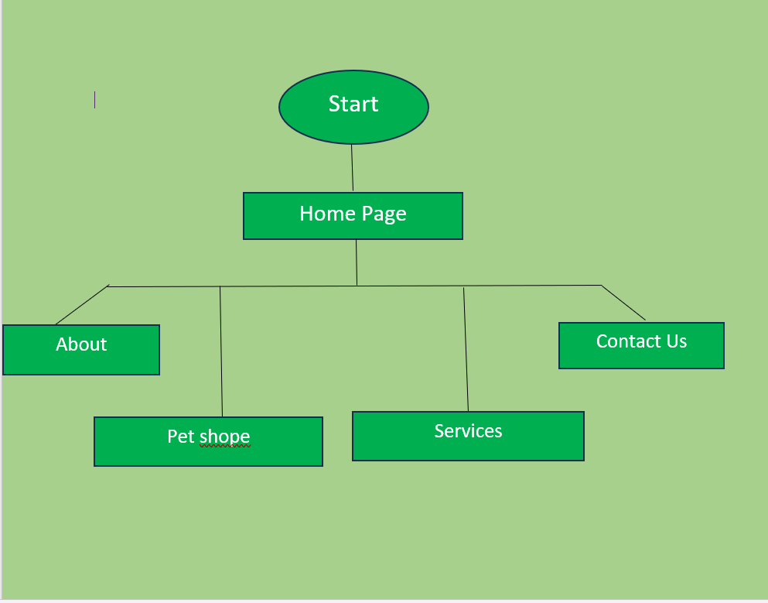

Certainly! Here's an explanation of the flowchart for the AdoptADoggo website:

1. **Homepage**:
   * The starting point for users when they land on the AdoptADoggo website.
   * Offers a central hub for users to navigate to different sections of the website.
2. **Options**:
   * Users are presented with four main options on the homepage: About, Find a Dog, Resources, and Contact Us.
   * Each option represents a different aspect of the website and serves specific purposes.
3. **About**:
   * Clicking on the "About" option takes users to the About Page.
   * Here, users can learn more about the mission, vision, and objectives of AdoptADoggo.
   * They can also find information about the team behind the website and its impact on dog adoption.
4. **Find a Dog**:
   * Selecting the "Find a Dog" option directs users to the Search Page.
   * This page enables users to search for adoptable dogs based on various criteria such as breed, size, age, and location.
   * Users can explore detailed profiles of dogs available for adoption and find their perfect match.
5. **Resources**:
   * Choosing the "Resources" option leads users to the Resources Page.
   * Here, users can access a wealth of resources and articles related to dog care, training, health, and adoption tips.
   * These resources aim to educate and support users throughout their adoption journey, providing valuable insights and advice.
6. **Contact Us**:
   * Clicking on the "Contact Us" option brings users to the Contact Us Page.
   * This page offers users various methods to get in touch with the AdoptADoggo team for assistance, support, or inquiries.
   * Users can find contact information such as email addresses, phone numbers, and a contact form for sending messages directly to the team.

This flowchart outlines the simple navigation structure of the AdoptADoggo website, guiding users to easily access information, search for dogs, explore resources, and get in touch with the team for support.

**3.2 TECHNOLOGIES USED:**

**1. REACT:**

React is a JavaScript library designed for creating interactive user interfaces, primarily for single-page applications. It revolves around a component-based architecture, where UIs are broken down into reusable and encapsulated components. React's virtual DOM efficiently updates only the necessary parts of the actual DOM, enhancing performance.

One of React's standout features is its declarative syntax, allowing developers to describe the desired UI state, leaving React to handle the underlying DOM updates. This simplifies development and enhances code maintainability.

Moreover, React promotes unidirectional data flow, making state management predictable and debugging easier. JSX, a JavaScript extension, enables the embedding of HTML-like syntax within JavaScript files, streamlining the creation of UI components.

In summary, React provides a robust framework for building modern web applications, emphasizing component reusability, performance optimization, and a straightforward approach to UI development.



Here are some of the commands of react js that we have used in this project:

**1. npx create-react-app my-app:** This command is used to create a new React application with a predefined project structure. npx is a tool that allows you to execute npm packages without installing them globally. create-react-app is a package provided by Facebook that sets up a new React project for you. my-app is the name of the directory that will be created for your new React application.

**2. cd my-app:** After running the create-react-app command and specifying a name for your project (in this case, my-app), you need to navigate into the newly created project directory. cd stands for "change directory", and my-app is the name of the directory created by create-react-app. This command moves your terminal session into the project directory so that you can start working on your React application.

**3. code .:** This command opens the current directory in Visual Studio Code, assuming you have it installed and configured as your default code editor. code is a command-line tool provided by Visual Studio Code, and . represents the current directory. This command opens the project directory in Visual Studio Code, allowing you to edit the files and work on your React application using the code editor.

**4. npm run start:** This command is used to start the development server for your React application. In a typical React project setup, the start script is defined in the package.json file and is configured to run the development server provided by react-scripts. This server compiles your React code, starts a local web server, and opens your application in a web browser. You can then view and interact with your React application in real-time while making changes to the code.

**5. npm run build:** This command is used to build a production-ready bundle of your React application. When you're ready to deploy your application to a production environment, you use the build script to generate optimized and minified files for better performance and smaller file sizes. The output of the build script is typically a set of static files that can be served by a web server.

**6. npm run dev:** This command is not a standard script in React projects by default. However, it might be used in some projects as a custom script to start a development server or perform other development-related tasks. The exact behavior of the dev script would depend on how it's defined in the package.json file of the project.

**2. REACT ROUTER DOM:**

React Router DOM provides a set of components that enable declarative routing in React applications. These components allow you to define routes, nested routes, and handle navigation between different views. Some key components provided by

React Router DOM include:

**1. BrowserRouter:** This component is used to wrap the entire application and provides the routing context for all other routing components. It utilizes HTML5 history API for navigation and rendering the appropriate components based on the current URL.

**2. Route:** The Route component is used to define a route within the application. It renders a specific component when the URL matches the specified path. You can also use additional props like exact, path, and component to configure the behavior of the route.

**3. Switch:** The Switch component is used to render the first Route or Redirect that matches the current URL. It helps in rendering a single route exclusively.

**4. Link:** The Link component is used to create navigation links within the application. It renders an anchor tag (<a>) with an href attribute that updates the URL and triggers the appropriate route rendering when clicked.

**5. NavLink:** Similar to Link, NavLink is used to create navigation links. It provides additional styling capabilities by applying an active class name to the link when its to prop matches the current URL.

**4. RESULTS:**

In the presentation of the results, visual representations of "AdoptaDoggo" to showcase its interface and features.

**4.1 HOMEPAGE**

The homepage of “AdoptADoggo” welcomes visitors with a captivating visual layout designed to inspire and engage. A heartwarming dog image background featuring joyful interactions between dogs and their adopters sets a warm and inviting tone, instantly drawing users into the adoption experience.

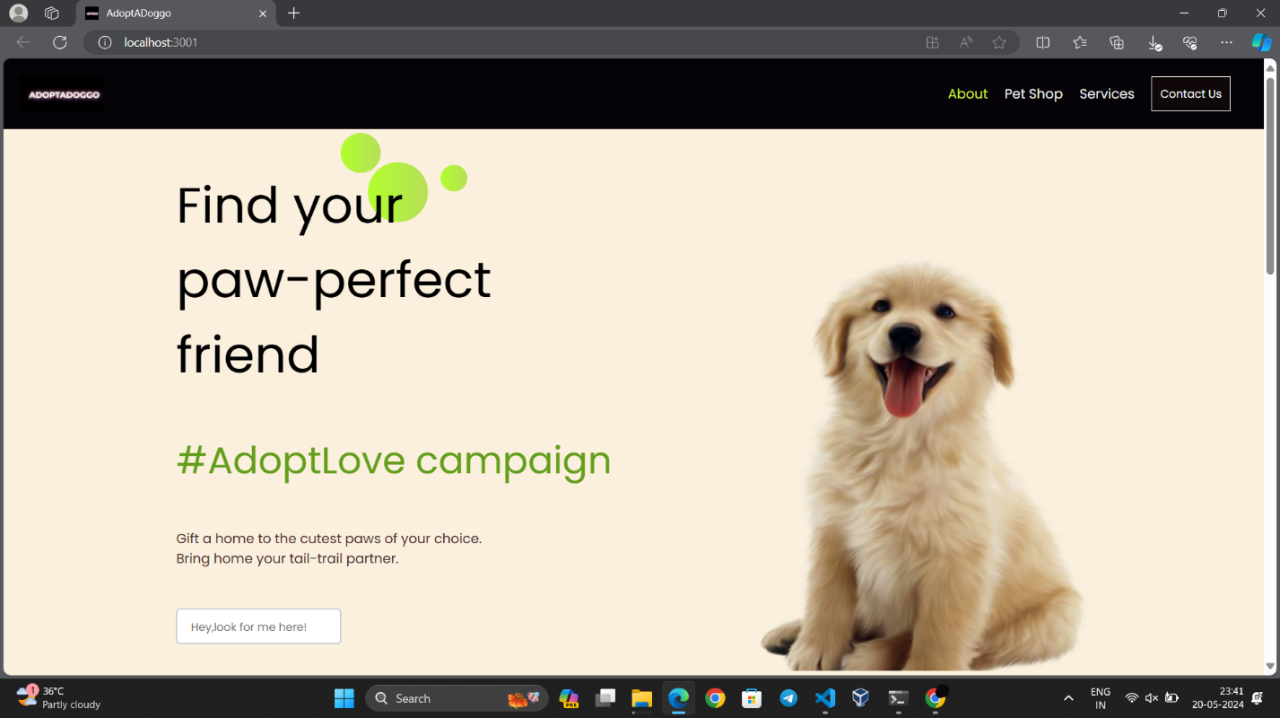

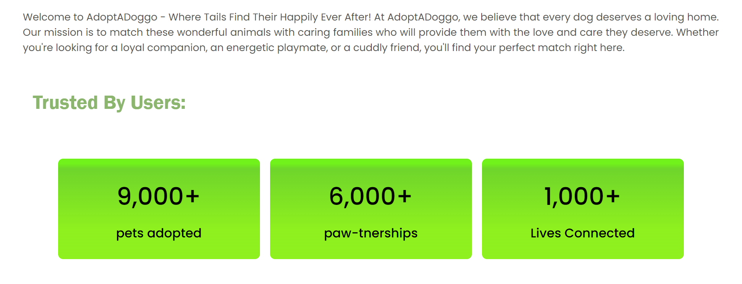

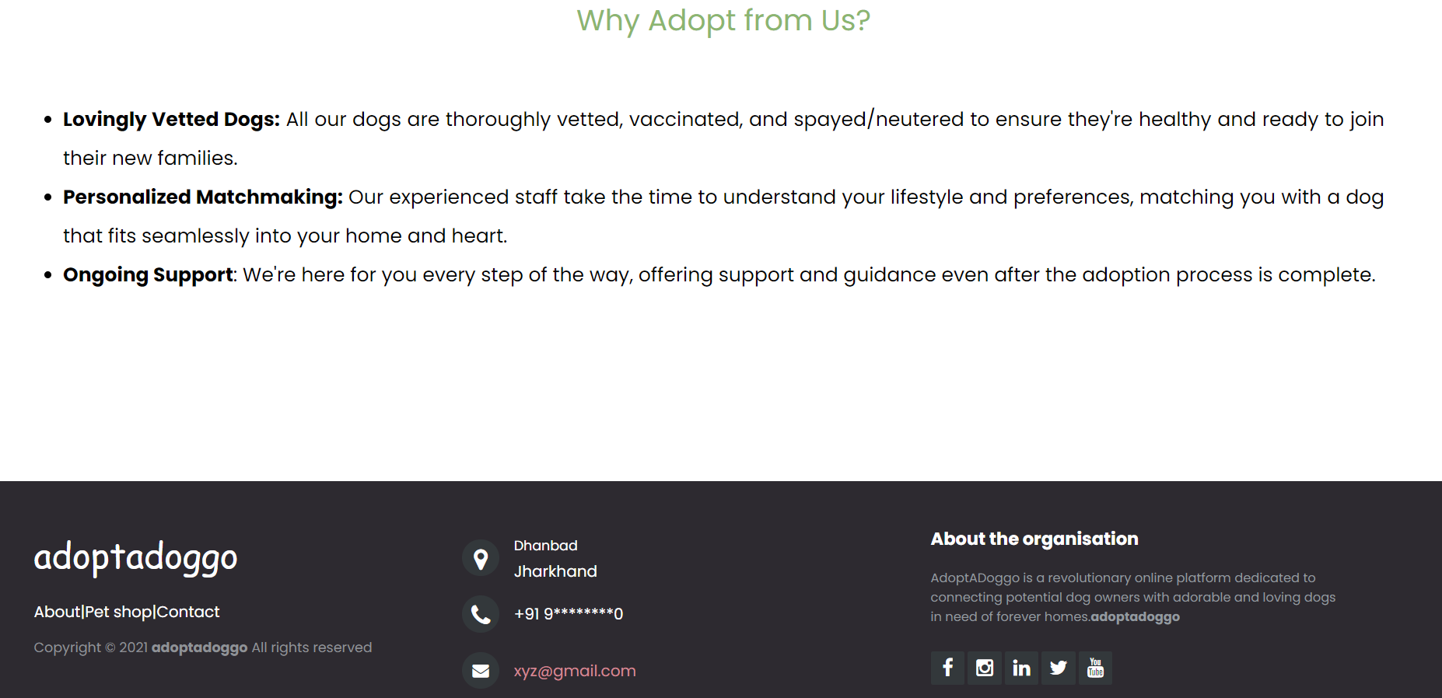

**Pet Shop**

**Welcome to our Pet Shop, where your search for the perfect canine companion begins! Our homepage showcases a diverse selection of dog breeds, each presented with stunning visuals to captivate your interest. With intuitive search and filtering options, finding your ideal furry friend is a breeze. Explore our website to discover more about our services, adoption process, and how we can assist you in welcoming a new member into your family.**

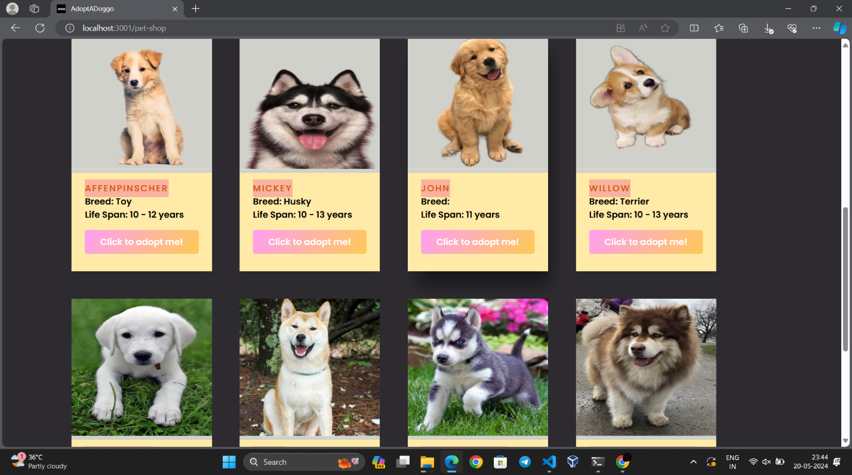

**When selecting a dog, an intuitive pop-up will guide you through the process, offering valuable insights and assistance every step of the way. Our goal is to ensure that you make an informed decision and find the perfect furry companion to enrich your life.**

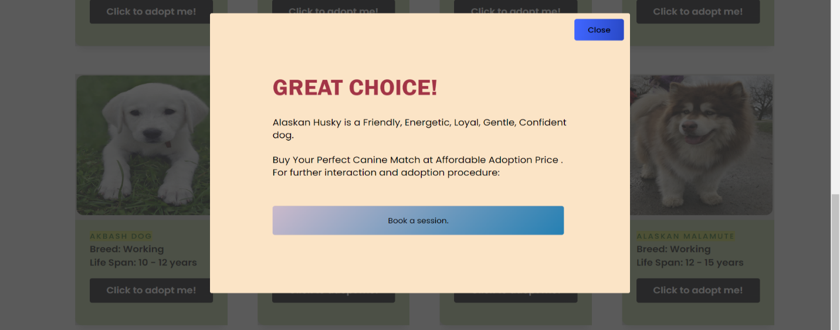

**4.3 Services**

We offer a personalized service dedicated to addressing all your inquiries and concerns, ensuring that every question you have about adopting a dog is met with expert guidance and support.

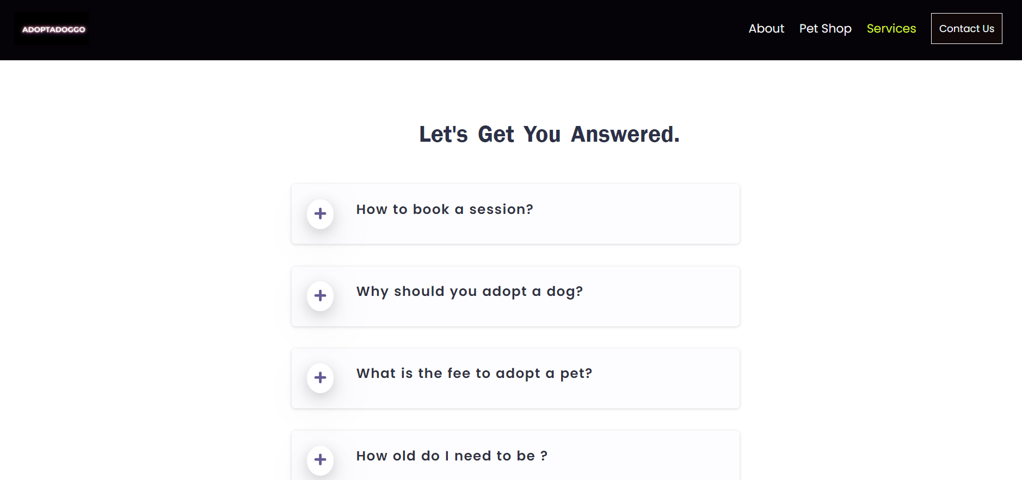

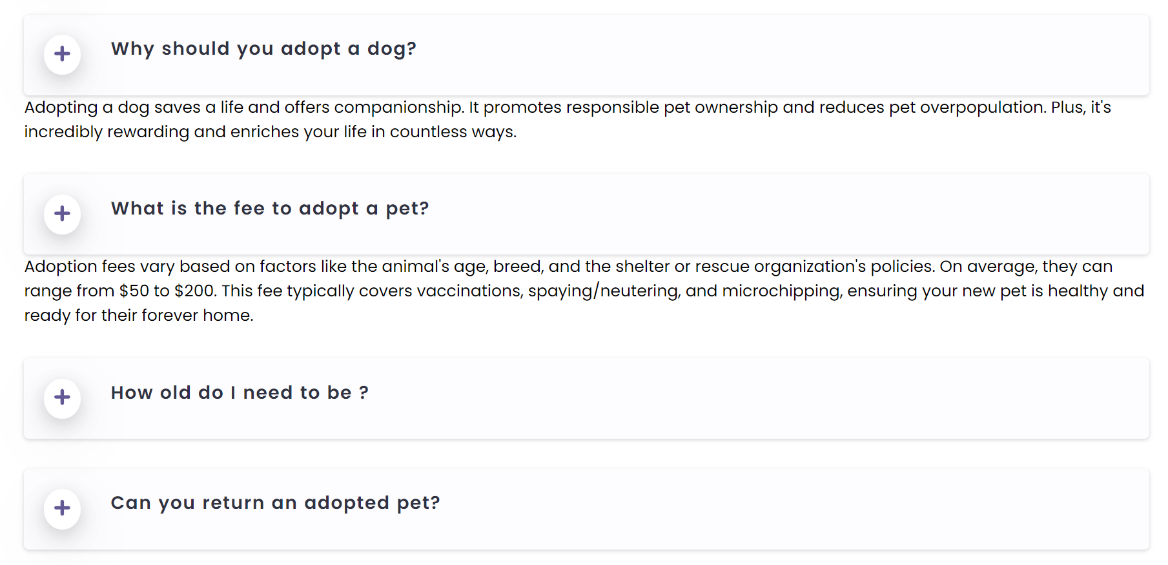

**4.4 Contact us**

Our contact page offers a flexible approach to communication, providing various avenues for reaching out to us. Whether you prefer to send us an email, give us a call, or fill out our convenient contact form, we're here to assist you every step of the way.

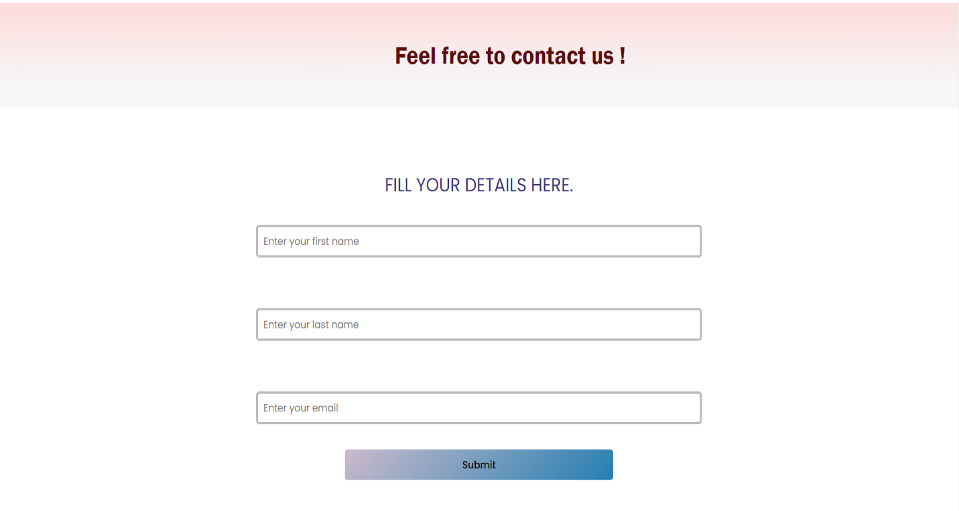

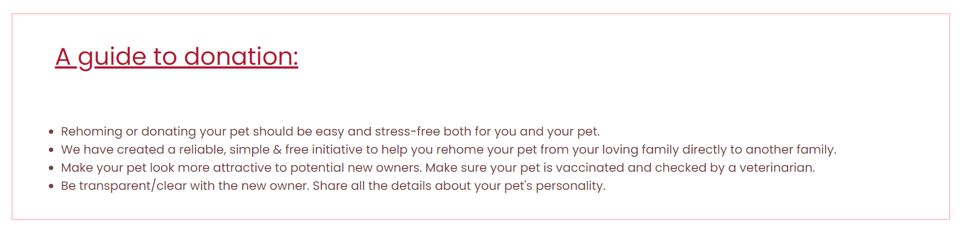

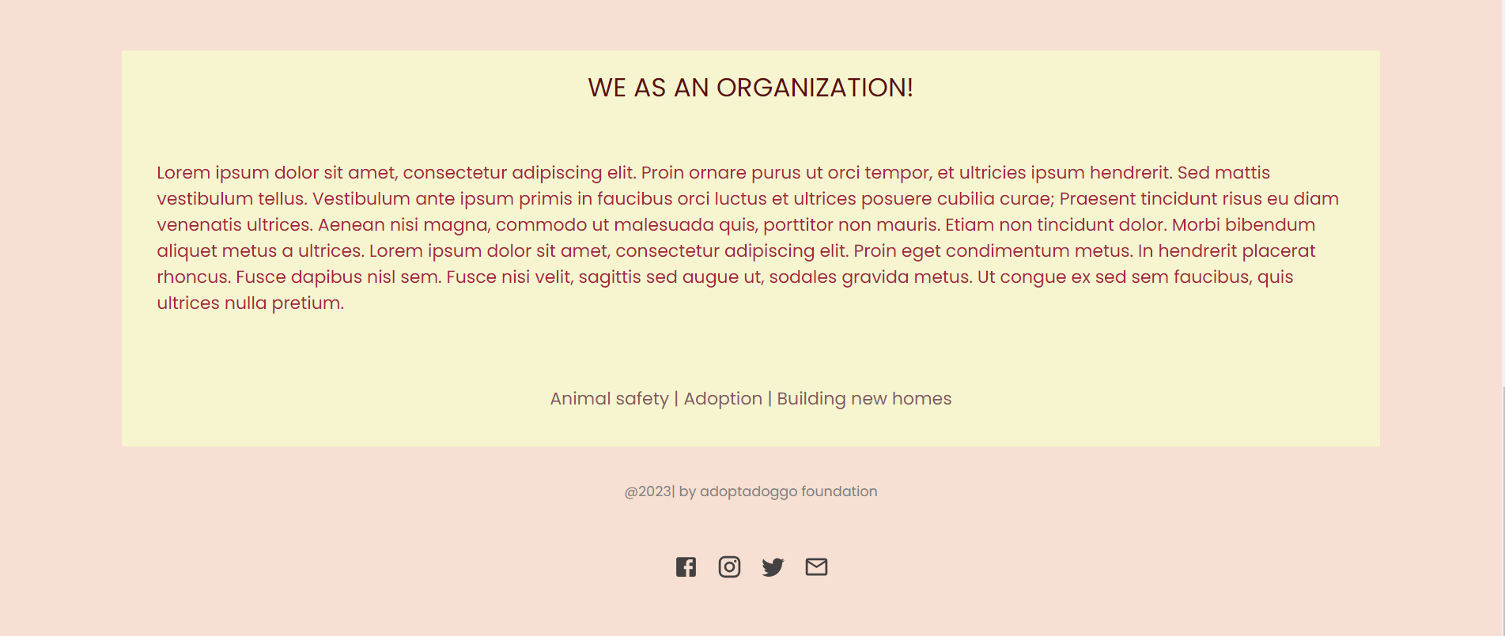

**4.7 REFERENCES**

* <https://www.mrnmrspet.com/dogs-for-adoption>
* <https://www.youtube.com/watch?v=Xe8CkYZvCig&t=4237s>

**Study Material:**

* [**www.w3schools.com**](http://www.w3schools.com)