AWS VPC Peering Project – Architecture and Implementation
AWS VPC peering enables private connectivity between two virtual networks. It creates a direct, bi‑directional link so that instances in either VPC can communicate as if they were on the same network. No VPN or gateway device is needed – VPC peering simply uses AWS’s backbone to route traffic. This keeps data on private IPs (never traversing the public internet) and even encrypts cross‑Region traffic, reducing exposure to exploits and DDoS attacks. Because there is no single point of failure or bandwidth bottleneck, peering is reliable, but it does not support transitive routing or overlapping CIDRs you must ensure each VPC has a unique IP range. For example, one VPC might use 10.0.0.0/16 and another 10.1.0.0/16 (with non-overlapping subnet ranges) to allow peering.

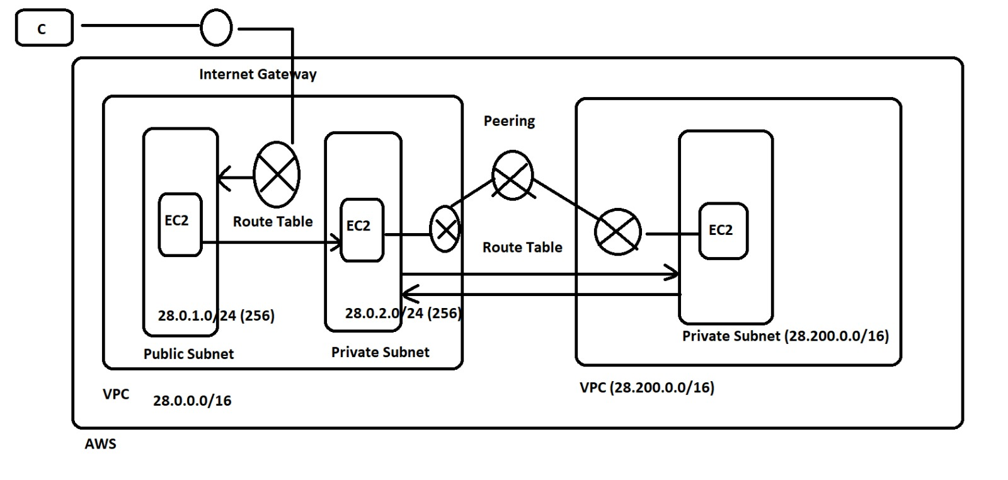 Figure: Example AWS VPC peering architecture. Two VPCs (left and right) are peered across accounts or regions. Each VPC has its own subnets and gateways; routes are added so that each VPC’s route table forwards the peer’s CIDR via the peering connection.
The diagram above illustrates a typical setup: two AWS accounts (or regions), each with one VPC that contains public and private subnets. Each VPC has an Internet Gateway (IGW) for internet access. To enable cross-VPC communication, a VPC Peering Connection is established between the VPCs, and each VPC’s route tables are updated. For example, if VPC A uses CIDR 10.0.0.0/16 and VPC B uses 10.1.0.0/16, then in VPC A’s route table you add a route for 10.1.0.0/16 pointing to the peering connection, and vice versa. This ensures that traffic for the peer network uses the peering link rather than an IGW or NAT. Note that public subnets still use an IGW for internet-bound traffic, while private subnets rely on the peering route or a NAT as needed.

Network Design and CIDR Allocation
In designing the network, define non-overlapping CIDR blocks for each VPC and their subnets. A common approach is:
- VPC1 (e.g. in us-east-1): CIDR 10.0.0.0/16
- Public Subnet (AZ-a): 10.0.1.0/24
- Private Subnet (AZ-a): 10.0.2.0/24
- VPC2 (e.g. in us-west-2): CIDR 10.1.0.0/16
- Public Subnet (AZ-a): 10.1.1.0/24
- Private Subnet (AZ-a): 10.1.2.0/24
These blocks must not overlap. AWS imposes a hard rule: “When using VPC Peering to connect two VPCs, the VPC range cannot overlap”. Overlap would confuse routing (traffic wouldn’t know which VPC to go to), so always plan unique ranges. You can also add secondary CIDRs if needed, but avoid any overlap across the peered networks. Each subnet CIDR is a subset of its VPC’s CIDR, ensuring full coverage of the VPC.

Routing and Gateways
Properly updating route tables is critical. By default, each VPC has a “main” route table; you can create additional route tables for public/private segmentation. Routes control where packets go: each route has a destination CIDR and a target (IGW, NAT, VPC peer, etc).
Peering routes: In each private subnet’s route table, add a route for the peer VPC’s CIDR via the VPC Peering Connection. For instance, in VPC1’s private route table add destination 10.1.0.0/16 → vpc-peering-connection-id. In VPC2’s private route table add 10.0.0.0/16 → vpc-peering-connection-id. This directs inter‑VPC traffic over the peering link.
- Internet routes: For public subnets, include a route to 0.0.0.0/0 via the IGW to allow internet access. Private subnets can route internet-bound traffic via a NAT Gateway (if they need internet) or leave it internal. Remember VPC peering does not support internet transit: you cannot route VPC1’s internet traffic through VPC2 (or vice versa) via a peering connection. Each VPC must have its own IGW or NAT for internet.
- No gateway needed for the peer link: Unlike VPN connections, a VPC peering uses no virtual appliances. The peering simply attaches to your VPCs; AWS handles it internally. This means there is “no single point of failure or bandwidth bottleneck”.
In summary, configure route tables so that each subnet’s routing table sends peer-VPC traffic over the peering connection. For example:
# Example route table entries
VPC1_Private_RouteTable:
- Destination: 10.1.0.0/16, Target: vpc-peering-connection-01234567
VPC2_Private_RouteTable:
- Destination: 10.0.0.0/16, Target: vpc-peering-connection-01234567
This aligns with AWS guidance: “Use route tables to specify which networks your VPC can communicate with, such as other VPCs. Each route specifies a destination (CIDR) and a target (such as a VPC peering connection…)”. After updating routes, instances can reach each other’s private IPs directly.

Terraform Implementation
We implement this design using Terraform. The Terraform project should include modules or configuration for:
- VPC creation: Define two VPCs with their CIDRs and tags.
- Subnets: Create subnets in each VPC (public/private) across availability zones.
- IGWs and NAT: Attach an Internet Gateway to each VPC; create NAT Gateways for private subnets if needed.
- Route Tables: Create route tables for public and private subnets and associate them.
- VPC Peering: Use aws_vpc_peering_connection resources to peer VPC1 and VPC2.
- Routes for Peering: Use aws_route to add cross-VPC routes in each private route table.
- Security Groups: Define security groups for EC2 instances allowing necessary ports (e.g. SSH, ICMP) from the peer network.
These Terraform resources implement the peering connection and update each VPC’s route table as recommended. You can organise this into modules (e.g. a vpc module and a peering module) for reuse. Note that community modules exist (for example, Cloud Posse’s terraform-aws-vpc-peering module) which handle much of this setup. When writing your code, follow Terraform best practices such as locking provider versions, using remote state (e.g. S3 backend), and formatting consistently.

Setup Steps (README excerpt)
- Install Prerequisites: Terraform CLI and AWS CLI. Configure AWS credentials (via aws configure or environment variables) with access to both AWS accounts or regions.
- Initialize Project: Clone the GitHub repo, navigate to the Terraform directory, and run terraform init to initialize modules and backend.
- Plan: Run terraform plan to review changes. You should see two VPCs being created, with subnets and the peering connection.
- Apply: Execute terraform apply to provision resources. Confirm when prompted.
- Verification: After apply, check AWS Console or CLI to ensure both VPCs exist, the peering status is active, and each private subnet’s route table has the peer route.
For example, one student project used this exact flow: “In this mini project, I implemented AWS VPC Peering using Terraform… I worked on: creating two VPCs (multi-region setup), subnets, route tables… establishing a VPC Peering Connection… [and] testing connectivity between resources using private IPs”.

Testing Connectivity
To test the setup, launch one EC2 instance in a private subnet of VPC1 and another in a private subnet of VPC2 (use a common SSH key or user data for access). Ensure the instances’ security groups allow ICMP (ping) or the desired protocol between the VPCs. Then:
- Ping/SSH by Private IP: From the VPC1 instance, ping the private IP of the VPC2 instance. If peering and routes are correct, the ping should succeed. Likewise, test from VPC2 to VPC1.
- Check VPC Peering Status: Use AWS Console or aws ec2 describe-vpc-peering-connections to confirm the peering connection is active.
- Route Table Audit: Verify that each relevant route table has a route to the other VPC’s CIDR via the peering connection.
- Failover Testing: (Optional) If in different regions, ensure that inter-region latency is reasonable, and that traffic is indeed staying on AWS’s backbone. According to AWS, “all inter-Region traffic is encrypted before leaving AWS facilities”, ensuring security and reliability.
Document in the README how you ran these tests (for example, using ssh and ping, or AWS CLI commands), and record the expected output (such as successful pings). Mention common troubleshooting: if ping fails, check security group rules and route configurations. The AWS VPC peering guide notes that misconfigured routes or overlapping CIDRs are common pitfalls.

Security Considerations
- Unique CIDRs: As noted, use non-overlapping CIDR blocks for peered VPCs. AWS enforces this to prevent routing ambiguity.
- Restrict Traffic with Security Groups: By default, security groups are isolated by VPC. Ensure you update security group rules to allow only necessary traffic across the peering link (e.g. allow ICMP or specific TCP ports from the peer’s CIDR).
- No Transitive Routing: Remember that peering is a direct link; it does not act like a central hub or VPN. Only the two VPCs can see each other. If you have more VPCs, each pair needs its own peering (or use Transit Gateway for many-to-many connectivity).
- Monitoring and Logging: Enable VPC Flow Logs on both VPCs to capture traffic flow. This helps audit and debug cross-VPC communications.
- Transit Gateway as Alternative: If you anticipate many VPCs or dynamic routing, consider AWS Transit Gateway instead – it scales better. But for simple dual-VPC setups, peering is cost-effective (no peering connection charges) and straightforward.
- Least Privilege IAM: Ensure the Terraform setup user/role has only the necessary permissions (e.g. ec2:CreateVpcPeeringConnection, ec2:CreateRoute, etc). Avoid using overly broad permissions.
Lastly, note that data transfer across a peering connection has costs: while creating the connection is free, transferring data between Availability Zones or Regions incurs standard AWS data transfer fees. Include a note about this in the README’s cost considerations.

Summary of Key References
- AWS official docs explain that VPC peering provides private IPv4/IPv6 routing between VPCs (same or different accounts/regions), with no gateway needed, but with limitations (no transitive peering, no overlapping CIDRs).
- Route tables direct which networks your VPC can reach; to use peering, add a route whose target is the peering connection.
- Network design should avoid overlapping CIDRs (as one Q&A succinctly states: “the VPC range cannot overlap”).
- A sample Terraform project (from a community post) demonstrates the process: create VPCs, subnets, peer them, update route tables, and test connectivity.
By following these guidelines and citing AWS’s documentation, the project README will provide a comprehensive walkthrough—from architecture diagram and CIDR table to Terraform modules, testing, and security measures. The final GitHub repository should include the architecture diagram image, Terraform code, and step-by-step documentation as outlined above, making it easy for others to understand and replicate the multi-VPC setup.
Sources: AWS VPC Peering documentation, AWS VPC Route Tables guide, AWS Prescriptive Guidance on peering, Terraform community examples, and Q&A on VPC overlapping CIDRs.

