AirAware
COMPLETE PROJECT CONCEPT & IMPLEMENTATION MAP
Personal air-quality planning, a What-If Simulator, and an adaptive Impact Loop
Version 1.0 | 10 October 2026 | Working product specification
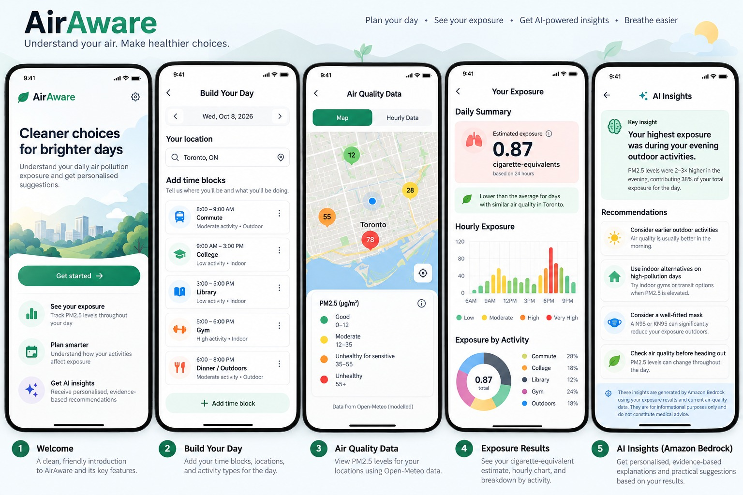
Visual reference supplied by the project team. The city, readings and cigarette-equivalent number shown in the mockup are illustrative placeholders, not live data.
The product in one sentence
AirAware helps users plan their day in the morning, receive updated suggestions whenever their schedule changes, explore alternatives with a What-If Simulator, and review an end-of-day cigarette-equivalent estimate alongside the data and assumptions behind it.

1. Executive Summary
AirAware is an AI-assisted air-quality planning application. It connects a user’s daily schedule to available outdoor pollution estimates, translates those estimates into understandable insights, and supports practical schedule changes throughout the day.
The product is designed around a repeating daily loop rather than a one-time report. The user creates a plan in the morning; AirAware evaluates it and offers suggestions; edits and new time blocks trigger refreshed analysis for the remaining day; the user can simulate alternatives before accepting them; and an end-of-day report summarises the day, including the planned cigarette-equivalent communication metric.

Core product promise
Plan → Understand → Adjust → Learn
AirAware does not simply show an AQI reading. It connects available environmental data with the user’s schedule, helps them test realistic alternatives, and adapts recommendations to the constraints they report.

The six product pillars
Pillar | Purpose
1. Build Your Day | Let users define activities, times, locations, duration and indoor/outdoor context.
2. Air-Quality Data | Retrieve available PM2.5 estimates for relevant locations and times; label model forecasts and station measurements clearly.
3. Calculation Engine | Calculate reproducible concentration-time estimates from supported activity blocks and explicit assumptions.
4. Adaptive Suggestions + AI Insights | Generate practical, rule-grounded recommendations; use Bedrock to explain—not invent—the evidence.
5. What-If Simulator | Compare feasible changes to the schedule using the same calculation methodology as the baseline.
6. Impact Loop + End-of-Day Report | Record decisions and follow-through, adapt to user constraints, and summarise the day with the intended cigarette-equivalent estimate and its caveats.

Product principles
- Schedule-aware: every insight must refer to the user’s current plan, not just generic air-quality advice.
- Continuously revisable: adding, moving or editing a time block triggers a fresh evaluation of the remaining schedule.
- Evidence-led: recommendations come from deterministic calculations and configured rules; AI explains the results.
- Constraint-aware: the app must not repeatedly recommend changes that conflict with fixed commitments.
- Honest about uncertainty: estimates are not presented as direct measurements of what the user inhaled.
- Privacy-first: no continuous GPS trail is required for the MVP.

2. The Daily User Journey
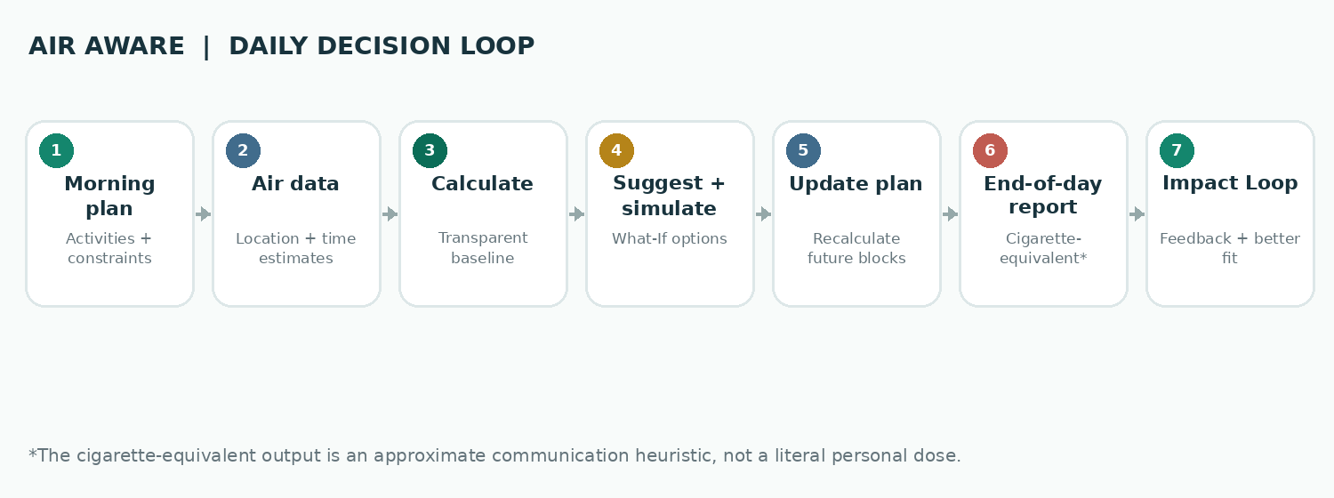
The daily workflow is the product’s backbone. Morning suggestions are a first pass; every user change creates an updated view of the day; the end-of-day report closes the loop.

Phase A — Morning planning
- The user opens AirAware and selects the date and their general location or enters locations manually.
- They add time blocks such as commute, college, work, exercise or outdoor errands. Each block includes start/end time, location, duration, activity type and indoor/outdoor context where known.
- The backend retrieves available air-quality estimates for relevant time blocks and records source metadata, timestamps and missing values.
- Python calculates a baseline estimate for supported parts of the schedule and identifies the largest contributors.
- AirAware presents initial suggestions before the day starts. Where useful, it provides two or three feasible alternatives rather than a long list of generic tips.

Phase B — Suggestions while the day evolves
- Whenever the user adds, edits, deletes, moves or resizes a time block, AirAware reruns the relevant calculations.
- The recommendation engine focuses on upcoming or still-changeable blocks. It must not suggest changing a past commute as though the user can still act on it.
- The What-If Simulator can compare alternatives before the user applies a change to their actual plan.
- The updated dashboard distinguishes completed/elapsed blocks, planned future blocks and a projected remainder-of-day estimate.
- If the environmental source updates materially, the application may refresh recommendations, but should avoid noisy or repetitive notifications.

Phase C — End-of-day closeout
- The day report summarises the available pollution estimates associated with supported activity blocks.
- The user sees a timeline, the largest estimated contributors, an activity breakdown and a daily cigarette-equivalent estimate produced using the documented conversion method selected by the project.
- The user can mark which suggestions they followed, modified or rejected and optionally explain why.
- AirAware records behavioural feedback separately from modelled environmental outcomes. The next day’s suggestions can reflect stated constraints and preferences.
Important state distinction
During the day, the product can show a provisional “so far + planned remainder” estimate. The end-of-day cigarette-equivalent card should be marked final only when the day is closed or the user explicitly generates the final report. Past blocks should not be silently rewritten when the user edits their future schedule.

3. Functional Modules

3.1 Build Your Day planner
The planner is the primary input surface. Its purpose is to provide enough schedule context for relevant estimates and suggestions without requiring intrusive tracking.
Field | Description / rule
Date | The calendar date being planned.
Activity | A human-readable label, e.g. commute, college, gym or outdoor walk.
Start and end time | Used to match time intervals and calculate duration. Overlaps should be flagged or resolved.
Location | Manual place selection or approximate location sufficient for the data provider. Exact home address should not be required.
Environment | Indoor, outdoor, mixed or unknown. The app must not assume indoor concentration equals outdoor concentration.
Flexibility | Fixed, movable within a window, or freely movable. This constrains simulator alternatives.
Optional activity context | Transport mode or activity intensity, if used by a documented calculation. Do not collect fields that are not used.

3.2 Air-quality data retrieval
Open-Meteo is the initial proposed source. The backend requests the relevant pollutant and time series. The UI must label the source and distinguish modelled forecasts from actual station observations wherever the data provider makes that distinction available.
- Store or return the pollutant name, unit, timestamp/time zone, source, data type and any data-quality flags alongside every estimate.
- Handle missing, stale or delayed responses explicitly. A missing value is not zero.
- Do not imply street-level accuracy merely because a user enters precise coordinates; confirm the source’s effective spatial and temporal resolution.
- Use a suitable fallback or an explicit unavailable state if the provider fails. Test fixtures used during development must be labelled as sample data.

3.3 Exposure calculation engine
Python owns the numerical truth. The module maps time-series estimates to supported activity blocks, integrates concentration over time, calculates totals and identifies the blocks that contribute most to the supported index.
Baseline concentration-time index: E = Σ(Cᵢ × Δtᵢ), where Cᵢ is an estimated ambient PM2.5 concentration in µg/m³ and Δtᵢ is the corresponding duration in hours. The result is an ambient concentration-time index in µg·h/m³, not inhaled mass or individual health risk.

3.4 Suggestion engine
Suggestions should be deterministic where possible and grounded in computed comparisons. Example rules include comparing a flexible outdoor activity across candidate times, prioritising future blocks that contribute most to the estimated index, and suppressing alternatives that violate the user’s constraints.
The engine should return the recommendation, the reason it was generated, the evidence used, the relevant time window, any trade-off, and a caveat when the difference is too uncertain to rank. Bedrock can make this explanation more natural but must not create the recommendation’s numerical basis.

4. What-If Simulator
The What-If Simulator is AirAware’s interactive decision layer. It lets the user explore realistic alternatives before modifying their actual schedule. It reuses the same calculation engine as the standard day analysis, ensuring the baseline and alternatives are compared consistently.

4.1 Example interactions
User asks / action | Simulator response
“What if I leave 30 minutes earlier?” | Retrieve estimates for the alternative commute window, check feasibility and compare the same duration or explain the changed duration.
“Can I move my outdoor workout?” | Compare available future time windows that preserve the workout duration and respect the user’s availability.
“What if I can’t change my commute?” | Lock the commute and search for alternatives in other flexible blocks.
“Are these two options meaningfully different?” | Compare the computed values and the source’s validated error characteristics; if the difference is not defensible, avoid a confident ranking.
“Apply this option to my day.” | Update the active plan, record which recommendation was applied and refresh all affected future calculations.

4.2 Scenario comparison logic
- Create a baseline snapshot of the current plan and its supporting data.
- Generate or accept two to three feasible alternative scenarios, respecting the user’s fixed and flexible constraints.
- Retrieve source data for all relevant times/locations, using the same provider and methodology whenever possible.
- Calculate each scenario with the shared Python calculation engine.
- Compare the baseline and alternatives. A positive difference indicates a lower calculated index under the stated assumptions; it does not establish a reduction in inhaled dose or health risk.
- Return the numerical comparison, assumptions, source/freshness information, trade-offs and a recommendation status: favoured, inconclusive or unavailable.

4.3 Metrics and guardrails
For a baseline Eᵦ and alternative Eₐ, the absolute difference can be expressed as ΔE = Eᵦ − Eₐ. A relative difference R = (Eᵦ − Eₐ) / Eᵦ × 100% is appropriate only when Eᵦ is positive and both scenarios represent comparable activities and durations.
No false precision
Do not label a small modelled difference as a proven cleaner route or meaningful exposure reduction. A confidence percentage must come from validated error analysis, not from a language model. If the source cannot distinguish two options reliably, AirAware should say so.

4.4 UI output for each scenario
- Proposed change and affected time block.
- Baseline and alternative concentration-time indices, with compatible units and durations.
- Estimated difference, if comparable.
- Practical trade-off: time, schedule conflict or any user-supplied constraint.
- Evidence type, source timestamp and limitations.
- Actions: apply option, edit it, compare another, or keep the original plan.

5. Impact Loop
The Impact Loop connects a recommendation to the user’s decision, follow-through and future preferences. The initial objective is to learn what is practical for the user—not to claim a verified health benefit.

5.1 The feedback cycle
Stage | What happens | What AirAware records
1. Recommendation | AirAware presents a proposed change or explains why it cannot rank alternatives. | Recommendation ID, baseline plan version, alternative, data reference and reason.
2. Decision | The user accepts, edits, rejects or keeps the original plan. | Choice and optional reason, such as fixed class hours or transport constraints.
3. Follow-through | After the relevant period, the user can mark whether they followed the change. | Self-reported complete, partial or not followed; optional note.
4. Outcome labelling | The application keeps evidence types distinct. | Behavioural report, modelled estimate, measured environmental data or unverified outcome.
5. Preference update | Rules adjust which suggestions are prioritised next time. | Explicit constraints and preference patterns, not hidden health inferences.
6. Progress summary | The user sees which suggestions were practical and how estimated scenarios compared. | Adoption/follow-through summaries and comparable modelled index differences.

5.2 What the Impact Loop learns
- Which time windows the user can realistically change.
- Whether commute timing is fixed or flexible.
- Which categories of suggestions are repeatedly rejected and the stated reasons.
- Whether the user wants fewer, more relevant suggestions rather than frequent generic notifications.
- Which planned changes were reported as completed, without claiming that the report proves a pollution or health improvement.

5.3 What it must not claim
- Accepting a recommendation is not proof that the user followed it.
- Following a recommendation is not proof that the user’s actual personal exposure decreased.
- A lower modelled concentration-time index is not equivalent to a verified reduction in inhaled pollutant mass or health risk.
- A sensor observation at a nearby station does not automatically verify a user’s personal exposure.

5.4 Lightweight MVP design
Start with a recommendation card containing “Apply”, “Modify”, and “Not feasible” actions. At the end of the day, ask whether the changed activity occurred. Store the answer and the reason, if supplied. Use simple transparent rules to adapt future suggestions. Machine learning is not required for the first version.

6. End-of-Day Exposure Report and Cigarette-Equivalent Metric
The end-of-day report is the final reflection point shown in the visual reference. It combines a daily summary, hourly chart, activity breakdown, key insight and cigarette-equivalent estimate.

6.1 Report contents
- Daily summary of the estimated ambient concentration-time for supported blocks.
- End-of-day cigarette-equivalent estimate, shown as an approximate educational comparison using an explicitly documented conversion method.
- Hourly timeline distinguishing available estimates and missing intervals.
- Activity contribution breakdown based only on activities included in the calculation.
- Highest-contributing supported time block and a natural-language explanation.
- Summary of What-If alternatives explored and which changes were actually reported as followed.
- Data source, timestamp, calculation coverage and limitations.

6.2 Cigarette-equivalent requirement
Keep the intended product experience, but make the methodology explicit
The product concept includes a cigarette-equivalent figure at the end of the day. Before implementing this number, the team must select, document and verify a specific published conversion method. Do not derive a personalised cigarette count by multiplying the concentration-time index by an arbitrary constant.

The interface should label the number as a rough PM2.5 cigarette-equivalent estimate or educational heuristic—not a literal number of cigarettes smoked, not an amount inhaled, and not a clinical measure of personal risk. Show an information tooltip explaining the underlying comparison and its assumptions. Display the concentration-time index or the underlying estimated PM2.5 information alongside it so the user can understand what was actually calculated.
If the team cannot establish a defensible conversion for the daily, time-weighted and location-dependent inputs used by AirAware, keep the cigarette-equivalent card disabled or explicitly marked as an experimental heuristic until the method is validated. This is a methodology gate, not a reason to hide the product’s intended UX from the concept.

6.3 End-of-day data coverage
The report must not silently treat missing time blocks as zero pollution or assume that indoor time has the same concentration as outdoor time. It should show what proportion of the planned day could be evaluated, list excluded/unknown blocks and make the data coverage visible. The cigarette-equivalent figure should not imply full-day certainty when coverage is incomplete.

7. AI Assistant: Responsibilities and Limits

What Amazon Bedrock does
- Explain why a supported time block contributes substantially to the calculated index.
- Summarise differences between a baseline and an already-computed scenario comparison.
- Turn deterministic suggestions into concise, understandable language.
- Explain data types, assumptions and missing information.
- Summarise user-reported preferences from the Impact Loop when those records are supplied.

What remains deterministic
- Exposure and concentration-time arithmetic.
- Scenario comparisons and relative differences.
- Feasibility checks against user constraints.
- Recommendation ranking and any evidence threshold.
- Cigarette-equivalent calculation after its methodology is approved.
- Impact Loop status and metrics.

Example prompts and required evidence
Question | Evidence needed before answering
“Why was my estimated value highest this morning?” | Calculated time-block results, valid timestamps, data source/type and calculation coverage.
“Would leaving 30 minutes earlier help?” | Source data for the alternative window, comparable duration assumptions and a completed scenario calculation.
“How has my plan changed today?” | Versioned schedule edits and activity blocks, with past and future states separated.
“Did my exposure go down this week?” | Comparable data coverage and validated calculations across the periods. If not available, describe modelled index differences rather than personal exposure reduction.
“Why did you not recommend an option?” | The rule result, data gap, error limitation or user constraint that prevented a defensible ranking.

AI fallback
If Bedrock is unavailable, the app should still calculate the estimates, simulate alternatives and show rule-based explanations. A language-model outage must not break the core product.

8. Technical Architecture
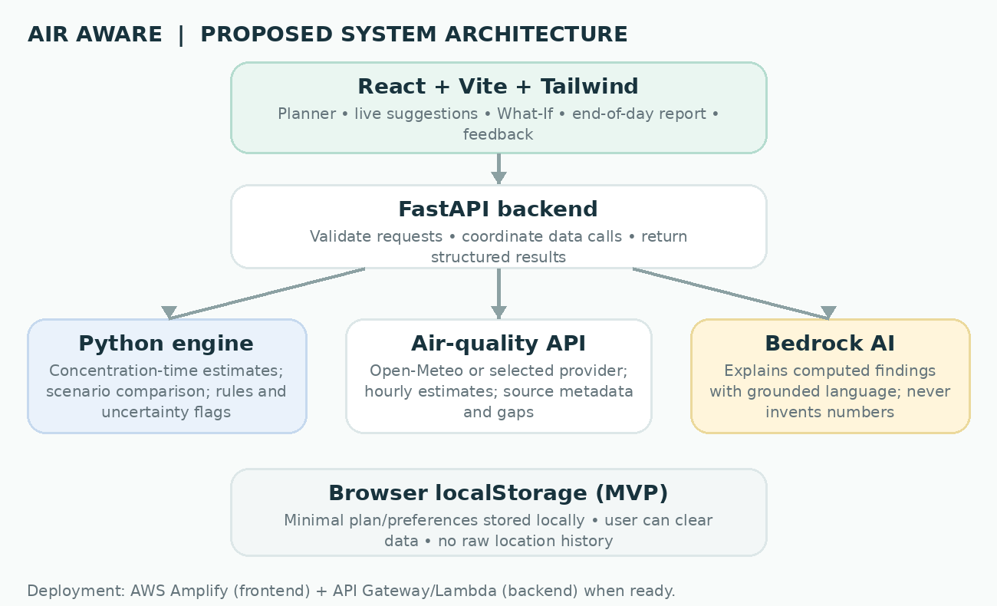
This architecture preserves the original stack while giving the new modules clear places in the system. The What-If Simulator reuses the Python calculation service; the Impact Loop adds feedback records and preference updates.

Technology responsibilities
Technology | Responsibility | Implementation note
React | Planner, dashboard, scenario comparison, live suggestion cards, report and feedback. | UI displays backend results; it should not be the source of truth for calculations.
Vite | Local dev server and production frontend build. | Development/build tool, not a runtime backend.
Tailwind CSS | Visual styling and responsive layout. | Reuse components to keep screens consistent.
FastAPI | HTTP endpoints, validation, orchestration and structured responses. | Keep the initial backend as one application rather than premature microservices.
Python | Calculation engine, scenario comparison, deterministic rules, metric logic. | Unit-test independently with fixed fixtures.
Open-Meteo | Initial external source for air-quality estimates. | Validate available resolution, units, freshness and provider limits.
Amazon Bedrock | Natural-language explanation. | Send only required summaries; never raw movement history by default.
localStorage | Minimal day plan and preference persistence for the prototype. | Browser-local, not a secure database or cloud backup.
AWS Lambda + API Gateway | Run backend functions and expose HTTPS endpoints after deployment configuration. | FastAPI requires a suitable adapter/integration to run on Lambda.
AWS Amplify | Host and deploy the frontend. | AWS deployment should be visible and working for the hackathon.

9. Suggested Data Model and Backend Operations
The first version can use a small set of JSON structures. The model below is conceptual; the implementation can simplify it as long as the core state and evidence distinctions are preserved.

9.1 Core records
Record | Key fields | Purpose
DayPlan | plan_id, date, location_reference, version, blocks[] | Current plan snapshot. Each edit increments the plan version.
TimeBlock | block_id, activity, start, end, place_reference, environment, flexibility, status | One scheduled activity. Status distinguishes planned, elapsed, completed and edited.
AirQualitySample | source, pollutant, value, unit, timestamp, data_type, coordinates/grid, quality_flags | A source value plus enough metadata to avoid losing its meaning.
AnalysisResult | plan_version, coverage, metric_name, total, block_contributions[], assumptions | Reproducible baseline calculation tied to a plan version.
Scenario | scenario_id, baseline_version, proposed_changes, calculated_result, tradeoffs, evidence_status | What-If comparison with the baseline and alternatives.
Recommendation | recommendation_id, scenario_id, reason, evidence_refs, status | Suggestion shown to the user and later evaluated in the Impact Loop.
Feedback | recommendation_id, decision, follow_through, reason, timestamp | User-reported outcome kept distinct from measured environmental results.
Preference | constraint_type, value, source=explicit_user_feedback | Minimal transparent personalisation inputs.

9.2 Logical backend operations
Operation | Expected behaviour
Analyse day plan | Validate blocks; resolve timestamps; retrieve needed data; return calculation, data coverage and contributing blocks.
Re-evaluate schedule | On add/edit/delete/move, increment plan version and recalculate affected current/future blocks.
Compare scenarios | Evaluate baseline and candidate plans using the shared calculation method.
Generate explanation | Send a structured summary to Bedrock and return grounded language with fallback handling.
Record recommendation feedback | Store accepted/modified/rejected and optional reasons; do not infer follow-through.
Close day / generate report | Create the end-of-day summary from supported blocks and selected cigarette-equivalent methodology.
Update preferences | Use explicit user constraints and repeated feedback to adjust suggestion ordering.

9.3 Event behaviour
A schedule change should create a new analysis snapshot rather than mutate the record of a prior calculation. This allows the application to distinguish what was known when an earlier suggestion was made from what the current plan now contains. A changed future schedule triggers new suggestions; elapsed blocks remain historical unless the user explicitly corrects the record.

10. Privacy, Reliability and Safety

Privacy by design
- Do not require background GPS tracking for the MVP.
- Offer manual location entry and use approximate locations where sufficient.
- Do not send a full location history to Bedrock; provide only the structured calculations and minimal context required to explain them.
- Do not include precise coordinates or personal schedules in routine logs.
- Use backend secrets management for provider credentials; never hardcode private credentials into React.
- Provide clear controls to edit and clear locally saved day plans and preferences.
- If cloud persistence is added later, define retention, access control, encryption and deletion behaviour explicitly.

Reliability safeguards
- Missing data is unknown, not zero.
- Forecasts and monitoring-station measurements are labelled distinctly.
- Stale data is not silently presented as current.
- The app can report “insufficient evidence to rank options.”
- An API outage does not cause fabricated values; it triggers a visible unavailable state or labelled development fixture.
- The cigarette-equivalent metric remains tied to a documented methodology and visible caveat.
- User-reported behaviour is not treated as measured exposure reduction.

Scientific boundaries
Concept | AirAware can say | AirAware must not claim without more evidence
Ambient concentration | A source estimates a pollutant concentration for a place/time. | That the value is measured exactly at the user’s position if it is modelled.
Concentration-time index | The estimate integrates supported ambient concentration values over time. | That it is the mass inhaled by the user.
Scenario comparison | One option has a lower calculated index under the same assumptions. | That the user’s health risk falls by the same percentage.
Indoor environment | The user marked the block indoor/mixed/unknown. | That outdoor PM2.5 equals indoor PM2.5.
Cigarette equivalent | A rough comparison derived using a documented published heuristic, if approved. | A literal count of cigarettes smoked or a clinical personal-dose measurement.
Impact Loop | The user reports accepting or following a suggestion. | That acceptance or follow-through proves reduced exposure or improved health.

11. MVP Scope, Build Order and Acceptance Criteria

MVP: include
- Morning planner with editable time blocks and location/activity context.
- Actual Open-Meteo data retrieval or a clearly marked fallback during development.
- Python calculation engine with tests and explicit data coverage.
- Initial suggestions after morning planning.
- Recalculation and refreshed suggestions on every meaningful add/edit/move/delete action.
- A What-If Simulator for two or three realistic alternatives.
- Bedrock explanation grounded in structured calculations, with a deterministic fallback.
- End-of-day report including the intended approximate cigarette-equivalent metric, subject to methodology review.
- Impact Loop actions and at least one follow-up asking whether the change occurred.
- Basic local persistence and an AWS-hosted working demo.

Defer
- Continuous background tracking and native mobile lifecycle work.
- Turn-by-turn navigation or full routing optimisation.
- Indoor pollution modelling without indoor inputs or measurements.
- Personal disease-risk scores or claims of verified health outcomes.
- Complex ML or autonomous agents without validated data and a clear benefit.
- Sensor ingestion that requires hardware procurement, calibration and field operations.
- Accounts and cross-device sync unless they are required by the demo.

Suggested implementation order
Phase | Deliverable | Exit condition
1. Calculation baseline | Python module with fixed input fixtures. | Arithmetic, units, time intervals and missing-data handling are tested.
2. Local backend | FastAPI day-plan analysis endpoint. | Valid JSON request returns deterministic structured output.
3. Real data | Open-Meteo integration. | Real response mapped to time blocks; errors and freshness handled.
4. Frontend | Planner and results dashboard. | User can create a plan and see backend results.
5. Dynamic suggestions | Reanalysis on schedule edits. | Future blocks update without rewriting past records.
6. What-If | Baseline-versus-alternative comparison. | Two or three feasible scenarios calculate with the same method.
7. Impact Loop | Decision and follow-through capture. | A reported action is available to adapt the next recommendation.
8. Bedrock + AWS | Grounded explanation and deployed application. | Core flow survives AI/API failure and is demonstrable end-to-end.

Acceptance checklist
- A user can plan a day in the morning and receive suggestions immediately.
- Adding or editing a time block causes affected future recommendations to refresh.
- Past events remain distinct from planned future activities.
- The What-If Simulator compares feasible scenarios using the same calculation engine.
- The end-of-day report communicates coverage, assumptions and the selected cigarette-equivalent method.
- The Impact Loop distinguishes user-reported follow-through from estimated or measured outcomes.
- Bedrock cannot override numerical results, and the app remains usable if Bedrock fails.
- The deployed app can demonstrate the entire core journey in a short recorded video.

12. Three-Minute Demo Narrative
The demo should follow one user across the same day, making the dynamic update behaviour and feedback loop visible. Use real data where available; if a screen uses a fixture, label it as sample data.
Time | Screen / action | Message to communicate
0:00–0:20 | Introduce AirAware and the user’s routine. | AirAware connects daily plans to available pollution estimates.
0:20–0:50 | Build the morning plan. | Time blocks provide the context for schedule-aware insights.
0:50–1:15 | Show initial recommendations. | The user gets suggestions before their day begins, with evidence and limitations.
1:15–1:50 | Edit a future activity and add a block. | AirAware refreshes the analysis for the remainder of the day; it does not advise changing the past.
1:50–2:15 | Open What-If and compare alternatives. | The user can test changes before applying one; Python recalculates and AI explains.
2:15–2:40 | Show end-of-day report and cigarette-equivalent card. | The final report explains what is estimated, the data coverage and the metric’s methodology caveat.
2:40–3:00 | Record follow-through in Impact Loop. | The system learns whether the suggestion was practical, while keeping behavioural feedback separate from environmental proof.

Fallback plan
- If the data provider is unavailable, show an explicit error or labelled test fixture rather than fabricated live values.
- If the data does not meaningfully distinguish alternatives, demonstrate that AirAware reports the comparison as inconclusive.
- If Bedrock fails, use a concise rule-based explanation generated from the same structured result.
- If cigarette-equivalent methodology has not passed review, show the card as an experimental estimate with an explicit caveat, or disable it in the live prototype rather than inventing a conversion.

13. Risks, Open Decisions and Validation Plan
Risk / unknown | Why it matters | Cheapest useful test
Spatial resolution and forecast quality | The app cannot support precise route/time recommendations if the data does not distinguish scenarios. | Compare several locations and times; evaluate source grid metadata and forecast values against CPCB station observations.
Cigarette-equivalent methodology | A visually compelling number can mislead if the conversion is not appropriate for schedule-weighted inputs. | Select and document a published method; review its assumptions and compare intended inputs with its original intended use.
User schedule edits during day | Recomputation can become confusing if past and future blocks are mixed. | Prototype event-driven reanalysis with a versioned plan and an elapsed/future state distinction.
Recommendation fatigue | Refreshing on every edit may overwhelm users. | Test immediate inline refresh plus limited notification frequency; always explain what changed.
Impact Loop follow-through | Users may not respond to prompts; self-report is imperfect. | Start with one optional end-of-day prompt and measure completion, not assumed benefit.
Indoor uncertainty | Outdoor ambient data cannot establish indoor concentrations. | Mark indoor/mixed blocks separately and exclude them from the ambient total unless supported by valid input data.
External API / Bedrock failures | The demo or product could fail when a dependency is unavailable. | Add timeouts, clear failure states, fixture-based development tests and deterministic fallback explanations.
Scope creep | Two developers may run out of time if mobile tracking, routing or custom ML is added. | Freeze the MVP around planner → updated suggestions → What-If → report → Impact Loop.

Decisions to lock before implementation
- Which exact cigarette-equivalent conversion methodology will be used, and what inputs does it validly support?
- Which Open-Meteo variables/model source are being requested, at what resolution and forecast horizon?
- Which time blocks count toward the daily estimate, and how will missing or indoor blocks be represented?
- What determines a recommendation being ranked, inconclusive or unavailable?
- Will localStorage be sufficient for the hackathon, and what exactly will be persisted?
- What is the team’s remaining build time, budget and access to AWS and any sensor hardware?

14. Product Definition and Success Measures

Final product definition
AirAware
AirAware is an AI-assisted, schedule-aware air-quality planning application that analyses available pollution estimates against a user’s daily activities, refreshes practical suggestions as the schedule changes, lets the user compare alternatives through a What-If Simulator, and uses an Impact Loop to learn which actions are feasible. At the end of the day, it provides a transparent exposure summary, including the intended approximate cigarette-equivalent metric under a documented methodology.

How success should be measured in the prototype
Dimension | Prototype measure
Functional execution | Core workflow completes from morning plan to refreshed suggestions, simulation, end-of-day report and feedback capture.
Calculation correctness | Fixed test cases produce reproducible values and correct units; missing data is handled as missing.
Data integrity | Source, timestamp, type and limitations are visible wherever relevant.
Scenario usefulness | At least some test cases distinguish feasible options; ambiguous cases are correctly labelled inconclusive.
Recommendation practicality | Test users can explain why a suggestion fits or conflicts with their stated constraints.
Impact Loop quality | The prototype distinguishes accepted suggestions from reported follow-through.
Scientific honesty | No claims of verified inhaled dose or health improvement are inferred from ambient model estimates.
Demo reliability | The same end-to-end workflow can be recorded without manual code intervention or unexplained mock data.

The defining experience
The user does not need to remember to open an AQI app and interpret a number on their own. They plan the day, receive relevant suggestions, adjust the plan as circumstances change, test realistic alternatives, and close the day with a transparent estimate and a record of what was practical. AirAware should always make clear the difference between a modelled environmental estimate, a user-reported action and a measured outcome.
End of concept document.

