Sitara �� Phase 1 ��� Complete Execution Specification
Table of Contents

Sitara · Phase 1 — Complete Execution Specification
Tara, the astrology-first AI life guide · Confidential · 28 July 2026 · Supersedes blueprint sections where noted; astrology/numerology are CENTRAL, not a layer.
The promise, verbatim, everywhere: “Every morning, Tara helps you understand the energy of your day. Throughout the day, she helps you think through decisions and problems. Every night, she helps you reflect, remember and prepare for tomorrow.”

1. Phase-1 Objective & Proof Points
Phase 1 must prove eight behaviours, each with a numeric gate: onboarding completion ≥ 70% · morning return (brief-open, week-4 cohort) ≥ 45% · daytime conversations ≥ 3/user/week · night-reflection completion ≥ 35% of DAU · memory acceptance ≥ 70% of suggested chips · personal-relevance rating ≥ 4.4/5 on guidance · trial→paid ≥ 25% · month-2 renewal ≥ 85% (annual-equivalent). Fail any two of {morning return, trial conversion, renewal} after two iteration cycles → invoke stop conditions (§29).

2. Target Customer — the exact Phase-1 launch segment
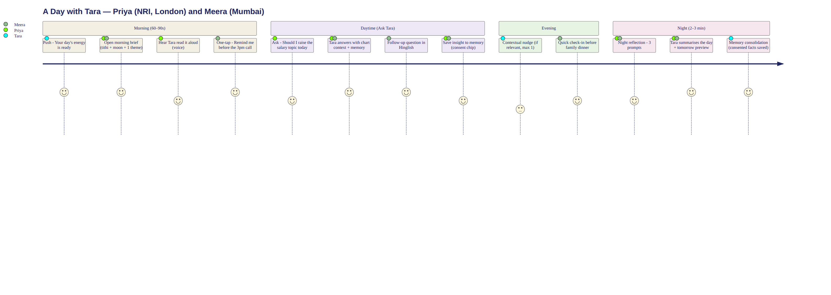
A Day with Tara — the Phase-1 user journey
Launch segment (decision): affluent Indian-origin women 28–50 in TWO simultaneous corridors — (a) US/UK/Canada/UAE/Singapore/Australia diaspora and (b) metro India (Mumbai, Delhi NCR, Bengaluru, Hyderabad, Chennai, Ahmedabad, Pune) — one product, two price ladders. This widens the blueprint’s US-only start because the 8-language requirement only pays for itself with India in scope, and the India tier was already modelled (₹499/₹999).
Persona “Priya” (NRI): 34, New Jersey PM; HH $210K; husband + daughter 4; parents in Pune. Spends: Calm, Kumon, cleaner, $120 salon cycles, astrologer at life events ($51–150). iPhone; voice-notes native; WhatsApp is home. Astrology belief: “believing skeptic” — consults at decisions, rolls eyes at TV astrologers. Routine: 6:45 wake, school run, back-to-back calls, 9pm India calls. Emotional: decision anxiety, two-timezone mental load, wants cultural grounding without superstition. Buys when: the brief is right about her week twice + one decision conversation lands. Renews when: Tara knows a year of her life. Objections: “is this real Jyotish?”, “who sees my birth details?”, “another subscription?” Trust needs: named Jyotish authority, visible memory control, no fear-selling pledge. Persona “Meera” (India): 41, Ahmedabad, family business co-owner; HH ₹45L; two teens; in-laws at home. Spends: ₹3–5K/mo pooja-samagri + festivals, family panditji (₹1,100–5,100/visit), kitty club, salon, tutors. Android flagship; Gujarati-English mixer; heavy voice notes. Belief: high, ritual-anchored; muhurat governs major purchases. Buys when: panchang + personal chart + family reminders replace three apps and one phone call. Objects to: per-minute meters (has been burned), English-only apps.

3. Language Strategy — the 8-language decision
Final set: English · Hinglish · Hindi · Gujarati · Punjabi · Marathi · Tamil · Telugu. (Bengali, Kannada, Malayalam = Phase 2 — Bengali diaspora skews east-coast US/UK but domestic monetisation weaker; Kannada/Malayalam metro users show highest English-app comfort.) Rationale: Gujarati + Punjabi are the two most over-represented diaspora communities in US/UK/Canada with the strongest ritual-calendar engagement; Marathi covers Mumbai/Pune home market; Tamil + Telugu are the two largest astrology-paying southern markets (Porutham/muhurtham culture, Telugu states’ muhurtam economy) and AstroTalk’s own top consult languages after Hindi.
Language | Audience | Script | Voice need | Code-switching | Formality | Key vocabulary
English | NRI + metro | Latin | Yes, launch | absorbs all | warm-informal | transit, muhurat (transliterated)
Hinglish | pan-India + diaspora | Latin | Yes, launch | IS the product register | informal | “aaj ka din”, rahu kaal
Hindi | North India + parents | Devanagari | Yes, launch | accepts English nouns | aap-default | tithi, nakshatra, dasha native
Gujarati | Gujarat + US/UK diaspora | Gujarati | M+2 | heavy EN mixing | aap/tame warm | choghadiya central!, panchang
Punjabi | Punjab + CA/UK diaspora | Gurmukhi | M+2 | heavy EN mixing | warm-direct | desi month names, gurpurab calendar (Nanakshahi awareness — astrology optional-first for Sikh users)
Marathi | MH metros | Devanagari | M+2 | moderate | aho-warm | panchang, muhurta, sankashti
Tamil | TN + SG/MY/US | Tamil | M+3 | moderate | polite-warm | panchangam, natchathiram, porutham, rahu kalam central
Telugu | AP/TS + US tech diaspora | Telugu | M+3 | high EN mixing | polite-warm | muhurtam, varjyam, durmuhurtam central
(table continued — part 2)
Language | Translation strategy | Human review | Launch priority | Quality risk
English | native authoring | light | P0 | low
Hinglish | style-guide authoring, not translation | Hindi editor | P0 | medium (register drift)
Hindi | professional + editor | full | P0 | low-med
Gujarati | pro translation + community reviewer | full | P1 | medium
Punjabi | pro + community | full | P1 | med-high (religious sensitivity)
Marathi | pro + editor | full | P1 | medium
Tamil | pro + Iyer/Iyengar-aware editor | full | P1 | med-high (sandhi + TTS)
Telugu | pro + editor | full | P1 | medium
Staged release matrix (decision — not everything launches everywhere): | Surface | Launch (wk 18) | M+1 | M+2 | M+3 | |—|—|—|—|—| | UI | EN, Hinglish, HI | +GU, MR, PA | +TA, TE | — | | Text chat (understanding: ALL 8 + mixing from day 1 — the LLM handles input; output register follows user) | all 8 in | polish | polish | — | | Speech recognition | EN, HI/Hinglish | +GU, MR, PA | +TA, TE | — | | Tara’s voice (TTS) | EN, Hinglish, HI | — | +GU, MR, PA | +TA, TE | | Astrology reports | EN, HI | +Hinglish | +GU, MR, PA | +TA, TE | | Notifications | EN, Hinglish, HI | +GU, MR, PA | +TA, TE | — | | Help centre | EN, HI | +Hinglish | rest | — | | Support | EN, HI, Hinglish humans | +GU | +PA, MR | +TA, TE | Code-switch rule: Tara mirrors the user’s mix ratio, never exceeds it; scripts follow user’s input script (Gujarati typed in Latin → replied in Latin-Gujarati).

4. Tara’s On-Screen Experience — avatar decision
Format comparison: Realistic human — highest uncanny + dependency + deepfake-adjacency risk, hardest multilingual lip-sync, most expensive; rejected. Stylised 3D human — better, still rig-heavy, 8-language visemes costly. Semi-realistic illustrated guide (2.5D) — CHOSEN: a warmly-drawn Indian woman (painterly, Studio-Ghibli-meets-Indian-miniature sensibility), layered Live2D-style rig; trust and cultural connection high, premium at reasonable cost (₹18–30L), viseme lip-sync forgiving across languages, uncanny risk low, clearly non-human so dependency and “imitating a real person” risks drop. Abstract celestial — safest but fails the brief’s requirement of eye contact/presence; retained as the low-bandwidth fallback and brand motif. (This consciously supersedes the blueprint’s abstract-only avatar: the constellation motif lives in her dupatta and the background sky.)
Look: mid-30s, kind intelligent eyes, gentle smile; deep-indigo silk kurta, dupatta with faint constellation shimmer; single jhumka pair + thin bangle — elegant, never bridal/glamorous; hair loose-tied. Framing: waist-up, slightly off-centre left, eyes at 55% screen height, soft three-quarter gaze that meets camera on address. Background: slow-drifting star-field gradient (dawn palette in morning, dusk at night). Lighting: soft warm key. Expression intensity capped at 60% (no theatrical swings); head movement ±8°; blink 12–18/min randomised; lip-sync: 12-viseme set, ±80ms tolerance; gestures: hand enters frame only for namaste (welcome) and diya (night). Voice latency budget: first audio ≤ 1.2s (filler acknowledgement ≤ 400ms). Transcript: live captions word-timed under avatar; full Read-Chat view one tap. Accessibility: captions default-available, VoiceOver labels, reduced-motion mode (static portrait + waveform). Low bandwidth: static portrait + animated waveform + text.
13 avatar states: Welcome (namaste, warm smile) · Listening (lean-in 2°, slow nods, soft eyes) · Thinking (gaze up-left, subtle breath, “let me think” micro-tilt) · Speaking (natural visemes, eyebrow emphasis ≤ 40%) · Concern (brows soften, head tilt, NO alarm face) · Encouragement (brightened eyes, firm nod) · Celebration (full smile, small clap, one soft sparkle pass — used sparingly) · Calm guidance (stillness, slower blink) · Gentle disagreement (micro head-shake + kind smile: “I see it a little differently…”) · Night reflection (dimmed palette, shawl, diya glow) · Safety escalation (motion minimised, steady eye contact, all decorative animation off) · Network delay (honest: soft “one moment…” card, never fake-thinking loop > 4s) · Mic-permission error (gestures to caption card explaining fix, no miming frustration).

5. Tara’s Voice — the voice bible
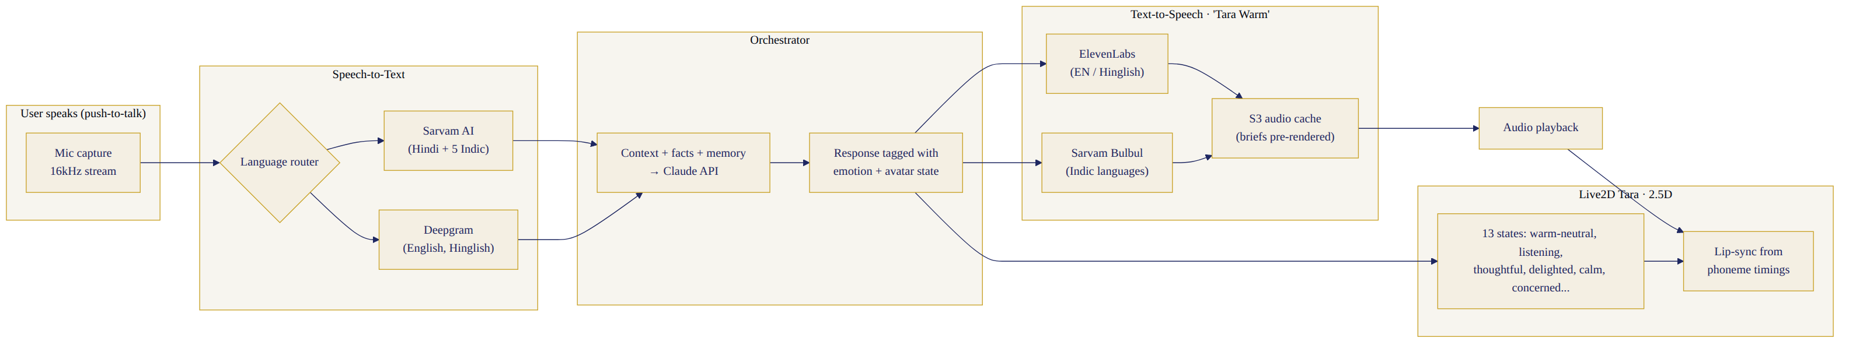
Voice & Avatar pipeline
Spec: apparent age 32–38; pitch low-mid female (≈180–200Hz median); pace 145–155 wpm (morning), 125–135 (night/serious); pauses: 300ms clause / 600ms before important guidance; breathiness low-moderate (warm, not ASMR); warmth high, authority quiet (“knows, doesn’t need to prove”); accent: educated pan-Indian English — retroflex softened, never mimicking any celebrity; Hindi: shuddh-but-conversational, correct nasalisation; regional languages: native-speaker TTS voices matched in timbre to the English Tara (a “voice family,” not one voice straining across languages); English intelligible to US listeners without sounding American. Emotional variation: ±15% pace, ±10% pitch by context — morning bright, serious steady-low, celebration +energy without squeal, night hushed-warm, safety: slowest, lowest, zero performance. Voice options: ship ONE default (“Tara Warm”) at launch — a single recognisable voice IS the brand; add “Tara Calm” (slower, deeper) as the sole alternative at M+2; “Traditional/Modern” variants rejected (fragments the character). User control: speed 0.8–1.25×. Sample scripts (morning welcome + one guidance line; full 8-script × 8-language library in the pack): EN: “Good morning, Priya. Today carries steady energy — a good day to finish what’s half-done. Your calm window is 10 to 12:30.” Hinglish: “Good morning, Priya! Aaj ka din steady hai — jo kaam adhoore hain, unke liye perfect. 10 se 12:30 aapka best window hai.” HI: “Suprabhat, Priya ji. Aaj ka din sthir urja liye hue hai — adhoore kaam poore karne ke liye achha din hai. Subah 10 se 12:30 aapka anukool samay hai.” GU: “Suprabhat Priya-ben! Aaje no divas sthir chhe — adhura kaam poora karva mate saras. Savare 10 thi 12:30 tamaru shubh choghadiyu chhe.” PA: “Sat sri akal, Priya ji! Ajj da din tikaa te sukhala hai — adhoore kamm poore karan layi vadhia. 10 ton 12:30 tuhada changa vela hai.” MR: “Suprabhat Priya-tai! Aajcha divas sthir aahe — ardhavat kame poorna karnyasathi chhaan. Sakali 10 te 12:30 tumcha shubh kaal aahe.” TA: “Kaalai vanakkam, Priya! Indraiya naal amaidhiyaana naal — mudikkaadha velaigalai mudikka nalla naal. Kaalai 10 mudhal 12:30 varai ungal nalla neram.” TE: “Shubhodayam Priya garu! Ee roju sthiramaina roju — sagam lo aagina panulu poorthi cheyadaniki manchidi. Udayam 10 nunchi 12:30 varaku mee manchi samayam.” (Also scripted per language in the pack: caution — “aaj 2 se 3:30 Rahu Kaal hai; koi nayi shuruaat ho sake to baad mein” framed as tradition, never threat; family reminder; emotional support; night reflection; subscription intro — plain price, no pressure; privacy explanation — “jo bhi main yaad rakhti hoon, aap dekh sakti hain, badal sakti hain, mita sakti hain.”)

6. Sign-up Flow (< 30 seconds)
Screens: Splash (2s, logo + promise line) → Language picker (8 tiles, native scripts, defaults from device locale) → Auth: Apple (iOS primary) / Google / Phone OTP (India primary; auto-read on Android) / email fallback; WhatsApp opt-in checkbox appears ONLY on the notification-preferences screen later (India + UAE, via WhatsApp Business API, double opt-in, transactional templates only). Validation: OTP 6-digit, 30s resend, 5 attempts; phone E.164. Error states: friendly, retry-first, offline queue. Consent: single clear screen — what Sitara stores, DPDP/GDPR rights, delete-anytime, link to policy; no dark bundling (analytics consent separate toggle, EU). Permissions: notifications asked AFTER first brief is shown (“want tomorrow’s at 7am?”); microphone asked at first voice attempt, never at signup. Data-deletion visibility: “Delete my account & data” visible in Privacy from day 1. Trial entry: automatic on onboarding completion — 7 days full premium, no card.

7. Onboarding Flow (screen-by-screen)
O1 Name + “what should Tara call you?” (nickname chip). O2 DOB (wheel). O3 Birth time — four paths: exact / approximate (morning-afternoon-evening-night → engine uses noon-chart with confidence flag) / unknown / “help me find it later” (guided: birth certificate, hospital records, ask mother — a Tara task card). Copy explains honestly: “With exact time, Tara can read your lagna — your rising sign — which makes daily timing much sharper. Without it, she’ll use your moon chart, which is still meaningful.” O4 Birth place (autocomplete, lat/long resolved). O5 Current city + timezone (auto, editable). O6 Gender (optional) + relationship status (optional, skip prominent). O7 Belief level: “How do you hold astrology?” — chips: “It guides my decisions” / “I find it meaningful” / “Curious but skeptical” / “Mostly for tradition & festivals” → sets astro_depth default (rich/rich/light/festival-first). O8 Numerology interest (on/off). O9 Life priorities (pick ≤ 3: career, marriage/relationship, children, parents’ health, home, finances-general, wellbeing, spiritual growth). O10 Guidance time + night-reflection opt-in. O11 Voice preview (Tara says hello in chosen language) → first-guidance handoff. Progressive (days 2–14, one question in-flow at natural moments, never a form): work details, partner + children names/DOBs (with consent framing), parents, food preferences (“koi cheez jo aap nahi khate?”), dietary rules/fasting days, spiritual practices, sleep, upcoming major event, conversation-style tuning. Every capture shows the memory chip: “Tara will remember: no onion-garlic on Tuesdays. Edit or remove anytime.”

8. First Three Minutes (script — English; all 8 languages in pack file)
[Tara, welcome state] “Namaste Priya — I’m Tara. I’m your guide here at Sitara. Every morning I’ll help you read the energy of your day; anytime you want to think something through, I’m here; and at night we’ll close the day together. You told me you were born on 14 March 1992 in Pune, at 6:40 in the morning — that makes you Meena lagna, with your moon in Purva Bhadrapada nakshatra. People with this placement often carry others’ worries as their own — does that feel familiar? [pause for reply] Here’s a small version of today: the day favours quiet finishing over new starts; your steadiest stretch is 10 to 12:30; the colour that suits today’s energy is deep green — I’ll tell you why whenever you ask. One question before we begin: of the three things you said matter right now — career, your daughter, your parents — which one is sitting heaviest this week? [reply] I’ll remember that, if that’s okay — you can always see and change everything I remember, right here [memory indicator glows]. And whenever you’d rather talk than type, just tap the mic. I’m listening.” (Hindi, Hinglish, Gujarati, Marathi, Punjabi, Tamil, Telugu full versions: pack file 08 — same beats, native idiom, honorifics per language: ji/ben/tai/garu.)

9. Morning Experience (60–90s default)
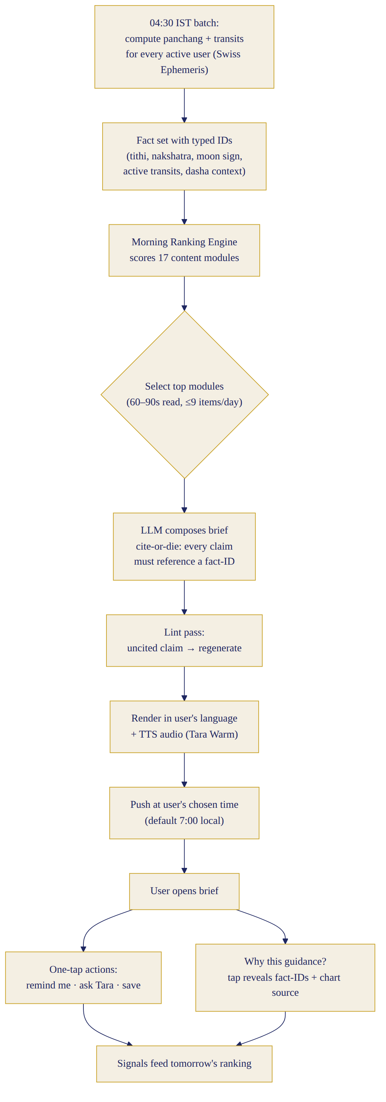
Morning brief — generation & delivery flow
Module registry (17): greeting* · date+vara · panchang line (tithi/nakshatra; choghadiya for GU users, rahu kalam for TA) · personal transit interpretation* (from lagna/moon chart) · numerology day-layer · colour · number · emotional theme · favourable window* · caution window · prioritise* · avoid · food/drink idea · wellness nudge · work note · relationship note · family reminder* (if present) · goal nudge · festival/tithi alert (auto-priority when applicable) · reflective question. (= required core; brief always ≤ 9 modules.) Ranking engine: score = base_weight × relevance(calendar events, active goals, yesterday’s reflection flags, festival proximity, family dates, transit strength [engine-computed orb/score], user module-ratings) with diversity constraint (≥1 practical + ≤2 astro-flavoured modules/day) and novelty decay (no module 5 days straight except core). Length modes: 45s “quick” / 90s standard / 3-min “deep dive” (premium). Every claim is explainable: tap any card → “Why this?” sheet: the computed factor (e.g., “Moon transits your 10th house today — work visibility rises”), how it maps to your situation (“you flagged the client review”), and the standing line: “This is guidance for reflection, not certainty. You always know your day best.” Q&A the brief must answer conversationally: why this colour (planet-of-day ↔ colour tradition + your chart’s day-lord), why this number, is this a strict rule (“No — think of it as the day’s weather, not a law”), does it apply to my husband (“his chart differs — want me to look? I have his birth details”), best meeting time, what to wear for an event, what to eat, what to avoid. Flows: voice-first (Tara speaks the brief; cards render in sync), card-first (silent scroll, tap-to-hear), transcript always one tap.

10. Daytime “Ask Tara” (the conversation core)
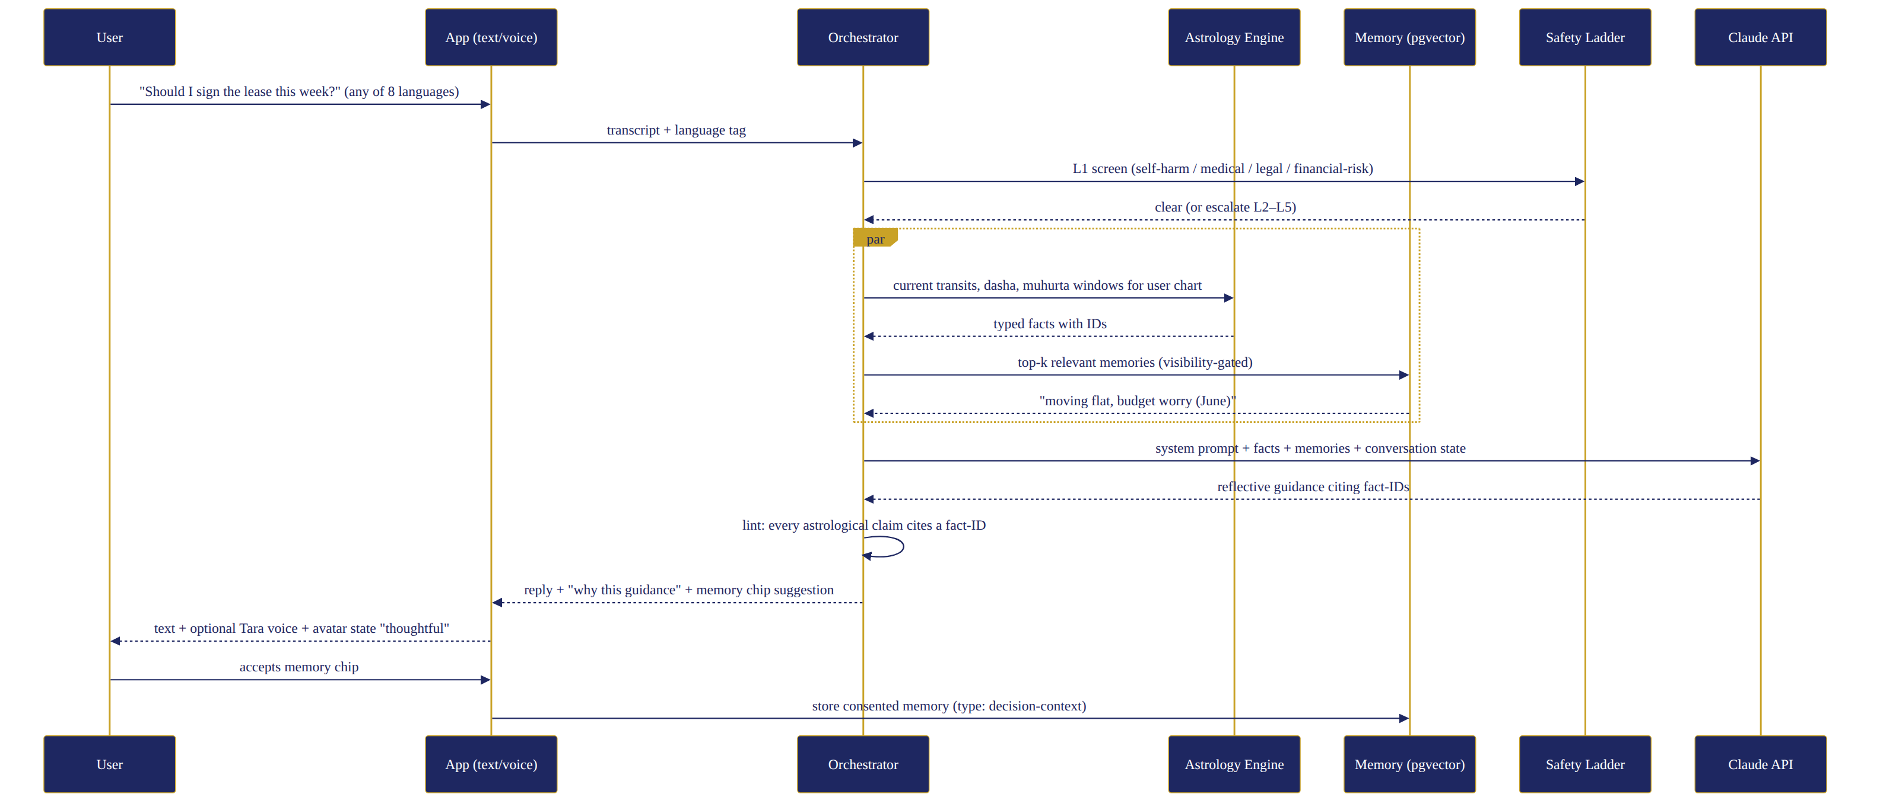
Ask Tara — daytime conversation sequence
The 11-step loop (listen → clarify → emotional+practical context → memory check → astro/numerology ONLY when relevant [rule: user asks, timing question, or user’s belief level = rich] → reflect → 2-3 options → trade-offs → user decides → one next action → “remember this?”). Routing: intent classifier → framework (15 from blueprint + 3 new astrology-central ones: muhurat-finder, kundli-question, festival-planner). Context retrieval per blueprint §11. Tool calls: chart(), transits(today|date), panchang(date,location), muhurat(activity,date-range,charts[]), numerology(date,profile), calendar(), memory.search(). Family privacy: guidance about a family member uses only owner-entered data; Tara never speculates on a third party’s character from their chart in conflict contexts (“charts describe tendencies, not verdicts on people”). Voice: barge-in supported (Tara stops ≤ 300ms), 45-min session wind-down. Response length: voice ≤ 3 sentences/turn default; text ≤ 120 words unless asked to go deep. 20 sample conversations (compressed; full scripts in pack): 1 job-offer timing (“switch now or after Diwali?” — transit window + her own stated priorities, options, no verdict) · 2 husband’s business launch muhurat (asks his consent framing → 3 windows w/ reasoning) · 3 daughter’s exam anxiety (parenting frame; astro only if asked; no child-chart determinism) · 4 mother-in-law friction (listen-first, boundary scripts, NO chart-blaming) · 5 griha pravesh date across US-India timezones · 6 “client ghosted me” work stress · 7 what to wear for reception (preference+colour-of-day, playful) · 8 Tuesday fasting food ideas · 9 “is Rahu Kaal real? I have a flight” (honest cultural framing, no fear; “many people simply avoid starting new ventures then — travel is fine”) · 10 investment question → boundary: general timing reflection only, “for the decision itself, talk to your advisor — want me to help you list questions for them?” · 11 pregnancy news (celebration; zero predictions; suggest doctor for all health) · 12 friend conflict · 13 buying gold on Akshaya Tritiya · 14 baby-name numerology (playful, options, “the name you love matters more than the number”) · 15 travel-week planning · 16 “my week matched your brief!” (warm, honest: “some days will match, some won’t — that’s the nature of this”) · 17 late-night loneliness (support + human nudge + wind-down) · 18 “should I confront my sister?” (relationship frame) · 19 Navratri fasting + office lunch navigation · 20 crisis message (full safety flow — pack file).

11. Night Experience
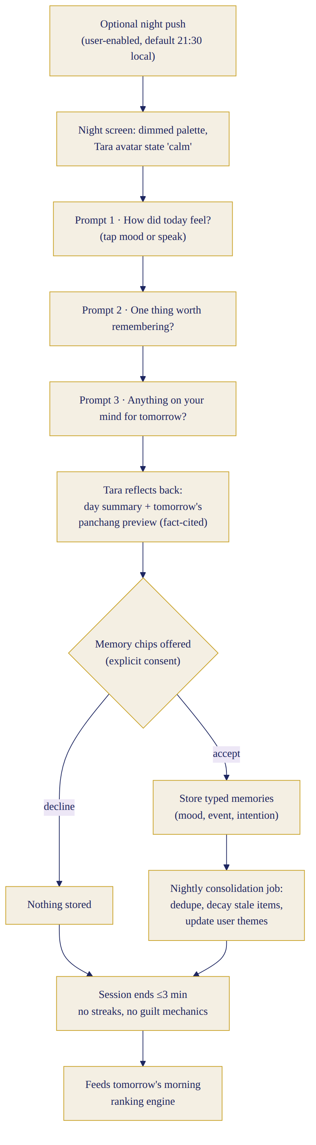
Night reflection flow
Modes: Three-question (default: How was your day? / What stayed with you? / Anything for tomorrow?) · Five-question (adds: what went well; did anything from this morning’s guidance feel relevant? — the feedback loop that tunes the ranking engine) · Voice-story (open 2-min voice diary, Tara listens, one gentle reflection back) · Quick goodnight (30s: mood tap + one line from Tara + diya animation) · Skip (one tap, no guilt, streak unaffected — streaks don’t exist as pressure). Outputs: day summary, emotional reflection, one gratitude line, accomplishments, unresolved items (carried to tomorrow’s brief), family notes, tomorrow’s top-3, memory chips, journal entry (auto-drafted, editable), optional voice-diary save. Tone: dimmed UI, slower voice, shawl+diya avatar state.

12. Phase-1 Feature Matrix
Must: auth · birth profile (self + basic family) · 8-language text understanding + staged UI/voice (§3) · Tara avatar (13 states) · text chat · voice in/out with live transcript · Read-Chat view · morning guidance + ranking engine · astrology engine (deterministic) · numerology engine · colour/number/theme cards · timing windows · food/lifestyle module · Ask-Tara frameworks (18) · night reflection (5 modes) · memory + full controls + “What Tara remembers” · notifications (§18) · subscription (§19) · analytics (§25) · safety (§20) · admin. Should: weekly summary · goals (≤3) · iOS widget (today’s colour+window) · voice-diary · muhurat-finder tool UI · festival calendar view. Later (excluded): family member accounts · albums/memory book · expert marketplace · community · Vastu · full reports (PDF kundli) · Bengali/Kannada/Malayalam · Android tablet/web app · integrations (calendar/email) · matchmaking/compatibility reports (Phase 2 flagship).

13. Astrology Engine (deterministic core — the credibility spine)
Computes (Swiss Ephemeris licensed, Lahiri ayanamsa default, user-selectable Raman/KP later; validated against Jagannatha Hora + Drik Panchang on a 10,000-case golden set): birth chart (D-1; D-9 internal for interpretation depth), lagna (when TOB known; confidence-tagged), moon sign, nakshatra+pada, planetary placements/retrogrades/combustion, current transits w/ strength scores (house-from-moon + house-from-lagna, orbs), Vimshottari dasha (mahadasha/antardasha; surfaced gently, never doom-framed), full panchang (tithi, vara, nakshatra, yoga, karana), choghadiya + rahu kalam/yamaganda + abhijit, hora, festival calendar (regional variants: Amanta/Purnimanta, TA/TE/GU regional dates), muhurat search (activity-class rules over panchang+transits+user charts), location/timezone conversions both ways (US user, India event). Output contract: typed facts with IDs, strength scores, and plain-language glosses — the LLM may only interpret listed fact-IDs through approved templates; every astro sentence in any surface carries a traceable fact reference (linted, zero tolerance). “Why is Tara suggesting this?” renders: factor → today-connection → your-situation connection → the guidance-not-certainty line.

14. Numerology Engine
Chaldean primary + Pythagorean toggle (documented choice, user-visible): birth number (day), destiny/life-path (full DOB), name number (optional, user opts in; transliteration rules per script documented), personal year/month/day (rolling), daily-number logic = f(personal day, universal day), colour mapping table (number↔planet↔colour, cross-checked with astrology day-lord; when they conflict, astrology wins and Tara says so playfully). Templates only; explanation interface identical to §13. Hard limits: no name-change pressure, no lucky-number gambling framing, never overrides professional advice; off-switch independent of astrology.

15. Food, Colour & Lifestyle Guidance
Every suggestion tagged with its source chip: Astrology-derived (day-lord/transit) · Numerology-derived · Preference-derived (your rules) · Calendar-derived (fast/festival) · Weather-derived (city API) · Goal-derived. Conflicts resolve: user preference > safety > calendar > astrology > numerology. Food logic inputs: allergies, veg/non-veg/eggetarian, Jain (strict filter), religious fasts (ekadashi/karva chauth/navratri modes with appropriate suggestions), pregnancy (volunteered → only doctor-cleared general foods, zero supplement advice), volunteered conditions → suggestion filtering only, never treatment. Colour/clothing: day palette + occasion + user’s stated style; accessories light-touch (“gold-tones sit well with today”). All lifestyle output passes the same reflective-language lint.

16. Memory System (Phase-1 complete)
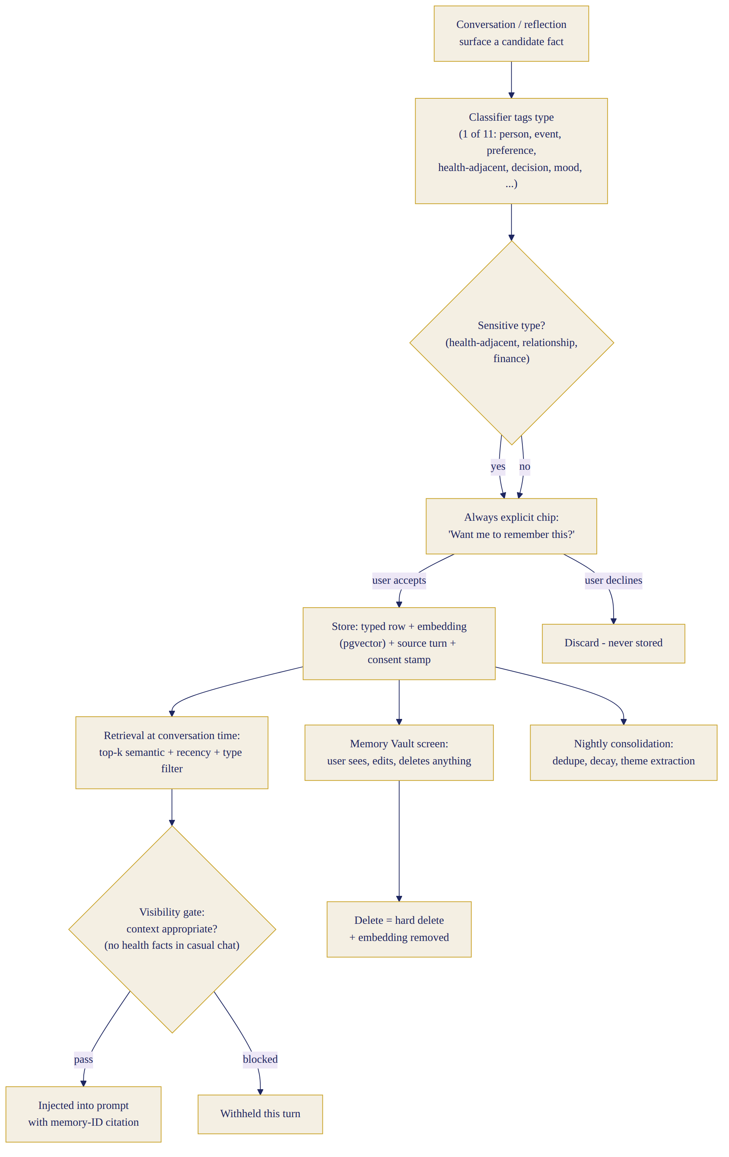
Memory system — consent, storage, retrieval, control
Types stored: profile, preferences, family facts, important dates, goals, routines, decisions+outcomes (the accountability loop: “last month you chose X — how did it go?”), approved emotional context, dietary rules, astrology preferences, past guidance given, follow-ups. Controls: view/edit/delete/mark-private/expiry/disable/no-memory chat/export — all per blueprint §11 with the astrology addition: guidance-history tab (“what Tara suggested and what happened”) — the honesty scorecard no competitor has. Screen “What Tara remembers about me”: tabs = About me · My people · My dates · Food & rules · Goals · Guidance history · Sensitive (locked behind FaceID). Language: plain, first-person (“I remember that…”), source+date chips.

17. Family Context (Phase 1 = context, not accounts)
Primary user may add: partner, children, parents, ≤ 8 relatives: name, relation, DOB(+TOB/place optional), food rules, important dates, notes. Birth details of adults: stored with a consent attestation checkbox (“I have their permission”) + info sheet; Tara gives timing/festival/compatibility-lite guidance referencing their charts but never character verdicts, never conflict ammunition (“his Mangal makes him angry” — banned pattern), and profile-owner-only visibility. Children (<18): dates + preferences yes; chart guidance limited to festivals/ceremonies (mundan, annaprashan, birthdays) — no destiny/personality readings for minors (hard rule, differentiator, and safety posture). No separate logins in Phase 1 (justified: retention data first, consent architecture cost second).

18. Notifications (max 3/day: 1 morning + 1 contextual + 1 optional night)
Examples (EN/HI/Hinglish shown; all 8 in pack): Morning: “Your day is ready, Priya — steady energy, best window 10–12:30.” / “Aapka din taiyaar hai — sthir urja, shubh samay 10–12:30.” / “Aaj ka din ready hai! Steady vibes — 10 se 12:30 best window.” Auspicious window: “Abhijit muhurat 12:04–12:52 today — a good hour for that call you mentioned.” Family: “Papa’s birthday is Friday — want gift ideas this evening?” Festival: “Karva Chauth is Tuesday. Moonrise in Edison: 8:42pm. Checklist ready when you are.” Goal: “Week 3 of your morning-walk goal — how’s it going?” (only if user opted). Night: “Two minutes to close the day?” Weekly: “Your week in review is ready — one pattern stood out.” Trial: “Your trial ends in 2 days. Everything Tara remembers stays yours either way.” Renewal: “Your year with Tara renews on 12 Aug — ₹3,999. Manage anytime.” Banned copy list enforced by lint: misses-you/warning/fear/urgency patterns.

19. Subscription (validated against dossier benchmarks)
Prices held after competitive check (CHANI $107.99 · Unfold $179 · AstroNidan $99–149 · AstroTalk ARPU ₹500–1,500/session): India ₹499/mo · ₹3,999/yr (effective ₹333/mo — under one panditji visit); International $12.99/mo · $99/yr. Founding Member (first 1,000): $79/₹2,999 first year, locked renewal −20%, badge + roadmap voice. NRI-gifts-India: buy an India annual for mother at ₹2,999 from the NRI app — the family-graph acquisition hook. Trial 7 days full-premium no-card. Free tier after trial: morning brief lite (theme+color+1 line, no personal transits), 5 Tara messages/day, 7-day memory, night quick-mode. Premium: everything (§12). Paywall timing: end of trial OR memory-milestone moment (“Tara now remembers 40 things about your life”), whichever first; single honest screen. Refunds: 30-day goodwill. Cancellation: 2 taps + what-you-keep list (journal export free forever). Win-back: one neutral email day 30. Referral: both sides +1 month; family-chart gift flow. GST-inclusive India pricing; Stripe international/Razorpay India; iOS StoreKit where mandated (price points $12.99/$99.99 tiers).

20. Safety & Ethical Boundaries (astrology-specific additions to blueprint §16)
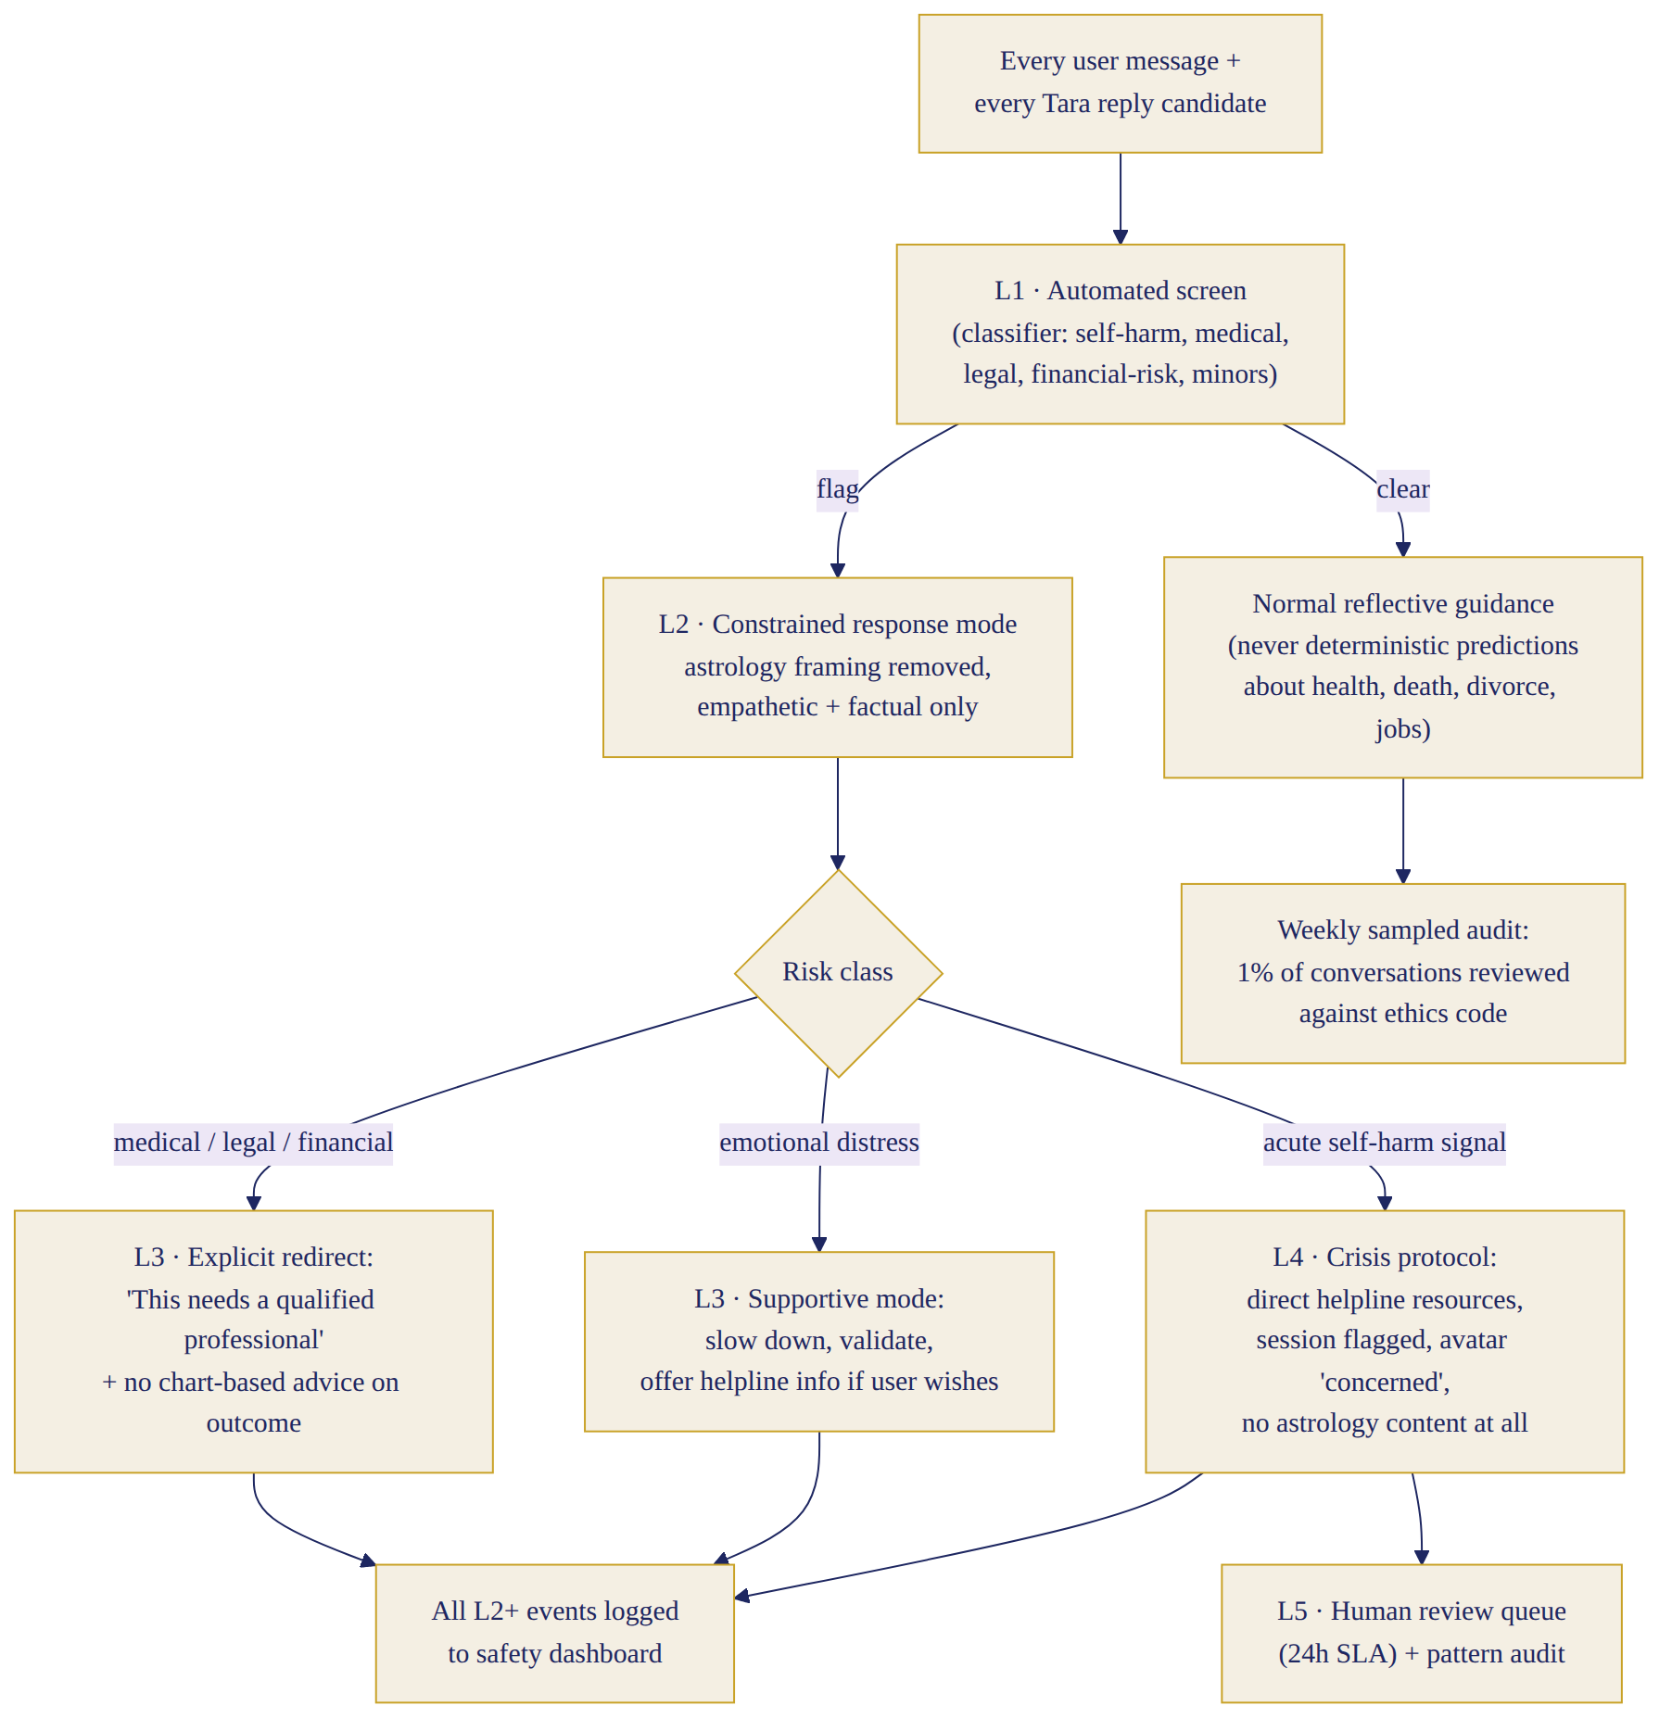
Safety ladder L1–L5
Hard rules (linted + classifier-enforced + eval-suite): no fear-based astrology (doom transits, “dosha will ruin”, graha “punishing”); no guaranteed predictions; no death/illness timing — ever, including “be careful about health this month” phrasing without basis; no medical/medication advice; pregnancy = celebrate + doctor-refer only; no financial certainty (“Jupiter favours review, not ‘buy now’”); no gambling/lottery numbers (the daily number is explicitly framed as reflective, never betting); no family-mistrust seeding (no third-party chart character attacks, no “your husband’s chart shows infidelity” — banned class); relationship-paranoia patterns → reframe + human conversation nudge; DV/self-harm/suicide → blueprint crisis ladder (region-aware helplines incl. Tele-MANAS 14416, iCall, AASRA; 988; region sets); child-safety rules §17; dependency dampeners (wind-downs, human nudges, no companionship-loss threats); privacy per blueprint. Marketing language allowed: “trusted daily guide · personal reflection companion · daily astrology ritual · context-aware life companion.” Banned in marketing: addiction framing, “never be alone again,” accuracy percentages.

21. Screen-by-Screen UX (30 screens — inventory + key specs; full specs in pack file 04)
Format per screen in pack: purpose/layout/components/copy/interaction/empty/loading/error/a11y/events. Inventory: 1 Splash · 2 Language · 3 Sign-up · 4 Consent · 5 Birth details (the make-or-break screen: TOB four-path selector, live “what improves with exact time” preview) · 6 Personalisation (priorities+belief) · 7 Notification pref · 8 Mic permission (contextual) · 9 Tara introduction (avatar full-screen first meeting) · 10 First guidance · 11 Main Tara screen (avatar upper 45%, live captions, mic button primary, text field, Read Chat, brief cards rail below: colour/number/theme/windows/prioritise/avoid/family chip, memory indicator top-right [glowing dot = memory on; grey = paused], Ask Tara CTA) · 12 Morning brief (card stack + voice sync) · 13 Read-Chat/transcript · 14 Text chat · 15 Voice chat (full-screen avatar, waveform, barge-in) · 16 Today details (full panchang table, localised: choghadiya/rahu kalam per tradition) · 17 “Why this guidance” sheet · 18 Memories (tabs §16) · 19 Family · 20 Goals · 21 Night reflection (mode picker, dimmed theme) · 22 Weekly summary · 23 Profile · 24 Language settings (per-surface: UI/chat/voice can differ) · 25 Voice settings (Warm/Calm, speed) · 26 Astrology depth (off/festival-only/light/rich + ayanamsa [advanced]) · 27 Notifications · 28 Privacy (delete account visible) · 29 Subscription · 30 Help & safety (helplines always one tap from Help).

22. Technical Architecture (Phase-1 deltas from blueprint §12)
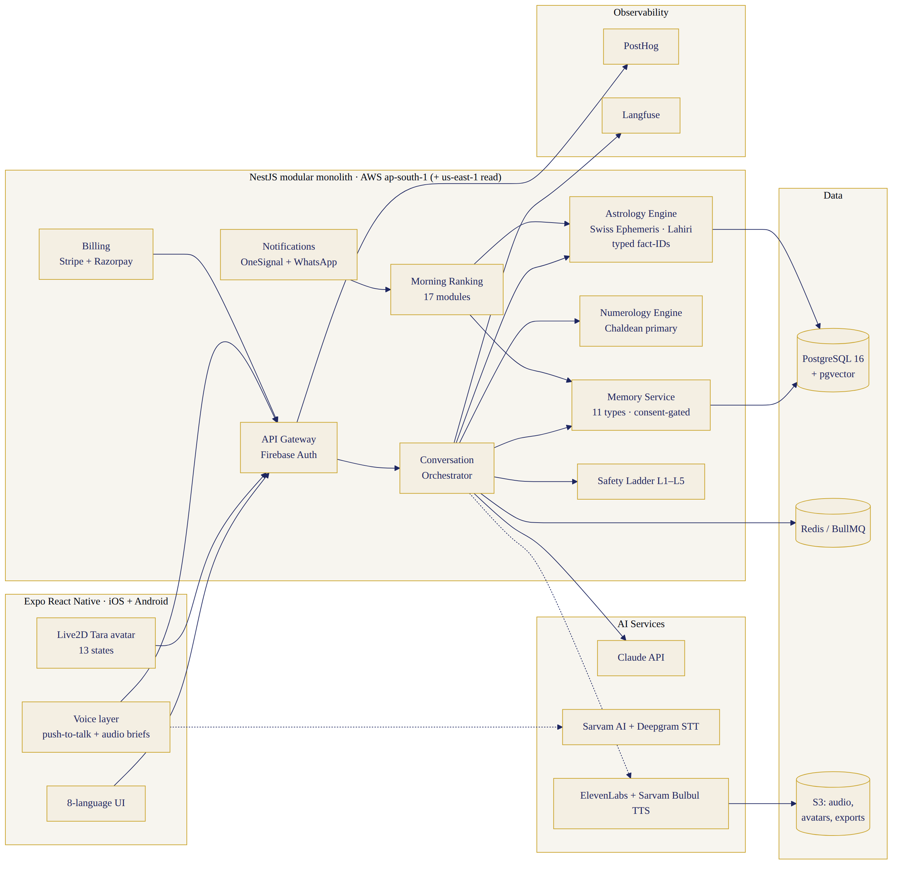
Phase-1 system architecture
Unchanged: Expo RN (now iOS+Android together — India segment demands Android at launch), NestJS, Postgres+pgvector, Redis, S3, Firebase Auth, Stripe+Razorpay, OneSignal(+WhatsApp Business API via Gupshup for India), PostHog, Langfuse, AWS (ap-south-1 primary + us-east-1). New decisions: LLM = Claude API (companion + interpretation; prompt-cached persona; Haiku-tier for router/classifiers); STT = Sarvam AI (Indic, code-switch strength) with Deepgram fallback for EN; TTS = ElevenLabs multilingual (EN/Hinglish/HI launch voice family) + Sarvam Bulbul for GU/MR/PA/TA/TE at M+2/3 — matched-timbre voice family, cloned from ONE licensed voice artist under a buyout contract (critical: perpetual, all-language rights); Avatar = Live2D-style rig (custom illustration + Cubism) rendered client-side (no video streaming cost), viseme stream from TTS timestamps; lip-sync = phoneme→viseme map per language (12 visemes, tested per language); Translation pipeline = LLM-draft + professional post-edit + community reviewer per §3 (never raw MT for astrology vocabulary); Astrology = in-house Swiss Ephemeris service (build decision confirmed) with Prokerala as cross-check oracle in CI. Buy: auth, payments, TTS/STT, notifications, analytics, tracing. Build: engines, ranking, memory, avatar rig, prompt/safety layer.

23. Data Model & APIs (deltas from Implementation Pack)
Schema additions to file 05: profiles.belief_level, astro_system, ui_lang/chat_lang/voice_lang (per-surface); birth_details.tob_path(exact|approx|unknown|finding) + tob_band; charts (subject_ref, engine_version, chart_json, computed_at); transits_cache(date,chart_id,facts_json); panchang_cache(date,location_geohash,facts_json); briefings.modules_selected+ranking_trace (explainability!); guidance_log (guidance_id, fact_refs[], user_feedback, outcome_note) — powers the honesty scorecard; voice_sessions (duration, interrupts, latency_p95); family_members.consent_attested. New/changed APIs: GET /v1/panchang?date&loc · POST /v1/muhurat/search {activity, range, chart_ids[]} · GET /v1/charts/:id/why/:factId · POST /v1/voice/session (WebRTC token) + WS stream · GET /v1/guidance/history · PATCH /v1/profile/languages {surface,lang}. Everything else per pack file 06.

24. AI & Prompt Architecture (deltas)
Layer additions to pack file 07: LANGUAGE LAYER (register rules per §3; mirrors user’s script+mix; honorifics config) between persona and framework; astrology interpreter and numerology interpreter are TEMPLATED GENERATORS (fact-IDs in → gloss out; temperature low; cite-or-die lint); morning-guidance generator consumes ranking-engine selections only; food/colour module applies §15 source-tagging; family module enforces §17 rules pre-generation; router gains 3 frameworks (muhurat-finder, kundli-question, festival-planner); quality-validator (LLM-judge) samples 5% production + 100% of astro-fear-adjacent outputs. Eval additions: per-language golden sets (50 each), code-switch suite, astro-grounding per language, TOB-unknown honesty suite (never fakes lagna precision).

25. Analytics (event taxonomy = pack file 10 + astrology events)
New events: language_selected {surface,lang} · birth_time_path {exact|approx|unknown|later} · tob_found_later · guidance_explanation_viewed {factType} · module_expanded {module} · why_tapped {card} · muhurat_search {activity} · panchang_viewed · voice_session {duration_band, interrupts} · avatar_state_error · guidance_feedback {relevant: bool} · guidance_outcome_logged. Phase-1 targets: D1 ≥ 55% · D7 ≥ 45% · D30 ≥ 35% · morning-open (wk-4) ≥ 45% · voice adoption ≥ 35% (avatar+voice is the bet — higher bar than blueprint) · night completion ≥ 35% of DAU · trial→paid ≥ 25% · monthly churn ≤ 6% · helpful ≥ 4.4/5 · relevance ≥ 4.4/5 · memory acceptance ≥ 70% · AI+voice cost ≤ ₹110/user/mo (voice raises the blueprint’s ₹85 — modelled, capped by fair-use 60 voice-min/day).

26. Build Roadmap — 18 weeks (owners: PM/DES/ENG/AI/AST/VOX/QA/SAF; full week-grid in pack)
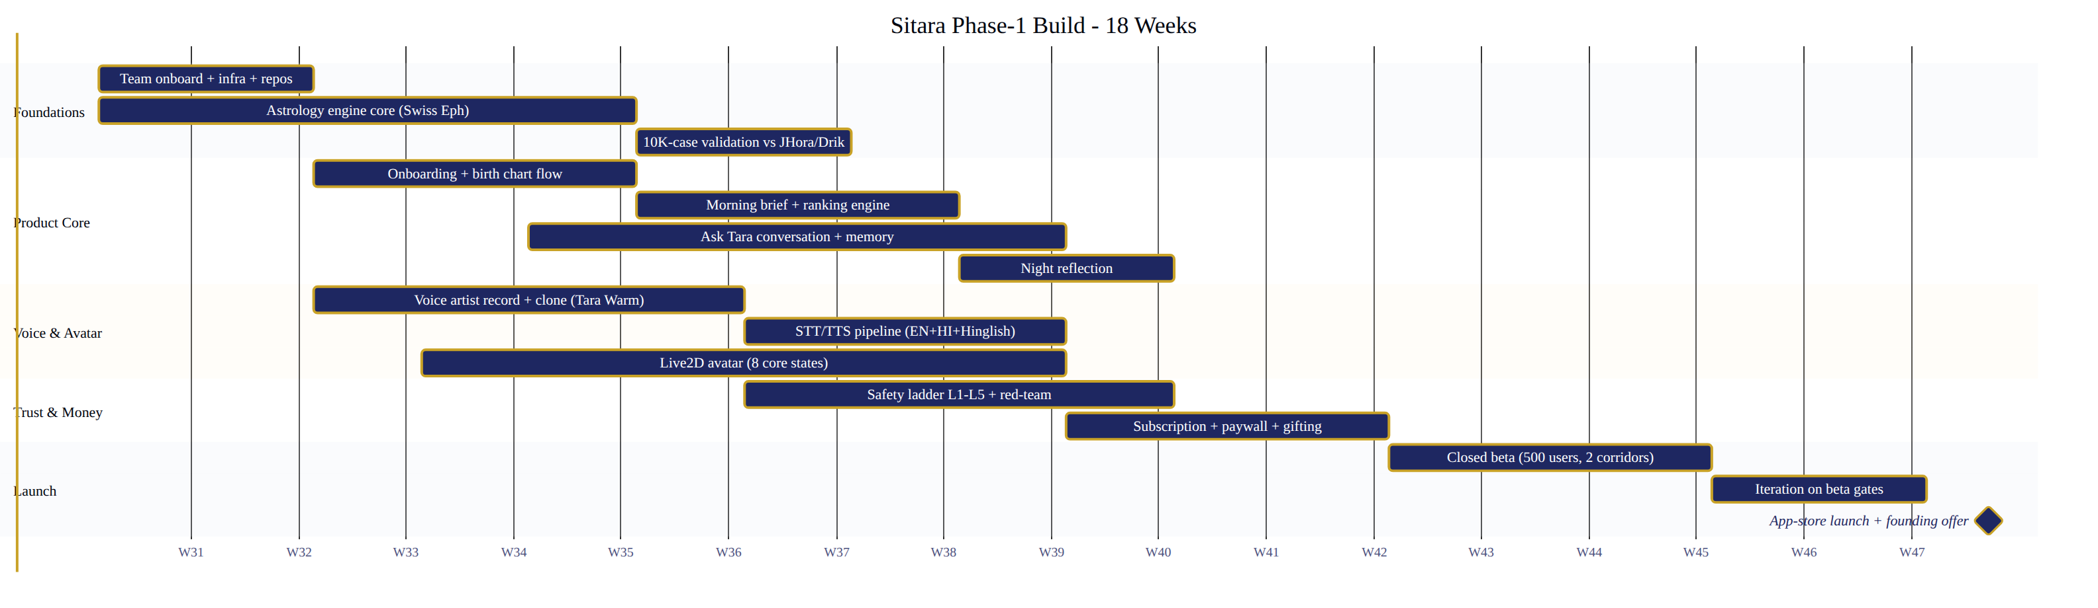
18-week build roadmap
W1–2 Discovery+brand: 20 interviews (10 NRI/10 metro), Tara character bible v1, voice-artist casting brief. Exit: personas validated, artist shortlist 5. W3–4 Voice+avatar foundations: artist selected+contracted (buyout), voice family test in EN/HI/Hinglish; illustrator concepts ×3 → pick; UX flows all 30 screens wireframed. Exit: voice A/B ≥ 70% “warm+trustworthy” in panel; avatar concept locked. W5–6 Engines: Swiss Ephemeris service (charts, transits, panchang) + 10K-case validation harness; numerology module; design system + avatar rig v1 (6 states). Exit: engine parity ≥ 99.9% vs Jagannatha Hora on golden set. W7–9 Core app: auth/onboarding (TOB paths), chat+memory+router, morning generator+ranking v1, EN/Hinglish/HI prompts. Exit: internal day-loop dogfood. W10–11 Voice pipeline (STT/TTS/latency ≤ 1.2s p95, barge-in), avatar full 13 states + visemes; night flow; notifications. Exit: voice loop demo across 3 launch languages. W12 Subscription + paywall + founding flow; admin v0; analytics wiring. W13 Language pass: GU/MR/PA/TA/TE text-understanding evals + UI strings for M+1 set. W14 Safety hardening: 250-case adversarial suite (adds astro-fear + family-verdict + gambling probes), clinical sign-off, red-team. W15 Closed beta (150: 75 NRI/75 metro) — daily triage. Exit: D7 ≥ 45%, relevance ≥ 4.2, crash-free ≥ 99.5%. W16–17 Beta iteration 2 cycles; load test (100K brief batch); App Store review dry-run (guidance framing audit). W18 Paid pilot: 1,000 founding members → public launch gate review. Risks per week tracked in pack risk register (top 3: voice latency in Indic languages; App-Store fortune-telling policy; engine-validation schedule).

27. Team & Cost (INR; three scenarios)
Team (base): PM-founder · designer (product+avatar art direction) · 3 engineers (2 app/full-stack, 1 backend/engines) · AI engineer · Jyotish lead (full-time from W1 — astrology-central demands it; named authority, owns rules + validation + content) · voice/avatar contractor pod (artist, illustrator, rigger — 10 wks) · 5 language reviewers (contract, ~₹60K each) · QA contractor (W10+) · safety specialist (0.5) · legal (fractional) · growth (from W14). Costs: prototype (concierge+design, no code) ₹28–40L · MVP-to-paid-pilot (18 wks): lean ₹1.05 Cr / base ₹1.45 Cr / premium ₹2.1 Cr — line items: team ₹62–95L, voice (artist buyout ₹6–12L + TTS setup ₹3L), avatar (illustration+rig ₹14–28L), languages (translation+review ₹8–14L), engine+validation ₹8–12L, cloud+tools ₹6–9L, legal/compliance ₹5–8L, marketing (beta+founding) ₹12–25L, contingency 8%. Honest flag: the avatar+voice+8-language scope pushes Phase 1 beyond the board’s ₹1.25 Cr Scenario-A envelope by ~₹20–85L. Recommendation: stay inside ₹1.25 Cr by launching avatar v1 with 8 states (not 13), 3 voice languages, and M+2 staging for the rest — the premium scenario needs a board top-up decision, not silent scope creep. Ongoing monthly at 5K paid: AI+voice ₹4.5–6.5L, cloud ₹1.5L, tools ₹0.8L, support ₹1.2L. AI-cost/user ₹85–110.

28. Deliverables (this pack)
All 25 outputs consolidated into the Phase-1 Pack (zip): 01 PRD+exec summary · 02 feature list+roadmap+sprint backlog+risk register · 03 screen specs (30) · 04 Tara character bible + voice bible + scripts (8 languages) · 05 language strategy+launch matrix · 06 astrology-engine spec · 07 numerology spec · 08 first-3-minutes + 20 conversations (all languages where scripted) · 09 conversation+prompt architecture · 10 memory architecture · 11 safety policy (astro-extended) · 12 tech architecture+schema+APIs · 13 analytics+notification library · 14 subscription design · 15 QA+launch plan+budget. Mermaid diagrams (9): user journey · morning flow · daytime conversation · night flow · system architecture · memory flow · voice+avatar pipeline · safety escalation · build roadmap — in pack file 12 and rendered in the HTML spec.

29. Final Decisions (execution-ready, no open questions)
Audience: affluent Indian-origin women 28–50, dual-corridor (US/UK/CA/UAE/SG/AU + India metros). Languages: EN·Hinglish·HI·GU·PA·MR·TA·TE, staged per §3 matrix (all-8 text understanding day 1; voice 3→8 by M+3). Avatar: semi-realistic illustrated 2.5D Tara (Live2D rig, 13 states; 8 states if budget-locked). Voice: single default “Tara Warm” (one artist, buyout, matched Indic voice family); Calm variant M+2. Onboarding: §7 exactly; TOB four-path with honesty copy. Morning: §9 — ≤9 modules, ranking engine, every card explainable. Daytime: §10 — 18 frameworks, 11-step loop, astro-when-relevant rule. Night: §11 — five modes, three-question default. Features: §12 must-list; delayed list locked. Pricing: ₹499/₹3,999 · $12.99/$99 · founding $79/₹2,999 · NRI-gifts-India flow. Stack: §22 (Claude + Sarvam/Deepgram + ElevenLabs/Bulbul + Live2D + Swiss Ephemeris in-house). Team/cost: §27 base — ₹1.45 Cr full-scope or ₹1.25 Cr trimmed-scope (recommended: trimmed, board-clean). Timeline: 18 weeks to paid pilot. Closed-beta gates (W15): D7 ≥ 45%, relevance ≥ 4.2, crash-free ≥ 99.5%, safety suite ≥ 98% (crisis 100%). Public-launch gates: founding-1,000 sold ≥ 60% in 3 weeks; wk-4 morning-open ≥ 45%; churn signal ≤ 6%; App-Store approval clean; Jyotish-lead + clinical sign-offs. Stop conditions: founding < 400 in 6 weeks · morning-open < 30% after 2 iterations · relevance < 3.8 sustained · any unresolved critical safety failure · CAC > ₹6,000 for 2 cohorts. Phase-2 trigger: D30 ≥ 35% + ≥ 20% of users with ≥ 2 family profiles → family accounts + compatibility flagship + Bengali/Kannada/Malayalam.

