Scanning Open / Closed Ports using Zenmap.

**Kali Linux**

* To scan open ports from Windows 10, we use Zenmap Tool.
* We use Intense Scan.

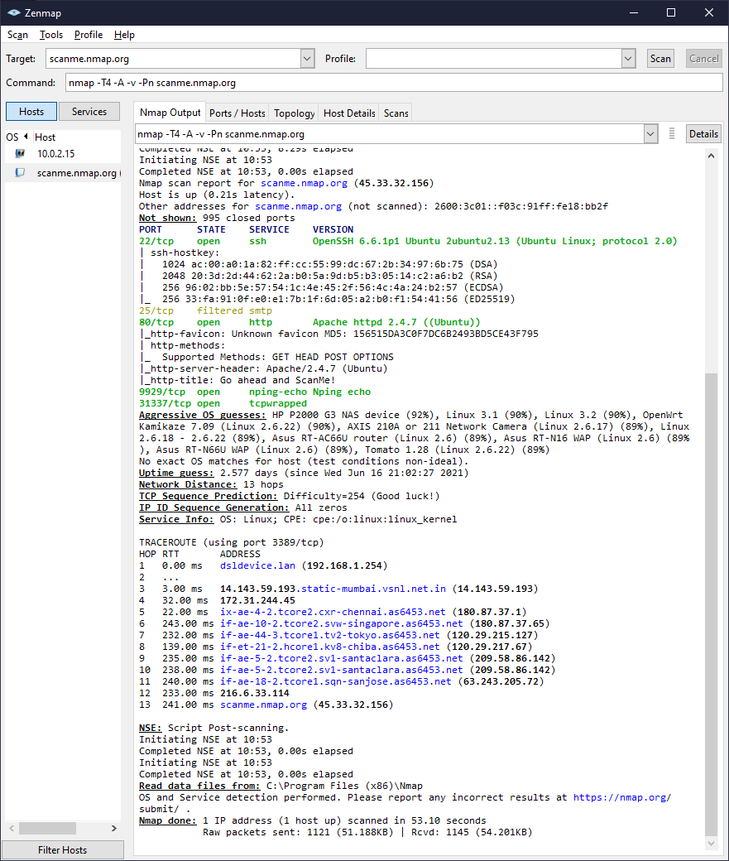

* We see that the following ports are open:
  + 22 / TCP – OpenSSH
  + 80 / TCP – Apache
  + 9929 / TCP – nping
  + 31337 / TCP – tcpwrapped
* We see that the following ports are filtered:
  + 25 / TCP – smtp

**Windows 7**

* To scan open ports from Windows 10, we use Zenmap Tool.
* We use Intense Scan.

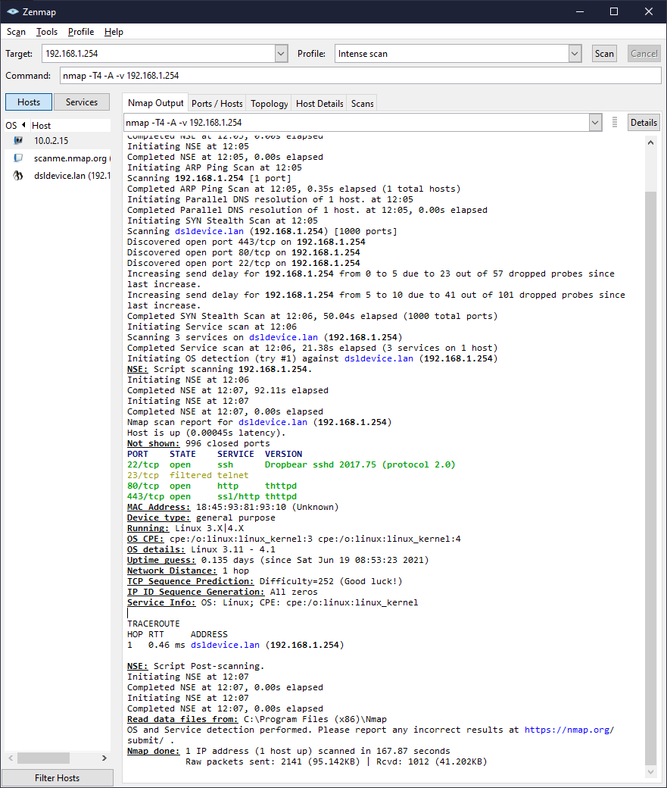

* We see that the following ports are open:
  + 22 / TCP – Dropbear sshd 2017.75
  + 80 / TCP – thttpd
  + 443 / TCP – thttpd
* We see that the following ports are filtered:
  + 23 / TCP – telnet