**Report on Microsoft Clarity Analysis for OmniFood Web-application**

**By**

**Nisha Makwana,**

**Software Engineer Intern, at**

**Promact Infotech Private Limited**

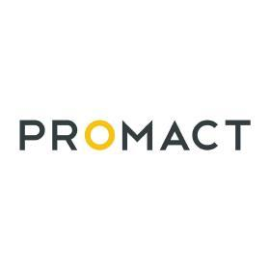

**Table of Contents:**

1. Introduction
2. Research Microsoft Clarity
3. Identify Key Features
4. Setup and Configuration
5. Data Analysis
6. Key Takeaways
7. Heatmap clicks
8. Recommendation
9. Conclusion

**1. Introduction:**

In this report, we explore the utilization of Microsoft Clarity, an analytics tool, to analyze user interactions with the OmniFood Website Hosted by me on Netlify. Here is the Link: <https://nisha-food.netlify.app/>. The primary objective is to identify the most frequently used features within the application, such as buttons, to understand user engagement patterns better.

**2. Research Microsoft Clarity:**

Microsoft Clarity is a comprehensive analytics tool that provides insights into user interactions on web pages. It offers features such as heatmaps, session recordings, and click tracking to understand user behavior effectively.

**3. Identify Key Features:**

Upon analyzing the OmniFood interface, we identified several key features/buttons that users interact with. These include:

* "How it Works" navigation link
* "Meals" navigation link
* "Testimonials" navigation link
* "Pricing" navigation link
* "Try for free" navigation link

**4. Setup and Configuration:**

The Microsoft Clarity tracking for the OmniFood application has been successfully set up and configured. It captures user interactions, including clicks on various features/buttons, providing valuable data for analysis.

Code Snippet For Setting Up Microsoft Clarity with My OmniFood:

<script type="text/javascript">

(function (c, l, a, r, i, t, y) {

c[a] = c[a] ||

function () {

(c[a].q = c[a].q || []).push(arguments);

};

t = l.createElement(r);

t.async = 1;

t.src = "https://www.clarity.ms/tag/" + i;

y = l.getElementsByTagName(r)[0];

y.parentNode.insertBefore(t, y);

})(window, document, "clarity", "script", "kzhdvs5kfk");

</script>

**5. Data Analysis:**

Upon collecting data on user interactions over the last 3 days, we analyzed which features/buttons received the most clicks. The following insights were gathered:

**→Sessions Overview:**

* Total Sessions: 18 (Excluding 2 bot sessions)
* Average Pages per Session: 1.78
* Average Scroll Depth: 65.16%
* Active Time Spent: 1.1 min out of 5.4 min total time

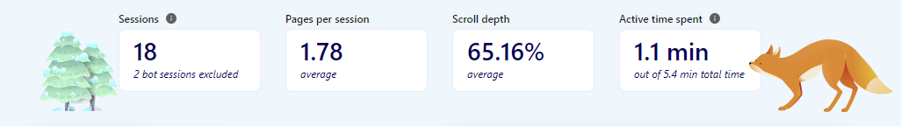

**–>Users Overview:**

* Live Users: 1 session active 1.0 min ago
* Unique Users: 13
* Sessions with New Users: 93.75%
* Sessions with Returning Users: 6.25%

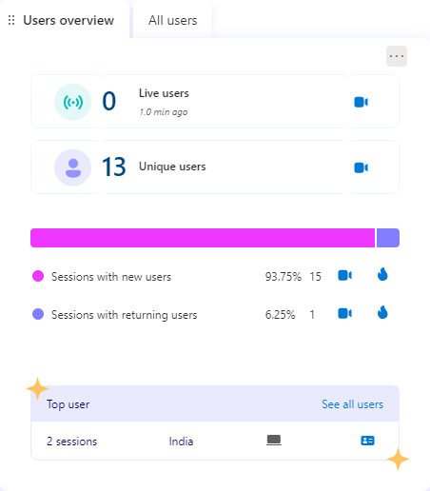

**–>Insights:**

* Rage Clicks: 0% (0 sessions)
* Dead Clicks: 43.75% (7 sessions)
* Excessive Scrolling: 6.25% (1 session)
* Quick Backs: 6.25% (1 session)

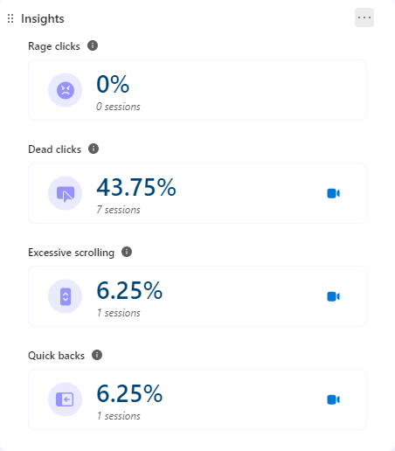

**–>Smart Events:**

* Sign Up: 7 sessions
* Submit Form: 6 sessions

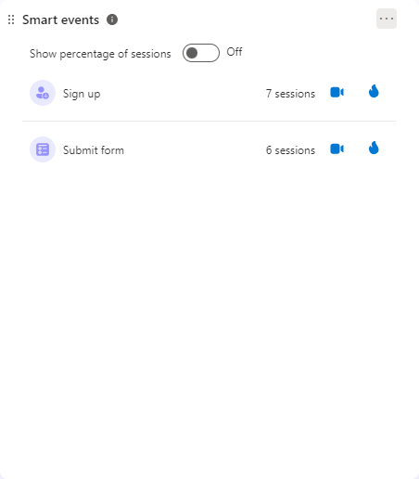

**–>Browsers:**

* Chrome Mobile: 62.50% (10 sessions)
* Chrome: 31.25% (5 sessions)
* Mobile Safari: 6.25% (1 session)

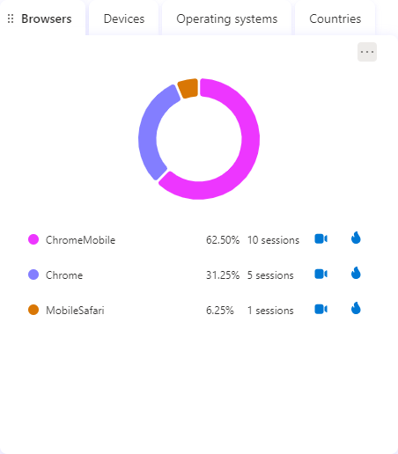

**–>Performance Overview:**

* URL Performance: 97/100
* Performance Score: 100% good, 0% needs improvement, 0% poor
* Performance Score Breakdown:
* Largest Contentful Paint (LCP): Good (2.1s)
* First Input Delay (FID): Good (5ms)
* Cumulative Layout Shift (CLS): Needs Improvement (0.12s)

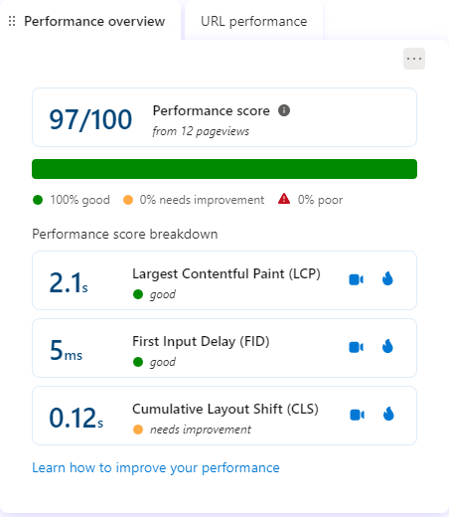

**→Popular Pages:**

* https://nisha-food.netlify.app/: 15 pageviews
* <http://127.0.0.1/index.html/>: 1 pageviews

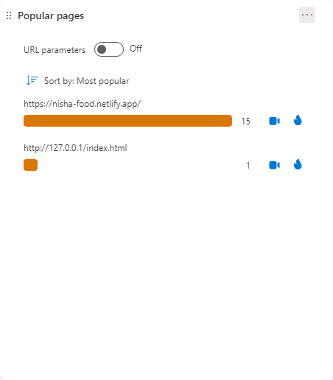

**6. Key Takeaways:**

**1)User Interaction Analysis:**

* Microsoft Clarity provides valuable insights into user interactions, such as clicks, scroll depth, and session recordings, allowing for a comprehensive understanding of user behavior on the application.

**2)Performance Monitoring:**

* Clarity offers performance metrics such as page load times, layout shifts, and JavaScript errors, enabling the identification of performance bottlenecks and areas for optimization.

**3)User Retention and Behavior Insights:**

* Clarity provides insights into user retention rates, session duration, and returning user behavior, facilitating the assessment of user engagement and satisfaction over time.

**7. HeatMaps Click**

**->HomePage Click Map**

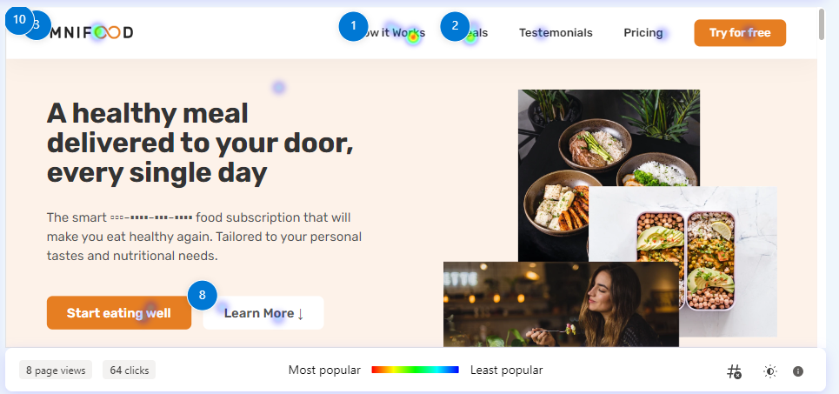

**->How It Works Section on home page Click Map**

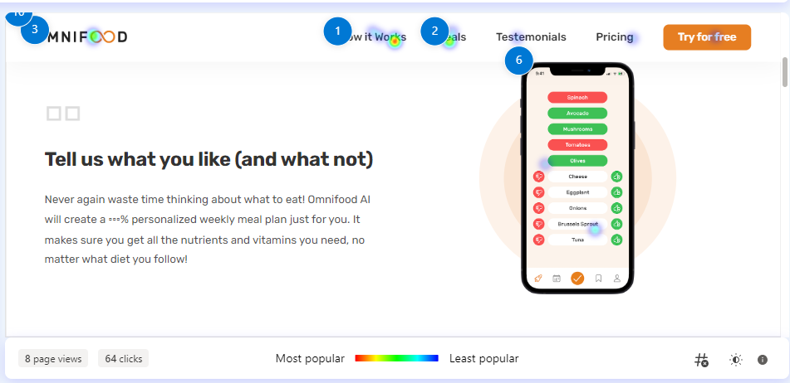

**–>Meals Section In Home Page Click Maps:**

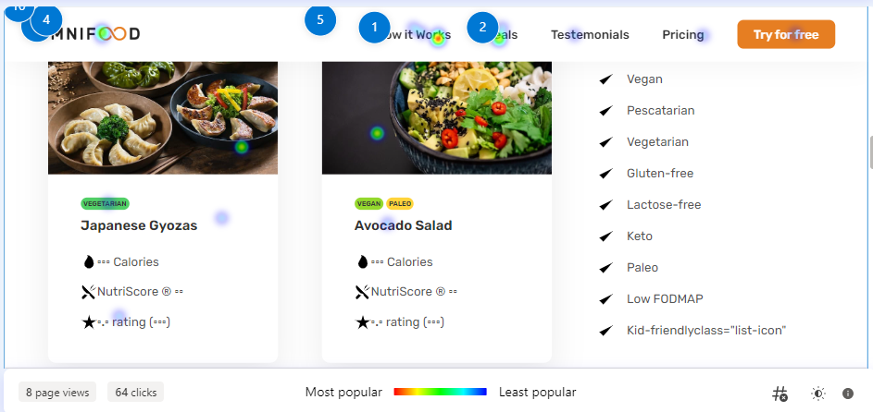

**→Try For Free Section In Home Page Click Maps:**

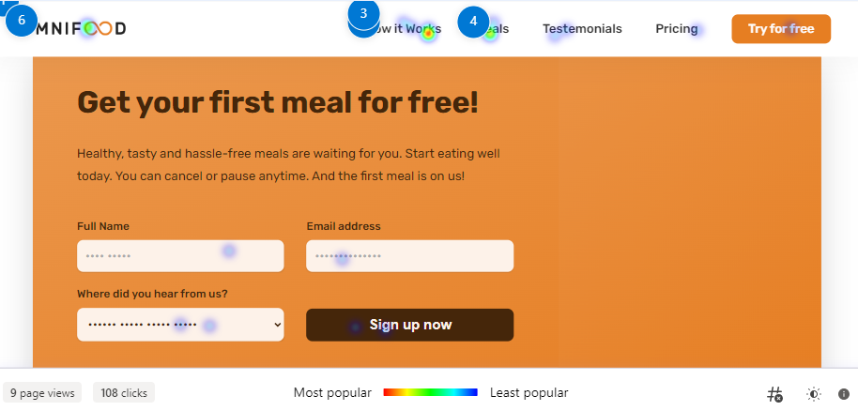

**→Pricing Section In Homepage ClickMaps:**

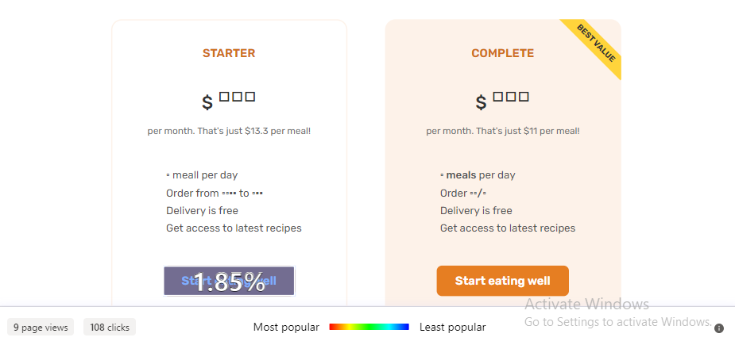

**8. Recommendations:**

* **Address Dead Clicks:** Investigate and resolve issues causing dead clicks, as they indicate users are interacting with non-functional elements.
* **Optimize Scroll Depth:** Analyze excessive scrolling instances to improve user experience and content organization.
* **Enhance Performance**: Although the overall performance score is high, focus on addressing Cumulative Layout Shift (CLS) to optimize page loading and stability further.
* **Track Referrer Sources:** Understand the traffic source to the application to refine marketing strategies and enhance user acquisition.
* **User Engagement:** Leverage smart events such as Sign Up and Submit Form to understand user behavior better and optimize conversion pathways.

**9. Conclusion**

With insights from Microsoft Clarity, we've pinpointed areas for improvement on the Omnifood website. Addressing issues like dead clicks and optimizing pathways will enhance user experience and site stability. These insights empower targeted enhancements, ensuring Omnifood stays competitive and user-focused online.