# Emarsys Documentation

This document is basically used for creating email campaigns to contact lists (that can be already created) , as per client requirement. So follow below steps:

1. Go to site <https://suite52.emarsys.net/bootstrap.php?r=home&startpage=1&session_id=59e1CMOylWfR23750285>
2. Login your profile with account name, username and password.

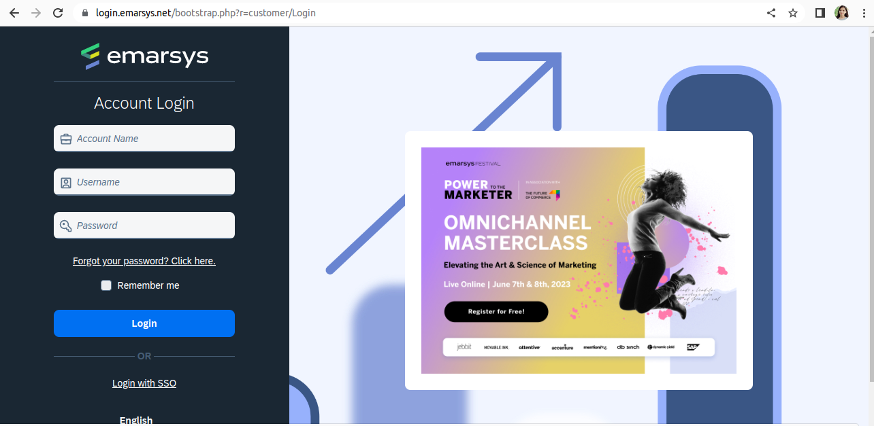

1. Go to left panel and click on Channel and then Email Campaigns

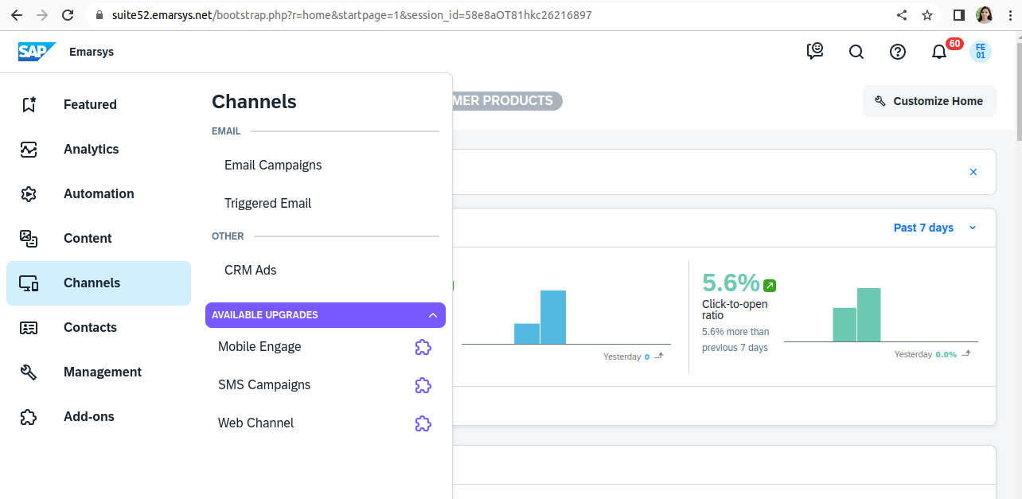

1. Click on Create Email then choose Email type and select Block-based Email.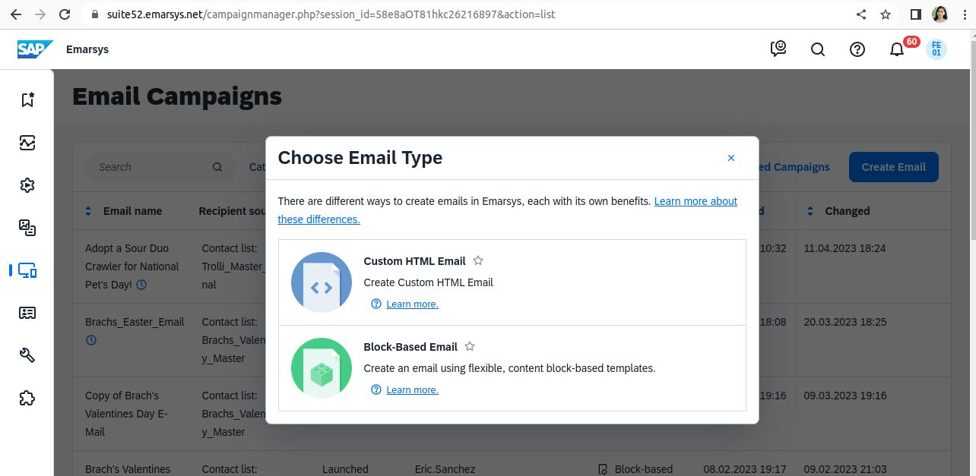

1. Select your template or create template.

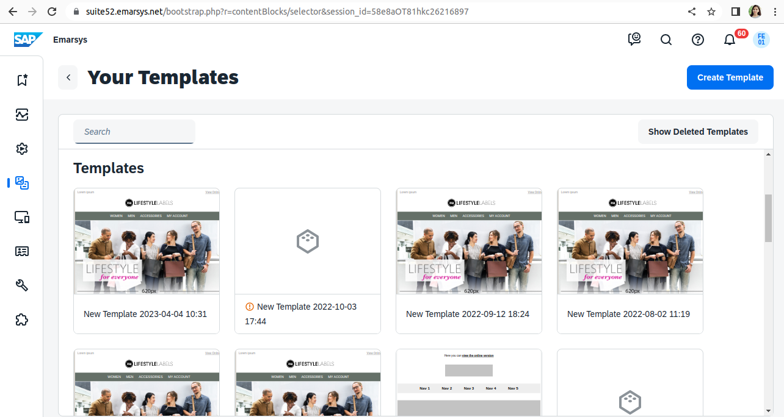

1. Change Email Settings like Email name and then select Recipient source and list as per your product and save it.
2. Next tab is Content Creation

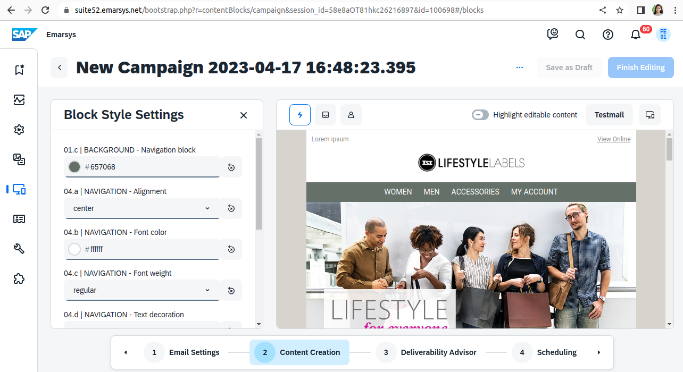

Change the content and images as per your requirement.

1. If we want to enable/disable the option then click on manage optional content.

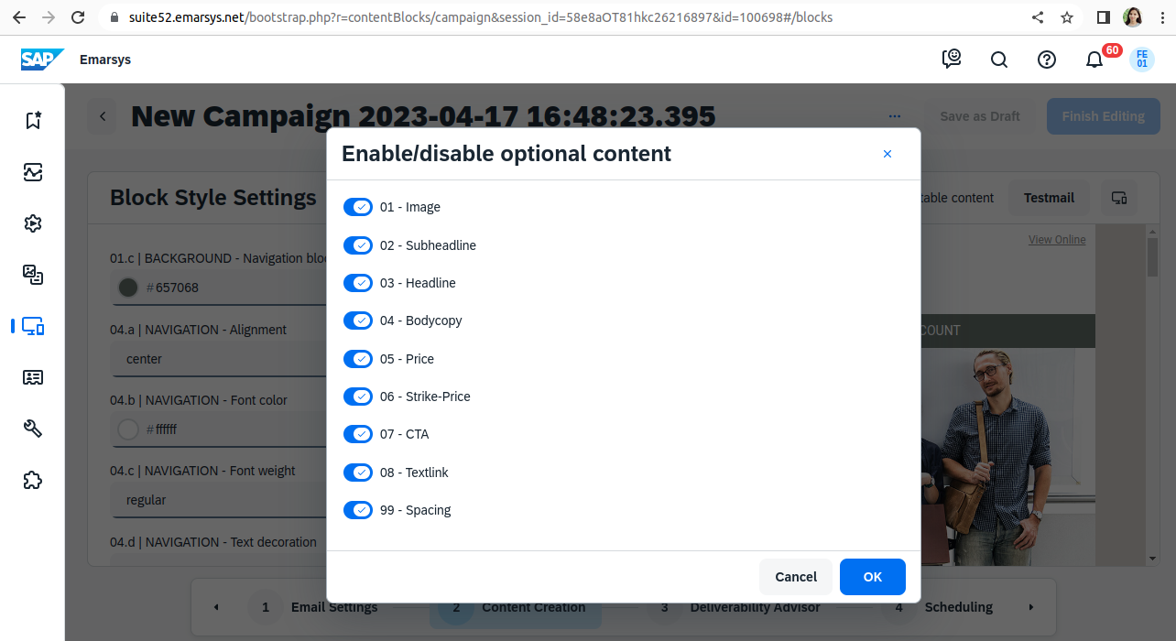

1. CSS related changes click on block style settings.

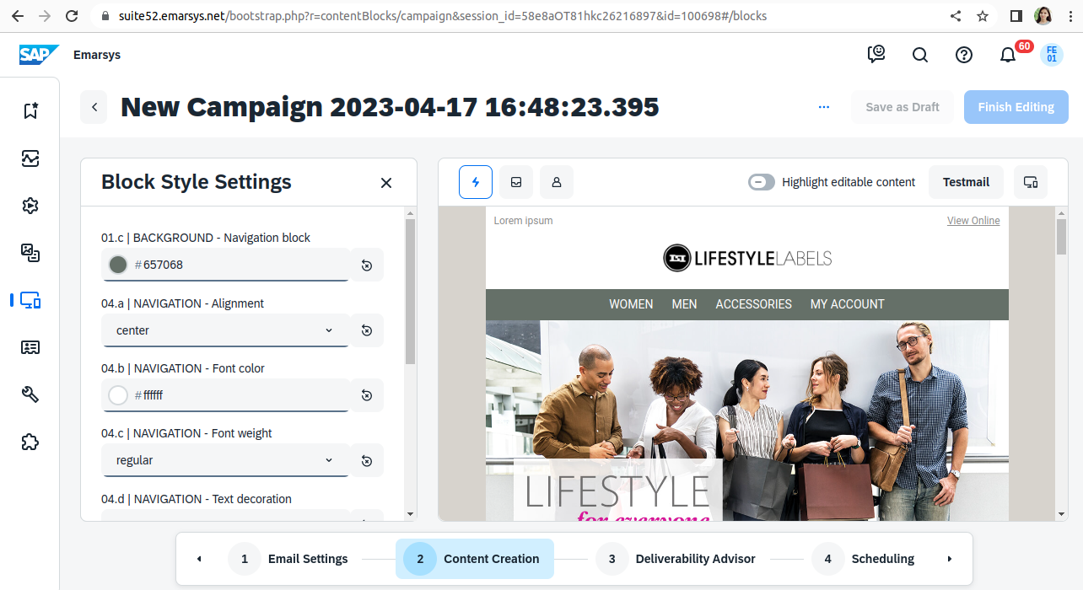

1. On the last step, if we need to test email there is a 'Test' email button in emarsys where you can input emails manually.
2. Change Email name and select recipient source “Enter Email Address Manually”.

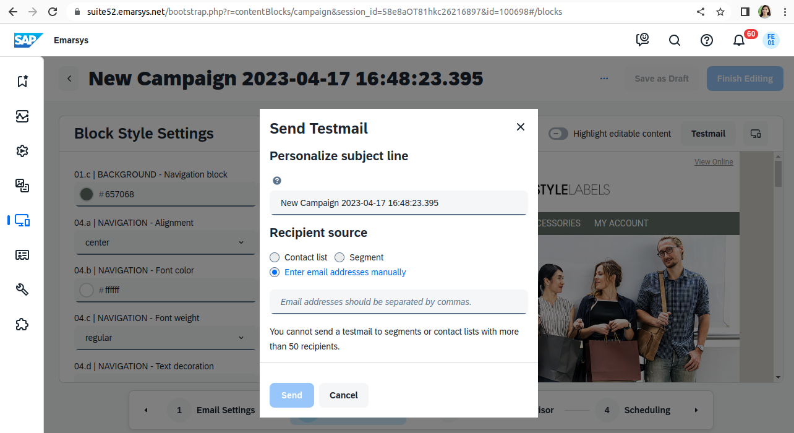

1. Then click on Send Button. Finished.