# FULL STACK DEVELOPMENT

# Assignment – 2

1: Styling Headings and Paragraphs

<!DOCTYPE html>

<html>

<head>

<title>Styled Page</title>

<style>

h1 {

text-align: center;

}

p {

color: darkgray;

font-size: 20px;

}

</style>

</head>

<body>

<h1>This is a Centered Heading</h1>

<p>This paragraph text is dark gray and 20px in size.</p>

</body>

</html>

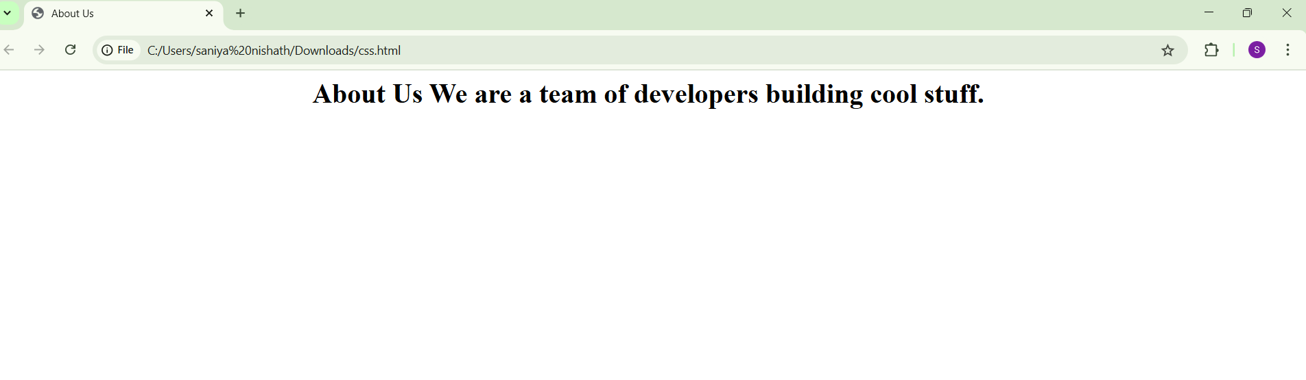

2. Styling a navigation bar

<!DOCTYPE html>

<html>

<head>

<title>Styled Links</title>

<style>

a {

text-decoration: none;

color: darkblue;

}

a:hover {

color: orange;

}

</style>

</head>

<body>

<h2>Navigation</h2>

<nav>

<a href="#">Home</a> |

<a href="#">About</a> |

<a href="#">Contact</a>

</nav>

</body>

</html>

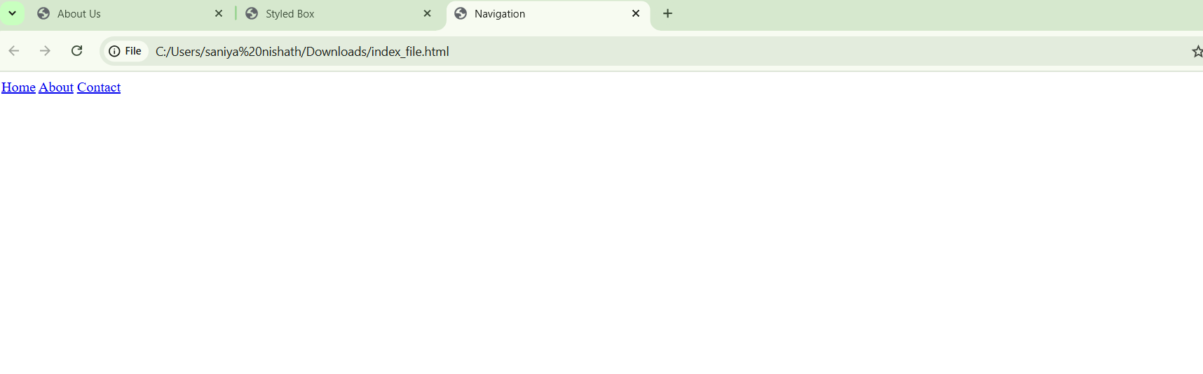

3. Box Styling

<!DOCTYPE html>

<html>

<head>

<title>Styled Box</title>

<style>

box {

background-color: lightgray;

padding: 20px;

border: 1px solid black;

}

</style>

</head>

<body>

<div class="box">

This is a styled box with light gray background, padding, and a black border.

</div>

</body>

</html>

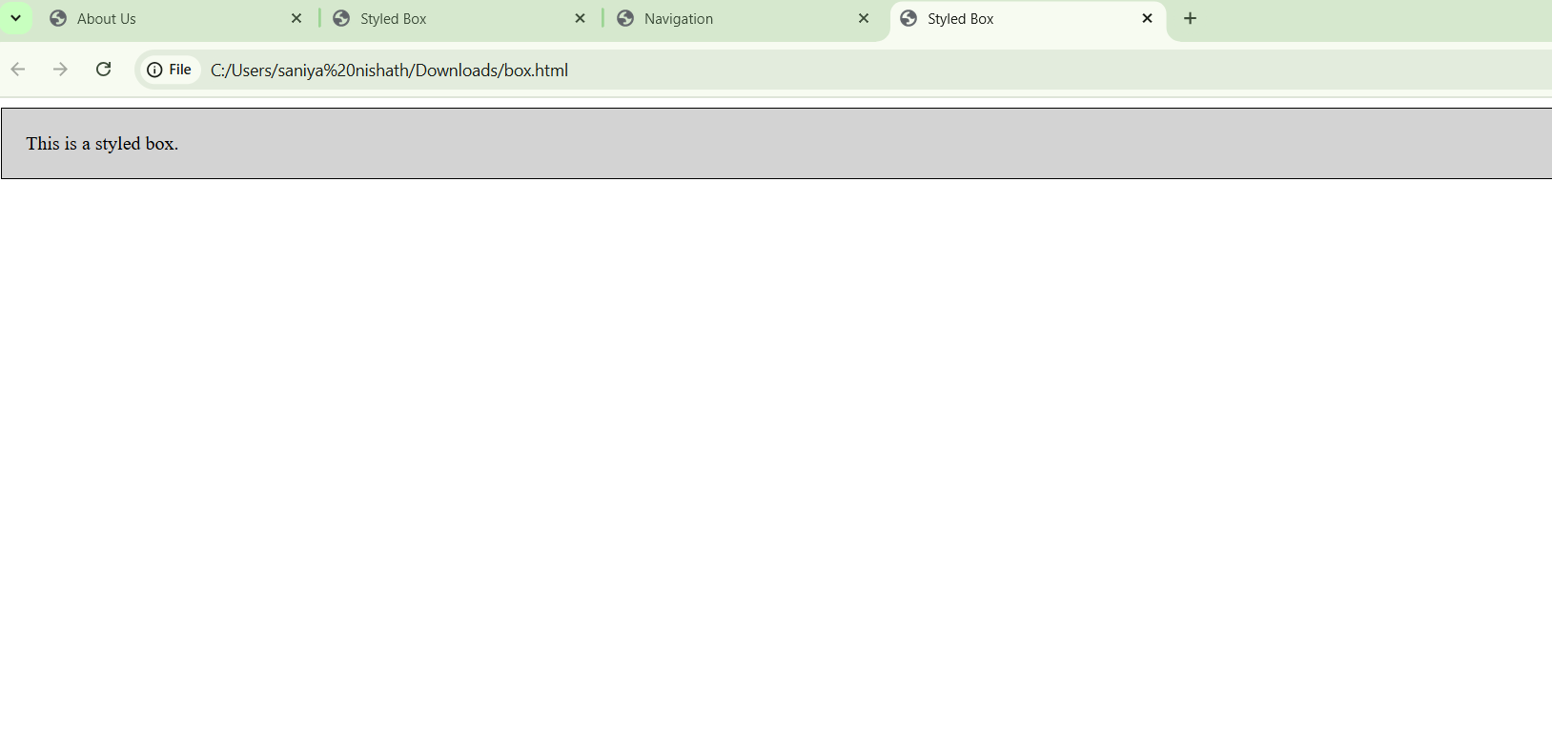

## 4: Button Styling

<!DOCTYPE html>

<html>

<head>

<title>Styled Button</title>

<style>

.btn {

border-radius: 10px;

padding: 10px 20px;

background-color: #007BFF;

color: white;

border: none;

cursor: pointer;

}

</style>

</head>

<body>

<button class="btn">Submit</button>

</body>

</html>

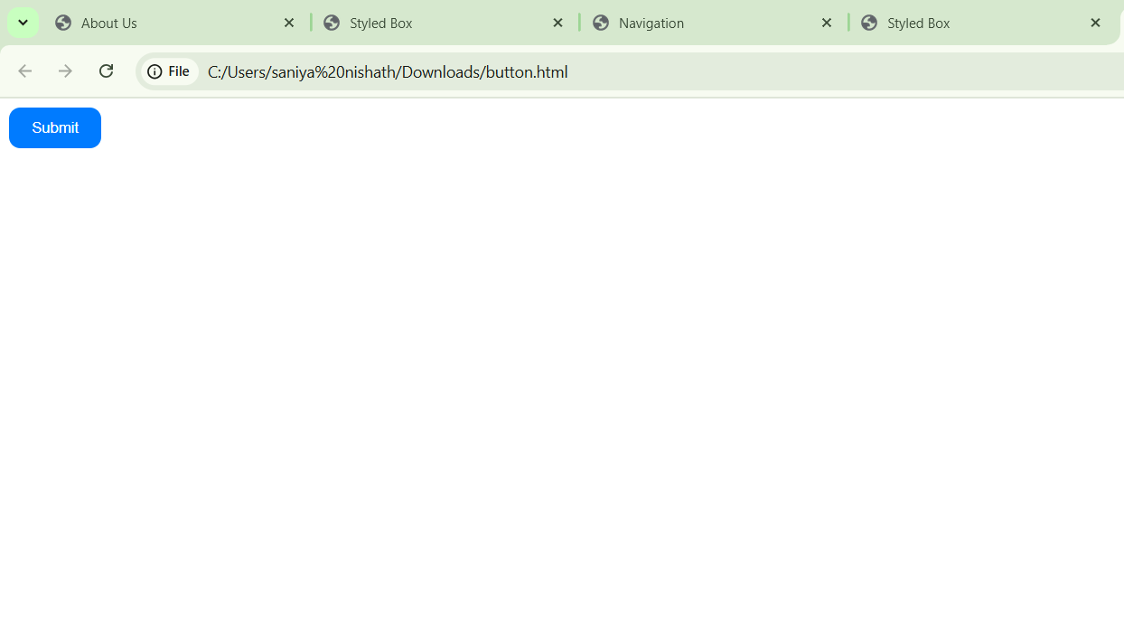

5: Layout with Flexbox

<!DOCTYPE html>

<html>

<head>

<title>Flexbox Layout</title>

<style>

.container {

display: flex;

justify-content: space-between;

padding: 20px;

background-color: #f0f0f0;

}

.container > div {

background-color: #007BFF;

color: white;

padding: 10px 20px;

border-radius: 5px;

}

</style>

</head>

<body>

<div class="container">

<div>Item 1</div>

<div>Item 2</div>

<div>Item 3</div>

</div>

</body>

</html>

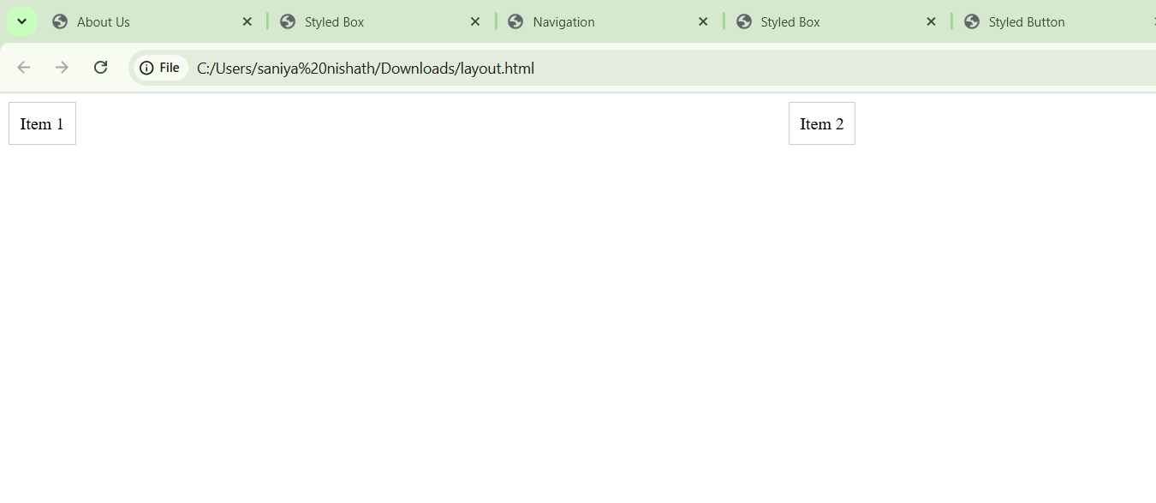

## 6. Hover Card with Shadow

<!DOCTYPE html>

<html>

<head>

<title>Styled Card</title>

<style>

.card {

border: 1px solid #ccc;

padding: 20px;

transition: box-shadow 0.3s ease;

}

.card:hover {

box-shadow: 0 4px 8px rgba(0, 0, 0, 0.2);

}

</style>

</head>

<body>

<div class="card">

<h3>Product Title</h3>

<p>Some product description goes here.</p>

</div>

</body>

</html>

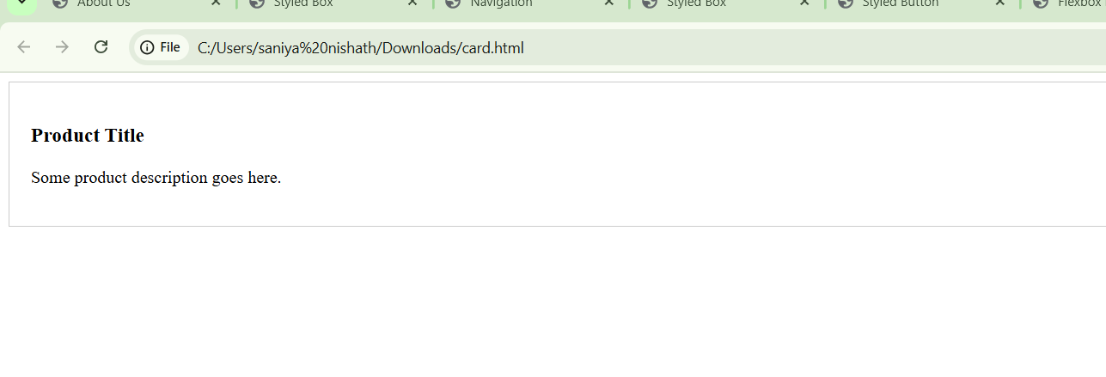

## 7: Style Even and Odd Rows Differently

<!DOCTYPE html>

<html>

<head>

<title>Styled Table Rows</title>

<style>

table {

width: 100%;

border-collapse: collapse;

}

tr:nth-child(even) {

background-color: #f2f2f2; /* Light gray for even rows */

}

tr:nth-child(odd) {

background-color: #ffffff; /* White for odd rows */

}

td {

padding: 8px;

border: 1px solid #ddd;

}

</style>

</head>

<body>

<table>

<tr><td>Row 1</td></tr>

<tr><td>Row 2</td></tr>

<tr><td>Row 3</td></tr>

<tr><td>Row 4</td></tr>

</table>

</body>

</html>

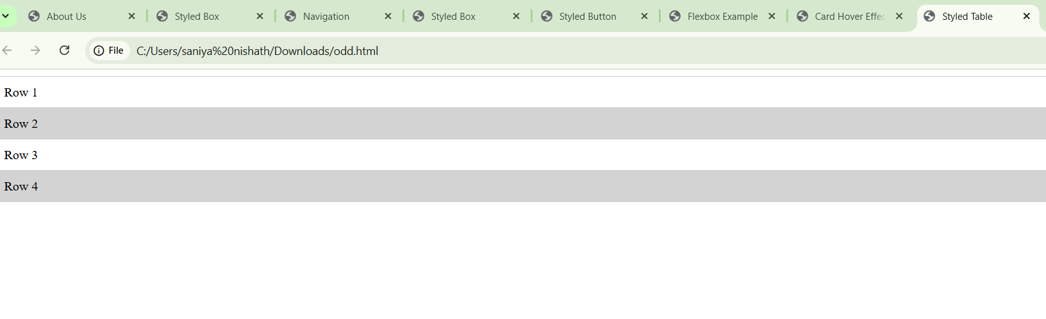

8: Positioning a Badge on an Image

<!DOCTYPE html>

<html>

<head>

<title>Image with Badge</title>

<style>

.image-container {

position: relative;

display: inline-block;

}

.badge {

position: absolute;

top: 10px;

right: 10px;

background-color: red;

color: white;

padding: 5px 10px;

font-size: 14px;

border-radius: 12px;

}

</style>

</head>

<body>

<div class="image-container">

<img src="product.jpg" alt="Product" width="200">

<span class="badge">New</span>

</div>

</body>

</html>

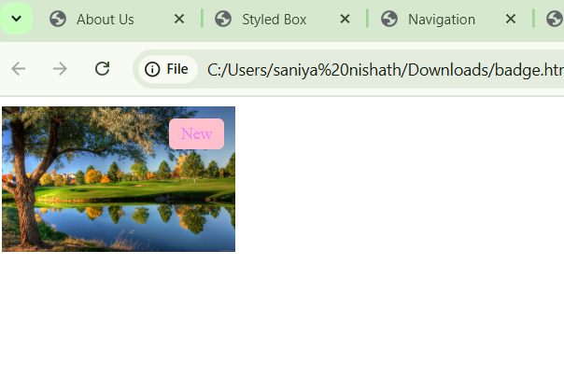

## 9: Responsive Text Size

<!DOCTYPE html>

<html>

<head>

<title>Image with Badge</title>

<style>

.image-container {

position: relative;

display: inline-block;

}

.badge {

position: absolute;

top: 10px;

right: 10px;

background-color: red;

color: white;

padding: 5px 10px;

font-size: 14px;

border-radius: 12px;

}

</style>

</head>

<body>

<div class="image-container">

<img src="product.jpg" alt="Product" width="200">

<span class="badge">New</span>

</div>

</body>

</html>

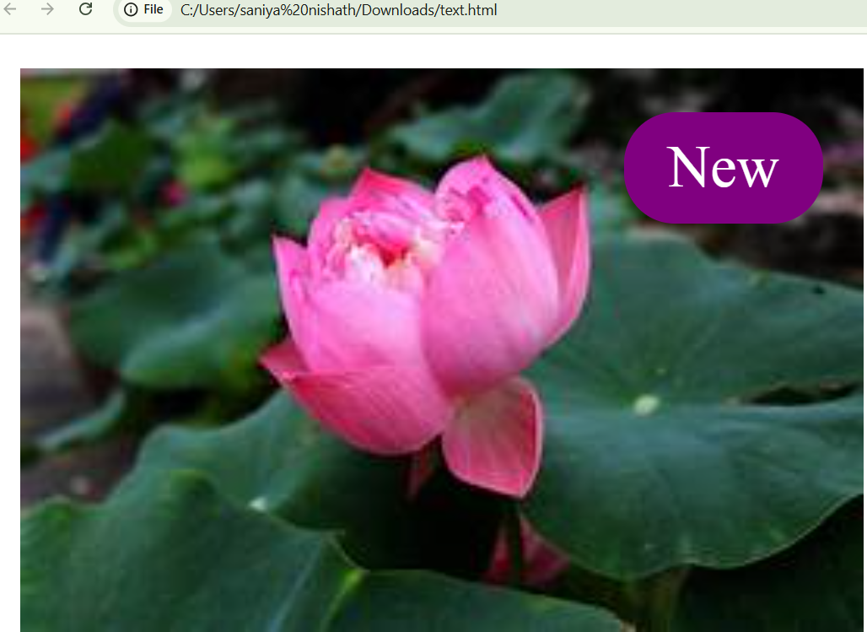

10: Navigation Menu with Active Link

<!DOCTYPE html>

<html>

<head>

<title>Styled Navigation Menu</title>

<style>

nav {

display: flex;

gap: 20px; /* Adds spacing between links */

padding: 10px;

background-color: #f9f9f9;

}

nav a {

text-decoration: none;

color: #333;

padding-bottom: 5px;

font-family: Arial, sans-serif;

font-size: 16px;

}

nav a.active {

border-bottom: 2px solid #007BFF; /* Highlight active link */

}

</style>

</head>

<body>

<nav>

<a href="#" class="active">Home</a>

<a href="#">About</a>

<a href="#">Services</a>

</nav>

</body>

</html>

