**Insights of WeRatedogs Tweets**

By Nishu Jain

**Introduction**

The dataset used in this project is the tweet archive of user [@dog_rates](https://twitter.com/dog_rates), known as **WeRateDogs** that rates dog’s with a humorous comment. In general ratings are from 1 to 10, but they thinks that every dog deserves at least 10 so their numerators are always greater than 10 with a denominator of 10.(12/10 , 14/10)

WeRateDogs has over 6 million followers and has received international media   
coverage.

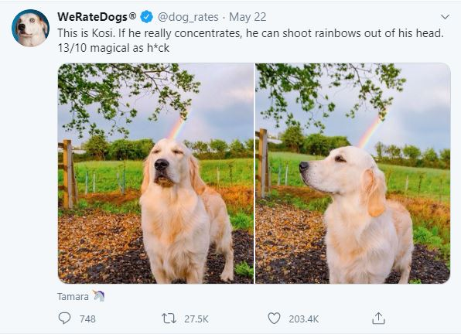

So, we will discuss some insights based on the data used for this project.

For eg, which dog breed is the most common in our dataset? Etc.

**Most common dog type**

The most rated dog was golden retriever with 150+ ratings.

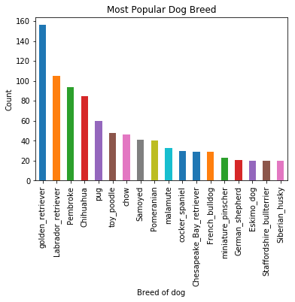



Hi! This is Kevin (Golden Retriever)

**Tweets over time**

We can see in the image below that over the time, tweets has been decreased sharply.

Unfortunately, we don’t have much information which tells us the reason for the same.

I hope [@dog_rates](https://twitter.com/dog_rates) are aware of the same.

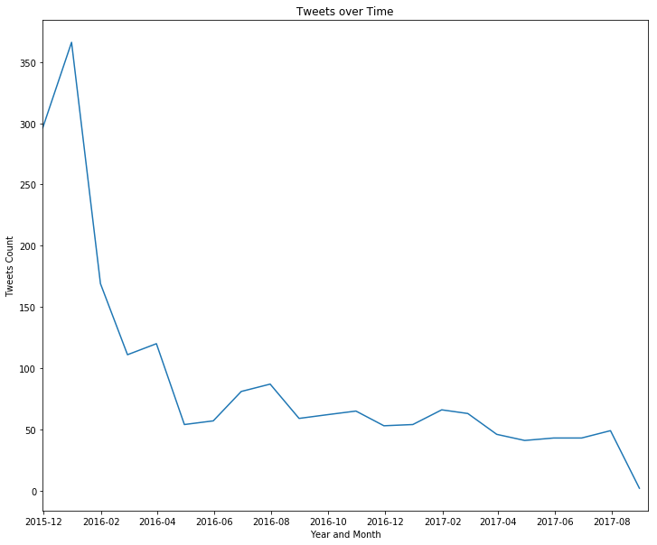

**Most Common dog name**

Most common and popular dog names are **Cooper** , **Charlie** & **Oliver**.

